E-Commerce Sales Dataset
Descriptive Analytics Report
Prepared by Subhaa | July 2026

1. Overview
This report presents a descriptive statistical analysis of a 1,200-row e-commerce order dataset covering January 2023 through June 2025. The dataset includes 14 fields: order and customer identifiers, product, quantity, unit price, shipping address, payment method, order status, tracking number, items in cart, coupon code, referral source, and total order price.
Aside from the coupon code field (309 orders had no coupon applied), the dataset has no missing values.

2. Basic Statistics
Summary statistics for Total Price (Rs.), the core revenue metric:
Statistic | Value (Rs.)
Count | 1,200 orders
Mean | 1,053.97
Median | 823.62
Standard deviation | 819.86
Minimum | 11.39
Maximum | 3,456.40
25th percentile | 410.52
75th percentile | 1,578.48

The mean (Rs. 1,053.97) is noticeably higher than the median (Rs. 823.62), indicating a right-skewed distribution: most orders are modest in value, while a smaller number of high-value orders pull the average upward.
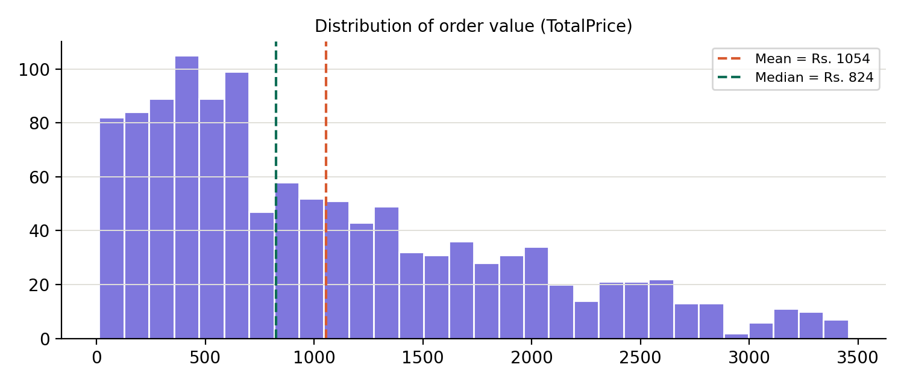

3. Trends

3.1 Revenue over time
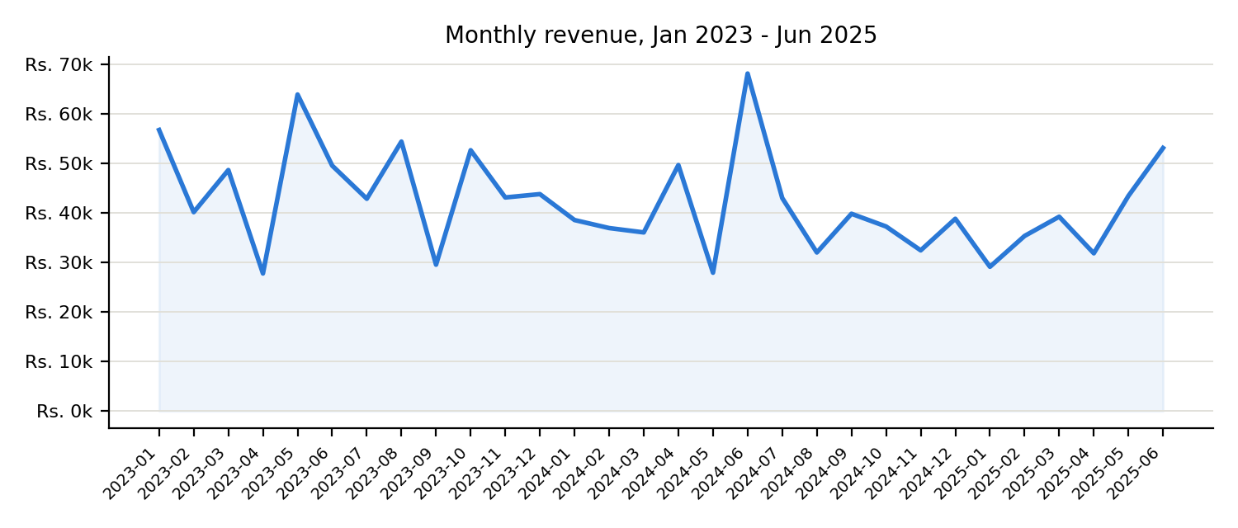
Monthly revenue fluctuates between roughly Rs. 28,000 and Rs. 68,000 with no sustained upward or downward trend across the two and a half years of data. This suggests either a stable, mature sales pattern or a dataset without built-in seasonality. Note that 2025 shows a lower yearly total simply because that year's data ends in June, not because of an actual decline.

3.2 Revenue by product
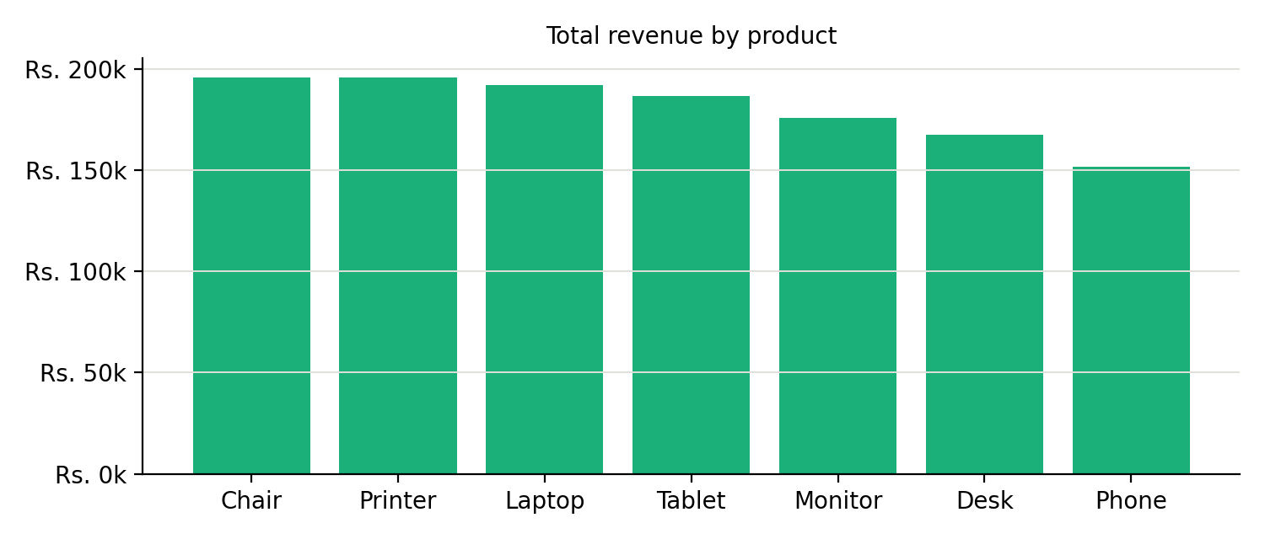
Revenue is spread fairly evenly across the seven products offered. Chairs (Rs. 195,620), Printers (Rs. 195,613), and Laptops (Rs. 192,127) lead, while Phones trail at Rs. 151,722 — a gap of about 22%, not a dominant or negligible category.

3.3 Payment method, order status, and referral source
Order counts and average values are near-identical across payment methods (Online, Cash, Credit Card, Debit Card, Gift Card — each 230-260 orders, Rs. 1,000-1,130 average) and referral sources (Instagram, Email, Google, Facebook, Referral — each 220-260 orders, similar averages). One notable pattern: Cancelled orders carry the highest average value (Rs. 1,105.58), while Returned orders carry the lowest (Rs. 984.93) — a Rs. 121 gap that could merit investigation in a real business setting, since it hints that higher-value orders may be somewhat more prone to cancellation.

3.4 Coupons and customer repeat rate
Orders that used a coupon averaged Rs. 1,057 versus Rs. 1,043 for orders without one — a negligible difference, suggesting coupon usage is not strongly linked to order size here. Separately, the dataset contains 1,189 unique customers across 1,200 orders, with only 11 customers placing more than one order — consistent with a broad, one-time-acquisition sales pattern rather than a repeat-purchase-driven business.

3.5 Correlations
Variable pair | Correlation (r)
Total Price vs. Unit Price | 0.72
Total Price vs. Quantity | 0.62
Total Price vs. Items in Cart | 0.39
Quantity vs. Items in Cart | 0.65

Total order value is driven most strongly by unit price and quantity, as expected. Items in cart is a weaker predictor of total price, since it reflects browsing behavior more than final purchase size.

4. Outlier Analysis
Using the interquartile range (IQR) method on Total Price (upper bound = Q3 + 1.5 x IQR = Rs. 3,330.41), 8 of the 1,200 orders (0.67%) are flagged as statistical outliers, all falling between Rs. 3,334.00 and Rs. 3,456.40.
Order ID | Product | Quantity | Unit Price (Rs.) | Total Price (Rs.)
ORD200789 | Tablet | 5 | 691.28 | 3,456.40
ORD201122 | Monitor | 5 | 678.19 | 3,390.95
ORD200632 | Laptop | 5 | 678.16 | 3,390.80
ORD200469 | Chair | 5 | 676.98 | 3,384.90
ORD200328 | Tablet | 5 | 674.04 | 3,370.20
ORD200107 | Printer | 5 | 670.75 | 3,353.75
ORD200326 | Laptop | 5 | 670.48 | 3,352.40
ORD201065 | Printer | 5 | 666.80 | 3,334.00

Each outlier shares the same profile: the maximum quantity allowed (5 units) combined with a high unit price. These are legitimate bulk, high-value purchases rather than data errors, and do not need to be removed or corrected.

5. Key Observations
- Order value is right-skewed: a typical order is around Rs. 824 (median), but the average is pulled up to Rs. 1,054 by a tail of high-value bulk orders.
- Revenue is flat over time - no clear growth, decline, or seasonal cycle across 30 months of data.
- The product mix, payment methods, and referral channels are all evenly diversified; no single category dominates sales.
- Cancelled orders average the highest order value, and Returned orders the lowest - a pattern worth investigating further if this were a live business.
- Coupon usage shows almost no relationship with order size.
- Nearly all customers (1,189 of 1,200 orders) are one-time buyers, indicating an acquisition-heavy rather than retention-driven sales pattern.
- The 8 statistical outliers are explainable, legitimate bulk purchases at maximum quantity and high unit price - not data quality issues.

