UID – **19BEC1012**

**Exp. No : 21 Designe a system that automatically turns on the light inside an almirah whenever it is opened and turns off the light after 100ms if there is enough light in the room.**

**THEORY**

**Circuit Diagram :**

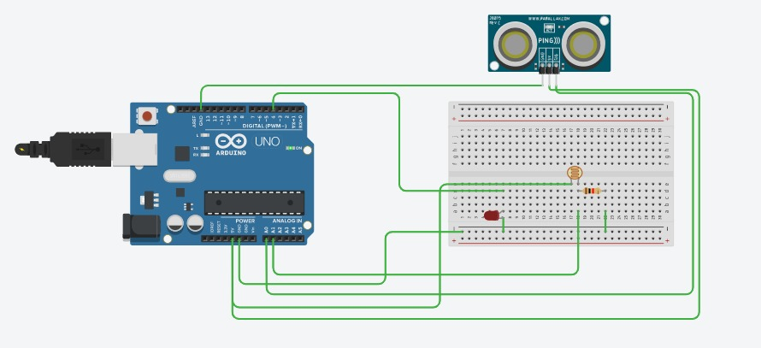

**Concepts : To designe a system in which light glows when the almira is opened and and after 100 ms it will sense the light ,if the light in room is sufficient then light will turn off and if the light is not sufficient then light will turn on.**

**Learning And Observation**: light glows when door opens and also when light is not sufficient .

**CODE:**

**int sensorPin=A0;**

**int ldrPin=A1;**

**int ledPin=4;**

**void setup()**

**{**

**pinMode(sensorPin, INPUT);**

**pinMode(ldrPin, INPUT);**

**pinMode(ledPin, OUTPUT);**

**Serial.begin(9600);**

**}**

**void loop()**

**{**

**int sensorStatus = analogRead(sensorPin);**

**int ldrStatus = analogRead(ldrPin);**

**Serial.print("sensor:");**

**Serial.println(sensorStatus);**

**delay(1000);**

**Serial.print("ldr:");**

**Serial.println(ldrStatus);**

**while(sensorStatus==1)**

**{**

**digitalWrite(ledPin,HIGH);**

**delay(100);**

**while(ldrStatus>300)**

**{**

**digitalWrite(ledPin,HIGH);**

**}**

**while(ldrStatus<300)**

**{**

**digitalWrite(ledPin,LOW);**

**}**

**}**

**if(sensorStatus==0)**

**{**

**digitalWrite(ledPin,LOW);**

**}**

**}**

**}**

**}**

1. Faced problem in connecting the LDR with arduino, troubleshooted it by changing the wires connected to GND And Analog INPUTS.
2. Faced Problem in detecting motio through ultrasonic sensor.

Precaution And Troubleshooting:

1. Connecting Wires in Common For GND for LED and sensors.
2. Connecting 5V, GND with Analog Input for LDR and ultrasonic sensor.

Learning And Outcomes:

To learn how a automatic light works.