**Performance Analysis of Underwater optical wireless communication**

Thesis/Report submitted in partial fulfillment of the requirements for the degree of

**Bachelor of Technology**

**In**

**Electronics and Telecommunication**

**By**

**Subham Supriya Padhi**

**(Roll no.: B219056)**

Under the guidance of

**Prof. Dr. Rajat Kumar Giri**

Department of Electronics and telecommunication

International Institute of Information Technology Bhubaneswar

Bhubaneswar, Odisha, 751003, India

May, 2023

With the blessings of almighty.

To my beloved parents, family members, and my mother

Department of Electronics and telecommunication

International Institute of Information Technology Bhubaneswar

Bhubaneswar- 751003, Odisha, India.

Supervisor’s Certificate

This is to certify that the work in the thesis/report entitled “Performance Analysis of Underwater optical wireless communication” by Subham Supriya Padhi, bearing roll number B219056, is a record of an original research work/work carried out by him under my supervision and guidance in partial fulfillment of the requirements for the award of the degree of Bachelor of Technology in Electronics and Telecommunication Engineering. Neither this thesis/report nor any part of it has been submitted for any degree or academic award elsewhere.

Date: 24.05.2023

Place: Bhubaneswar

Prof. Dr. Rajat Kumar Giri

Professor of Electronics and Telecommunication

Department of Electronics and Telecommunication

International Institute of Information & Technology

Bhubaneswar, Odisha, India

Department of Electronics and telecommunication

International Institute of Information Technology Bhubaneswar

Bhubaneswar- 751003, Odisha, India.

**Certificate of Examination**

**Roll:** B219056

**Name:** Subham Supriya Padhi

**Title of Thesis/Report:** Performance Analysis of Underwater optical wireless communication

We the below signed, after checking the thesis/report mentioned above and the official record book(s) of the student, hereby state our approval of the thesis/report submitted in partial fulfillment of the requirements of the degree of Bachelor of Technology in Electronics and Telecommunication at International Institute of Information Technology, Bhubaneswar. We are satisfied with the volume, quality, correctness, and originality of the work.

Prof. Dr. Rajat Kumar Giri Prof. Dr. Rajat Kumar Giri

Supervisor Head of the department

Department of Electronics and telecommunication

International Institute of Information Technology Bhubaneswar

Bhubaneswar- 751003, Odisha, India.

**Declaration of Originality**

I, SUBHAM SUPRIYA PADHI, bearing roll number B219056, hereby declare that this thesis/report entitled “Performance Analysis of Underwater optical wireless communication” presents my original work carried out as a bachelor student of International Institute of Information Technology, Bhubaneswar, and to the best of my knowledge, contains no material previously published or written by another person, nor any material presented by me for the award of any degree or diploma of International Institute of Information Technology, Bhubaneswar or any other institution. Any contribution made to this work by others, with whom I have worked at International Institute of Information Technology, Bhubaneswar or elsewhere, is explicitly acknowledged in the thesis/report. Works of other authors cited in this dissertation have been duly acknowledged under the sections “Reference” or “Bibliography”. I have also submitted my original research records to the scrutiny committee for evaluation of my thesis/report.

I am fully aware that in case of any non-compliance detected in future, the Senate of International Institute of Information Technology, Bhubaneswar may withdraw the degree awarded to me on the basis of the present dissertation.

Date: 24.05.2023

Place: Bhubaneswar

Subham Supriya Padhi

Roll: B219056

Department of Electronics & Telecommunication International Institute of Information Technology Bhubaneswar, Odisha, India

**Acknowledgement**

I take the opportunity to express my gratitude to all who have directly or indirectly made this thesis possible. This dissertation, though an individual work, has benefited in various ways from several people. Whilst it would be simple to name them all, it would not be easy to thank them enough.

Subham Supriya Padhi

**Abstract**

Despite the fact that water covers most of the Earth's surface, the undersea world continues to be a complicated mystery that has captured the attention of scientists and researchers all around the globe. The development of trustworthy and effective communication techniques has been the subject of extensive theoretical and experimental research. These techniques are essential for the successful implementation of critical industrial, military, and security applications as well as the sustainable management of marine resources. Underwater communication systems have substantially advanced over time, using both cable and wireless methods. This has been done by using acoustic and electromagnetic waves that operate in the radiofrequency or optical spectrum. Although acoustic communication allows for transmission across large distances of kilometers, it is now necessary to investigate electromagnetic-based communication due to its poor data rate, sluggish pace, and negative impacts on the marine environment. High data speeds and quick transmission are provided by electromagnetic waves, which can also seamlessly transition between water and air and are unaffected by turbidity in the water. These benefits, however, come at a high price. Surprisingly, owing to its high bandwidth and low cost, wireless communication in the optical spectrum has outperformed all previous methods. As a result, this analysis concentrates on the many features of underwater optical wireless communications (UOWC), giving a summary of key communication strategies and outlining their benefits and drawbacks.

**Contents**

**Page No.**

|  |
| --- |
| **Supervisor’s Certificate**  3 |
| **Certificate of Examination** 4 |
| **Declaration of Originality** 5 **Acknowledgement** 6 |
| **Abstract** 7 |
| **List of Acronyms** 9 |
| **List of Symbols** 10 |
| **List of Figures** 11 |
| **List of Tables** 12 |
| 1. **Introduction** 13  1.1 Introduction to Underwater Optical Wireless Communication 14 |
| 1.2 An Overview of Underwater Optical Wireless Communication 15 |
| 1.3 Importance of Underwater Optical Wireless Communication 15 |
| 2. **Need for wireless communication techniques** 16 |
| 2.1 Wired Communication 17 |
| 2.2 Wireless Communication 17  2.2.1 Acoustic 17  2.2.2 RF 18  2.2.3 Optical 18 |
|  |
| 3. **Challenges in UWOC** 20 |
| 3.1 Light propagation in water 21 |
| 3.2 Types of water 23 |
|  |
| 4. **Implementation & Results** 25 |
| 4.1 Optisystem 26 |
| 4.2 Optisystem Design 26 |
| 4.3 Eye diagram 27 |
| 4.4 Q-factor Vs. Distance 30 |
|  |
| 5. **Conclusion & Future work** 31 |
| 5.1 Conclusion 32 |
| 5.2 Future work 33 |
|  |
| 6. **Bibliography and References** 34 |

**List of Acronyms**

OWC Optical Wireless Communication

UV Ultraviolet

UOWC Underwater Optical Wireless Communications

RF Radiofrequency

UAWC Underwater Acoustic Wireless communications

FSO Free Space optical

IOPs Inherent optical properties

AOPs Apparent optical properties

SNR Signal-to-Noise Ratio

ISI Inter-symbol interference

CDOM Colored dissolved organic matter

SPM Suspended particulate matter

NRZ Non-return-to-zero

BER Bit Error Rate

**List of Symbols**

|  |  |
| --- | --- |
| PA | absorbed power |
| PS | dispersed power |
| PT | and transmitted power |
| c(λ) | attenuation coefficient |
| ∆V | amount of water |
| ∆D | with a certain thickness |
| λ | wavelength |
| aw(λ) | absorption due to pure seawater |
| aCDOM (λ) | absorption due to CDOM |
| aphy(λ) | absorption due to phytoplankton |
| adet(λ) | absorption due to detritus. |
| bw(λ) | scattering due to pure seawater |
| bphy(λ) | scattering due to phytoplankton, |
| bdet(λ) | scattering due to detritus |

**List of Figures**

**Page No.**

**Figures**

**Fig.1** Geometry of inherent optical properties for a volume ∆V 21

**Fig.2** Block Diagram of a typical underwater optical wireless communication 26

**Fig.3** Optisystem Design 26

**Fig.4** Eye Diagrams

**Fig 4.1** Eye diagram for pure sea water at 1500m @5Gbps 27

**Fig 4.2** Eye diagram for pure sea water at 2000m @5Gbps 28

**Fig 4.3** Eye diagram for pure sea water at 2500m @5Gbps 28

**Fig 4.4** Eye diagram for pure sea water at 3000m @5Gbps 29

**Fig 4.5** Eye diagram for pure sea water at 3500m @5Gbps 29

**Fig.5** Impact on Q-factor with transmission distance for NRZ modulation 30

**List of Tables**

**Page No.**

**Tables**

**Tab 1.** Comparison Table between Acoustic, RF

and Optical communication techniques 19

**Tab 2.** Typical Values of a(λ), b(λ) and c(λ) for different water types24

**Tab 3.** Simulation Parameters 27

**Tab4.** Impact on Q-factor with transmission distance for NRZ modulation 30

**Chapter 1**

**Introduction**

An Overview of Underwater Optical Wireless Communication

Importance of Underwater Optical Wireless Communication

**Introduction**

* 1. **Introduction to Underwater optical wireless communication**

Underwater optical wireless communication (UOWC) is a cutting-edge technology that enables the transmission of data through light signals in underwater environments. As the demand for reliable and efficient communication systems in the subaquatic world continues to grow, UOWC has emerged as a promising solution. By utilizing the properties of light, this technology offers several advantages over traditional underwater communication methods, opening up new possibilities for various applications.

Underwater environments present unique challenges for communication due to factors such as signal attenuation, multipath propagation, and limited bandwidth. Acoustic communication has traditionally been the primary method for underwater data transmission, but it suffers from limitations such as low data rates, significant propagation delays, and susceptibility to noise and interference. UOWC addresses these challenges by harnessing the power of light to transmit information through the water medium.

One of the key advantages of UOWC is its high bandwidth capabilities. Optical signals can carry a large volume of data, allowing for fast and efficient communication. This high bandwidth is particularly beneficial for applications that require real-time data transfer, such as underwater video streaming, remote sensing, and underwater robotics. With UOWC, researchers, engineers, and explorers can gather and transmit large datasets without compromising on speed or quality.

Another advantage of UOWC is its low latency. Light signals travel much faster in water than sound waves, resulting in reduced transmission delays. This low latency makes UOWC well-suited for applications that demand quick response times, such as remote control of underwater vehicles or real-time monitoring of critical operations. The ability to receive and process data in near real-time enhances the effectiveness and efficiency of underwater operations.

Furthermore, UOWC offers enhanced security compared to other underwater communication technologies. Optical signals are less susceptible to interception and eavesdropping, providing a higher level of data confidentiality. This makes UOWC a valuable tool for applications involving sensitive information, such as defense operations, scientific research, and subsea infrastructure monitoring.

However, UOWC is not without its challenges. Light signals in water are subject to absorption, scattering, and signal degradation over distance, which limits the range of communication. Additionally, underwater conditions such as turbidity, particulate matter, and marine life can obstruct the line-of-sight between UOWC transmitters and receivers. These challenges necessitate the development of innovative solutions to extend the range and improve the reliability of UOWC systems.

* 1. **An Overview of Wireless Underwater Optical Communication**

Despite the ocean covering a large portion of our world, there are still many things we do not know about the deep water. Monitoring many undersea elements, such as the seabed, deep-sea and ocean oil pipelines, marine life, unmanned systems, navigation, and climate change, is vital. The management of ocean resources sustainably and the averting of future environmental catastrophes both depend on gathering this data. Therefore, it is crucial to create efficient underwater communication techniques to support vital commercial, military, and academic applications.

Technologies for ocean exploration have advanced significantly, and communication systems for underwater use have also been created. Acoustic waves, electromagnetic waves (including radio-frequency and optical waves), or hybrid systems are some of the many methods used by these systems. Although mature, acoustic communication technology has drawbacks such slow speeds, poor data rates owing to constrained bandwidth, and harmful effects on the aquatic environment. Additionally, it is significantly impacted by the salinity and turbidity of the water channel, which leads to less than ideal performance. Contrarily, radio-frequency transmission is faster than sound waves and is unaffected by the properties of water channels, but it is heavy, costly, and only capable of small communication distances.

In optical wireless communication (OWC), data is sent via an optical carrier in an unguided propagation medium using ultraviolet (UV), visible, or infrared wavelengths. The least attenuation occurs in the visible spectrum, especially between 450 and 550 nm. High data speeds, low cost, quick speed, and safety are all advantages of underwater optical wireless communications (UOWC). The water channel and the creation of appropriate channel models for various undersea conditions, however, present difficulties for UOWC. Although there isn't currently a complete model that addresses every issue with underwater channels, UOWC performs better than other approaches because of the aspects stated above.

**1.3 Importance of Underwater Optical Wireless Communication:**

The Underwater Optical Wireless Communication (UOWC) system aims to overcome the limitations of traditional underwater communication methods, such as acoustic and RF, by offering higher data rates, longer range, and improved efficiency. By utilizing a wide spectrum, particularly the blue-green region, UOWC provides increased bandwidth, enabling faster data transfer rates and the ability to handle large data volumes for real-time applications. Operating in the optical spectrum, UOWC ensures reduced interference in crowded underwater environments, resulting in improved reliability and communication quality. Additionally, the highly directional nature of optical signals in UOWC provides enhanced security, preventing eavesdropping and interception, making it suitable for secure communication in sensitive underwater applications. Moreover, UOWC is compatible with existing technologies as it leverages off-the-shelf commercial electronics components, making it accessible, cost-effective, and easy to integrate with other underwater systems, allowing seamless compatibility with existing technologies.

**Chapter 2**

**NEED OF WIRELESS COMMUNUCATION TECHNIQUES**

Wired communication

Wireless communication

(Acoustic, RF, Optical)

**2.1 Wired communication**

Directly attaching a cable to the device's platform is one way to communicate. Remotely operated vehicles (ROVs) are the sort of communication technology that this term is most often used to describe. Operators may have real-time visual feedback and control over the vehicle by powering it via the connection. The user may gather and manipulate real-time data thanks to the cable's direct connection. The ability to supply power over the same cable allows for a bigger power budget, which is a key benefit of employing a cable connection method.

However, using the cable connection approach has a number of drawbacks. Long wire runs may be difficult to maintain and installing them is expensive. The available space is limited and is based on the length of the wire. Due to the difficult underwater environment, wires may also break or tangle under choppy sea conditions.

**2.2 Wireless Communication**

**2.2.1 Acoustic**

Techniques for transmitting and receiving information underwater using sound waves are referred to as acoustic underwater communication techniques. These methods establish communication between underwater devices or between underwater devices and surface stations using acoustic signals.

Since acoustic communication can travel great distances in water, it has been frequently used in underwater applications. It is often utilized in a variety of industries, including ocean monitoring, underwater military operations, underwater robots, and marine research.

While the acoustic approach is still the most popular underwater communication (UWC) technique, it has several built-in technical restrictions. First off, owing to the frequency range of underwater audio waves, which ranges from 10Hz to100kHz, the acoustic communications data rate is quite on the lower side, usually falling within the range kilobits per second.

Secondly, at 20 degrees Celsius, the transmission speed of sound waves in water is only around 1500 metres per second (m/s). The auditory connection thus has a large propagation delay, which is often measured in seconds. For real-time applications requiring the interchange of substantial volumes of data, this latency renders it unsuitable.

Thirdly, transceivers in acoustic communication are often large, expensive, and energy intensive. They are expensive and unusable for large scale underwater wireless sensor network (UWSN) applications because of these problems.

Additionally, marine life may be impacted by the usage of auditory communication, which is a crucial factor in underwater ecosystems.

**2.2.2 Radio Frequency**

Radiofrequency (RF) waves are used for data transmission and reception in underwater settings, which is referred to as RF wireless underwater communication. In order to establish communication, electromagnetic signals must be sent, often in the radio-frequency band. Temperature, salinity, and depth are a few variables that affect how electromagnetic waves behave underwater. These waves thus suffer severe attenuation, which reduces the range of their transmission over water. Additionally, radio waves behave differently in water than they do in air due to the greater electrical conductivity of water at higher frequencies.

The use of radio waves provides two important benefits over the use of acoustic and optical waves for underwater RF communication. First, radio waves enable communication that integrates terrestrial and underwater RF systems by permitting relatively smooth transmission over the air-water interface. Second, radio waves are more dependable in these situations because to their exceptional resistance to water turbulence and turbidity.

Nevertheless, despite these benefits, there remain a number of obstacles preventing the advancement of underwater RF communication. The high conductivity of water, which serves as a conductive transmission medium, causes RF waves to have a limited range, which is the first restriction. Consequently, RF waves can travel a few meters, especially at low frequencies between 30 and 300 Hz.

The second restriction relates to the intricate design specifications for big antennas, which depend on whether they are positioned above or below the sea line. The difficulties of deploying RF communication in aquatic settings are exacerbated by this intricacy.

Another indication that data transmission rates are not as high as hoped is the fact that underwater RF communication still moves at very sluggish speeds.

**2.2.3 Optical Communication**

The goal of researchers was to find a different strategy to address the shortcomings of existing wireless techniques. Large antennas and high-power requirements in freshwater, as well as severe attenuation in saltwater, all pose challenges to RF communications. However, the bandwidth and data rate of underwater acoustic wireless communications (UAWC) are constrained.

Optical wireless communication (OWC), notably employing visible light, was thought to provide a solution to these limitations. In the last ten years, interest in underwater optical wireless communication (UOWC), a relatively young topic, has grown significantly. By lowering device complexity, cost, and power consumption, the usage of off-the-shelf commercial electronics components has contributed to this rising interest.

OWC entails the transmission of data across an optical carrier in an unguided propagation medium, such as ultraviolet (UV), visible, or infrared light. OWC's wide spectrum, which spans from 100 to 780 nm (around 30 pHz), permits gigabit-per-second (Gbit/s) wireless data transfer. Compared to other regions of the electromagnetic spectrum, underwater visible light benefits from suffering less attenuation while travelling through water. Underwater, the blue-green wavelength region (450-550 nm) of the electromagnetic spectrum is where the optical window with lesser attenuation is most prevalent. Interest in optical wireless communication underwater has grown because of this particular optical window.”

|  |  |  |  |
| --- | --- | --- | --- |
|  | **Acoustic** | **RF** | **Optical** |
| **Attenuation** | High | Mid | Low |
| **Speed** | 1500 m/s | 2.2*108 m/s | 2.2*108 m/s |
| **Data rate** | Kbps | Mbps | Gbps |
| **Latency** | High | Mid | Low |
| **Distance** | ~km | 10m | ~km |
| **Bandwidth** | Hz, kHz | ~MHz | (10-150) MHz |
| **Frequency Band** | 10-15 kHz | 30-300 Hz | 1012-1015 Hz |
| **Transmission Power** | Tens of watts | Few mW to 100 W | Few watts |
| **Antenna Size** | 0.1m | 0.5m | 0.1m |
| **Efficiency** | 100 bits/J |  | 30000 bits/J |
| **Performance Parameter** | Temperature, Salinity, Pressure | Conductivity, Permittivity | Absorption, Scattering, Turbidity |

**Tab.1 Comparison Table between Acoustic, RF and Optical communication techniques**

**Chapter 3**

**Challenges in Underwater Optical Communication**

Light Propagation in Water

Types of water

**3.1 Light Propagation in Water**

“Underwater optical communication (UWOC) channels differ from terrestrial free-space optical (FSO) communication channels in several ways. The creation of trustworthy new channel models is required since the current terrestrial FSO channel models are insufficient for underwater situations. Understanding the underlying characteristics of light propagation in the underwater environment is essential to developing these models for UWOC. Inherent optical properties (IOPs) and apparent optical properties (AOPs) are two categories into which the optical characteristic of water is divided. IOPs are optical characteristics that are entirely determined by the transmission medium, particularly by its make-up and the presence of particulate matter. They are unaffected by the properties of the light source. The scattering coefficient, absorption coefficient, attenuation coefficient, and volume scattering function are some of the main IOPs of water. AOPs, on the other hand, are optical properties that are impacted by the light field's geometric structure and transmission medium, including diffusion and collimation. Reflectance, irradiance, and radiance are the three main AOPs of water. IOPs are utilized in UWOC systems to assess communication connection budgets, while AOPs are used to estimate ambient light levels close to the ocean's surface. The emphasis of this section will be on IOPs rather than AOPs since IOPs have a stronger influence on link performance. AOPs are discussed in more depth elsewhere.

The scattering and absorption coefficients are the two main IOPs that control the attenuation of light under water. Photons lose energy via the process of absorption, which transforms it into other forms like heat or chemical processes like photosynthesis. When light interacts with atoms and molecules in the transmission medium, scattering takes place. In UWOC systems, absorption and scattering result in three unfavorable outcomes. First, absorption lowers the overall energy of light that is communicated, reducing the UWOC's communication range. Second, since optical apertures have a limited number of openings, scattering stretches the light beam, lowering the number of photons the receiver can gather and degrading the Signal-to-Noise Ratio (SNR).

A straightforward approach is presented to determine the absorption and scattering coefficients numerically. It assumes that a body of water will be lighted by a collimated light beam of a certain wavelength. According to the rule of conservation, the incident light power is separated into three categories: absorbed power (PA), dispersed power (PS), and transmitted power (PT). The ratios of the absorbed power and dispersed power to the incident power, respectively, are then used to establish the absorption and scattering coefficients. The attenuation coefficient (c(λ)), which is the total of the absorption and scattering coefficients, is used in underwater optics to characterize the overall attenuation effects of absorption and scattering.

**Fig.1 Geometry of inherent optical properties for a volume ∆V**

We make the assumption that a specific amount of water (∆V) with a certain thickness (∆D) is exposed to a focused light beam of wavelength λ. The initial power of the incoming light is denoted as PI. Within this scenario, a fraction of the incident light power, PA, is absorbed by the water, while another portion, PS, is scattered. The remaining power of light, PT, represents the light that will continue to propagate as intended.

**PI = PA + PS + PT .**

Seawater's absorption coefficient may also be broken down into absorption coefficients for coloured dissolved organic matter (CDOM), phytoplankton, detritus, and pure seawater. At various wavelengths, each component displays varied absorption characteristics. Similar to this, the scattering coefficient is shown as the sum of scattering factors attributable to phytoplankton, detritus, and clean saltwater. While absorption is more wavelength-dependent, scattering is substantially influenced by the particulate matter density.

Underwater light absorption coefficient can be further represented as the summation of four absorption factors:

**a(λ) = aw(λ) + aCDOM (λ) + aphy(λ) + adet(λ)**

where aw(λ) is the absorption due to pure seawater, aCDOM (λ) is the absorption due to CDOM, aphy(λ) denotes the absorption due to phytoplankton, and adet(λ) represents the absorption due to detritus.

Another way to describe the scattering coefficient for underwater light propagation is as the sum of many scattering components.

**b(λ) = bw(λ) + bphy(λ) + bdet(λ)**

where bw(λ) is the scattering due to pure seawater, bphy(λ) denotes the scattering due to phytoplankton, and bdet(λ) represents the scattering due to detritus. Compared with absorption, scattering is relatively independent of wavelength. The dominant factor that impacts scattering is the density of particulate matters.

**c(λ) = a(λ) + b(λ)**

To characterize light attenuation effects in the undersea environment, Beer-Lambert's law is often utilized. The transmission distance (z), attenuation coefficient (c(λ)), and incoming light power (I0) are all related by this formula. The absorption and scattering coefficients, which influence the attenuation coefficient, vary depending on the kind and depth of the water. Tables are supplied with typical values of these coefficients for the main kinds of water.

The combined effects of absorption and scattering in the UWOC (Underwater Optical Wireless Communication) system determine the overall attenuation. The extinction coefficient, also known as the attenuation coefficient, which is computed using Beer-Lambert's law, serves to quantify this attenuation. This is how the law is stated:

**𝐼 = 𝐼0 𝑒 −𝑐(𝜆)z**

In this equation, I0 stands for the power of the light that is being communicated, z stands for the distance over which the light is being transmitted, and I stand for the power of the light after it has travelled the distance z. With various water kinds and depths, the attenuation coefficient, or c(λ), changes in value.

The properties of the water have an impact on parameters impacting the UWOC transmission system, such as wavelength, depth, and season. Biological elements including humic acid, fulvic acid, and chlorophyll content have an impact on absorption. The presence of both big and tiny particles may affect scattering, whereas scattering coefficients are determined by statistical distribution and scattering intensity.

The characteristics of water and the undersea environment provide difficulties for underwater optical communication.

**3.2. Types of water**

Both geographical and vertical considerations may be used to explain variations in ocean waters. Geographically, variances in water transparency and coastal areas occur, whereas vertically, background radiation and the quantity of sunshine received are important factors.

On the basis of the downwelling sunlight, they may be largely categorized as oceanic and coastal regions despite the variety of water types present. The four primary water kinds that are often mentioned in the literature are further divided into the oceanic group.

1. **Pure seawater**: Low scattering enables almost straight beam propagation. However, absorption still predominates in these areas, causing greater signal loss than scattering.

2. **Clear ocean water**: Due to the large concentration of dissolved particles, scattering is the main factor, which significantly reduces the total signal.

3. In **coastal ocean water**, phytoplankton-induced absorption is the main limiting factor, and the best wavelengths for transmission are mostly green.

4. **Turbid harbour water**: Due to suspended particles and colour dissolved organic matter (CDOM) such fulvic and humic acids, strong absorption in blue wavelengths occurs.

Suspended particulate matter (SPM) clustering and settling velocity are influenced by salinity. Due to the effects of salt on particle stability and attachment at the bottom, oceans and estuaries often have lower average turbidities than freshwater in lakes and rivers. This depicts how salinity, SPM, and water clarity are related.

The water's nature and depth affect the attenuation coefficient, or c(**λ**). The scattering, absorption, and attenuation coefficients for various kinds of water are shown in the following table.”

|  |  |  |  |
| --- | --- | --- | --- |
| **Water types** | **a(λ) (m−1 )** | **b(λ) (m−1 )** | **c(λ) (m−1 )** |
| **Pure sea water** | 0.053 | 0.003 | 0.056 |
| **Clear ocean water** | 0.114 | 0.037 | 0.151 |
| **Coastal ocean water** | 0.179 | 0.219 | 0.298 |
| **Turbid harbor water** | 0.295 | 1.875 | 2.17 |

**Tab.2 TYPICAL VALUES OF a(λ), b(λ), AND c(λ) FOR DIFFERENT WATER TYPES**

**Chapter 4**

**Implementation and Results**

Optisystem

Optisystems Design

Eye Diagram

Q-factor vs. Distance Graph

**4.1 OptiSystem:**

OptiSystem Simulation Software, a full programming suite created for creating, testing, and simulating optical connections in complex optical systems, is used to carry out the simulation. A transmitter that uses NRZ signals, a wireless optical channel, an optical receiver made up of a PIN photodetector, a Bessel filter, and a BER analyzer to examine the output findings are all components of the suggested method. Ocean or sea water's natural characteristics are the main obstacle to wireless communication underwater. A thorough knowledge of the intricate physio-chemical and biological processes at play is necessary to meet these difficulties. The optical system's transmission distance is changed to examine how nonlinearities affect the optical communication system.

**Fig.2 Block Diagram of a typical underwater optical wireless communication**

**4.2 Optisystem Design**

**Fig.3 Optisystem design**

|  |  |
| --- | --- |
| **Parameters** | **Values** |
| Bit rate | 5 Gbps |
| Modulation | NRZ |
| Maximum Distance | (1.5, 2.0, 2.5, 3.0, 3.5) km |
| Power | 20mW |
| Wavelength | 1550nm |

**Tab.3 Simulation Parameters**

**4.3 Eye diagrams:**

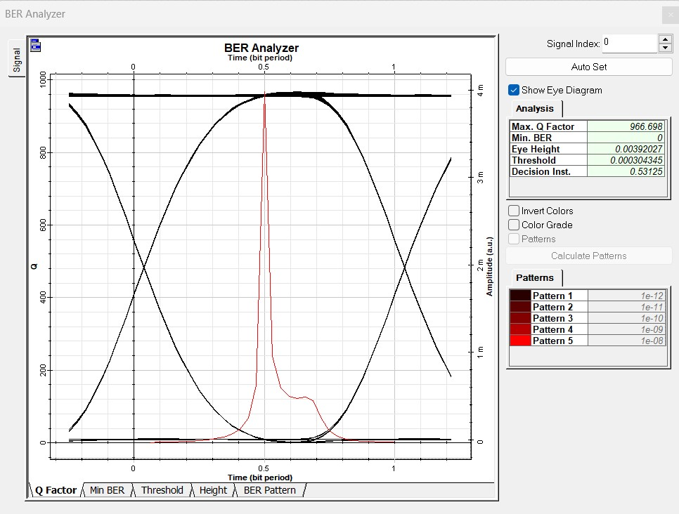

**Fig4.1 Eye diagram for pure sea water at 1500m @5Gbps**

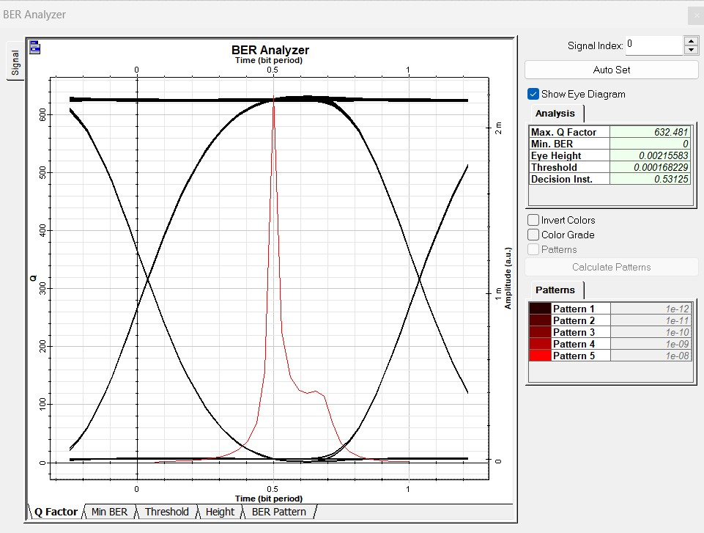

**Fig4.2. Eye diagram for pure sea water at 2000m @5Gbps**

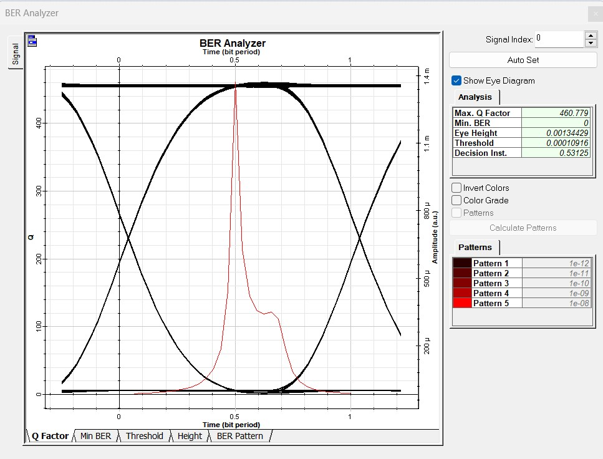

**Fig4.3 Eye diagram for pure sea water at 2500m @5Gbps**

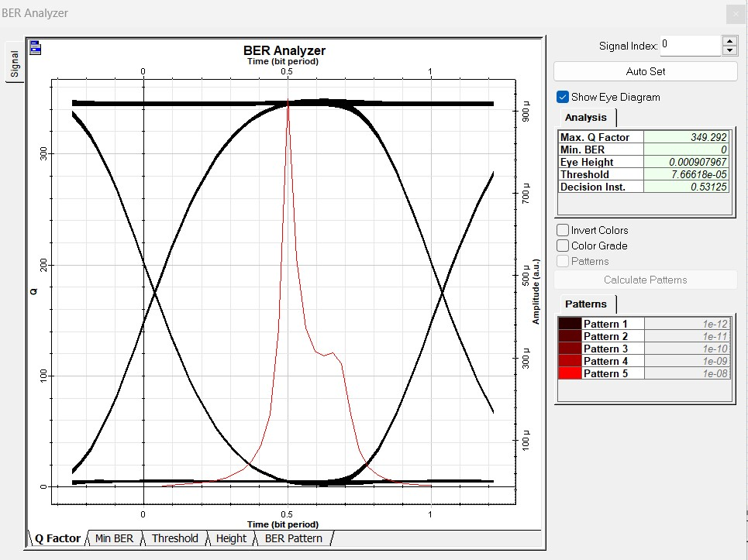

**Fig4.4 Eye diagram for pure sea water at 3000m @5Gbps**

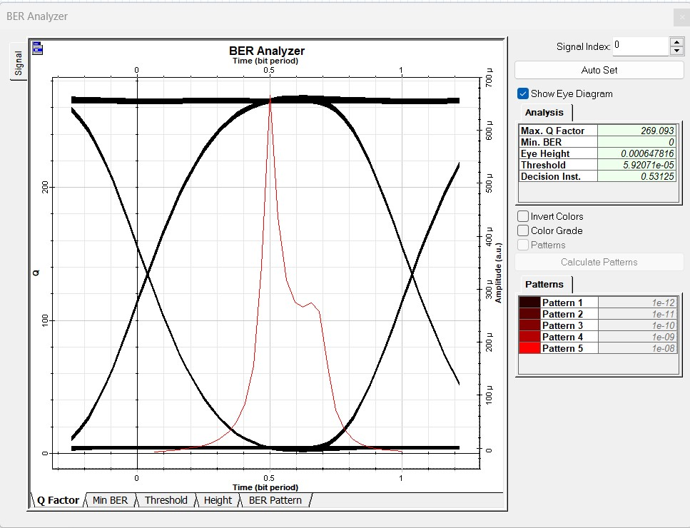

**Fig4.5 Eye diagram for pure sea water at 3500m @5Gbps**

We performed a simulation of a 5 Gbps optical connection in operation. By employing Eye Diagrams to analyse the Q Factor and BER, the nonlinear effects were investigated. The table that follows shows how, as transmission distance for NRZ modulation grows, nonlinear effects have an impact on the Q-factor.

|  |  |  |  |  |
| --- | --- | --- | --- | --- |
| Distance(m) | Types of water and their corresponding Q-factors | | | |
| Pure  sea  water | Clear ocean water | Coastal ocean water | Turbid  harbor  water |
| 1500 | 966.6 | 856.1 | 847.4 | 749.9 |
| 2000 | 644.9 | 590.6 | 528.1 | 429.6 |
| 2500 | 460.7 | 382.3 | 360.7 | 281.8 |
| 3000 | 349.2 | 295.9 | 247.5 | 178.5 |
| 3500 | 269.09 | 220.9 | 182.09 | 120.8 |

**Tab4. Impact on Q-factor with transmission distance for NRZ modulation**

**4.4 Graph between Q-factor and distance:**

**Fig.5 Q-factor Vs Distance**

**Chapter 5**

**Conclusion & Future Work**

**5.1 Conclusion:**

“There is a rising interest in investigating the underwater environment on a worldwide scale since the underwater environment is widely used in many crucial applications, including underwater environmental monitoring, marine research, disaster response, and military activities. In spite of the difficult underwater circumstances, underwater wireless communication (UWC) refers to the transfer of data across a fluctuating underwater channel using technologies including acoustic waves, radio frequency (RF), and optical waves. This study provides a thorough analysis of various UWC methodologies, techniques for enhancing system performance, and recent developments in this area.

The blue-green portion of the electromagnetic spectrum is where underwater optical communication (UWOC) functions most effectively. Optical communications is advantageous in this situation due to its much larger transmission bandwidth and data throughput compared to other technologies. Numerous noise sources, intrinsic optical qualities including absorption and scattering, and perceived optical properties all have an impact on the UWOC system. This paper focuses on underwater light propagation, modulation systems, coding strategies, and the underlying physical processes impacting them. It also discusses their merits and disadvantages.

The system design utilised for underwater communications is covered in the article. It examines the advantages and disadvantages of each kind of system as well as the particular circumstances under which they are used. Additionally, it offers a thorough analysis of the key elements and sections of an underwater optical communication system.”

“As power consumption is an important issue in under-water missions, it is fundamental to minimize the intensity loss by reducing the beam divergence, data transmission in relatively high turbidity waters appeals for the use of energy-efficient modulations and powerful channel codes at the physical and data link layers. In this paper underwater wireless optical link is generated using optisystem software. The link is simulated for 1.5 km to 3.5 km and the distortions are taken into consideration. It can be seen from the result that as the distance increases the output gets more distorted. The output is better at 1.5 km compared to 3.5 km in terms of Q-factor, Bit Error Rate and eye Diagram.”

**5.2 Future Work:**

Underwater optical communication (UWOC) research has advanced significantly in both academia and industry, as was covered in the preceding sections. The discipline is currently developing in many areas, and there are still a number of unsolved problems. Extensive field research and the use of testbeds are needed to get a better knowledge of the underwater environment and channel characteristics. Some possible obstacles to UWOC research are outlined in the sections below:

- As stated in section 6, link misalignment is an unavoidable event. The creation of extremely intelligent UWOC transceivers is still necessary despite the fact that several research projects have suggested using smart transceivers to combat connection misalignment.

To completely understand laser beam propagation through a randomly fluctuating underwater channel, further research and study of innovative theoretical models, including statistical and numerical techniques, is required. It is also necessary to look into and take into account the effects of transceiver noise on UWOC, which have not been sufficiently covered in most theoretical study.

While prior research has explored a variety of modulation and coding strategies and produced positive results, it is still difficult to modify the modulation and coding scheme to account for connection changes that occur in real time. In a few restricted implementations, adaptive modulation and coding methods for UOWC have been investigated. To increase performance and expand the coverage area of UOWC systems, it is required to offer various transmission strategies. The system may save a substantial amount of energy needed for decoding complexity, resulting in a longer operating duration, by including a device to dynamically alter modulation and coding schemes dependent on water turbidity.

- Up to now, little study has been done on UWOC networks. Novel and effective network protocols must be created due to the special properties of wireless optical channels in an underwater environment.

The progress of UWOC and realization of its full potential in underwater communication systems will result from addressing these research issues.

**Bibliography/References**

[1] Ashok Reddy1, J Rajani Kanth2, D Muneendra– “Under Water Optical Wireless Communication” ISSDN No.:978-1-6654-9529-5/22/$31.00 ©2022 IEEE

[2] S. Tang, Y. Dong, and X. Zhang, “Impulse response modeling for underwater wireless optical communication links,” IEEE Trans. Commun., vol. 62, no. 1, pp. 226–234, Jan. 2014.

[3] Zhaoquan Zeng, Huihui Zhang, Student Member, IEEE, Yuhan Dong, Member, IEEE, Julian Cheng, Senior Member, IEEE,- “A Survey of Underwater Wireless Optical Communication” DOI: 10.1109/COMST.2016.2618841

[4] P. Vijayakumari, K.Chanthirasekaran, Jayamani KNirmala P, R. ThandaiahPrabu- “BIT Error Rate Analysis of Various Water Samples in Underwater Wireless Optical Communication System” DOI: 10.1109/ACCAI53970.2022.9752642

[5] Mohammad Vahid Jamali, Student Member, IEEE, Jawad A. Salehi, Fellow, IEEE, and Farhad Akhoundi- “Performance Studies of Underwater Wireless Optical Communication Systems With Spatial Diversity”

[6] Saleha Al-Zhrani, Nada M. Bedaiwi, Intesar F El-Ramley, Abeer Z. Barasheed,1 Ali Abduldaiem, Yas Al-Hadeethi1, and Ahmad Umar.- “Underwater Optical Communications: A Brief Overview and Recent Developments” DOI: https://dx.doi.org/10.30919/es8d574

[7] Mohammad-Ali Khalighi1, Chadi Gabriel, Tasnim Hamza, Salah Bourennane. Pierre Le´on, Vincent Rigaud. ―”Underwater WirelessbOptical Communication; Recent Advances and Remaining Challenges”, Published by-IEEE. ISSDN No.: 978-1-4799-5601-2, 2014

[8] Hai-Han Lu1, Chung-Yi Li1, Hung-Hsien Lin1, Wen-Shing Tsai2, Chien-An Chu1, Bo-Rui Chen1, and Chang-Jen Wu1, ― “An 8 m/9.6 Gbps underwater wireless optical communication System” , Published by- IEEE,2016

[9] Yuhan Dong, Jinxing Liu ― “On BER Performance of Underwater Wireless Optical MISO Links under Weak Turbulence” published by- IEEE ISSDN No. : 978-1-4673- 9724-7, 2016.

[10] H. Kaushal and G. Kaddoum, “Underwater optical wireless communication,” IEEE Access, vol. 4, pp. 1518–1547, 2016.

[11] Giuseppe SchirripaSpagnolo, Lorenzo Cozzella, Fabio Lecce, “A Brief Survey on Underwater Optical Wireless Communications”, 2020 IMEKO TC-19 Internatio8nal Workshop on Metrology for the Sea Naples, Italy, October 5-7, 2020.

[12] Santos, R.; Orozco, J.; Micheletto, M.; Ochoa, S.; Meseguer, R.; Millan, P.; Molina, C. Real-Time Communication Support for Underwater Acoustic Sensor Networks. Sensors 2017,17, 1629.

[13] I. Mizukoshi, N. Kazuhiko, and M. Hanawa, “Underwater optical wireless transmission of 405nm, 968mbit/s optical im/dd-ofdm signals,” in Proc. OptoElectronics and Communication Conference and Australian Conference on Optical Fibre Technology (OECC/ACOFT), Melbourne, VIC, Australia, Jul. 2014, pp. 216–217.

[14] Bocus, M.J.; Doufexi, A.; Agraﬁotis, D. Performance of OFDM-based massive MIMO OTFS systems for underwater acoustic communication. IET Commun. 2020,14, 588–593.

[15] Sarath Gopi, G. Kannan, Deepthi Chander, U. B. Desai and S. N. Merchant, “PULRP: Path Unaware Layered Routing Protocol for Underwater Sensor Networks”, publication in the ICC proceedings, 3141- 3145, 2008.

[16] Anjana P Das, Sabu M Thampi, “Fault-resilient localization for underwater sensor networks”, Adhoc Networks, 55, 132-142, 2017.

[17] Eliyeh Mortazavi, Reza Javidan, Mohammad Javad Dehghani, Vali Kavoosi, “A robust method for underwater wireless sensor joint localization and synchronization”, Ocean Engineering, 137, 276-286, 2017.

[18] Jingjie Gao, Xiaohong She, Haiyan Wang, “A hybrid localization algorithm for multi‑hop mobile underwater acoustic networks”, 2-7, 2017.

[19] Patrick Carroll, Katherine Domrese, Hao Zhou, Shengli Zhou, “Doppler Aided localization of mobile nodes in an underwater distributed antenna system”, Physical Communication,18, 49-59, 2016.

[20] Mukesh Beniwal, Rishi Pal Singh, Anju Sangwan, “A Localization Scheme for Underwater Sensor Networks Without Time Synchronization”, Wireless Pers Communication, 88,537–552,2016.

[21] Ali, M.F.; Jayakody, D.N.K.; Chursin, Y.A.; Aﬀes, S.; Dmitry, S. Recent Advances and Future Directions on Underwater Wireless Communications. Arch. Comput. Methods Eng. 2019, 1–34.