Software Engineering Tools Lab

**Assignment no. 1**

**Date: 08-02-2023**

**PRN:** 2020BTECS00002

**Name:** Subham Kumar

* 1. **Differentiate between free software, open source and proprietary software w.r.t. its properties.**

*Ans:*

|  |  |  |
| --- | --- | --- |
| **Free software** | **Open Source software** | **Proprietary software** |
| “Free software” means software that respects users’  freedom and community. | Open-source software is computer software whose source code is available openly on the internet and programmers can modify it to add new features and  capabilities without any cost. | Proprietary software is computer software where the source codes are publicly not available only the company which has created can modify it. |
| In free software the source code is public. | In open-source  software the source code is public. | In proprietary  software, the source code is protected. |
| Free Software can be shared and used by everyone in a non- exclusive way,  serving the public good. | Open-source software can be installed on any computer. | Proprietary software can not be installed into any computer without a valid license. |

|  |  |  |
| --- | --- | --- |
| A Free Software license allows you to run an unlimited number of  installations, without paying extra. | Users do not need to have any  authenticated license to use this software. | Users need to have a valid and  authenticated license to use this software. |
| Free software is managed by free software foundation. | Open-source software is managed by an open-source community of  developers. | Proprietary software is managed by a closed team of individuals or groups  that developed it. |
| Free Software resists monopolization and improves competition. | It is more flexible and provides more  freedom which encourages innovation. | It is not much flexible so there is a very limited innovation scope with the  restrictions. |
| Free Software  licenses reinforce independence from vendors and provide more choice in  service providers. | Users can get open software free of charge. | Users may have to pay to get the proprietary software. |
| A Free Software license encourages innovation for your software. | In open-source software faster fixes of bugs and better security are availed  due to the community. | In proprietary software, the vendor is completely responsible for fixing malfunctions. |
| Examples: Google chrome, Mozilla Firefox, Audacity, etc. | Examples: Android, Linux, Firefox, Open Office, GIMP, VLC Media player, etc. | Examples: Windows, macOS, Internet  Explorer, Google Earth, Microsoft Office, Adobe Flash  Player, Skype, etc. |

* 1. Enlist some examples along with its purpose and properties (at least 10) of FOSS & proprietary software w.r.t. database.

*Ans:*

***FOSS database s/w:*** MySQL

* + - Purpose: For web use.
    - Properties:

1. It is a relational database management system (RDBMS).
2. It is easy to use.
3. It is secure.
4. It follows client-server architecture.
5. It is free to download.
6. It supports multi-threading (scalable).
7. Compatible with many OS.
8. It allows rollback.
9. It is platform independent.
10. It has GUI support.

***Proprietary database s/w:*** Oracle DB

* + - Purpose: Running Online Transaction Processing (OLTP) & Data Warehousing (DW).
    - Properties:

1. It has Real Application Clustering and Portability.
2. Its data is available during the time of planned or unplanned downtimes and failures.
3. Its layout has complete recovery features to recover data from almost all kinds of failures.
4. It provides mechanisms to control data access and usage.
5. Its database supports managing multiple database instances on a single server.
6. It supports PL/SQL extension for procedural programming.
7. It is compatible with the standards of industries.
8. It allows users to replicate groups of tables and their supporting objects to multiple sites.
9. It has high transaction processing performance.
10. It allows processing to be split into client and server application programs.
    1. **Enlist some examples of free open source exam software for online assessment**.

*Ans:*

1. [TCExam](https://tcexam.org/)
2. [VirtualX](https://myvirtualx.com/)
3. [Moodle](https://moodle.org/)
4. [TAO](https://www.taotesting.com/)
5. [Kaldin](https://www.kaldin.in/)
6. [Papershala](https://papershala.com/)
7. [Edbase](https://www.edbase.net/)
8. [Mettl](https://mettl.com/)
   1. **Demonstrate any one exam software which is open source and freely available.**

Ans:

Interface

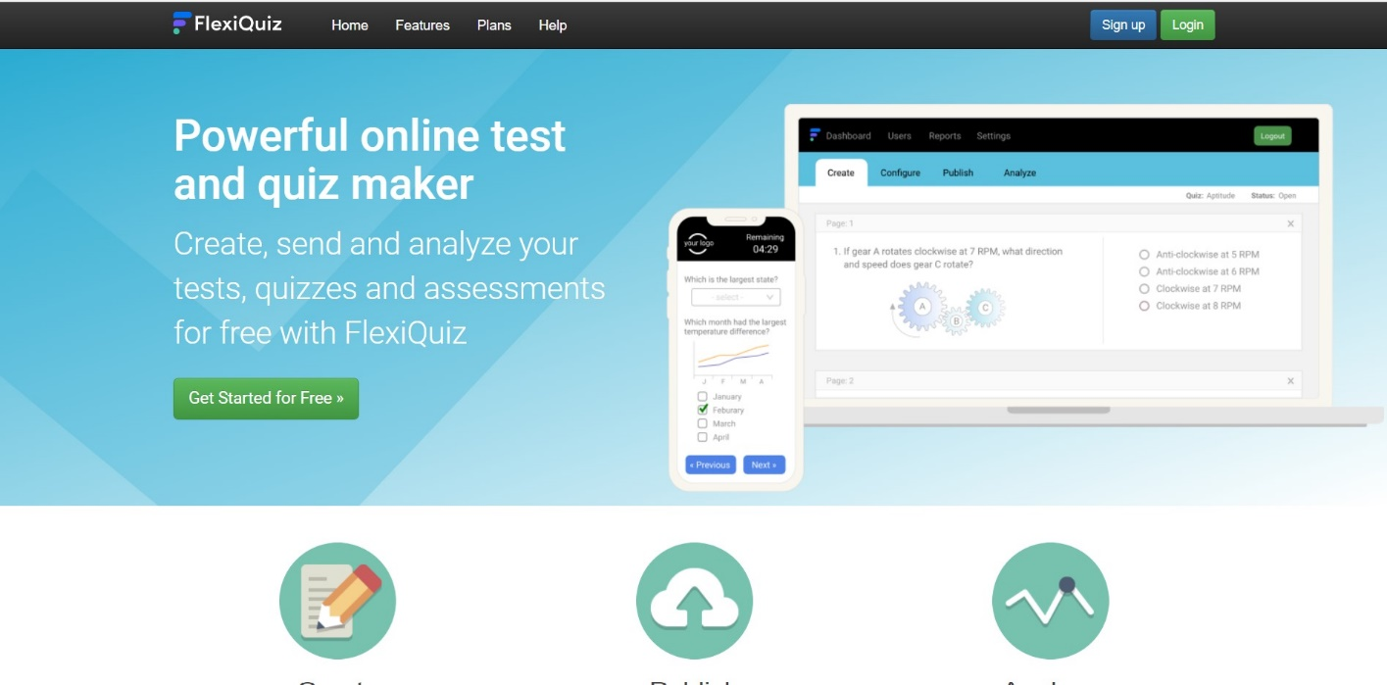

Create Quiz

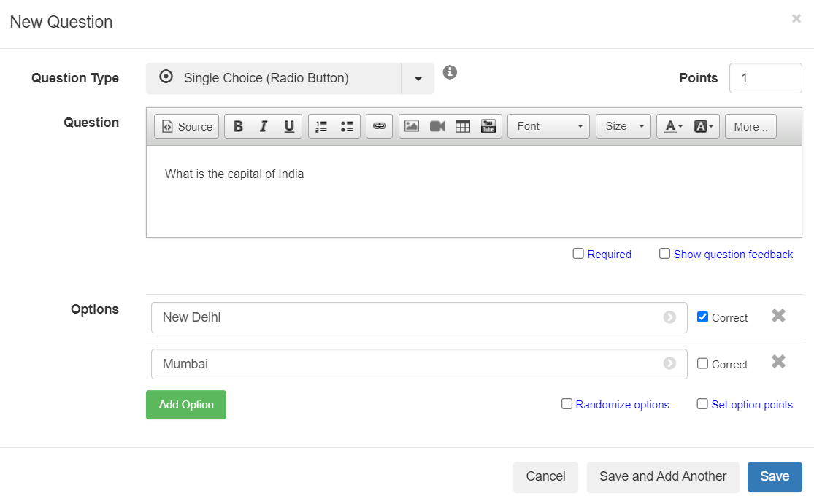

Configure

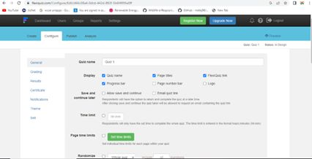

Publish

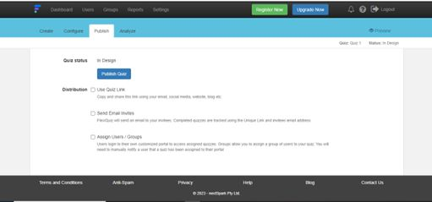

Test

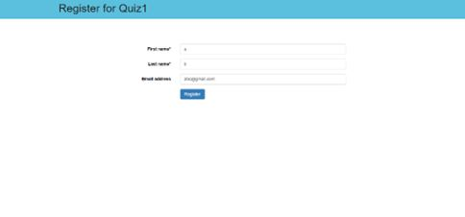

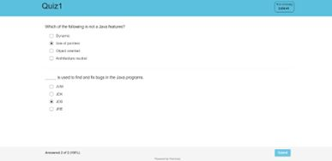

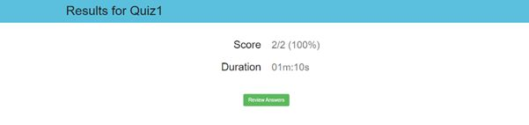

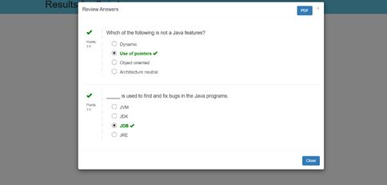

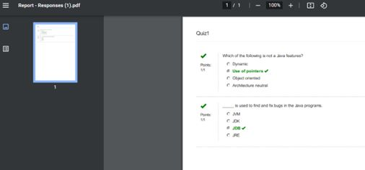

Analyze

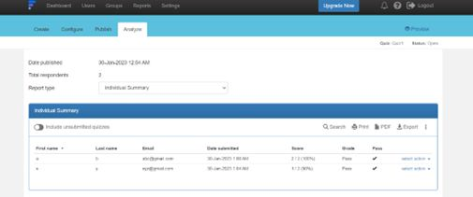

Q6. How does exam software work?

*Ans:*

## Students’ Registration

Online exam software helps with the registration process of students and generates unique IDs for them.

## Test Paper Creation

You can create a subjective, objective, multiple-choice, and other types of questions online and ensure zero spam.

## Take Tests Anytime, Anywhere

Students can take tests from anywhere with a stable internet connection and a system. Similarly, teachers can invigilate directly through the system.

## Automated Evaluation

Teachers don’t need to evaluate answers manually, as the

exam software helps analyze students’ performance digitally.

## Track Students’ Progress

YouTube broadcast software enables users to list their live streams as videos on their channels. This way the live stream can be seen even after it ended.

## Data analysis

The performance reports include detailed info about the strengths and weaknesses of every student. Accordingly, teachers can make the improvement plan.

**Assignment 1.B**

* + - **Name of s/w:**  Project Manager

# Features:

## 1. Board (All plans)

The [kanban board](https://www.projectmanager.com/software/kanban) appeals to the visual workers on your team, as it helps them visualize their workflows. We’ve recently rolled out a new [custom workflows and task approvals](https://learn.projectmanager.com/custom-workflows) feature where users can build workflows and set limitations on who can move tasks to certain statuses. Only those with the approved permissions can set task rules and approvers to keep workflows productive.

In the board view, drag and drop tasks into the appropriate statuses so your team can see task status at a glance. It’s also an ideal spot to pinpoint project bottlenecks and collaborate on waterfall projects without needing the Gantt view.

## 2. Gantt (Team, Business and Enterprise plans)

Traditional project managers regularly [use the Gantt chart](https://www.projectmanager.com/software/gantt-chart) for planning large projects consisting of many moving parts and resources, often importing plans from Excel and Microsoft Project. ProjectManager’s Gantt is one of our most popular features as it allows for time-based plans and schedules, offering hybrid teams both a visual and data-driven view in one.

Our newest software update also rolled out [custom templates and more featured templates](https://www.projectmanager.com/blog/product-update-custom-templates) where teams can use our pre-built templates and customize them accordingly for faster project kickoffs.

## 3. List (All plans)

The List is another popular view as it is simple yet effective; here, you can assign task priorities, create filters and collaborate with your team members regardless of their location. Head to the List view to create weekly tasks or checklists for your hybrid team. You can also see project details such as assignee, priority and overall progress.

## 4. Project Dashboard (All plans)

Another feature in our top 10 list is the [Project Dashboard,](https://www.projectmanager.com/software/dashboard) a convenient place to see a high-level status report of your projects. There are six widgets on this view including project health, tasks, progress, time, cost and workload. With a few clicks, hybrid team leads can share data from the Dashboard with both internal and external team members for an easy status update.

Many project managers use the Dashboard to pinpoint issues within the project to continually improve their processes for even better results.

## 5. Team Page (All plans)

In a hybrid work environment, it can be difficult to understand what team members are taking on what projects. [The Team section](https://www.projectmanager.com/software/team-management) of our hybrid work management software features helpful data such as the workload, progress and due date for each individual team member.

Use the Team view to determine which team members can take on additional work and which are falling behind.

## 6. My Work (All plans)

The easiest way to keep tabs on all of your individual tasks across projects is My Work. Here, you can quickly understand what’s on your plate across all of your projects and create personal tasks to keep track of your individual workload.

This is an excellent view to reassign tasks to other team members and see all uploaded files in one place.

## 7. Sheet (Team, Business & Enterprise plans)

Need the functionality of a spreadsheet without the visual aspect of the Gantt chart? Head to the Sheet view to create custom columns, oversee resource details and share filtered project data with key stakeholders.

The Sheet view offers the familiar layout of an Excel spreadsheet, except it’s even easier to use. Plus, ProjectManager users can set up the Sheet view one way and the Gantt chart another way without worrying about impacting data—each experience is unique.

## 8. Reports (Team, Business & Enterprise plans)

Put critical project data to good use in [the Reports view.](https://www.projectmanager.com/software/reporting) It only takes a few clicks to build and share status reports, task reports and workload reports, to name a few. The Reports view is completely customizable so you can include exactly the information that your team members need to see. Monitor the health of your entire project portfolio, keep a close eye on project budget and timelines, and ensure key stakeholders have the latest data.

Need more information on making Reports via ProjectManager? Make sure to download the complete version of our Quick Start Guide for hands-on guidance on some of our most popular features.

## 9. Workload (Business & Enterprise plans)

In a hybrid work environment, it’s easy for project resources to slip into the red if they are not closely tracked. In the Workload view, project managers have the visibility to oversee the workload for their contractors and vendors and see the planned versus realized effort across their portfolios.

Keep remote contractors as productive as possible by [monitoring their logged hours](https://www.projectmanager.com/software/time-management) and determining patterns to predict the future time spent on projects. The Workload view is particularly useful for contractors and vendors who are keeping track of their time spent on projects.

## 10. Roadmap (Business & Enterprise plans)

Rounding out our list of 10 of our most popular features is the Roadmap. Although it is only available on Business and Enterprise plans, it is a feature worth exploring for your hybrid team.

The Roadmap allows you to see all of your projects on a single timeline, making it easy to see what is ahead of schedule and what projects are falling behind. It has the familiar Gantt view that project teams know and love in addition to the planned versus actual effort it takes to complete a project.

Operations Performed

1. Creating a new Project and adding my team members to it.

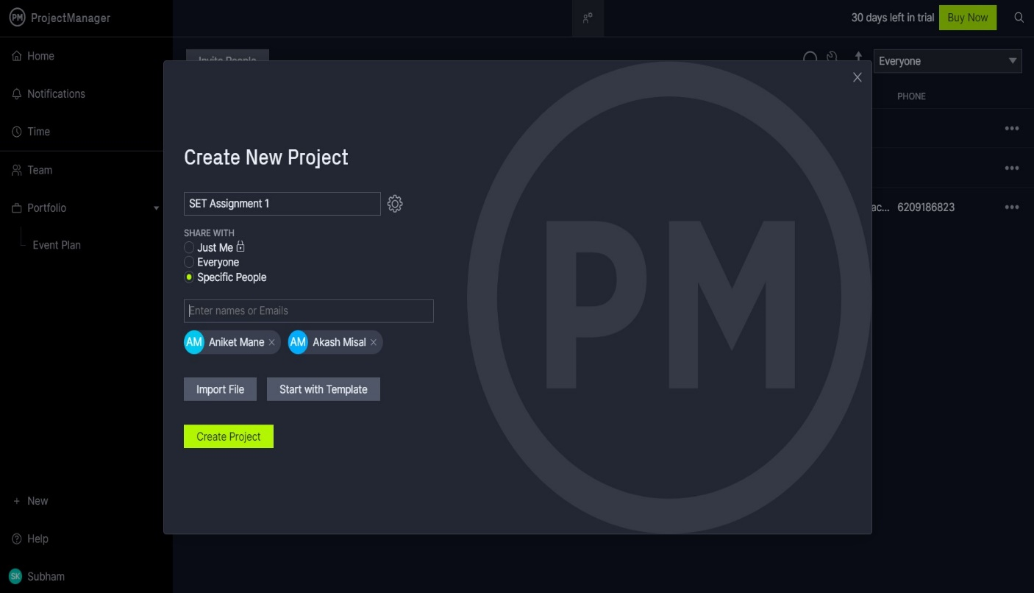

1. Assigning tasks to all my team members and to myself.

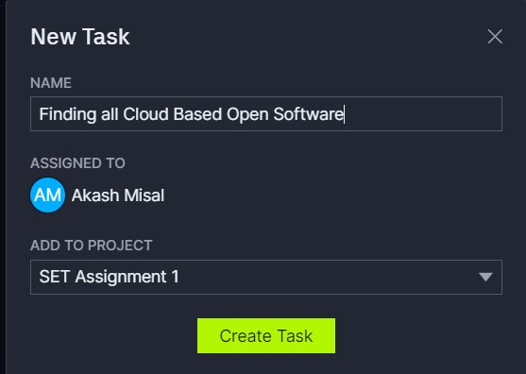

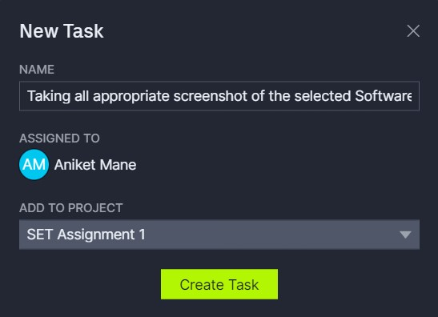

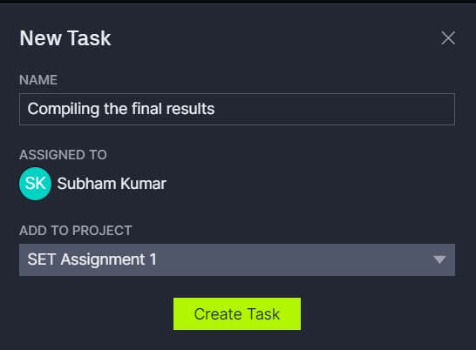

1. Checking Progress of all members.

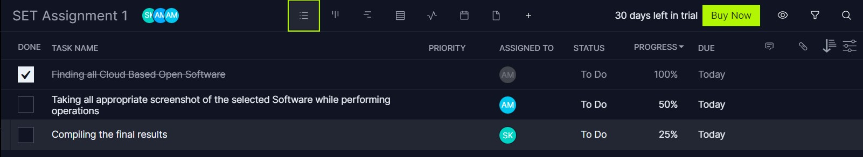

1. Gantt chart to see progress

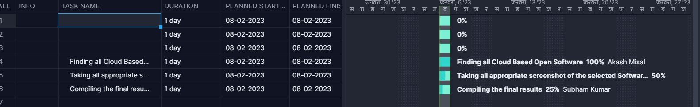

1. Seeing tasks on Calender

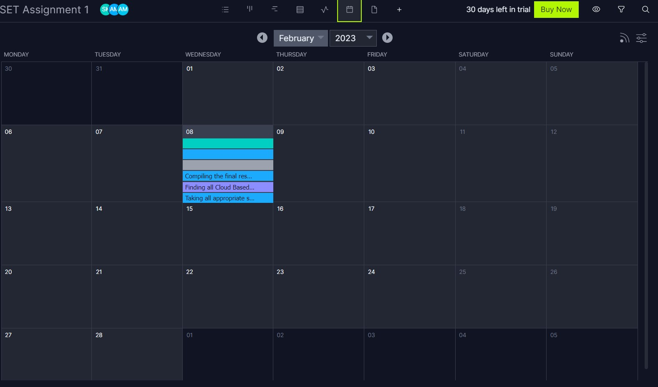

* 1. Demonstrate FOSS software related to database.

*Ans:* [MySQL](https://www.mysql.com/)

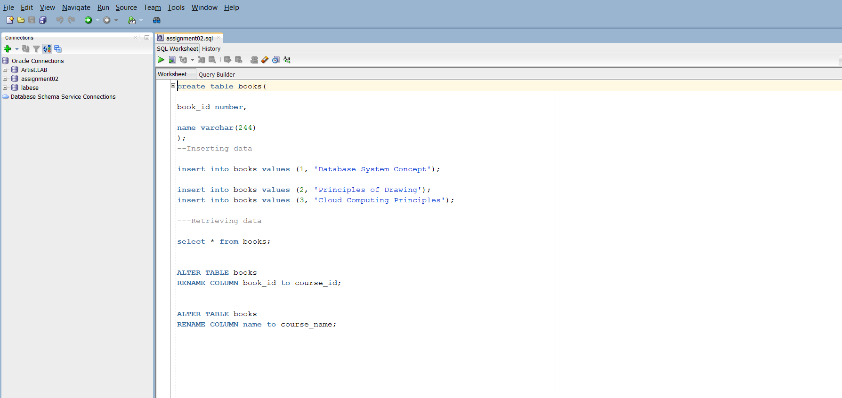

Is one of the example of FOSS software related to database which is free for usage.

* 1. How does exam software work?

Ans:

## Students’ Registration

Online exam software helps with the registration process of students and generates unique IDs for them.

## Test Paper Creation

You can create a subjective, objective, multiple-choice, and other types of questions online and ensure zero spam.

## Take Tests Anytime, Anywhere

Students can take tests from anywhere with a stable internet connection and a system. Similarly, teachers can invigilate directly through the system.

## Automated Evaluation

Teachers don’t need to evaluate answers manually, as the

exam software helps analyze students’ performance digitally.

## Track Students’ Progress

YouTube broadcast software enables users to list their live streams as videos on their channels. This way the live stream can be seen even after it ended.

## Data analysis

The performance reports include detailed info about the strengths and weaknesses of every student. Accordingly, teachers can make the improvement plan.

Example

