**TITLE :** Setting up a network using ospf

**OBJECTIVE :** To build network using ospf routing protocol

**THEORY :**

The OSPF (Open Shortest Path First) protocol is one of a family of IP Routing protocols, and is an Interior Gateway Protocol (IGP) for the Internet, used to distribute IP routing information throughout a single Autonomous System (AS) in an IP network.

The OSPF protocol is a link-state routing protocol, which means that the routers exchange topology information with their nearest neighbours. The topology information is flooded throughout the AS, so that every router within the AS has a complete picture of the topology of the AS. This picture is then used to calculate end-to-end paths through the AS, normally using a variant of the Dijkstra algorithm. Therefore, in a link-state routing protocol, the next hop address to which data is forwarded is determined by choosing the best end-to-end path to the eventual destination.

The main advantage of a link state routing protocol like OSPF is that the complete knowledge of topology allows routers to calculate routes that satisfy particular criteria. This can be useful for traffic engineering purposes, where routes can be constrained to meet particular quality of service requirements.

Now we make a simple network :

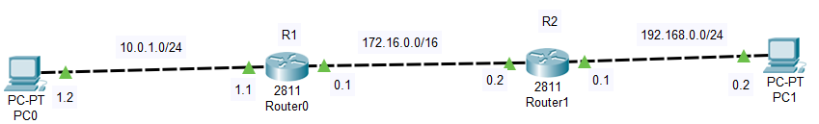

To design this network we have to do following steps:

-give ip address to pc and configure interface ip of routers

Then use ospf routing protocol to do this on router0,

Router(config)#router ospf 1

Rouer(config-router)#network 10.0.1.0 0.0.0.255 area 1

Rouer(config-router)#network 172.16.0.0 0.0.255.255 area 1

And on router1

Router(config)#router ospf 2

Rouer(config-router)#network 192.168.0.0 0.0.0.255 area 1

Rouer(config-router)#network 172.16.0.0 0.0.255.255 area 1

For using ospf protocol we do following:

Router(config)#router ospf <process_id>

Router(config-router)#network <ip_address> <wildcard_mask> <Area_name> //ip_address is neighbours n/w address.

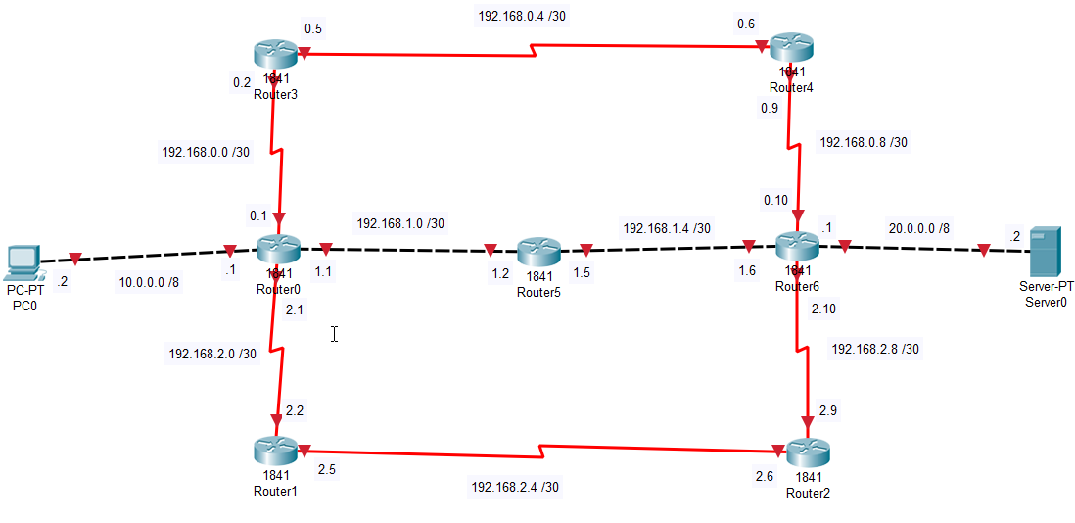Now we make another complex network :

We gave all interfaces ip addresses and to pc and server as well.

Now use ospf ,

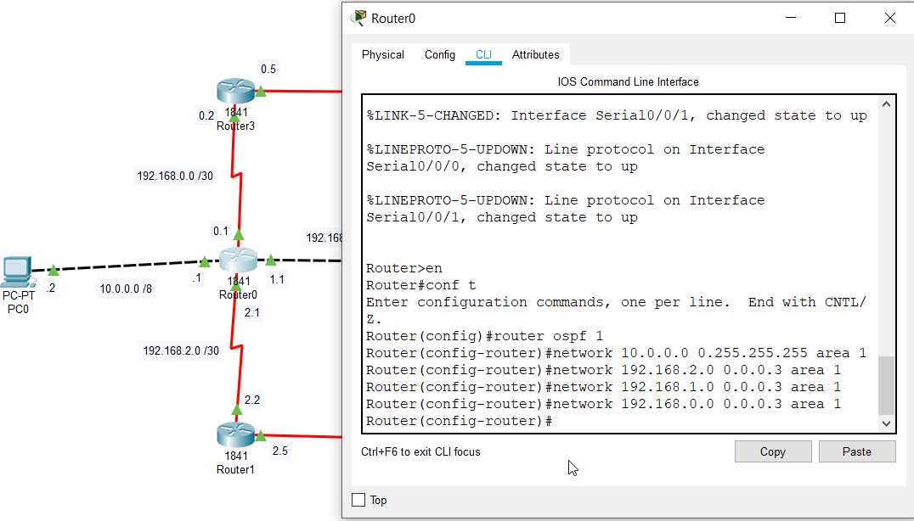

We do same process to all remaining 6 routers. Process id is different but area name is same to all routers.

**RESULT :** Hence we set up a network using ospf protocol.