**LAB 2**

**TITLE :** Setting Up our First WAN Network

**OBJECTIVE :** To Build our First WAN Network

**THEORY :**

**Gateway::================================================================================================RIP::=======================================================================================================================================================**

Assigning Gateway IP to host :

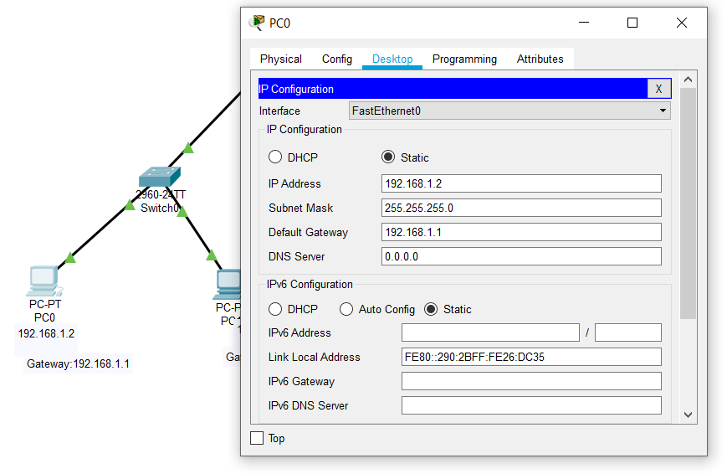

Now do this to all 4 hosts(computers).

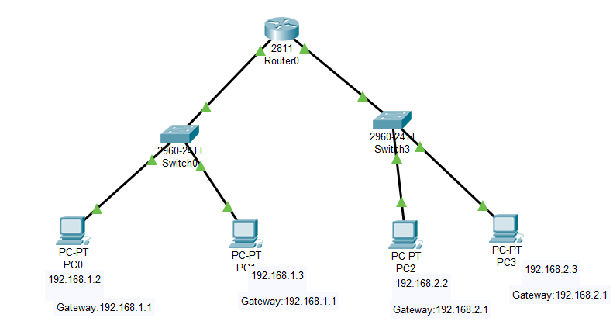

Pinging from PC3 to PC0, it gets reply :

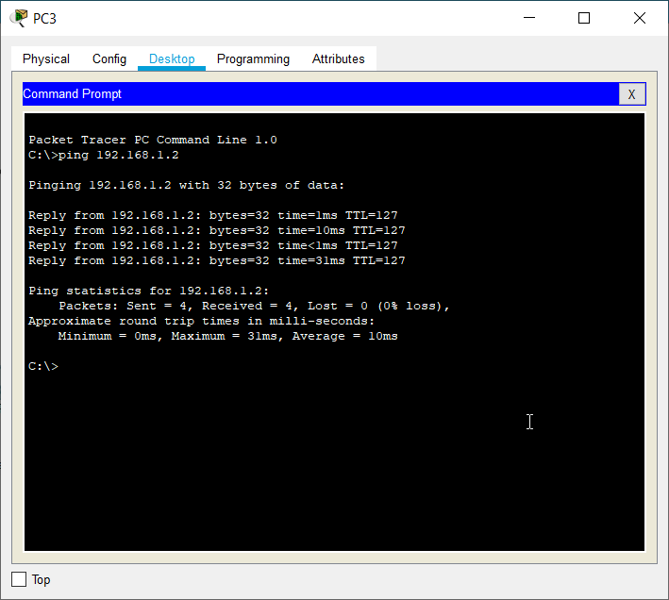

Now create a new network as like before and assign IP addresses and gateway IP addresses to hosts.In this case, one network is labelled as HTD and another as KTM.

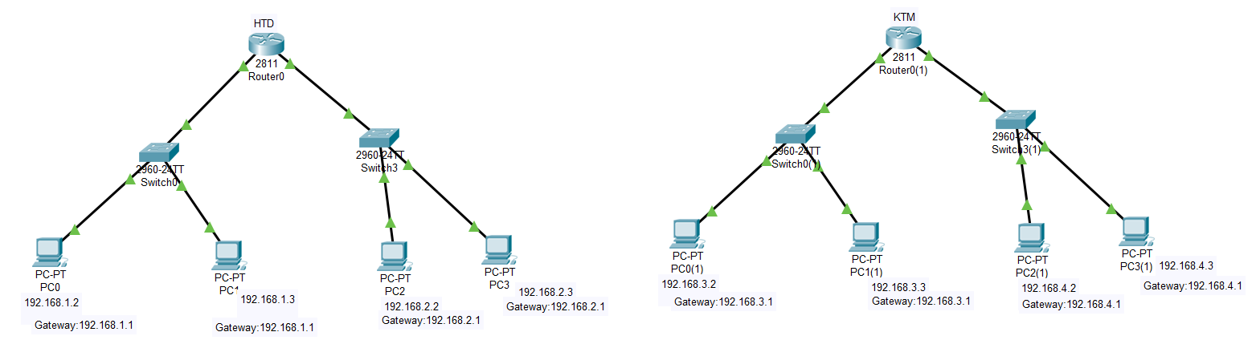

In both routers add a serial link interface :

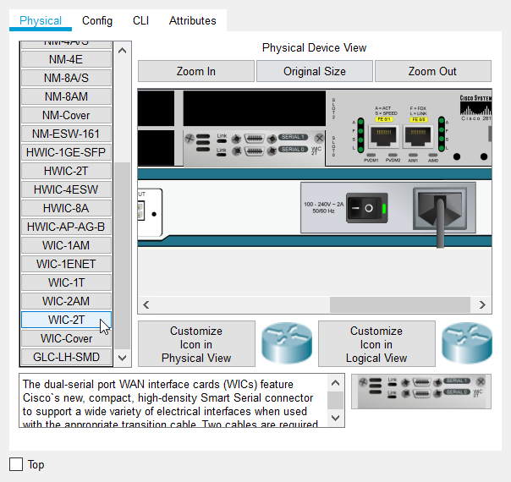

Then our configuration get lost as shown below :

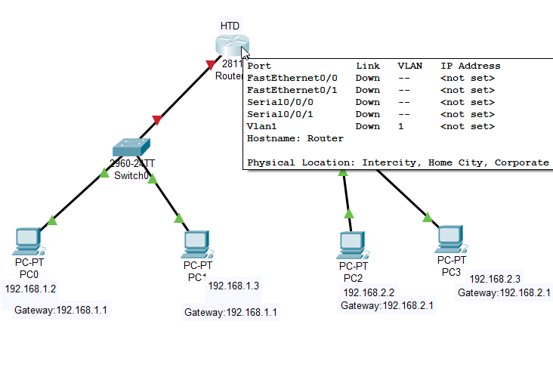

Now, again give interface IP addresses to both routers.

Connect both routers by serial link :

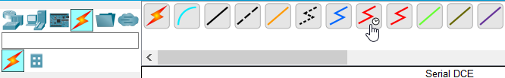

Hover the cursor on the link to find serial link.

In the router’s global configuration mode do the following :

se000added5.1samedoinanotherrouter

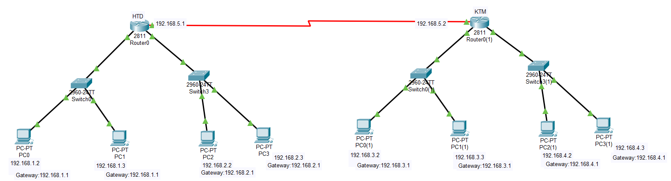Do the same step in another router’s configuration mode by taking its interface value(se0/0/0 or se0/0/1 depending upon interfaces) and assign IP address 192.168.5.2

Synchronous serial point to point lines need a clock signal to keep each other in step,only one end, the DCE end, needs to be set up as the clock – the other end, the DTE end does not.

**To set clock rate :**

**Router(config-if)#** clock rate 64000 ;64000 is standard value

**To save running-config from RAM into the startup-config into NVRAM :**

to make sure the changes to the router's configuration remain saved, you must copy the running-config from RAM into the startup-config into NVRAM(non-volatile random access memory)

**Router#** copy running-config startup-config

Destination filename [startup-config]? <enter>

Building configuration...

[OK]

to display saved configuration located in NVRAM

**Router#** show startup-config

Now, When we ping from one network to another it doesn’t get reply due to the lack of routing protocol.So we give routing protocol.

In this case we use RIP(Routing Information Protocol).

In the global configuration mode of Router0 type :

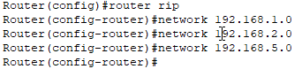

Also in Router0(1) type :

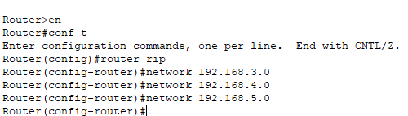

**To display current configuration of router, type :**

**Router>** en

**Router#** show run

Now we get reply from PC0 to PC1(1) :

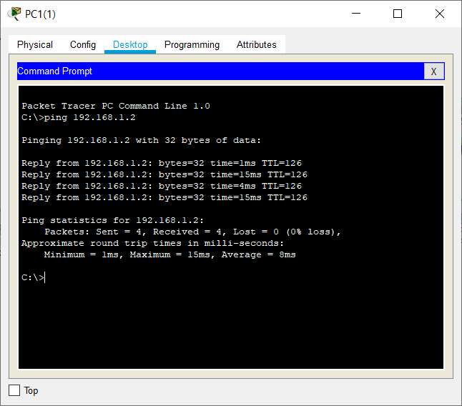

To display the current state of the routing table, use the show ip route command in privileged EXEC mode.

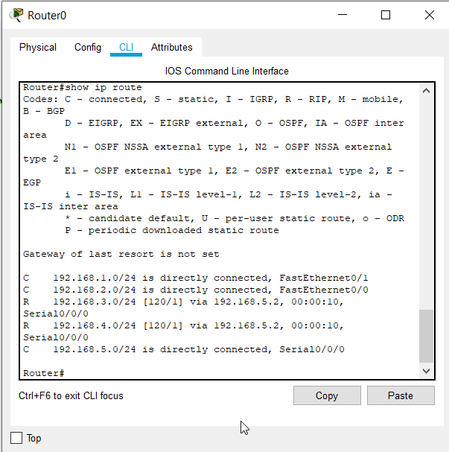

**If You want to clear an old configuration out of your router and return it to a factory default configuration.**

**Router#** erase startup-config

Erasing the nvram filesystem will remove all files!

Continue? [confirm] <enter>

[OK]

Erase of nvram: complete

**Router#** reload

Proceed with reload? [confirm]<enter>

**RESULT :**

So we set up serial WAN link between two routers. And communication can be done from one network to another network.

i.e. message can be send from one network’s pc to another network’s pc and vice-versa.

**Conclusion :**

Hence we build our first WAN network by using RIP protocol successfully.