**TITLE :** Setting Up our DHCP Network

**OBJECTIVE :** To configure DHCP server

**THEORY :**

DHCP (Dynamic Host Configuration Protocol) is a protocol used to provide quick, automatic, and central management for the distribution of IP addresses within a network.

DHCP is also used to configure the proper subnet mask, default gateway, and DNS server information on the device.

DHCP automates and centrally manages these configurations rather than requiring network administrators to manually assign IP addresses to all network devices. DHCP can be implemented on small local networks as well as large enterprise networks.

DHCP will assign new IP addresses in each location when devices are moved from place to place, which means network administrators do not have to manually initially configure each device with a valid IP address or reconfigure the device with a new IP address if it moves to a new location on the network. Versions of DHCP are available for use in Internet Protocol version 4 (IPv4) and Internet Protocol version 6 (IPv6).

How to configure DHCP server:

-4 steps

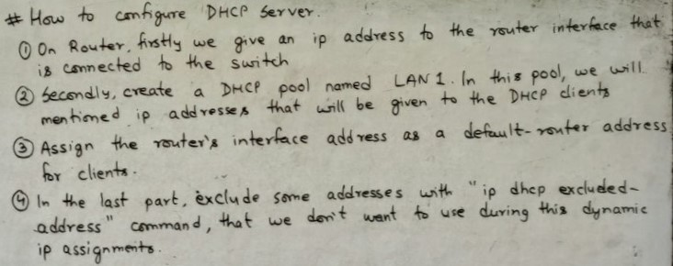

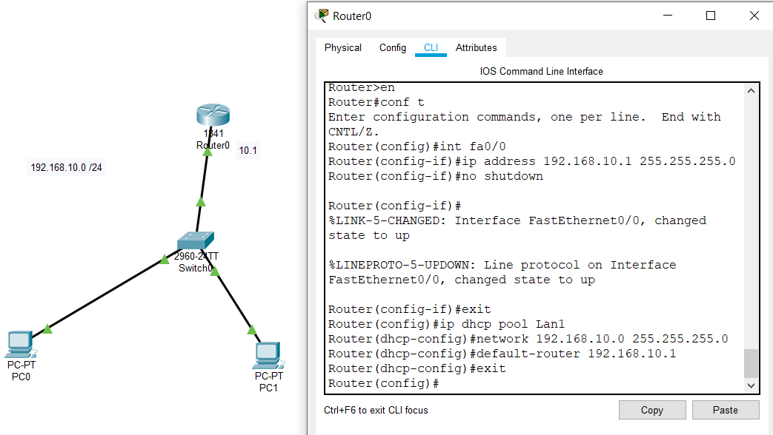

Now exclude some ip addresses that we don’t want to use during this dynamic ip assignments.

mmmmmmmmmmm

Now go to pc0->desktop->ip configuration and select dhcp then automatically it assign ip address like below

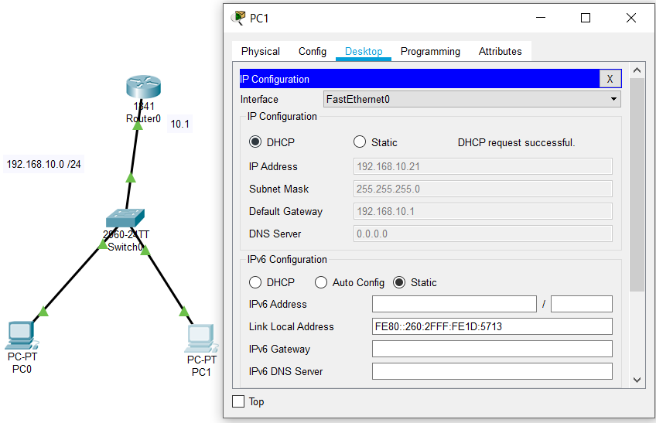

Do the same to another pc.

**RESULT :** In this way we set up dhcp server successfully.