Subham Goyal 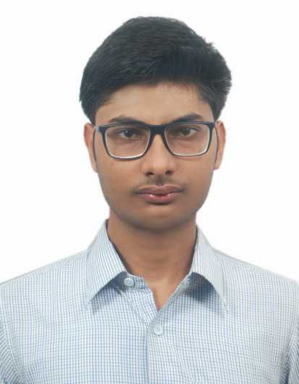
E-Mail : goyalsubham0504@gmail.com
Linked-In : https://www.linkedin.com/in/subham-goyal-237767119
Contact : +91-8651225972

Career objective is to confront any challenge and prove myself useful to the organization I work with. Be an astute learner and the best performer in the organization.

Profile Summary
- I have done web development projects using AI prompt.
- Worked with GitHub copilot in IntelliJ.
- I have done enhancements in existing code & made a fresh code for the particular work.
- Knowledge in Kafka, to send or receive messages.
- Worked in putty for ETL (Extract Transform Load) monitoring system.
- Have worked in pl/SQL.
- Have a good knowledge in core & advanced java.
- Designed a website based on ecommerce (Eat –Street) by using MVC.
- Expertise in Spring Boot, Hibernate, Maven, Json, Kubernetes
- Worked in Azure cloud.
- Worked in CI/CD (Jenkins and azure devops)
- Worked in Microservices, Restful Api’s.
- J2EE Developer, MS Sql, Mvc Architecture
- Worked in Agile Model.

Projects
- Liberty Specialty Steel- Worked in migration activities. Batch for 42 inch, 84 inch pipe and AVB (Added Value Bay) runs every night and customer orders for the pipe, we process the orders. In this, we have written Java program, Spring boot, Microservices and also used pl/SQL. In this project, I worked as one of the developer along with one more member. We developed the code which has having batch issues. Also, debugging the code, if found some errors in that.
Working as an Assistant System Engineer from Oct 2017 to Feb 2019

- Johnson’s & Johnson’s- Worked in Amazon Workspace, migrating the data from nfs (Network File System) to SharePoint site. Also, migrated from one drive to one drive and Box to OneDrive.
We had the PowerShell script where we had to run the script by inserting a template with inputs (source path, destination path, date, locale). After the job is done the status key of the table changes and we got to know the failure and success message. If it was failure, we had set the different status key to check the issue and was doing the troubleshoot accordingly. Sometimes if the file was not migrating and it is larger file, we tried to migrate it manually.
Worked as a system engineer from Mar 2019 to Mar 2021.

- Parexel -Worked as SharePoint Administrator, Exchange Admin, Exchange Online. - In this project, worked on how to create DL, shared mailbox, worked in hybrid environment, Access mailbox, cisco gateway, mail flow . Also , worked as SharePoint administration.
Worked as an It Analyst from Apr 2021 to Apr 22

- MetLife Asia Hub – It is an Insurance sector where worked as a senior developer and team lead where I developed a restful api. Also, deployed the api, when the api matches with the requirements. We have a HLD (High Level Design Document) and LLD (Low Level Design Document) from where get to know the requirements. For checking the logs, we have Splunk. Also, we can check through azure. We have Bitbuckets for the repository. We are having Solar, HBase, Hadoop, Oracle db. We are also having a sonar tool to analyze the codes. Also, we have used azure devops ci cd tool. Converted synchronous communication service to asynchronous to reduce the time latency. Also, worked in JMeter to do the performance testing after developing the code.
Worked as a consultant, team lead and as a scrum master in agile model from May 22 – Jul 23

- JPMC Chase, Private bank – It is a banking domain where i worked single handedly to enhance the apis using java, spring boot, microservices. Client provides the requirement and there is a jira ticket created where we are adding the story points for the sprint and working on the task. Also, we have daily status call internally and with client. Worked in bitbucket, Jira, postman, Jenkins, cloud foundry. We had many modules under one service and finding through the logs, if some issue came in the particular module. Also, involved in developing the Apis like we enhanced the code in which controller will directly points to end service which will reduce the time. Earlier it was going through one service to another sequentially whose use was not there. So, we changed it. And did some business level changes in the service as well. Also, involved in migrating the java version from java 8 to java 17. Worked on Apache Kafka and Graphql.

- Us Bank – It is a banking domain where I worked in developing the code implementation and proactively worked in the migrating the apis from on Prem to azure. Also, did the vulnerability fixes for most of the apis. Here we used Jenkins pipeline as a CI CD tool. We are checking the logs in Kibana and Splunk. For versioning took, we used GitLab, for hitting the endpoints we used postman. Cloud we have azure. For checking the vulnerability report we have blackbuck and fortify.

Technical Skills
~ Tools worked on : Net Helpdesk, Outside View, Putty, Cmdr., Eclipse, Notepad++ , Notepad, Microsoft Office, SkySync, SQL Server 2012, Mural, Postman, Assyst Net/ Web, Splunk,, Azure Cloud, Azure portal, Jira, Xwiki, Confluence, Bitbucket, IntelliJ idea, Spring tool suite, Apache JMeter, Apache Kafka, Graphql, Kibana, Datadog, Aegis, Jfrog, IntelliJ idea, Gitlab, Blackduck, fortify, Jenkins, github copilot, claude.
Organizational Experience
Organization 1 : Tata Consultancy Services, India
Duration : October 2017 – Apr 2022
Designation : System Engineer
Organization 2 : Capgemini India
Duration : May 2022 – Sep 2023
Designation : Consultant
Organization 3 : Cognizant India
Duration : Oct 2023 – Jun 2023
Designation : Sr. Associate
Certification/Awards
- TCS On The Spot Award(2017)
- Java certificate from udemy
- Azure 900 Fundamentals
- Azure, Java, Spring boot, Docker, Kubernetes certificate from udemy
Education
Done Btech from Heritage Institute Of Technology, Kolkata with 7.8 GPA.
Personal Details
- Date of Birth : 5th April 1994
- Gender : Male
- Languages Known : English, Hindi and Bengali
- Inter-personal Strength : Team Work, Assertive, Proactive, Energetic and Courteous.

