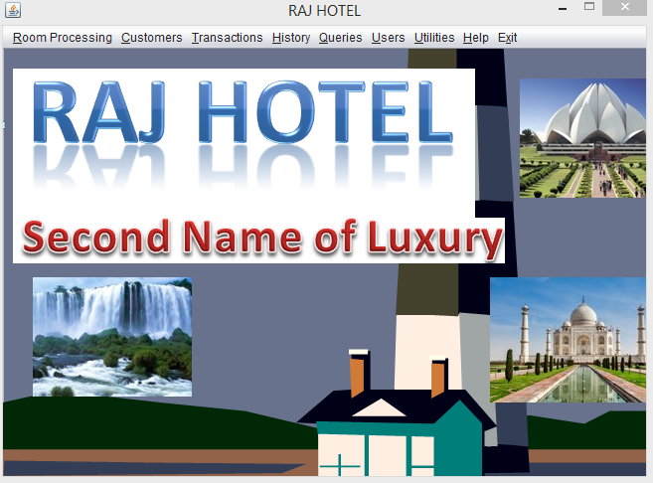

Hotel Management Software

HOTEL MANAGEMENT SYSTEM

CONTENTS

- Preface

- Project Introduction

- Form Layouts

- Database Files Used

- Program Code

PREFACE

Today’s age is the age of computers .Computers has become the essential part of our life as they automate our task in easy & convenient way. That’s why computers are used everywhere.
Hence I’ve also put my efforts by creating a computerized project on “Hotel Management System”.
The decisions made before making a project are:-
- Goals & objectives of the proposed system.
- Output that is to be produced.
- Input to be used.
- Type of interface to be provided.

The Front End used in this application is “Java Netbeans IDE 7.4” as it is responsible for receiving user’s queries, requests, & passing it to the Back End. It has the following features:-
- It is the successor of Basic language.
- It supports event driven programming.
- It provides common programming platform across all MS-Office application.

The back end used in this application is MySQL as it is Relational Database management System & very large no. of facilities for security, fast processing, removing inconsistency.

INTRODUCTION

This project is a kind of HOTEL record keeping system which is combination of three smaller systems:-
- HOTEL Management
- CUSTOMER Management

This project is capable of handling all the operations for maintaining the details about the HOTEL. We can Add, Modify, and Remove the information about a HOTEL and CUSTOMERS which includes the personal details and
Room Details. The different reports produced by this project are:-
- Room detail report grouped by ID
- Customer Details

The efforts have been provided to make this project user-friendly & interactive as possible.
-Subham Pathak

A Note of Thanks:

I would like to thank my teacher of Informatics Practices, Mr Vinay Srivastava, for his help with this project.

LOGIN:-

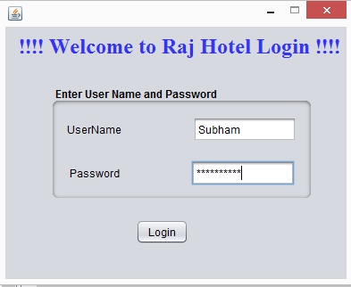

MAIN PAGE:-

ADD ROOM:-

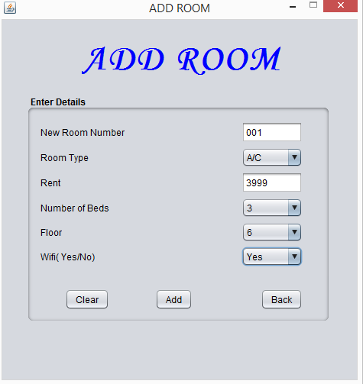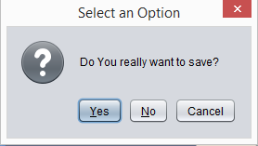

REMOVE ROOM:-
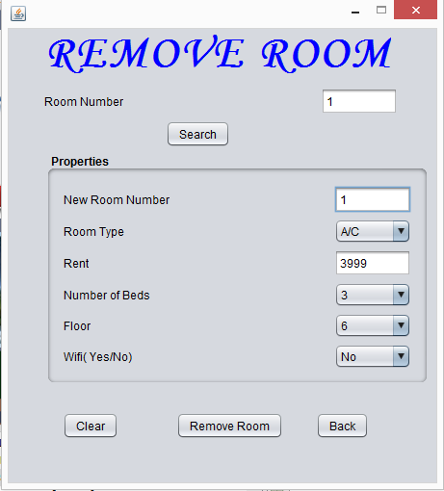

MODIFY ROOM
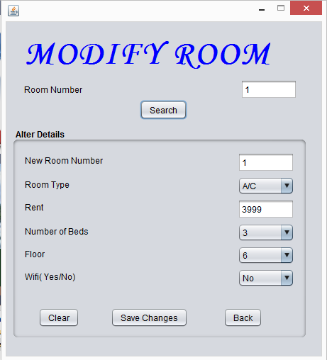
ADDCUSTOMER
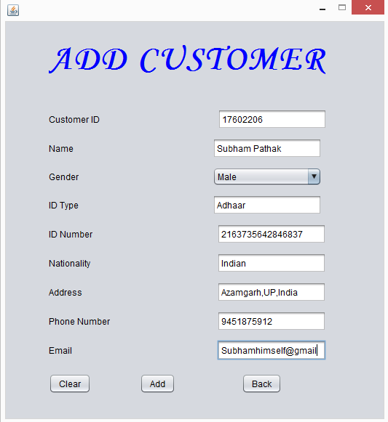

REMOVE CUSTOMER:-

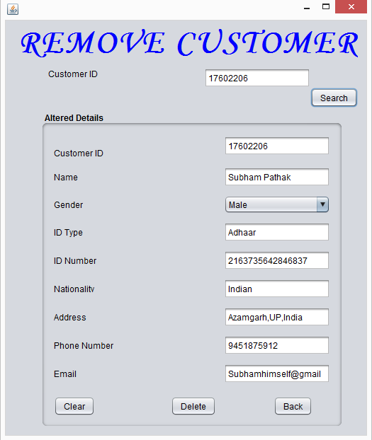

MODIFY CUSTOMER
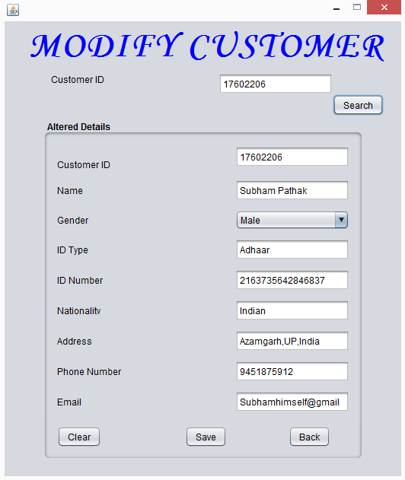

TRANSACTIONS:-
CHECKIN
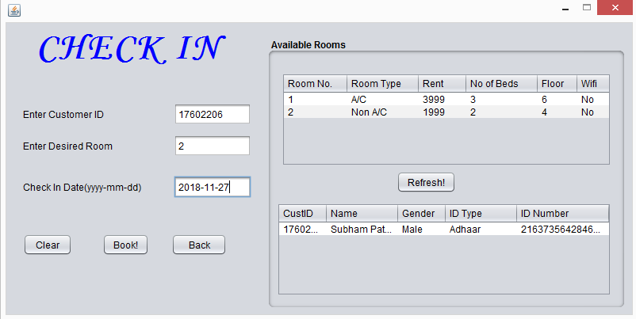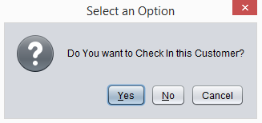
CHECK OUT
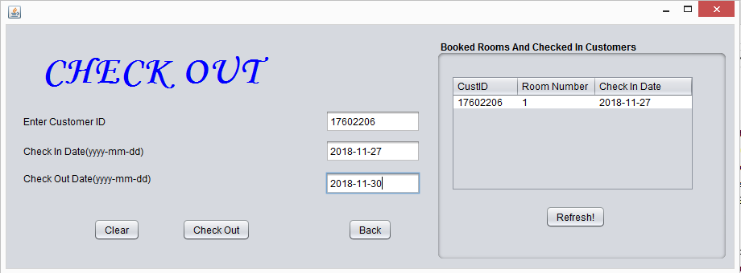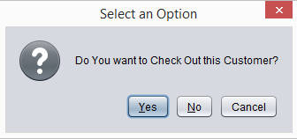
QUERY:-
SEE ALL
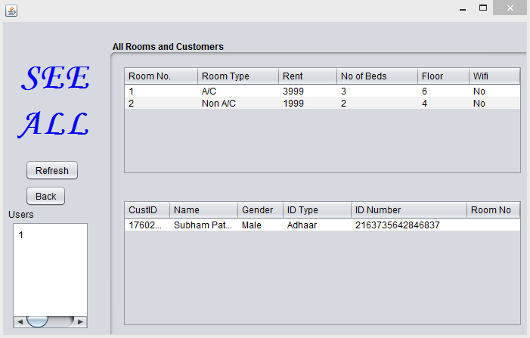
SEARCH CUSTOMERS
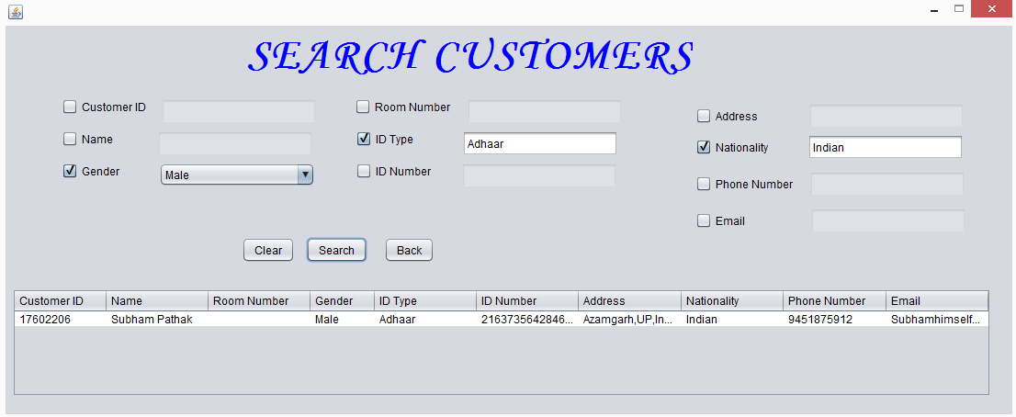
SEARCH ROOMS

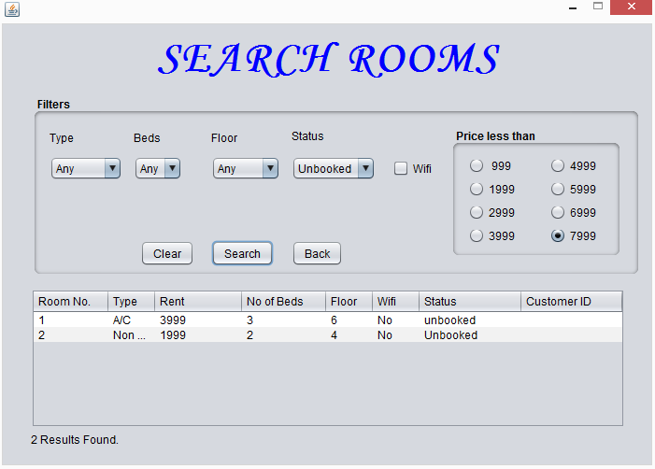

THE GEEKY STUFF

DATABASE FILES USED
RELATION: User
Field Type & size

- UserName varchar(20)
- PassWord varchar(20)

RELATION: Rooms
Field Type & size

- RoomNo int(4)
- Type varchar(10)
- Rent int(5)
- Beds int(2)
- Status varchar(10)
- CustID varchar(10)
- Floor int(1)
- WiFi varchar(4)
RELATION:Customer
Field Type & size

- CustID int(8)
- Name varchar(20)
- RoomNo int(4)
- Gender varchar(6)
- ID_Type varchar(20)
- ID_No varchar(30)
- Address varchar(50)
- Nationality varchar(20)
- PhoneNo varchar(15)
- Email varchar(30)
RELATION:History
Field Type & size
- CustID int(8)
- RoomNo int(4)
- CheckInDate date
- CheckOutDate date

PROGRAM CODE

The following code is to be written at the beginning of code for each frame:

import java.sql.*;
import javax.swing.table.DefaultTableModel;
import javax.swing.JOptionPane;

public class AddRoom extends javax.swing.JFrame {
Connection con=null;
statement stmt=null;
ResultSet rs=null;

GALLERY FRAME MENU:
- ROOM Processing:
- Code for Add ROOM:
RNo.setText("");
RType.setSelectedIndex(2);
Rent.setText("");
NoOfBeds.setSelectedIndex(4);
RFloor.setSelectedIndex(10);
WiFi.setSelectedIndex(2);
AddRoom.setVisible(true);
- Code for Modify ROOM :
RNo1.setText("");
SRNo.setText("");
Rent1.setText("");
RFloor1.setSelectedIndex(10);
NoOfBeds1.setSelectedIndex(4);
WiFi1.setSelectedIndex(02);
RType1.setSelectedIndex(02);
ModifyRoom.setVisible(true);
- Code for Remove ROOM:
RNo2.setText("");
SRNo1.setText("");
Rent2.setText("");
RFloor2.setSelectedIndex(10);
NoOfBeds2.setSelectedIndex(4);
WiFi2.setSelectedIndex(02);
RType2.setSelectedIndex(02);
RemoveRoom.setVisible(true);

- Customer Processing:

- Code for Add Customer:
AddCustomer().setVisible(true);
- Code for Modify Customer:
ModifyCustomer().setVisible(true);
- Code for Remove Customer:
RemoveCustomer().setVisible(true);

- Transaction:

- Code for CheckIn:
CheckIn().setVisible(true);

- Code for ROOM Return:
CheckOut().setVisible(true);

- Queries:

- See All:
SeeAll.setVisible(true);

- Search Rooms:
SearchRooms().setVisible(true);

- Search Customers:
SearchCustomers().setVisible(true);

- History:
AllHistory.setVisible(true);

- utilities

- Calculator:
try
{
Runtime rt=Runtime.getRuntime();
Process p=rt.exec("c:\\windows\\system32\\calc.exe");
}
catch (Exception e)
{
JOptionPane.showMessageDialog(rootPane, e.getMessage());
}

- Media:
try
{
Runtime rt=Runtime.getRuntime();
Process p=rt.exec("c:\\program files\\Windows Media Player\\wmplayer.exe");
}
catch (Exception e)
{
JOptionPane.showMessageDialog(rootPane, e.getMessage());
}

- Notepad:
try
{
Runtime rt=Runtime.getRuntime();
Process p=rt.exec("c:\\windows\\system32\\notepad.exe");
}
catch (Exception e)
{
JOptionPane.showMessageDialog(rootPane, e.getMessage());
}

- Help
- About Us:-
AboutUs.setVisible(true);
- Help:-
Help.setVisible(true);

- Exit
system.Exit(0);

CODE FOR LOGIN
try
{

Class.forName("java.sql.Driver");
con=DriverManager.getConnection("jdbc:mysql://localhost:3306/RajHotel","root","sunbeam");
stmt=con.createStatement();
string pass=new String(Pass.getPassword());
string query="Select * from Users where UserName='"+Uname.getText()+"' and password='"+pass+"';";

rs=stmt.executeQuery(query);

if (rs.next())
{
new Main().setVisible(true);
dispose();
}
else
JOptionPane.showMessageDialog(rootPane,"Wrong ID or Password!!!");
}

catch(Exception e)
{
JOptionPane.showMessageDialog(rootPane,e.getMessage());
}
CODE FOR ROOM PROCESSING:-
CODE FOR ADD ROOM

try
{
Class.forName("java.sql.Driver");
con=DriverManager.getConnection("jdbc:mysql://localhost:3306/RajHotel","root","sunbeam");
stmt=con.createStatement();
int res=JOptionPane.showConfirmDialog(rootPane,"Do You really want to delete this room permanently?");
if (res==JOptionPane.YES_OPTION)
{
String query="Delete from rooms where RoomNo="+SRNo1.getText()+";";
int r=stmt.executeUpdate(query);
JOptionPane.showMessageDialog(rootPane,"Room Deleted Succesfully!!");
RNo2.setText("");
SRNo1.setText("");
Rent2.setText("");
RFloor2.setSelectedIndex(0);
NoOfBeds2.setSelectedIndex(0);
WiFi2.setSelectedIndex(0);
RType2.setSelectedIndex(0);
}
else
JOptionPane.showMessageDialog(rootPane,"No Record Saved!!");
}
catch(Exception e)
{
JOptionPane.showMessageDialog(rootPane,e.getMessage());
}
}

private void jButton6ActionPerformed(java.awt.event.ActionEvent evt) {
RemoveRoom.setVisible(false);
RNo2.setText("");
SRNo1.setText("");
Rent2.setText("");
RFloor2.setSelectedIndex(10);
NoOfBeds2.setSelectedIndex(4);
WiFi2.setSelectedIndex(02);
RType2.setSelectedIndex(02);
}

private void jButton7ActionPerformed(java.awt.event.ActionEvent evt) {
RNo2.setText("");
SRNo1.setText("");
Rent2.setText("");
RFloor2.setSelectedIndex(10);
NoOfBeds2.setSelectedIndex(4);
WiFi2.setSelectedIndex(02);
RType2.setSelectedIndex(02);
}

CODE FOR REMOVE ROOM
try
{
Class.forName("java.sql.Driver");
con=DriverManager.getConnection("jdbc:mysql://localhost:3306/RajHotel","root","sunbeam");
stmt=con.createStatement();
int res=JOptionPane.showConfirmDialog(rootPane,"Do You really want to delete this room permanently?");
if (res==JOptionPane.YES_OPTION)
{
String query="Delete from rooms where RoomNo="+SRNo1.getText()+";";
int r=stmt.executeUpdate(query);
JOptionPane.showMessageDialog(rootPane,"Room Deleted Succesfully!!");
RNo2.setText("");
SRNo1.setText("");
Rent2.setText("");
RFloor2.setSelectedIndex(0);
NoOfBeds2.setSelectedIndex(0);
WiFi2.setSelectedIndex(0);
RType2.setSelectedIndex(0);
}
else
JOptionPane.showMessageDialog(rootPane,"No Record Saved!!");}
catch(Exception e){
JOptionPane.showMessageDialog(rootPane,e.getMessage()); } }
private void jButton6ActionPerformed(java.awt.event.ActionEvent evt) {
RemoveRoom.setVisible(false);
RNo2.setText("");
SRNo1.setText("");
Rent2.setText("");
RFloor2.setSelectedIndex(10);
NoOfBeds2.setSelectedIndex(4);
WiFi2.setSelectedIndex(02);
RType2.setSelectedIndex(02);
}
private void jButton7ActionPerformed(java.awt.event.ActionEvent evt) {
RNo2.setText("");
SRNo1.setText("");
Rent2.setText("");
RFloor2.setSelectedIndex(10);
NoOfBeds2.setSelectedIndex(4);
WiFi2.setSelectedIndex(02);
RType2.setSelectedIndex(02);
}
CODE FOR MODIFY ROOM

try
{
Class.forName("java.sql.Driver");
con=DriverManager.getConnection("jdbc:mysql://localhost:3306/RajHotel","root","sunbeam");
stmt=con.createStatement();
int res=JOptionPane.showConfirmDialog(rootPane,"Do You really want to save?");
if (res==JOptionPane.YES_OPTION&&RType1.getSelectedIndex()!=2&&NoOfBeds1.getSelectedIndex()!=4&&RFloor1.getSelectedIndex()!=10&&WiFi1.getSelectedIndex()!=2)
{String query="Update rooms set RoomNo="+RNo1.getText()+", Type='"+(RType1.getSelectedIndex()==0?"A/C":"Non A/C")+"' ,Rent="+Rent1.getText()+", Beds="+(NoOfBeds1.getSelectedIndex()+1)+", Floor="+RFloor1.getSelectedIndex()+", Wifi='"+(WiFi1.getSelectedIndex()==0?"Yes":"No")+"' where RoomNo="+SRNo.getText()+";";
int r=stmt.executeUpdate(query);
JOptionPane.showMessageDialog(rootPane,"Record Saved Succesfully!!!");
RNo1.setText("");
SRNo.setText("");
Rent1.setText("");
RFloor1.setSelectedIndex(0);
NoOfBeds1.setSelectedIndex(0);
WiFi1.setSelectedIndex(0);
RType1.setSelectedIndex(0);
jPanel3.setEnabled(false);
}
else
JOptionPane.showMessageDialog(rootPane,"No Record Saved!!!");
}catch(Exception e)
{
JOptionPane.showMessageDialog(rootPane,"Please Check Your Input!!!");
}

CODE FOR CUSTOMER PROCESSING:-
CODE FOR ADD CUSTOMER
try
{
Class.forName("java.sql.Driver");
con=DriverManager.getConnection("jdbc:mysql://localhost:3306/RajHotel","root","sunbeam");
stmt=con.createStatement();
int res=JOptionPane.showConfirmDialog(rootPane,"Do You really want to save?");
if (res==JOptionPane.YES_OPTION)
{string query="insert into Customer values("+CustId.getText()+",'"+Name.getText()+"',"+"null"+","+((Gender.getSelectedIndex()==0?"'Male'":"'Female'"))+",'"+IDtype.getText()+"','"+IDNo.getText()+"','"+Address.getText()+"','"+Nationality.getText()+"','"+PhoneNo.getText()+"','"+Email.getText()+"')";
int r=stmt.executeUpdate(query);
JOptionPane.showMessageDialog(rootPane,"Record Saved Succesfully");
Gender.setSelectedIndex(0);}
else
JOptionPane.showMessageDialog(rootPane,"No Record Saved");}
catch(Exception e){
JOptionPane.showMessageDialog(rootPane,e.getMessage()); }

CODE FOR REMOVE CUSTOMER

try {
Class.forName("java.sql.Driver");
con=DriverManager.getConnection("jdbc:mysql://localhost:3306/RajHotel","root","sunbeam");
stmt=con.createStatement();
int res=JOptionPane.showConfirmDialog(rootPane,"Do You really want to delete this Customer permanently?");
if (res==JOptionPane.YES_OPTION){
String query="Delete from Customer where CustId="+scustid1.getText()+";";
int r=stmt.executeUpdate(query);
JOptionPane.showMessageDialog(rootPane,"Customer Deleted Succesfully!!");}
else
JOptionPane.showMessageDialog(rootPane,"No Record Deleted!!");}
catch(Exception e){
JOptionPane.showMessageDialog(rootPane,e.getMessage()); }
CODE FOR MODIFY CUSTOMER
try {
Class.forName("java.sql.Driver");
con=DriverManager.getConnection("jdbc:mysql://localhost:3306/RajHotel","root","sunbeam");
stmt=con.createStatement();
int res=JOptionPane.showConfirmDialog(rootPane,"Do You really want to save?");
if (res==JOptionPane.YES_OPTION){
String query="Update customer set CustId="+CustId1.getText()+", Name='"+Name1.getText()+"',gender='"+(Gender1.getSelectedIndex()==1?"Female":"Male")+"',ID_type='"+IDtype1.getText()+"',ID_No='"+IDNo1.getText()+"',Address='"+Address1.getText()+"',Nationality='"+Nationality1.getText()+"',PhoneNo='"+PhoneNo1.getText()+"',Email='"+Email1.getText()+"' Where CustId='"+scustid.getText()+"';";
int r=stmt.executeUpdate(query);
JOptionPane.showMessageDialog(rootPane,"Record Saved Succesfully");}
else
JOptionPane.showMessageDialog(rootPane,"No Record Saved");}
catch(Exception e){
JOptionPane.showMessageDialog(rootPane,e.getMessage()); }
CODE FOR TRANSACTION:-
CODE FOR CHECK IN
try {
Class.forName("java.sql.Driver");
con=DriverManager.getConnection("jdbc:mysql://localhost:3306/RajHotel","root","sunbeam");
stmt=con.createStatement();
int res=JOptionPane.showConfirmDialog(rootPane,"Do You want to Check In this Customer?");
if (res==JOptionPane.YES_OPTION)
{ int i=0;
string query="Select * from rooms where status='unbooked';";
rs=stmt.executeQuery(query);
while(rs.next())
{String p12=rs.getString("RoomNo");
if (p12.equalsIgnoreCase(sRoom.getText()))
i=1; }
string query3="Select * from customer where RoomNo is Null;";
rs=stmt.executeQuery(query3);
if (i==1){
i=0;
while(rs.next()){
string p12=rs.getString("CustID");
if (p12.equalsIgnoreCase(sCid.getText()))
i=1; }}
if(i==1){
String query1="Update Rooms set status='booked', CustID='"+sCid.getText()+"' where RoomNo="+sRoom.getText()+" ;";
String query2="Update Customer set RoomNo="+sRoom.getText()+" where CustId= '"+sCid.getText()+"';";
String query4="Insert into History values('"+sCid.getText()+"','"+sRoom.getText()+"','"+Idate.getText()+"',null);";
stmt.executeUpdate(query1);
stmt.executeUpdate(query2);
stmt.executeUpdate(query4);
JOptionPane.showMessageDialog(rootPane,"Customer Checked In Succesfully!!");
Idate.setText("");
DefaultTableModel model=(DefaultTableModel) troom.getModel();
int rows=model.getRowCount();
if (rows>0)
for(int i1=0;i1<rows;i1++)
model.removeRow(0);
try{
Class.forName("java.sql.Driver");
con=DriverManager.getConnection("jdbc:mysql://localhost:3306/Rajhotel","root","sunbeam");
stmt=con.createStatement();
query="Select * from rooms where status='unbooked';";
rs=stmt.executeQuery(query);
while(rs.next()){
string p12=rs.getString("RoomNo");
String p22=rs.getString("Type");
String p32=rs.getString("Rent");
String p42=rs.getString("Beds");
String p52=rs.getString("Floor");
String p62=rs.getString("WiFi");
model.addRow(new Object[]{p12,p22,p32,p42,p52,p62}); }}
catch(Exception e){
JOptionPane.showMessageDialog(null,e.getMessage());}
DefaultTableModel model1=(DefaultTableModel) tcust.getModel();
int rows1=model1.getRowCount();
if (rows1>0)
for(int i1=0;i1<rows1;i1++)
model1.removeRow(0);
try{
Class.forName("java.sql.Driver");
con=DriverManager.getConnection("jdbc:mysql://localhost:3306/Rajhotel","root","sunbeam");
stmt=con.createStatement();
query="Select * from customer where RoomNo is null;";
rs=stmt.executeQuery(query);
while(rs.next()){
string p12=rs.getString("CustID");
String p22=rs.getString("Name");
String p32=rs.getString("Gender");
String p42=rs.getString("ID_Type");
String p52=rs.getString("ID_No");
model1.addRow(new Object[]{p12,p22,p32,p42,p52});}
catch(Exception e){
JOptionPane.showMessageDialog(null,e.getMessage());}
sCid.setText("");
sRoom.setText}
else
JOptionPane.showMessageDialog(rootPane,"Check Your Input!!!"); }
else
JOptionPane.showMessageDialog(rootPane,"No Customer Checked In!!");}
catch(Exception e){
JOptionPane.showMessageDialog(null,e.getMessage());}
CODE FOR
CHECKOUT
try
{
Class.forName("java.sql.Driver");
con=DriverManager.getConnection("jdbc:mysql://localhost:3306/RajHotel","root","sunbeam");
stmt=con.createStatement();
int res=JOptionPane.showConfirmDialog(rootPane,"Do You want to Check Out this Customer?");
if (res==JOptionPane.YES_OPTION){
int x=0;
rs1=stmt.executeQuery("Select * from customer where RoomNo is not null;");
while(rs1.next()) {
if (rs1.getString("CustID").equalsIgnoreCase(sCid1.getText()))
x=1; }
if (x==1){
stmt.executeUpdate("Update Rooms set CustID=null, status='unbooked' where CustID='"+sCid1.getText()+"';");
stmt.executeUpdate("Update Customer set RoomNo=null where CustId='"+sCid1.getText()+"';");
stmt.executeUpdate("Update History set CheckOutDate='"+Odate.getText()+"' where CustId='"+sCid1.getText()+"' and CheckInDate='"+Idate1.getText()+"';");
JOptionPane.showMessageDialog(rootPane,"Customer Checked Out Succesfully!!");
sCid1.setText("");
Odate.setText("");
Idate1.setText("");
DefaultTableModel model1=(DefaultTableModel) tcust1.getModel();
int rows1=model1.getRowCount();
if (rows1>0)
for(int i=0;i<rows1;i++)
model1.removeRow(0);
try{
Class.forName("java.sql.Driver");
con=DriverManager.getConnection("jdbc:mysql://localhost:3306/Rajhotel","root","sunbeam");
stmt=con.createStatement();
string query="Select * from customer where RoomNo is not null;";
rs=stmt.executeQuery(query);
while(rs.next()){
string p12=rs.getString("CustID");
string p22=rs.getString("Name");
string p32=rs.getString("Gender");
string p42=rs.getString("ID_Type");
string p52=rs.getString("ID_No");
string p62=rs.getString("RoomNo");

model1.addRow(new Object[]{p12,p22,p62,p32,p42,p52}); }}
catch(Exception e) {
JOptionPane.showMessageDialog(null,e.getMessage());} }
else
JOptionPane.showMessageDialog(null,"Customer not Checked In!!!"); }
else
JOptionPane.showMessageDialog(rootPane,"No Customer Checked Out!!");}
catch(Exception e){
JOptionPane.showMessageDialog(null,e.getMessage());}

CODE FOR HISTORY

DefaultTableModel model1=(DefaultTableModel) troom2.getModel();
int rows1=model1.getRowCount();
if (rows1>0)
for(int i=0;i<rows1;i++)
model1.removeRow(0);
try{
Class.forName("java.sql.Driver");
con=DriverManager.getConnection("jdbc:mysql://localhost:3306/Rajhotel","root","sunbeam");
stmt=con.createStatement();
string query="Select * from history;";
rs=stmt.executeQuery(query);
while(rs.next()) {
String p12=rs.getString("CustID");
String p62=rs.getString("RoomNo");
String p72=rs.getString("CheckInDate");
String p82=rs.getString("CheckOutDate");
model1.addRow(new Object[]{p12,p62,p72,p82}); }}
catch(Exception e) {
JOptionPane.showMessageDialog(null,e.getMessage());}
CODE FOR SEARCH ROOMS

DefaultTableModel model=(DefaultTableModel) troom3.getModel();
int i;
int rows=model.getRowCount();
if (rows>0)
for(i=0;i<rows;i++)
model.removeRow(0);
try {
Class.forName("java.sql.Driver");
con=DriverManager.getConnection("jdbc:mysql://localhost:3306/Rajhotel","root","sunbeam");
stmt=con.createStatement();
i=0;
Stringquery="select*fromroomswhere"+((stype.getSelectedIndex()==0)?"":((stype.getSelectedIndex()==1)?" type='A/C' and":" type='Non A/C' and "))+((sbed.getSelectedIndex()==0)?"":(" Beds="+sbed.getSelectedIndex()+" and "))+((sfloor.getSelectedIndex()==0)?"":(" Floor="+(sfloor.getSelectedIndex()-1)+" and "))+((sstatus.getSelectedIndex()==0)?"":((sstatus.getSelectedIndex()==1)?" status='Booked' and ":" status='Unbooked' and "))+((swifi.isSelected())?" Wifi='yes' and ":"")+" rent <= "+buttonGroup1.getSelection().getMnemonic()+";";
rs=stmt.executeQuery(query);
while(rs.next()){
i++;
string p12=rs.getString("RoomNo");
string p22=rs.getString("Status");
string p32=rs.getString("Rent");
string p42=rs.getString("Beds");
string p72=rs.getString("CustID");
string p82=rs.getString("Type");
string p52=rs.getString("Floor");
string p62=rs.getString("WiFi");
model.addRow(new Object[]{p12,p82,p32,p42,p52,p62,p22,p72}) }
jLabel73.setText(i+" Results Found.");}
catch(Exception e) {
JOptionPane.showMessageDialog(null,"Please select some Filters!!!"); }
CODE FOR SEARCH CUSTOMER

DefaultTableModel model=(DefaultTableModel) troom4.getModel();
int rows=model.getRowCount();
if (rows>0)
for(int i=0;i<rows;i++)
model.removeRow(0);
try{
Class.forName("java.sql.Driver");
con=DriverManager.getConnection("jdbc:mysql://localhost:3306/Rajhotel","root","sunbeam");
stmt=con.createStatement();
string query="select * from customer where CustID like '%"+scust.getText()+"%' and "+"Name like '%"+sname.getText()+"%' and"+((gender.getSelectedIndex()==0)?"":((gender.getSelectedIndex()==1)?"gender='male'and":"gender='female'and"))+(rn.isSelected()?(" RoomNo="+rno.getText()+" and "):"")+" ID_Type like '%"+idt.getText()+"%' and "+" ID_No like '%"+idn.getText()+"%' and "+" Address like '%"+add.getText()+"%' and "+" Nationality like '%"+nat.getText()+"%' and "+" PhoneNo like '%"+phn.getText()+"%' and "+" Email like '%"+ema.getText()+"%' "+";";
rs=stmt.executeQuery(query);
while(rs.next()){
string p12=rs.getString("CustID");
string p22=rs.getString("Address");
string p32=rs.getString("RoomNo");
string p42=rs.getString("Gender");
string p72=rs.getString("Nationality");
string p82=rs.getString("Name");
string p52=rs.getString("ID_Type");
string p62=rs.getString("ID_No");
string p92=rs.getString("PhoneNo");
string p102=rs.getString("Email");
model.addRow(newObject[]{p12,p82,p32,p42,p52,p62,p22,p72,p92,p102}); } }
CODE FOR SEE ALL
DefaultTableModel model=(DefaultTableModel) troom1.getModel();
int rows=model.getRowCount();
if (rows>0)
for(int i=0;i<rows;i++)
model.removeRow(0);
try{
Class.forName("java.sql.Driver");
con=DriverManager.getConnection("jdbc:mysql://localhost:3306/Rajhotel","root","sunbeam");
stmt=con.createStatement();
string query="Select * from rooms;";
rs=stmt.executeQuery(query);
while(rs.next()){
string p12=rs.getString("RoomNo");
string p22=rs.getString("Type");
string p32=rs.getString("Rent");
String p42=rs.getString("Beds");
String p52=rs.getString("Floor");
string p62=rs.getString("WiFi");
model.addRow(new Object[]{p12,p22,p32,p42,p52,p62});}}
DefaultTableModel model1=(DefaultTableModel) tcust2.getModel();
int rows1=model1.getRowCount();
if (rows1>0)
for(int i=0;i<rows1;i++)
model1.removeRow(0);
try{
Class.forName("java.sql.Driver");
con=DriverManager.getConnection("jdbc:mysql://localhost:3306/Rajhotel","root","sunbeam");
stmt=con.createStatement();
string query="Select * from customer;";
rs=stmt.executeQuery(query);
while(rs.next()){
string p12=rs.getString("CustID");
string p22=rs.getString("Name");
string p32=rs.getString("Gender");
string p42=rs.getString("ID_Type");
string p52=rs.getString("ID_No");
string p62=rs.getString("RoomNo");
model1.addRow(new Object[]{p12,p22,p32,p42,p52,p62}); }
try{
Class.forName("java.sql.Driver");
con=DriverManager.getConnection("jdbc:mysql://localhost:3306/Rajhotel","root","sunbeam");
stmt=con.createStatement();
string query="Select * from users;";
rs=stmt.executeQuery(query);
while(rs.next()) {
jTextArea3.append(rs.getString("username")+"\n");} }
CODE FOR
ADD USER
try {
Class.forName("java.sql.Driver");
con=DriverManager.getConnection("jdbc:mysql://localhost:3306/RajHotel","root","sunbeam");
stmt=con.createStatement();
int res=JOptionPane.showConfirmDialog(rootPane,"Do You really want to save?");
if (res==JOptionPane.YES_OPTION){
string query="insert into users values("+uname.getText()+","+upass.getText()+");";
int r=stmt.executeUpdate(query);
JOptionPane.showMessageDialog(rootPane,"User added Succesfully !!!");
uname.setText("");
upass.setText("");}
else
JOptionPane.showMessageDialog(rootPane,"User Not Saved !!!");
}
catch(Exception e){
JOptionPane.showMessageDialog(rootPane,"Please Check Your Input!!!");}

CODE FOR
REMOVE USER
try{
Class.forName("java.sql.Driver");
con=DriverManager.getConnection("jdbc:mysql://localhost:3306/RajHotel","root","sunbeam");
stmt=con.createStatement();
string query="Select * from Users where UserName='"+uname1.getText()+"' and password='"+upass1.getText()+"';";
rs=stmt.executeQuery(query);
if (rs.next()){
stmt.executeUpdate("Delete from Users where UserName='"+uname1.getText()+"' and password='"+upass1+"';");
JOptionPane.showMessageDialog(rootPane,"User Removed !!!");
uname1.setText("");upass1.setText(""); }
else
JOptionPane.showMessageDialog(rootPane,"Wrong ID or Password!!!");
}
catch(Exception e){
JOptionPane.showMessageDialog(rootPane,e.getMessage());}

