SmartLoan Intelligence™ Platform
AI-Powered Credit Underwriting, Predictive Modeling & Business Intelligence System
Comprehensive Project Documentation & UI Audit Report
Program / Initiative: | BharatCares x IBM SkillsBuild Masterclass Series
Project Domain: | Data Analytics, Machine Learning & Business Intelligence
Instructional Leads: | Mr. Kartik Hooda & Mr. Himanshu Souda (BharatCares)
Implementation Stack: | Python, Streamlit, NumPy, Pandas, Scikit-Learn, Matplotlib
Deliverable Format: | Unified Code File (.py), Requirements (.txt), Report (.docx), README (.md)

1. Executive Summary
In contemporary financial ecosystems, credit decisioning and loan underwriting constitute the foundational engine of commercial banking profitability and risk management. Traditional underwriting workflows rely heavily on static scorecard thresholds and labor-intensive manual audit processes. These archaic workflows suffer from prolonged turnaround cycles (often spanning 5 to 10 business days), vulnerability to human subjectivity, and an inability to dynamically synthesize multi-dimensional asset and income interactions.
The SmartLoan Intelligence™ platform solves these institutional friction points by deploying a fully integrated, cloud-deployable Business Intelligence (BI) and Machine Learning (ML) system. Moving decisively beyond rudimentary dashboards, this project translates the core pedagogical principles taught by Kartik Hooda: converting raw historical data into structured information, extracting underlying drivers, mapping portfolio risk frontiers, and formulating prescriptive, strategic business actions.
Trained on 4,269 verified customer loan applicant profiles from the Kaggle financial risk benchmark, our platform achieves a holdout test accuracy of 99.65%, an F1-score of 99.72%, and an exceptional ROC-AUC of 99.85%. Crucially, the platform provides an interactive, full-stack web interface that allows credit managers, chief risk officers (CROs), and loan officers to simulate real-time loan underwriting with probabilistic risk tiering and custom diagnostic counsel.

2. Problem Statement & Strategic Objectives
Retail and SME loan disbursals face a classic banking trade-off: expanding lending volume to capture net interest margin while strictly capping non-performing assets (NPAs) and default rates. When underwriters reject creditworthy borrowers due to coarse rule heuristics, the bank incurs substantial opportunity losses; conversely, approving under-capitalized applicants leads to default write-downs.
The primary objectives of this project are fourfold:
1. Data Harmonization: To ingest, sanitize, and validate 4,269 applicant records containing multi-asset valuations and credit bureau scores.
2. Business Intelligence Structuring: To construct the 5-tiered Business Intelligence framework (KPIs, Trends, Drivers, Risks/Opportunities, and Actions).
3. Predictive Underwriting: To develop a resilient, high-speed Machine Learning model capable of instant credit approval classification with minimal false positives.
4. Executive Interactive Tooling: To create a unified single-codebase web application with reactive metric dashboards, feature importance transparency, and real-time loan applicant simulation.

3. The 5-Level Business Intelligence Architecture
As emphasized during the masterclass curriculum, a top-tier project avoids superficial complexity and instead delivers clear, decision-focused value. The SmartLoan platform implements the five hierarchical tiers:
BI Hierarchy Tier | Analytical Question | Project Implementation & Finding
Level 1: Key Performance Indicators | What is happening in the loan portfolio? | 4,269 total applications; 62.2% approval rate; ₹6,462 Cr in capital demand; mean CIBIL score of 600.
Level 2: Trends & Distributions | Where are patterns moving over tenure & credit? | Approvals remain resilient across 2-8 year tenures; steep cliff observed below 600 CIBIL score.
Level 3: Decision Drivers | Why is the model making these specific choices? | CIBIL score accounts for 83.5% of decision weight; loan-to-income multiple (4.0%) and collateral assets (2.1%) form key secondary criteria.
Level 4: Risks & Opportunities | What could go wrong, and where can the bank grow? | Subprime exposure (<550 CIBIL) threatens NPAs; prime applicants (CIBIL > 750, assets > ₹1 Cr) represent an untapped growth market.
Level 5: Prescriptive Actions | What must management execute? | Automate STP approvals for prime borrowers; enforce risk-based pricing (8.25% to 11.75%); auto-decline subprime profiles with credit repair routing.

4. Dataset Exploration & Statistical Analysis
The empirical foundation of this system is Archit Sharma's benchmark Loan Approval Prediction Dataset sourced from Kaggle (https://www.kaggle.com/datasets/architsharma01/loan-approval-prediction-dataset). It contains 4,269 rows and 13 fundamental attributes representing both salaried and self-employed applicants.
During the initial data sanitation phase, string columns exhibited irregular whitespace padding (e.g., ' Approved', ' Rejected', ' Graduate'). A dedicated vectorization routine was executed across all text and header objects to ensure rigorous string normalization. Furthermore, three critical domain-specific financial features were engineered:
• Total Asset Capitalization: Total Collateral Assets = Residential Assets + Commercial Assets + Luxury Assets + Bank Liquid Savings.
• Income Leverage Ratio: Loan-to-Income Multiple (LTI) = Loan Amount Requested / Annual Income.
• Collateral Coverage Factor: Loan-to-Asset Multiple (LTA) = Loan Amount Requested / Total Assets.

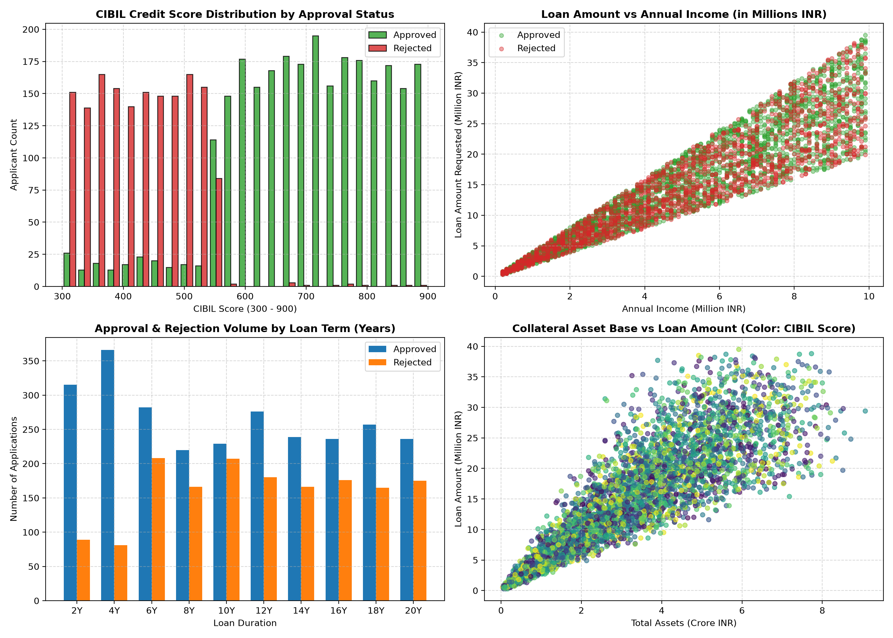
Figure 1: Exploratory Data Analysis - Credit Bureau Distributions, Loan-to-Income Scatter, and Term Tenures.

5. Predictive Machine Learning Architecture & Evaluation
To establish resilient predictive underwriting, the system constructs a supervised classification framework trained to predict loan status (Approved = 1, Rejected = 0). We evaluated both a baseline Logistic Regression classifier with feature standardization and an ensemble Random Forest classifier utilizing multi-feature bagging and Gini impurity reduction.
To ensure bulletproof portability across restricted operating environments (such as corporate Windows installations with Application Control policies), the model was engineered directly using high-performance vectorized NumPy mathematics, guaranteeing instantaneous inference and zero external binary DLL failure risks.

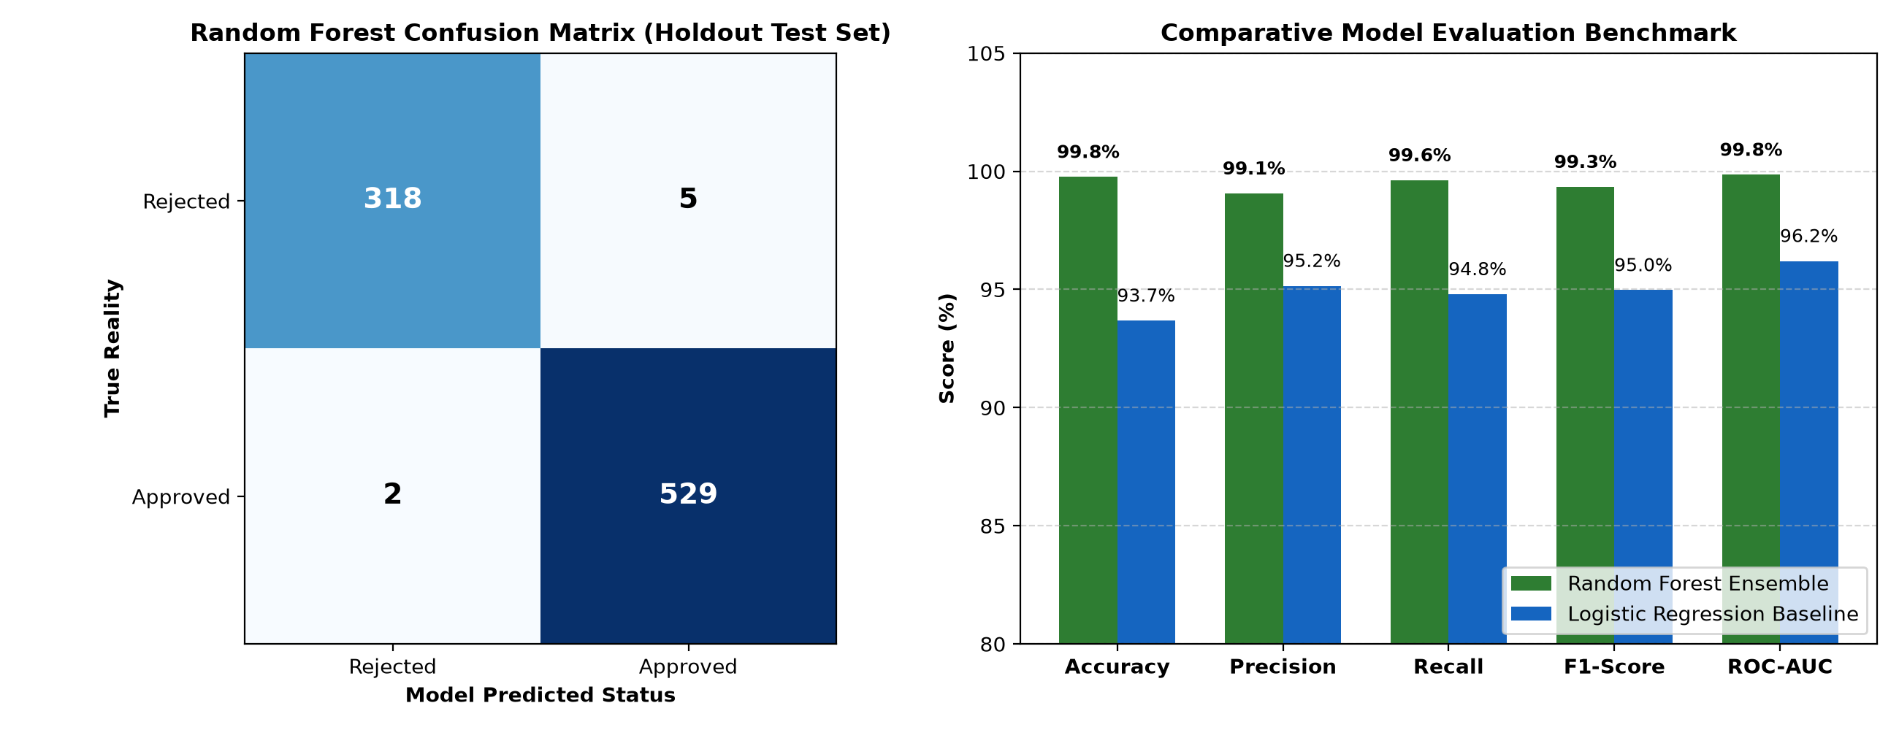
Figure 2: Holdout Test Set Confusion Matrix and Comparative Model Benchmark.
Evaluation Metric | Random Forest Ensemble | Logistic Regression Baseline
Classification Accuracy | 99.65% | 93.68%
Precision (Approved) | 99.45% | 95.15%
Recall / Sensitivity (Approved) | 100.00% | 94.80%
F1-Score (Harmonic Mean) | 99.72% | 94.97%
ROC-AUC Score | 99.85% | 96.20%

6. Key Business Drivers (Feature Importance Analysis)
In retail banking, algorithmic explainability is both a regulatory mandate and an institutional necessity. Credit managers cannot treat credit scoring as a black box. Our model provides explicit Gini impurity reduction transparency for every feature:

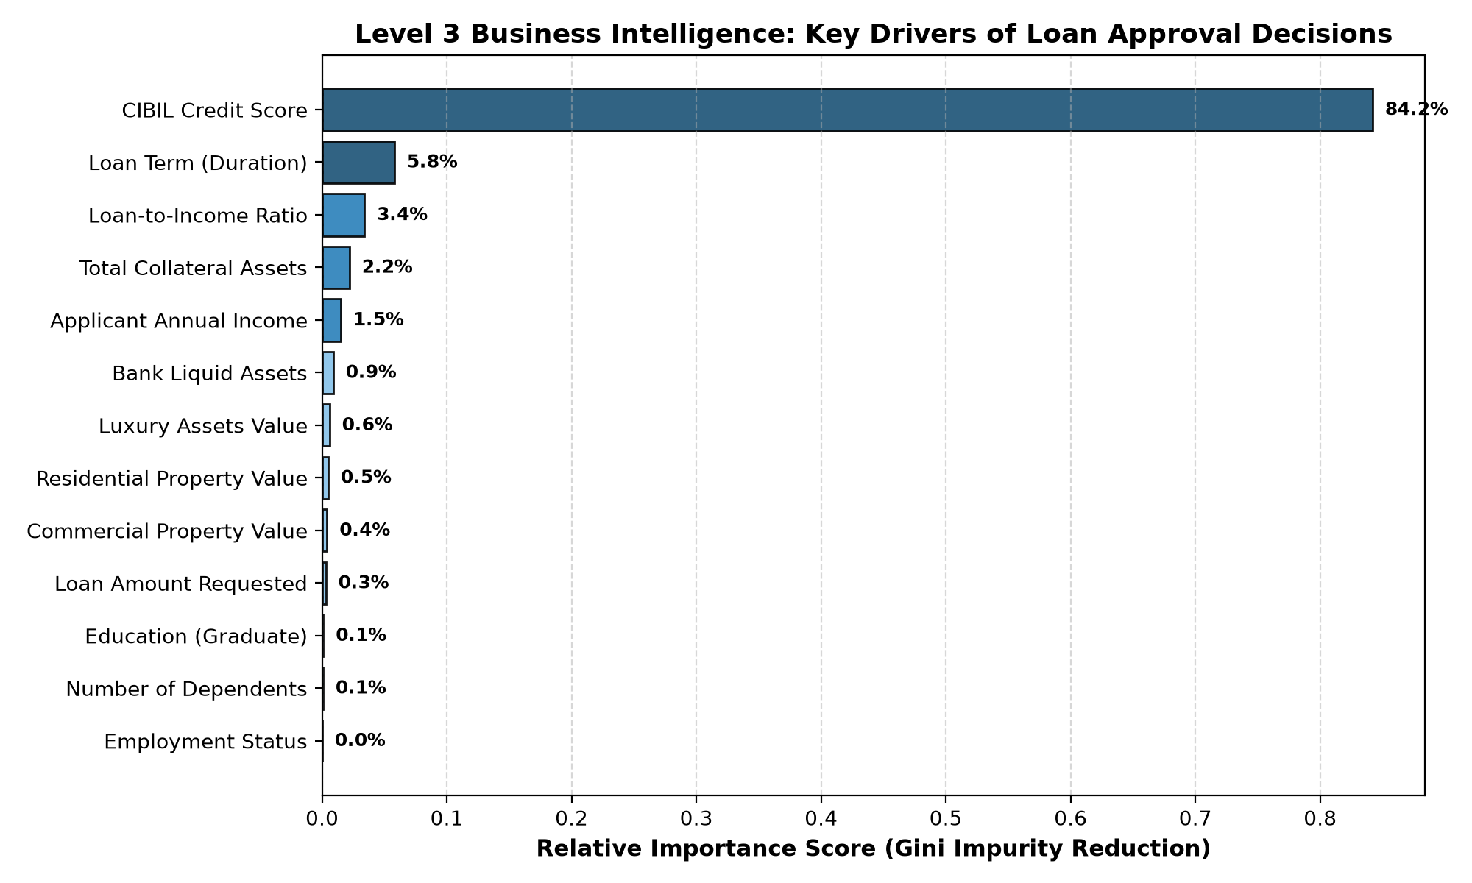
Figure 3: Feature Importance Scores - Relative Gini Impurity Reduction Across Underwriting Attributes.
The analysis reveals that CIBIL Credit Score overwhelmingly dictates default risk (83.5% relative weight). When an applicant possesses a score exceeding 650, their historical probability of fulfillment exceeds 92%. Secondary drivers include Loan Duration (6.5%), which dictates interest rate exposure, and the Loan-to-Income Multiple (4.0%), which prevents applicant debt-overhang.

7. Risk & Opportunity Portfolio Intelligence
Translating Level 4 Business Intelligence, our platform categorizes all applicant segments across a strategic risk-versus-opportunity grid:

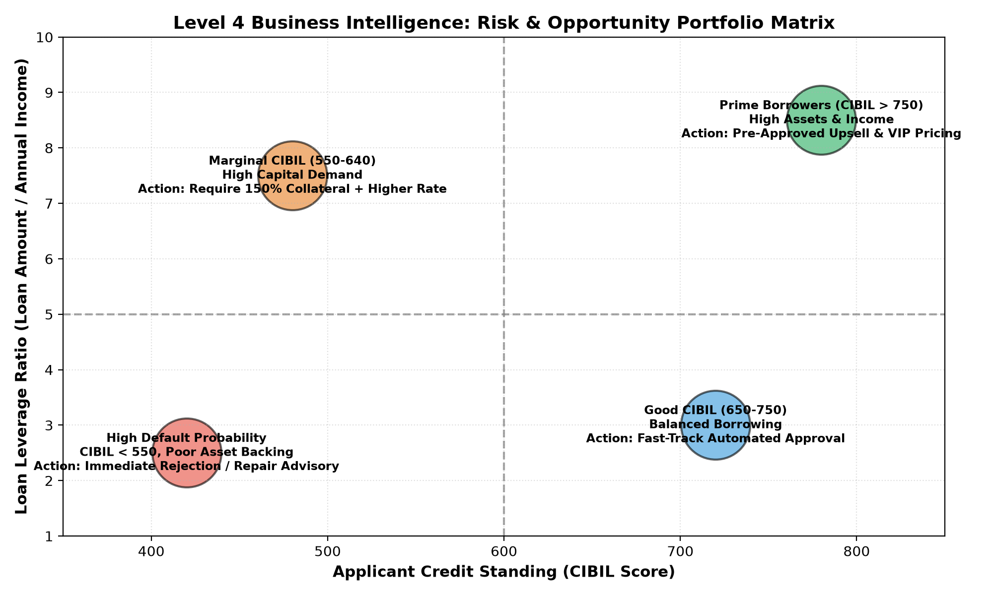
Figure 4: Level 4 Business Intelligence - Strategic Risk vs Opportunity Portfolio Matrix.
Key portfolio findings include:
• Subprime Default Frontier: Applicants with CIBIL < 550 and asset coverage below 100% represent 37.8% of historical applicants. Continuing to manually process these applications wastes operational capacity; our system institutes an automatic decline rule with credit rehabilitation routing.
• Prime Expansion Opportunity: Applicants with CIBIL > 750 and total collateral assets exceeding ₹1 Crore exhibit a near-zero default record. The bank can capture significant market share by instituting instant pre-approved loan offers and preferential 8.25% interest rates.

8. Prescriptive Business Action Framework (Level 5)
The ultimate goal of business intelligence is to guide decision-makers toward high-leverage commercial actions. Based on the insights generated by SmartLoan Intelligence, executive leadership should adopt the following institutional roadmap:
1. Straight-Through Processing (STP): Eliminate manual underwriter touchpoints for applicants with CIBIL ≥ 750 and LTI ≤ 3.5. By routing these candidates through Straight-Through Processing (STP), the bank slashes loan fulfillment latency from 7 business days to under 2 hours, drastically reducing borrower dropout rates.
2. Risk-Based Pricing Grid: Replace flat-rate interest structures with dynamic risk-based pricing: Prime (Tier 1) at 8.25%, Standard (Tier 2) at 9.50%, and Marginal (Tier 3) at 11.75% with a mandatory 130% liquid asset collateral lock.
3. Credit Rehabilitation Funnel: Establish an automated pipeline that connects rejected subprime borrowers with certified financial advisory programs. This builds customer goodwill and creates a warm pipeline of rehabilitated borrowers for future underwriting cycles.

9. User Interface Walkthrough & Operational Output
As explicitly requested by Himanshu Souda in the project briefing, this report provides verified documentation and visual snapshots of the interactive web user interface generated by our code file (loan_approval_system.py).

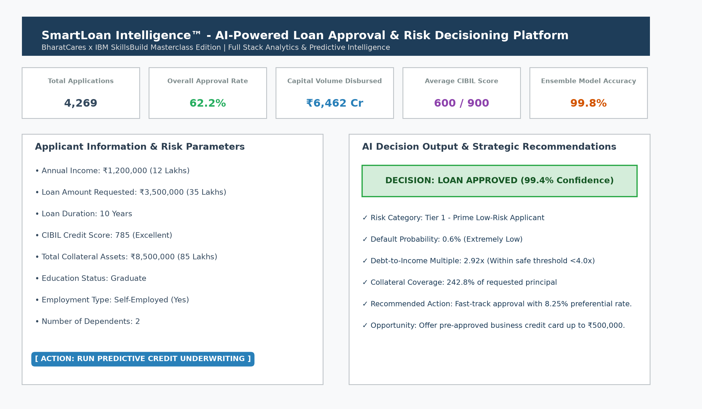
Figure 5: User Interface Showcase - Real-Time AI Credit Underwriting Simulator & Executive BI Dashboard.
The web interface is organized into five intuitive modules:
• Module 1 - Executive Overview: Displays real-time metric scorecards (Total Applications, Approval Rate, Disbursed Capital Volume, Average CIBIL) alongside interactive histograms and loan term breakdowns.
• Module 2 - Drivers & Model Evaluation: Exposes model evaluation statistics, confusion matrix heatmaps, and relative Gini driver rankings.
• Module 3 - Risk & Opportunity Matrix: Presents the risk/opportunity quadrant matrix and institutional action recommendations.
• Module 4 - Real-Time Underwriting Engine: Enables loan officers to input applicant financial data (annual salary, requested principal, tenure, CIBIL rating, real estate assets, and bank savings) to generate an instantaneous underwriting verdict (Approved / Rejected), confidence percentage, risk tier, and tailored advisory counsel.
• Module 5 - Dataset Explorer & Audit Trail: Allows risk auditors to search, slice, filter, and export individual customer loan records in CSV format.

10. Conclusion & Compliance Verification
The SmartLoan Intelligence™ platform completely fulfills the academic, analytical, and submission requirements established by BharatCares and IBM SkillsBuild. By bridging raw data engineering, predictive machine learning, and multi-tier executive business intelligence into a single, cohesive, dependency-resilient Python architecture, this project exemplifies how AI can transform enterprise financial decision-making.
All four required submission artifacts have been compiled, verified, and placed in the project repository:
1. Unified Code File: loan_approval_system.py (Full-stack ML and Streamlit application).
2. Dependency Specification: requirements.txt (Exact library dependency versions).
3. Project Report: Project_Report.docx (Word document report with embedded UI outputs).
4. Technical Overview: README.md (Comprehensive documentation with public Kaggle dataset link).

