**Experiment Title. 1**

**Student Name:** Shubham Sah  **UID:**18BCS6537

**Branch:** B.E/B.Tech **Section/Group:** 18BCS-16/B

**Semester:** 7th **Date of Performance:**24th August, 2021

**Subject Name:** Modelling and Simulation Lab **Subject Code:**CSP-443

1. **Aim/Overview of the practical:** Implementation of Random number generator function.
2. **Task to be done:Write a program to implement a random number generator using Octave-online command prompt by trying various functions like rand(),randn().**
3. **Code for experiment/practical:**

rand(2,2)

rand(2,3)

rand(4,4)

rand(3,3)

randn(3,3)

randi(1,2)

randi(3,2)

randi(3,5)

randi(55,1)

randi(55,3)

1. **Result/Output/Writing Summary:**

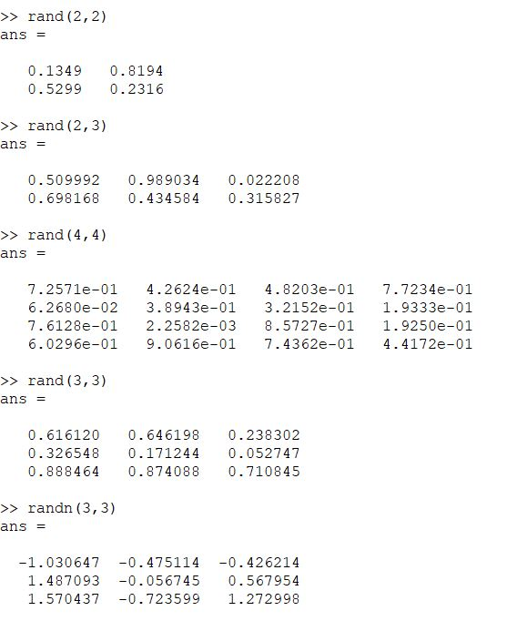

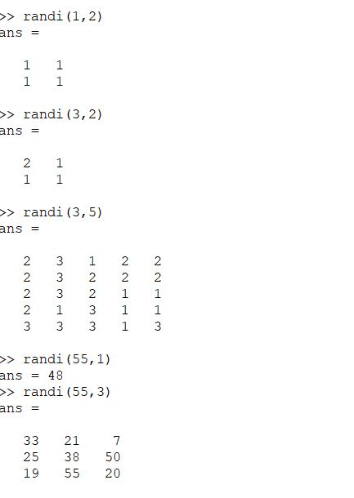

**Learning outcomes (What I have learnt):**

**1.** Learnt about MATLAB.

**2.**Learnt about Modullation.

**3.** Learnt about Simulation.

**4.**Learnt about how to generate random number.

**Evaluation Grid:**

|  |  |  |  |
| --- | --- | --- | --- |
| Sr. No. | Parameters | Marks Obtained | Maximum Marks |
| 1. | Demonstration and Performance (Pre Lab Quiz) |  | 5 |
| 2. | Worksheet |  | 10 |
| 3. | Post Lab Quiz |  | 5 |