
Tribhuvan University
Faculty of Humanities and Social Sciences

PAUSHTIK AAHAR (High Protein Meal Delivery System)
A PROJECT REPORT
Submitted to
Department of Computer Application
D.A.V College

In partial fulfillment of the requirements for the Bachelors in Computer Application
Submitted by
Subham Raj Singh Suwal
TU Reg No: 6-2-469-34-2024
OCTOBER, 2026

Under the Supervision of
Pesal Rai
Tribhuvan University
Faculty of Humanities and Social Sciences
D.A.V College

SUPERVISOR’S RECOMMENDATION
I hereby recommend that this project prepared under my supervision by SUBHAM RAJ SINGH SUWAL entitled “PAUSHTIK AAHAR – HIGH PROTEIN MEAL DELIVERY SYSTEM” in partial fulfillment of the requirements for the degree of Bachelor of Computer Applications is recommended for the final evaluation.

______________
Pesal Rai
SUPERVISOR
Lecturer
D.A.V College
Jawalakhel, Lalitpur

Tribhuvan University
Faculty of Humanities and Social Sciences
D.A.V College
LETTER OF APPROVAL
This is to certify that this project prepared by SUBHAM RAJ SINGH SUWAL entitled “PAUSHTIK AAHAR – HIGH PROTEIN MEAL DELIVERY SYSTEM” in partial fulfillment of the requirements for the degree of Bachelor of Computer Applications has been evaluated. In our opinion it is satisfactory in the scope and quality as a project for the required degree.
Pesal Rai, Lecturer  Department of Bachelor in Computer Applications  Jawalakhel, Lalitpur | Sudip Adhikari, Program Head  Department of Bachelor in Computer Applications  Jawalakhel, Lalitpur
Internal Examiner | External Examiner

ABSTRACT
Paushtik Aahar is a web-based high-protein meal ordering application designed to make meal selection and kitchen order management more convenient. Customers can browse meals, search the catalogue, filter dietary categories, compare prices and nutritional values, and view ingredients and allergens. A session-based cart supports quantity changes and checkout with delivery details. Registered customers can view account information and order history, while guest customers can place orders and use order lookup. Administrators manage meal listings, images, availability, customer records, business settings, and preparation and delivery statuses. The application uses HTML, CSS, Bootstrap, and JavaScript for the frontend, PHP for server-side processing, and MySQL-compatible relational storage in XAMPP. The current implementation supports cash on delivery and an online-payment simulation. Subscription scheduling, personalized nutrition plans, delivery-partner accounts, GPS tracking, and a verified payment gateway remain future work. The project demonstrates a focused meal catalogue and ordering workflow, while the retained design diagrams document the wider proposed system.
Keywords: High-Protein Meals, Meal Ordering, Nutritional Information, Shopping Cart, Order Management, PHP, MySQL, Admin Dashboard, Web Application.

ACKNOWLEDGEMENT
I am grateful to the Department of Computer Application, D.A.V College, for providing me the opportunity to work on a minor project as a part of Project ‘I’. I would like to express my sincere gratitude to my supervisor, Pesal Rai sir, for his guidance and encouragement during this project. I also thank Sudip Adhikari sir and the department for their support throughout the preparation of the project.
I would also like to thank my friends, who willingly shared their precious time, advice, and encouragement during the planning and development of this project.
Finally, my special thanks go to the college, the department, and everyone who directly or indirectly extended their hands in making this project successful.

Subham Raj Singh Suwal
6-2-469-34-2024

TABLE OF CONTENTS
SUPERVISOR’S RECOMMENDATION i
LETTER OF APPROVAL ii
ABSTRACT iii
ACKNOWLEDGEMENT iv
TABLE OF CONTENTS v
LIST OF FIGURES vii
LIST OF TABLES viii
LIST OF ABBREVIATION ix
CHAPTER 1: INTRODUCTION 1
1.1 Introduction 1
1.2 Problem Statement 2
1.3 Objectives 2
1.4 Scope and Limitation 2
1.5 Methodology 3
1.6 Report Organization 4
CHAPTER 2: BACKGROUND STUDY AND LITERATURE REVIEW 6
2.1 Background Study 6
2.2 Literature Review 6
CHAPTER 3: SYSTEM ANALYSIS AND DESIGN 8
3.1 System Analysis 8
3.1.1 Requirement Analysis 8
3.1.2 Feasibility Study 9
3.1.3 Data Modeling 12
3.1.4 Process Modeling 13
3.2 System Design 15
3.2.1 Architectural Design 15
3.2.2 Database Schema Design 16
3.2.3 Interface Design (UI / UX) 17
CHAPTER 4: IMPLEMENTATION AND TESTING 18
4.1 Implementation 18
4.1.1 Tools Used 18
4.1.2 Implementation Details of Module 19
4.2 Testing 20
4.2.1 Test Cases for Unit Testing 20
4.2.2 Test Cases for System Testing 22
CHAPTER 5: COMPLETED AND REMAINING TASK 23
5.1 Completed 23
5.2 Remaining Task 24
REFERENCES 25
APPENDIX 26

LIST OF FIGURES
Figure 1.1: Waterfall Model for Paushtik Aahar 4
Figure 3.1: Use Case Diagram of Paushtik Aahar 9
Figure 3.2: Gantt Chart of Paushtik Aahar 10
Figure 3.3: ER Diagram of Paushtik Aahar 12
Figure 3.4: DFD Level 0 of Paushtik Aahar 13
Figure 3.5: DFD Level 1 of Paushtik Aahar 14
Figure 3.6: System Architecture of Paushtik Aahar 15
Figure 3.7: Database Schema of Paushtik Aahar 16
Figure 3.8: Proposed Login Page of Paushtik Aahar 17
Figure 3.9: Proposed Landing Page of Paushtik Aahar 17

LIST OF TABLES
Table 3.1: Functional Requirements of the system 8
Table 4.1: Test Case of unit testing for Login Module 20
Table 4.2: Test Cases for Meal Catalogue Module 20
Table 4.3: Test Case of unit testing for Cart Module 21
Table 4.4: Test Cases for Meal Management Module 21
Table 4.5: Test Case of unit testing for Admin Module 22
Table 4.6: Test Case of System testing 22

LIST OF ABBREVIATION
API Application Programming Interface
CSS Cascading Style Sheets
DFD Data Flow Diagram
ER Entity Relationship
PDO PHP Data Objects
HTML HyperText Markup Language
HTTP HyperText Transfer Protocol
JSON JavaScript Object Notation
PHP PHP: Hypertext Preprocessor
SDLC Software Development Life Cycle
SQL Structured Query Language
UI User Interface
UX User Experience
CHAPTER 1: INTRODUCTION
1.1 Introduction
Paushtik Aahar: High Protein Meal Delivery System is a web-based platform intended to help people choose and order protein-rich meals. Fitness enthusiasts, students, and busy professionals may have limited time to plan menus, purchase ingredients, and prepare meals. A meal catalogue that clearly displays nutritional information can help customers compare available dishes before ordering. The project brings meal descriptions, prices, ingredients, allergens, and macronutrient values into one interface, making the information easier to find and use.
The project connects a customer-facing meal catalogue with a kitchen administration area. Customers can browse breakfast, lunch, dinner, vegetarian, high-protein, and low-carbohydrate options. Each meal has calorie, protein, carbohydrate, fat, and fibre values. Customers select dishes, update quantities in a session-based cart, and provide contact and delivery details at checkout. Registered accounts additionally provide access to order history and profile management.
The application is implemented using PHP, HTML, CSS, Bootstrap, JavaScript, and a MySQL-compatible database in XAMPP. Administrators can add and edit meals, upload images, change availability, view customer records, and update preparation and delivery statuses. Checkout stores an order and its items within a database transaction. Cash on delivery is supported; the online-payment option is a demonstration and does not verify payment through a financial service.
The main aim is to provide an accessible meal-ordering workflow while applying web development and relational database concepts. The original proposal includes a wider vision involving meal subscriptions, personal nutrition targets, and delivery coordination. The current phase concentrates on catalogue browsing, nutritional transparency, ordering, and kitchen administration. This report explains the implementation and distinguishes it from those proposed extensions.

1.2 Problem Statement
People looking for protein-rich meals often need to compare ingredients, portion information, prices, and nutritional values before deciding what to order. When this information is scattered or unavailable, meal selection becomes less convenient. Preparing food at home also requires shopping, planning, cooking, and cleaning time. A dedicated website can reduce the effort involved in locating suitable dishes by presenting each meal and its declared nutritional values in a consistent format.
For a small kitchen, manually recording meal requests and delivery details can make it difficult to maintain a clear order queue. Customers also need a way to check whether an order has been received, prepared, or dispatched. Paushtik Aahar addresses these operational needs with a searchable meal catalogue, a shopping cart, structured checkout, and an administrator-controlled status timeline. Nutritional values are entered by the kitchen; the application does not calculate individual medical or dietary requirements.
1.3 Objectives
1. To develop a user-friendly web application for browsing high-protein meals and comparing their nutritional information.
2. To implement a shopping cart and checkout workflow that records customer details, ordered meals, and delivery information.
3. To provide customer account access and an administration area for managing meals, availability, orders, and business settings.
1.4 Scope and Limitation
i. Scope
- Meal Catalogue: Displays meal descriptions, images, prices, calories, protein, carbohydrates, fat, fibre, ingredients, and allergens.
- Browsing and Filtering: Supports keyword searches, dietary category filters, and sorting by protein, calories, or price.
- Cart and Checkout: Allows guest and registered customers to select meals, adjust quantities, review totals, and submit delivery details.
- Customer Account: Provides registration, login, profile updates, and order history for registered customers, together with a guest order lookup page.
- Kitchen Administration: Supports meal editing, image uploads, availability changes, order status updates, customer lookup, and business settings.
ii. Limitation
- Local Environment: The current demonstration uses Apache, PHP, and MySQL in XAMPP. Public deployment and operational delivery arrangements require additional configuration and validation.
- Payment Limitation: The online-payment option is simulated. It marks an order paid without a verified gateway transaction and must not be treated as evidence of received funds.
- Delivery and Logistics: Order progress is updated manually by the administrator. GPS tracking, driver accounts, route planning, and automated delivery scheduling are not implemented.
- Platform Availability: The project provides a responsive website. It does not include a separate native mobile application.
- Nutrition and Subscriptions: Nutritional values are catalogue data. Personalized recommendations, recurring meal subscriptions, ingredient-level customization, and ratings are proposed extensions.
1.5 Methodology
The project uses the Waterfall Model of the Software Development Life Cycle as its documentation framework. The process moves through feasibility study, requirement analysis, design, coding and unit testing, integration and system testing, and maintenance. This sequence provides an organized way to define the meal-ordering problem, prepare models, implement the application, and assess the result. The original proposal supplies the development model and wider design scope [1]. The current implementation focuses on the customer and administrator workflows described in this report.
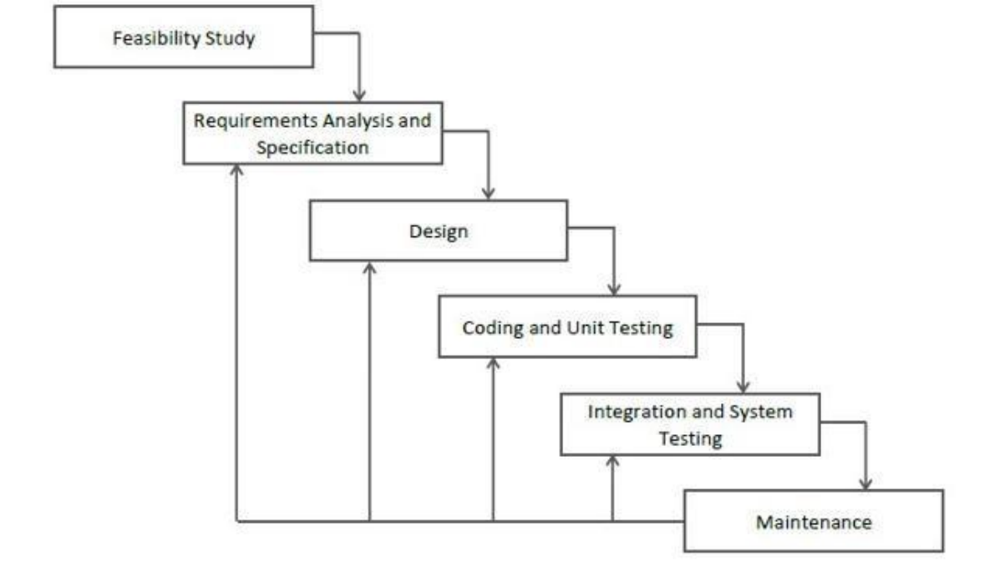

Figure 1.1: Waterfall Model for Paushtik Aahar
This methodology is suitable for developing the system as the requirements, features, and roles are fixed and clearly defined from the beginning. The Waterfall Model also provides a systematic and structured approach to software development, which allows for proper planning, clear documentation, and better scheduling of the entire project.
Another important advantage of this model is that it supports better project planning and estimation. Because the requirements of the system are already known, it becomes easier to define timelines, allocate resources, and manage tasks efficiently. This makes the development process more organized and predictable.
1.6 Report Organization
- Chapter 1: This chapter includes a brief introduction, the problem statement, objectives, scope and limitation, and the methodology of the project.
- Chapter 2: This chapter presents the background of meal ordering and nutritional information, followed by a review of the project proposal and relevant web technologies.
- Chapter 3: This chapter covers requirements, feasibility, data and process models, system architecture, database design, and interface designs for Paushtik Aahar.
- Chapter 4: This chapter covers the implementation of the system, the tools used, the details of each module, and the testing of the system through unit and system test cases.
- Chapter 5: This chapter identifies the implemented features and the remaining tasks for the High Protein Meal Delivery System.

CHAPTER 2: BACKGROUND STUDY AND LITERATURE REVIEW
2.1 Background Study
Online meal ordering combines a catalogue, customer selection, order capture, and kitchen fulfilment. A specialist high-protein catalogue adds nutritional information to this process. Customers can compare the declared protein and calorie values of meals alongside prices and ingredients. The Paushtik Aahar proposal identifies this need and outlines a broader service involving meal plans and delivery management [1]. The implemented website narrows that proposal to a manageable ordering application with customer and administrator interfaces [2].
The current design emphasizes information visibility rather than personalized dietary calculation. Meal records hold the nutritional values supplied by the kitchen. The browser displays these values and provides category filters and sorting controls. Customer contact and delivery information are collected at checkout. An administrator then updates the order status as preparation and fulfilment proceed. Subscription schedules, driver locations, and personal macro targets are outside the implemented data model.
The application separates presentation, request handling, and stored records. HTML and CSS define the pages, Bootstrap supplies interface components, and JavaScript manages browser interactions. PHP handles sessions, forms, and database access through PDO [3]. Relational tables link users, orders, meals, and order items. These technologies support a small local web application without requiring a separate frontend framework or an external payment service.
2.2 Literature Review
The original project proposal describes Paushtik Aahar as a high-protein meal service with transparent nutrition information, ordering, subscription plans, and delivery coordination [1]. Its Waterfall, use-case, schedule, entity-relationship, data-flow, architecture, and schema diagrams provide the conceptual design context. The proposed model is broader than the present implementation. Retaining those diagrams makes the planned direction visible, while the implementation sections identify the features already represented in the source code.
Review of the local application shows a direct ordering model centred on one kitchen [2]. Customers browse meals and submit orders; administrators manage the catalogue and fulfilment statuses. This differs from a multi-provider marketplace or a subscription platform. The session cart avoids a separate persistent cart table, and the order items preserve purchased meal names and prices. These choices keep the student project focused on the basic ordering workflow.
The PHP PDO documentation describes a common database-access interface and provides operations for prepared statements and transactions [3]. In the application, prepared statements pass values to database queries, while checkout begins a transaction before inserting the order and its items. The transaction is committed after successful inserts and rolled back if an exception occurs. These mechanisms support consistent order recording, although complete runtime and failure-path testing remains necessary.
Bootstrap documentation describes a frontend toolkit and the inclusion of its styles and scripts [4]. The project combines Bootstrap components with custom styling. The MDN JavaScript guide documents the browser language used for interaction [5]; the application uses JavaScript to filter meal cards, sort displayed values, and update quantity controls. The project schema defines relational keys and deletion rules for the records used by these interfaces [6].
The reviewed materials support a focused design: expose meal information clearly, keep ordering simple, and provide administrative control over the catalogue and fulfilment status. The current system does not implement all proposed services. Future development should add verified payment processing, subscriptions, and delivery integration after the basic workflows have been tested and access controls reviewed. The diagrams in the following chapter retain the original proposal and should be read with these scope boundaries.

CHAPTER 3: SYSTEM ANALYSIS AND DESIGN
3.1 System Analysis
3.1.1 Requirement Analysis
i. Functional Requirements
S.N. | Requirement | Description
1 | Customer and Admin Authentication | Customers register and log in; administrators use a separate login and role-based access.
2 | Meal Catalogue and Nutrition | Displays meal images, prices, ingredients, allergens, calories, protein, carbohydrates, fat, and fibre.
3 | Search, Filter, and Sort | Searches meal names and descriptions; filters categories and sorts protein, calories, or prices.
4 | Session Cart | Adds and removes meals, changes quantities, and calculates subtotals and delivery charges.
5 | Checkout and Orders | Stores guest or customer delivery details and order items in a transaction; displays order progress.
6 | Meal Management | Administrators add and edit meals, upload images, and manage availability and featured dishes.
7 | Kitchen Administration | Provides order status updates, a customer directory, dashboard totals, and business settings.
Table 3.1: Functional Requirements of the system
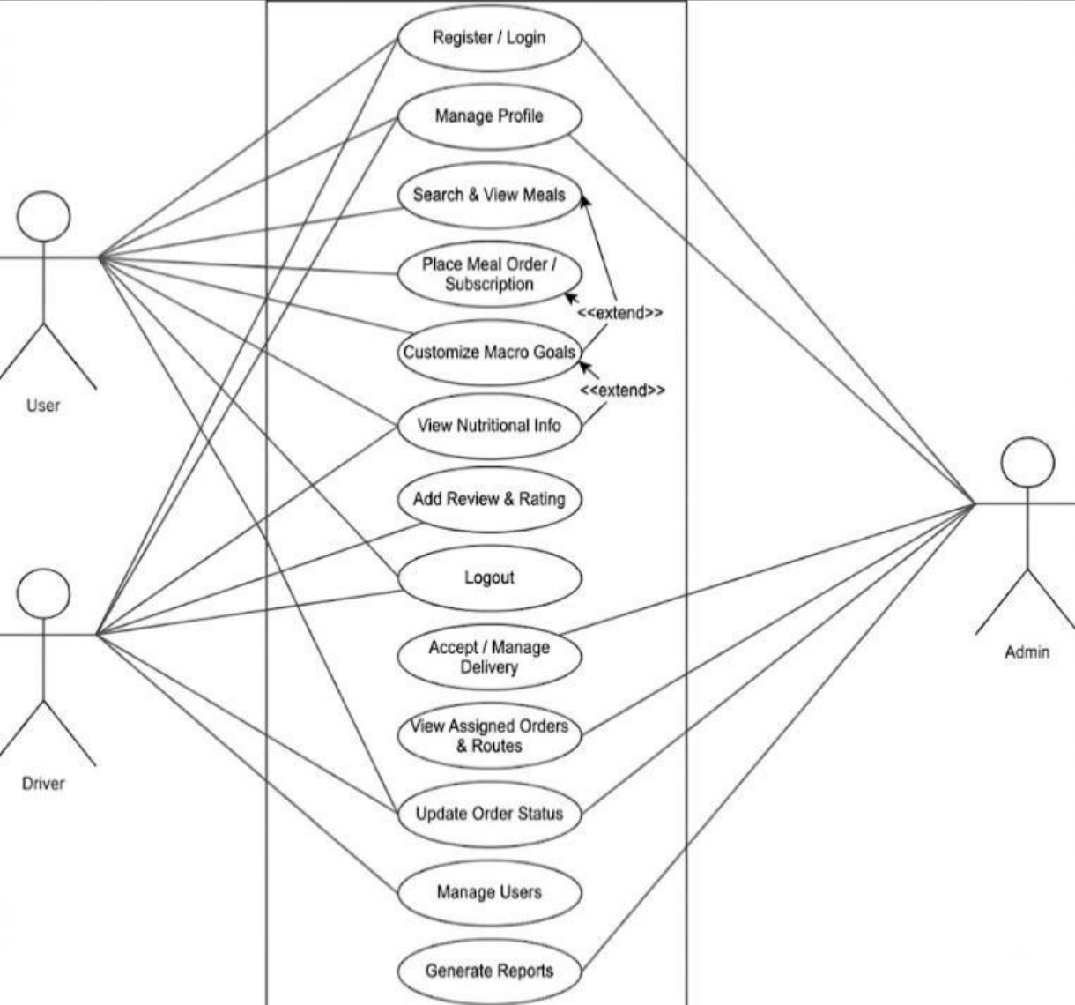
Figure 3.1: Use Case Diagram of Paushtik Aahar
The use-case diagram is retained from the original proposal [1]. It includes customer, delivery, and administrator activities within the planned system. The current website implements customer registration and login, meal browsing, a cart, checkout, order lookup, and kitchen administration. Dedicated driver access, recurring subscriptions, and delivery assignment shown in the wider design are not present in this version. Table 3.1 describes the implemented requirements.
ii. Non-Functional Requirements
- The system should protect account and order information using authentication, authorization, and server-side validation.
- The system should maintain consistent orders and order items when checkout succeeds or fails.
- The interface should remain usable on common desktop and mobile browser sizes.
- The code and database should remain maintainable as meal and order records increase.
- The catalogue should provide clear nutritional labels and responsive search and filter controls.
3.1.2 Feasibility Study
i. Technical Feasibility
The current scope is technically feasible using the technologies already present in the project: PHP, HTML, CSS, Bootstrap, JavaScript, Apache, and MySQL-compatible storage. PHP sessions maintain authentication and the cart, while PDO connects to the database. The website can be demonstrated locally through XAMPP. A payment gateway, mapping service, and subscription scheduler would require additional components and testing, so they are not prerequisites for the present ordering demonstration.
ii. Operational Feasibility
The system supports familiar customer activities: browsing dishes, reviewing nutritional information, choosing quantities, and entering delivery details. The kitchen can maintain meal records and view an order queue through its administration pages. Order statuses communicate progress when customers revisit the tracking page. Physical cooking and delivery remain external activities. Operational readiness still depends on reliable kitchen data, trained staff, and tested handling of exceptional orders.
iii. Economic Feasibility
The project uses freely available development technologies and can be demonstrated on an existing local computer. This limits software acquisition costs for the academic prototype. A public service would also incur hosting, maintenance, food preparation, packaging, and delivery costs. No measured operating budget or revenue study is available, so profitability and return on investment are not established by this report. The current work demonstrates the software workflow rather than a validated commercial business model.
iv. Schedule Feasibility
The time schedule of the different stages of the project can be seen below in the following Gantt chart.
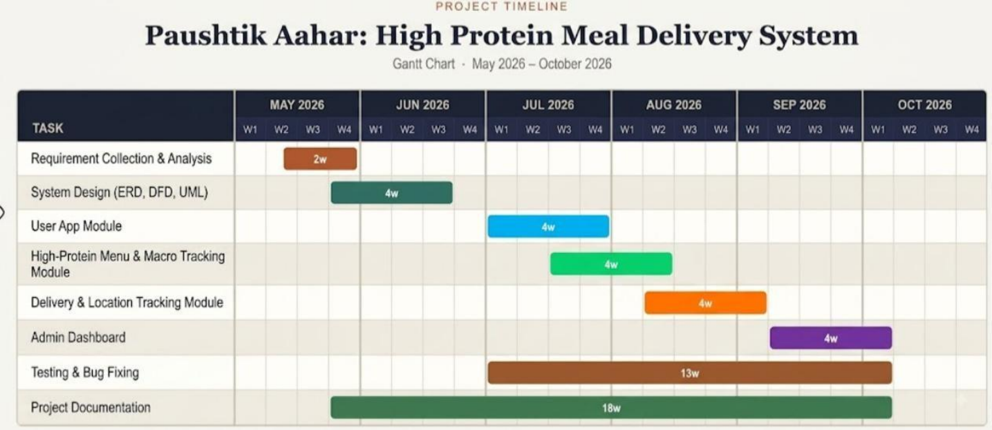
Figure 3.2: Gantt Chart of Paushtik Aahar
The retained Gantt chart presents the original proposed schedule from May to October 2026 [1]. It covers requirements, design, user functions, high-protein menu features, delivery tracking, administration, testing, and documentation. The bars represent a plan rather than verified completion dates. Current source files demonstrate the catalogue, cart, checkout, account, and admin modules. Delivery tracking in the GPS sense and recurring subscriptions remain outside the implemented scope despite their inclusion in the proposed schedule.
3.1.3 Data Modeling
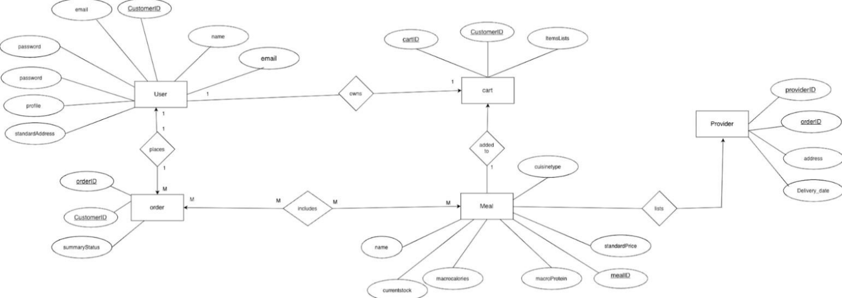
Figure 3.3: ER Diagram of Paushtik Aahar
The retained ER diagram shows the conceptual proposal with User, Cart, Order, Meal, and Provider entities [1]. It expresses the intended relationship between customers, meal selections, orders, and providers. The current application uses a simpler relational implementation: users, meals, orders, order_items, and settings. There is no persistent cart or separate provider table. The cart is stored in the PHP session, and kitchen administration is represented by the admin role in users.
In the implemented schema, a registered user can have many orders, while a guest order has a null user_id. An order contains many order_items, and a meal can be referenced by many order_items. Each item stores the purchased meal name, price, quantity, and subtotal. Foreign keys link these records. The settings table stores key-value business configuration. This implementation mapping explains the difference between the original conceptual diagram and the current database [6].
3.1.4 Process Modeling
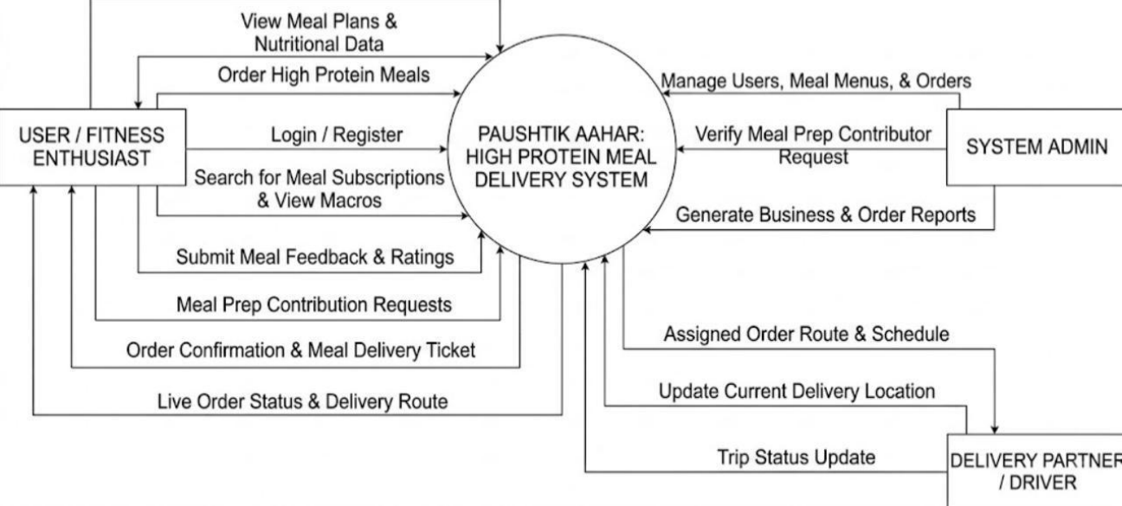
Figure 3.4: DFD Level 0 of Paushtik Aahar
The context DFD is retained from the proposal [1] and represents the wider exchange of meal requests, nutrition information, order details, and administrative updates. In the current website, customers send selections and delivery details and receive catalogue and order information. Administrators maintain meals and fulfilment statuses. Planned provider, subscription, and dispatch flows are not separate implemented services. Payment handling remains cash on delivery or an unverified online-payment simulation.
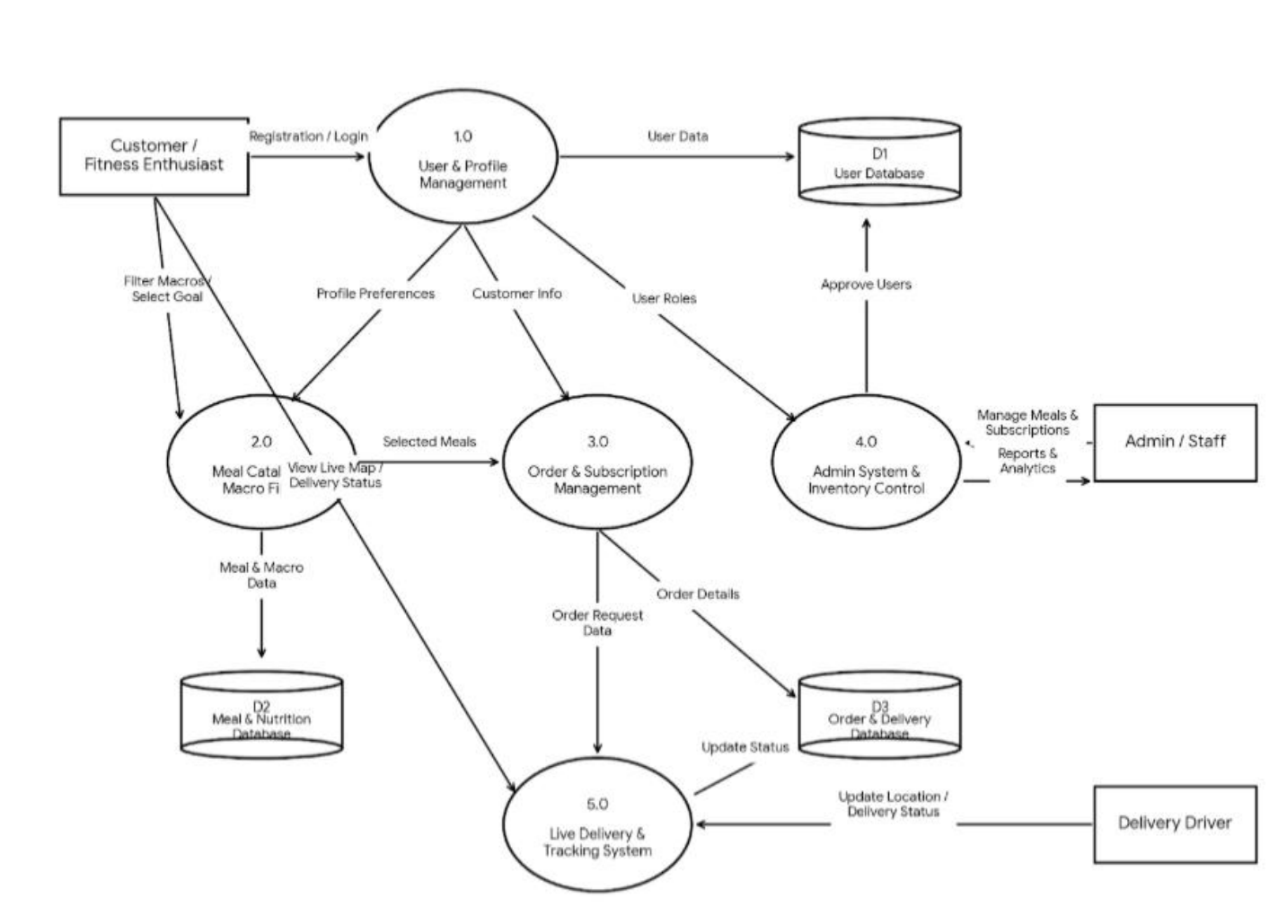
Figure 3.5: DFD Level 1 of Paushtik Aahar
The retained Level 1 DFD expands the proposed processes into account access, meal information, order handling, delivery activities, and related stores [1]. The current code implements account management, catalogue browsing, session-cart operations, transactional order creation, and administrator updates. It does not store reviews, subscriptions, driver routes, or personal nutrition programmes. The proposed flows therefore guide future work; the five-table schema and PHP modules describe the implemented data processing.

3.2 System Design
3.2.1 Architectural Design
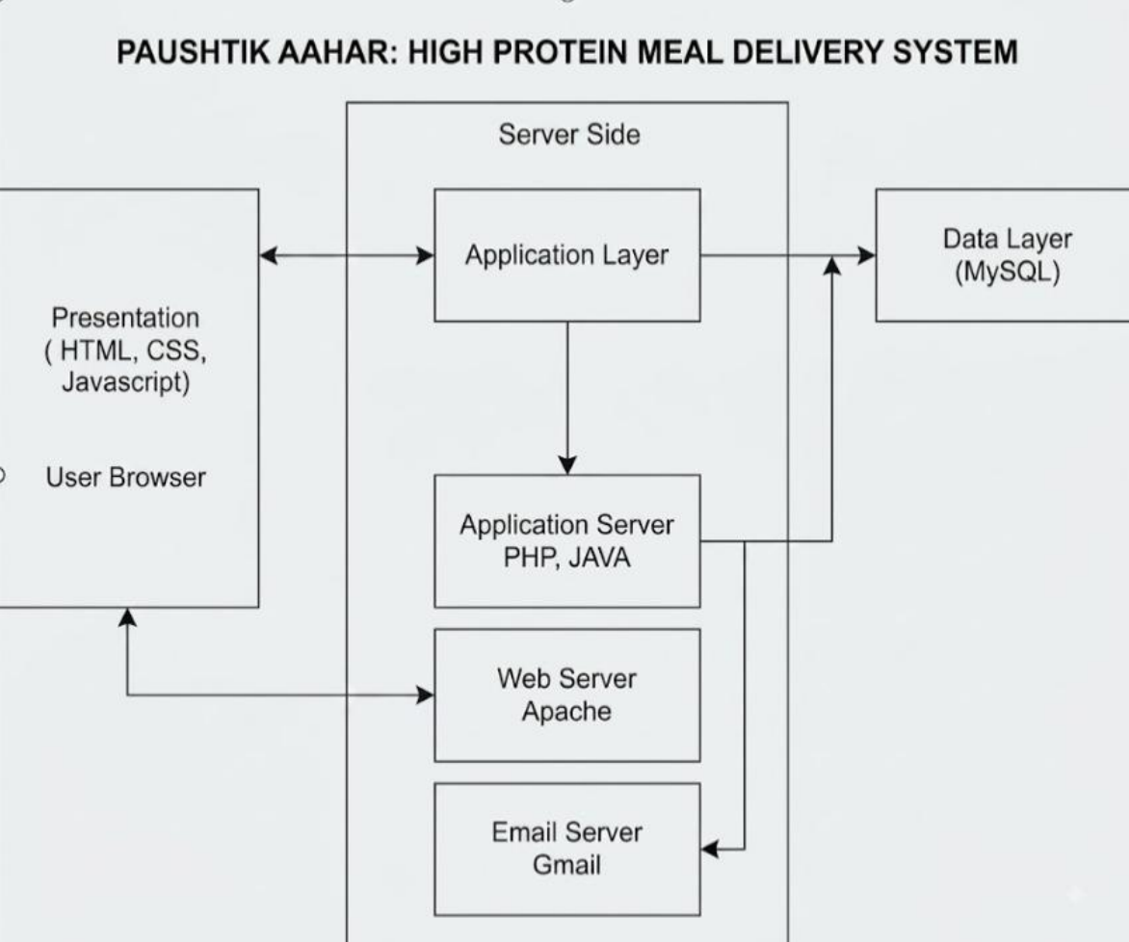
Figure 3.6: System Architecture of Paushtik Aahar
The retained architecture diagram describes browser presentation, application processing, and database storage [1]. This three-tier arrangement matches the core implementation: HTML, CSS, Bootstrap, and JavaScript render the interface; PHP on Apache processes requests; and MySQL-compatible storage holds application records. PHP includes provide shared authentication, cart, formatting, and database helpers. The email-server component in the proposal has no configured notification workflow in the current source. External delivery and payment integrations also remain future work.

3.2.2 Database Schema Design
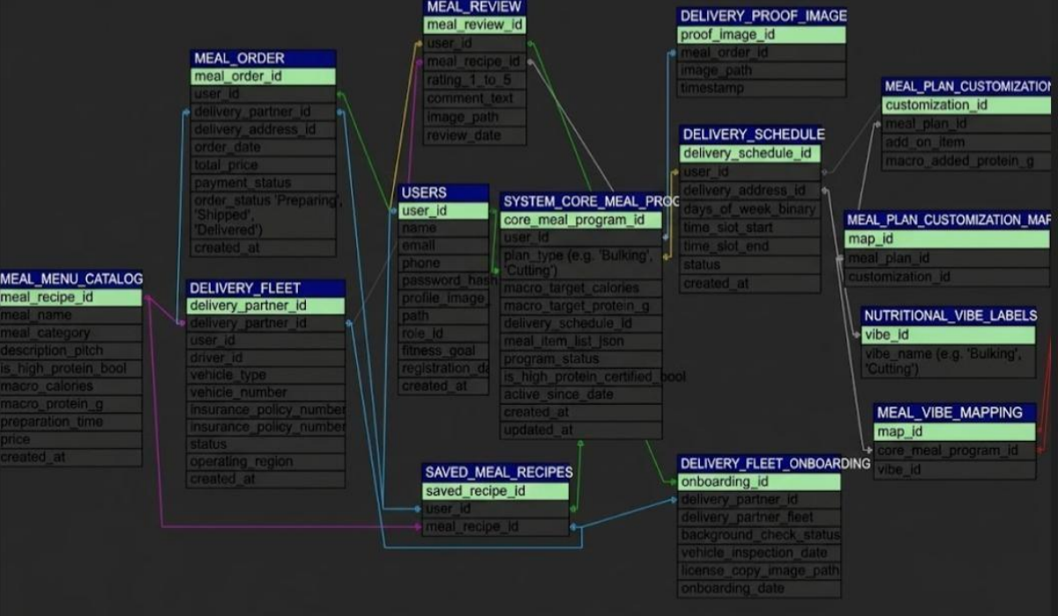
Figure 3.7: Database Schema of Paushtik Aahar
The schema illustration is retained from the original proposal [1]. Its extended tables for delivery fleets, meal plans, reviews, and saved recipes are not the schema used by the current website. The implemented database contains users, meals, orders, order_items, and settings [6]. Integer id keys identify the first four tables; settings uses key_name. Foreign keys connect orders to users and order_items to orders and meals. Role values distinguish customers from administrators, while payment and fulfilment status are stored in orders.

3.2.3 Interface Design (UI / UX)
The following interface illustrations are retained from the original PDF [1]. They show proposed visual designs; the implemented PHP pages use the current PaushtikAahar Kitchen layout and do not provide all controls pictured here.
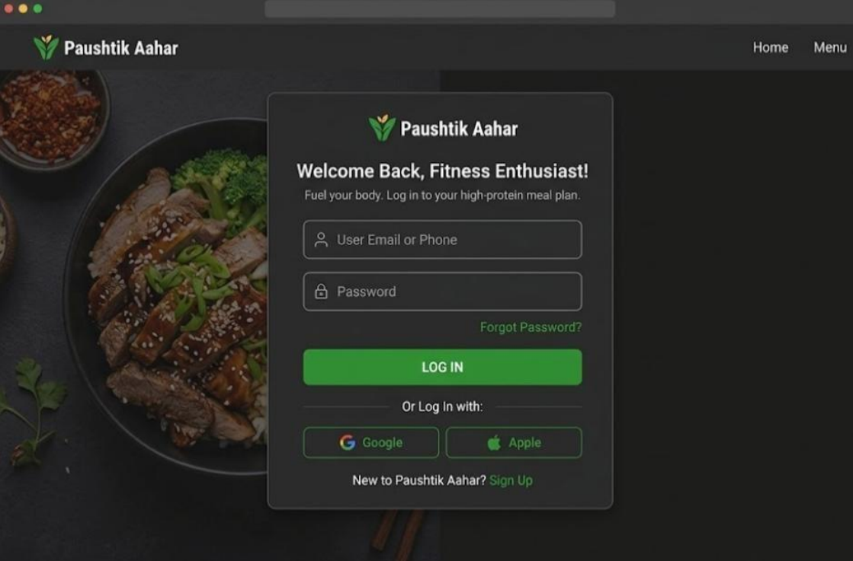
Figure 3.8: Proposed Login Page of Paushtik Aahar
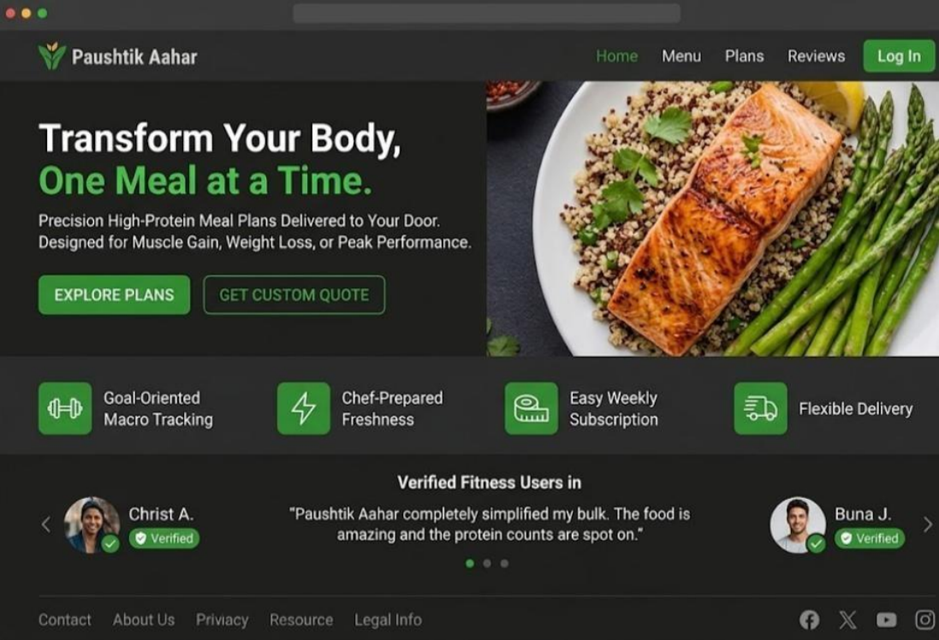
Figure 3.9: Proposed Landing Page of Paushtik Aahar
CHAPTER 4: IMPLEMENTATION AND TESTING
4.1 Implementation
The application implements a meal-ordering workflow with public pages, customer accounts, and a kitchen administration area. Meal records contain descriptive text, category, image, price, ingredients, allergens, nutritional values, preparation time, and availability flags. PHP retrieves these records for catalogue and detail pages. JavaScript filters and sorts the displayed meal cards. Shared PHP helpers provide session authentication, output escaping, form tokens, cart calculations, and image-upload validation.
Checkout collects contact and delivery details, validates required fields, and creates the order and its items within a database transaction. Guest orders use a null user_id. The cart is cleared after the transaction succeeds. Administrators update the order and payment statuses through the order-detail page. Cash on delivery is supported. Selecting Online Payment sets the order to Paid in the demonstration code without gateway verification; this behaviour requires replacement before real online payments can be accepted.
4.1.1 Tools Used
The various system tools and technologies that have been used in developing the project, for both the frontend and the backend, are described below.
FrontEnd:
- HTML5: Defines navigation, meal cards, nutritional information, forms, the cart, checkout, order pages, and administration screens.
- CSS and Bootstrap: Provide responsive layout, typography, colour, cards, buttons, status indicators, and reusable interface components.
- JavaScript: Handles catalogue search, category filtering, nutritional and price sorting, quantity controls, and interactive page behaviour.
Backend:
- PHP: Handles form requests, sessions, authentication, cart calculations, database queries, uploads, and order processing through reusable modules.
Database:
- MySQL: Stores users, meals, orders, order_items, and settings. Foreign keys connect account and order records, while the cart remains in the PHP session.
Version Control:
- Git: The project folder includes a Git repository for source version management. The report does not infer a development timeline from its presence.
Design & Diagram:
- Interface Design: The original PDF provides visual designs for login, landing, meal details, and profile setup. These are design references, not screenshots of the current PHP website.
- System Diagrams: The Waterfall model, use-case diagram, Gantt chart, ER diagram, DFDs, architecture, and schema illustrations are retained from the original PDF.
4.1.2 Implementation Details of Module
- Account Module: Provides customer registration and login, session-based access, profile updates, and a separate admin login page. Password hashes are used for authentication.
- Meal Catalogue Module: Displays meals, images, ingredients, allergens, preparation time, calories, and macronutrients. Search, dietary filters, and sorting operate on displayed cards.
- Cart Module: Stores meal IDs and quantities in the session, retrieves meal details, and calculates item subtotals, delivery fee, and the order total.
- Order Module: Stores contact and delivery information with order items in a transaction. Registered customers see order history; the lookup page displays fulfilment progress.
- Payment Module: Supports cash on delivery and a simulated online-payment choice. Payment status is recorded separately from fulfilment status; no gateway callback verifies collection.
- Meal Management Module: Allows administrators to create and edit dishes, upload images, set nutritional values, and change availability and featured-meal flags.
- Admin Module: Provides order summaries, status updates, a customer directory, and business settings. Authorization timing and guest order access require further review before deployment.
4.2 Testing
4.2.1 Test Cases for Unit Testing
The following cases define the verification plan for the current application. NT means not tested: no runtime result has been recorded for these cases. Source-code inspection identifies implemented paths but does not establish a runtime pass. The availability and access-control cases specifically require further validation.
Table 4.1: Test Case of unit testing for Login Module
SN | Test Case | Test Data | Expected Result | Status
1 | Valid customer login | Valid email and password | Customer session starts | NT
2 | Incorrect password | Existing email, wrong password | Login is rejected | NT
3 | Empty login fields | Empty email and password | Validation is displayed | NT
4 | Customer registration | New valid account details | Customer account is created | NT
5 | Admin login | Valid admin credentials | Admin area is accessible | NT
Table 4.2: Test Cases for Meal Catalogue Module
SN | Test Case | Test Data | Expected Result | Result
1 | Load meal catalogue | Available meal records | Meals and nutrition are displayed | NT
2 | Filter high protein | Select High Protein | Matching meal cards are shown | NT
3 | Search meal name | Known meal keyword | Matching meals remain visible | NT
4 | View meal details | Valid meal ID | Nutrition and ingredients appear | NT
5 | Sort by price | Select lowest price | Cards sort in ascending price | NT
Table 4.3: Test Case of unit testing for Cart Module
SN | Test Case | Test Data | Expected Result | Result
1 | Add available meal | Meal ID and quantity | Meal is added to the session cart | NT
2 | Update quantity | Quantity of two | Quantity and subtotal change | NT
3 | Remove cart item | Existing meal ID | Item is removed | NT
4 | Recalculate totals | Two meals and delivery fee | Total equals lines plus fee | NT
5 | Empty-cart checkout | No selected meals | Redirect to meal catalogue | NT
Table 4.4: Test Cases for Meal Management Module
SN | Test Case | Test Data | Expected Result | Result
1 | Add a meal | Valid details and image | Meal record is saved | NT
2 | Edit nutrition | Changed protein and calories | Updated values are displayed | NT
3 | Incomplete meal form | Missing required name | Validation is displayed | NT
4 | Unsupported upload | Non-image file | Upload is rejected | NT
5 | Toggle availability | Existing available meal | Meal becomes unavailable | NT
Table 4.5: Test Case of unit testing for Admin Module
SN | Test Case | Test Data | Expected Result | Result
1 | Update fulfilment | Valid order and status | Order status is saved | NT
2 | View customer list | Registered customers | Directory and order totals appear | NT
3 | Update delivery fee | Valid fee value | New fee is used for the cart | NT
4.2.2 Test Cases for System Testing
Table 4.6: Test Case of System testing
SN | Test Case | Test Data | Expected Result | Result
1 | Registration and login | New customer account | Account can sign in | NT
2 | Browse to checkout | Meal and delivery details | Order and items are recorded | NT
3 | Admin edits meal | Updated meal description | Public detail page changes | NT
4 | Payment simulation | Online Payment selection | Paid flag set without gateway | NT
5 | Availability at checkout | Meal disabled after cart add | Checkout should reject the meal | NT
6 | Protected admin action | Non-admin request | No protected change occurs | NT

CHAPTER 5: COMPLETED AND REMAINING TASK
5.1 Completed
- Customer Authentication: Registration and login code, password hashing, and session creation are implemented.
- Customer Profile: Account pages provide profile information and order history for signed-in customers.
- Admin Authentication: A dedicated login page and administrative access guard are present.
- Meal Catalogue: Meals are displayed with descriptions, images, prices, ingredients, allergens, and nutritional values.
- Search and Filtering: Keyword search, dietary category filters, and protein, calorie, and price sorting are implemented.
- Meal Detail Pages: Individual meals display macronutrients, ingredients, preparation information, and ordering controls.
- Session Cart: Customers can add meals, change quantities, remove items, and review calculated totals.
- Order Recording: Checkout inserts orders and their line items within a transaction and clears the cart after success.
- Meal Administration: Admin pages support meal creation, editing, image uploads, and availability management.
- Form and Image Validation: Required-field checks, CSRF helpers, and upload validation routines are present.
- Order Progress: Administrators can update preparation and delivery statuses shown in the customer timeline.
- Dashboard and Settings: Summary counts, customer lookup, delivery-fee configuration, and kitchen contact settings are implemented.
- Implementation Status: These items are present in the source code. Their inclusion here does not imply that all runtime or security tests have passed.
5.2 Remaining Task
- Payment Integration: Replace the online-payment simulation with a verified gateway flow and reconcile actual payment receipts.
- Subscriptions and Delivery: Add recurring meal plans, delivery-partner access, route assignment, and GPS tracking if the wider proposal is pursued.
- Runtime Verification: Execute the test cases in Chapter 4 using a clean database, check rollback behaviour, and test supported browsers and screen sizes.
- Access Control Review: Require ownership verification for guest order lookup and ensure authorization checks occur before protected mutations or queries.
- Order and Availability Checks: Revalidate meal availability during checkout, restrict payment and status values, and verify totals and reporting definitions.
- Deployment Preparation: Configure hosting, HTTPS, protected database credentials, backups, and notifications before public operation.
- Nutrition and Feedback: Consider personal goals, subscription customization, and purchased-meal reviews as future enhancements; these are not implemented modules.

REFERENCES
[1] S. R. S. Suwal, “Paushtik Aahar: High Protein Meal Delivery System,” project proposal and design document, August 2026.
[2] S. R. S. Suwal, “PaushtikAahar Kitchen,” local PHP website source, subham project folder, reviewed October 2026.
[3] The PHP Group, “PHP Data Objects,” PHP Manual. Available: https://www.php.net/manual/en/book.pdo.php. Accessed: October 1, 2026.
[4] Bootstrap, “Get started with Bootstrap,” Bootstrap 5.3 Documentation. Available: https://getbootstrap.com/docs/5.3/getting-started/introduction/. Accessed: October 1, 2026.
[5] MDN Web Docs, “JavaScript.” Available: https://developer.mozilla.org/en-US/docs/Web/JavaScript. Accessed: October 1, 2026.
[6] S. R. S. Suwal, “high_protein_meals database schema,” database.sql, PaushtikAahar Kitchen source, reviewed October 2026.

APPENDICES
The original proposal includes the following meal-detail and profile-setup designs [1]. Subscription ordering and personalized goal setup shown here remain proposed functions.
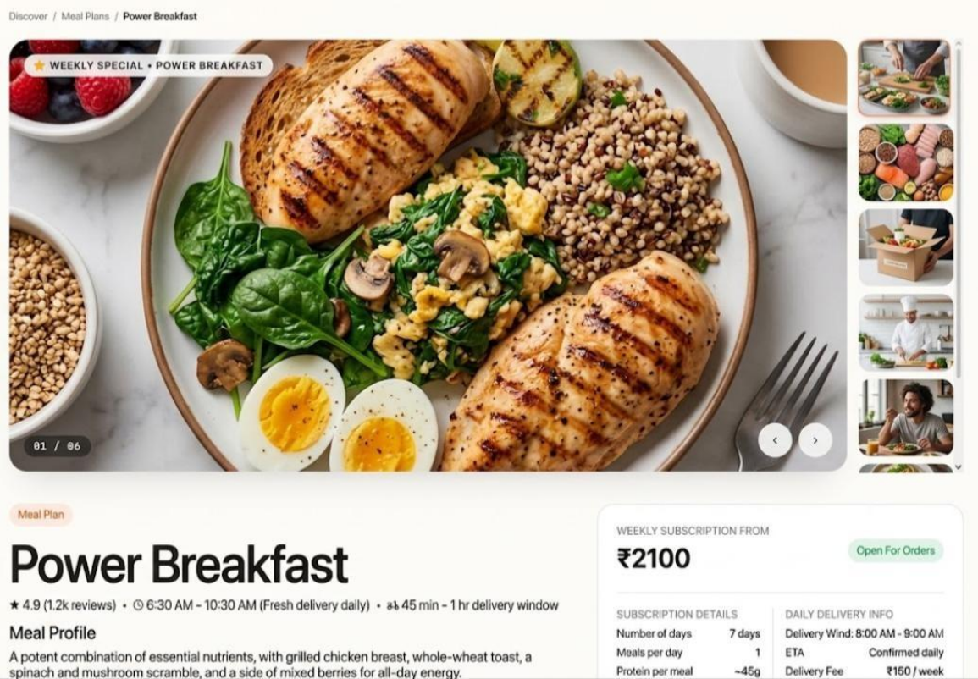
Appendix A: Proposed Meal Detail and Subscription Interface
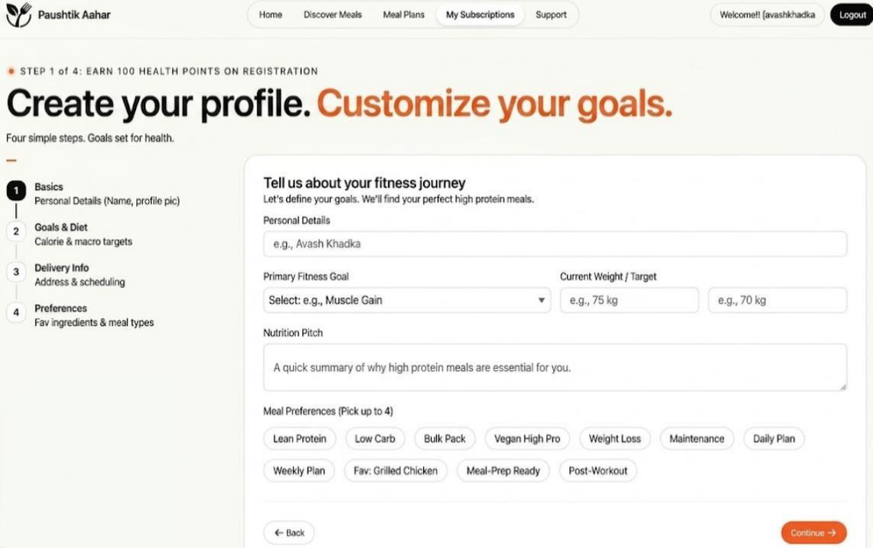
Appendix B: Proposed Customer Profile and Goal Setup

