**Tasks:**

**Task 1 : Programming Exercises:[Data types and Conditional Statements]**

1. Write a program that takes a temperature value from the user. It should then allow the user to choose between Celsius (C) and Fahrenheit (F) for conversion. After the user selection, it should then convert the entered temperature to the chosen scale and display the result.

Use appropriate data types for temperature and handle error like non-numeric input.

Use the following formula for conversion:

F = (C x 9/5) + 32

C = (F - 32) x 5/9

1. Write a C++ program to implement a number guessing game with different difficulty levels.

Easy difficulty ranges from 1-8, medium from 1-30, hard from 1-50.Then,generate a random number to check if the guess is correct based on the user's selection.

1. Write a program that reads an array of integer numbers from the user and sorts the numbers in the ascending order.

1. Write a program that reads a number from the user and based on the user input, it says what day of the week it is, Sundays being 1 and Saturdays being 7. You system should give appropriate response for invalid input entries.

**Task 2: Programming Exercises:[Control Statements]**

1. Create a program that takes a positive integer as input and determines whether it's a "bouncy number". A bouncy number is one where the digits neither consistently increase nor consistently decrease when read from left to right. For example:

* 123 is NOT bouncy (digits consistently increase)
* 321 is NOT bouncy (digits consistently decrease)
* 120 is bouncy (neither consistently increasing nor decreasing)

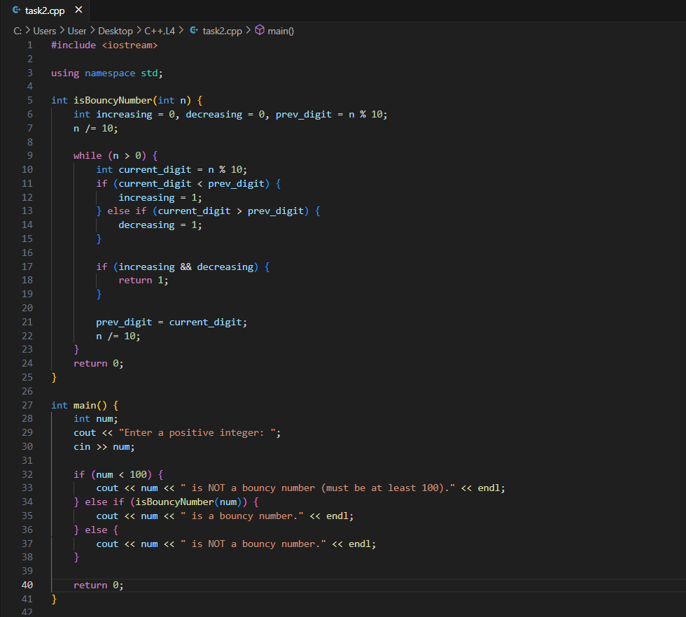

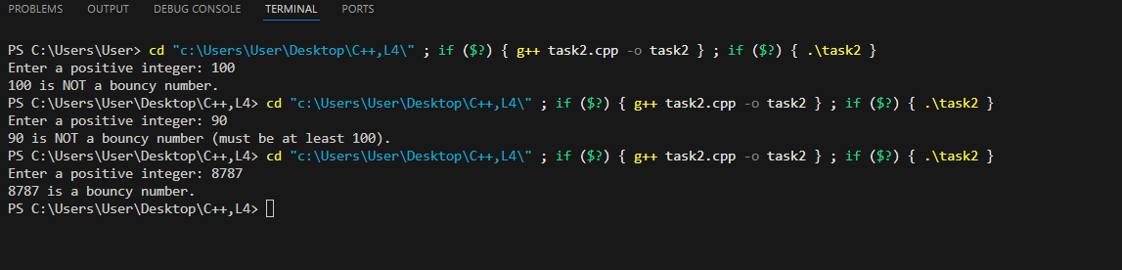

**Task 3: Programming Exercises on Arrays**

1. Write a program that manages a cinema ticket booking system. The program should display a 5x5 seating arrangement where:
   1. Available seats are marked with 'O'
   2. Booked seats are marked with 'X'

