**Tasks**

**Task 1 : 30 marks**

1. Create a Time class to store hours and minutes. Implement:
   1. Overload the + operator to add two Time objects
   2. Overload the > operator to compare two Time objects
   3. Handle invalid time (>24 hours or >60 minutes) by throwing custom exceptions

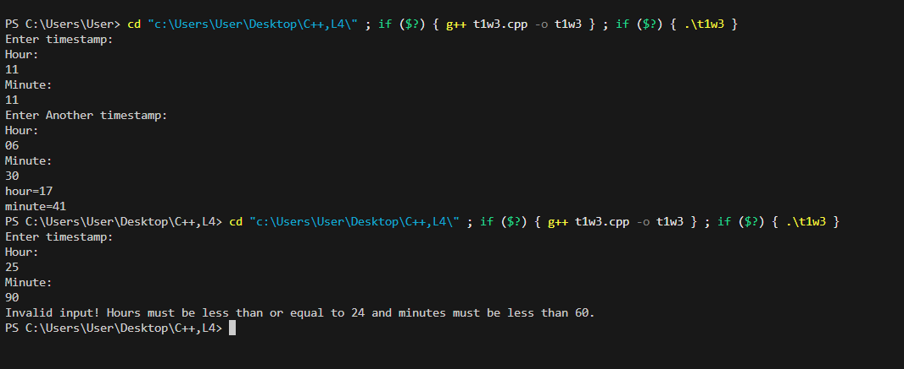

**Task 2: 70 marks**

1. Create a base class Vehicle and two derived classes Car and Bike:
   1. Vehicle has registration number and color
   2. Car adds number of seats
   3. Bike adds engine capacity
   4. Each class should have its own method to write its details to a file
   5. Include proper inheritance and method overriding

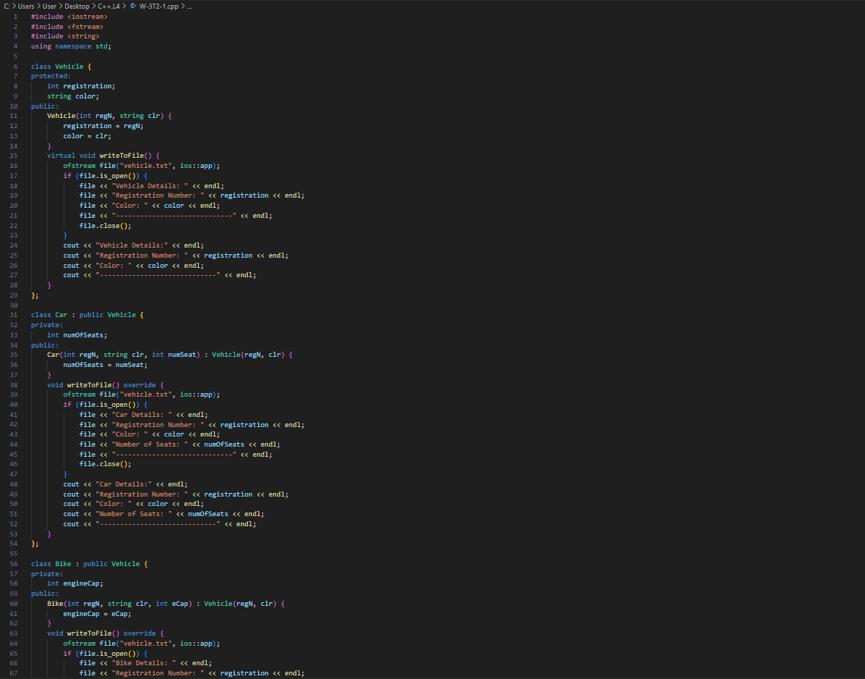

1. Create a program that:
   1. Reads student records (roll, name, marks) from a text file
   2. Throws an exception if marks are not between 0 and 100
   3. Allows adding new records with proper validation
   4. Saves modified records back to file

