SOFTWARE DESIGN DOCUMENT
A2C Architecture-to-Code Framework
High-Level and Low-Level Design

This document describes A2C, the framework that uses E2A-governed agents to generate the NFR and observability modules, infrastructure-as-code and CI/CD pipelines of a service, with mandatory NFRs injected before any model call, and that turns what a request declares (app settings, contracts, dependencies, repository layout) into those artifacts and keeps a scaffold upgradable. It covers the problem, use cases, HLD, the DevRequest contract, the agent, workflow, validation, artifact and tool contracts, the NFR-first generation order, the two-phase invocation with G2C and P0, the v1.2 declarations and upgrades, and the concurrency rules, so that a reader can form a complete mental model of A2C without opening the Python source.
Framework | A2C — Architecture-to-Code (developer-platform framework built on E2A)
Document type | Design Document (HLD + LLD)
Author | Subham Gupta, Principal Platform Architect
Source baseline | subhamviky/a2c-framework v1.2.1 — a2c_base.py (670 lines), a2c_settings.py, a2c_contracts.py, a2c_layout.py, a2c_upgrade.py, a2c_cli.py; on subhamviky/e2a-framework v1.2.0 (the e2a package; e2a_base is its compatibility module)
Date | 13 November 2026 (v1.2.1; v1.2.0 the same day; baseline 7 November 2026)
Status | Aligned to A2C v1.2.1 and its smoke tests (wave C, design notes C-01, C-02 and C-04; wave D note D-01)

Contents
1. Introduction 4
1.1 Purpose 4
1.2 Audience 4
1.3 Status 4
1.4 Related documents 4
2. Problem Statement and Motivation 6
2.1 The problem 6
2.2 Approach 6
2.3 Design goals 6
3. Core Use Cases 7
3.1 Actors 7
3.2 Use-case catalogue 7
3.3 Non-goals 7
4. Design Principles and Invariants 8
4.1 Principles 8
4.2 Invariants 8
5. High-Level Design 9
5.1 Context 9
5.2 E2A to A2C mapping 9
5.3 Workflow 10
5.4 Generation order 11
5.5 Two-phase invocation 12
5.6 Declarations (v1.2) 12
5.7 Upgrades (v1.2) 14
5.8 Evaluation sets and the release gate (v1.2.1) 14
6. Data Contracts 16
6.1 DevRequest 17
6.2 MANDATORY_NFRS and the pattern check 18
6.3 ValidationResult 18
6.4 Configuration 18
7. Low-Level Design — Class Model 20
8. Low-Level Design — Class Contracts 21
8.1 SDLCAssistantAgent 21
8.2 CodeCriticAgent 21
8.3 Specialist agents 22
8.4 SDLCAgentChain 22
8.5 SDLCWorkflow 22
8.6 Artifacts, LocalArtifactWriter and tools 23
8.7 DevPlatformValidationService 24
8.8 Declarations and upgrades (v1.2) 24
9. Dynamic Behaviour 26
9.1 Request lifecycle 26
9.2 Policy injection 27
9.3 Quality gate and regeneration 27
10. Concurrency and Capacity 28
11. Non-Functional Design 29
12. Extension Guide 30
13. Verification 31
14. Implementation Reality, Gaps and Design Observations 32
Appendix A. Glossary 33
Appendix B. Traceability 34

1. Introduction

1.1 Purpose
A2C (Architecture-to-Code) applies E2A's governance mechanism to code generation. E2A defines how governed agentic systems are built; A2C uses governed agents — each a BaseAgent subclass with an inherited run() — as the engine of a developer platform. A developer states what to build in a DevRequest (project name, type, context, target cloud, language); A2C's agents decide how it must be built: they inject mandatory NFRs, generate Clean Architecture code, Terraform and GitHub Actions workflows, pass everything through a CodeCriticAgent quality gate and write the artifacts into the P0 workspace.
The design principle is that architecture is a constraint, not a prompt. SDLCAssistantAgent._apply_policy() adds every missing mandatory NFR to the generation contract before the model is called, so a generated service cannot lack idempotency or observability merely because the developer forgot to ask; and the critic checks those NFRs in the code itself, with comments removed.

1.2 Audience
Reader | Read first | Use the document to
Platform architect | Sections 2, 4, 5 | Place A2C beside P0 and under G2C and AI-DLC.
Framework author | Sections 6–8, 12 | Extend agents, the workflow, validators and tools.
Platform engineer | Sections 6.4, 9–11 | Wire validation, the gateway, the claim store and the workspace.
Reviewer | Sections 4, 13, 14 | Check invariants, evidence and gaps.

1.3 Status
All A2C classes are implemented in a2c_base.py on top of E2A (installed as the e2a-framework package, pinned to v1.2.0; a2c_base.py imports through E2A's e2a_base compatibility module). The v1.2 declarations live in four modules beside it (Section 8.8). A2C's own agents still use E2A's v1.1 hook signatures, which E2A v1.2 runs unchanged with one DeprecationWarning per class (observation O-8). Two contracts are worth naming:
Table 1 — Contract provenance
Element | Provenance
SDLCWorkflow.execute(dev_request, config) → DevRequest | Inherited from E2A BaseWorkflow.execute(). The A2C Reference describes the workflow but publishes no method table for it; this signature is the one its callers (BootstrapAndGenerateWorkflow, the AI-DLC orchestrator) use, and it is now implemented.
Specialist agents' hooks, DeliveryState | The Reference names the agents' responsibilities only. The hooks are defined here (Section 8.3). The workflow returns the enriched DevRequest; DeliveryState is not a separate type.

1.4 Related documents
Document | Relationship
A2C Framework Reference | Normative intent and contracts.
E2A Framework Design Document | BaseAgent, BaseWorkflow, BaseToolService, BaseValidationService, BaseLLMAgentService, BaseIdempotencyStore, config registry.
P0 Framework Design Document | Produces dev_request (with tenant_id, project_root); composed with A2C by BootstrapAndGenerateWorkflow.
G2C Framework Design Document | Generates a2c_base.py (template mode emits this file) and team SDLCAssistantAgent subclasses; since v1.2 also the service's E2A v1.2 agents, workflow and governance, which is where business logic lives now.
E2A AI-DLC Profile Design Document | Runs SDLCWorkflow as Phase B.

2. Problem Statement and Motivation

2.1 The problem
Table 2 — Failure modes of unconstrained code generation
Failure mode | Description | Consequence
NFR amnesia | No idempotency, circuit breakers, retry or structured logging unless asked. | Duplicate writes, cascading failures, silent errors.
Architecture drift | Business logic in route handlers; no service layer or contracts. | Untestable, tightly coupled code.
Governance gap | No approval gates, policy-as-code, PII redaction or tool allow-lists. | Compliance failures found in production.
IaC afterthought | Infrastructure configured by hand. | Environment drift, no audit trail.
CI/CD bolted on | Pipelines added after the code works. | No evaluation gate, scan or rollback.

2.2 Approach
A2C makes NFRs, IaC and CI/CD mandatory generation targets. Each concern has its own specialist agent; every agent inherits idempotency, latency SLO, token budget, governance and observability from BaseAgent.run(); every model call goes through the E2A inference gateway; every request is validated before the workflow and claimed once by BaseWorkflow.execute(); artifacts are written only after review, each write conditional on what was read.

2.3 Design goals
ID | Goal
G-1 | Mandatory NFRs injected structurally before any model call.
G-2 | Separation of concerns: one specialist agent per artifact kind, in NFR-first order.
G-3 | Generated code verified by a review that a comment cannot satisfy (≥ 0.75).
G-4 | Input validation outside the agents, before the workflow starts.
G-5 | Every write idempotent and, where writers compete, conditional.
G-6 | Model capacity governed only at the gateway.
G-7 | A2C is self-hosting: its agents follow the patterns they generate.

3. Core Use Cases

3.1 Actors
Actor | Interaction
Developer | Submits a DevRequest (directly or via scaffold-config.json's a2c section).
P0 | Produces dev_request when config['a2c'].enabled.
BootstrapAndGenerateWorkflow | Runs P0, validates the dev_request, runs A2C.
G2C | Generates the A2C classes; does not run them.
AI-DLC orchestrator | Runs SDLCWorkflow in Phase B.

3.2 Use-case catalogue
Table 3 — A2C use cases
ID | Use case | Outcome
UC-1 | Python FastAPI service on AWS | Spec, observability and NFR modules, Terraform with a DLQ, GitHub Actions with OIDC, scan and deploy — written into the P0 workspace.
UC-2 | Agentic service | As UC-1; the agents, workflow and tools are generated by G2C from harness.agents (E2A v1.2 contract).
UC-3 | Spring Boot service | Java artifacts (src/generated/*.java), Terraform, workflow.
UC-4 | The platform itself | a2c_base.py is A2C's own reference implementation.
UC-5 | Team SDLC agent | A G2C-generated subclass of SDLCAssistantAgent adds team NFRs on top of the mandatory set.
UC-6 | Duplicate request | One generation; the second caller gets the stored result (replayed) or IN_PROGRESS.
UC-7 | Code with NFRs only in comments | Critic fails; the NFR module is regenerated with the findings (≤ 2), else CRITIC_THRESHOLD_NOT_MET with nothing written.
UC-9 | Service with app settings, a secret and an event contract (v1.2) | Settings reach Terraform, the runtime and the code with one Terraform assertion each; the secret is a reference to the cloud's secret store; the contract becomes models with a round-trip test.
UC-10 | Existing scaffold, new A2C version (v1.2) | aidlc-build --upgrade replaces untouched files and writes a patch for the files you changed.
UC-8 | Competing writer on an artifact path | Typed conflict; never a silent overwrite.

3.3 Non-goals
- Project scaffolding (P0) and class-file generation (G2C).
- Applying Terraform or executing pipelines; A2C produces and checks artifacts.
- Input-shape validation inside agents.

4. Design Principles and Invariants

4.1 Principles
Principle | Application
Meta-application of E2A | Same contract (run(), protected hooks, private steps); SDLC domain.
Policy before inference | _apply_policy() runs inside run() before the model call.
Specialist agents | Requirements, code (observability and NFR modules), IaC, CI/CD and critique are separate runs.
Declare, don't patch (v1.2) | What projects used to patch after scaffolding (settings, contracts, dependencies, layout) is a request field; a manifest makes the scaffold upgradable.
Validation outside agents | BaseValidationService with _validate_<agent_name>; no _validate_state hook.
Review that comments cannot pass | Critic score = min(model review, deterministic NFR-pattern check on comment-free code).
Writes last, conditionally | Artifacts are written only after the critic passes, each conditional on the version read at the start.
Gateway capacity | config['llm_service'] owns permits, quotas and timeouts.
Composable siblings | P0 and A2C are independent; BootstrapAndGenerateWorkflow composes them.

4.2 Invariants
ID | Invariant
INV-01 | No agent overrides run(); SDLCWorkflow does not override execute().
INV-02 | After _apply_policy(), mandatory_nfrs ⊇ MANDATORY_NFRS.
INV-03 | A target_cloud outside approved_clouds (or an agent outside approved_agents) raises GovernanceViolationError before any model call.
INV-04 | The workflow receives only state that passed DevPlatformValidationService and carries tenant_id.
INV-05 | No A2C agent holds a semaphore, rate limiter or provider SDK.
INV-06 | Two identical DevRequests produce one generation (claim on a2c:<generation_key>, tenant-scoped).
INV-07 | Nothing is written unless the critic score is ≥ the threshold; two writers on one path never silently overwrite each other.
INV-08 | Class generation (G2C) never produces IaC or CI/CD; SDLCWorkflow must be run explicitly.
INV-09 | CodeCriticAgent (A2C) and GeneratorCriticAgent (G2C) are separate gates; DevRequest and GeneratorRequest are separate contracts.

5. High-Level Design

5.1 Context
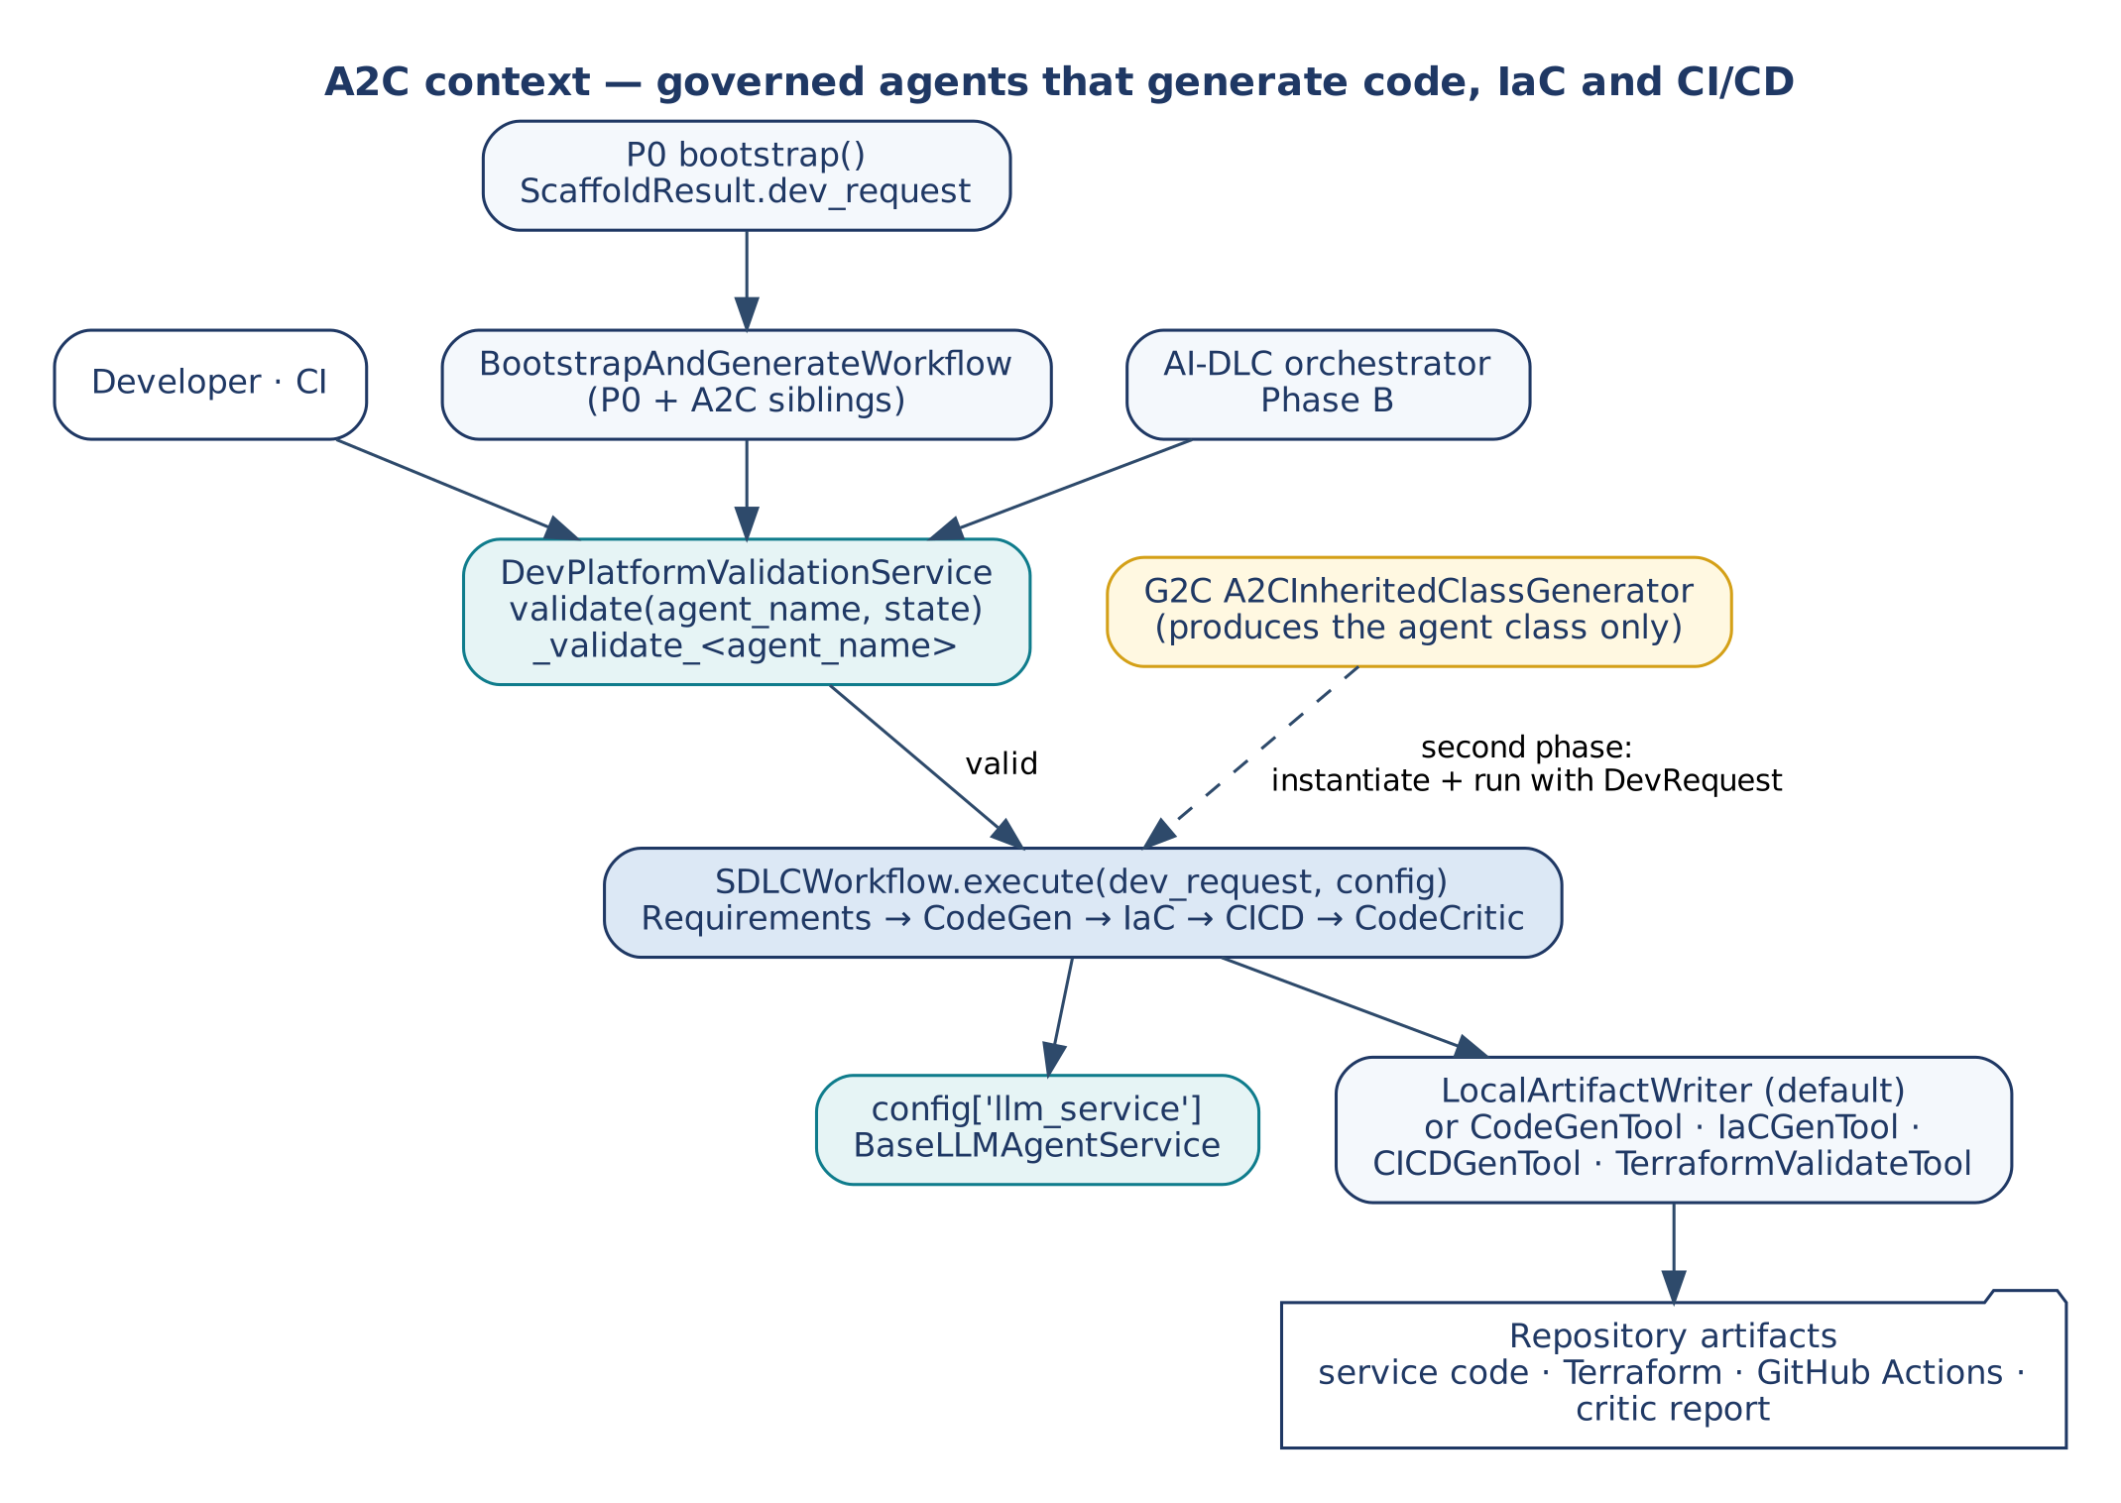
Figure 1 — A2C context

5.2 E2A to A2C mapping
Layer | E2A | A2C
Data model | AgentState | DevRequest
Agent contract | BaseAgent | SDLCAssistantAgent and its specialists; CodeCriticAgent
Quality gate | CriticAgent (groundedness ≥ 0.85) | CodeCriticAgent (NFR patterns ≥ 0.75)
Tool layer | HTTP microservice calls | LocalArtifactWriter (default), CodeGenTool, IaCGenTool, CICDGenTool, TerraformValidateTool
Orchestration | BaseWorkflow | SDLCWorkflow + SDLCAgentChain
Validation | BaseValidationService | DevPlatformValidationService
Configuration | E2A_CONFIG registry | A2C keys registered with register_config_key()

5.3 Workflow
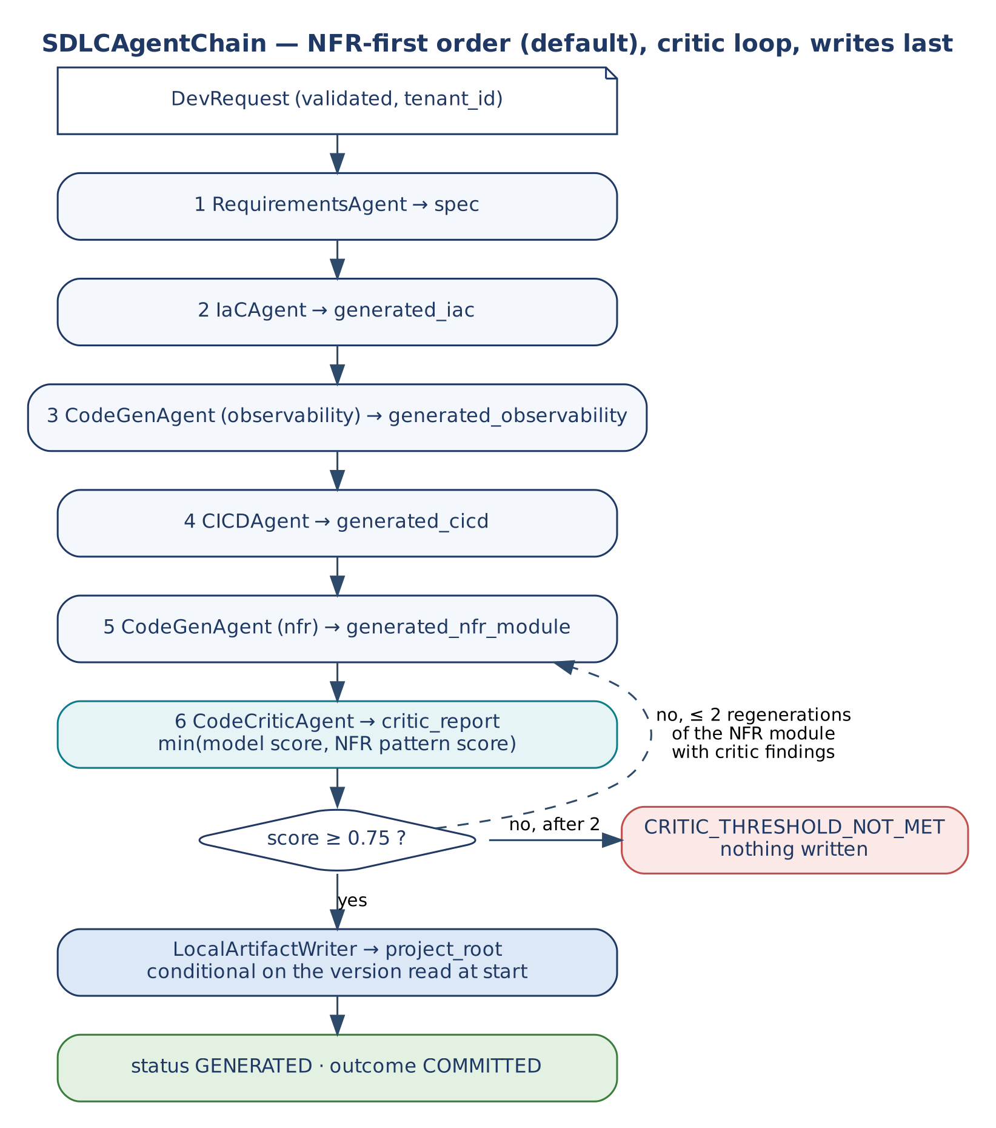
Figure 2 — SDLCAgentChain: NFR-first order, critic loop, writes last
BaseWorkflow.execute() runs exactly one agent per request; SDLCWorkflow._get_agent() therefore returns an SDLCAgentChain — the workflow's node sequence, which exposes run() with the agent signature and runs each specialist through its own inherited BaseAgent.run(). The claim, propagation fields, deadline, telemetry, DLQ and claim settlement stay in the unmodified execute().

5.4 Generation order
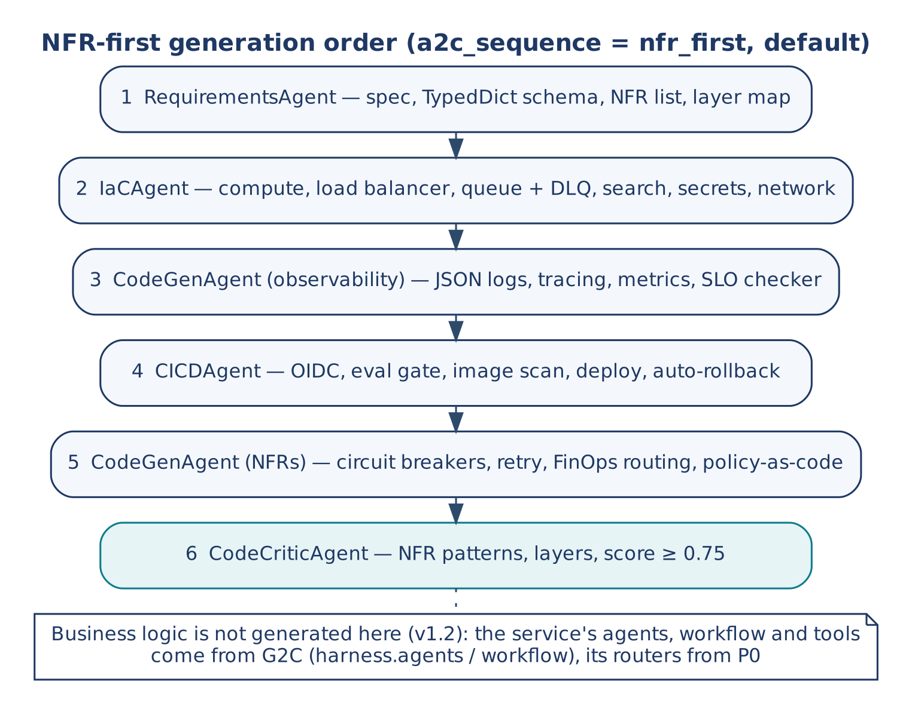
Figure 3 — NFR-first generation order
a2c_sequence | Order | Model calls (no regeneration)
nfr_first (default) | Requirements → IaC → CodeGen (observability) → CI/CD → CodeGen (NFR module) → Critic | 6
topology | Requirements → CodeGen (NFR module) → IaC → CI/CD → Critic | 5

Since v1.2 neither order generates a business-service module (generated/service.py, <Project>Service.java): no project used it, and the service's real entry point is the workflow G2C generates from harness.agents (A-4).
The NFR-first order implements Section 5 of the Reference (production-readiness priority); the topology order is the five-agent graph of its Section 3.2.

5.5 Two-phase invocation
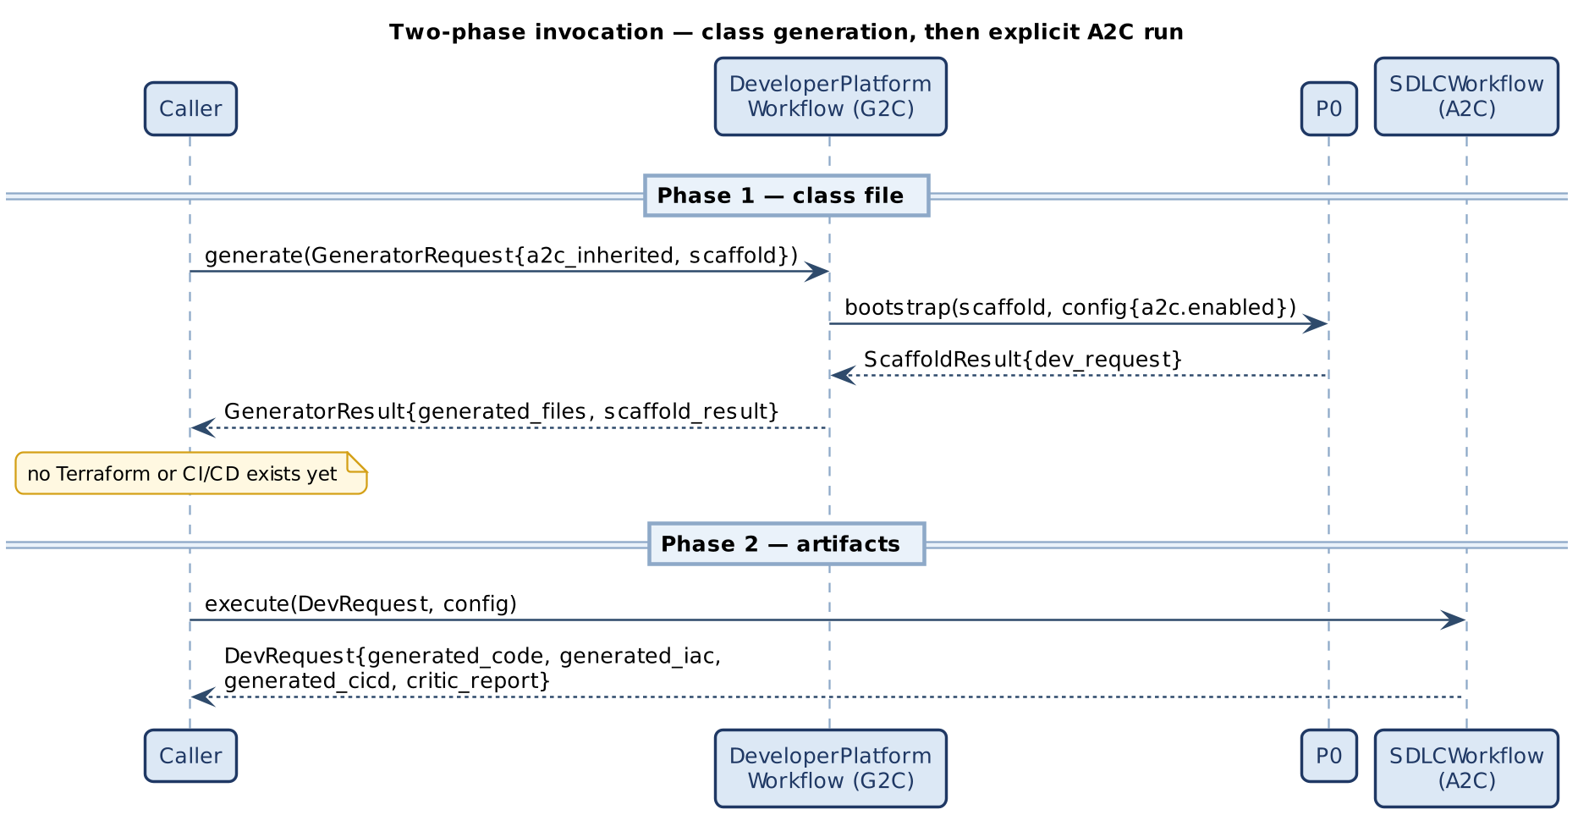
Figure 4 — Class generation, then an explicit A2C run

5.6 Declarations (v1.2)
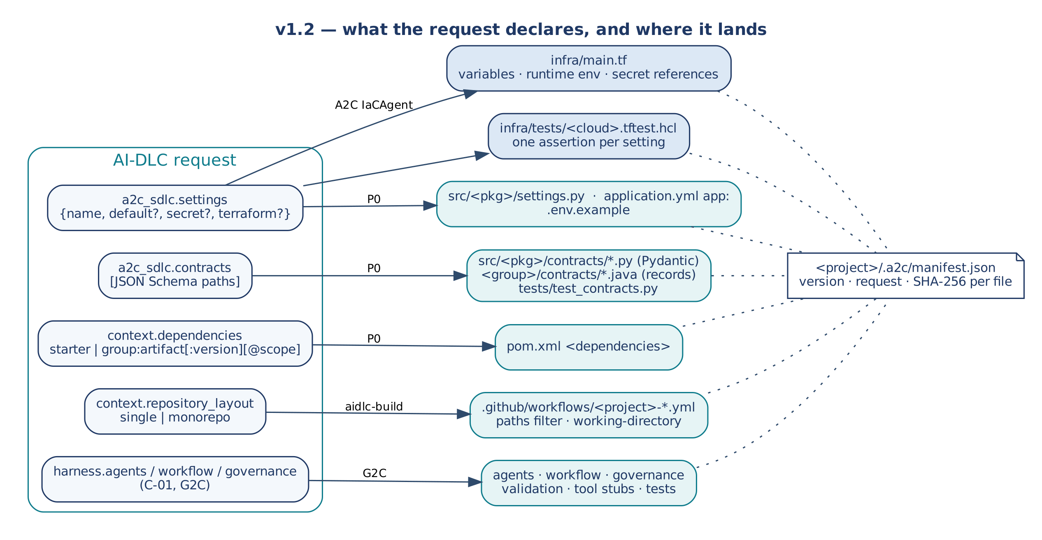
Figure 5 — What the request declares, and where it lands
Every project of the Order-to-Cash programme patched its scaffold by hand: environment variables in main.tf, models re-typed from a JSON-Schema contract, Maven dependencies in pom.xml, workflows moved out of the service folder. v1.2 makes each of these a request field, read once by aidlc-build and written by the component that owns the file:
Table 4 — Declarations
Request field | Written by | Result
a2c_sdlc.settings: [{name, default?, secret?, terraform?, description?}] | A2C IaCAgent (Terraform), P0 (code), ProjectStaticPipeline (Terraform test) | A Terraform variable and runtime environment variable per setting on AWS, GCP and Azure; a secret becomes a reference to Secrets Manager, Secret Manager or Key Vault (never a value); terraform takes the value from the project's own Terraform; .env.example; src/<pkg>/settings.py (load_settings() fails naming missing settings) or an app: block in application.yml; one terraform test assertion per setting.
a2c_sdlc.contracts: [path] | P0 | Pydantic models in src/<pkg>/contracts/ and a test that round-trips the schema's examples, or Java records with Jackson names in <group>/contracts/. A declared subset of JSON Schema; anything else is refused by name.
context.dependencies | P0 | A short name is a Spring starter; group:artifact[:version][@scope] is a Maven coordinate (version from the Spring Boot BOM when omitted).
context.repository_layout (or --repository-layout) | aidlc-build | monorepo moves the generated workflows to the repository root as <project>-<name>.yml, scoped with paths, job working directories, hashFiles and the Maven cache path.
harness.agents, harness.workflow, harness.governance | G2C | The service's E2A v1.2 agents, workflow, governance, validation, tool stubs and tests (G2C design document).

5.7 Upgrades (v1.2)
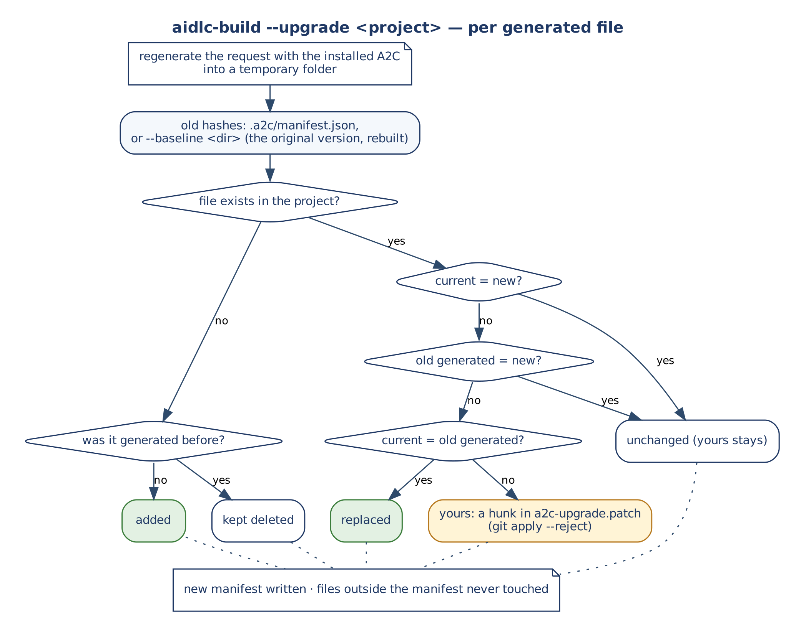
Figure 6 — aidlc-build --upgrade, per generated file
Every build writes <project>/.a2c/manifest.json: the A2C version, the request and the SHA-256 of every generated file (paths relative to the repository root, so root workflows count). aidlc-build --upgrade <project> regenerates the request with the installed version into a temporary folder and decides per file: untouched (current hash = manifest) → replaced; new → added; changed by you → a hunk in a2c-upgrade.patch, applied with git apply --reject; unchanged by the generator → yours stays, without a patch. Files outside the manifest are never touched and nothing is deleted. A project scaffolded before v1.2 has no manifest: --baseline <dir> is the same request rebuilt with the project's original A2C version, which reproduces the original scaffold byte for byte (verified on reconciliation and settlement, both scaffolded with v1.1.0).

5.8 Evaluation sets and the release gate (v1.2.1)
Design note C-04 (D-2). A Python service on E2A v1.2 is judged by E2A's release gate, e2a.release.ProjectReleaseGate. The request can name the cases that decide the domain stages.
Table 5 — What `a2c_sdlc.evaluation` produces
Request | Generated | Checked where
no evaluation (E2A v1.2 service) | a CI step python -m e2a.release --skip-tests: the generic stages (secrets, strict conformance, compile) | the project CI, every commit
{"set": "evals/golden.json"} | src/<package>/release/gate.py: a ProjectReleaseGate subclass whose _score_case stub fails until written; the set with one example case; a CI step running that gate | the project CI scores the cases; Phase C checks the set is well formed
+ "redteam": "evals/redteam.json" | a _probe stub and the red-team set (injections, PII) | as above
+ "threshold": 0.9 | --config with faithfulness_threshold in the CI step | the project CI

Phase C (aidlc-build) on E2A's checks. ProjectStaticPipeline takes E2A's secret patterns. For an E2A v1.2 project it runs:
- strict e2a.conformance over src/;
- compileall;
- a check that each declared evaluation set is well formed (report.evaluation_cases).
It does not score the cases, because the domain code behind them is written after the build. A Java service or an E2A v1.1 service with evaluation is refused: the gate is a Python E2A v1.2 class.

6. Data Contracts
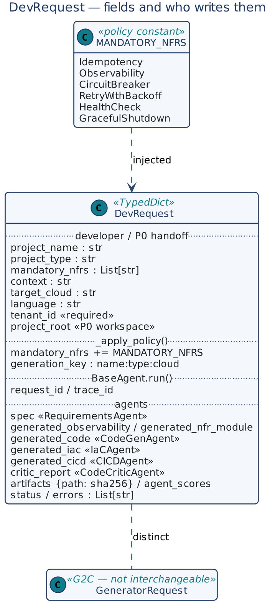
Figure 7 — DevRequest fields and writers

6.1 DevRequest
Table 6 — DevRequest fields
Field | Type | Written by | Meaning
project_name | str | Developer / P0 | Service name.
project_type | str | Developer / P0 a2c block | FastAPI Microservice, Spring Boot, LangGraph Agent.
mandatory_nfrs | List[str] | Developer; extended by _apply_policy | Requested plus injected NFRs.
context | str | Developer / P0 a2c block | Domain context.
target_cloud | str | Developer / P0 (platform) | aws, gcp, azure, standalone.
language | str | Developer / P0 (runtime) | python, java (also node, go for file extensions).
tenant_id | str | Developer / P0 | Required by execute(); scopes the claim.
project_root | str | P0 | Workspace where artifacts are written; absent → nothing written.
generation_key | str | _apply_policy | project_name:project_type:target_cloud.
spec | str | RequirementsAgent | Schema, NFR list, layer map, E2A mapping.
generated_observability, generated_nfr_module | str | CodeGenAgent | The two code modules written since v1.2 (generated_code, the business mode, is no longer run by either order).
port, package_name | int, str | P0 | The service port (one value for Dockerfile and Terraform) and the Python package (Lambda handler).
settings | List[dict] | Developer (a2c_sdlc.settings) | Normalised app settings for IaCAgent (Section 5.6).
generated_iac, generated_cicd | str | IaCAgent, CICDAgent | Terraform, workflow YAML.
critic_report | dict | CodeCriticAgent | {score, model_score, pattern_check, missing, passed, regenerations}.
artifacts | dict | Chain | Relative path → SHA-256 of what was written.
agent_scores | dict | Agents | Per-agent evaluation score.
status | str | Chain | GENERATED, AGENT_FAILED, CRITIC_THRESHOLD_NOT_MET, ARTIFACT_CONFLICT; on duplicates REPLAYED, IN_PROGRESS, CONFLICT, RECOVERY_REQUIRED, FAILED_FINAL (from BaseWorkflow).
response, outcome | — | Chain | Run summary (all artifacts) and physical outcome; what a replay restores.
correlation_id, idempotency_key, message_log, failed_keys, errors | — | BaseWorkflow / agents | Propagation fields and errors.

6.2 MANDATORY_NFRS and the pattern check
NFR | Code pattern (case-insensitive, comments and docstrings removed)
Idempotency | idempot, request_id, conditional write, put_if_version, claim(
Observability | structlog, opentelemetry, otel, logging.getLogger, logger.
CircuitBreaker | circuit, breaker, pybreaker, resilience4j
RetryWithBackoff | retry, backoff, tenacity
HealthCheck | /health, healthcheck, actuator
GracefulShutdown | sigterm, signal., graceful, shutdown

nfr_pattern_report(code, nfrs) returns {score, passed, missing}, where the score is the share of requested NFRs that have a known pattern and appear in the code. Team NFRs without a pattern do not count against the score.

6.3 ValidationResult
{valid, errors, agent_name, correlation_id}. A failure is a normal return value (an HTTP 400 body), not an exception.

6.4 Configuration
Table 7 — Configuration
Key (env) | Default | Used by
a2c_min_confidence (A2C_MIN_CONFIDENCE) | 0.75 | Agent fallback threshold and critic threshold
a2c_max_latency (A2C_MAX_LATENCY) | 30 s | Per-agent latency SLO
a2c_max_tokens (A2C_MAX_TOKENS) | 32 000 | Per-agent token budget
a2c_max_regenerations (A2C_MAX_REGENERATIONS) | 2 | NFR-module regenerations after a failed review
a2c_sequence (A2C_SEQUENCE) | nfr_first | Agent order
a2c_write_artifacts (A2C_WRITE_ARTIFACTS) | true | Write into project_root
critic_model_id (CRITIC_MODEL_ID) | — | Model for CodeCriticAgent (passed as that run's model_id)
a2c_artifact_paths | see Section 8.6 | Override artifact locations
approved_clouds, approved_agents | aws, gcp, azure, standalone / none | _apply_policy
llm_service, idempotency_store | — | Gateway; claim store
tool_base_url | E2A default | Remote tools

The A2C keys are registered in the E2A configuration registry at import time and resolved with resolve_config() (kwargs › config › env › default).

7. Low-Level Design — Class Model
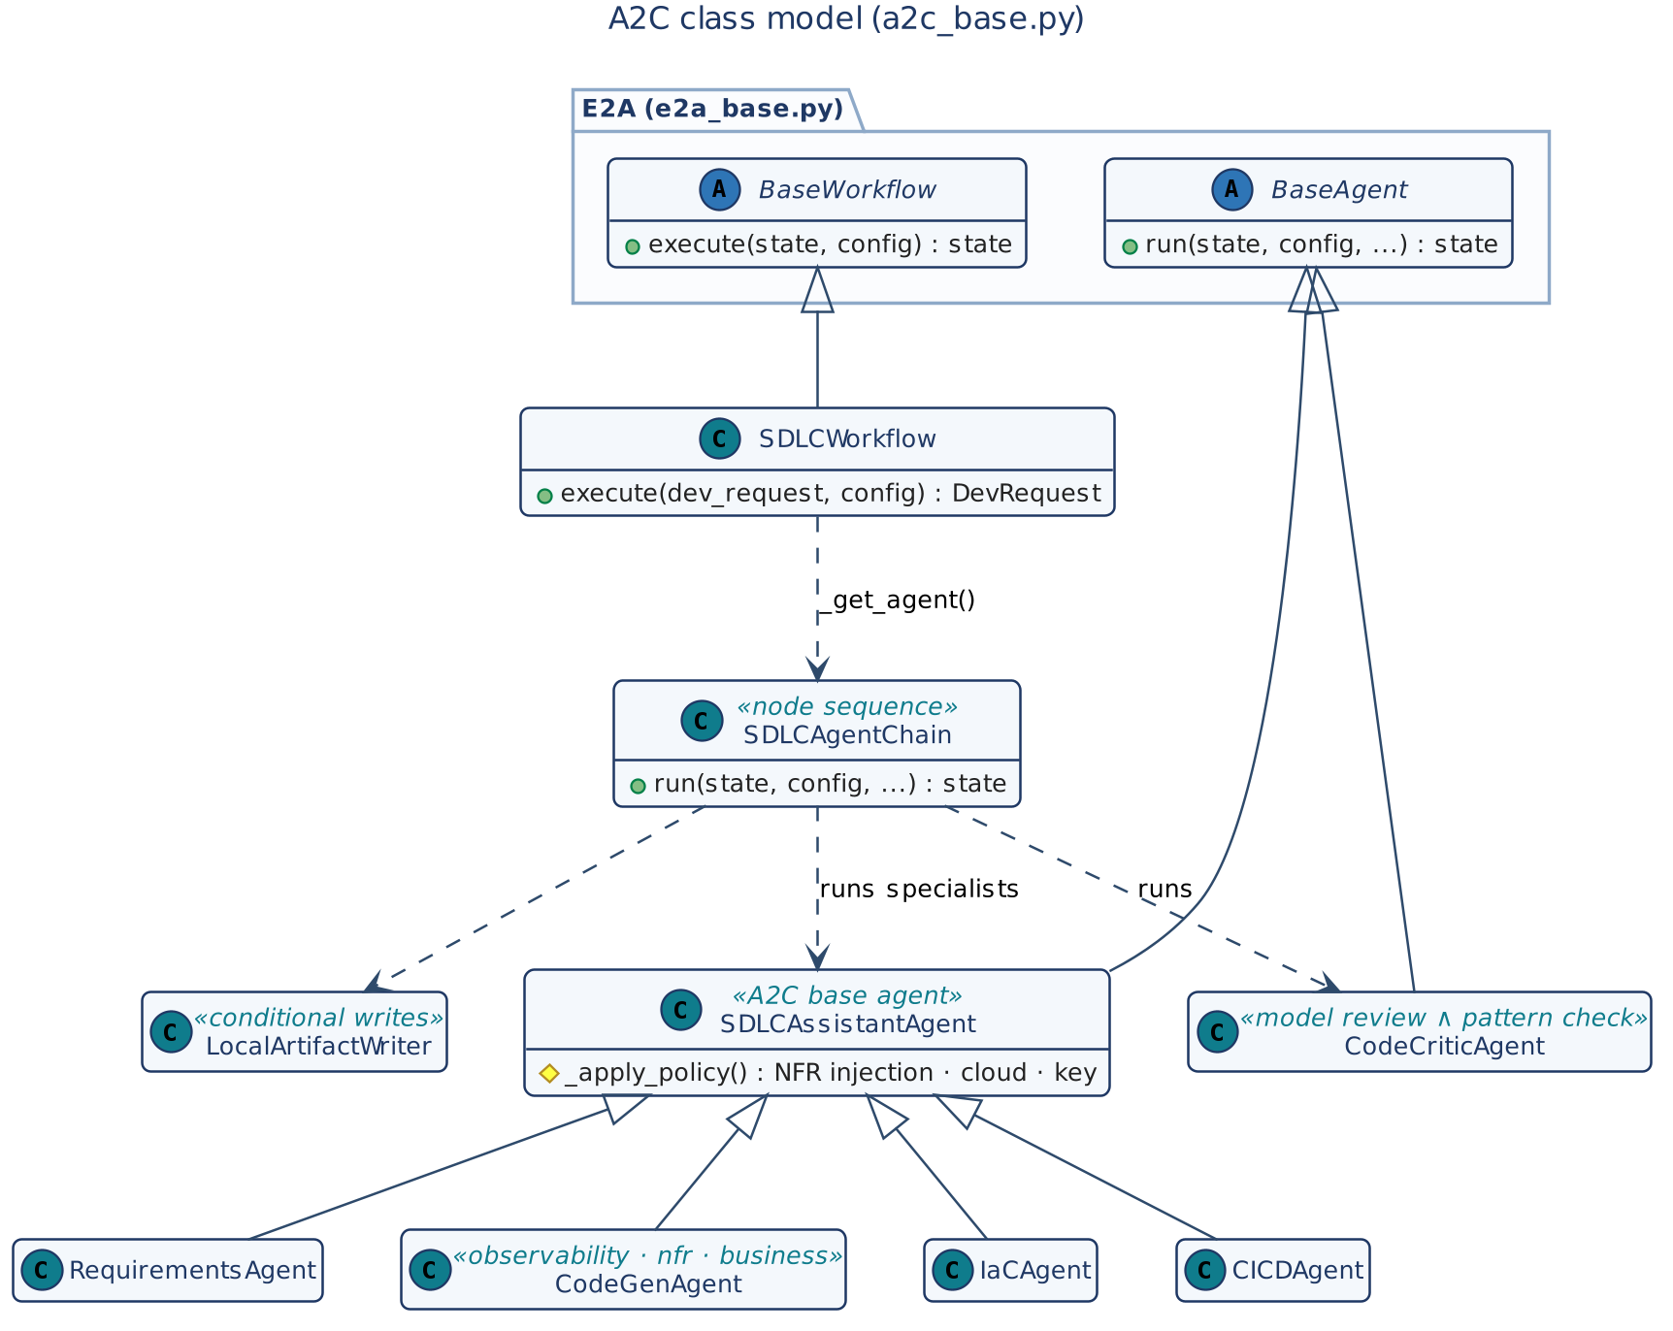
Figure 8 — A2C class model
Class | Base | Role
SDLCAssistantAgent | BaseAgent | A2C base agent: mandatory NFR policy, prompts, pattern scoring.
RequirementsAgent, CodeGenAgent, IaCAgent, CICDAgent | SDLCAssistantAgent | Specialists sharing the policy.
CodeCriticAgent | BaseAgent | Quality gate.
SDLCAgentChain | — | Node sequence run by BaseWorkflow.execute().
SDLCWorkflow | BaseWorkflow | Entry point; claim; settlement.
DevPlatformValidationService | BaseValidationService | Validators and entitlement hook.
LocalArtifactWriter | — | Conditional local writes.
CodeGenTool, IaCGenTool, CICDGenTool, TerraformValidateTool | BaseToolService | Remote write/validate endpoints.
GovernanceViolationError | NFRViolationError | Unapproved cloud or agent.

8. Low-Level Design — Class Contracts

8.1 SDLCAssistantAgent
Table 8 — SDLCAssistantAgent methods
Method | Kind | Signature → returns | Contract
run | inherited | (state, config, correlation_id, io_config, idempotency_key, tenant_id, message_log, failed_keys, **kw) → state | E2A lifecycle: messages, policy (or governance engine), gateway call, token tracking, evaluation, fallback below min_confidence, latency SLO. Errors go to _handle_error.
_apply_policy | hook | (state, config, **kw) | Inject missing MANDATORY_NFRS (logged); check approved_clouds and approved_agents → GovernanceViolationError; set generation_key.
_system_prompt | helper | (state) → str | Clean Architecture, NFRs as code, JSON logging, tracing, /health, template method, gateway-only model access. Specialists override.
_build_messages | hook | (state, config, **kw) → list | System prompt; user prompt with context, spec and, on regeneration, the critic's findings.
_evaluate_output | hook | (response, state, config, **kw) → float | Store the text in artifact_field; score with nfr_pattern_report; record agent_scores.
_fallback | hook | (state, config, **kw) → dict | Degraded response naming the missing patterns (the artifact stays in state for the critic).
_handle_error | hook | (error, state, config, **kw) → state | Log with project; append "<agent>: <error>" to errors.

8.2 CodeCriticAgent
Method | Kind | Signature → returns | Contract
_apply_policy | hook | (state, config, **kw) | approved_agents check. The cheaper model is selected by the chain (model_id=critic_model_id).
_build_messages | hook | (state, config, **kw) → list | Senior-architect rubric over the observability and NFR modules; JSON {score, missing, passed}.
_evaluate_output | hook | (response, state, config, **kw) → float | Parse the model score (parse error → 0); run nfr_pattern_report on the same code; score = minimum; store critic_report.
_fallback, _handle_error | hook | — | Degraded response; append to errors.

8.3 Specialist agents
Table 9 — Specialist agents
Agent | Writes | _evaluate_output score
RequirementsAgent | spec | Share of: non-empty; every mandatory NFR named; layers/architecture described.
CodeGenAgent | generated_observability / generated_nfr_module by codegen_mode | nfr_pattern_report against the mode's NFRs (observability: Observability; nfr: CircuitBreaker, RetryWithBackoff, Idempotency). The business mode remains selectable but neither order runs it since v1.2.
IaCAgent | generated_iac | Share of: > 100 chars; resource/module blocks; DLQ/redrive present; no literal secret or password. The prompt carries the service port, the Python package and (v1.2) App settings: [...].
CICDAgent | generated_cicd | Share of: on:; jobs:; id-token: write (OIDC); deploy step; scan (Trivy).

8.4 SDLCAgentChain
Method | Signature → returns | Contract
run | (state, config, **propagation) → state | Resolve A2C settings; pass min_confidence, max_latency, max_tokens and an idempotency key <key>:<agent>:<mode> to each agent run; check the deadline before every step; stop on the first agent error (AGENT_FAILED). Then, while the critic score is below the threshold and regenerations remain, rerun CodeGen (NFR module) with the findings and the critic. Below threshold after that → CRITIC_THRESHOLD_NOT_MET, nothing written. Otherwise write artifacts (Section 8.6), set GENERATED, and put the run summary in response. Every failure appends the key to failed_keys so the workflow settles the claim as failed.
_write | (state, config, root, versions, failed_keys, key) | Write each present artifact with LocalArtifactWriter; a conflict stops writing, sets ARTIFACT_CONFLICT, and sets outcome='UNKNOWN' if an earlier artifact was committed (parked for reconciliation). All good → outcome='COMMITTED' when anything changed.

8.5 SDLCWorkflow
Method | Kind | Signature → returns | Contract
__init__ | ctor | (config=None, agents=None, writer=None) | Default agent set; injectable agents and writer (tests, teams).
execute | inherited | (dev_request, config) → DevRequest | Requires tenant_id (ValueError otherwise). Claim a2c:<project_name>:<project_type>:<target_cloud> (tenant-scoped) when config['idempotency_store'] is an E2A BaseIdempotencyStore; duplicates short-circuit with a typed status. Runs the chain; settles: UNKNOWN outcome → parked; failed keys → retryable fail; else complete.
_build_workflow / _validate_workflow | hook | — | Node list and sequence; all five agents must be present.
_get_agent | hook | (intent, config) → SDLCAgentChain | The chain.
_generate_idempotency_key | hook | (state, config) → str | a2c:<generation_key>.
_replayable_result | hook | (state, config) → dict | {response, outcome} — response holds every artifact, because BaseWorkflow restores only response on replay.
_physical_outcome | hook | (state, config) → PhysicalOutcome or None | From state['outcome'].
_handle_error | hook | (error, state, config) → state | Append to errors.

8.6 Artifacts, LocalArtifactWriter and tools
Field | Default path in project_root
spec | docs/a2c/spec.md
generated_observability / generated_nfr_module | src/generated/observability.<ext> / nfr.<ext>; inside a P0 scaffold src/<package>/generated/… (Python) or <group_id>.generated (Java) via a2c_artifact_paths
generated_iac | infra/main.tf
generated_cicd | .github/workflows/a2c-ci.yml

LocalArtifactWriter.write(root, rel, content, expected_version) reads the file's current SHA-256 under a per-path lock: equal to the new content → UNCHANGED; different from the version read at the start of the run → CONFLICT; otherwise write → COMMITTED.
Table 10 — Remote tools (BaseToolService)
Tool | Endpoint | Idempotency key | Input validation
CodeGenTool | /codegen/write | project_name:file_path (+ expected_version) | project_name, file_path, content
IaCGenTool | /iac/write | project_name:resource_type | terraform_hcl > 100 chars
CICDGenTool | /cicd/write | project_name:workflow_name | OIDC, jobs and deploy present
TerraformValidateTool | /terraform/validate | none (read) | terraform_hcl present

Endpoints are relative to tool_base_url. The default chain writes locally; the tools are for a deployment where a write service owns the repository.

8.7 DevPlatformValidationService
Method | Signature → returns | Contract
__init__ | (entitlement_policy=None) | Registry: SDLCAssistantAgent and SDLCWorkflow → _validate_sdlc_assistant_agent; CodeCriticAgent → _validate_code_critic_agent.
validate | inherited (agent_name, state, config, correlation_id) → ValidationResult | Unregistered agent → strict_mode decides; validator failure → result; then entitlement.
_validate_sdlc_assistant_agent | (state, config) → (bool, errors) | project_name, project_type, mandatory_nfrs, target_cloud, tenant_id; mandatory_nfrs must be a list.
_validate_code_critic_agent | (state, config) → (bool, errors) | generated_nfr_module, mandatory_nfrs (v1.2; was generated_code).
_enforce_entitlement_gate | (agent_name, state, config) → ValidationResult | ABAC hook: entitlement_policy(agent_name, state, config) → (ok, reason); default allow.

Runtime-configuration policy (approved_clouds) stays in _apply_policy, because it is governance, not input shape.

8.8 Declarations and upgrades (v1.2)
Table 11 — v1.2 modules
Module | Public functions | Contract
a2c_settings | normalize(settings), terraform(cloud, settings), env_example, python_module, python_test, java_yaml | normalize refuses names that are not UPPER_SNAKE_CASE, duplicates, a secret with a default, and terraform combined with a default or a secret (SettingsError). terraform() returns the placeholders of the cloud template (settings_variables, settings_env, settings_resources, settings_secret_arns, settings_test_*), formatted so that terraform fmt -check passes.
a2c_contracts | Contract(path, schema), python(contract), python_test(package, contracts), java(contract, package), contracts_from(paths, base) | Supported: type (incl. [T, "null"]), properties, required, additionalProperties: false, enum, const, format (uuid, date-time, date, decimal), pattern, minLength, maxLength, minimum, maximum, items, local $ref/$defs, annotations, and the "present only when" idiom if {properties: {p: {const: v}}} then {required: [x]} else {not: {required: [x]}} (a model validator). Anything else raises ContractError naming the keyword and its path.
a2c_layout | to_monorepo(text, project), move_workflows(output, project) | Text transformation of the generated workflows; validated with actionlint in CI.
a2c_upgrade | write_manifest(output, project, request), upgrade(project_dir, build, request=None, baseline=None) | Section 5.7. Raises UpgradeError without a manifest or a baseline, or when the request builds another project.

aidlc-build (a2c_cli.py) reads the declarations once in _prepare: settings are normalised into context.settings and a2c_sdlc.settings; contracts are loaded relative to the working directory or the request file and passed to P0 as context.contract_schemas; --repository-layout overrides context.repository_layout. A declaration that cannot be generated stops the build with a JSON error before any model call.

9. Dynamic Behaviour

9.1 Request lifecycle
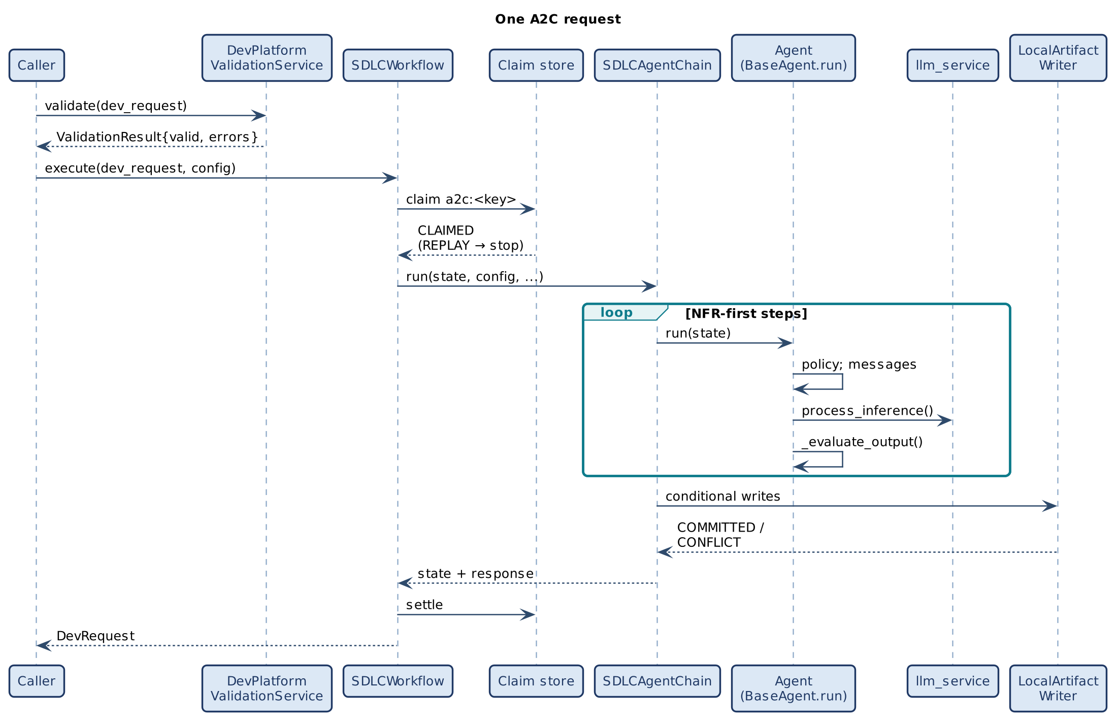
Figure 9 — Validation, claim and the chain of governed agent runs

9.2 Policy injection
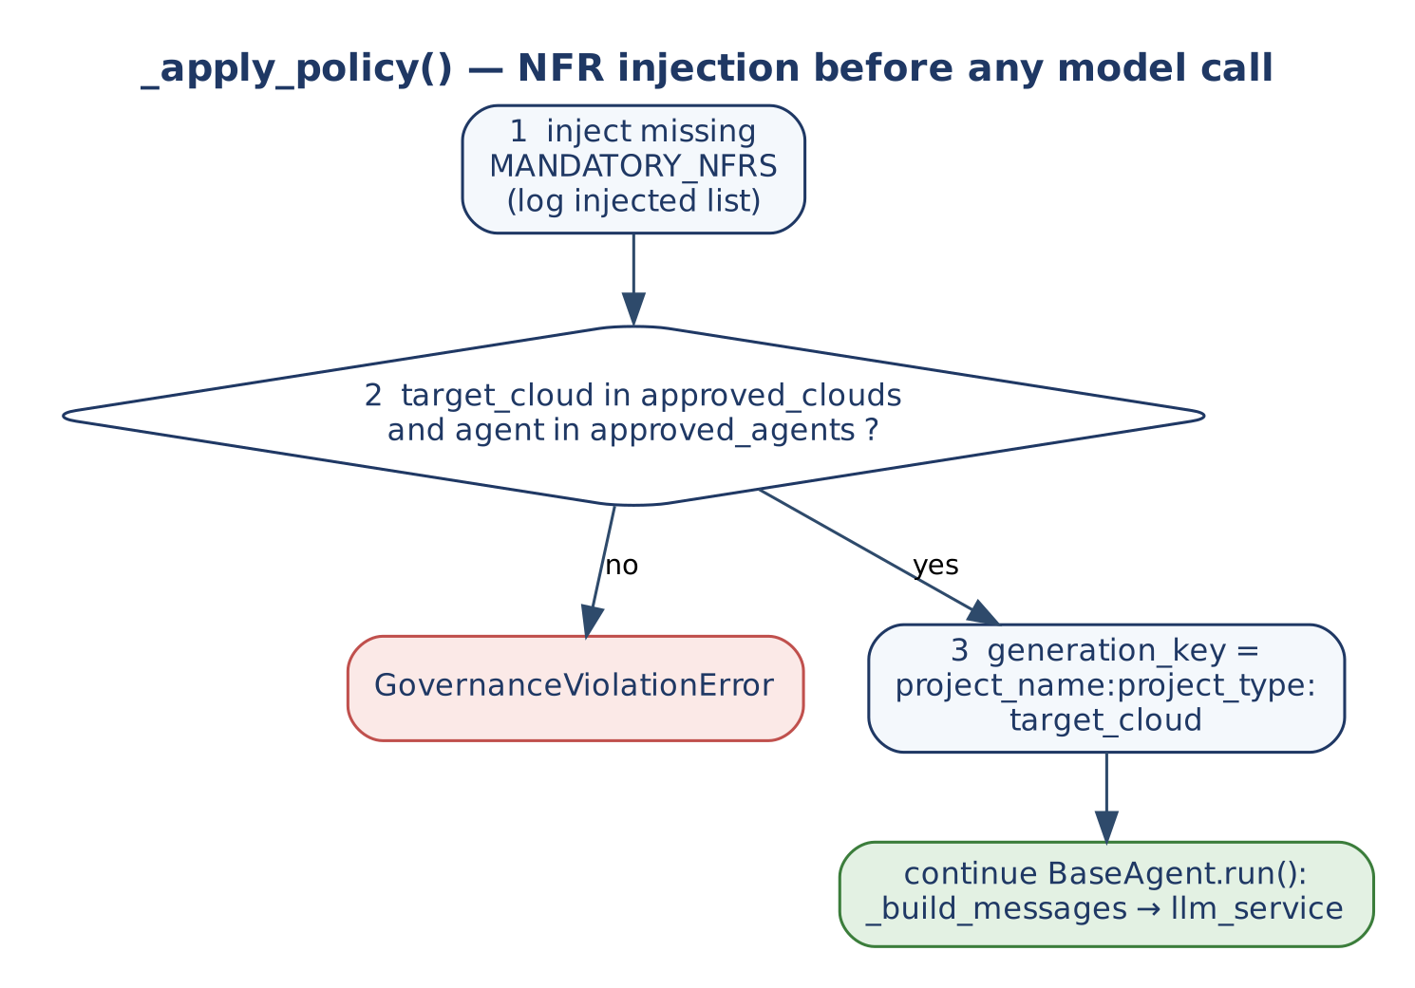
Figure 10 — _apply_policy(): NFR injection before any model call
Resolution example: a developer supplies mandatory_nfrs = ['Audit']; _apply_policy adds the six mandatory NFRs and sets generation_key = 'SettlementEngine:FastAPI Microservice:aws'; the workflow claim adds idempotency_key = 'a2c:SettlementEngine:FastAPI Microservice:aws'; run() adds correlation_id.

9.3 Quality gate and regeneration
The critic reviews the observability and NFR modules together (both carry every mandatory NFR pattern; the business module removed in v1.2 added none). Below the threshold, CodeGen (NFR module) runs again with the critic's missing list in the prompt, followed by the critic, at most a2c_max_regenerations times. Fleet model capacity must be sized including these retries.

10. Concurrency and Capacity
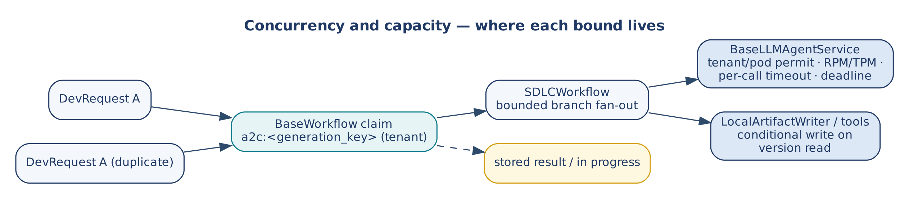
Figure 11 — Where each bound lives
Concern | Rule
Model capacity | Gateway only: tenant/pod permit, RPM/TPM, per-call timeout, deadline. Rejections are typed and retryable; quota is refunded.
Duplicates | BaseWorkflow claims a2c:<generation_key> per tenant; the second identical request gets REPLAYED (artifacts in response) or IN_PROGRESS. The a2c: namespace keeps it apart from P0 (p0:), G2C (g2c:) and AI-DLC keys in a shared store.
Fan-out | Sequential; no parallel branches.
Competing writes | Conditional on the version read; typed CONFLICT.
Partial writes | outcome='UNKNOWN' → claim parked for reconciliation, never blindly re-run.
Cancellation | The deadline is checked before every agent run and caps each gateway call.

11. Non-Functional Design
NFR | Mechanism
Correctness of output | Mandatory NFR injection; critic ≥ 0.75 on comment-free code; writes only after review.
Latency | 30 s per agent call SLO (NFRViolationError on breach, from BaseAgent).
Cost | Token budgets; cheaper critic model; deterministic pattern check.
Security | Validation and entitlement before the workflow; no credentials in agents; OIDC required in generated pipelines; literal secrets in Terraform lower the IaC score; declared secrets are references to the cloud's secret store, never values.
Maintainability (v1.2) | Declarations instead of patches; the manifest and --upgrade bring fixes to existing scaffolds.
Auditability | correlation_id, generation_key, critic_report, agent_scores, artifact hashes.

12. Extension Guide
# | Rule
1 | Set agent_name; add it to approved_agents when that list is used.
2 | Add _validate_<agent_name> to the validation service; never a _validate_state hook.
3 | Override _apply_policy (call super() first in team subclasses), _system_prompt or _build_messages, _evaluate_output, _fallback, _handle_error.
4 | Never override run() or execute().
5 | Completions only through config['llm_service']; no local semaphores or provider calls.
6 | Pass a custom agent set or writer to SDLCWorkflow(agents=..., writer=...) rather than editing the chain.

TEAM_NFRS = ['DoubleEntryLedgerInvariant', 'SagaCompensation']

class FinancialSettlementSDLCAgent(SDLCAssistantAgent):
agent_name = 'FinancialSettlementSDLCAgent'

def _apply_policy(self, state, config=None, **kwargs) -> None:
super()._apply_policy(state, config, **kwargs) # mandatory NFRs, cloud, key
for nfr in TEAM_NFRS:
if nfr not in state['mandatory_nfrs']:
state['mandatory_nfrs'].append(nfr)

agents = {'RequirementsAgent': RequirementsAgent(), 'CodeGenAgent': CodeGenAgent(),
'IaCAgent': IaCAgent(), 'CICDAgent': CICDAgent(), 'CodeCriticAgent': CodeCriticAgent()}
workflow = SDLCWorkflow(config=config, agents=agents)

13. Verification
Table 12 — Evidence (v1.2.0)
Suite | What it shows
smoke_test_a2c.py (26 checks, real e2a_base) | Validation result vs exception; happy path in NFR-first order (6 runs); the critic validates against the NFR module; mandatory NFRs injected; generation_key; critic = min(model, pattern); critic on the cheaper model; artifacts in the workspace; claim SUCCEEDED; replay without a model call with artifacts in response; unapproved cloud stops before any model call; comment-only NFRs fail the pattern check; one regeneration fixes them; persistent failure stops after 2 with nothing written; conflict on the first write → retryable; conflict after earlier writes → UNKNOWN; topology order (5 runs); tenant_id required; P0 → A2C through BootstrapAndGenerateWorkflow; a2c_base.py passes G2C's a2c_abstract critic.
smoke_test_aidlc_integration.py (15 checks) | AI-DLC Phase B runs the real SDLCWorkflow; five artifacts written into the P0 workspace; the build reaches E2A_VERIFIED.
smoke_test_declarations.py (32 checks) | Settings (refusals, three clouds, secret references, values from the project's Terraform, load_settings), contracts (examples, additionalProperties, the present-only-when idiom, refusal by name, Java records, a test that compiles), Maven coordinates, monorepo workflows, upgrades (replace, add, patch, untouched files, no patch on a repeat, refusal without a baseline).
CI job declarations | On AWS, GCP and Azure: a generated service with settings, a secret and a contract passes terraform fmt and terraform test and its generated tests; a three-agent service passes its tests; a generated monorepo passes actionlint.
CI job images | The Java image now has a contract, a setting, Flyway and H2, and starts.

14. Implementation Reality, Gaps and Design Observations
At the earlier baseline no A2C code existed: BootstrapAndGenerateWorkflow's A2C phase was a placeholder and the AI-DLC orchestrator imported SDLCWorkflow from a module that did not exist. Both now run the implementation described here. The earlier naming drift (SDLCBaseAgent, CriticAgent) is resolved in favour of SDLCAssistantAgent and CodeCriticAgent; the two orders (topology vs NFR-first) are both implemented, NFR-first by default.
Table 13 — Remaining observations
ID | Observation | Effect | Recommendation
O-1 | Agent-level scores are heuristics (keywords, block presence). | A response can match patterns without being correct code. | Add compilers/linters (terraform validate, actionlint, language parsers) as tools in CI.
O-2 | A governance violation is settled retryable (E2A's workflow settles a caught agent error as retryable). | Redelivery repeats a request that cannot pass. | Classify GovernanceViolationError as final in E2A's settlement.
O-3 | Three business keys coexist: P0 scaffold_key, G2C generator_key, A2C generation_key (no runtime). | Python and Java variants of one project share an A2C key. | Add language to generation_key, or document one project per key.
O-4 | BaseWorkflow restores only response on replay. | Top-level generated_* fields are absent on a replayed result; callers read response. | Read artifacts from response, or extend E2A's replay contract.
O-5 | The AI-DLC orchestrator passes its dev_request object straight to execute(), which enriches it in place. | The orchestrator's result['dev_request'] shows generated content. | Pass a copy in AI-DLC (E2A change).
O-6 | Artifact paths default to src/generated/…; aidlc-build derives them from the P0 tree (a2c_artifact_paths). | Direct SDLCWorkflow callers outside aidlc-build still get the defaults. | Pass a2c_artifact_paths, or build through aidlc-build.
O-7 | All tests use in-memory doubles. | Not validated against a live gateway, store or load. | Add adapter tests.
O-8 | A2C's own agents (SDLCAssistantAgent and the specialists) use E2A's v1.1 hook signatures. | E2A v1.2 runs them unchanged with one DeprecationWarning per class; E2A v1.3 removes that adapter. | Move them to the v1.2 contract before E2A v1.3.
O-9 | Settings are values or project Terraform expressions; a setting that needs a per-environment secret version is not modelled. | Teams add version pinning by hand. | Extend the setting declaration if a project needs it.
O-10 | --upgrade decides per file; a generator change and your change in the same file need a human (a .rej hunk). | Expected: the upgrade never merges silently. | Review a2c-upgrade.patch; keep generated files close to their generated form.

Appendix A. Glossary
Term | Definition
A2C | Architecture-to-Code.
DevRequest | A2C input and output contract; distinct from G2C's GeneratorRequest.
generation_key | project_name:project_type:target_cloud; claimed as a2c:<generation_key>.
Mandatory NFRs | Six NFRs injected by _apply_policy.
NFR-first order | Infrastructure and observability first; since v1.2 the order ends with the NFR module and the critic (business logic comes from G2C).
Declaration (v1.2) | A request field that replaces a hand patch: settings, contracts, dependencies, repository layout.
Manifest (v1.2) | <project>/.a2c/manifest.json: version, request and hashes of the generated files; the basis of --upgrade.
Second phase | Explicit SDLCWorkflow run after G2C class generation.

Appendix B. Traceability
Goal / invariant | Element | Anchor (a2c_base.py)
G-1, INV-02/03 | SDLCAssistantAgent._apply_policy | L163
G-2 | NFR_FIRST, TOPOLOGY, SDLCAgentChain.run | L419, L421, L425
G-3, INV-07 | CodeCriticAgent._evaluate_output, nfr_pattern_report | L342, L130
G-4, INV-04 | DevPlatformValidationService | L576
G-5, INV-07 | LocalArtifactWriter, SDLCAgentChain._write | L368, L497
INV-01, INV-06 | SDLCWorkflow (inherits execute) | L529
Declarations, upgrades (v1.2) | a2c_settings, a2c_contracts, a2c_layout, a2c_upgrade; a2c_cli._prepare | modules
Configuration | A2C keys registered | L48–71
Tools | CodeGenTool … TerraformValidateTool | L612–670

