SOFTWARE DESIGN DOCUMENT
P0 Project Bootstrap Framework
High-Level and Low-Level Design

This document describes P0, the Phase Zero project bootstrap framework, from problem statement to method-level contract. P0 turns one declarative ScaffoldRequest into a correct-by-construction project workspace — build manifest, directory tree, git, environment, README, licence, container and Makefile — guarded by an atomic claim, and optionally hands a populated DevRequest to A2C. It is written so that a reader can form a complete mental model of P0 without opening the Python source, which remains the reference for line-level detail.
Framework | P0 — Phase Zero Project Bootstrap (composable sibling of A2C within the E2A family)
Document type | Design Document (HLD + LLD)
Author | Subham Gupta, Principal Platform Architect
Source baseline | subhamviky/a2c-framework branch fix/g2c-p0-a2c-contracts @ c0583ac (on main e546cc5) — base_project_bootstrapper.py (1 492 lines), a2c_concurrency.py
Date | 7 November 2026
Status | Baseline design, aligned to the reference implementation and its smoke tests

Contents
1. Introduction 3
1.1 Purpose 3
1.2 Audience 3
1.3 Status labels 3
1.4 Related documents 4
2. Problem Statement and Motivation 5
2.1 The problem 5
2.2 Why a framework and not a template repository 5
2.3 Design goals 5
3. Core Use Cases 6
3.1 Actors 6
3.2 Use-case catalogue 6
3.3 Non-goals 6
4. Design Principles and Invariants 7
4.1 Principles 7
4.2 Invariants 7
5. High-Level Design 8
5.1 Context and composition 8
5.2 Components 8
5.3 Configuration sources 9
5.4 Deployment 10
6. Data Contracts 11
6.1 ScaffoldRequest 11
6.2 ScaffoldResult 12
6.3 The A2C handoff 13
6.4 scaffold-config.json 13
6.5 Configuration keys 13
7. Low-Level Design — Class Model 15
8. Low-Level Design — Class Contracts 16
8.1 BaseProjectBootstrapper 16
8.2 Concrete bootstrappers 18
8.3 ProjectBootstrapperFactory 19
8.4 BootstrapAndGenerateWorkflow 19
9. Dynamic Behaviour 20
9.1 bootstrap() sequence 20
9.2 Composition modes 21
9.3 Error path 22
10. Concurrency and Failure 23
10.1 Atomic claim 23
10.2 Failure matrix 24
11. Non-Functional Design 25
12. Extension Guide 26
13. Verification 27
14. Implementation Reality, Gaps and Design Observations 28
Appendix A. Glossary 29
Appendix B. Traceability 30

1. Introduction

1.1 Purpose
Every service built on the E2A family starts from an empty directory. Before an agent can generate business logic (A2C) or a class generator can emit an inherited class (G2C), something has to decide the build tool, write the manifest, lay out the directory tree so that it mirrors the E2A tiers, exclude secrets from git, and produce a non-root, health-checked container. P0 is that something. It is a small template-method framework with one public entry point, BaseProjectBootstrapper.bootstrap(), a fixed 16-step sequence, and a factory that selects the concrete bootstrapper from (runtime, build_tool).
P0 is deliberately narrow: it writes files that are the same for every service of a given runtime and project type. It never writes business logic, never calls cloud APIs and never generates Terraform or CI/CD workflow content — those belong to A2C. Its one outward contract beyond the workspace is the A2C handoff: when config['a2c'].enabled is true, bootstrap() returns a populated dev_request that A2C's SDLCWorkflow consumes unchanged, and BootstrapAndGenerateWorkflow runs that second phase.
This document covers the problem and motivation (Section 2), use cases (Section 3), principles and invariants (Section 4), the HLD (Section 5), data contracts (Section 6), the LLD class model and contracts (Sections 7–8), dynamic behaviour (Section 9), concurrency and failure (Section 10), NFRs (Section 11), extension (Section 12), verification (Section 13) and the remaining gaps (Section 14).

1.2 Audience
Reader | Read first | Use the document to
Platform architect | Sections 2, 4, 5 | Decide where P0 runs and how it composes with G2C, A2C and AI-DLC.
Framework author | Sections 7, 8, 12 | Add a bootstrapper for a new runtime/build tool without breaking the sequence.
Platform engineer | Sections 6, 9, 10 | Configure sources, output paths, the claim store and the A2C handoff.
Reviewer | Sections 4, 13, 14, Appendix B | Check invariants, evidence and gaps.

1.3 Status labels
Label | Meaning
Implemented | Present at the baseline and exercised by the smoke tests in Section 13.
Reference contract | Specified in the P0 Framework Reference but not present in the repository. Design-complete; an implementer must build it to this contract.

Table 1 — Status of every P0 element
Element | Status | Note
ScaffoldRequest, ScaffoldResult | Implemented | TypedDict, total=False.
BaseProjectBootstrapper | Implemented | 16-step bootstrap(), eight abstract hooks, atomic claim.
PythonPoetryBootstrapper | Implemented | fastapi_microservice, lambda, langgraph_agent, library.
JavaMavenBootstrapper | Implemented | spring_boot, library; requires project_type.
PythonPipBootstrapper, JavaGradleBootstrapper, NodeNpmBootstrapper, GoModulesBootstrapper | Reference contract | Commented out in the factory registry.
ProjectBootstrapperFactory | Implemented | Two registered entries; resolves JSON/prompt requests before selection.
Input resolution (resolve_scaffold_request) | Implemented | Inline, JSON and prompt; inline fields win.
BootstrapAndGenerateWorkflow | Implemented | P0, then DevRequest validation, then A2C SDLCWorkflow.execute().
Concurrent bootstrap (claim of p0:<scaffold_key>) | Implemented | a2c_concurrency.ClaimGuard; any store with E2A's claim/complete/fail surface.

1.4 Related documents
Document | Relationship
P0 Project Bootstrap Framework Reference | Normative source for the contracts in this document.
G2C Framework Design Document | G2C's inherited generators call P0 inline; G2C always produces a class file.
A2C Framework Design Document | Consumes ScaffoldResult.dev_request through SDLCWorkflow.
E2A AI-DLC Profile Design Document | Runs P0 through G2C in Phase A of the governed build.
E2A Framework Design Document | Three-layer method contract, BaseIdempotencyStore, BaseLLMAgentService.

2. Problem Statement and Motivation

2.1 The problem
Project scaffolding is repeated for every service and is where non-functional defects are cheapest to introduce and most expensive to find:
- Drift. Hand-copied templates diverge: one service runs as root, another commits .env, a third has no health check.
- Layer mismatch. A tree that does not mirror the E2A tiers (models/, services/, routers/, tools/) makes later generation by G2C and A2C guess where files go.
- Prompt-only NFRs. Asking a model to "remember to add a health check" is not enforcement; a generated workspace must be correct by structure.
- Lost handoff. Project identity (name, runtime, cloud, tenant) is re-typed when the next tool runs, so code generation and scaffold disagree.
- Concurrent callers. Two builds scaffolding the same target interleave writes into one manifest.

2.2 Why a framework and not a template repository
A template repository solves drift for one runtime and one project type. P0 keeps the guarantees in one base class and moves the per-runtime differences into hooks, so that:
- the order of steps, the claim, validation, the latency SLO, logging and the A2C handoff are written once;
- a new runtime is a subclass plus a registry entry, not a fork;
- the same sequence is callable from a CLI, CI, G2C and the AI-DLC build service.

2.3 Design goals
ID | Goal
G-1 | One public entry point with a fixed, non-overridable sequence.
G-2 | NFRs enforced by construction: non-root container, health check, secrets excluded from git, tier-aligned tree.
G-3 | Three input sources (inline, JSON, prompt) that all resolve to one ScaffoldRequest.
G-4 | Business-level idempotency that holds under concurrent callers.
G-5 | A complete DevRequest handed to A2C with no re-typing, on first run and on replay.
G-6 | Runtime extensibility through a factory registry.
G-7 | No cloud calls, no provider SDKs, no secrets; model access only through the E2A inference service.

3. Core Use Cases

3.1 Actors
Actor | Interaction
Developer | Runs P0 directly or through BootstrapAndGenerateWorkflow with a JSON file, a prompt or an inline dict.
CI job | Scaffolds a project as the first stage of a pipeline.
G2C inherited generator | Calls bootstrap() inline when the request carries a scaffold section.
AI-DLC orchestrator | Reaches P0 only through G2C in Phase A.
A2C | Receives dev_request; never calls P0.

3.2 Use-case catalogue
Table 2 — P0 use cases
ID | Use case | Outcome
UC-1 | Scaffold a Python FastAPI service (Poetry) | pyproject.toml, tier-aligned src/<pkg>/ tree, Dockerfile (non-root, HEALTHCHECK), Makefile, .env.example, git files, README, LICENSE.
UC-2 | Scaffold a LangGraph agent (Poetry) | UC-1 plus agents/, rag/, workflows/ packages.
UC-3 | Scaffold a Spring Boot service (Maven) | pom.xml with Spring Boot parent, config/domain/service/controller/repository packages, application*.yml.
UC-4 | Bootstrap then generate | BootstrapAndGenerateWorkflow.execute() scaffolds, validates the dev_request and runs A2C's SDLCWorkflow; A2C artifacts land in the workspace.
UC-5 | Bootstrap only | bootstrap_only=True, or config['a2c'].handoff_only to return the dev_request without running A2C.
UC-6 | Generate only | generate_only=True; A2C runs against an existing project with config['a2c_dev_request'].
UC-7 | Re-run safely | Same scaffold_key: the stored result (with dev_request) is replayed; no writes.
UC-8 | Concurrent duplicates | Exactly one caller writes; the others get in_progress or replay.
UC-9 | Deliberate re-scaffold | Subclass sets idempotency=False; concurrent re-scaffolds are still serialised.
UC-10 | Add a runtime | Subclass + ProjectBootstrapperFactory.register().

3.3 Non-goals
- Business logic, domain classes, Terraform, CI/CD workflow content (A2C).
- Abstract or inherited class generation (G2C).
- Cloud resource creation, dependency installation, git init execution.
- Rollback of a partially written workspace (a subclass may add one in _handle_error; the claim parks it for reconciliation).

4. Design Principles and Invariants

4.1 Principles
Principle | Application in P0
Three-layer method contract | Public bootstrap() → protected _hooks → private __steps (name-mangled, framework-owned).
Template method | Order, guards and settlement live in the base class; subclasses supply content only.
Correct by structure | NFR artifacts are emitted by code paths, not requested from a model.
Composable siblings | P0 and A2C are independent frameworks composed by BootstrapAndGenerateWorkflow; neither is the other's parent.
Approved lists | Runtimes, platforms and build tools are checked against class-level allow-lists.
Claim is the authority | Under concurrency the atomic claim decides who writes; the directory check is only a fast path beneath it.
Gateway-only model access | source='prompt' goes through config['llm_service'] (a BaseLLMAgentService).

4.2 Invariants
ID | Invariant
INV-01 | bootstrap() is never overridden; its 16 steps run in order.
INV-02 | A request that fails _validate_request() writes no files.
INV-03 | With a store, exactly one caller per (tenant, p0:scaffold_key) reaches Step 5; others get a typed outcome.
INV-04 | The idempotency check and Step 5 resolve the target directory with the same rule.
INV-05 | bootstrap() never raises for a step failure; every exception becomes success=False with errors, and the claim is settled on every exit path.
INV-06 | A successful result always contains build_manifest_path and readme_path in scaffolded_files (Step 14).
INV-07 | dev_request is produced on success and on replay when config['a2c'].enabled, and a replay returns the result as settled.
INV-08 | bootstrap() never mutates the caller's request.
INV-09 | P0 performs no network I/O except the optional inference-gateway call for source='prompt'.

5. High-Level Design

5.1 Context and composition
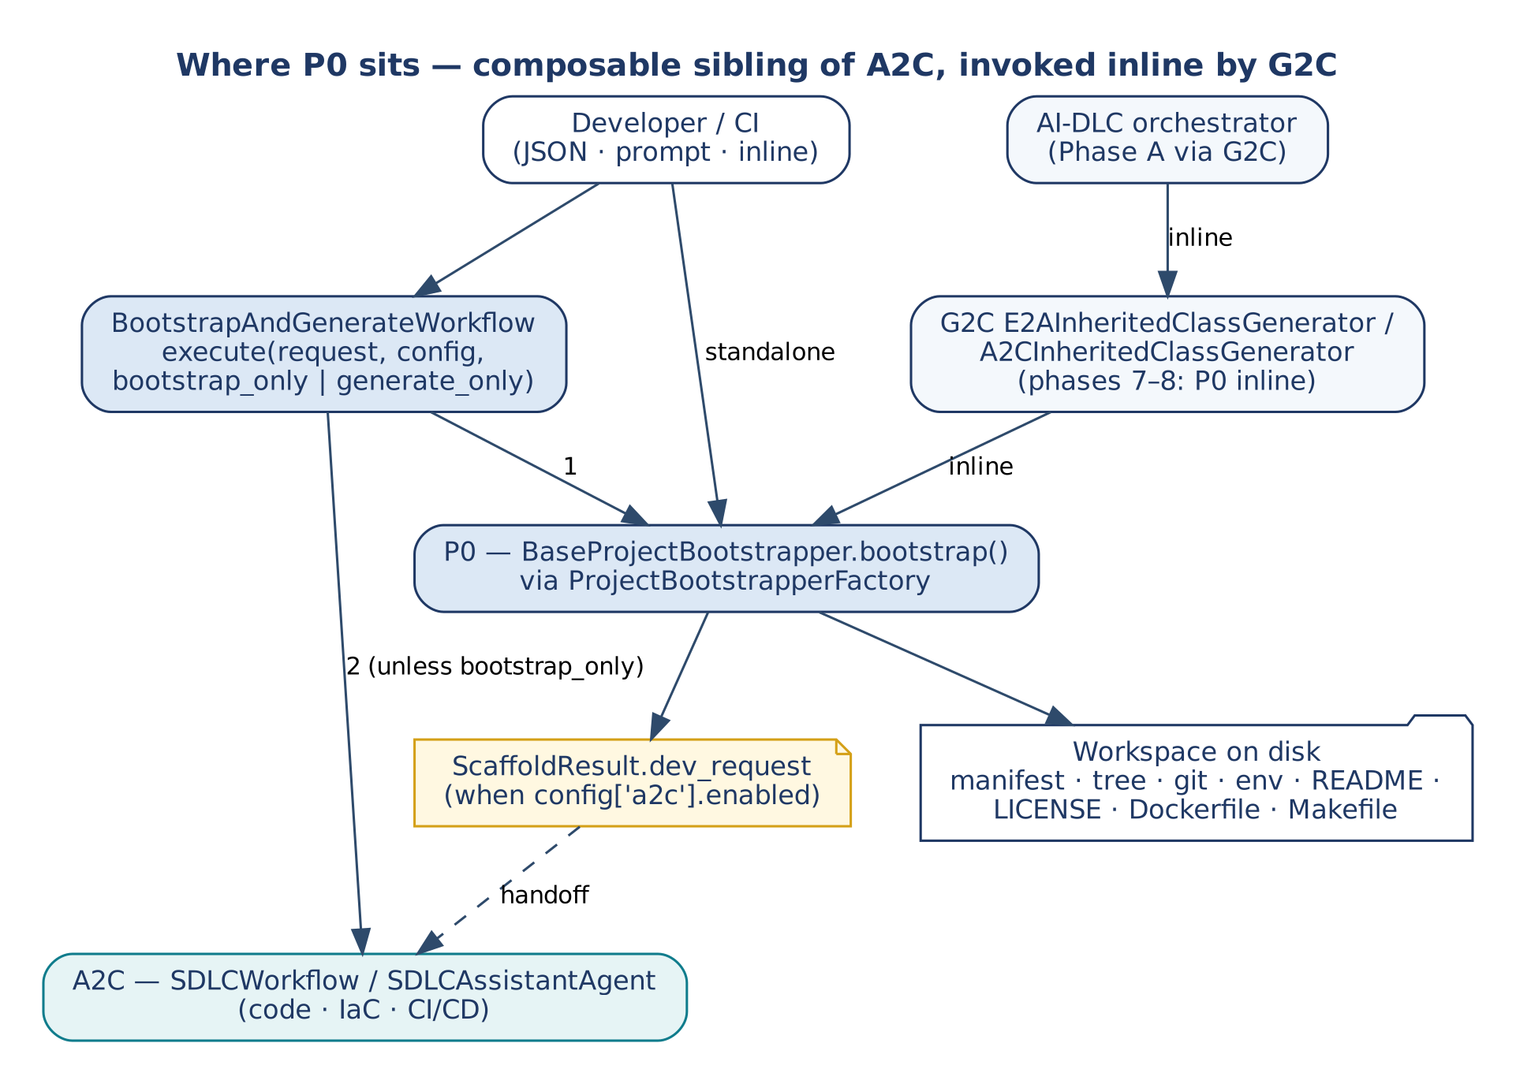
Figure 1 — Where P0 sits: composable sibling of A2C, invoked inline by G2C
P0 has three callers. A developer or CI job calls it directly or through BootstrapAndGenerateWorkflow; G2C's inherited-class generators call it inline when the request carries a scaffold section; the AI-DLC orchestrator reaches it only through G2C. P0's outputs are the workspace on disk and, optionally, dev_request.

5.2 Components
Component | Responsibility
BaseProjectBootstrapper | Owns the sequence, guards, claim, file writing, SLO, logging, A2C handoff.
Concrete bootstrappers | Own the content: manifest, tree, git rules, env templates, README, Docker, Makefile.
resolve_scaffold_request() | Turns a JSON or prompt request into an inline ScaffoldRequest.
ProjectBootstrapperFactory | Maps (runtime, build_tool) to a bootstrapper class, resolving the request first when needed.
BootstrapAndGenerateWorkflow | Composes P0 and A2C: scaffold, validate the dev_request, run SDLCWorkflow.
a2c_concurrency.ClaimGuard | One claim per key, settled exactly once; works with any claim/complete/fail store.
config['llm_service'] | Inference gateway for prompt resolution (E2A BaseLLMAgentService).

5.3 Configuration sources
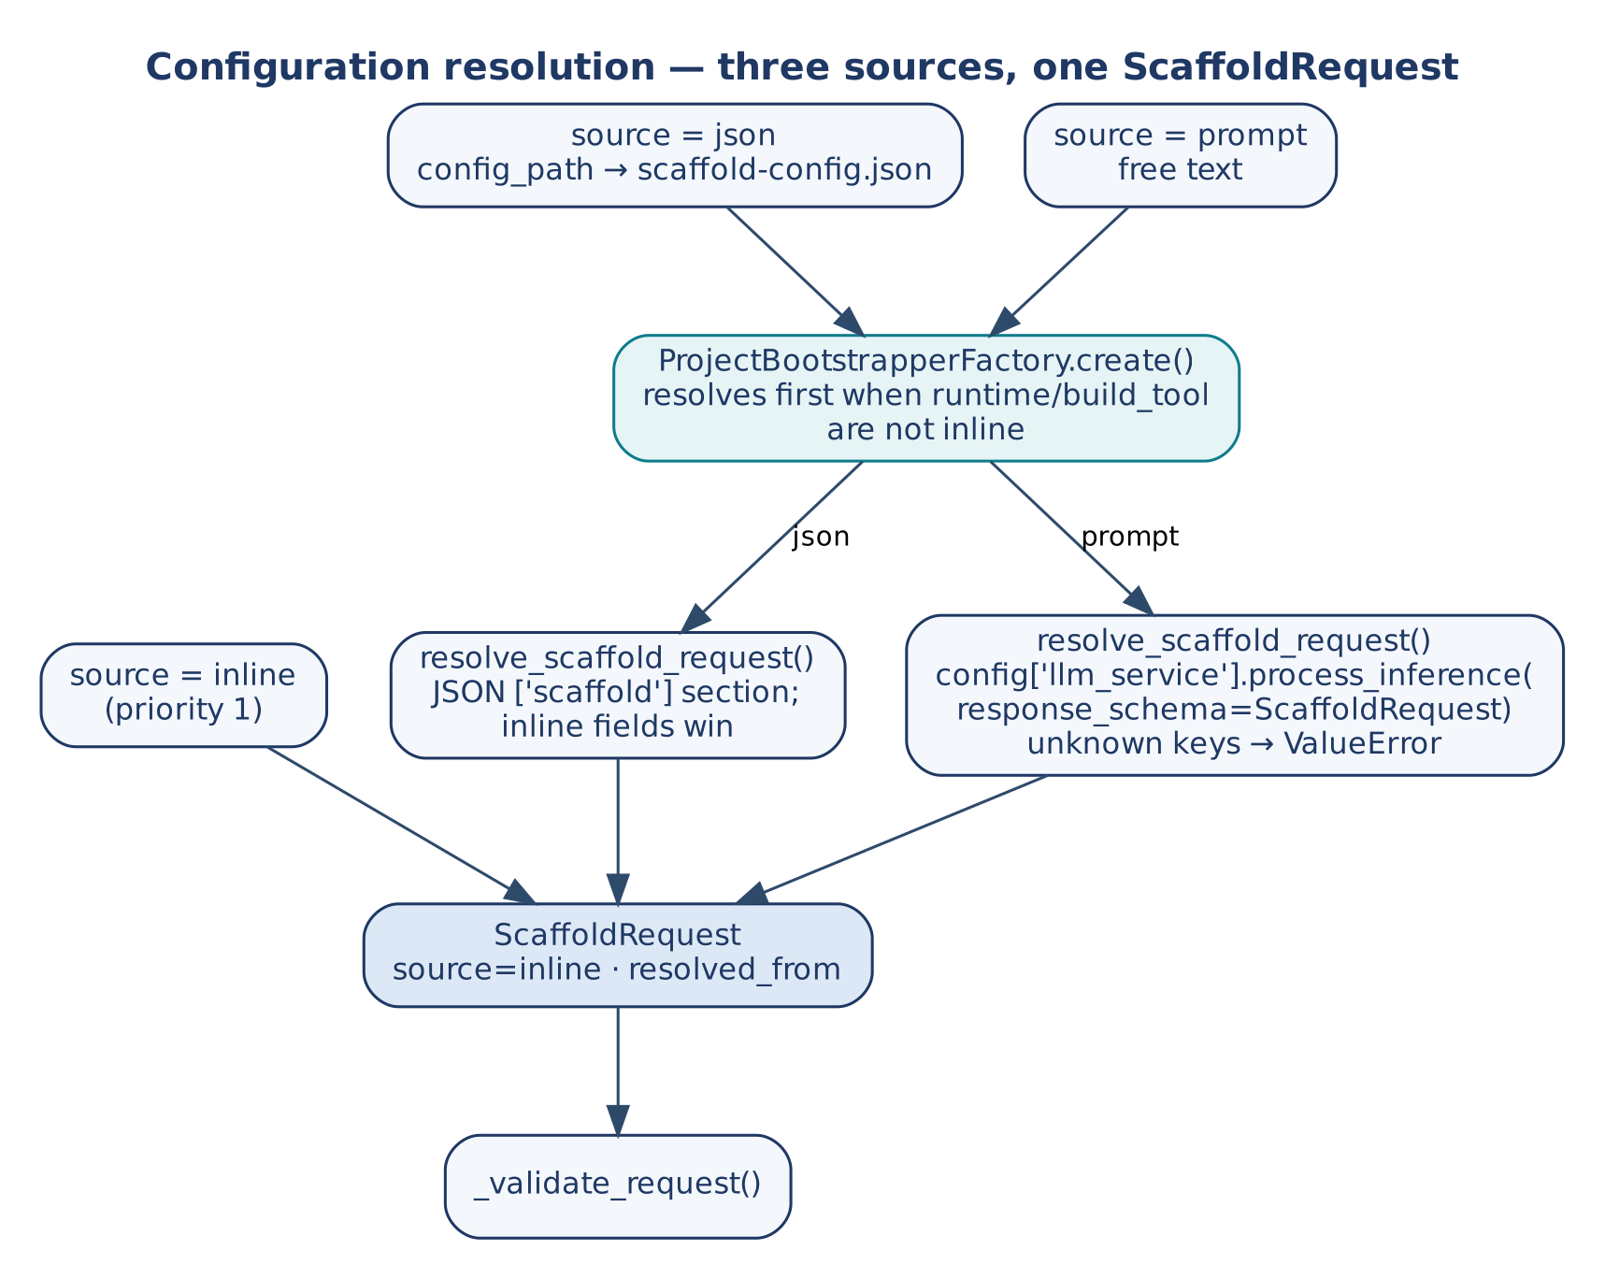
Figure 2 — Configuration resolution: three sources, one ScaffoldRequest
Priority | Source | How to use
1 | Inline (source='inline', default) | Pass a complete ScaffoldRequest. Inline fields also win over loaded ones.
2 | JSON (source='json') | config_path → scaffold-config.json; the scaffold section is merged under the inline fields.
3 | Prompt (source='prompt') | Free text resolved by the inference gateway with response_schema=ScaffoldRequest; unknown keys are rejected.

A resolved request has source='inline' and resolved_from='json'|'prompt', so it is never resolved twice. The factory resolves a JSON or prompt request that lacks runtime or build_tool before choosing the class.

5.4 Deployment
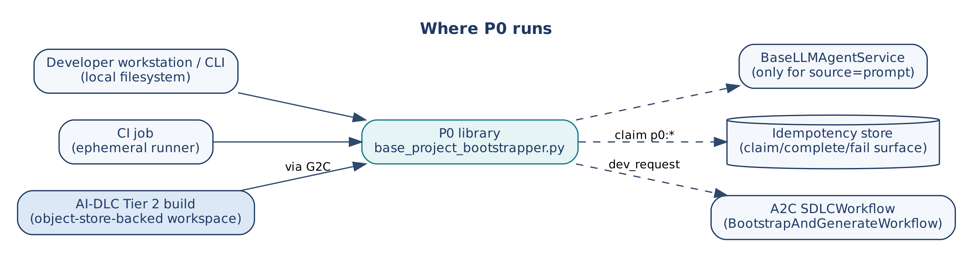
Figure 3 — Where P0 runs
P0 is a library, not a service. It runs in-process on a workstation, a CI runner, or inside the AI-DLC Tier 2 build (through G2C). Its external dependencies are the filesystem, the inference gateway (prompt source only), the claim store (multi-process deployments) and, through BootstrapAndGenerateWorkflow, A2C's a2c_base with E2A's e2a_base on the import path.

6. Data Contracts
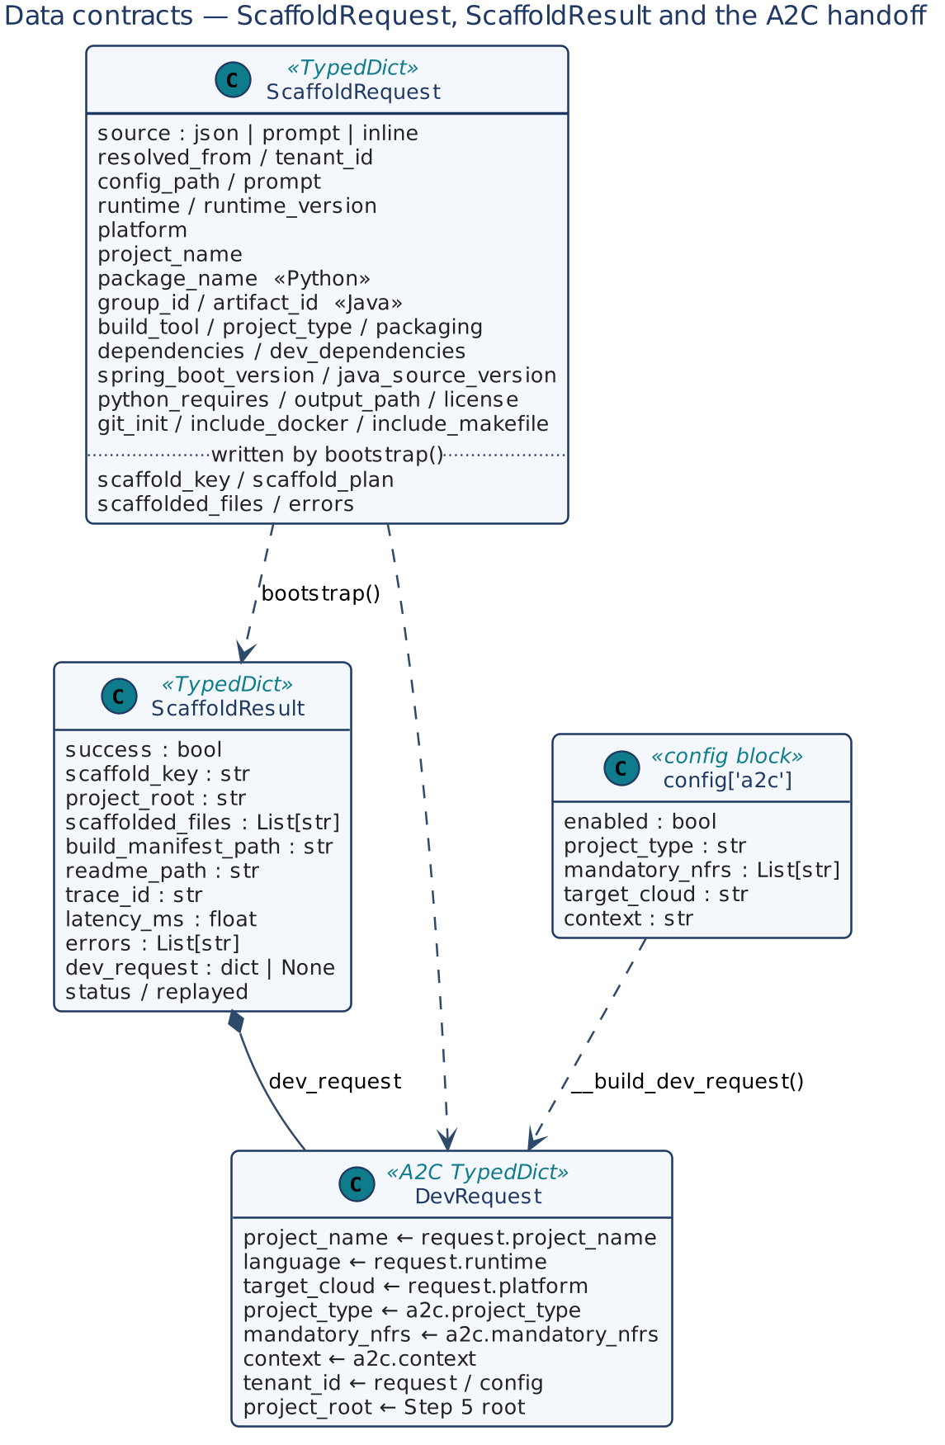
Figure 4 — ScaffoldRequest, ScaffoldResult and the A2C handoff

6.1 ScaffoldRequest
Table 3 — ScaffoldRequest fields
Field | Type | Meaning
source | str | inline (default), json, prompt.
config_path / prompt | str | Input for the json / prompt sources.
resolved_from | str | Written on resolution: json or prompt.
tenant_id | str | Scopes the claim; copied into dev_request.
runtime, runtime_version | str | python, java, node, go; version string.
platform | str | aws, gcp, azure, standalone.
build_tool | str | Per runtime: poetry/pip, maven/gradle, npm/yarn, go_modules.
project_type | str | Drives the tree. Required for Java; Python defaults to fastapi_microservice (logged).
project_name | str | Directory name and first part of scaffold_key.
package_name | str | Python package (required by Poetry).
group_id, artifact_id, packaging | str | Java coordinates (required by Maven).
spring_boot_version, java_source_version, python_requires | str | Toolchain versions.
dependencies, dev_dependencies | List[str] | Declared dependencies; Spring Boot starters by short name.
output_path | str | Parent directory of the project root (request › config › env › ./).
license | str | Apache-2.0 (default), MIT, PROPRIETARY (no file).
git_init, include_docker, include_makefile | bool | Optional artifacts (default true).
scaffold_key, scaffold_plan, scaffolded_files, errors | — | Written on the internal copy of the request.

6.2 ScaffoldResult
Field | Type | Meaning
success | bool | Overall outcome.
status | str | scaffolded, replay, in_progress, conflict, recovery_required, failed_final.
replayed | bool | True when a stored result or the existing project is returned.
scaffold_key | str | project_name:runtime:build_tool:platform.
project_root | str | Absolute project root (also on replay).
scaffolded_files | List[str] | Every file written, including package markers created by _scaffold_structure().
build_manifest_path, readme_path | str | Required outputs checked by Step 14.
trace_id, latency_ms, errors | — | Observability.
dev_request | dict | A2C DevRequest (Section 6.3).

6.3 The A2C handoff
__build_dev_request() maps the scaffold onto A2C's DevRequest, so nothing is re-typed:
DevRequest field | Source
project_name | request.project_name
language | request.runtime (default python)
target_cloud | request.platform, else a2c.target_cloud, else aws
project_type | config['a2c'].project_type, else request.project_type
mandatory_nfrs | config['a2c'].mandatory_nfrs (copied)
context | config['a2c'].context
tenant_id | request.tenant_id, else config.tenant_id (A2C's workflow requires it)
project_root | Step 5 root (A2C writes its artifacts there)

DevRequest (A2C) and GeneratorRequest (G2C) are distinct contracts; P0 produces only the former.

6.4 scaffold-config.json
A combined file carries a required scaffold section (the ScaffoldRequest) and an optional a2c section (enabled, project_type, mandatory_nfrs, target_cloud, context, handoff_only).
{
"scaffold": { "source": "json", "runtime": "python", "platform": "aws",
"build_tool": "poetry", "project_type": "fastapi_microservice",
"project_name": "SettlementEngine", "package_name": "settlement_engine",
"output_path": "./generated/", "license": "Apache-2.0" },
"a2c": { "enabled": true, "project_type": "FastAPI Microservice",
"mandatory_nfrs": ["Idempotency", "Observability"],
"target_cloud": "aws",
"context": "Financial settlement microservice with saga orchestration" }
}

6.5 Configuration keys
Key | Read by | Default
output_path / env BOOTSTRAP_OUTPUT_PATH | __output_base (Step 3 check and Step 5) | ./
max_latency_ms / env BOOTSTRAP_MAX_LATENCY_MS | Step 15 | 10 000 ms
scaffold_idempotency_store or idempotency_store | Step 3 claim | none (single-process)
claim_lease_seconds | Step 3 claim | 300
tenant_id | Claim scope, dev_request | —
a2c (enabled, handoff_only, …) | Step 16, BootstrapAndGenerateWorkflow | disabled
a2c_dev_request | BootstrapAndGenerateWorkflow (generate-only) | —
validation_service | BootstrapAndGenerateWorkflow | DevPlatformValidationService()
llm_service, model_id | Prompt resolution | —

7. Low-Level Design — Class Model
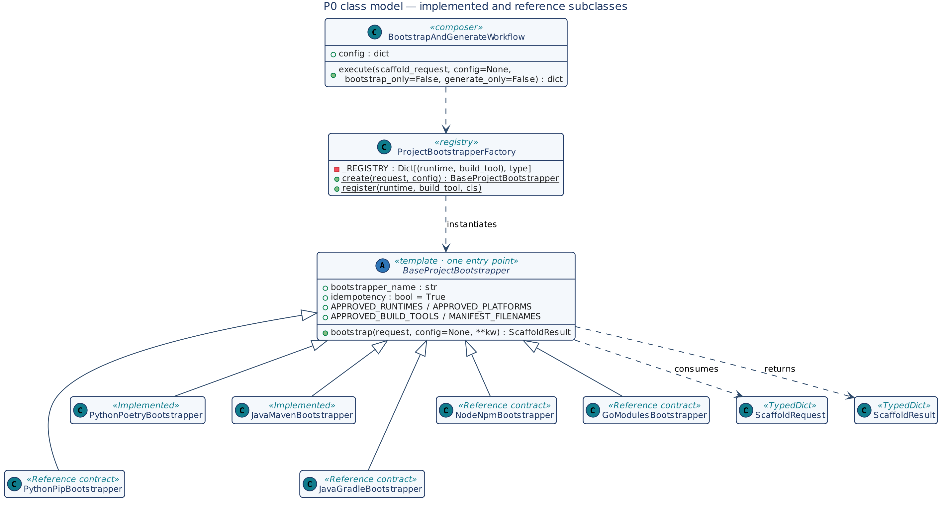
Figure 5 — P0 class model
Class | Kind | Role
BaseProjectBootstrapper | ABC | Template with one entry point and eight abstract hooks.
PythonPoetryBootstrapper | Concrete | Python + Poetry.
JavaMavenBootstrapper | Concrete | Java + Maven (Spring Boot).
Pip / Gradle / Npm / Go bootstrappers | Reference contract | See Table 6.
ProjectBootstrapperFactory | Registry | Class-method create / register.
BootstrapAndGenerateWorkflow | Composer | Not a BaseWorkflow subclass: it coordinates two frameworks rather than routing agent intent.

8. Low-Level Design — Class Contracts

8.1 BaseProjectBootstrapper
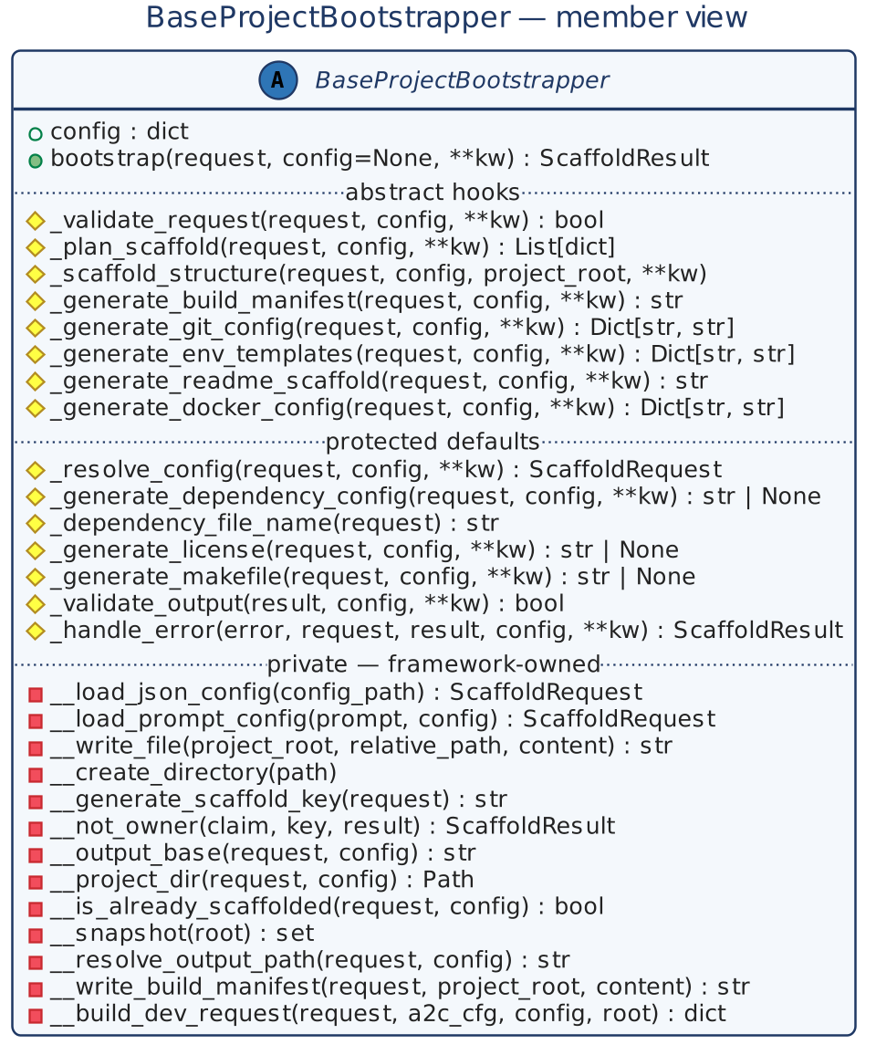
Figure 6 — BaseProjectBootstrapper member view
Aspect | Detail
Class attributes | bootstrapper_name; idempotency = True; APPROVED_RUNTIMES = [python, java, node, go]; APPROVED_PLATFORMS = [aws, gcp, azure, standalone]; APPROVED_BUILD_TOOLS per runtime; MANIFEST_FILENAMES per (runtime, build_tool).
State | config (constructor default; overridden per call).
Invariants | INV-01 to INV-09.

Table 4 — BaseProjectBootstrapper methods
Method | Kind | Signature → returns | Contract
bootstrap | entry | (request, config=None, **kw) → ScaffoldResult | Copies the request, then runs the 16 steps of Section 9.1. Never overridden, never raises for a step failure.
_validate_request | abstract | (request, config, **kw) → bool | Required fields and approved runtime/platform/build tool. False → ValueError, no writes, no claim.
_plan_scaffold | abstract | (request, config, **kw) → List[dict] | Ordered {step, file, description} list, stored in scaffold_plan.
_scaffold_structure | abstract | (request, config, project_root, **kw) | Create the directory tree and package marker files.
_generate_build_manifest | abstract | (request, config, **kw) → str | Full manifest content.
_generate_git_config | abstract | (request, config, **kw) → Dict[path, str] | .gitignore and .gitattributes.
_generate_env_templates | abstract | (request, config, **kw) → Dict[path, str] | .env.example or application*.yml.
_generate_readme_scaffold | abstract | (request, config, **kw) → str | Name, badges, E2A link, structure tree.
_generate_docker_config | abstract | (request, config, **kw) → Dict[path, str] | Multi-stage Dockerfile, non-root UID 1001, HEALTHCHECK; .dockerignore.
_resolve_config | default | (request, config, **kw) → ScaffoldRequest | resolve_scaffold_request(): JSON or prompt, inline fields win.
_generate_dependency_config | default | (request, config, **kw) → str or None | Secondary dependency file; default None.
_dependency_file_name | default | (request) → str | Default requirements.txt.
_generate_license | default | (request, config, **kw) → str or None | Apache-2.0 (default), MIT, or None for PROPRIETARY.
_generate_makefile | default | (request, config, **kw) → str or None | Targets install, test, lint, build, run, docker-build, clean.
_validate_output | default | (result, config, **kw) → bool | Manifest and README paths are in scaffolded_files. False → claim settled final.
_handle_error | default | (error, request, result, config, **kw) → ScaffoldResult | Log, append error, success=False. Override for alerting or cleanup.
__generate_scaffold_key | private | (request) → str | project_name:runtime:build_tool:platform.
__not_owner | private | (claim, key, result) → ScaffoldResult | Typed outcome for a non-owner: stored result on REPLAY; in_progress, conflict, recovery_required, failed_final otherwise.
__output_base / __project_dir | private | (request, config) → str / Path | One resolution rule: request › config › env › ./, joined with project_name.
__is_already_scaffolded | private | (request, config) → bool | Fast path after the claim: the Step 5 directory exists and is non-empty.
__snapshot | private | (root) → set | Files under root; used to record files created by _scaffold_structure().
__resolve_output_path | private | (request, config) → str | __project_dir resolved and created.
__write_file, __create_directory, __write_build_manifest | private | — | mkdir -p; UTF-8 write; manifest name from MANIFEST_FILENAMES.
__load_json_config, __load_prompt_config | private | — | Thin wrappers over the module loaders.
__build_dev_request | private | (request, a2c_cfg, config, project_root) → dict | Mapping of Section 6.3.

Module functions: resolve_scaffold_request(request, config) → dict, _load_json_scaffold(path), _load_prompt_scaffold(prompt, config) (gateway call through a2c_concurrency.run_coro_sync).

8.2 Concrete bootstrappers
Table 5 — Implemented bootstrappers
Aspect | PythonPoetryBootstrapper | JavaMavenBootstrapper
Required fields | project_name, runtime, platform, build_tool, package_name | project_name, runtime, platform, build_tool, group_id, artifact_id, project_type
Extra checks | runtime=python, build_tool=poetry, platform approved | runtime=java, build_tool=maven, platform approved
Tree | src/<pkg>/{models,services,routers,tools,config}, tests/, .github/workflows/; +agents, rag, workflows for langgraph_agent | src/main/java/<group>/{config,domain,service,controller,repository}, src/main/resources, src/test/java/<group>, .github/workflows/
Manifest | pyproject.toml (Poetry) | pom.xml (Spring Boot parent)
Env templates | .env.example (AWS/GCP/Azure + E2A NFR keys) | application.yml, -dev, -prod
Docker | Multi-stage Python, UID 1001, HEALTHCHECK /health | Multi-stage Temurin, non-root, HEALTHCHECK /actuator/health
Makefile | Poetry commands | Maven commands

Python layout (UC-1; the tree mirrors the E2A tiers):
SettlementEngine/
pyproject.toml .gitignore .gitattributes .env.example README.md
LICENSE Dockerfile .dockerignore Makefile
.github/workflows/ CI/CD directory (content from A2C)
src/settlement_engine/
__init__.py
config/ models/ services/ routers/ tools/ each with __init__.py
agents/ rag/ workflows/ (langgraph_agent only)
tests/

Table 6 — Reference-contract bootstrappers
Class | Build tool | Project types | Key overrides
PythonPipBootstrapper | pip | fastapi_microservice, lambda, library | setup.cfg manifest; requirements.txt via _generate_dependency_config.
JavaGradleBootstrapper | gradle | spring_boot, library | build.gradle.kts; Gradle-wrapper Makefile.
NodeNpmBootstrapper | npm | express_api, next_app, library | package.json with scripts.
GoModulesBootstrapper | go_modules | http_service, cli, library | go.mod; cmd/, internal/, pkg/ layout.

8.3 ProjectBootstrapperFactory
Method | Kind | Signature → returns | Contract
create | classmethod | (request, config=None) → BaseProjectBootstrapper | If source is json/prompt and runtime or build_tool is missing, resolve the request in place first. Look up (runtime, build_tool); unregistered → ValueError listing registered keys; instantiate with config.
register | classmethod | (runtime, build_tool, cls) | Add or replace a registry entry at import time.

8.4 BootstrapAndGenerateWorkflow
Method | Kind | Signature → returns | Contract
__init__ | ctor | (config=None) | Store default config.
execute | entry | (scaffold_request, config=None, bootstrap_only=False, generate_only=False) → dict | Unless generate_only: factory → bootstrap(); failure → {success: False, errors}; bootstrap_only returns after P0. Then dev_request = scaffold result's or config['a2c_dev_request'] (generate_only without one → error). With config['a2c'].handoff_only return {status: 'ready', dev_request}. Otherwise validate with config['validation_service'] or DevPlatformValidationService (invalid → INVALID, errors) and run SDLCWorkflow(config).execute(dev_request, config); its errors or a typed non-success status fail the call. Returns {success, scaffold_result, generation_result, errors}; exceptions are caught.

The A2C phase needs a2c_base.py and e2a_base.py importable; if they are not, the call fails with an explicit message pointing to handoff_only.

9. Dynamic Behaviour

9.1 bootstrap() sequence
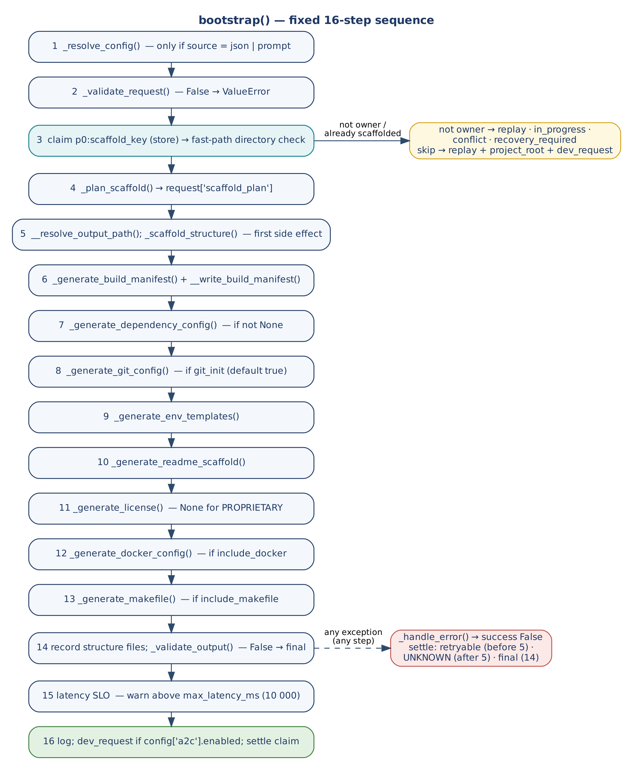
Figure 7 — bootstrap(): fixed 16-step sequence
Step | Action | Condition
1 | _resolve_config() | source is json or prompt
2 | _validate_request() | Always; False → abort before the claim
3 | Key; claim p0:<key>; then directory fast path | Claim if a store is set; fast path if idempotency=True
4 | _plan_scaffold() | Always
5 | __resolve_output_path() + _scaffold_structure() | Always; first side effect
6 | Manifest | Always
7 | Dependency file | Hook returns content
8 | Git config | git_init (default true)
9 | Env templates | Always
10 | README | Always
11 | LICENSE | Not PROPRIETARY
12 | Docker | include_docker (default true)
13 | Makefile | include_makefile (default true)
14 | Record structure files; _validate_output() | Always; False → abort, claim final
15 | Latency SLO | Warn above max_latency_ms
16 | Log; dev_request; settle claim | dev_request when config['a2c'].enabled

9.2 Composition modes
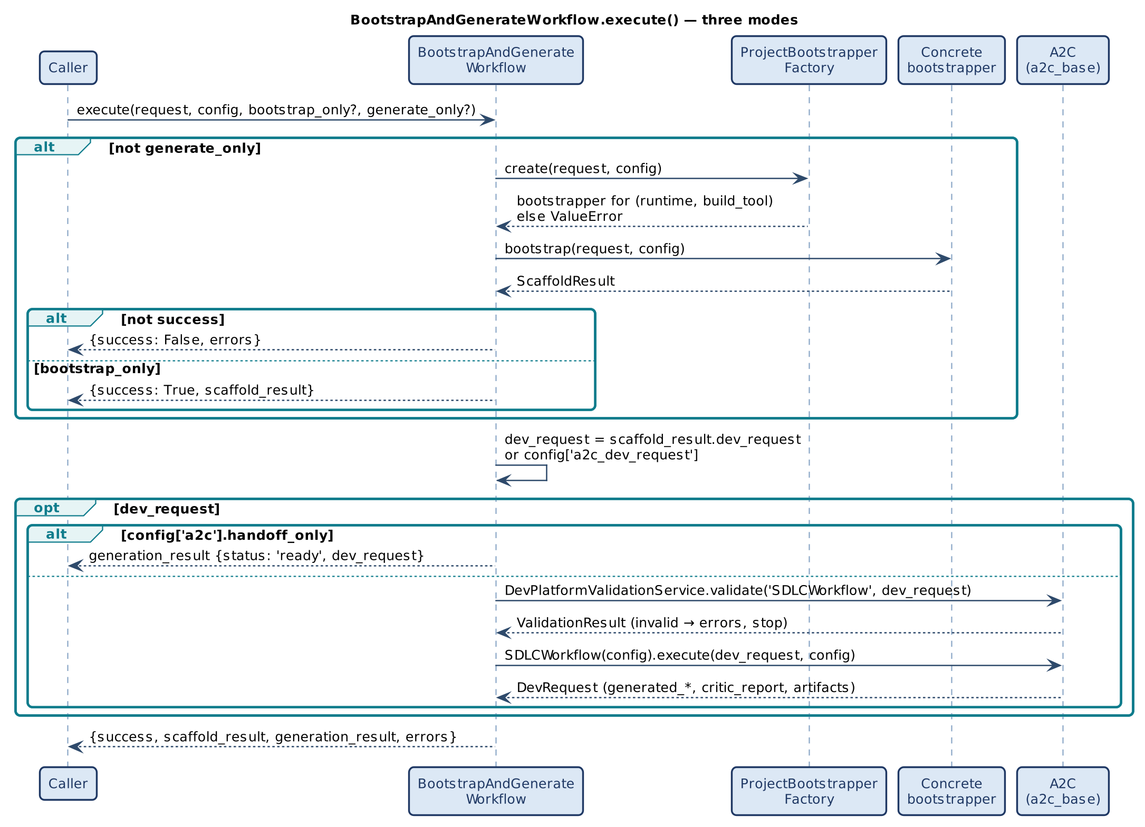
Figure 8 — BootstrapAndGenerateWorkflow.execute(): modes and the A2C phase

9.3 Error path
Any exception in Steps 1–16 goes to _handle_error(), which returns success=False with the message in errors. Before that, the claim is settled: retryable before Step 5, UNKNOWN after Step 5 began, final when Step 14 failed. A finally block settles any claim still open (for example on cancellation). Files already written stay on disk; the default handler performs no rollback.

10. Concurrency and Failure

10.1 Atomic claim
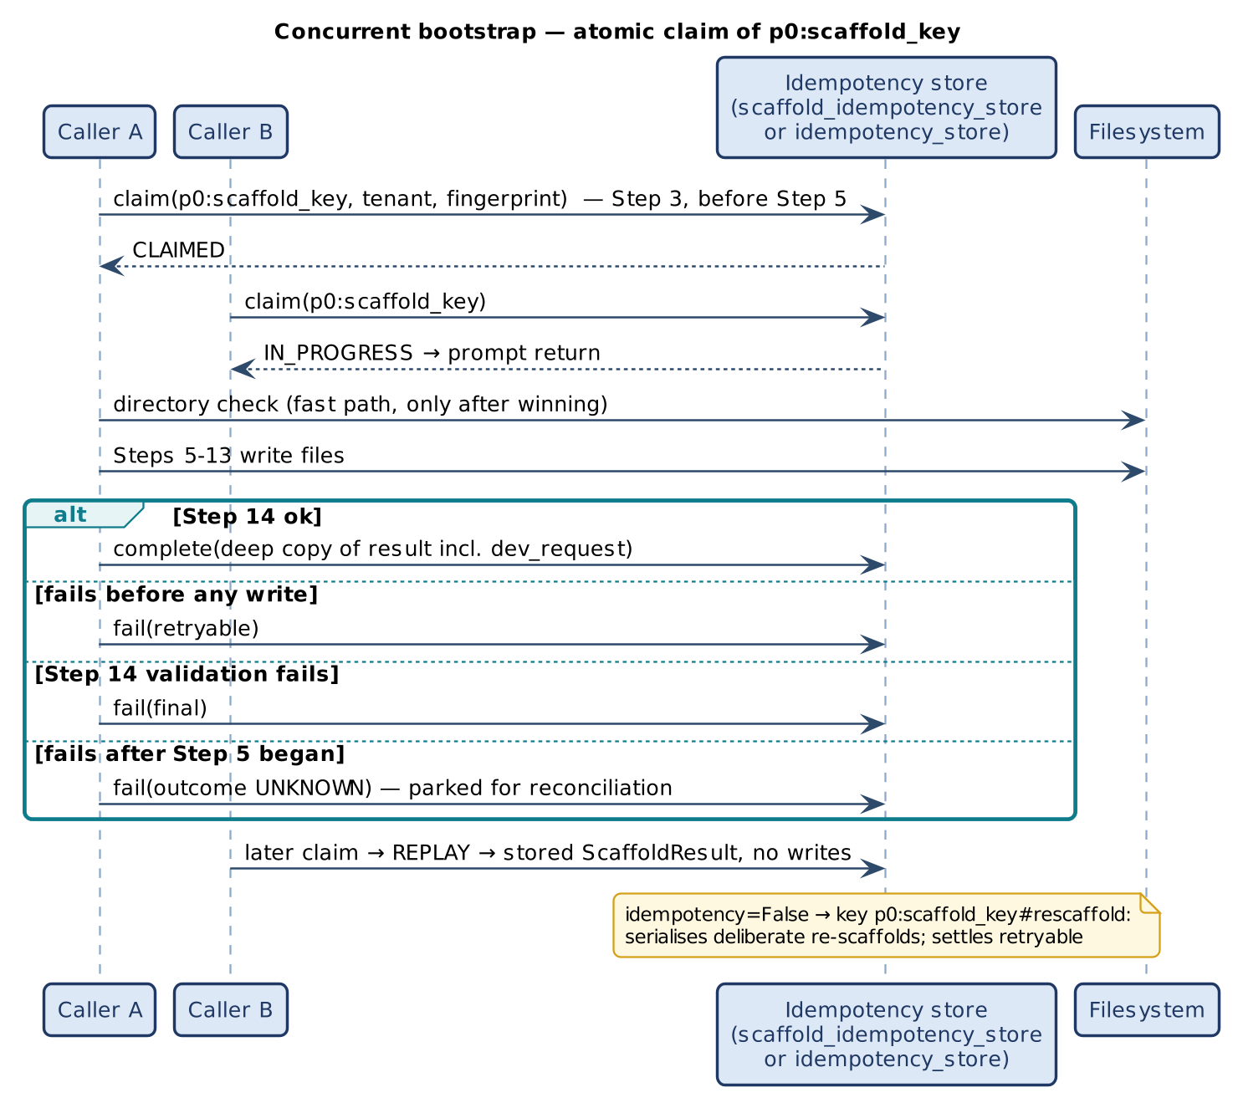
Figure 9 — Concurrent bootstrap: atomic claim of p0:scaffold_key
Rule | Contract
Store | config['scaffold_idempotency_store'] or config['idempotency_store']; any object with E2A's claim/complete/fail surface (a2c_concurrency.InMemoryClaimStore, E2A's InMemoryIdempotencyStore, a managed-store adapter). Without a store the guarantee is single-process.
Key | p0:<scaffold_key>, scoped by tenant_id; fingerprint = hash of the request's business fields. The p0: namespace keeps P0 from colliding with a composing caller's key of the same shape (AI-DLC's build key).
Claim point | Step 3, after validation, before Step 5. The directory check runs only after the claim is won.
Outcomes | Claimed → proceed; succeeded → stored ScaffoldResult replayed (with dev_request), no writes; in progress → prompt in_progress; different fingerprint → conflict; expired or unknown → recovery_required; final → failed_final.
Settlement | Success after Step 14 (a deep copy is stored, so later changes to the returned object never change a replay); retryable before Step 5; final when Step 14 fails; UNKNOWN after Step 5 began (parked for reconciliation, never blindly re-run).
Deliberate re-scaffold | idempotency=False claims p0:<key>#rescaffold as mutual exclusion and settles retryable, so the next deliberate run can claim again.

10.2 Failure matrix
Failure | Behaviour
Unregistered runtime/build tool | Factory ValueError; workflow returns success=False.
Invalid request | ValueError at Step 2; no files, no claim.
Prompt gateway failure | RuntimeError / ValueError at Step 1.
Write error mid-sequence | success=False; claim UNKNOWN; partial workspace remains.
Missing manifest or README | Step 14 abort; claim final.
Duplicate while running | in_progress, no wait.
Slow run | Warning log only.
Invalid dev_request | BootstrapAndGenerateWorkflow returns INVALID before A2C runs.

11. Non-Functional Design
Table 7 — NFRs enforced by structure
NFR | Enforcement | Artifact
Non-root container | Multi-stage build; useradd/adduser UID 1001 | Dockerfile
Health probes | HEALTHCHECK on /health or /actuator/health | Dockerfile
No secrets in git | .gitignore excludes .env, *.key, chroma_db/, *.zip, .venv/ | .gitignore
Env-driven config | Model IDs, endpoints, thresholds as registry keys | .env.example
Multi-cloud portability | Platform-specific variables for AWS/GCP/Azure | .env.example
Tier alignment | models/ services/ routers/ tools/ mirror E2A layers | Tree
CI/CD readiness | .github/workflows/; Makefile targets match pipeline stages | Makefile
Idempotency under concurrency | Atomic claim; directory fast path | bootstrap() Step 3
Latency | 10 s SLO warning | Step 15
Observability | Structured log: bootstrapper, key, trace_id, latency, file count, root | Step 16

Security: P0 holds no credentials; prompt resolution goes through the inference gateway, which owns model choice, quota, DLP and latency limits.

12. Extension Guide
# | Rule | Required
1 | Set bootstrapper_name. | Yes
2 | ProjectBootstrapperFactory.register(runtime, build_tool, cls). | Yes
3 | Override the eight abstract hooks. | Yes
4 | Override _generate_dependency_config + _dependency_file_name when dependencies are not in the manifest. | If pip/yarn
5 | Override _generate_makefile, _validate_output, _handle_error. | Recommended
6 | Override _resolve_config only to add a new source. | Optional
7 | Never override bootstrap() or call private methods from outside. | Never
8 | Keep claim and settlement in the base class. | Never

class NodeNpmBootstrapper(BaseProjectBootstrapper):
bootstrapper_name = 'NodeNpmBootstrapper'

def _validate_request(self, request, config=None, **kw) -> bool:
need = ['project_name', 'runtime', 'platform', 'build_tool', 'project_type']
return (all(k in request for k in need)
and request['runtime'] == 'node' and request['build_tool'] == 'npm'
and request['platform'] in self.APPROVED_PLATFORMS)

def _plan_scaffold(self, request, config=None, **kw):
return [{'step': 1, 'file': 'package.json', 'description': 'npm manifest'}]

def _scaffold_structure(self, request, config=None, project_root='./', **kw):
for d in ('src/routes', 'src/services', 'src/models', 'tests', '.github/workflows'):
Path(project_root, d).mkdir(parents=True, exist_ok=True)

def _generate_build_manifest(self, request, config=None, **kw) -> str: ...
def _generate_git_config(self, request, config=None, **kw): ...
def _generate_env_templates(self, request, config=None, **kw): ...
def _generate_readme_scaffold(self, request, config=None, **kw) -> str: ...
def _generate_docker_config(self, request, config=None, **kw): ...

ProjectBootstrapperFactory.register('node', 'npm', NodeNpmBootstrapper)

13. Verification
Table 8 — Evidence at the baseline
Suite / check | Result
smoke_test_generator_concurrency.py (P0 part) | 6 concurrent bootstraps of one target: exactly one writes, others in_progress/replay; replay returns the stored result and the same dev_request; different request → conflict; Step 14 failure → FAILED_FINAL; failure after Step 5 → UNKNOWN then recovery_required; failure before Step 5 → retryable then success; idempotency=False serialises; no store → directory fast path.
smoke_test_a2c.py (P0 → A2C) | BootstrapAndGenerateWorkflow scaffolds, validates and runs SDLCWorkflow; A2C artifacts land in the P0 workspace.
smoke_test_g2c_contract.py | P0 inline from G2C; Java without project_type → typed scaffold_failed.
smoke_test_aidlc_integration.py | AI-DLC build over the real modules: P0's claim does not collide with the orchestrator's claim; build reaches E2A_VERIFIED.
Probe: JSON request with no inline runtime/build_tool | Factory resolves it; 15 files scaffolded.
Probe: prompt request | Resolved through the gateway double; success.
Probe: git_init=False | No .gitignore/.gitattributes; caller's request unchanged.
Probe: request-level output_path | Honoured by both the check and Step 5; skip returns project_root and dev_request (with tenant_id, project_root).
Probe: caller mutates a returned dev_request | A later replay is unaffected.

14. Implementation Reality, Gaps and Design Observations
The defects recorded against the earlier baseline are fixed on this branch: the missing a2c_concurrency module (every import failed); the idempotency check ignoring a request output_path; the skip result without project_root or dev_request; unreachable prompt resolution and the JSON-only resolvers; git_init ignored; request mutation; unrecorded structure files; Java project_type not required; the placeholder A2C phase; claim-key collision with AI-DLC; and replay results aliased to live objects.
Table 9 — Remaining observations
ID | Observation | Effect | Recommendation
O-1 | Pip, Gradle, Npm and Go bootstrappers are not implemented. | Only Python/Poetry and Java/Maven can be scaffolded. | Implement against Table 6.
O-2 | Step 15 reads BOOTSTRAP_MAX_LATENCY_MS from the environment rather than the E2A configuration registry (P0 does not import e2a_base). | Resolution order matches the registry, but the key is not listed in the generated reference table. | Register the key when e2a_base is available.
O-3 | No rollback after a failure past Step 5. | The claim parks UNKNOWN; an operator or reconciler must clean up. | Add a reconciler that compares scaffold_plan with the directory.
O-4 | Python requests without project_type default to fastapi_microservice. | Explicit but silent for callers that ignore logs. | Require it for Python too once callers are updated.
O-5 | Without a store the guarantee is single-process. | Two processes can interleave writes. | Configure a claim store in multi-process deployments.
O-6 | All tests use in-memory doubles. | Not validated against a live store, gateway or load. | Add an adapter test against a managed store.

Appendix A. Glossary
Term | Definition
P0 / Phase Zero | The bootstrap step that precedes all code generation.
scaffold_key | project_name:runtime:build_tool:platform; claimed as p0:<scaffold_key>.
Handoff | ScaffoldResult.dev_request consumed by A2C.
Composable siblings | P0 and A2C: independent frameworks composed by BootstrapAndGenerateWorkflow.
Correct by structure | An NFR produced by a code path rather than a prompt.
Fast path | The directory check consulted only after the claim is won.

Appendix B. Traceability
Goal / invariant | Element | Anchor (base_project_bootstrapper.py)
G-1, INV-01 | bootstrap() | L256–465
G-3 | resolve_scaffold_request, _resolve_config | L166, L485
INV-02 | Step 2 | L301
G-4, INV-03 | Step 3 claim (p0: key) and fast path | L309–340
INV-04 | __output_base, __project_dir, __is_already_scaffolded | L700–716
INV-06 | _validate_output | L625
G-5, INV-07 | __build_dev_request; skip result | L740, L327–340
Typed outcomes | __not_owner | L682
G-6 | ProjectBootstrapperFactory | L1334
Composition | BootstrapAndGenerateWorkflow (validation L1472) | L1396–1492
Claim mechanics | a2c_concurrency.ClaimGuard | a2c_concurrency.py L150–220

