SOFTWARE DESIGN DOCUMENT
G2C Generate-to-Class Framework
High-Level and Low-Level Design

This document describes G2C, the framework of E2A-governed generator agents that produce E2A abstract classes, A2C abstract classes and their inherited concrete classes, scaffolding the project through P0 inline. Since v1.2 it generates Python agents for the E2A v1.2 contract and, from one request, the whole agent layer of a service: several agents, their workflow, governance, validation, tool stubs and tests. It covers the problem, use cases, HLD, data contracts, class and method contracts, the Phase Trigger decision model and the concurrency contract, so that a reader can form a complete mental model of G2C without opening the Python source.
Framework | G2C — Generate-to-Class (top layer of the E2A / A2C / P0 framework stack)
Document type | Design Document (HLD + LLD)
Author | Subham Gupta, Principal Platform Architect
Source baseline | subhamviky/a2c-framework v1.2.0 — g2c_v12.py (v1.2), base_generator_agent.py, inherited_generator.py, the four generators, generator_critic_agent.py, generator_templates.py, generator_factory.py, developer_platform_workflow.py, generator_api_router.py, typedicts.py, a2c_concurrency.py
Date | 13 November 2026 (v1.2.0; baseline 7 November 2026)
Status | Aligned to A2C v1.2.0 and its smoke tests (wave C, design note C-01)

Contents
1. Introduction 4
1.1 Purpose 4
1.2 Audience 4
1.3 Status 4
1.4 Related documents 5
2. Problem Statement and Motivation 6
2.1 The problem 6
2.2 Approach 6
2.3 Design goals 6
3. Core Use Cases 7
3.1 Actors 7
3.2 Use-case catalogue 7
3.3 Non-goals 8
4. Design Principles and Invariants 9
4.1 Principles 9
4.2 Invariants 9
5. High-Level Design 10
5.1 Context 10
5.2 Components 11
5.3 Generation chain 12
5.4 Abstract-class sources 13
5.5 API 14
5.6 E2A v1.2 generation and several agents (v1.2) 15
6. Data Contracts 17
6.1 GeneratorRequest 18
6.2 GeneratorResult 18
6.3 generator-config.json 19
6.4 Configuration keys 19
7. Low-Level Design — Class Model 20
8. Low-Level Design — Class Contracts 21
8.1 BaseGeneratorAgent 21
8.2 E2AAbstractClassGenerator 23
8.3 A2CAbstractClassGenerator 23
8.4 BaseInheritedClassGenerator and the two inherited generators 23
8.5 GeneratorCriticAgent 24
8.6 g2c_v12 (v1.2) 25
8.7 GeneratorFactory 25
8.8 DeveloperPlatformWorkflow 26
9. Dynamic Behaviour 27
9.1 generate() sequence 27
9.2 Critic routing 29
9.3 The second phase 29
9.4 Phase Trigger decision model 30
10. Concurrency and Failure 32
11. Non-Functional Design 33
12. Extension Guide 34
13. Verification 35
14. Implementation Reality, Gaps and Design Observations 36
Appendix A. Glossary 37
Appendix B. Traceability 38

1. Introduction

1.1 Purpose
E2A defines how governed agentic services are built; A2C uses governed agents to generate software; P0 scaffolds projects. G2C (Generate-to-Class) sits on top of all three: a developer supplies one GeneratorRequest (inline or generator-config.json) and G2C produces the class files — the E2A abstract base (e2a_base.py / E2ABase.java / e2aBase.ts / e2a_base.go), the A2C abstract base (a2c_base.py), or a concrete inherited class inside a P0-scaffolded project.
G2C is self-referential: every generator is itself an E2A-style agent. BaseGeneratorAgent follows the same three-layer contract as E2A's BaseAgent — one public entry point (generate()), protected hooks, private framework steps — and calls a model only through the E2A inference gateway (config['llm_service'], a BaseLLMAgentService). A GeneratorCriticAgent quality gate scores every output structurally before it is written. Without a gateway the generators run in template mode: they emit deterministic skeletons that pass the same critic, so the whole sequence works offline (CI, tests, air-gapped scaffolding).
Since v1.2 a Python e2a_inherited request targets the E2A v1.2 contract by default (e2a_contract: "1.2"): each generated hook declares only the parameters it uses (_prepare(state, ctx, io_read), _build_messages(state, ctx), _act(state, ctx, io_modify), …), and the class imports the installed e2a package. A request may declare several agents, the workflow that runs them and the governance stages (harness.agents, harness.workflow, harness.governance); G2C then writes all of them, with validation, tool stubs and tests (Section 5.6). Java and A2C's own SDLC agents stay on the v1.1 contract.
G2C always produces a class file. It never produces Terraform, CI/CD YAML or other infrastructure artifacts; those come from running A2C's SDLCWorkflow (with IaCAgent and CICDAgent) in an explicit second phase against a DevRequest.

1.2 Audience
Reader | Read first | Use the document to
Platform architect | Sections 2, 4, 5, 9.4 | Place G2C in the stack and choose the correct phase-trigger case.
Framework author | Sections 6–8, 12 | Implement or extend generators against the contract.
Platform engineer | Sections 5.5, 6, 10, 11 | Configure models, prompts, stores and the API.
Reviewer | Sections 4, 13, 14 | Check invariants, evidence and gaps.

1.3 Status
Every G2C class in this document is implemented at the baseline and exercised by the smoke tests in Section 13. Where a capability of the G2C Framework Reference is not implemented it is named in Section 14.
Table 1 — G2C elements and files
Element | File | Note
GeneratorRequest, GeneratorResult | typedicts.py | Full field set (Section 6).
BaseGeneratorAgent | base_generator_agent.py | 12-step generate(); claim; template mode.
BaseInheritedClassGenerator | inherited_generator.py | Abstract chain, P0 inline, base copy, class placement.
Four generators | e2a_/a2c_*_class_generator.py | Real files with runtime-correct names.
Skeletons | generator_templates.py | Python, Java, Node, Go (v1.1 contract).
E2A v1.2 generation | g2c_v12.py | Agents, workflow, governance, validation, tools and tests from the declaration (v1.2).
GeneratorCriticAgent | generator_critic_agent.py | Structural rules per critic type + concurrency rules.
GeneratorFactory | generator_factory.py | create(request, config), register().
DeveloperPlatformWorkflow | developer_platform_workflow.py | Flat GeneratorResult; shared-artifact registry; compensation.
GeneratorAPIRouter | generator_api_router.py | Five POST endpoints + health.
Claims, deadlines, artifact registry | a2c_concurrency.py | Mirrors E2A's claim/complete/fail and Deadline.

1.4 Related documents
Document | Relationship
G2C Framework Reference | Normative contract.
G2C Phase Trigger Decision Reference | Which phases to run per case; reconciled to canonical names in Section 9.4.
P0 Framework Design Document | Called inline by inherited generators.
A2C Framework Design Document | Content of a2c_base.py; the second-phase SDLCWorkflow run.
E2A Framework Design Document | BaseAgent contract the generated classes follow; BaseLLMAgentService.
E2A AI-DLC Profile Design Document | Calls DeveloperPlatformWorkflow(config).generate(request, config) in Phase A.

2. Problem Statement and Motivation

2.1 The problem
- Framework adoption is copy-paste. Teams that want an E2A agent copy e2a_base.py, guess which hooks to override and drift from the template.
- Unconstrained code generation ignores architecture. A model asked for "a refund agent" produces working code with no idempotency, no SLO, no governance and overridden entry points.
- Language spread. The same abstract layer is needed in Python, Java, Node and Go.
- Order of operations. An inherited class needs its abstract base and a scaffolded project first; doing these by hand in the wrong order overwrites tuned artifacts.
- Shared bases. Several services reference one abstract class; deleting it during a failed build breaks the others.

2.2 Approach
G2C turns the framework specifications into versioned system prompts, runs them through governed generator agents, and enforces structure with a critic that checks required classes, inheritance, overridden hooks, untouched entry points and the shared-gateway rules. The inherited generator resolves the order itself (abstract base, then P0, then the class) after its claim, so one call produces a consistent result and a repeat call is a no-op.

2.3 Design goals
ID | Goal
G-1 | One public entry point per generator with a fixed 12-step sequence.
G-2 | Runtime-agnostic output from Python generators (python, java, node, go).
G-3 | Every output passes a structural quality gate (score ≥ 0.75) or fails explicitly.
G-4 | Model calls only through the E2A inference gateway; no provider SDKs in generators.
G-5 | One call from request to inherited class, including abstract-class resolution and P0 scaffolding.
G-6 | Idempotent under concurrency: one owner per generator_key; repeats replay.
G-7 | Safe sharing of abstract-class artifacts across generator keys.
G-8 | Usable offline: template mode needs no gateway.

3. Core Use Cases

3.1 Actors
Actor | Interaction
Developer | generator-config.json or API call.
UI / agentic orchestrator | POST /api/v1/g2c/*.
AI-DLC orchestrator | DeveloperPlatformWorkflow(config).generate(request, config) in Phase A.
P0 | Called by inherited generators.
Inference gateway | Serves generation calls.

3.2 Use-case catalogue
Table 2 — G2C use cases
ID | Scenario | generator_type / source | Output
UC-1 | E2A base class only | e2a_abstract | e2a_base.py / E2ABase.java / e2aBase.ts / e2a_base.go; no scaffold.
UC-2 | A2C base class only | a2c_abstract | a2c_base.*; the E2A base is generated first (or read from a path) and given as context.
UC-3 | New E2A app, no base | e2a_inherited / generate (default for non-Python and e2a_contract: "1.1") | E2A base + P0 scaffold + inherited class inside the scaffold; base copied to the project's common/.
UC-4 | New E2A app, base in repo | e2a_inherited / path | P0 scaffold + inherited class.
UC-5 | New E2A app, base as package | e2a_inherited / package | Inherited class importing from package_name; no base file.
UC-6 | Team SDLC agent | a2c_inherited / generate | E2A and A2C bases + scaffold + SDLCAssistantAgent subclass with team NFRs.
UC-7 | Second service in the same tenant | inherited / generate | Shared base reused (replayed), referenced, copied into the new project.
UC-8 | Re-request the same key | any | Stored GeneratorResult replayed; no model call, no write.
UC-9 | Offline scaffolding | any, no llm_service | Deterministic skeleton (template mode).
UC-10 | Stub-to-real regeneration | any, idempotency=False | Output regenerated rather than hand-edited.
UC-11 | Python agent on E2A v1.2 (default) | e2a_inherited, e2a_contract: "1.2" | An agent with v1.2 hooks importing e2a; no base file (the source is forced to package).
UC-12 | Several agents in one workflow (v1.2) | e2a_inherited with agents, workflow, governance | Every agent, the workflow (Steps), governance (stages, tool_policy), validation, tool stubs and tests, inside the scaffold.

3.3 Non-goals
- Terraform, CI/CD YAML, NFR artifacts (A2C second phase).
- Executing, compiling or importing generated code.
- Publishing abstract classes as packages (a CI/CD concern).

4. Design Principles and Invariants

4.1 Principles
Principle | Application
Self-referential governance | Generators are E2A-style agents with the same three-layer contract.
Template method | generate() owns order, guards and settlement; subclasses supply prompts, validation and file layout.
Specification as versioned prompt | prompts/<generator>_system_v<N>.txt; additions never remove the base specification.
Structural quality gate | GeneratorCriticAgent (distinct from A2C's CodeCriticAgent) checks structure, not style.
Gateway-only model access | _infer() → config['llm_service']; capacity is bounded at the gateway, not in generators.
Embedded scaffold | The scaffold field rides in the GeneratorRequest; P0 runs inside the inherited generator, never as a separate manual step.
Chain after claim | Abstract generation and P0 run after the claim, so a replay costs nothing.

4.2 Invariants
ID | Invariant
INV-01 | generate() is never overridden; its 12 steps run in order.
INV-02 | No output is written unless the critic score is ≥ 0.75 (after at most two regenerations).
INV-03 | A generator never calls a model SDK directly.
INV-04 | G2C outputs are class files and P0 scaffolds only.
INV-05 | Generated inherited classes do not override run()/execute()/retrieve(), do not use name-mangled private access, and do not define _validate_state (input validation lives in the BaseValidationService subclass as _validate_<agent_name>).
INV-06 | One owner per (tenant, g2c:generator_key); a settled success is replayed, never regenerated (unless idempotency=False).
INV-07 | An abstract-class artifact is removed during compensation only if this run created it fresh and no other generator_key references it; artifacts from path or package are never removed.
INV-08 | GeneratorRequest (G2C input) and DevRequest (A2C input) are never interchanged.
INV-09 | A replay returns the result as settled (a deep copy is stored).
INV-10 | A v1.2 Python agent passes E2A's Governed Entry Point rules (no R1 finding); generated projects pass e2a.conformance --strict.
INV-11 | e2a_contract: "1.2" is accepted only for Python e2a_inherited; anything else is refused before generation.

5. High-Level Design

5.1 Context
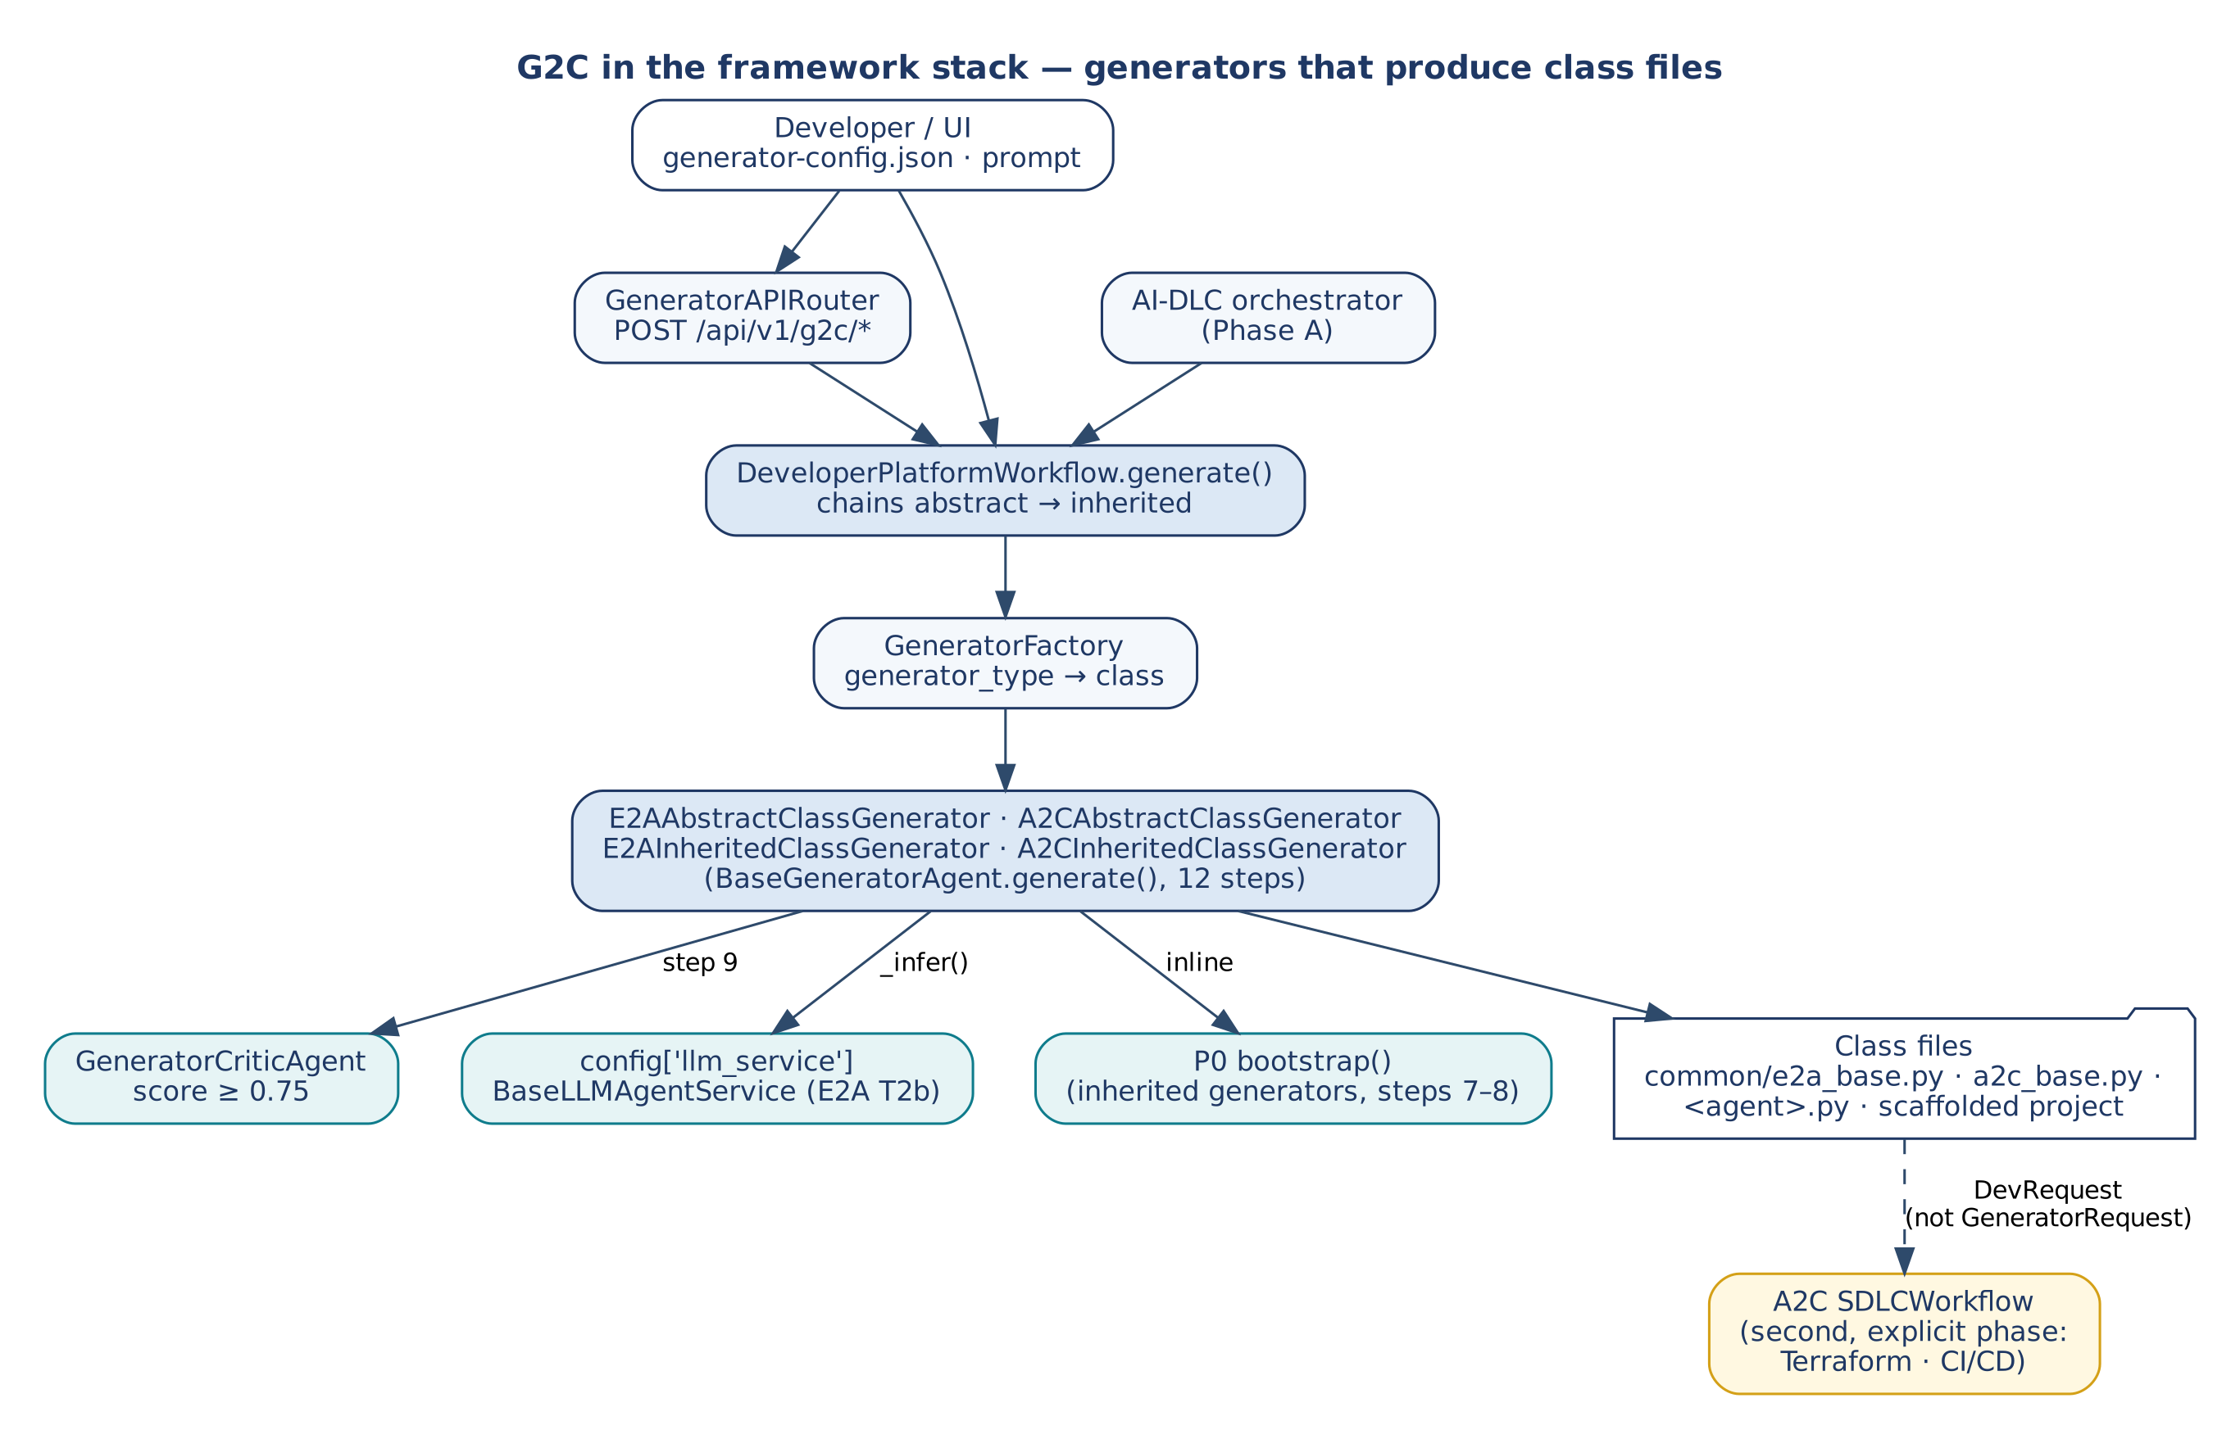
Figure 1 — G2C in the framework stack
Layer | Framework | Entry point | Produces
1 | E2A | agent.run() | Governed agents, RAG pipelines, tool services
2 | A2C | SDLCWorkflow.execute() | Code, Terraform, CI/CD
3 | P0 | bootstrapper.bootstrap() | Project structure, manifests, Docker, Makefile
4 | G2C | generator.generate() / DeveloperPlatformWorkflow.generate() | Abstract and inherited class files, scaffolded projects

5.2 Components
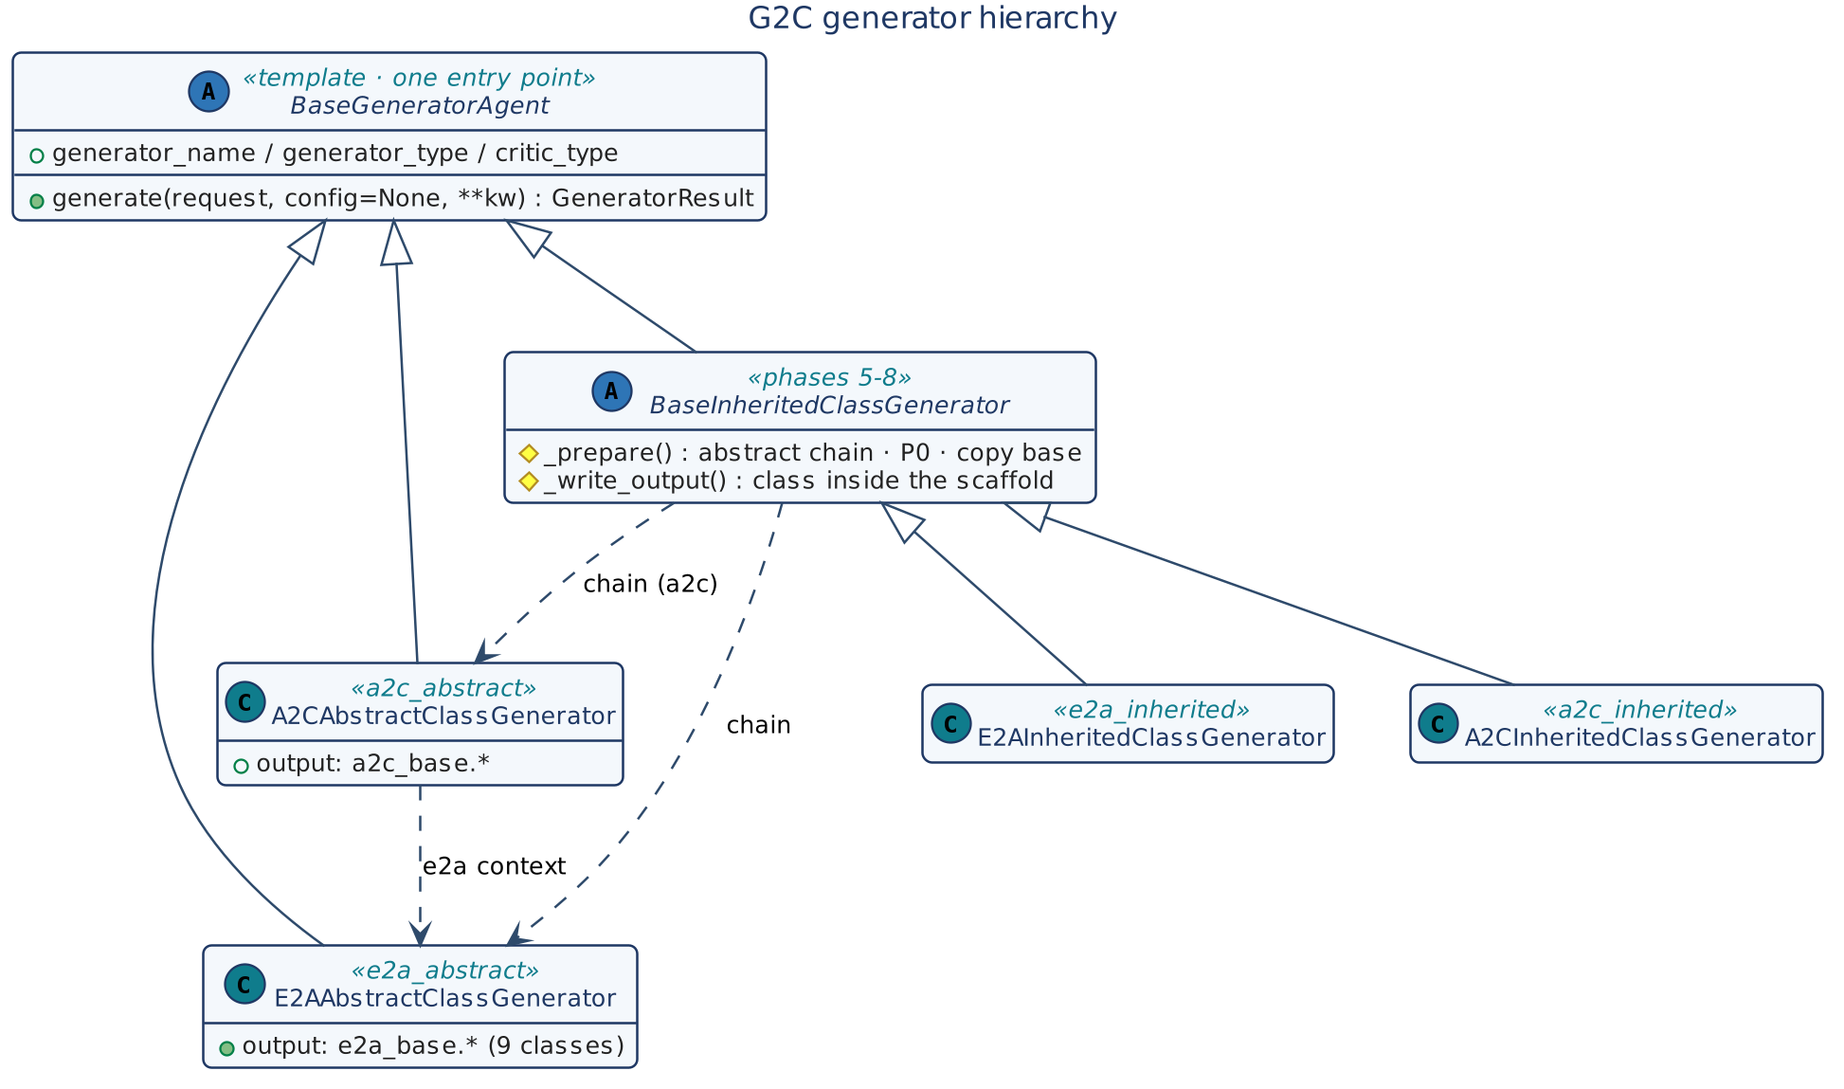
Figure 2 — G2C generator hierarchy
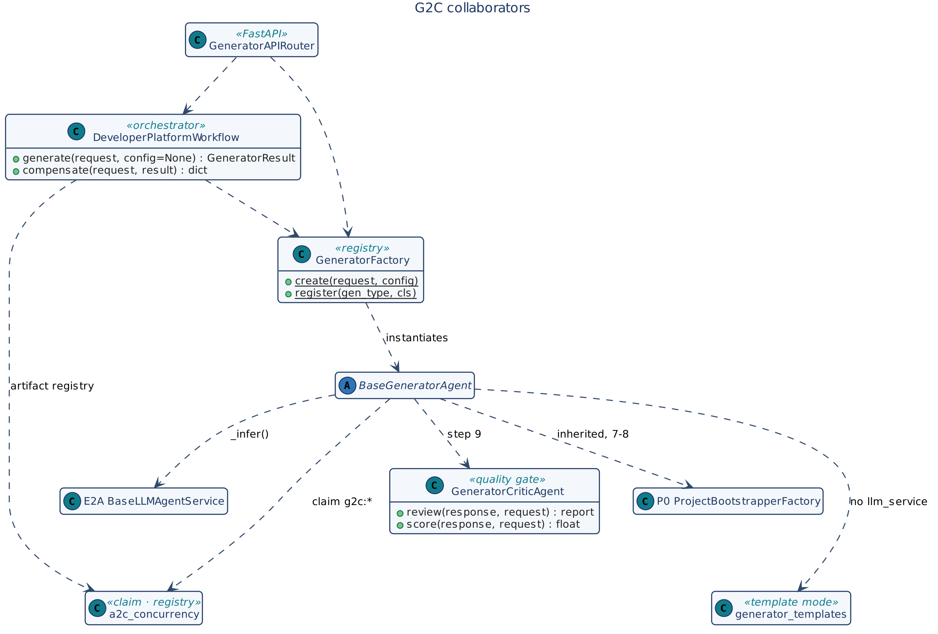
Figure 3 — G2C collaborators
Component | Responsibility
BaseGeneratorAgent | 12-step sequence, policy, claim, token budget, inference delegation or template output, critic loop, writing, SLO, logging.
BaseInheritedClassGenerator | Abstract chain, P0 inline, base copy, class placement inside the scaffold.
Four generators | Prompts, validation, file names and skeletons per output kind.
GeneratorCriticAgent | Structural scoring with critic_type rules.
GeneratorFactory | generator_type → generator class.
DeveloperPlatformWorkflow | Defaults, the flat result, the shared-artifact registry and compensation.
GeneratorAPIRouter | FastAPI exposure; no business logic.
a2c_concurrency | Claim guard, deadline, artifact registry.

5.3 Generation chain
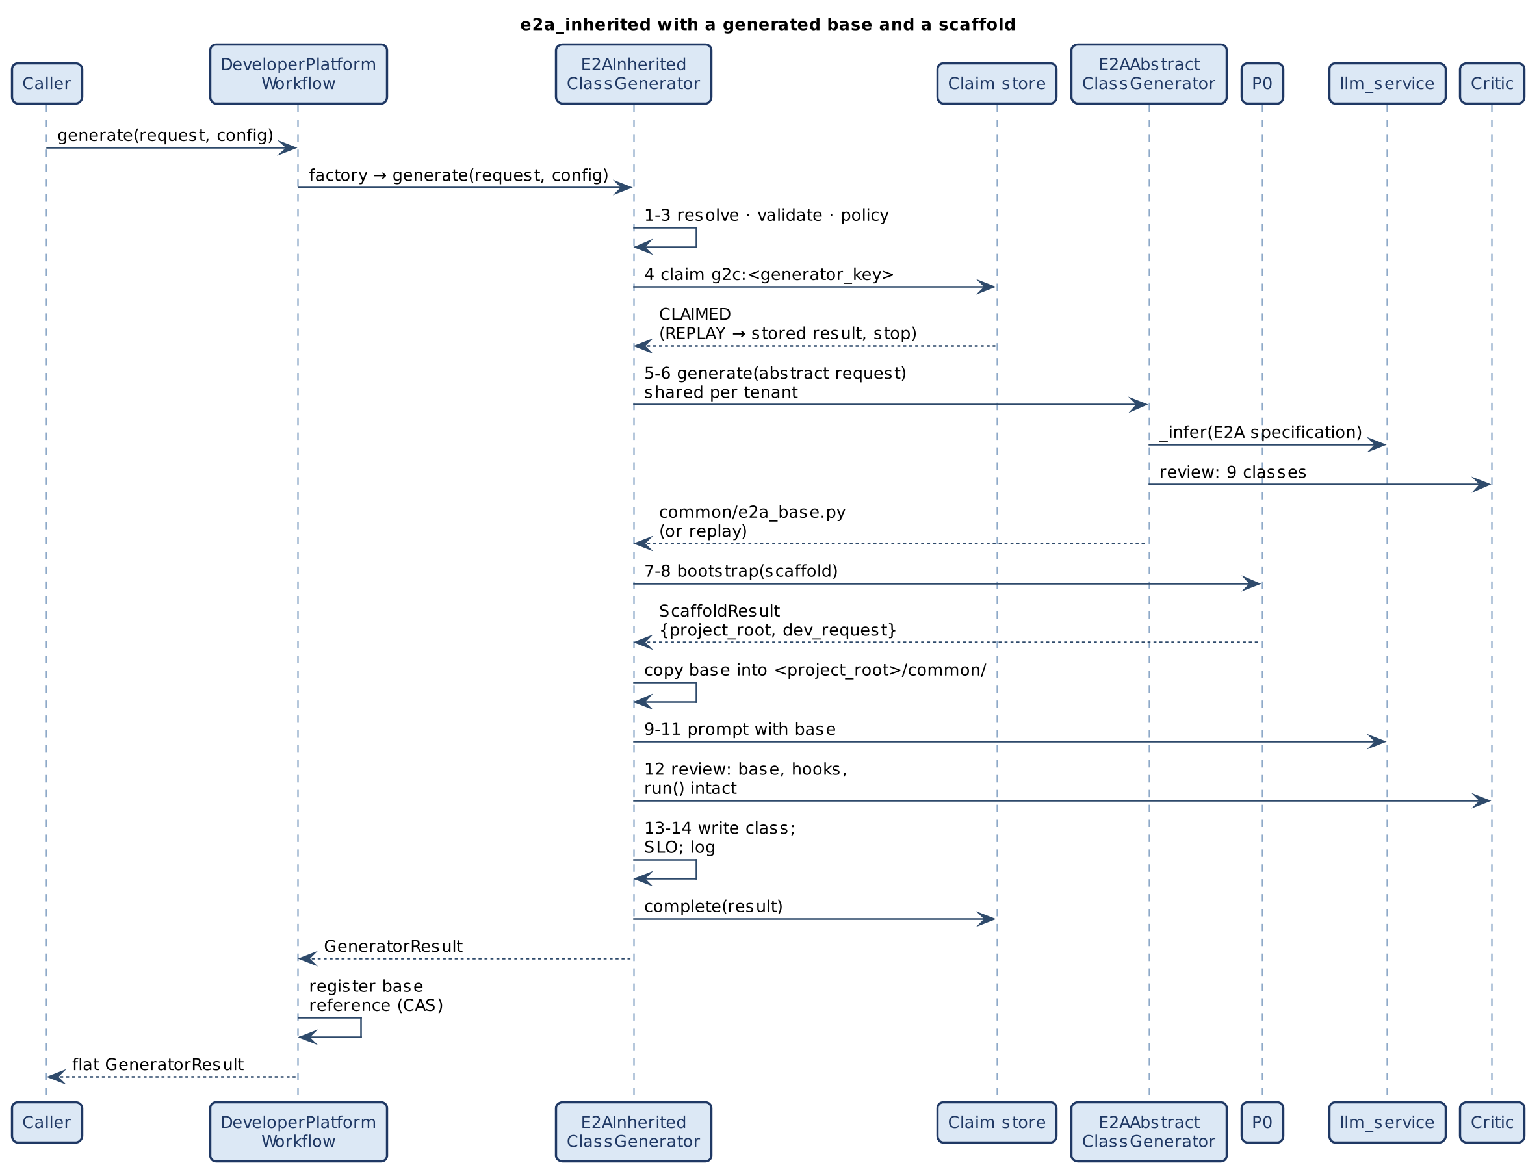
Figure 4 — e2a_inherited with a generated base and a scaffold

5.4 Abstract-class sources
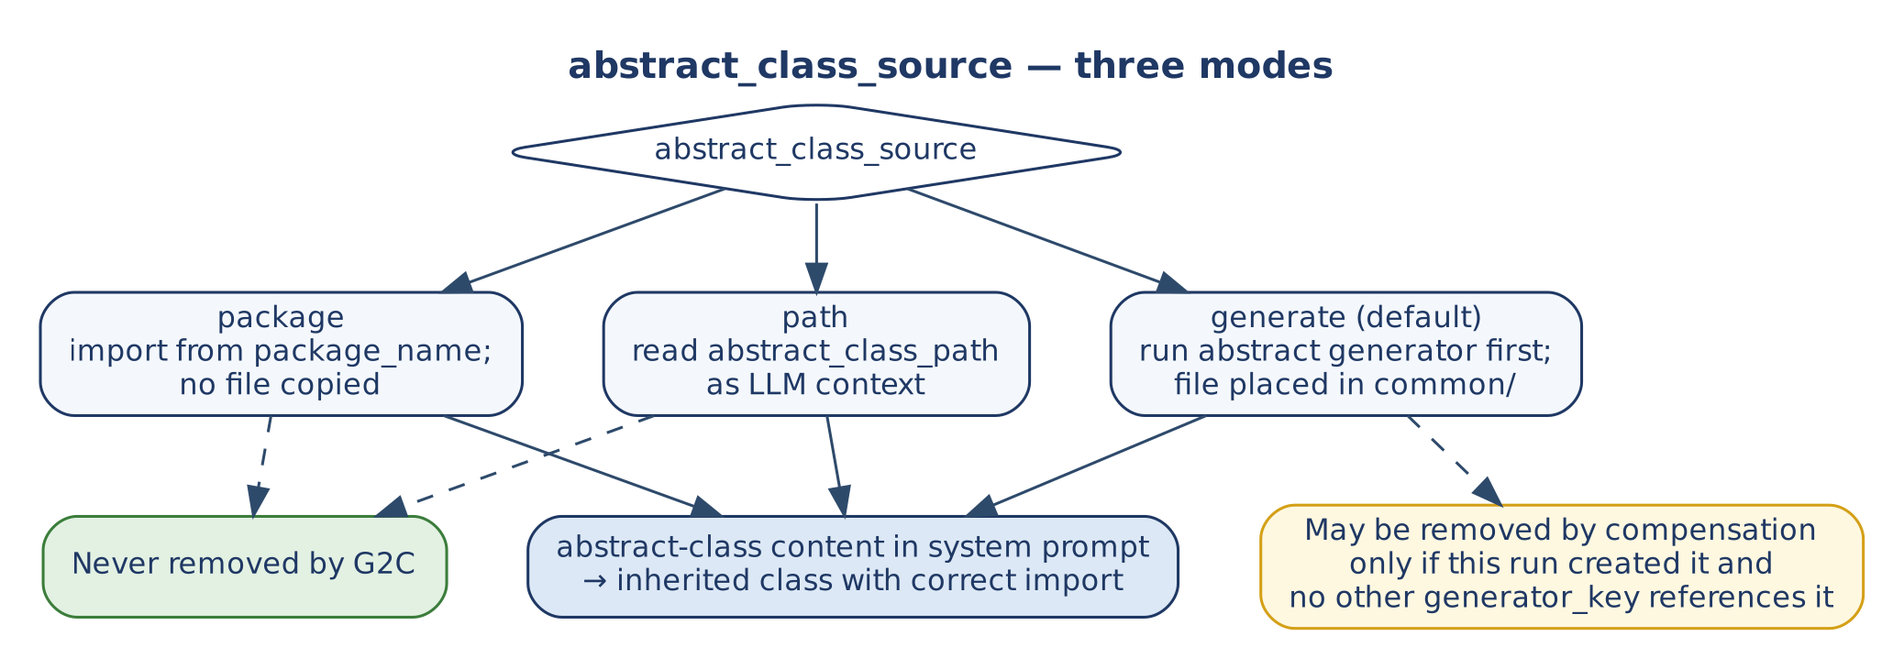
Figure 5 — abstract_class_source modes and artifact ownership
Mode | When | Effect
generate (default) | No base exists | Abstract generator(s) run after the claim; output goes to config['abstract_class_output_path'] or <output_path>/common/; its fingerprint excludes output_path, so the base is shared per tenant; the request switches to path.
path | Base file exists | Content read from abstract_class_path as model context; copied into <project_root>/common/.
package | Base published as a package | Inherited class imports from package_name; no file copied. With e2a_contract: "1.2" the source is always package with package_name = 'e2a' (E2A v1.2 is the installed package).

5.5 API
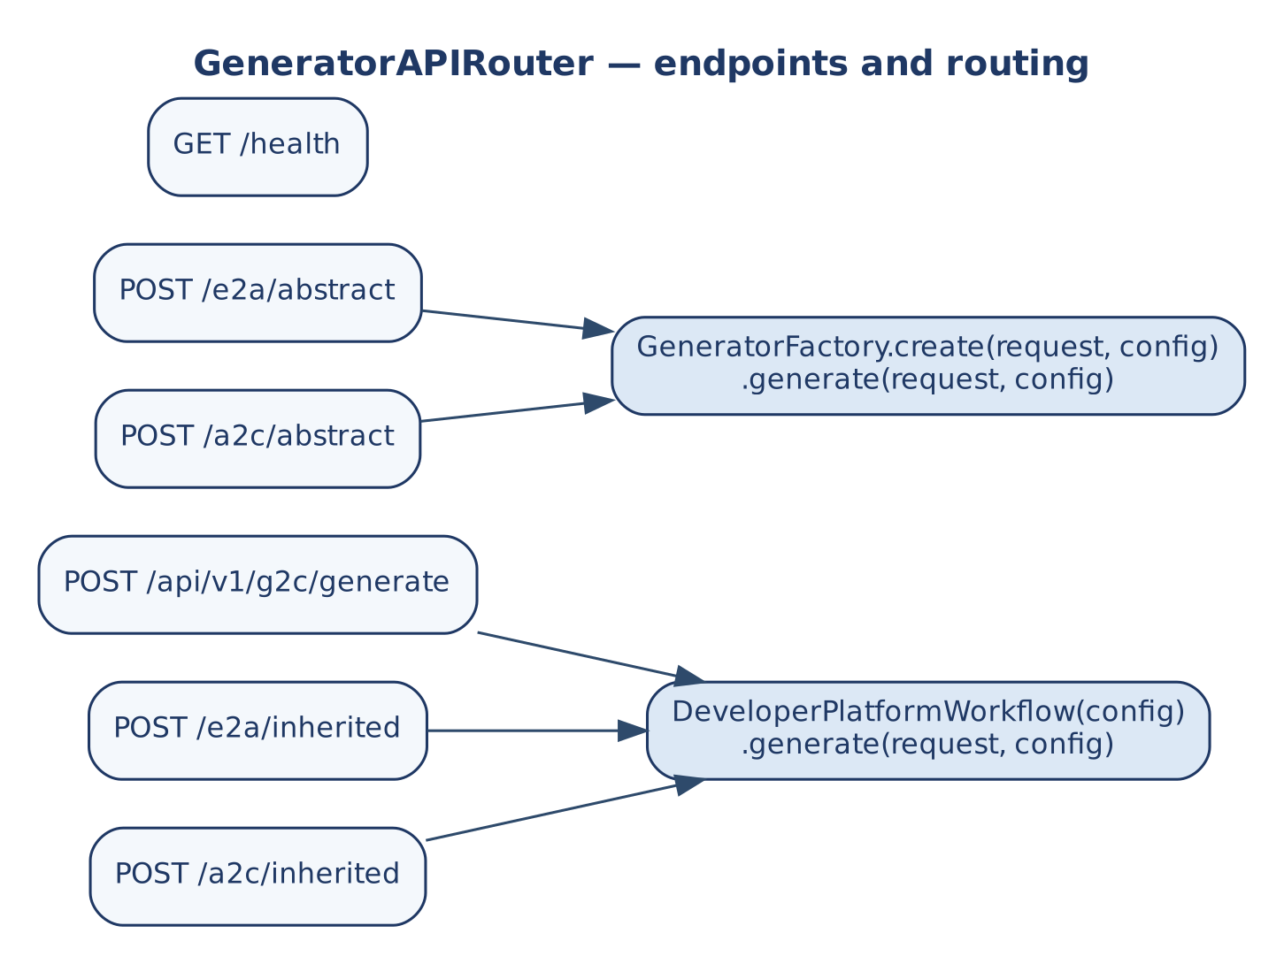
Figure 6 — GeneratorAPIRouter endpoints
Endpoint | Routes to
GET /api/v1/g2c/health | {status: ok}
POST /api/v1/g2c/generate | DeveloperPlatformWorkflow.generate(request, config)
POST /api/v1/g2c/e2a/abstract, /a2c/abstract | GeneratorFactory.create(request, config).generate(request, config)
POST /api/v1/g2c/e2a/inherited, /a2c/inherited | DeveloperPlatformWorkflow.generate(request, config)

The type-specific endpoints set generator_type. Config is bound once with configure_generator(config) and injected with Depends(get_generator_config); one workflow instance is kept so its artifact registry outlives single requests. Endpoints are synchronous, so FastAPI runs each long generation in its threadpool. ValueError and PermissionError map to HTTP 400.

5.6 E2A v1.2 generation and several agents (v1.2)
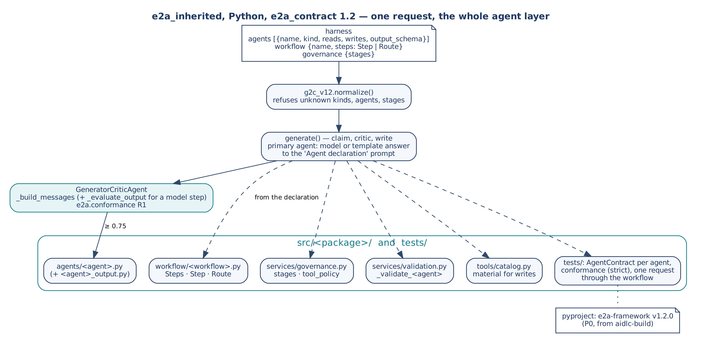
Figure 7 — One request, the whole agent layer
The request's harness may declare:
- agents: each with name, kind (model or deterministic), reads, writes and an optional output_schema (model agents only).
- workflow: {name, steps}. A step is {step, agent} or {step, route_by, agents: {value: agent}}, optionally material.
- governance: {stages} drawn from capacity, token_budget, firewall, approval, sandbox and redaction.
The first agent is the primary one. It goes through generate() as before (claim, model or template, critic, write), with its declaration in the user prompt. Every other file is written from the declaration by g2c_v12.files():
Table 3 — What a declaration generates (Python, E2A v1.2)
Declaration | Generated
kind: model | _build_messages(state, ctx), _evaluate_output(response, state, ctx), _fallback(state, ctx)
kind: deterministic | _build_messages returns None (no model step); no _evaluate_output
reads: [tool] | _prepare(state, ctx, io_read) with one io_read.call() per tool; the tool stub is a read
writes: [tool] | _act(state, ctx, io_modify) returning the typed outcomes; the tool stub has material = True
output_schema | <agent>_output.py, a Pydantic model (A2C's contract generator) that _evaluate_output validates
workflow | workflow/<name>.py: _build_workflow(self, ctx) returning Steps(Step(...), Route(...)); _generate_idempotency_key raises until you decide what makes two requests the same
governance.stages | services/governance.py: the stages in order, tool_policy = each agent's reads and writes
always | services/validation.py (a _validate_<agent> stub per agent), tools/catalog.py, tests/test_agents_contract.py (E2A AgentContract), tests/test_conformance.py (strict), and with a workflow tests/test_workflow.py (one request with the simulated model)

The approved_agents check of v1.1 skeletons is no longer generated: E2A v1.2's governance stages cover it. aidlc-build adds e2a-framework v1.2.0 to the project's dependencies, because the generated code and tests import e2a.

6. Data Contracts
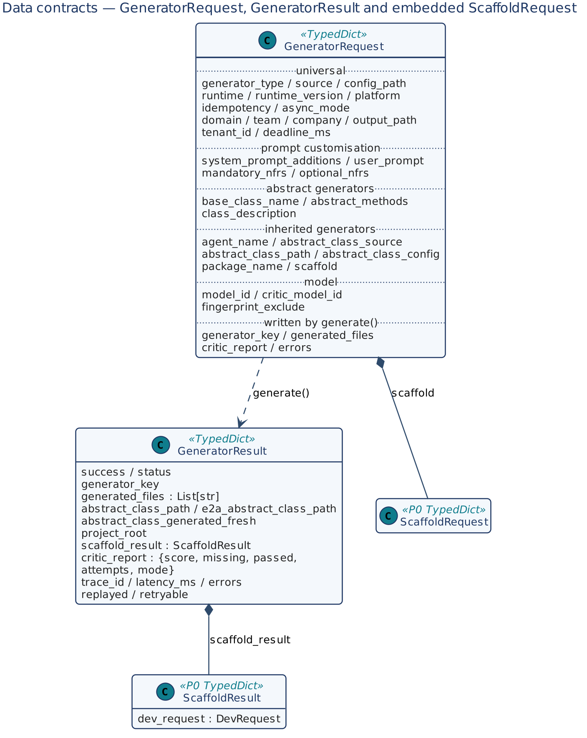
Figure 8 — GeneratorRequest, GeneratorResult and the embedded P0 contracts

6.1 GeneratorRequest
Table 4 — GeneratorRequest fields
Group | Fields and meaning
Universal | generator_type (e2a_abstract, a2c_abstract, e2a_inherited, a2c_inherited); source (inline default, json); config_path; runtime; runtime_version; idempotency; async_mode; platform (part of the key; default standalone); domain; team; company; output_path; tenant_id (claim scope; required with a gateway); deadline_ms (remaining budget).
Prompt customisation | system_prompt_additions (added to, never replacing, the base spec); user_prompt; mandatory_nfrs (checked against config['approved_nfrs'] when set); optional_nfrs.
Abstract generators | base_class_name (also names the key); abstract_methods; class_description.
Inherited generators | agent_name (defaults to the first of agents); abstract_class_source; abstract_class_path; abstract_class_config; package_name; scaffold (P0 ScaffoldRequest; missing identity fields default from the request).
E2A v1.2 (v1.2) | e2a_contract ("1.2" default for Python e2a_inherited, else "1.1"); agents; workflow; governance; project_package (set by aidlc-build when no scaffold result carries the package).
Model | model_id; critic_model_id.
Advanced | fingerprint_exclude (fields left out of the claim fingerprint).
Written by generate() | generator_key; generated_files; critic_report; errors (on the internal copy).

Minimum requests: abstract generators need runtime, output_path; inherited generators also need agent_name, plus abstract_class_path for path and package_name for package.

6.2 GeneratorResult
Field | Meaning
success | Overall outcome.
status | generated, replay, in_progress, conflict, recovery_required, failed_final, inference_rejected, deadline_exceeded, critic_threshold_not_met, scaffold_failed.
generator_key | name:type:runtime:platform, where name is agent_name, else base_class_name, else the generator name.
generated_files | All files written (copied base, class file).
abstract_class_path, e2a_abstract_class_path | Bases used (the second only for a2c_inherited).
abstract_class_generated_fresh | This request created the base (read by AI-DLC's artifact ownership).
project_root, scaffold_result | P0 workspace and ScaffoldResult (incl. dev_request).
critic_report | {score, missing, passed, findings, attempts, mode}.
trace_id, latency_ms, errors, replayed, retryable | Observability and typed retry hint.

6.3 generator-config.json
{
"generator": {
"generator_type": "e2a_inherited", "runtime": "python", "platform": "aws",
"tenant_id": "acme", "domain": "financial", "agent_name": "SettlementAgent",
"abstract_class_config": { "base_class_name": "BaseSettlementAgent" },
"user_prompt": "Charge-to-settlement reconciliation agent",
"system_prompt_additions": "Additional NFR: double-entry ledger invariant",
"output_path": "./generated/"
},
"scaffold": { "project_name": "SettlementEngine", "package_name": "settlement_engine",
"project_type": "langgraph_agent" }
}

With source='json', the generator section is merged under the inline fields and a top-level scaffold section becomes request['scaffold']. The schema is schemas/generator-config-schema.json.

6.4 Configuration keys
Key | Used in | Default
llm_service | _infer(); absent → template mode | —
idempotency_store, claim_lease_seconds | Step 4 claim | none / 300
tenant_id | Claim scope (if not in the request) | —
max_tokens / GENERATOR_MAX_TOKENS | Step 7 | 32 000
min_critic_score / GENERATOR_MIN_CRITIC_SCORE | Steps 9–10 | 0.75
max_latency_ms / GENERATOR_MAX_LATENCY_MS | Step 12 | 60 000
prompt_dir / GENERATOR_PROMPT_DIR | __load_prompt_file | prompts/
approved_nfrs | _apply_policy | none
abstract_class_output_path | Abstract chain | <output_path>/common/
critic_config | _critic_review | {critic_type}
deadline | Deadline when no deadline_ms | none

Resolution order is config › environment › default.

7. Low-Level Design — Class Model
Class | generator_type / critic_type | Output | Prompt file | P0
E2AAbstractClassGenerator | e2a_abstract | E2A base: 5 abstract classes + 4 foundation interfaces | e2aabstractclassgenerator_system_v1.txt | No
A2CAbstractClassGenerator | a2c_abstract | A2C base | a2cabstractclassgenerator_system_v1.txt | No
E2AInheritedClassGenerator | e2a_inherited | Base (if needed) + scaffold + inherited class | e2ainheritedclassgenerator_system_v1.txt | Yes
A2CInheritedClassGenerator | a2c_inherited | E2A + A2C bases (if needed) + scaffold + SDLCAssistantAgent subclass | a2cinheritedclassgenerator_system_v1.txt | Yes

8. Low-Level Design — Class Contracts

8.1 BaseGeneratorAgent
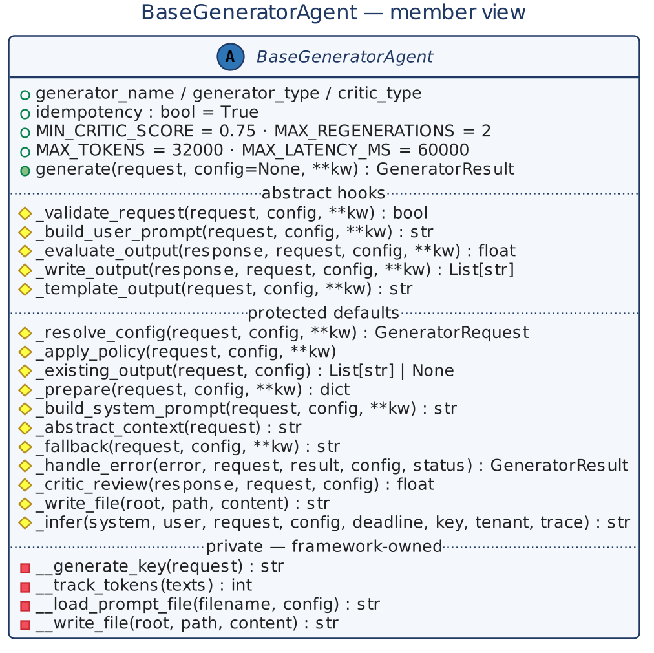
Figure 9 — BaseGeneratorAgent member view
Aspect | Detail
Class attributes | generator_name, generator_type, critic_type; idempotency = True; APPROVED_RUNTIMES; APPROVED_GENERATOR_TYPES; PROMPT_DIR; MIN_CRITIC_SCORE = 0.75; MAX_REGENERATIONS = 2; MAX_TOKENS = 32000; MAX_LATENCY_MS = 60000.
Module data | RUNTIME_PATTERNS[runtime] — abstract_base, abstract_method, private_prefix, protected_prefix, type_hints, extension.
Invariants | INV-01 to INV-06, INV-09.

Table 5 — BaseGeneratorAgent methods
Method | Kind | Signature → returns | Contract
generate | entry | (request, config=None, **kw) → GeneratorResult | Copies the request; runs the 12 steps of Section 9.1. Validation/policy failures raise ValueError/PermissionError; typed outcomes are returned; an unexpected exception propagates after the claim is settled.
_validate_request | abstract | (request, config, **kw) → bool | Required fields. False → ValueError.
_build_user_prompt | abstract | (request, config, **kw) → str | Developer-facing prompt.
_evaluate_output | abstract | (response, request, config, **kw) → float | Score via _critic_review; store critic_report.
_write_output | abstract | (response, request, config, **kw) → List[str] | Write with runtime-correct names; return paths.
_template_output | abstract | (request, config, **kw) → str | Deterministic skeleton for template mode.
_resolve_config | default | (request, config, **kw) → GeneratorRequest | json: merge generator (+ scaffold) under inline fields; prompt: rejected (free text goes in user_prompt).
_apply_policy | default | (request, config, **kw) | Approved runtime and type; approved_nfrs; tenant_id required with a gateway.
_existing_output | default | (request, config) → List[str] or None | Earlier output, consulted only without a store (local mode).
_prepare | default | (request, config, **kw) → dict | Hook after the claim: {result}, {files_before} or {abort: {status, errors, retryable}}.
_build_system_prompt | default | (request, config, **kw) → str | Prompt file + RUNTIME_PATTERNS + additions + _abstract_context(); unknown placeholders render empty.
_abstract_context | default | (request) → str | Base content given as context (inherited and A2C abstract generators).
_fallback | default | (request, config, **kw) → str | Stricter addendum naming the critic's missing items.
_handle_error | default | (error, request, result, config, status, error_text) → GeneratorResult | Log, append to errors, typed status, safe result.
_critic_review | helper | (response, request, config) → float | GeneratorCriticAgent(critic_config).review().
_write_file | helper | (root, path, content) → str | Base-owned writer for subclasses.
_infer | base-owned | (system, user, request, config, deadline, key, tenant, trace) → str | llm_service.process_inference(messages, tenant_id, deadline, correlation_id, idempotency_key[, model_id]); non-SUCCESS → InferenceRejected; no gateway → _template_output(); strips code fences.
__generate_key | private | (request) → str | name:type:runtime:platform.
__track_tokens | private | (texts) → int | ~4 characters per token.
__load_prompt_file | private | (filename, config) → str | From prompt_dir, then the package's prompts/.
__write_file | private | (root, path, content) → str | mkdir -p; UTF-8; absolute path.

8.2 E2AAbstractClassGenerator
Hook | Contract
_validate_request | runtime and output_path.
_build_user_prompt | Runtime, optional base_class_name, abstract_methods, class_description, user_prompt.
System prompt | Full E2A specification: one public entry point per class, nine classes (BaseAgent, BaseWorkflow, BaseRAGPipeline, BaseToolService, BaseLLMAgentService with process_inference + process_inference_stream, and the interfaces BaseInfraProvisioner, BaseObservability, BasePipeline, BaseGovernanceFramework), NFRs in code, concurrency rules, validation in BaseValidationService.
_write_output / _existing_output | <output_path>/e2a_base.py | E2ABase.java | e2aBase.ts | e2a_base.go.
_template_output | Skeleton of the nine classes per runtime (Java as nested types of E2ABase, matching import com.company.common.E2ABase.BaseAgent).

8.3 A2CAbstractClassGenerator
Hook | Contract
_prepare | With generate and no path, run E2AAbstractClassGenerator first (shared fingerprint) and switch to path; a failed base aborts with its status.
_abstract_context | E2A base content (or a package note).
_write_output | <output_path>/a2c_base.*.
_template_output | Python: this repository's a2c_base.py (the A2C reference); other runtimes: skeletons with DevRequest, SDLCAssistantAgent, CodeCriticAgent, SDLCWorkflow, MANDATORY_NFRS.

8.4 BaseInheritedClassGenerator and the two inherited generators
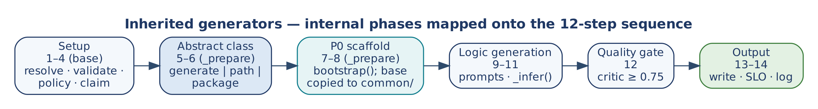
Figure 10 — Inherited generators: internal phases
Table 6 — BaseInheritedClassGenerator methods
Method | Contract
_v12 | (request) → bool: sets the default e2a_contract ("1.2" only for Python e2a_inherited) and says whether this request targets E2A v1.2.
_validate_request | runtime, agent_name, output_path (agent_name defaults to the first declared agent); path needs abstract_class_path, package needs package_name. v1.2: refuses 1.2 outside Python e2a_inherited and forces abstract_class_source='package', package_name='e2a'.
_prepare | Phases 5–8 after the claim: _generate_abstracts() for generate; _scaffold() when scaffold is set (failure aborts as scaffold_failed, retryable unless P0 returned conflict/failed_final); copy the base(s) into <project_root>/common/. Both steps are idempotent, so a later model failure still settles retryable.
_generate_abstracts | E2A abstract (plus A2C abstract for a2c_inherited) with fingerprint_exclude=['output_path']; sets abstract_class_path, e2a_abstract_class_path, abstract_class_generated_fresh (false when replayed).
_scaffold | P0 inline. Defaults from the request: runtime, platform, build_tool (poetry/maven/npm/go_modules), project_name (<agent_name>Service), Python package_name, output_path, tenant_id. Java identity (group_id, artifact_id, project_type) must be supplied.
_abstract_context | E2A and A2C base content, or a package note.
_build_user_prompt | v1.1: class, base, import line, domain, requirement, NFRs. v1.2: the E2A v1.2 hook contract plus Agent declaration: {json} of the primary agent.
_write_output | Python src/<pkg>/agents/<snake>.py; Java src/main/java/<group>/service/<Agent>.java; Node src/agents/<Agent>.ts; Go internal/agents/<snake>.go; without a scaffold, under output_path. v1.2 with a project: the primary agent from the response, then every other file of g2c_v12.files(); returns all paths.
_template_output | v1.1 skeleton: E2A → extends BaseAgent with _build_messages, _apply_policy, _evaluate_output, _fallback, _handle_error; A2C → extends SDLCAssistantAgent, calls super()._apply_policy() then adds the request's mandatory_nfrs. v1.2: g2c_v12.agent_source() of the primary agent's declaration.

E2AInheritedClassGenerator and A2CInheritedClassGenerator set only generator_name, generator_type, critic_type and kind.

8.5 GeneratorCriticAgent
Method | Signature → returns | Contract
review | (response, request) → {score, critic_type, missing, passed, findings} | Rules of Table 7 for config['critic_type'] or request['generator_type']; Python is parsed with ast (a syntax error scores 0).
score | (response, request) → float | review()['score'].
concurrency_findings | (source) → List[str] | Shared-gateway rule violations.

Table 7 — Critic rules
critic_type | Checks | Deduction
all | Agent-level _validate_state; own semaphore; own rate limiter; provider SDK import; direct provider call | 0.25 each
e2a_abstract | Nine E2A classes present; Python uses @abstractmethod | 0.10 per class; 0.15
a2c_abstract | SDLCAssistantAgent, DevRequest, SDLCWorkflow, CodeCriticAgent, _apply_policy, mandatory-NFR injection | 0.15 each
e2a_inherited, a2c_inherited | Class <agent_name> exists (else 0.5); has a base (SDLCAssistantAgent for A2C); _build_messages and _evaluate_output overridden; no run/execute/retrieve override; no name-mangled private access | 0.15 each
e2a_inherited with e2a_contract: "1.2" | As above, but _evaluate_output is required only for an agent with a model step; each e2a.conformance R1 finding in the source | 0.15 each

The critic is deterministic and makes no model call; GeneratorCriticAgent checks generated class structure, A2C's CodeCriticAgent checks NFR patterns in generated business code.

8.6 g2c_v12 (v1.2)
Function | Signature → returns | Contract
normalize | (harness) → {agents, workflow, stages} | One agent from agent_name when no agents; PascalCase, unique names; kind in (model, deterministic); output_schema only for model agents; workflow steps unique and naming declared agents; known stages. Else HarnessError (a ValueError).
agent_source | (agent, package) → str | The agent module (Table 3).
output_model | (agent) → str or None | Pydantic model of output_schema, through A2C's contract generator.
workflow_source, governance_source, validation_source, tools_source | (spec, …) → str | The modules of Table 3.
tests | (spec, package) → {path: source} | Contract, conformance and workflow tests.
example | (schema) → value | A minimal valid instance, used as the simulated model's answer in the workflow test.
files | (harness, package) → {path: source} | Everything above, relative to the project root.

8.7 GeneratorFactory
Method | Signature → returns | Contract
create | (request or type, config=None) → BaseGeneratorAgent | Look up generator_type; unknown → ValueError listing registered types; instantiate with config.
register | (gen_type, cls) | Register at import time; the type must also be approved by the generator's policy.

8.8 DeveloperPlatformWorkflow
Method | Signature → returns | Contract
__init__ | (config=None, artifact_registry=None) | Registry from the argument, config['artifact_registry'], or in-memory.
generate | (request, config=None) → GeneratorResult | Copy the request; default abstract_class_source='generate' for inherited types; GeneratorFactory.create(request, config).generate(request, config); on success register this key's reference on each base (creator only when fresh). Returns the flat result.
compensate | (request, result) → {released, removed, removed_paths, may_delete, path} | Release this key's references; delete a base only where the registry allows (creator, last reference, not deleted). Accepts the flat result or a wrapped {output: ...}.

9. Dynamic Behaviour

9.1 generate() sequence
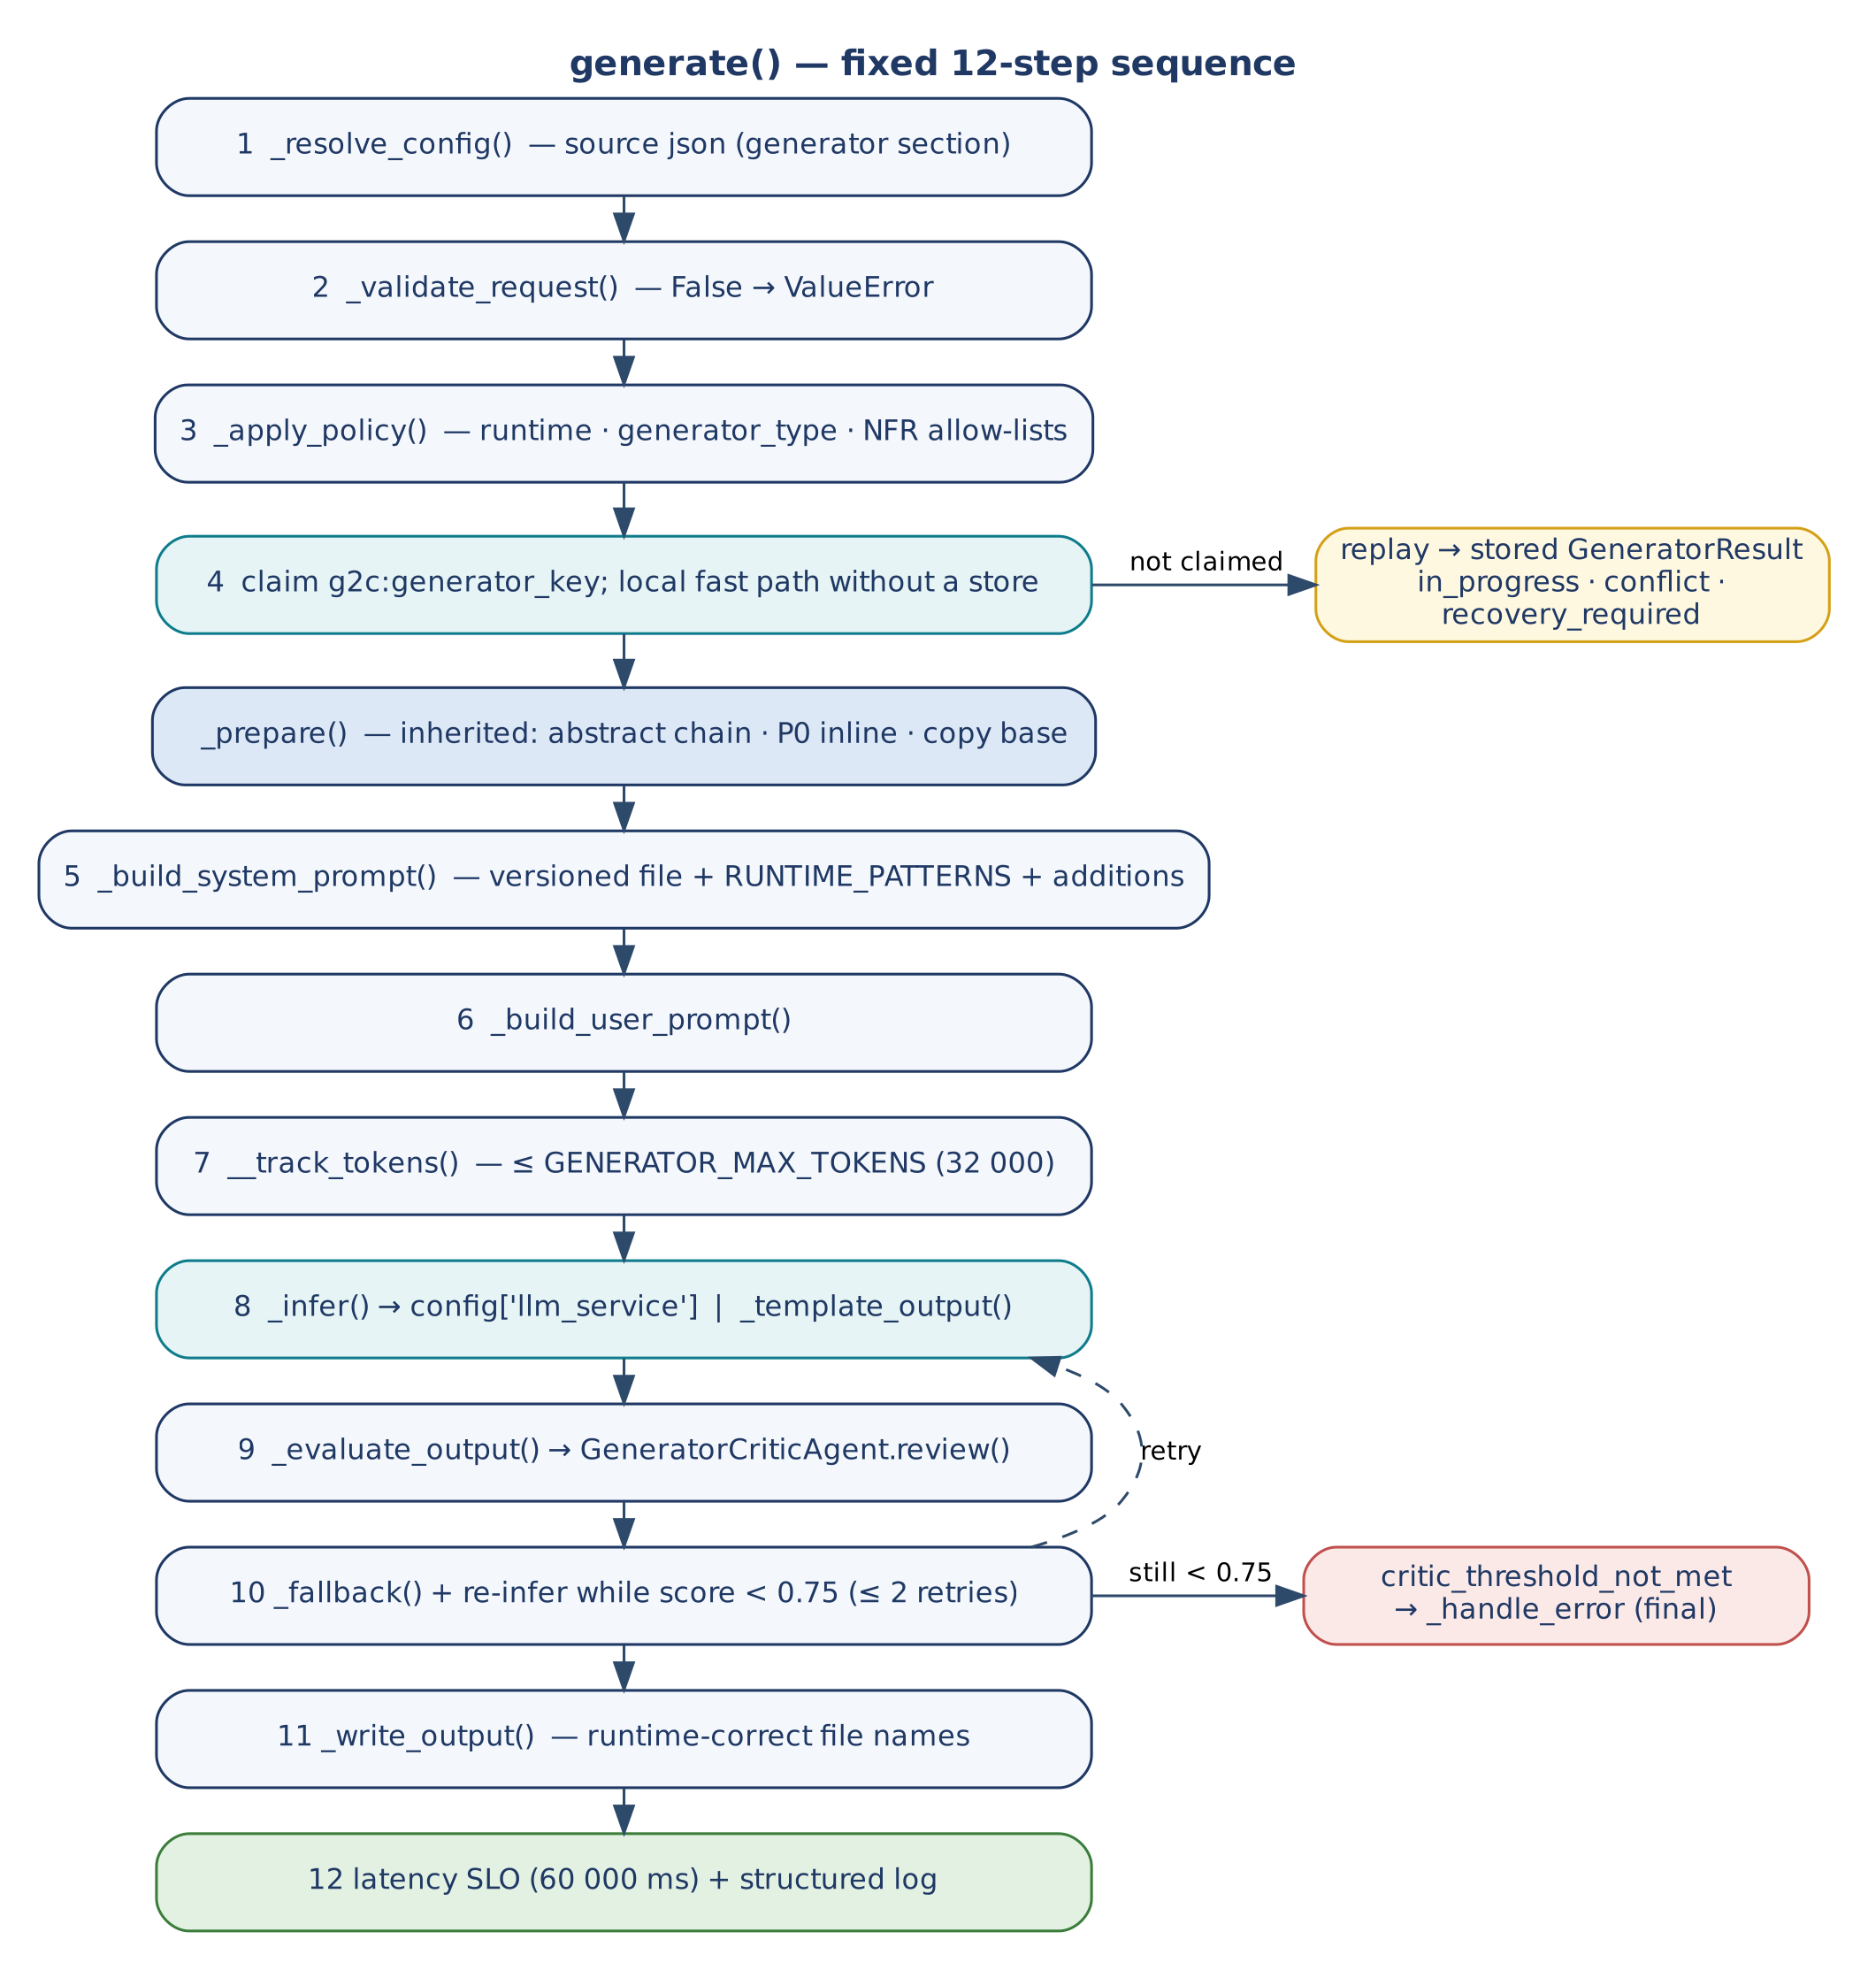
Figure 11 — generate(): fixed 12-step sequence
Step | Action | Condition
1 | _resolve_config() | source='json'
2 | _validate_request() | Always; False raises
3 | _apply_policy() | Always
4 | Claim g2c:<key>; local fast path | Claim with a store; fast path without one
— | _prepare() (inherited phases 5–8) | Inherited generators, A2C abstract
5 | _build_system_prompt() | Always
6 | _build_user_prompt() | Always
7 | __track_tokens() ≤ max_tokens | Always; over budget → ValueError, settled final
8 | _infer() or _template_output() | Always
9 | _evaluate_output() | Always
10 | _fallback() + re-infer | Score < threshold, ≤ 2 regenerations
11 | _write_output() | Score ≥ threshold
12 | SLO + log (trace_id, latency, tokens, score, attempts, mode) | Always

9.2 Critic routing
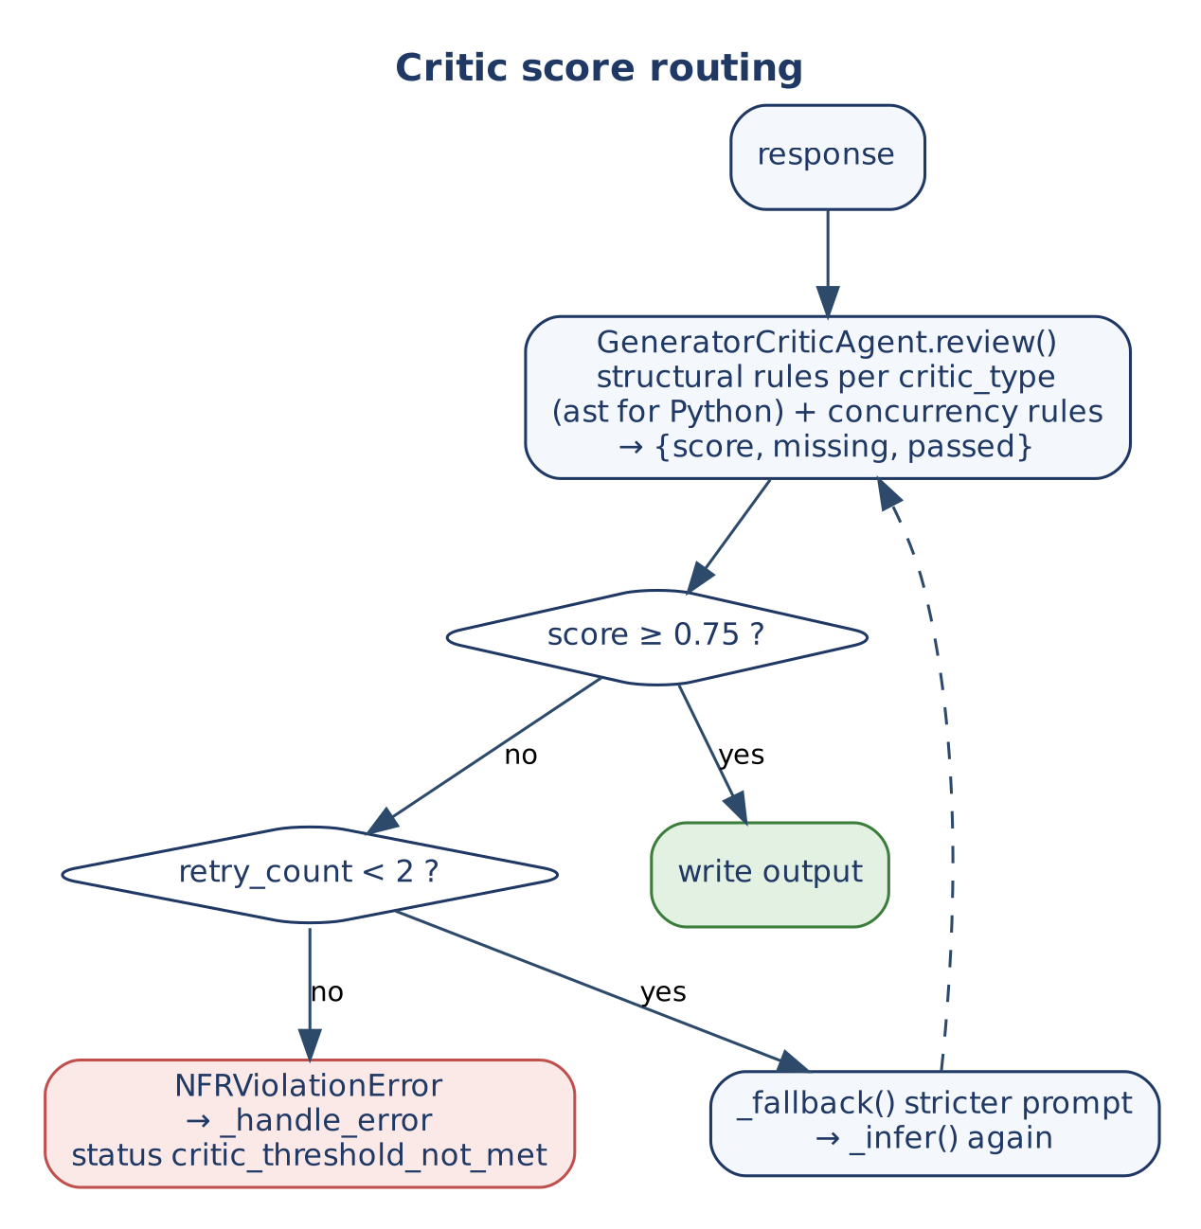
Figure 12 — Critic score routing

9.3 The second phase
G2C ends at a class file. When config['a2c'].enabled, the P0 result inside scaffold_result carries a dev_request (with tenant_id and project_root); producing Terraform and CI/CD requires an explicit run of A2C's SDLCWorkflow.execute(dev_request, config). Omitting it is the most common adoption error (E-01).

9.4 Phase Trigger decision model
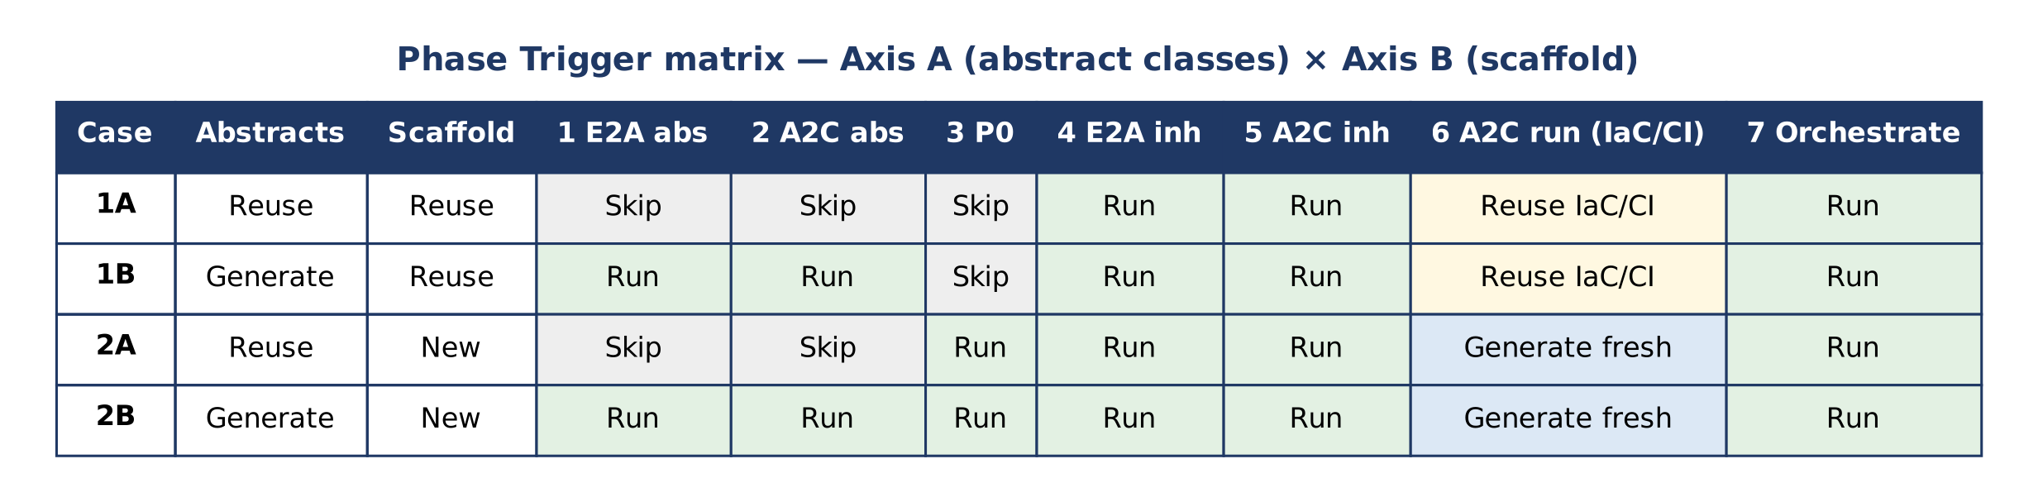
Figure 13 — Phase Trigger matrix
Two axes are evaluated from repository state before any generation: Axis A — do the E2A and A2C abstract classes exist (an e2a_base.py without BaseLLMAgentService is stale and must be regenerated); Axis B — does a P0 scaffold with a build manifest exist.
Case | Situation | Canonical way to express it
1A | Day-two module in a bootstrapped domain | Inherited generators with abstract_class_source='path' or 'package'; omit scaffold (or rely on P0's replay); reuse IaC/CI.
1B | Skeleton made outside G2C, no abstractions | abstract_class_source='generate' (v1.1 contract); omit scaffold; the critic gates the bases before the inherited class. With E2A v1.2 (Python) there is no base to generate: the source is the e2a package.
2A | Proven abstractions, new service | path/package with scaffold; then the A2C second phase for fresh IaC/CI.
2B | Greenfield | generate with scaffold; then the A2C second phase.

Table 8 — Phase Trigger errors
ID | Severity | Error | Remedy
E-01 | Critical | Second phase skipped | Run SDLCWorkflow with the DevRequest after the class is generated.
E-02 | High | Abstract generation over existing bases | Use path/package; regenerate only with intent (idempotency=False).
E-03 | High | P0 over an existing project | Omit scaffold; P0's claim and fast path make a repeat a replay, and a partial scaffold is parked, not overwritten.
E-04 | Medium | Defective base propagates | Bases pass the critic before inherited generation (built into the chain).
E-05 | Medium | DevRequest / GeneratorRequest confused | GeneratorRequest for generators; DevRequest for A2C.
E-06 | Low | Legacy branch not frozen | Tag legacy-non-g2c before the first run; it is the counterfactual baseline.

Table 9 — Reconciling Phase Trigger terminology with canonical contracts
Phase Trigger Reference wording | Canonical contract
"E2A (Enterprise-to-Abstract)", "A2C (Abstract-to-Class)" layers | E2A is the Enterprise-to-Agentic architecture framework; A2C is Architecture-to-Code. Abstract and inherited class generation belong to G2C.
Phase 3 as a separate P0 step; BaseProjectBootstrapper.scaffold() | P0 runs inline in inherited generators (phases 7–8) through bootstrap().
Phase 7 BootstrapAndGenerateWorkflow.run_workflow() with _invoke_p0/_invoke_e2a/_invoke_a2c and SKIP_* flags | G2C chaining is DeveloperPlatformWorkflow.generate(). BootstrapAndGenerateWorkflow.execute() composes P0 and A2C. Full-stack orchestration is the AI-DLC orchestrator. Skips are expressed by abstract_class_source and the presence of scaffold.
E2AAbstractClassGenerator.run() | generate().
GeneratorCriticAgent.evaluate() | score() / review().
A2C abstract generator class with hooks validate_request() … write_output() | Those are BaseGeneratorAgent hooks (_validate_request() …). A2CAbstractClassGenerator produces a2c_base.py.
IaCAgent.execute_pipeline(), CICDAgent.deploy() | SDLCWorkflow.execute(dev_request, config) running IaCAgent and CICDAgent.

10. Concurrency and Failure
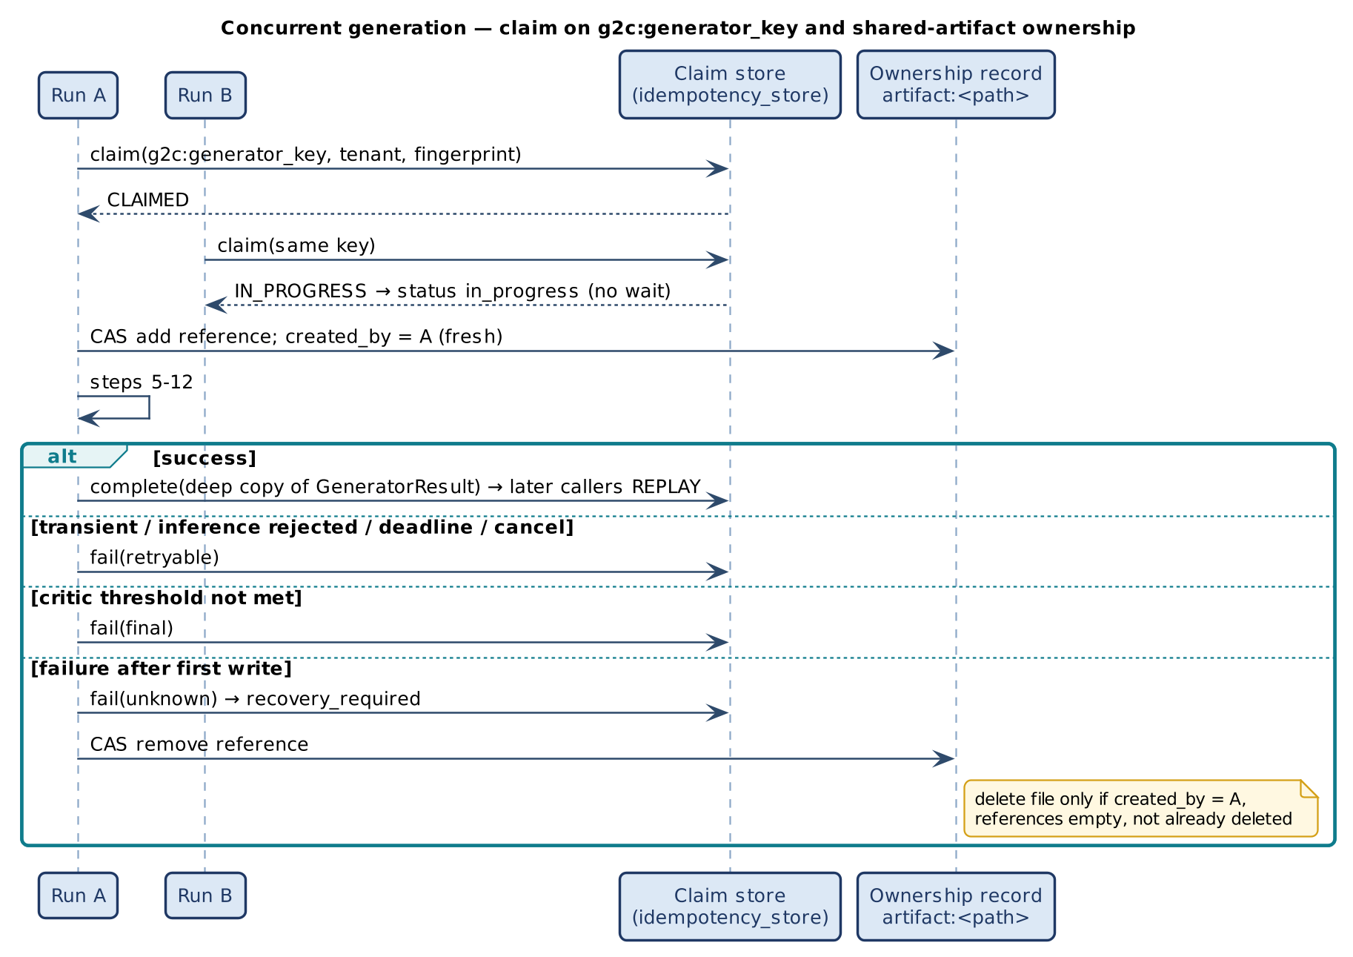
Figure 14 — Claim on g2c:generator_key and shared-artifact ownership
Outcome of claim | Meaning | generate()
Claimed | This run owns the key | Proceeds; settles on every exit path
Replay | Key already succeeded | Returns stored result (replayed); no writes, no model call, no chain
In progress | Another run holds it | Returns in_progress promptly
Conflict | Same key, different fingerprint | Returns conflict
Recovery required | Expired claim or unknown outcome | Returns recovery_required; never blindly re-run
Failed final | Earlier deterministic failure | Returns failed_final

Settlement: succeeded on success (a deep copy is stored); retryable on model rejection, deadline or cancellation before any write; final on deterministic errors (validation, token budget) and when the critic threshold is not met after two regenerations; UNKNOWN when failing after the first write began. The claim key is namespaced g2c: so it never collides with P0 (p0:), A2C (a2c:) or a composing caller's key in a shared store.
Shared abstract classes carry an ownership record (references, creator, deleted flag) updated by compare-and-set, so only one releasing run can delete a file and only when no reference remains. Capacity is bounded by the gateway's tenant/pod permits and RPM/TPM quotas; generators add no semaphores. The deadline (deadline_ms) is checked at every step boundary and passed to the gateway (it converts to E2A's Deadline).

11. Non-Functional Design
NFR | Mechanism
Quality | Structural critic ≥ 0.75; ≤ 2 regenerations; final failure is typed.
Latency | 60 s SLO per generation (warning).
Cost | 32 000-token budget before the model call; deterministic critic (no model call).
Security | No credentials in generators; DLP, quota and model choice at the gateway; policy allow-lists; prompt-injection rules at the API edge.
Reproducibility | Versioned prompt files; template mode is deterministic.
Observability | trace_id, latency, tokens, score, attempts, mode per call.

12. Extension Guide
# | Rule
1 | Set generator_name, generator_type, critic_type; register with GeneratorFactory and add the type to APPROVED_GENERATOR_TYPES.
2 | Override the five abstract hooks; _prepare, _existing_output, _fallback, _handle_error as needed.
3 | Never call a model SDK; use _infer().
4 | Never override generate() or call private methods.
5 | Add prompts/<generator>_system_v<N>.txt with {runtime}, {runtime_patterns}, {idempotency}, {async_mode}, {domain}, {agent_name}, {abstract_class_content}, {system_prompt_additions}; verify critic ≥ 0.75 before committing.
6 | Keep claim, settlement and artifact-ownership rules in the base class.

class E2AToolServiceGenerator(BaseInheritedClassGenerator):
generator_name = 'E2AToolServiceGenerator'
generator_type = 'e2a_tool'
critic_type = 'e2a_inherited'
kind = 'e2a_inherited'
APPROVED_GENERATOR_TYPES = BaseInheritedClassGenerator.APPROVED_GENERATOR_TYPES + ['e2a_tool']

def _build_user_prompt(self, request, config=None, **kw) -> str:
return (f"Generate tool service {request['agent_name']} extending BaseToolService: "
f"{request.get('user_prompt', '')}\nReturn only the source file.")

GeneratorFactory.register('e2a_tool', E2AToolServiceGenerator)

13. Verification
Table 10 — Evidence (v1.2.0)
Suite | What it shows
smoke_test_generator_concurrency.py (55 checks) | Generation through the gateway double; key format; claim SUCCEEDED; replay without a model call; conflict; tenant scoping; 8 concurrent duplicates → one generation; rejection → retryable then success; deadline before any call; critic regeneration and final failure; UNKNOWN after a write failure; stale owner cannot settle; tenant required with a gateway; CAS artifact ownership including 200 racing releases; workflow chain, replay and compensation; critic concurrency rules; the P0 concurrency checks.
smoke_test_g2c_contract.py (35 checks; its requests pin e2a_contract: "1.1", the abstract-class path) | Template mode writes critic-passing files for all four runtimes; a structurally bad model reply is regenerated twice then fails final with nothing written; inherited generation with P0 inline (manifest, class inside the scaffold, base in common/, dev_request handoff, fresh flag); second project shares the base (two references, one creator) and compensation keeps it; a2c_inherited chain; package source; Java placement; P0 failure typed; factory config/register/unknown; runtime and NFR policy; JSON source; deadline interop; router endpoints and HTTP 400.
smoke_test_aidlc_integration.py (15 checks) | E2A's AI-DLC orchestrator calls DeveloperPlatformWorkflow(config=...) on the real module and reaches E2A_VERIFIED.
smoke_test_g2c_v12.py (17 checks) | Refusals (kind, unknown agent, stage, schema on a deterministic agent); a three-agent request builds with the critic at 1.0; v1.2 hooks; deterministic agent without a model step, writes through io_modify; output schema validated; material tools; no application service; generated tests; strict conformance; one request through the generated workflow routes to the right agent; the E2A dependency; Java with 1.2 refused; a single-agent request defaults to v1.2.
CI job declarations (gcp) | The three-agent example passes its own generated tests.

14. Implementation Reality, Gaps and Design Observations
The stubs recorded against the earlier baseline are replaced on this branch: public hook names and a five-step generate(); no model call; critic and generator scores fixed at 1.0; nothing written; DeveloperPlatformWorkflow() without config and with a wrapped result; no abstract chain and no P0; a factory without config or register; a health-only router; incomplete typedicts; and the missing a2c_concurrency module.
Table 11 — Remaining observations
ID | Observation | Effect | Recommendation
O-1 | The critic is deterministic and structural; the Reference's model-assisted critic (critic_model_id) is not used. | Semantic defects that keep the structure pass. | Add an optional model review whose score is combined with the structural one (lower wins), as A2C's CodeCriticAgent does.
O-2 | Non-Python outputs are checked by patterns, not parsed. | Weaker evidence for Java, Node and Go. | Add parsers per runtime in CI.
O-3 | source='prompt' is rejected by the generators. | Free text goes in user_prompt; no structured extraction of the request from prose. | Add prompt resolution through the gateway if needed.
O-4 | Template-mode skeletons are minimal. | Useful for structure and offline runs, not as finished code. | Treat template output as a starting point; regenerate with a gateway.
O-5 | The local fast path (no store) reuses any existing file at the abstract output location. | Two different base_class_names targeting one directory share a file. | Use distinct abstract_class_output_paths, or a store.
O-6 | The Phase Trigger Reference uses legacy names and flags. | Readers may look for methods that do not exist. | Use Table 9; the reference carries a v1.2 note.
O-7 | All tests use in-memory doubles. | Not validated against a live store, gateway or load. | Add adapter tests.
O-8 | Only the primary agent passes through the model and the critic; the other generated files come from deterministic templates. | They are correct skeletons with TODOs, not domain code. | Fill the TODOs; or declare each agent in its own request to have each one generated by the model.
O-9 | Java, Node and Go stay on the v1.1 contract. | No E2A v1.2 runtime outside Python. | e2a-java is wave D (G-4).
O-10 | Generated tool stubs raise NotImplementedError and the workflow's _generate_idempotency_key raises until written. | The generated workflow test passes a client idempotency key; a material call returns UNKNOWN until the tool is implemented. | Implement the tools and the key first.

Appendix A. Glossary
Term | Definition
G2C | Generate-to-Class: generators that produce class files.
generator_key | name:type:runtime:platform; claimed as g2c:<generator_key>.
Abstract class source | generate, path or package.
Template mode | Generation without a gateway, from deterministic skeletons.
e2a_contract | "1.2" (default for Python e2a_inherited) or "1.1": the E2A hook contract generated agents follow.
Declaration (v1.2) | harness.agents, workflow, governance: what G2C generates the agent layer from.
Second phase | Explicit A2C SDLCWorkflow run with a DevRequest.
Case 1A/1B/2A/2B | Phase Trigger cases from Axis A × Axis B.

Appendix B. Traceability
Goal / invariant | Element | Anchor
G-1, INV-01 | generate() | base_generator_agent.py L87–206
G-6, INV-06 | Claim g2c: and local fast path | base_generator_agent.py L113–132
G-4, INV-03 | _infer() | base_generator_agent.py L331
G-3, INV-02 | Critic loop; _critic_review | base_generator_agent.py L384, L317; generator_critic_agent.py L65
INV-05 | Inherited rules | generator_critic_agent.py L161
G-5 | Abstract chain, P0 inline | inherited_generator.py L62, L96, L155
G-8 | Skeletons | generator_templates.py
INV-10, INV-11, UC-11/12 (v1.2) | _v12, _validate_request, _write_output, _template_output; g2c_v12.files; critic v1.2 rule | inherited_generator.py L36, L43, L212, L239; g2c_v12.py L64, L348; generator_critic_agent.py L191
G-7, INV-07 | Registry and compensation | developer_platform_workflow.py L35, L50; a2c_concurrency.py L321, L344
Factory | create, register | generator_factory.py L20, L31
API | Router | generator_api_router.py L49–81

