SOFTWARE DESIGN DOCUMENT
E2A Deterministic CQRS Profile
High-Level and Low-Level Design

This document describes the E2A Deterministic CQRS Profile from problem statement to method-level contract. It is written so that a reader can build a complete mental model of the profile — why it exists, which use cases it serves, how it is deployed, how every class collaborates, and what each method guarantees — without opening the Python source. The source files remain the reference for line-level implementation detail.
Framework | E2A — Enterprise-to-Agentic Architecture Framework
Document type | Design Document (HLD + LLD)
Author | Subham Gupta, Principal Platform Architect
Source baseline | subhamviky/e2a-framework @ main 32c99c0 — reference/e2a_cqrs_base.py (540 lines) and the shared contracts it imports from reference/e2a_base.py
Date | 7 November 2026
Status | Baseline design, aligned to the current reference implementation

Contents
1. Introduction 4
1.1 Purpose 4
1.2 Audience 4
1.3 Status labels used in this document 4
1.4 Source of truth and related documents 5
2. Problem Statement and Motivation 6
2.1 The problem 6
2.2 Why a separate profile 6
2.3 Design goals 7
3. Core Use Cases 8
3.1 Actors 8
3.2 Use-case catalogue 8
3.3 Non-goals 8
4. Design Principles and Invariants 10
4.1 Principles 10
4.2 Invariants 10
5. High-Level Design 11
5.1 System context 11
5.2 Zones and tiers 11
5.3 Structural isomorphism 13
5.4 Request paths at a glance 14
5.5 Capacity, ordering and consistency per boundary 15
5.6 Vendor mapping 15
5.7 End-to-end command sequence 16
6. Data and Propagation Contracts 17
6.1 Cross-class propagation fields 17
6.2 Request state keys 17
6.3 Status vocabulary 18
6.4 Configuration keys 18
7. Low-Level Design — Class Model 20
7.1 Module structure 20
7.2 Class catalogue 20
7.3 Orchestration layer 21
7.4 Cross-cutting classes 22
7.5 Collaborations and injected ports 22
7.6 Shared contracts imported from e2a_base.py 23
7.7 Exception taxonomy 24
8. Low-Level Design — Class Contracts 25
8.1 BaseOrchestrator 25
8.2 BaseCommandService 26
8.3 BaseQueryService 27
8.4 _PropagationMixin 28
8.5 BaseGovernanceFramework (CQRS-adapted) 29
8.6 BaseObservability (CQRS-adapted) 29
8.7 BaseValidationService and ValidationResult 30
8.8 Exceptions 31
8.9 Shared concurrency contracts (summary) 31
9. Dynamic Behaviour 33
9.1 Orchestrator admission, routing and settlement 33
9.2 Command write path internals 34
9.3 Query read path with single-flight 35
9.4 Idempotency record life cycle 36
9.5 Claim settlement 37
9.6 Saga decision flow 37
10. Concurrency, Consistency and Failure Model 39
10.1 Ownership of concurrency risks 39
10.2 Conflict and replay matrix 39
10.3 Consistency model 40
10.4 Error routing summary 40
11. Asynchronous Paths: Consumers and Scheduled Repair 41
11.1 Tier 4 consumer model (runtime obligation) 41
11.2 Outbox sweeper and reconciler 42
12. Non-Functional Design 43
12.1 Performance targets 43
12.2 Capacity sizing 43
12.3 Security and tenant isolation 43
12.4 Observability 44
13. Extension Guide 45
13.1 Building a concrete service 45
13.2 Skeleton 45
13.3 Rules and anti-patterns 45
14. Verification 47
15. Implementation Reality, Gaps and Design Observations 48
Appendix A. Glossary 49
Appendix B. Traceability 50

1. Introduction

1.1 Purpose
The E2A Deterministic CQRS Profile is a companion execution profile of the Enterprise-to-Agentic (E2A) framework. It gives cloud-native microservices that need sub-second, schema-strict, highly concurrent request handling — and no LLM reasoning on the request path — the same architectural guarantees the agentic profile gives AI workloads: one public entry point per class, an explicit cross-class propagation contract, base-owned governance and observability, and a one-to-one mapping between class boundaries and cloud tiers.
This document is the single design reference for that profile. It covers:
- the problem the profile solves and the motivation behind its shape (Section 2);
- the core use cases it is built for, and what it deliberately does not do (Section 3);
- the design principles and invariants every implementation must preserve (Section 4);
- the high-level design: context, zones, tiers, deployment and vendor mapping (Section 5);
- the data and propagation contracts that cross class boundaries (Section 6);
- the low-level design: the class model, and a contract card for every class and method (Sections 7 and 8);
- the dynamic behaviour as sequence, state and activity models (Section 9);
- the concurrency, consistency and failure model (Section 10), the asynchronous consumer and repair paths (Section 11), and the non-functional design (Section 12);
- how to extend the profile (Section 13), how it is verified (Section 14), and known gaps (Section 15).

1.2 Audience
Reader | Read first | Use the document to
Solution / platform architect | Sections 2–5, 10, 12 | Decide whether a workload belongs on this profile and size the landing zone.
Service developer | Sections 6–9, 13 | Implement a concrete orchestrator, command service and query service correctly.
SRE / operations | Sections 5, 10–12, 14 | Understand failure semantics, alerts, capacity limits and repair jobs.
Reviewer / auditor | Sections 4, 10, 15, Appendix B | Check invariants, traceability and the implemented-versus-runtime boundary.

1.3 Status labels used in this document
Every class and behaviour is labelled so the reader can tell what exists in code from what is an obligation on the deploying team.
Table 1 — Status labels
Label | Meaning
Implemented | Present in reference/e2a_cqrs_base.py or imported from reference/e2a_base.py, and exercised by the smoke tests.
Abstract hook | Declared with @abstractmethod. The scaffold defines the contract; a concrete subclass must supply the body or instantiation fails with TypeError.
Runtime obligation | Behaviour the platform runtime around the scaffold must provide (for example the Tier 4 consumer loop). The scaffold supplies the primitives, not the loop.
Infrastructure | A cloud component provisioned by the landing zone, not by Python code.

1.4 Source of truth and related documents
The reference implementation is reference/e2a_cqrs_base.py. It imports its concurrency contracts (Deadline, ClaimStatus, BaseIdempotencyStore, BaseCacheStore, BaseTransactionalStore, ConcurrencyConflict, CommitResult, PhysicalOutcome, _DETERMINISTIC_ERRORS) and the configuration resolver resolve_config() from reference/e2a_base.py. Where this document and the code disagree, the code is authoritative and Section 15 records the difference.
Table 2 — Related documents
Document | Relationship
E2A Framework Design Document | Agentic profile; defines every shared contract this profile imports.
CQRS Cloud Landing Zone (HLD) | Infrastructure view of the same profile; Sections 5 and 12 here summarise it.
CQRS Implementation Playbook | Method listings and the complete scaffold source (Appendix A).
E2A Master Abstraction Reference | Framework-wide class taxonomy and naming rules.
reference/smoke_test_cqrs_concurrency.py | Executable evidence for the race tests in Section 14.

2. Problem Statement and Motivation

2.1 The problem
Most enterprise transactions — placing an order, posting a settlement, adjusting a balance, reading an account — need no language model. They need determinism: a validated schema, exactly one durable effect per business request, a fast and correct read, and an audit trail. Teams building these services on a shared cloud platform repeatedly run into the same failure modes:
- Duplicate effects. At-least-once messaging, client retries and timeouts cause the same command to execute twice — a double charge, a double shipment.
- Lost updates. Two writers read version n and both write version n+1; one change silently disappears.
- Stale or stampeding reads. A popular key expires and hundreds of concurrent requests hit the database at once, or a read immediately after a write returns the old value.
- Unbounded waits. A slow dependency holds threads and connections until the whole pool is exhausted.
- Ambiguous outcomes. A commit times out — did it land? Blind retry duplicates; blind dead-lettering loses work.
- Inconsistent cross-cutting concerns. Every team reinvents tenant isolation, quota enforcement, telemetry and error routing, each slightly differently, so platform-wide controls cannot be applied.
- Architecture drift. The code structure no longer matches the deployment topology, so security zones, scaling units and ownership boundaries become guesswork.

2.2 Why a separate profile
The agentic E2A profile already solves items 6 and 7 for AI workloads through BaseWorkflow and BaseAgent. Reusing those classes for deterministic services would carry LLM-specific machinery — prompt registries, token budgets, inference gateways, semantic routing — onto a path that never calls a model, and would hide the most important structural fact of a transactional service: reads and writes have different consistency, caching and failure contracts.
The CQRS profile therefore keeps everything that is profile-independent and replaces only the Tier 2 orchestration layer:
Table 3 — What the profile keeps and what it replaces
Concern | Agentic profile | CQRS profile
Lifecycle manager | BaseWorkflow | BaseOrchestrator
Unit of work | BaseAgent | BaseCommandService (write) + BaseQueryService (read)
Edge validation | BaseValidationService | Reused unmodified; also classifies read vs write intent
Governance | Token budget, MCP sandbox | Tenant request quota, external-API isolation (same ABC shape)
Observability | Token and cost metrics | Command / query / cache-hit / error counters (same ABC shape)
Concurrency contracts | e2a_base.py | Imported unchanged from e2a_base.py
Inference tier (2b) | BaseLLMAgentService | Not provisioned; tier numbers 0–5 unchanged

2.3 Design goals
Table 4 — Design goals
ID | Goal | How the design meets it
G-1 | Effectively-once material effects under at-least-once delivery | Atomic, tenant-scoped idempotency claim before any work; owner-checked settlement; replay of stored results.
G-2 | No lost updates | Store-side conditional commit (put_if_version) is the authority; losers get a typed ConcurrencyConflict.
G-3 | Fast, stampede-free, read-after-write-consistent reads | Cache-aside with per-key single-flight; synchronous cache synchronisation on the write path.
G-4 | Bounded waits everywhere | One deadline propagated across classes; every wait is min(timeout, remaining).
G-5 | Honest outcomes | PhysicalOutcome.UNKNOWN is parked for reconciliation, never blindly retried or dead-lettered.
G-6 | Uniform platform controls | Governance and observability are injected ABCs with fixed hook names, shared with the agentic profile.
G-7 | Code-to-cloud isomorphism | Each class maps to one tier; tier numbers are shared across all E2A profiles.
G-8 | Vendor neutrality | Stores, caches and telemetry are ports; AWS, GCP and Azure bindings are adapters.

3. Core Use Cases

3.1 Actors
Table 5 — Actors
Actor | Description
Tenant client | A UI, partner system or batch job acting for one tenant, authenticated by a JWT.
Edge (T0/T1) | API gateway plus the validation function; mints correlation_id and classifies intent.
CQRS service (T2) | The concrete BaseOrchestrator subclass and its command and query services.
Domain consumer (T4) | A bounded-context worker (billing, shipping, inventory) reacting to committed events.
Saga edge (T5) | Workflow engine that commits, compensates or dead-letters a command batch.
Reconciler | Scheduled, lease-holding job that repairs parked and dead-lettered work.
Approver | A human who approves a command above a policy threshold (dehydration path).

3.2 Use-case catalogue
Table 6 — Use cases
ID | Use case | Main flow | Guarantee
UC-1 | Submit a command | Edge validates → Intake topic → execute() claims key → governance → mutate() → conditional commit → outbox → cache sync → claim completed | One durable effect; 202 returned before Tier 2 runs
UC-2 | Retry or duplicate a command | claim() returns REPLAY → __short_circuit() returns the stored result | No business logic, outbox or cache work is repeated
UC-3 | Concurrent writers on one aggregate | Both execute; put_if_version commits one | Loser receives status = CONFLICT; nothing dead-lettered; no outbox record from the loser
UC-4 | Read a resource | Edge invokes Tier 2 synchronously → fetch() → cache hit, or single-flight miss to read replica | One database read per key per process however many concurrent callers
UC-5 | Read after own write | _synchronize_cache() evicts or hydrates the key inside the command | The next read cannot observe the pre-write value from cache
UC-6 | High-value command needs approval | Governance raises DehydrationInterrupt after persisting state | status = AWAITING_WEBHOOK; key stays claimable for the resumed run
UC-7 | Commit outcome unknown | Subclass sets state['outcome'] = UNKNOWN | Key parked; reconciler confirms truth and replays only NOT_COMMITTED, once
UC-8 | Fan out a committed event | CDC / outbox sweeper publishes → partitioned consumers apply through their own claim | Per-aggregate ordering; effectively-once at the consumer
UC-9 | Compensate a failed batch | Task queue → Saga edge evaluates failed_keys | Clean batch commits; failed items are isolated, compensated and dead-lettered

3.3 Non-goals
- No LLM call on the request path. A workload that needs reasoning, retrieval or tool selection belongs on the agentic profile.
- No exactly-once delivery. The guarantee is effectively-once material effects under at-least-once delivery.
- No cross-aggregate ordering or distributed transactions. Ordering is per partition (tenant + aggregate); cross-aggregate invariants use the Saga edge or a single-store transaction.
- No consumer base class. Tier 4 consumers are a runtime obligation built from existing primitives (Section 11).
- Reads are never compensated. A failed query has no side effect; it is returned as an error, never sent to the Saga or DLQ.

4. Design Principles and Invariants

4.1 Principles
- Single public entry point per class. Each class exposes exactly one public method — execute, mutate, fetch, validate, enforce_governance_gate, record_telemetry. Everything else is a protected hook or a name-mangled base-owned step.
- Template method, not framework magic. Base classes own the control flow; subclasses fill well-named hooks. A missing hook fails at instantiation, never silently in production.
- Propagate, never store. Request-scoped fields travel as arguments; none is held on self, so one instance is safe to share across concurrent requests.
- Concurrency is owned by invariant. Each shared-resource risk is assigned to exactly one class, contract or config key. There is no global concurrency manager.
- Advisory checks are cheap; authoritative checks are atomic. _commit_gate() may fast-fail early; only the store's conditional write decides.
- Configuration is central. Every key resolves through resolve_config(): call-time kwargs, then the config dict, then the environment variable, then the registry default.
- Isomorphism. Class boundary equals tier boundary; tier numbers never change between profiles.

4.2 Invariants
Table 7 — Invariants every implementation must preserve
ID | Invariant | Enforced by
INV-01 | A request without tenant_id never executes. | BaseOrchestrator.execute() raises ValueError before any work.
INV-02 | At most one owner executes a given tenant-scoped idempotency key at a time. | Atomic BaseIdempotencyStore.claim().
INV-03 | The same key with a different request fingerprint is a CONFLICT, never a replay. | _request_fingerprint() + store.
INV-04 | A claim is settled exactly once, and only by its current owner. | __settle_claim() in finally; owner-checked complete() / fail().
INV-05 | A losing concurrent writer leaves no aggregate change and no outbox record. | _commit_versioned() runs before _execute_outbox_commit().
INV-06 | A ConcurrencyConflict or DehydrationInterrupt is never dead-lettered. | Dedicated except branches in execute().
INV-07 | The query path never reaches the DLQ or the Saga. | if failed_keys and not is_read guard.
INV-08 | An UNKNOWN physical outcome is never retried or replayed blindly. | fail(retryable=False, outcome=UNKNOWN); reconciler confirms first.
INV-09 | Deterministic errors are never retried. | _DETERMINISTIC_ERRORS → FAILED_FINAL.
INV-10 | Every wait is bounded by the request deadline. | Deadline.check() / Deadline.bound().
INV-11 | Cache keys are tenant-namespaced. | _generate_cache_key(query_params, tenant_id) contract.
INV-12 | A command response is never success-shaped before the outbox write succeeded. | Fixed order inside mutate().

5. High-Level Design

5.1 System context
The CQRS service sits behind the platform edge, owns its Tier 3 data perimeter, and emits committed events to downstream bounded contexts and the Saga edge.
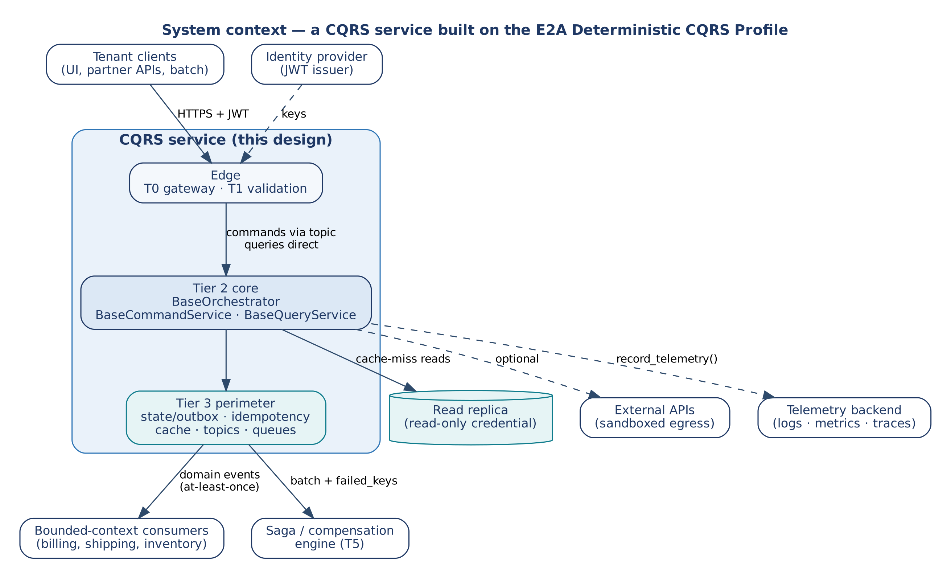
Figure 1 — System context of a service built on the CQRS profile

5.2 Zones and tiers
The profile reuses the three network zones and six compute tiers of the agentic landing zone. Tier numbers are load-bearing identifiers shared across all E2A HLDs and LLDs; the agentic Tier 2b inference gateway is simply not provisioned.
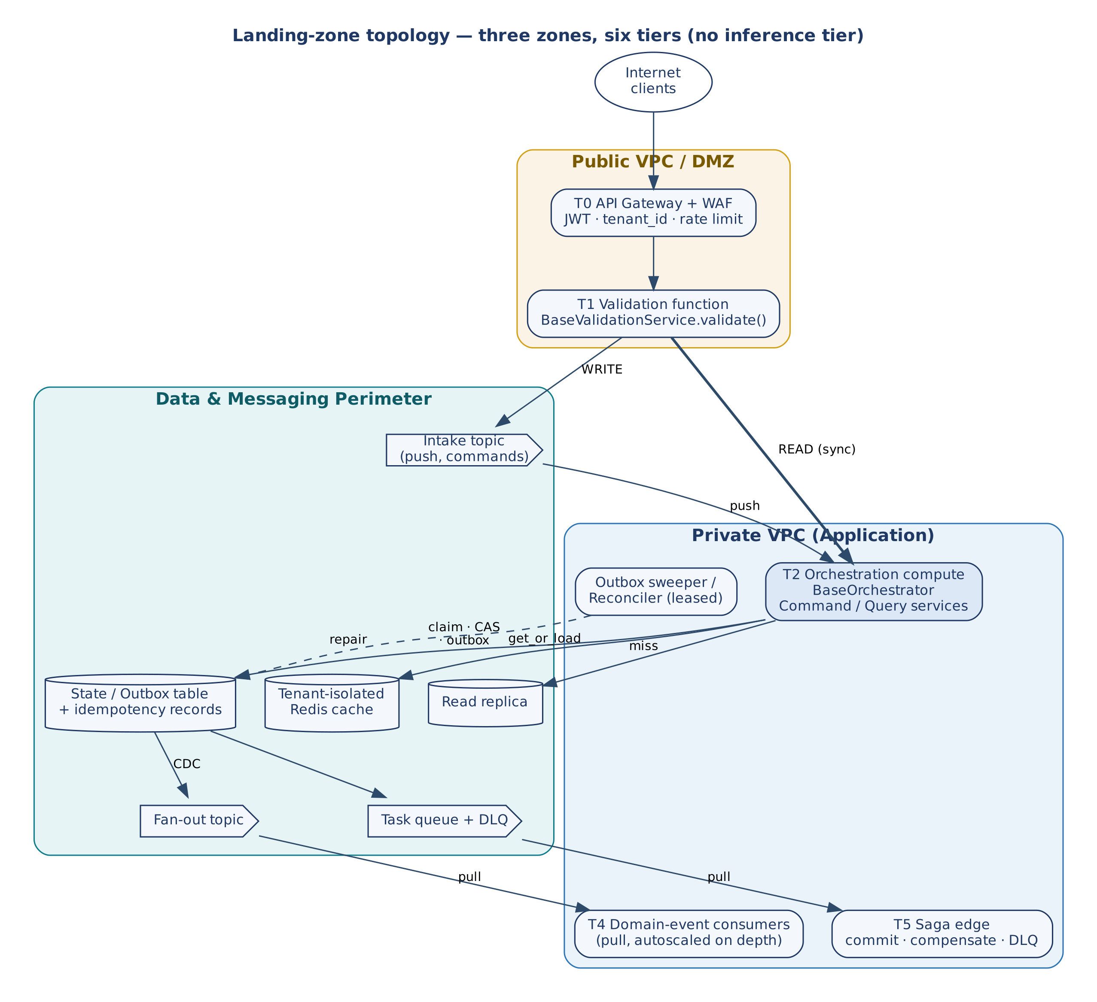
Figure 2 — Landing-zone topology: three zones, six tiers, command and query paths
Table 8 — Zones and trust boundaries
Zone | Contains | Trust boundary
Public VPC / DMZ | T0 API gateway and WAF; T1 validation function | Only zone with an internet route. No tenant data at rest, no business logic.
Data & Messaging Perimeter | T3 intake topic, state/outbox and idempotency table, tenant-isolated cache, read replica, fan-out topic, task queue and DLQ | No route from the DMZ or the internet; private connectivity only.
Private VPC (Application) | T2 orchestration compute; T4 domain-event consumers; T5 Saga edge; leased sweeper and reconciler jobs | No inbound internet route; invoked by push (T2) or pull (T4, T5).

Table 9 — Tier responsibilities
Tier | Component | Responsibility
T0 | API gateway + WAF | JWT verification, route inspection, rate limiting; extracts the verified tenant_id.
T1 | Validation function | BaseValidationService.validate(): schema and business rules, intent classification, correlation_id origination. Writes go to the intake topic (202 Accepted); reads invoke T2 synchronously.
T2 | Orchestration compute | BaseOrchestrator, BaseCommandService, BaseQueryService; governance inline; telemetry and DLQ hand-off in finally.
T3 | Data & messaging | Intake topic, state/outbox and idempotency records, tenant cache, read replica, fan-out topic, task queue, DLQ.
T4 | Domain-event consumers | Pull-based, per-bounded-context, autoscaled on queue depth; apply events through their own idempotency claim.
T5 | Saga edge | Command path only: commit a clean batch, or isolate, compensate and dead-letter failed items.

5.3 Structural isomorphism
Each LLD class has exactly one home in the HLD. This is what lets a reviewer read a security zone, a scaling unit or an on-call boundary straight off the class diagram.
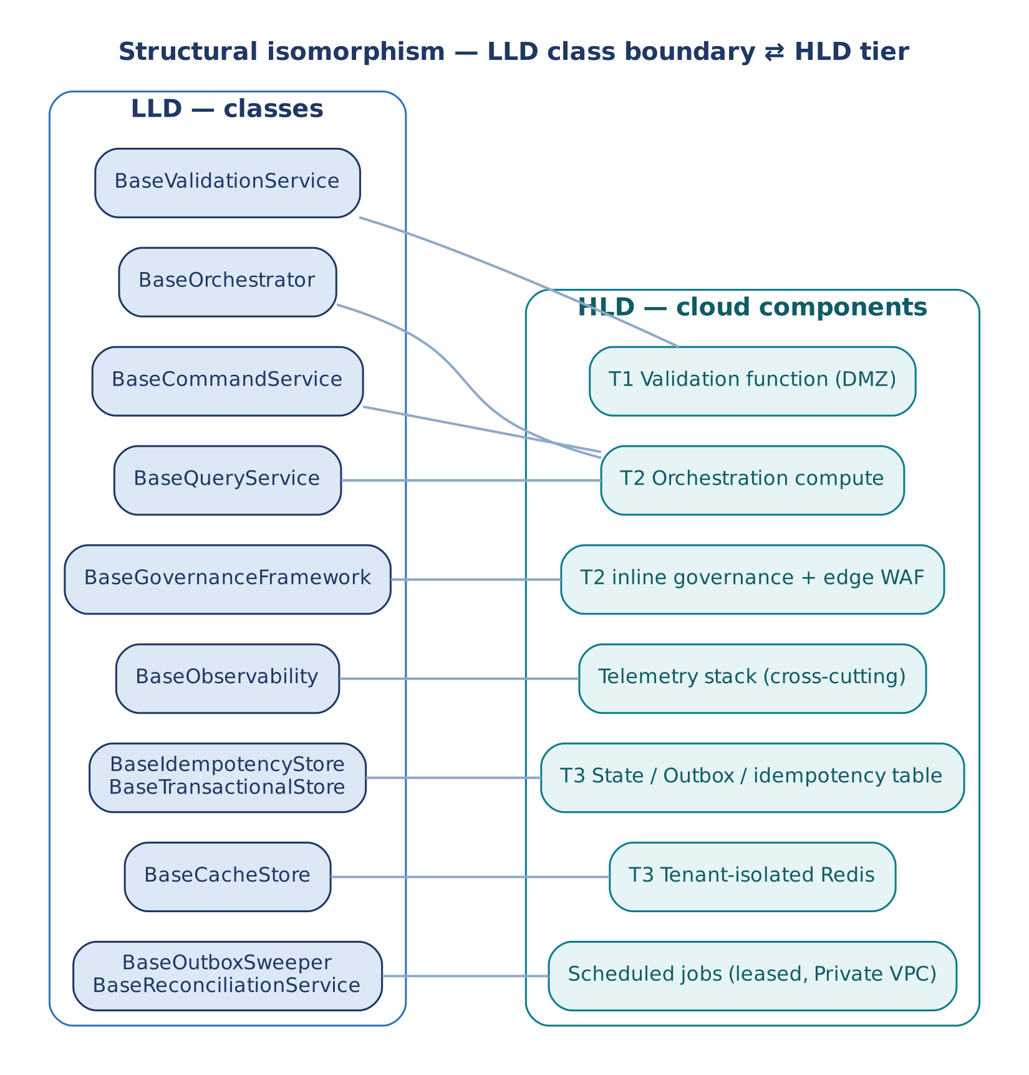
Figure 3 — Class-to-tier mapping

5.4 Request paths at a glance
Command (write) path. T0/T1 validate and return 202 → intake topic pushes to T2 → atomic claim → governance gate → mutate() (DTO, commit gate, deadline, business logic, conditional commit, outbox, cache sync) → claim settled, telemetry shipped → CDC fans the event out to T4 → task queue feeds T5.
Query (read) path. T0/T1 validate → synchronous invoke of T2 (no topic hop, no claim) → governance gate → fetch() → cache hit returns immediately; a miss performs one single-flight read against the read replica and hydrates the cache.

5.5 Capacity, ordering and consistency per boundary
Table 10 — Capacity, ordering and consistency
Component | Capacity bound | Ordering | Consistency
Command admission (T2) | Claim costs one store round trip; db_pool_size bounds concurrent commits; deadline bounds every wait | None across commands | Strong: one winner per key, one writer per aggregate version
State/outbox + idempotency store | replicas × db_pool_size below the database connection limit | Per aggregate via version | Strong for claim and conditional commit (single item / partition)
Query path (T2) | Separate read pool so reads never starve commands | None | Eventual via cache-aside; read-after-own-write via _synchronize_cache()
Tenant cache | Distinct keys × value size × TTL (single-flight collapses misses) | None | Advisory; expiry is an explicit field, provider TTL is GC only
Read replica | Read pool separate from write pool | None | Stale by replication lag + cache TTL
Intake topic | Durable backlog; DLQ after max receives | Not needed — claim absorbs duplicates | At-least-once
Fan-out topic / queues | Depth drives consumer scale-out | Per partition (tenant + aggregate) | At-least-once; consumers apply through a claim
T4 consumers | worker_concurrency ≤ db_pool_size; worker_prefetch ≥ worker_concurrency | Per partition | Effectively-once material effects
Sweeper / reconciler | One leader by lease; renew < TTL; fencing token on publish | None | Stale leaders rejected downstream

5.6 Vendor mapping
Table 11 — Generic component to cloud service
Generic component | AWS | GCP | Azure
API gateway / WAF | API Gateway + WAF | API Gateway / Cloud Endpoints | API Management
Validation function | Lambda | Cloud Run functions | Azure Functions
Orchestration compute | ECS Fargate / EKS | Cloud Run | Container Apps
Intake topic (push) | SNS → Fargate | Pub/Sub push subscription | Service Bus topic
Fan-out consumers | SNS → SQS queues | Pub/Sub subscriptions | Service Bus subscriptions
State / outbox / idempotency | DynamoDB (conditional writes) | Firestore / Cloud SQL (preconditions) | Cosmos DB (ETag If-Match)
Tenant cache | ElastiCache (Redis) | Memorystore (Redis) | Azure Cache for Redis
Read replica | RDS read replica | Cloud SQL read replica | Azure SQL read replica
Task queue + DLQ | SQS FIFO + DLQ | Pub/Sub pull + DLQ | Service Bus queue + DLQ
Saga processor | Step Functions | Workflows | Logic Apps
Partition ordering | SQS FIFO message group | Pub/Sub ordering key | Service Bus session
Lease store / scheduler | Versioned item + EventBridge Scheduler | Versioned document + Cloud Scheduler | Blob lease + Container Apps job
Observability | CloudWatch + X-Ray | Cloud Monitoring + Cloud Trace | Azure Monitor + App Insights

5.7 End-to-end command sequence
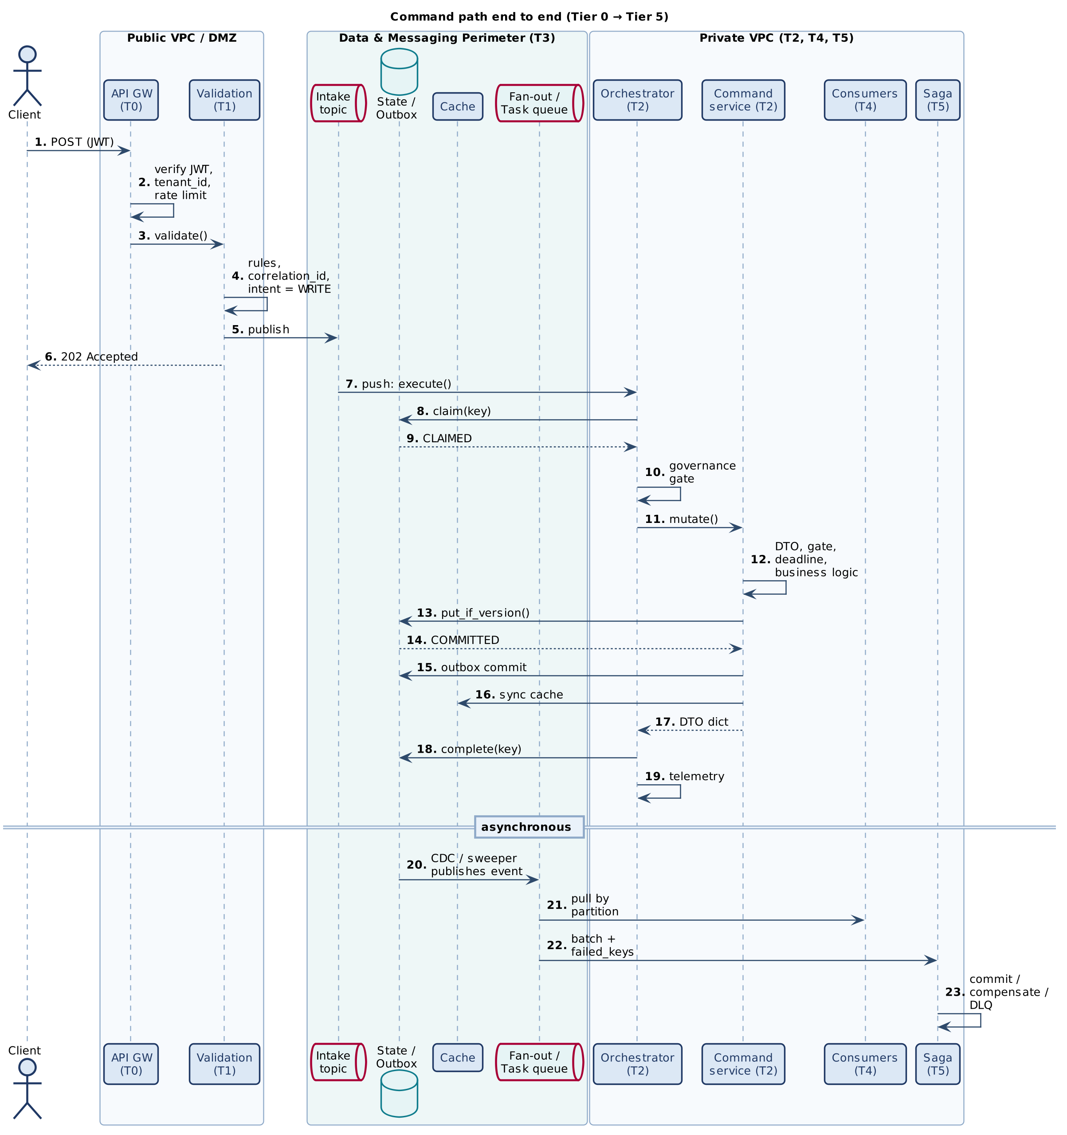
Figure 4 — Command path end to end, Tier 0 to Tier 5

6. Data and Propagation Contracts

6.1 Cross-class propagation fields
Six fields are shared with every E2A profile; three are additive for concurrency. None is ever stored on self.
Table 12 — Propagation fields
Field | Dir. | Origin | Purpose
correlation_id | In | BaseValidationService.validate(); execute() mints one if absent | Joins every log, metric and trace of one logical transaction; also the claim owner.
tenant_id | In | Verified JWT claim at T0; required in state | Cache-key namespace, idempotency scope, data partition / silo routing.
idempotency_key | In | Client key, else _generate_idempotency_key() | Claim key on the command path; appended to failed_keys on failure.
io_config | In | _resolve_io_config() — config entries with the io_ prefix | Endpoint and quota configuration kept apart from behavioural config.
message_log | Out | Empty list per request | Ordered structured events; shipped once to observability.
failed_keys | Out | Empty list per request | Command-path failures for the DLQ and Saga; never forwarded from reads.
deadline | In | Inbound Deadline / remaining ms, else request_deadline_seconds | Bounds every wait; travels as remaining milliseconds across processes (x-e2a-deadline-ms).
expected_version | In | Caller (kwargs or state) | Advisory fast-fail in _commit_gate(); authoritative in put_if_version.
fencing_token | In | Caller holding a lease | Lets the store reject a superseded writer (FENCED).

Inside execute() these are bundled into a common dict and passed as keyword arguments to the governance gate and to mutate() / fetch().

6.2 Request state keys
state is a plain dict. The base classes read and write the following keys; everything else belongs to the concrete subclass and its DTOs.
Table 13 — State keys read or written by the base classes
Key | R/W | Meaning
tenant_id | R | Mandatory; ValueError if missing.
correlation_id, idempotency_key | R | Optional caller-supplied values (kwargs win).
action / resource | R | Passed to _get_command_service() / _get_query_service() for routing.
expected_version, fencing_token | R | OCC and lease evidence, copied into common if present.
requires_manual_approval, approval_granted | R | Trigger dehydration in the governance gate.
pending_external_call | R | Triggers _verify_sandbox_profile().
cumulative_requests_in_window | R | Current tenant usage compared against io_config['max_requests_per_window'].
outcome | R | A PhysicalOutcome; UNKNOWN parks the claim.
result | R | Included in the replayable result.
status | W | Terminal status (Table 14).
conflict, idempotency_status, replayed | W | Conflict detail, raw claim status, replay marker.
message_log, failed_keys | W | Always written back on exit (except short-circuit, which writes an empty failed_keys).

Note — the state is replaced by the DTO.
On the normal path execute() assigns state = service.mutate(...) (or fetch(...)), so the returned dict is the service's output DTO plus message_log and failed_keys. An output DTO that should replay meaningfully must expose result and/or outcome fields, because _replayable_result() keeps only those two keys.

6.3 Status vocabulary
Table 14 — Values of state['status'] set by the base classes
Status | Set when | Caller action
(service-defined) | Normal completion; the DTO decides | Use the result.
blocked | _commit_gate() rejected the key (output DTO with reason='commit_gate_rejection') | Investigate the batch / version.
REPLAYED | Claim returned REPLAY | Use the stored result; the effect already happened.
IN_PROGRESS | Another owner holds an unexpired claim | Retry later.
CONFLICT | Fingerprint mismatch on claim, or ConcurrencyConflict from the store | Reload, re-evaluate, resubmit (new key for a new payload).
RECOVERY_REQUIRED | Prior owner's lease expired or outcome UNKNOWN | Wait for the reconciler.
FAILED_FINAL | A deterministic failure is on record | Submit a corrected request with a new key.
AWAITING_WEBHOOK | DehydrationInterrupt | Resume after approval webhook.

6.4 Configuration keys
All keys resolve through resolve_config(key, config, kwargs, scope=None) from the central registry in e2a_base.py. This profile adds no keys of its own; its one profile-specific default is max_latency = 1.0 s under scope CQRS.
Table 15 — Configuration consumed by the CQRS path
Key | Default | Used by
observability_engine | — | execute() finally; absent → local structured logging.
governance_engine | — | execute(); absent → gate skipped (fail-open — bind in production).
idempotency_store | — | execute() claim; absent → no claim (bind in production).
transactional_store | — | _commit_versioned(); absent or no _entity_key() → no OCC.
cache_store | — | fetch() single-flight; absent → _read_from_cache() / _write_to_cache() hooks.
io_config_prefix | io_ | _resolve_io_config().
commit_gate_enabled | True | _commit_gate() (CQRS mixin reads kwargs/config only — see Section 15).
dlq_queue_url | none | _send_to_dlq().
strict_mode | True | validate(): no validator registered → invalid.
max_latency | 1.0 s (scope CQRS) | Latency SLO at the end of mutate() and fetch().
request_deadline_seconds | 0 (none) | Origin of deadline.
idempotency_lease_seconds | 300 | IN_PROGRESS claim expiry.
idempotency_ttl_seconds | 86 400 | Retention of settled keys for replay (GC only).
cache_fill_timeout_seconds | 5.0 | Follower wait in get_or_load().
cache_fill_on_timeout | load | Follower policy: load, stale or raise.
db_pool_size, worker_concurrency, worker_prefetch, drain_timeout_seconds | 20, 8, 16, 20.0 | Capacity gate (validate_capacity()) and consumer runtime.
lease_ttl_seconds, lease_renew_interval_seconds | 60, 20 | Sweeper and reconciler leases.

7. Low-Level Design — Class Model

7.1 Module structure
Table 16 — Modules
Module | Contents
reference/e2a_cqrs_base.py | DehydrationInterrupt, NFRViolationError, _PropagationMixin, BaseObservability, BaseGovernanceFramework, ValidationResult, BaseValidationService, BaseOrchestrator, BaseCommandService, BaseQueryService. "Drop into src/, import and subclass — never modify."
reference/e2a_base.py (imported) | resolve_config, Deadline, ClaimStatus, ClaimResult, CommitResult, PhysicalOutcome, ConcurrencyConflict, DeadlineExceeded, AdmissionTimeout, _DETERMINISTIC_ERRORS, BaseIdempotencyStore, BaseTransactionalStore, BaseCacheStore; also the repair classes BaseDistributedLock, BaseOutboxSweeper, BaseReconciliationService.
reference/e2a_inmemory_adapters.py | Test doubles: InMemoryIdempotencyStore, InMemoryTransactionalStore, InMemoryCacheStore, InMemoryLease.
src/… (project) | Concrete orchestrator, command and query services, validators, governance and observability engines, store adapters.

7.2 Class catalogue
Table 17 — Classes in scope
Class | Module | Status | Role
BaseOrchestrator | cqrs | Implemented (ABC) | Tier 2 single entry point; admission, routing, settlement.
BaseCommandService | cqrs | Implemented (ABC) | Write path: DTO, gate, logic, conditional commit, outbox, cache sync, SLO.
BaseQueryService | cqrs | Implemented (ABC) | Read path: cache-aside with single-flight, SLO.
_PropagationMixin | cqrs | Implemented | Shared helpers: io_config, log, DLQ, commit gate.
BaseValidationService | cqrs | Implemented (ABC) | Tier 1 validator registry and result builder.
ValidationResult | cqrs | Implemented | HTTP-400-serialisable dict.
BaseGovernanceFramework | cqrs | Implemented (ABC) | Quota, dehydration, sandbox, firewall; CQRS-adapted.
BaseObservability | cqrs | Implemented (ABC) | Enrich, derive metrics, ship logs/metrics/traces.
DehydrationInterrupt, NFRViolationError | cqrs | Implemented | Signal and NFR-breach exceptions (CQRS-local definitions).
Deadline, ClaimStatus, ClaimResult, CommitResult, PhysicalOutcome | base | Implemented | Shared concurrency value types.
BaseIdempotencyStore, BaseTransactionalStore, BaseCacheStore | base | Implemented (ABC ports) | Claim, conditional commit, cache with single-flight.
ConcurrencyConflict, DeadlineExceeded, AdmissionTimeout | base | Implemented | Typed concurrency outcomes.
BaseOutboxSweeper, BaseReconciliationService, BaseDistributedLock | base | Implemented (ABC) | Scheduled repair under a lease (Section 11).
Tier 4 consumer | — | Runtime obligation | Partitioned handler loop (Section 11.1).

7.3 Orchestration layer
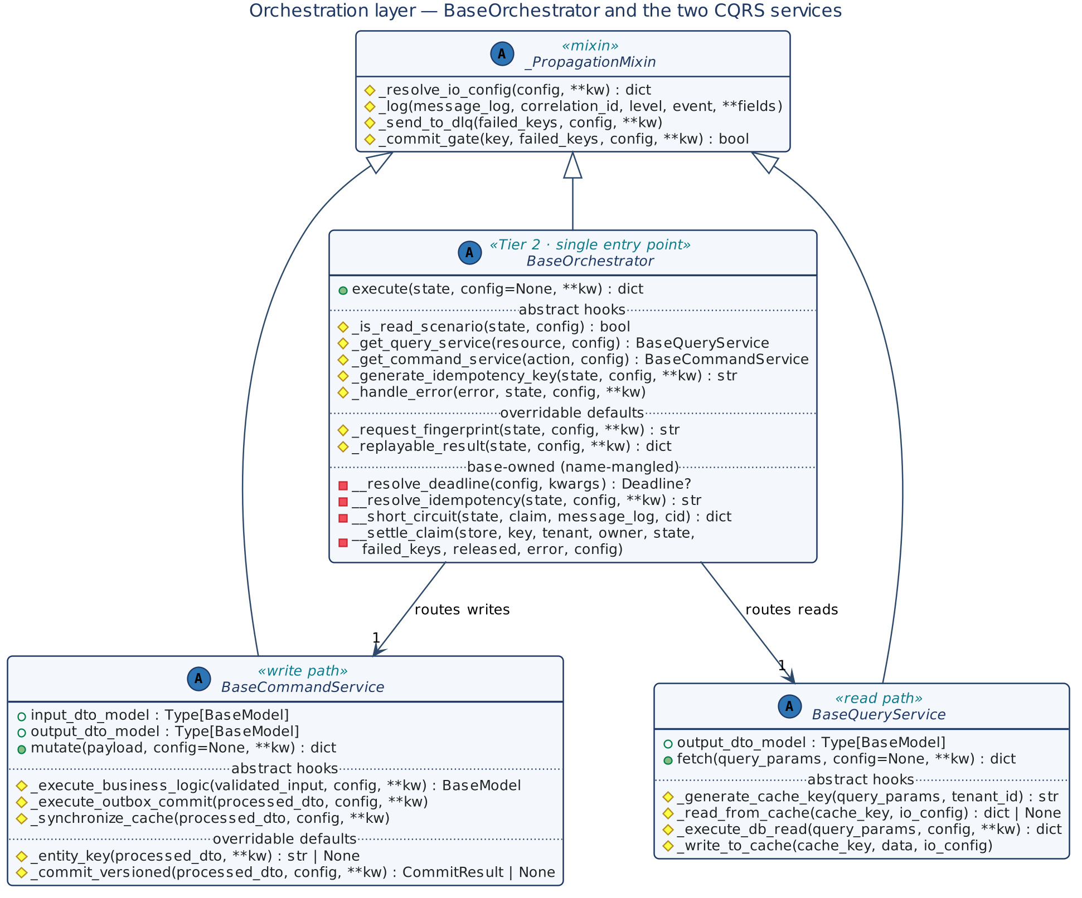
Figure 5 — Orchestration layer: BaseOrchestrator, BaseCommandService and BaseQueryService
UML notation: + public, # protected hook, - name-mangled base-owned step; italic members are abstract.

7.4 Cross-cutting classes
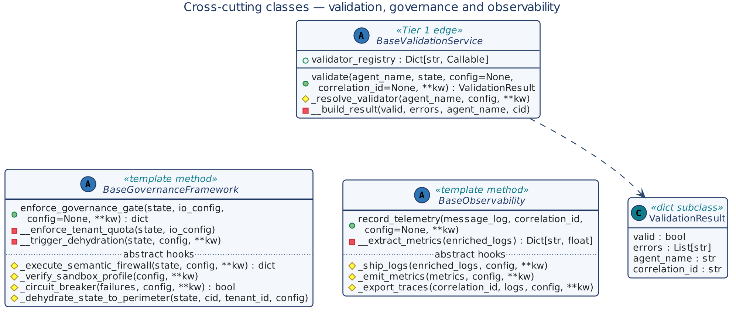
Figure 6 — Validation, governance and observability

7.5 Collaborations and injected ports
All collaborators except the two services are injected through config, never constructed by the base classes. This keeps the scaffold vendor-neutral and lets tests bind in-memory doubles.
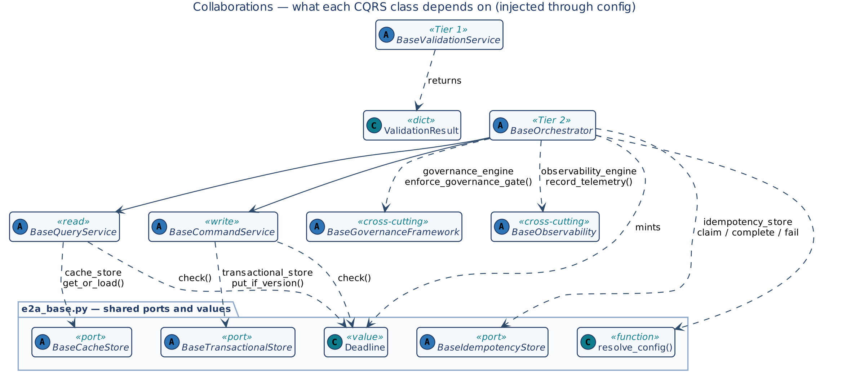
Figure 7 — Collaborations injected through config

7.6 Shared contracts imported from e2a_base.py
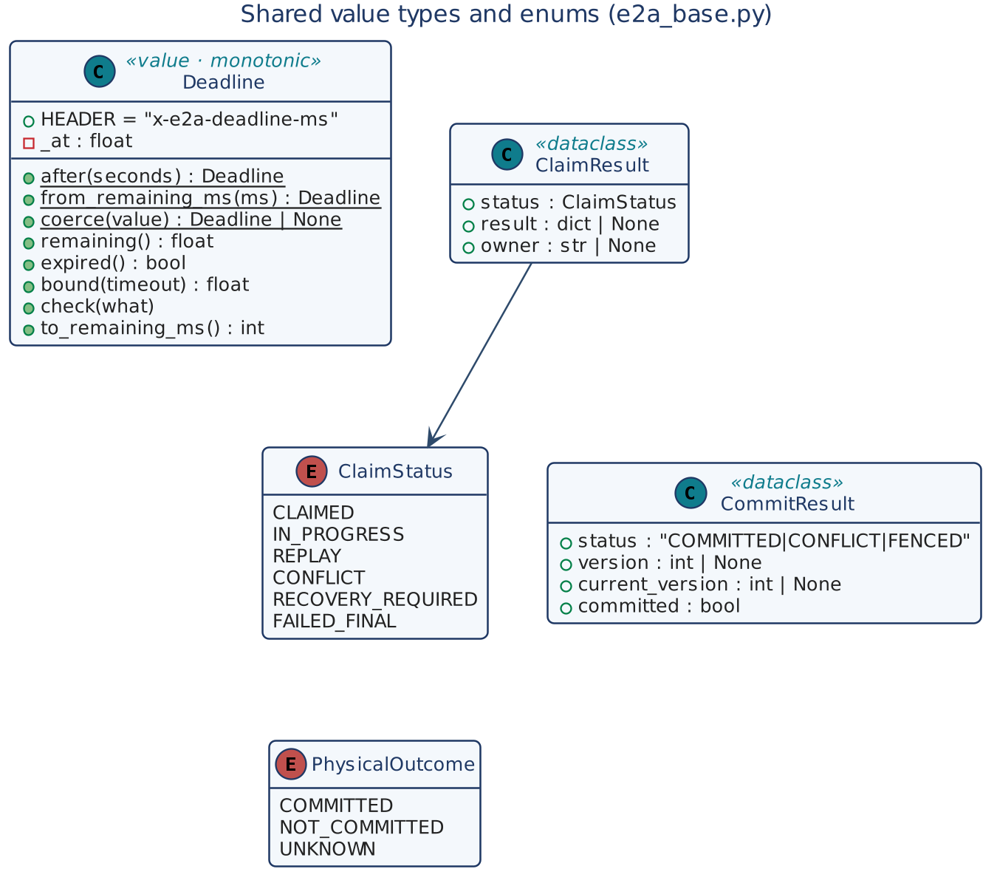
Figure 8 — Shared value types and enums
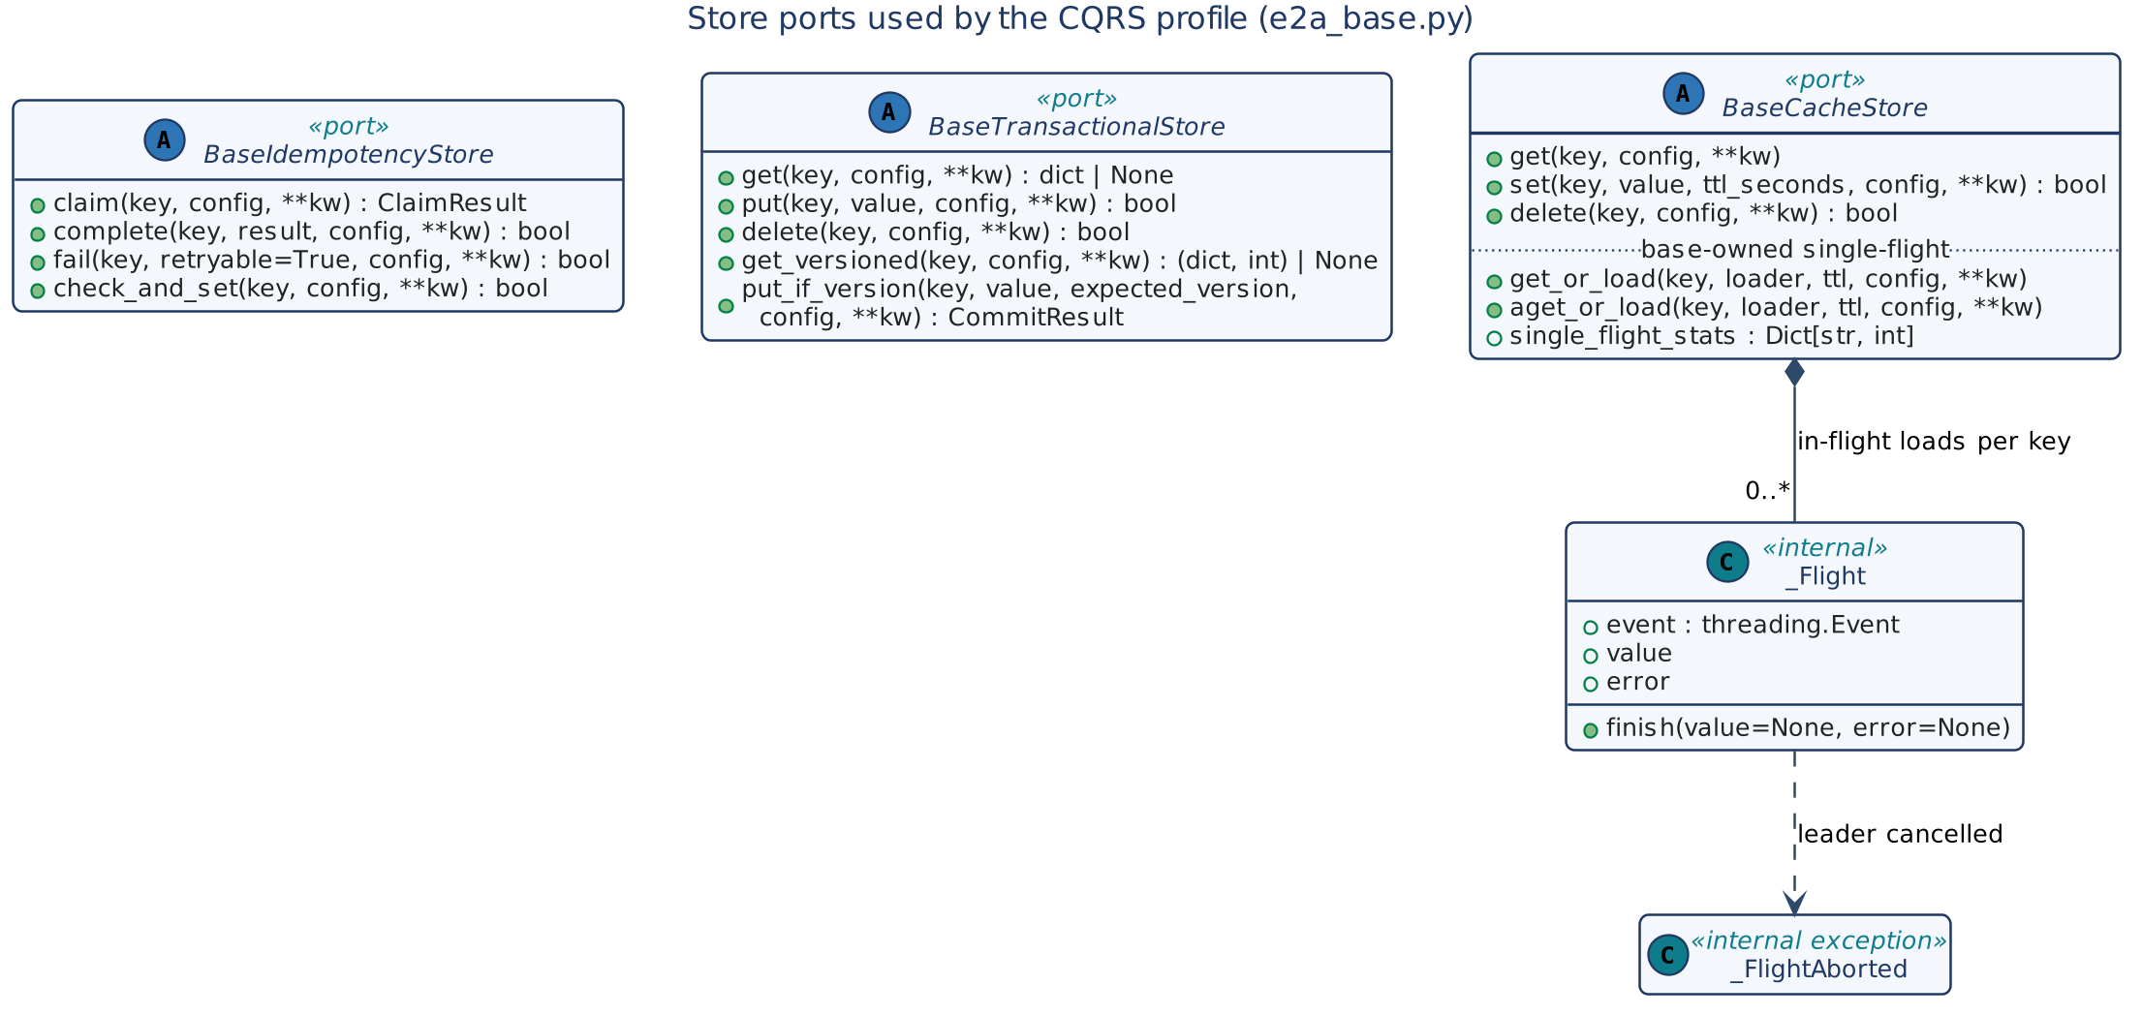
Figure 9 — Store ports used by the CQRS profile

7.7 Exception taxonomy
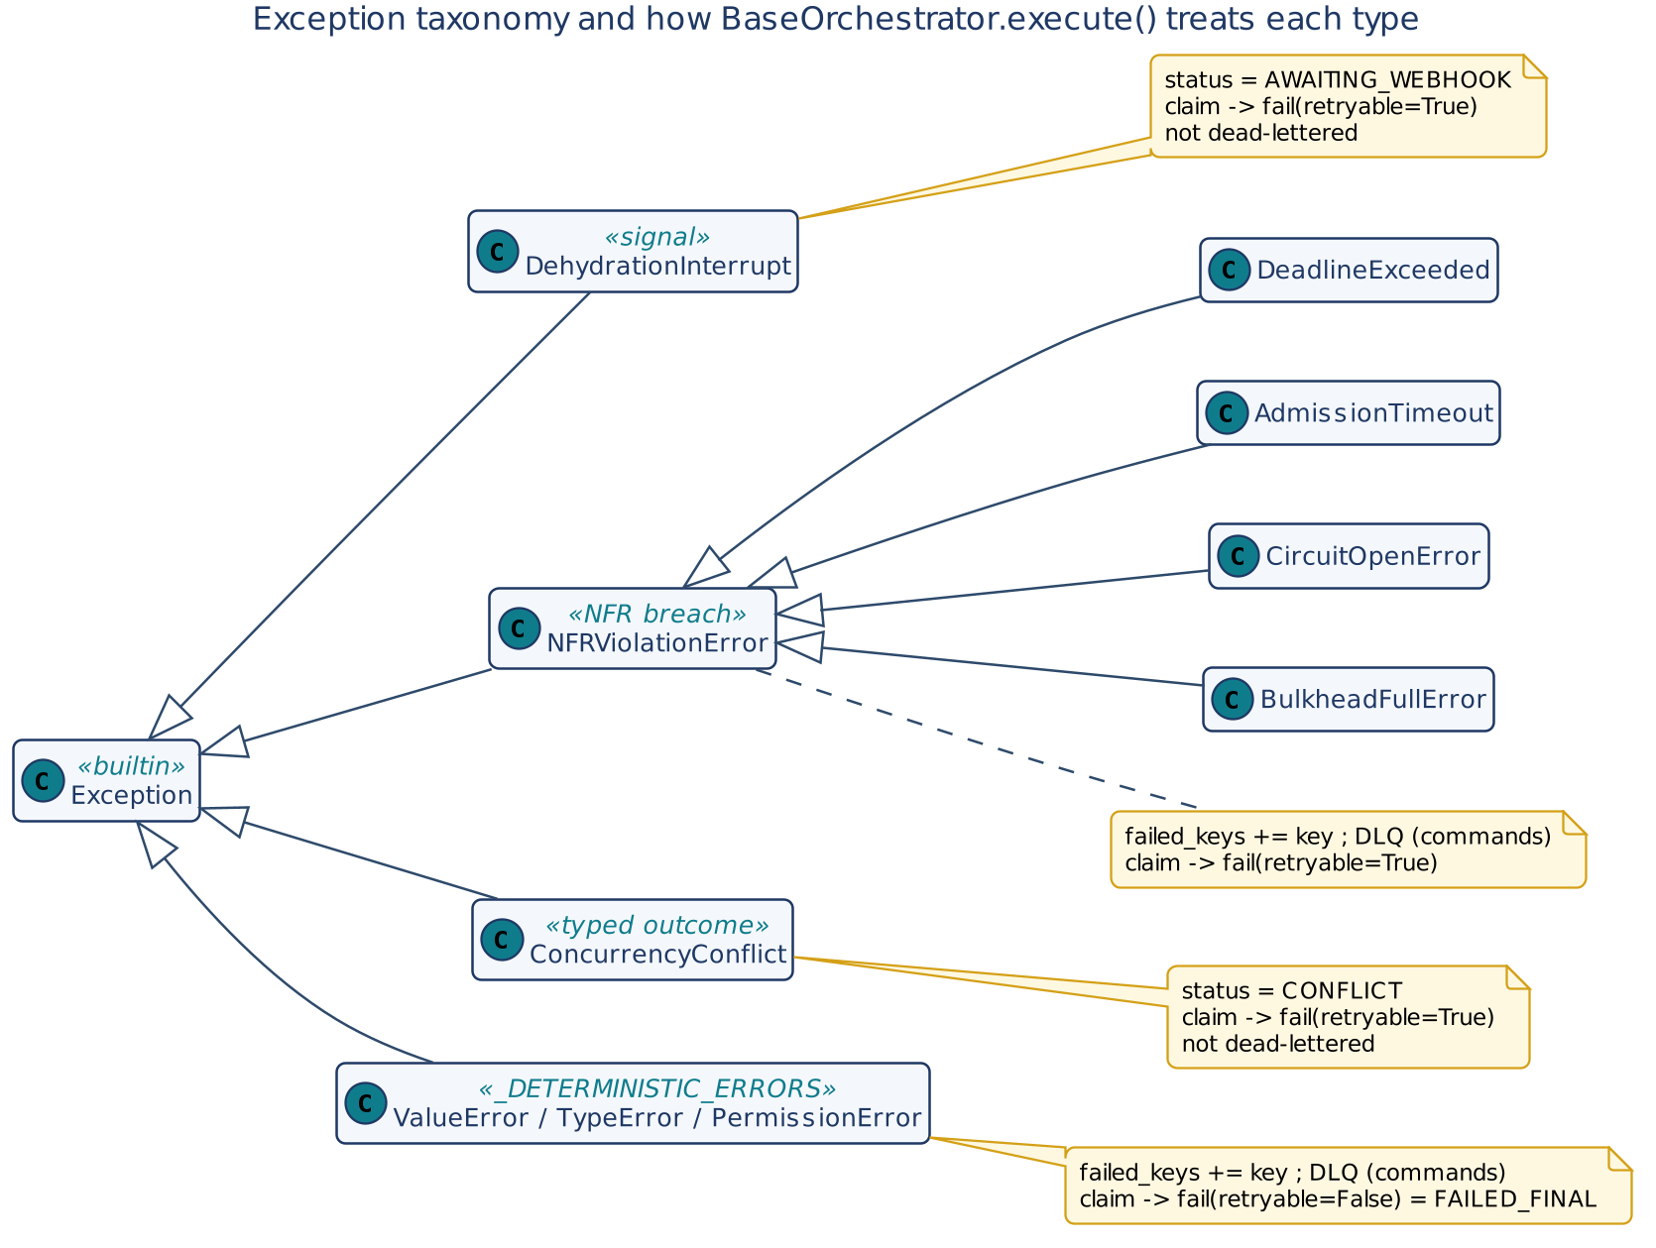
Figure 10 — Exception taxonomy and orchestrator handling

8. Low-Level Design — Class Contracts
Each contract card lists the class's purpose, its collaborators and invariants, followed by a method table. Kind is one of: entry (the single public method), template (base-owned step), hook (abstract, must be implemented), default (protected, may be overridden), helper (inherited utility).

8.1 BaseOrchestrator
Aspect | Detail
Stereotype | Abstract base class; Tier 2 lifecycle manager; replaces BaseWorkflow
Inherits | ABC, _PropagationMixin
Responsibility | Resolve propagation fields; claim the idempotency key for commands; run governance; route to a command or query service; translate exceptions into statuses; settle the claim; ship telemetry; dead-letter command failures.
Collaborators | BaseIdempotencyStore, BaseGovernanceFramework, BaseObservability (all via config); BaseCommandService / BaseQueryService (via hooks); Deadline; resolve_config
Thread safety | Stateless between requests; all request data are locals or arguments. One instance may serve concurrent requests.
Invariants | INV-01 to INV-09

Table 18 — BaseOrchestrator methods
Method | Kind | Signature → returns | Contract
execute | entry | (state: dict, config: dict = None, **kwargs) → dict | Pre: state['tenant_id'] present, else ValueError. Steps: resolve correlation_id (kwargs › state › uuid4), io_config, deadline, idempotency_key; classify read/write; for commands with an idempotency store, claim() and short-circuit unless CLAIMED; governance gate; route; map exceptions (Table 25); in finally ship telemetry, settle the claim, dead-letter command failures, write back message_log / failed_keys. Never raises for service errors — they are converted to state and passed to _handle_error().
_is_read_scenario | hook | (state, config) → bool | Return True for queries. Must be pure and cheap; drives claim, routing and DLQ policy.
_get_query_service | hook | (resource: str, config) → BaseQueryService | Resolve the read service for state['resource']. May return a shared instance.
_get_command_service | hook | (action: str, config) → BaseCommandService | Resolve the write service for state['action'].
_generate_idempotency_key | hook | (state, config, **kwargs) → str | Mint a deterministic key from business content when the client supplied none. Must be stable across redeliveries of the same request.
_handle_error | hook | (error, state, config, **kwargs) → None | Map a failure to a caller-visible error shape (for example HTTP status). Called after failed_keys is appended; must not raise.
_request_fingerprint | default | (state, config=None, **kwargs) → str | SHA-256 of state minus volatile keys (correlation_id, idempotency_key, message_log, failed_keys, deadline, status, result, outcome, conflict), JSON with sorted keys. Override to fingerprint a canonical DTO instead.
_replayable_result | default | (state, config=None, **kwargs) → dict | Subset of state stored on complete() and returned on REPLAY: keys result and outcome. Must be post-redaction.
__resolve_deadline | template | (config, kwargs) → Deadline | None | Pops deadline from kwargs and coerces it; else Deadline.after(request_deadline_seconds) when > 0; else None.
__resolve_idempotency | template | (state, config=None, **kwargs) → str | Client key (kwargs › state) wins; else _generate_idempotency_key(). Derives the key only — ownership is the claim.
__short_circuit | template | (state, claim, message_log, correlation_id) → dict | Map claim status to state['status'] (Table 14), copy result/outcome on REPLAY, log idempotent_short_circuit, return with empty failed_keys. No service, governance or telemetry call.
__settle_claim | template | (store, key, tenant_id, owner, state, failed_keys, released, error, config) → None | Exactly one of complete() / fail() per owned claim (Figure 15).

8.2 BaseCommandService
Aspect | Detail
Stereotype | Abstract base class; Tier 2 write path; with BaseQueryService, replaces BaseAgent
Inherits | ABC, _PropagationMixin
Class attributes | input_dto_model: Type[BaseModel], output_dto_model: Type[BaseModel] (pydantic)
Responsibility | Validate the payload into a typed DTO; apply the advisory commit gate; check the deadline; run business logic; commit the aggregate conditionally; write the outbox; synchronise the cache; enforce the latency SLO.
Collaborators | BaseTransactionalStore (config['transactional_store']), Deadline, resolve_config
Ordering guarantee | logic → conditional commit → outbox → cache sync → SLO check (INV-05, INV-12)

Table 19 — BaseCommandService methods
Method | Kind | Signature → returns | Contract
mutate | entry | (payload: dict, config: dict = None, **kwargs) → dict | Pops failed_keys from kwargs. input_dto_model(**payload); pydantic ValidationError → logs dto_validation_failed and raises ValueError (deterministic). If a key exists and _commit_gate() rejects → returns output_dto_model(status='blocked', reason='commit_gate_rejection').dict(). deadline.check() → DeadlineExceeded. Then the fixed write order. Measures latency; > max_latency (scope CQRS) → NFRViolationError. Returns processed_dto.dict().
_execute_business_logic | hook | (validated_input: BaseModel, config, **kwargs) → BaseModel | Pure domain decision producing the output DTO. No I/O to the outbox or cache. May set outcome on the DTO for external side effects.
_entity_key | default | (processed_dto, **kwargs) → str | None | Durable aggregate key. None (default) opts out of OCC. Return e.g. f"{tenant}:order:{id}" to opt in.
_commit_versioned | default | (processed_dto, config, **kwargs) → CommitResult | None | With an entity key and a bound BaseTransactionalStore: put_if_version(key, dto.dict(), expected_version, config, fencing_token=…). CONFLICT / FENCED → ConcurrencyConflict. Override to commit aggregate and outbox in one store transaction.
_execute_outbox_commit | hook | (processed_dto, config, **kwargs) → None | Write the domain event to the outbox in the same local transaction scope as the state change. Must not publish to Tier 4 itself — CDC / sweeper owns that hop. Should be idempotent if not transactional with the aggregate.
_synchronize_cache | hook | (processed_dto, config, **kwargs) → None | Evict or hydrate the affected tenant-scoped cache key synchronously, before mutate() returns (read-after-write).
_commit_gate | helper | (key, failed_keys, config, **kwargs) → bool | From the mixin: blocks keys already in failed_keys; advisory OCC check against actual_version_lookup when expected_version is supplied; disabled by commit_gate_enabled=False.

8.3 BaseQueryService
Aspect | Detail
Stereotype | Abstract base class; Tier 2 read path (Tier 3 cache-aside)
Inherits | ABC, _PropagationMixin
Class attributes | output_dto_model: Type[BaseModel]
Responsibility | Check the deadline; build a tenant-scoped cache key; serve from cache or perform one single-flight database read; enforce the latency SLO; marshal into the output DTO.
Collaborators | BaseCacheStore (config['cache_store']), read replica (via hook), Deadline
Side effects | None on the system of record. Never claims a key, never dead-letters.

Table 20 — BaseQueryService methods
Method | Kind | Signature → returns | Contract
fetch | entry | (query_params: dict, config: dict = None, **kwargs) → dict | deadline.check(); cache_key = _generate_cache_key(params, tenant_id). With cache_store: get_or_load(cache_key, _load, None, config, deadline=deadline) where _load logs query_cache_miss and calls _execute_db_read(); a hit logs query_cache_hit and returns immediately. Without: _read_from_cache() → hit returns; miss → _execute_db_read() → _write_to_cache() if data. Then SLO check (NFRViolationError), log query_fetch_complete, return output_dto_model(**db_data).dict().
_generate_cache_key | hook | (query_params: dict, tenant_id: str) → str | Must include tenant_id (INV-11), e.g. TENANT:acme:ORDER:123. Deterministic for equal params.
_read_from_cache | hook | (cache_key, io_config) → dict | None | Fallback cache read when no cache_store is bound; also the place for a custom stampede guard.
_execute_db_read | hook | (query_params, config, **kwargs) → dict | Read through the read-only replica credential, so a write attempt fails at the driver. Should return a dict compatible with output_dto_model (see Section 15 on empty results).
_write_to_cache | hook | (cache_key, data, io_config) → None | Fallback cache hydrate; unused when cache_store is bound (get_or_load sets the value).

8.4 _PropagationMixin
Aspect | Detail
Stereotype | Mixin of base-owned helpers; identical in intent to the agentic mixin (CQRS-local copy)
Used by | BaseOrchestrator, BaseCommandService, BaseQueryService, BaseValidationService

Table 21 — _PropagationMixin methods
Method | Signature → returns | Contract
_resolve_io_config | (config=None, **kwargs) → dict | Entries of config whose key starts with io_config_prefix (default io_).
_log | (message_log, correlation_id, level, event, **fields) → None | Append {timestamp, correlation_id, level, event, class, **fields}; no-op when message_log is None.
_send_to_dlq | (failed_keys, config=None, **kwargs) → None | Resolve dlq_queue_url; scaffold logs a warning — a concrete runtime binds the queue client.
_commit_gate | (key, failed_keys, config=None, **kwargs) → bool | False if the key is already failed in this batch, or if expected_version differs from actual_version_lookup(key, config); True when disabled. Advisory only.

8.5 BaseGovernanceFramework (CQRS-adapted)
Aspect | Detail
Stereotype | Abstract base class; template method; injected as config['governance_engine']
Runs | Inside execute() after the claim and before routing, identically for commands and queries
Adaptation | Tenant request quota replaces LLM token budget; external-API isolation replaces MCP tool sandboxing; dehydration unchanged

Table 22 — BaseGovernanceFramework methods
Method | Kind | Signature → returns | Contract
enforce_governance_gate | entry | (state, io_config, config=None, **kwargs) → dict | Order: quota → dehydration (if requires_manual_approval and not approval_granted) → sandbox check (if pending_external_call) → semantic firewall. Returns the sanitised state.
__enforce_tenant_quota | template | (state, io_config) → None | state['cumulative_requests_in_window'] ≥ io_config['max_requests_per_window'] → NFRViolationError.
__trigger_dehydration | template | (state, config, **kwargs) → None | Calls _dehydrate_state_to_perimeter() then raises DehydrationInterrupt.
_execute_semantic_firewall | hook | (state, config, **kwargs) → dict | Detect injection patterns; redact PII before business logic.
_verify_sandbox_profile | hook | (config, **kwargs) → None | Assert the outbound call runs inside an isolated egress / IAM boundary; raise if not.
_circuit_breaker | hook | (failures: int, config, **kwargs) → bool | Trip on repeated downstream failures. Declared but not called by the base gate — call it from service hooks (Section 15).
_dehydrate_state_to_perimeter | hook | (state, correlation_id, tenant_id, config) → None | Persist resumable state to the Tier 3 perimeter before the interrupt.

8.6 BaseObservability (CQRS-adapted)
Aspect | Detail
Stereotype | Abstract base class; template method; injected as config['observability_engine']; one instance shared by both paths
Runs | In execute()'s finally for every non-short-circuited request

Table 23 — BaseObservability methods
Method | Kind | Signature → returns | Contract
record_telemetry | entry | (message_log, correlation_id, config=None, **kwargs) → None | Enrich each entry with correlation_id, tenant_id, host_epoch_ms, framework_version='e2a-cqrs-v1.0'; derive metrics; call the three hooks; on any exception log the error and fall back to local logging. Never raises.
__extract_metrics | template | (enriched_logs) → dict | command_count, query_count, cache_hit_count, cache_miss_count, error_count derived from event names and ERROR level.
_ship_logs | hook | (enriched_logs, config, **kwargs) | Send structured logs to the backend.
_emit_metrics | hook | (metrics, config, **kwargs) | Publish counters.
_export_traces | hook | (correlation_id, logs, config, **kwargs) | Export spans; forward W3C traceparent if a trace context is present.

8.7 BaseValidationService and ValidationResult
Aspect | Detail
Stereotype | Abstract base class; Tier 1 edge; reused unmodified from the agentic profile
Class attribute | validator_registry: Dict[str, Callable[[state, config, **kw], (bool, List[str])]]
Profile responsibility | Also classifies intent (read vs write) so T1 can publish commands and invoke queries directly

Table 24 — BaseValidationService methods
Method | Kind | Signature → returns | Contract
validate | entry | (agent_name, state, config=None, correlation_id=None, **kwargs) → ValidationResult | Resolve validator; none → invalid in strict_mode (default) else valid; run validator → (valid, errors). correlation_id from argument › state › uuid4.
_resolve_validator | default | (agent_name, config=None, **kwargs) | Registry lookup; override for dynamic resolution.
__build_result | template | (valid, errors, agent_name, correlation_id) → ValidationResult | Build the dict result.

ValidationResult is a dict subclass with keys valid, errors, agent_name, correlation_id, directly serialisable as an HTTP 400 body.

8.8 Exceptions
Table 25 — Exceptions and their handling in execute()
Exception | Raised by | Handling
ValueError (missing tenant) | execute() pre-check | Propagates to the caller (no claim taken).
DehydrationInterrupt | Governance gate | status = AWAITING_WEBHOOK; claim fail(retryable=True); no DLQ.
ConcurrencyConflict | _commit_versioned() | status = CONFLICT; conflict set; claim fail(retryable=True); no DLQ.
NFRViolationError (quota, latency) | Governance gate, mutate(), fetch() | Generic branch: failed_keys += key; _handle_error(); claim fail(retryable=True); DLQ for commands.
DeadlineExceeded | Deadline.check() | As NFRViolationError (subclass).
AdmissionTimeout | get_or_load() follower with policy raise | As NFRViolationError (query path: no DLQ).
ValueError / TypeError / PermissionError | DTO validation, hooks | Generic branch; claim fail(retryable=False) → FAILED_FINAL; DLQ for commands.
Any other Exception | Hooks, stores | Generic branch; claim fail(retryable=True); DLQ for commands.

8.9 Shared concurrency contracts (summary)
These are defined in e2a_base.py and documented in full in the E2A Framework Design Document; the CQRS profile uses them as follows.
Table 26 — Imported contracts and their use in this profile
Contract | Key members | Use in CQRS
Deadline | after, from_remaining_ms, coerce, remaining, expired, bound, check, to_remaining_ms, HEADER | Minted in execute(); checked in mutate() / fetch(); bounds the single-flight follower wait.
BaseIdempotencyStore | claim(key, tenant_id, fingerprint, owner, lease_seconds, ttl_seconds, recover), complete(key, result, tenant_id, owner), fail(key, retryable, tenant_id, owner, outcome) | Command admission and settlement in execute(); consumer and reconciler admission.
ClaimResult / ClaimStatus | status, result, owner | Drives __short_circuit().
BaseTransactionalStore | get, put, delete, get_versioned, put_if_version(key, value, expected_version, fencing_token) | Authoritative OCC in _commit_versioned(). expected_version=None means create-if-absent.
CommitResult | status (COMMITTED/CONFLICT/FENCED), version, current_version, committed | Loser detection.
BaseCacheStore | get, set, delete, get_or_load, aget_or_load, single_flight_stats | Single-flight read path.
PhysicalOutcome | COMMITTED, NOT_COMMITTED, UNKNOWN | UNKNOWN parks the claim.
_DETERMINISTIC_ERRORS | (ValueError, TypeError, PermissionError) | Selects FAILED_FINAL.

9. Dynamic Behaviour

9.1 Orchestrator admission, routing and settlement
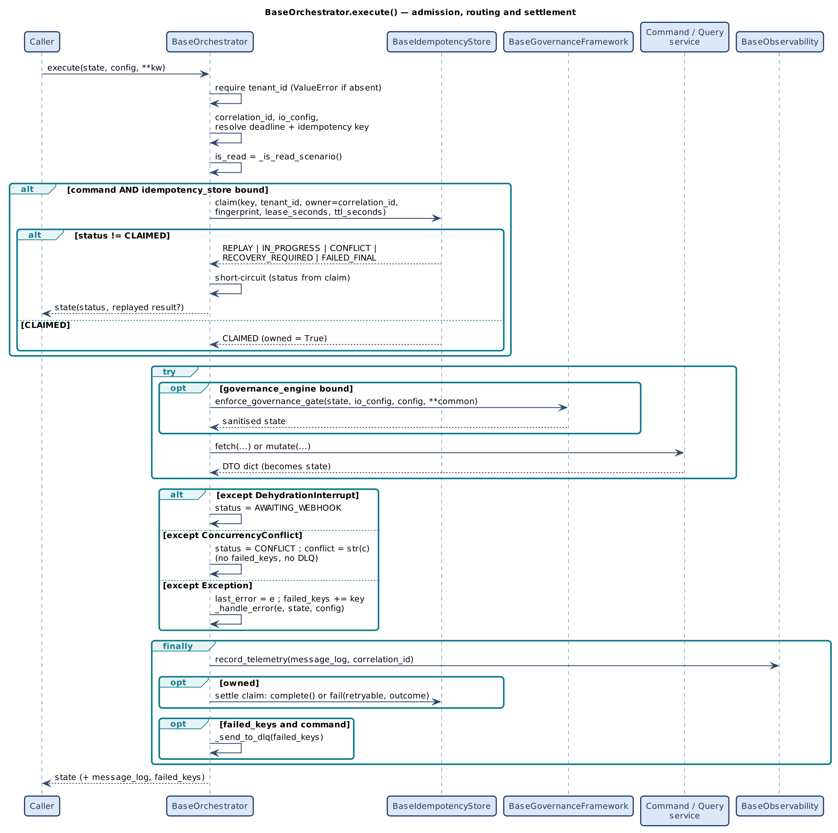
Figure 11 — BaseOrchestrator.execute(): admission, routing and settlement
Key points: the claim happens before governance, so a duplicate never consumes quota or reaches business logic; the short-circuit returns before the try block, so no service, settlement or telemetry call is made for duplicates; everything in finally runs even when the service raised.

9.2 Command write path internals
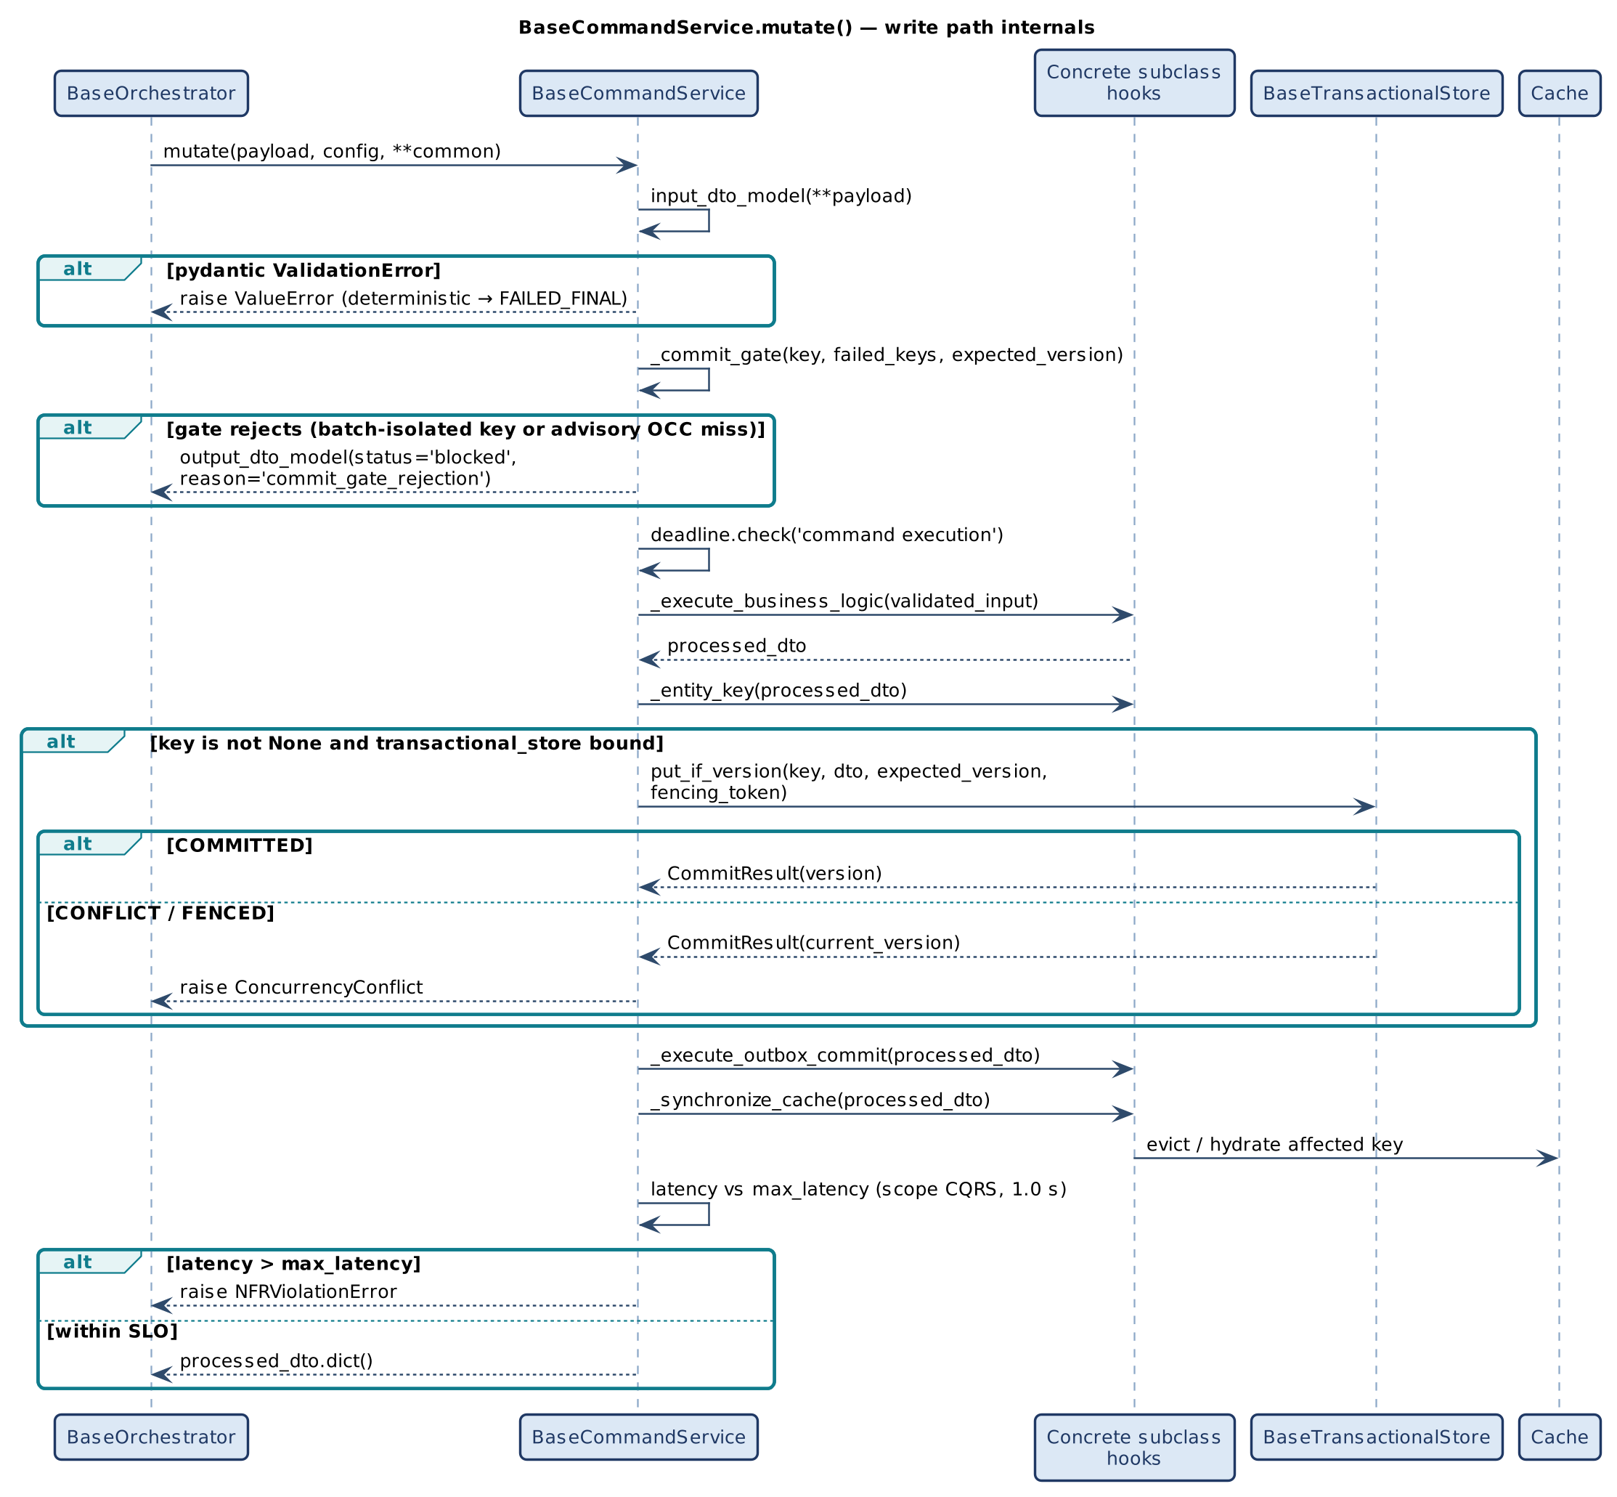
Figure 12 — BaseCommandService.mutate(): write-path internals

9.3 Query read path with single-flight
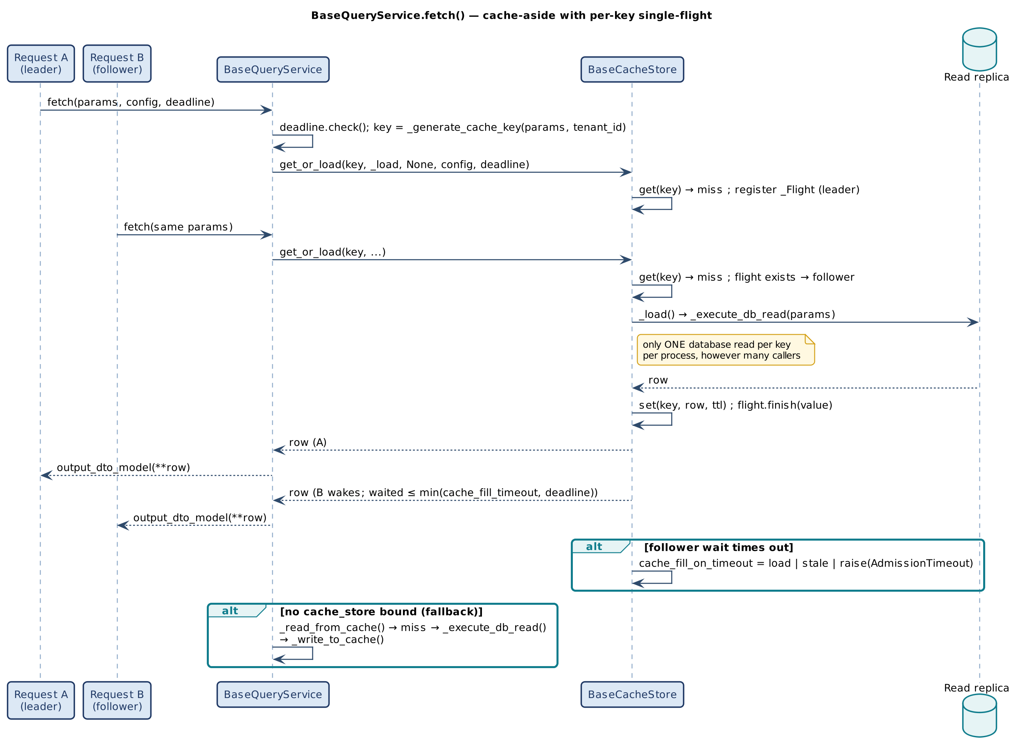
Figure 13 — BaseQueryService.fetch(): cache-aside with per-key single-flight
A follower waits at most min(cache_fill_timeout_seconds, deadline.remaining()) and then applies cache_fill_on_timeout: load (run its own read — freshest), stale (return the last cached value — protects the database) or raise (AdmissionTimeout — strictest). A loader exception propagates to every waiter and is never cached. If the leader is cancelled, followers receive _FlightAborted internally and fall back rather than inheriting the cancellation.

9.4 Idempotency record life cycle
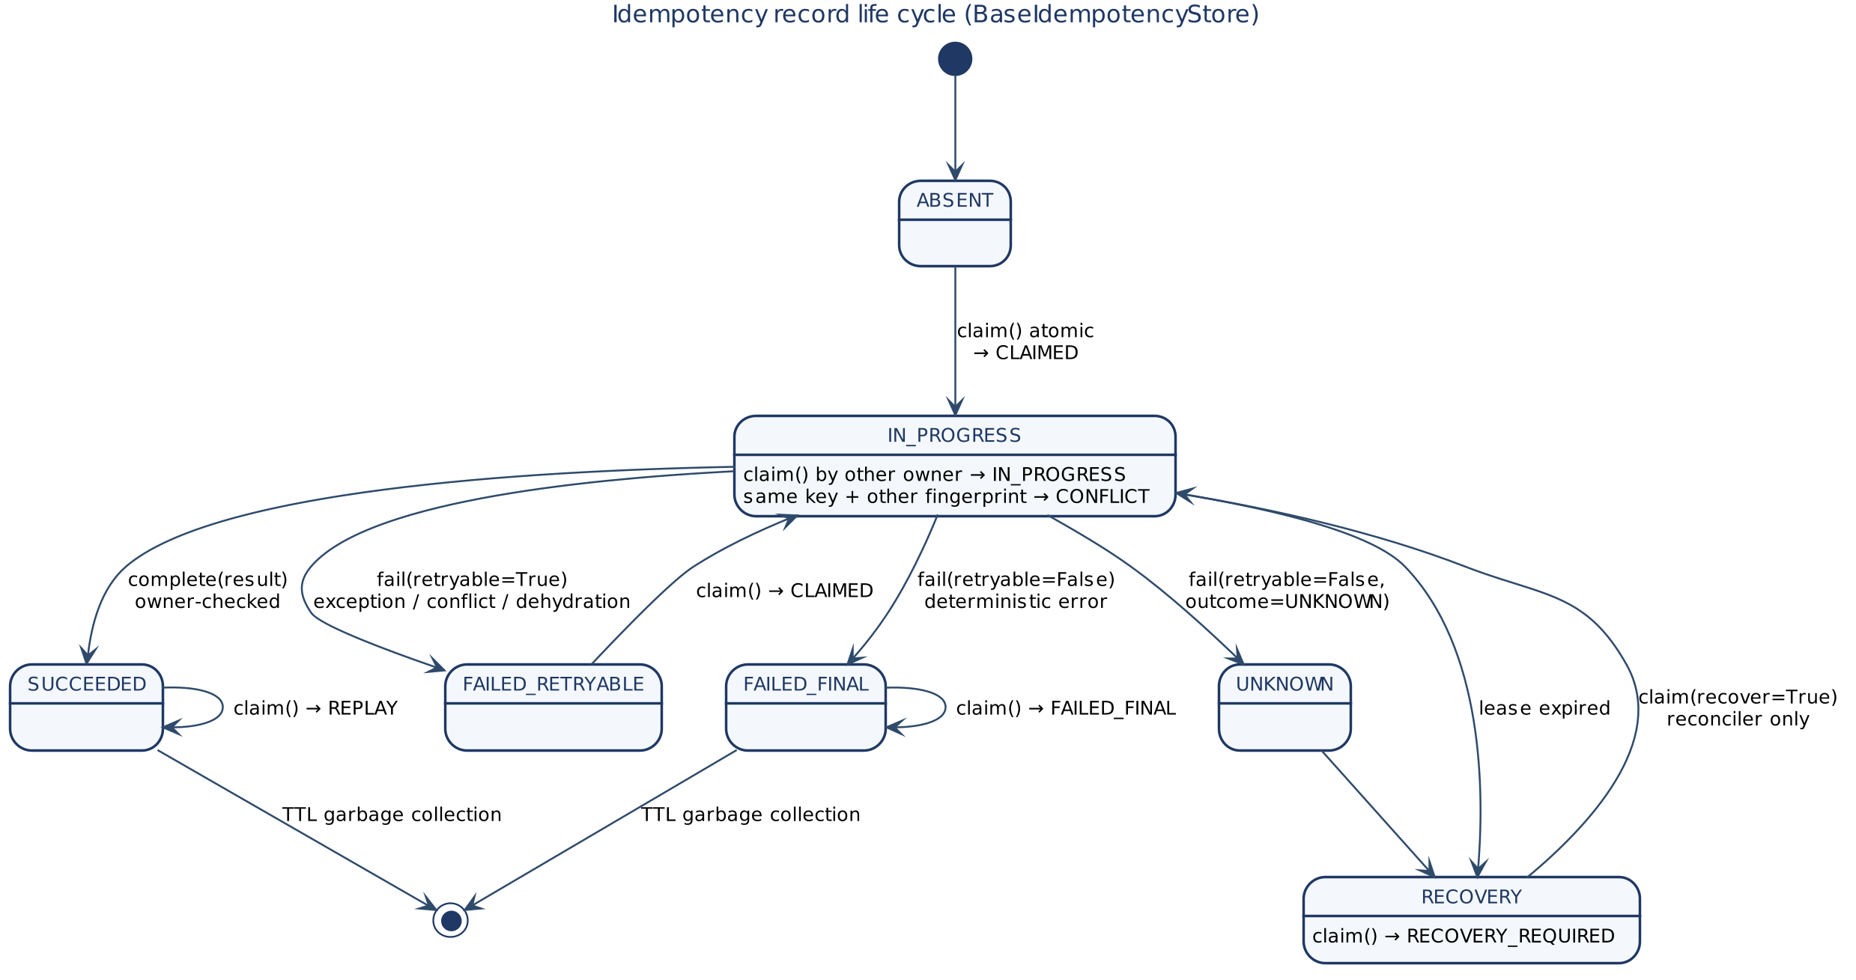
Figure 14 — Idempotency record life cycle
Table 27 — Claim result to caller outcome
Claim result | state['status'] | Caller receives / guidance
CLAIMED | (proceeds) | The command runs.
REPLAY | REPLAYED | Stored result / outcome, replayed = True. Do not retry.
IN_PROGRESS | IN_PROGRESS | No result; retry later.
CONFLICT | CONFLICT | Same key, different payload — a client bug; do not retry unchanged.
RECOVERY_REQUIRED | RECOVERY_REQUIRED | Only the reconciler may take over.
FAILED_FINAL | FAILED_FINAL | A corrected request needs a new key.

9.5 Claim settlement
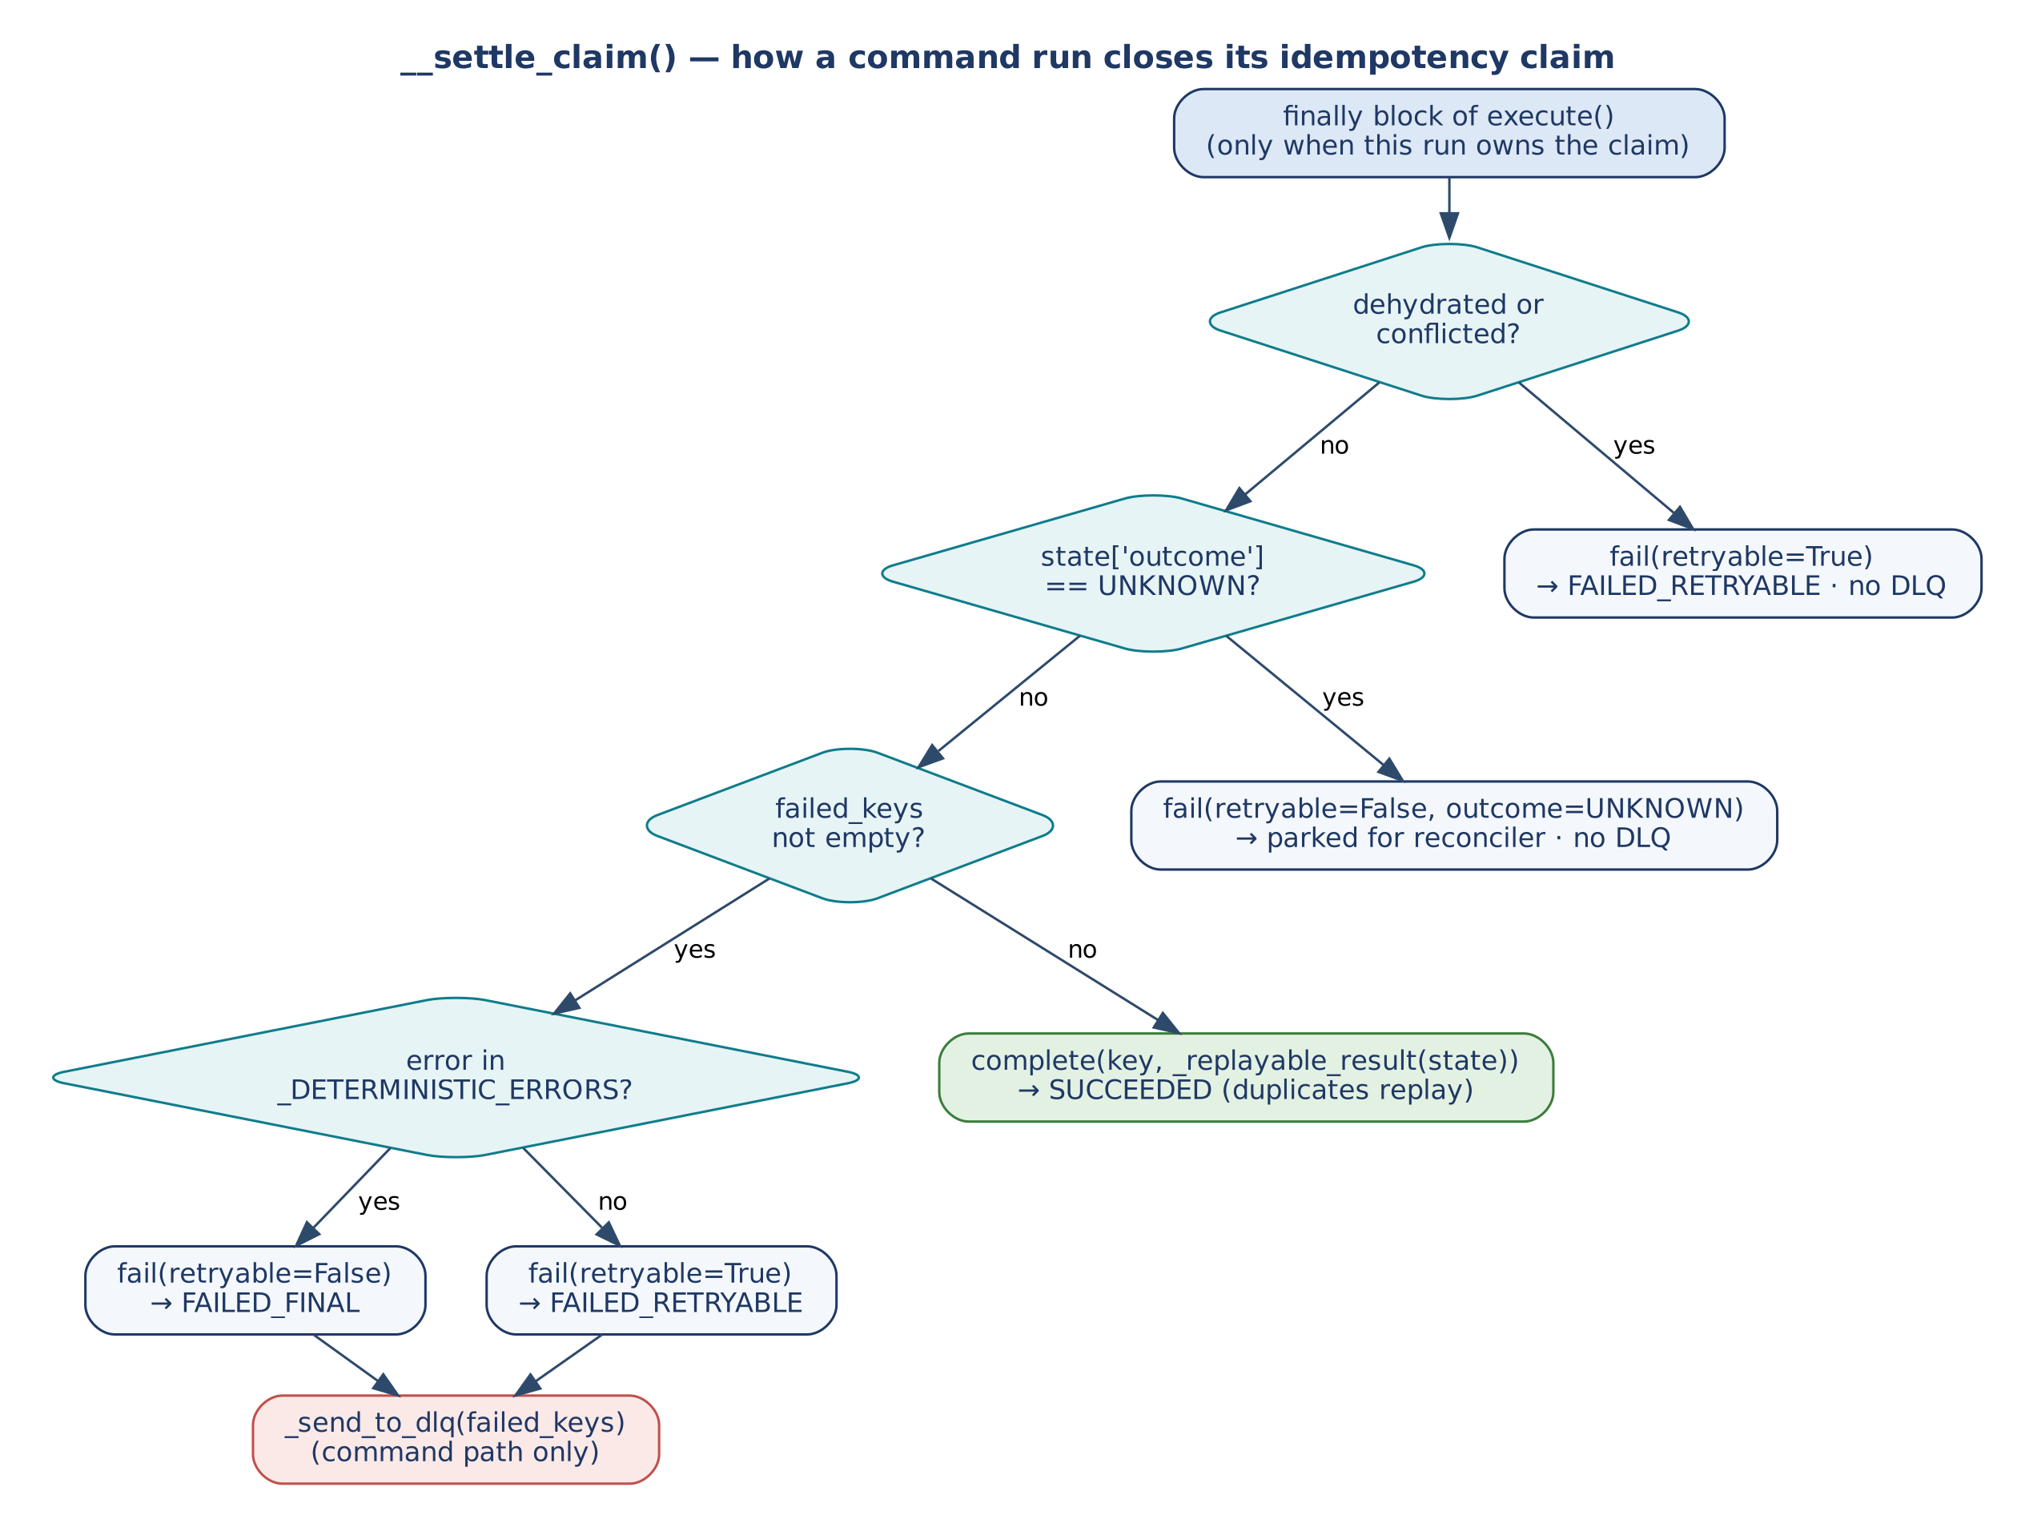
Figure 15 — __settle_claim(): closing an owned claim

9.6 Saga decision flow
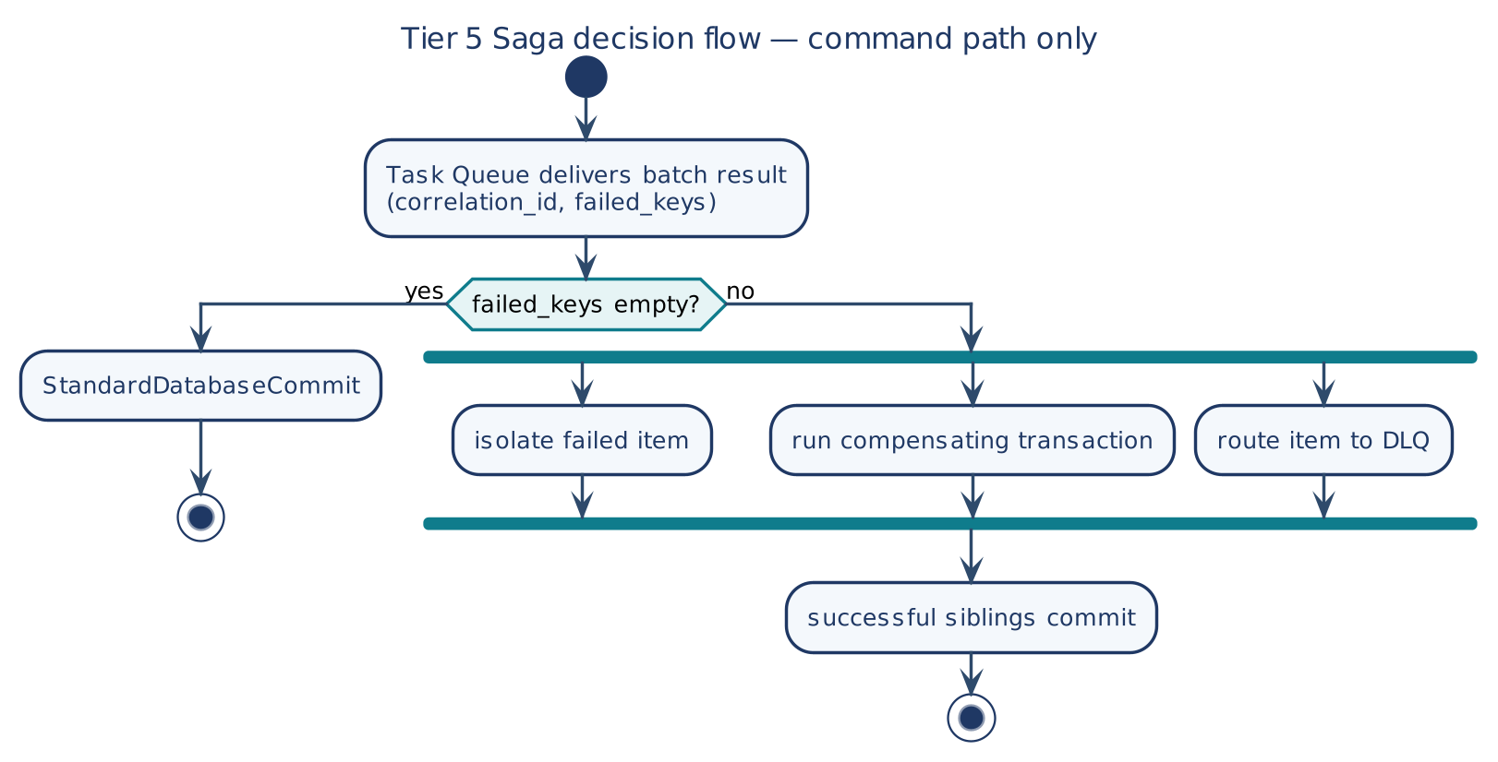
Figure 16 — Tier 5 Saga decision flow, command path only
Only the command path populates failed_keys destined for Tier 5. A clean batch goes to the standard commit; any failed key sends the batch to a parallel isolate / compensate / dead-letter branch while successful siblings commit.

10. Concurrency, Consistency and Failure Model

10.1 Ownership of concurrency risks
Each risk has exactly one owner. No global concurrency manager exists, and none should be added.
Table 28 — Concurrency risk ownership
Risk | Owner | Mechanism
Duplicate command execution | BaseOrchestrator + BaseIdempotencyStore | Atomic, tenant-scoped claim with fingerprint; replay of stored result.
Lost update | BaseCommandService._commit_versioned + BaseTransactionalStore | put_if_version compare-and-set; typed ConcurrencyConflict.
Stale writer after lease loss | BaseTransactionalStore | fencing_token → FENCED.
Cache stampede | BaseCacheStore.get_or_load | Per-key single-flight; bounded follower wait.
Stale read after own write | BaseCommandService._synchronize_cache | Synchronous evict/hydrate inside the command.
Unbounded waits | Deadline | Checked before work; bounds every wait.
Orphaned in-progress work | idempotency_lease_seconds + reconciler | Expired lease → RECOVERY_REQUIRED; claim(recover=True).
Unknown commit | PhysicalOutcome.UNKNOWN + reconciler | Park; confirm physical truth; replay NOT_COMMITTED once.
Pool exhaustion | validate_capacity() + config | worker_concurrency ≤ db_pool_size; fleet connections below DB limit.
Duplicate scheduled jobs | BaseDistributedLock | Lease + renew + fencing token.

10.2 Conflict and replay matrix
Table 29 — Command conflict and replay semantics
Situation | Detected by | Outcome | DLQ
Same key, same payload, already succeeded | Claim | REPLAYED; nothing re-run | No
Same key, same payload, running elsewhere | Claim | IN_PROGRESS | No
Same key, different payload | Fingerprint | CONFLICT | No
Two writers, same expected_version | put_if_version | One commits; loser CONFLICT, key FAILED_RETRYABLE | No
Writer with superseded lease | put_if_version + fencing token | CONFLICT (FENCED) | No
Deadline already expired | Deadline.check() | Failure | Yes
Commit outcome unknown | state['outcome'] == UNKNOWN | Parked for reconciliation | No
Deterministic error | _DETERMINISTIC_ERRORS | FAILED_FINAL | Yes

10.3 Consistency model
- Command side — strong per aggregate. One winner per idempotency key; one writer per aggregate version. Single-item (or single-partition) scope: an invariant spanning items must be confined to one item or use a store transaction.
- Query side — eventual, with read-your-writes. Reads are stale by at most replica lag plus cache TTL, except that _synchronize_cache() guarantees a read after a write to the same resource sees the write.
- Events — at-least-once, effectively-once effects. Consumers apply through their own claim; ordering is per partition only.
- Cache — advisory. Freshness is decided by the value's own expiry field, not by key presence (provider TTL deletion can lag).

10.4 Error routing summary
execute() handles three exception families separately and treats everything else uniformly. Command-path failures reach the DLQ and the Saga; query-path failures terminate at Tier 2 as an error response. NFRViolationError (quota, latency, deadline) is not a special branch — it is an ordinary failure.

11. Asynchronous Paths: Consumers and Scheduled Repair

11.1 Tier 4 consumer model (runtime obligation)
The scaffold deliberately ships no consumer base class. A domain-event consumer is a thin runtime around existing contracts — claim, complete, fail, Deadline, ResiliencePolicy — and must meet the obligations below.
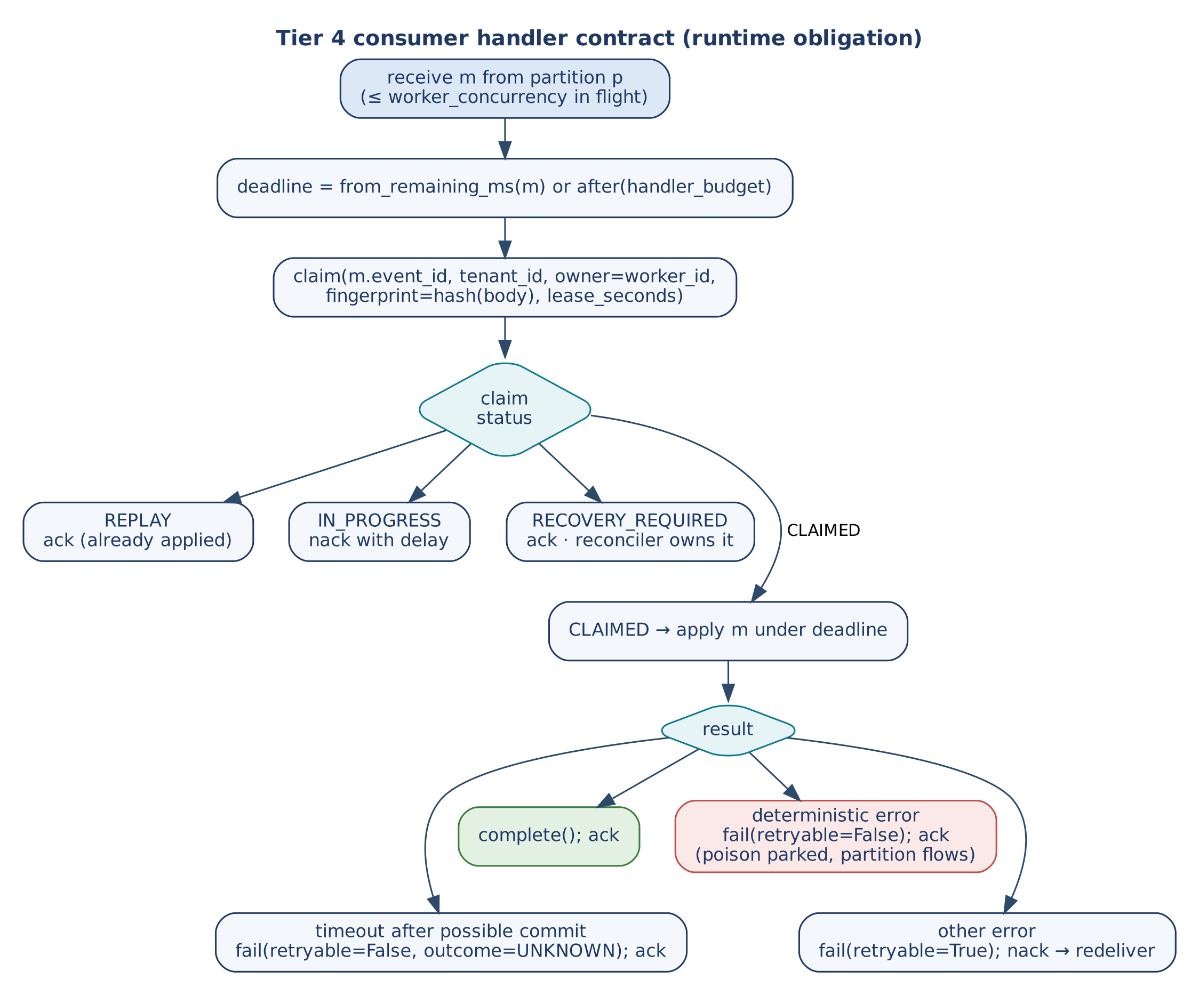
Figure 17 — Tier 4 consumer handler contract
- Ordering. Partition by tenant_id + the aggregate key returned by _entity_key(). Never assume order across partitions.
- Bounded in-flight work. worker_concurrency messages per instance, worker_prefetch ≥ worker_concurrency, and worker_concurrency ≤ db_pool_size. validate_capacity() checks these at start-up.
- Poison messages. Settle deterministic failures as FAILED_FINAL and acknowledge, so the partition keeps flowing. Broker behaviour differs: SQS FIFO blocks the message group until the message reaches the DLQ; Pub/Sub with ordering redelivers the key's tail; Service Bus dead-letters and moves the session on.
- Replay. Redelivery is harmless (REPLAY). A dead-lettered message is replayed only by the reconciler, never by hand.
- Graceful shutdown. Stop polling, drain for at most drain_timeout_seconds, nack the rest. The drain bound must be shorter than the platform's termination grace (about 10 s on Cloud Run, 30 s default on ECS, 30 s on Container Apps).

11.2 Outbox sweeper and reconciler
BaseOutboxSweeper.sweep() republishes outbox records stuck in PENDING; BaseReconciliationService.reconcile() repairs parked and dead-lettered keys. Both run on a schedule, each as a single leader holding a lease from BaseDistributedLock (acquire → LeaseHandle(owner_token, fencing_token, expires_at), renew, owner-checked release).
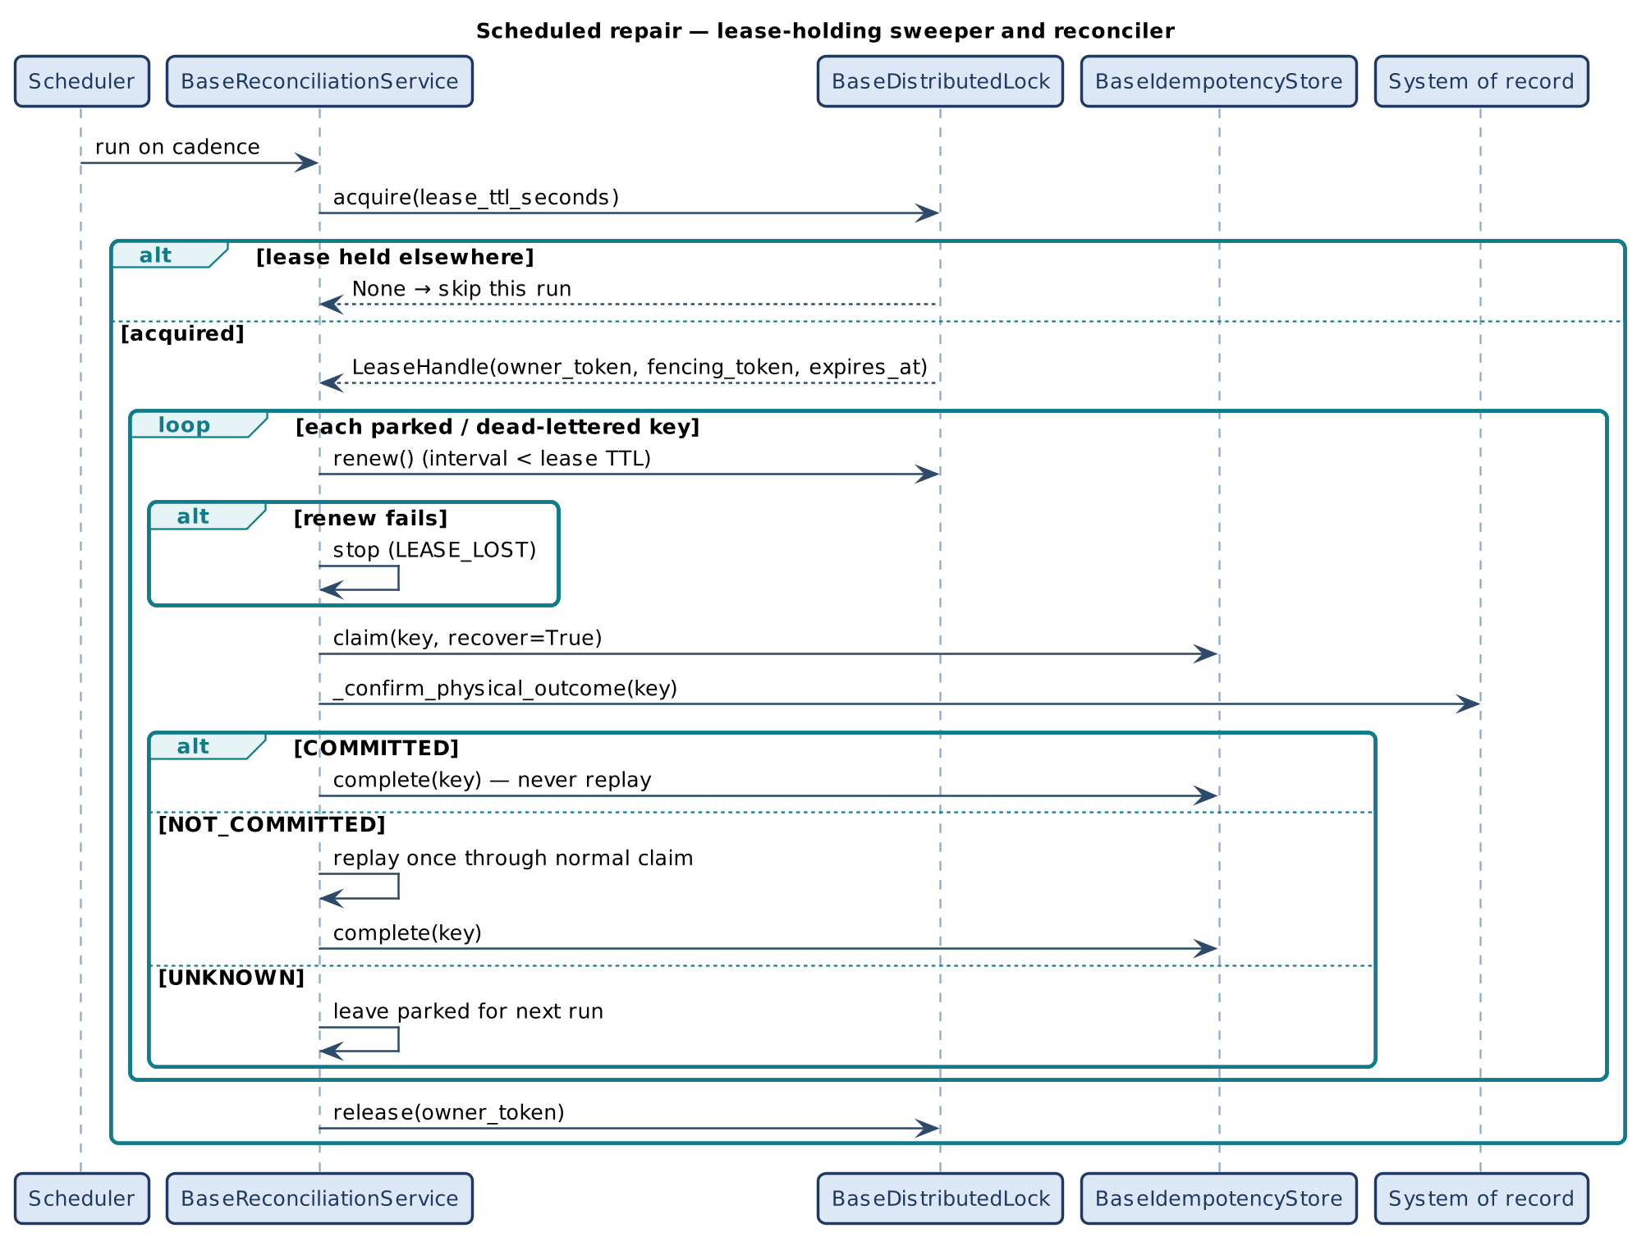
Figure 18 — Scheduled repair under a lease
- Lease, not lock. Renew interval below lease_ttl_seconds; a worker that cannot renew stops (LEASE_LOST).
- Fencing where a stale writer can commit. The sweeper passes the lease's fencing_token on every publish. Providers have no native fencing token, so the store adapter issues one from a versioned counter.
- Confirm before acting. The reconciler claims with recover=True, calls _confirm_physical_outcome() (default UNKNOWN), then: COMMITTED → mark done, never replay; NOT_COMMITTED → replay once through the normal claim; UNKNOWN → leave parked.

12. Non-Functional Design

12.1 Performance targets
Baseline load reuses the agentic landing zone: 20,000 daily active tenants × 5,000 operations ≈ 1,157 RPS average, ≈ 3,472 RPS design peak (3.0× surge). The CQRS split changes the distribution, not the total.
Table 30 — Performance targets
Metric | Basis | Target
Read : write ratio | Typical CQRS workload | 80 : 20 (planning assumption)
Query P99, cache hit | Redis round trip + DTO marshal | < 25 ms
Query P99, cache miss | Single-flight replica read + hydrate | < 150 ms
Command P99, accepted | T0/T1 synchronous portion (202) | < 200 ms
Command end to end | Outbox + fan-out + Saga | < 5 s
In-code SLO | max_latency, scope CQRS | 1.0 s per mutate() / fetch()

P99 targets are ceilings measured in the platform; the only self-enforcing limit in code is max_latency.

12.2 Capacity sizing
Little's Law: in-flight commands = command rate × mean handler time. At the design peak, commands are ≈ 694/s; at an assumed 0.5 s handler time that is ≈ 347 in flight across the fleet, which instances × worker_concurrency and the database connection limit must cover. Replace the assumption with measured handler time. Four checks apply: (1) worker_concurrency ≤ db_pool_size and replicas × db_pool_size below the connection limit; (2) read pool sized apart from the write pool; (3) cache capacity follows distinct keys × TTL, not request rate; (4) drain_timeout_seconds below the termination grace.

12.3 Security and tenant isolation
Table 31 — Security controls by construction
Control | Where it lives
Authenticated tenant identity | tenant_id from the verified JWT at T0; mandatory in execute().
Network isolation | Data perimeter unreachable from the DMZ or internet; T2/T4/T5 have no inbound internet route.
Payload firewall and PII redaction | _execute_semantic_firewall() before any business logic, both paths.
Egress isolation | _verify_sandbox_profile() before external calls (pending_external_call).
Tenant-scoped data | Claim keys scoped by tenant_id; cache keys must include it; storage pool or silo per tenant tier.
Read-only reads | _execute_db_read() uses the replica's read-only credential.
Fair use | Tenant request quota in the governance gate; gateway rate limiting at T0.
Human approval | Dehydration for commands above a policy threshold.

12.4 Observability
Table 32 — Structured log events emitted by the base classes
Event | Emitted by | Meaning
routing_to_command_service | execute() | Command routed (→ command_count).
routing_to_query_service | execute() | Query routed (→ query_count).
idempotent_short_circuit | __short_circuit() | Duplicate / in-progress / conflict short-circuit (claim_status).
orchestrator_dehydrated | execute() | Awaiting approval webhook.
concurrency_conflict (WARN) | execute() | Lost OCC race.
dto_validation_failed (ERROR) | mutate() | Schema rejection.
commit_gate_rejected (WARN) | mutate() | Advisory gate blocked the key.
command_mutation_complete | mutate() | Includes latency.
query_cache_hit / query_cache_miss | fetch() | Cache effectiveness.
query_fetch_complete | fetch() | Includes latency.

Platform metrics from the shared catalogue that matter most for this profile: e2a.occ.conflicts_total, e2a.idempotency.replays_total, e2a.fencing.rejections_total, e2a.cache.single_flight_followers_total, e2a.lease.lost_total, e2a.queue.depth, e2a.queue.oldest_age_seconds, e2a.admission.rejected_total. Alarm on DLQ depth and oldest-message age (Service Bus has no native oldest-age metric — derive it from the enqueue time of a peeked message).

13. Extension Guide

13.1 Building a concrete service
- Define DTOs. A pydantic input model and output model per command; one output model per query. Give command output models result and/or outcome fields if replay should return data, and status / reason fields if the commit gate is enabled.
- Implement the command service. Subclass BaseCommandService; implement _execute_business_logic, _execute_outbox_commit, _synchronize_cache. Override _entity_key to opt in to OCC.
- Implement the query service. Subclass BaseQueryService; implement the four hooks; fold tenant_id into the cache key; read through the replica credential.
- Implement the orchestrator. Subclass BaseOrchestrator; implement read classification, the two service resolvers, deterministic key generation and error mapping.
- Bind engines and ports in config. idempotency_store, transactional_store, cache_store, governance_engine, observability_engine. All five should be bound in production.
- Register validators. Add per-intent validators to BaseValidationService.validator_registry; keep strict_mode on.
- Register project config keys with register_config_key() in src/settings.py — never edit the scaffold.
- Run the scaffold-compliance gate, including validate_capacity(), before deploy.

13.2 Skeleton
class PlaceOrder(BaseCommandService):
input_dto_model, output_dto_model = PlaceOrderIn, PlaceOrderOut
def _entity_key(self, dto, **kw): return f"{kw['tenant_id']}:order:{dto.order_id}"
def _execute_business_logic(self, v, config, **kw): ... # pure decision -> PlaceOrderOut
def _execute_outbox_commit(self, dto, config, **kw): ... # same transaction scope as the aggregate
def _synchronize_cache(self, dto, config, **kw): ... # evict TENANT:<t>:ORDER:<id>

class GetOrder(BaseQueryService):
output_dto_model = OrderView
def _generate_cache_key(self, q, tenant_id): return f"TENANT:{tenant_id}:ORDER:{q['order_id']}"
def _read_from_cache(self, key, io): ...
def _execute_db_read(self, q, config, **kw): ... # read-only replica credential
def _write_to_cache(self, key, data, io): ...

class OrderOrchestrator(BaseOrchestrator):
def _is_read_scenario(self, state, config): return state.get('intent') == 'READ'
def _get_query_service(self, resource, config): return GetOrder()
def _get_command_service(self, action, config): return PlaceOrder()
def _generate_idempotency_key(self, state, config, **kw): return f"{state['tenant_id']}:{state['client_ref']}"
def _handle_error(self, error, state, config, **kw): state['http_status'] = 400 if isinstance(error, ValueError) else 500

13.3 Rules and anti-patterns
Table 33 — Do and do not
Do | Do not
Call only the public entry point of another class. | Call _execute_business_logic() or other hooks from outside the class.
Pass request data as arguments / kwargs. | Store correlation_id, tenant_id or keys on self.
Raise ValueError / TypeError / PermissionError for permanent errors. | Raise generic exceptions for validation failures (they become retryable).
Set state['outcome'] = UNKNOWN when a side effect may or may not have landed. | Retry or dead-letter an ambiguous commit.
Use put_if_version for competing writers. | Treat _commit_gate()'s version check as the authority.
Keep _synchronize_cache() synchronous. | Defer cache invalidation to an async handler.
Let the CDC / sweeper publish outbox events. | Publish to Tier 4 from inside _execute_outbox_commit().
Add config keys with register_config_key(). | Read os.getenv() in a subclass or edit the scaffold.

14. Verification
Tests below run against the in-memory doubles in e2a_inmemory_adapters.py. Rows marked runtime need the consumer runtime or a load environment and are not claimed as passed by the scaffold.
Table 34 — Race and saturation test matrix
ID | Scenario | Expected | Evidence
T-01 | Duplicate command, same key and payload | REPLAYED; logic and outbox run once | smoke_test_cqrs_concurrency.py
T-01 | 20 concurrent claimers on one key | Exactly one wins | smoke_test_concurrency.py
T-01 | Same key, different payload | CONFLICT; nothing executed | smoke_test_concurrency.py
T-02 | Two writers, same expected_version | One commits; loser typed CONFLICT, not DLQ; key claimable | smoke_test_cqrs_concurrency.py
T-09 | Writer with superseded lease | FENCED → CONFLICT | smoke_test_cqrs_concurrency.py
T-03 | 15 concurrent cold reads, one key | One database read | smoke_test_cqrs_concurrency.py
T-03 | Loader failure during shared fill | Propagates; not cached | smoke_test_concurrency.py
— | Warm read | Served from cache | smoke_test_cqrs_concurrency.py
T-10 | Expired deadline | Rejected before work; dead-lettered | smoke_test_cqrs_concurrency.py
T-12 | Outcome UNKNOWN | Parked; no replay | smoke_test_concurrency.py
T-12 | Reconciler, NOT_COMMITTED | Replayed once, then SUCCEEDED | smoke_test_concurrency.py
— | Lease held by another sweeper | Second sweeper skips | smoke_test_concurrency.py
— | Mis-sized consumer or pool | Capacity gate fails start-up | smoke_test_concurrency.py
— | Same-partition ordering under redelivery | Applied in order, once | runtime
— | Poison message on a FIFO group | Parked FAILED_FINAL; partition proceeds | runtime
— | Consumer saturation | Prefetch holds; pool not exhausted | runtime
— | Rolling deploy under load | Drain within bound; no key left IN_PROGRESS past lease | runtime

Recommended additions, derived from the observations in Section 15: a latency-SLO breach after a successful commit; an empty query result; a short-circuited request reaching the telemetry backend.

15. Implementation Reality, Gaps and Design Observations
The following were found by reading the reference implementation against this design and, for O-1 and O-2, reproduced with the in-memory adapters. They are recorded here so implementers can guard against them; none changes the public contract.
Table 35 — Design observations
ID | Observation | Effect | Recommendation
O-1 | mutate() checks the latency SLO after the aggregate, outbox and cache writes. | A slow but successful command raises NFRViolationError: its key is dead-lettered and settled FAILED_RETRYABLE, so a redelivery executes it again. Without _entity_key() OCC this duplicates the outbox record (reproduced). | Record the breach as a metric / log after commit instead of raising, or set state['outcome'] = COMMITTED before the check so settlement completes the claim.
O-2 | fetch() calls output_dto_model(**db_data) even when _execute_db_read() returns None. | A not-found read raises TypeError instead of a typed not-found (reproduced on both cache paths). | Return an empty-but-valid dict from the hook, or treat None as not-found before marshalling.
O-3 | __short_circuit() returns before the try/finally. | Replays, in-progress and conflict short-circuits are logged into state['message_log'] but never shipped to observability_engine. | Ship telemetry on the short-circuit path, or count replays in the store adapter (e2a.idempotency.replays_total).
O-4 | _circuit_breaker() is abstract but never called by the base gate. | Circuit breaking only happens if a subclass calls it from a hook. | Call it from service hooks around dependency calls, or use ResiliencePolicy from e2a_base.py.
O-5 | The tenant quota compares state['cumulative_requests_in_window'], which the framework never maintains. | Quota is only as good as the counter the edge supplies. | Populate the counter at T0/T1 from a shared rate-limit store.
O-6 | The CQRS _commit_gate() reads commit_gate_enabled from kwargs/config only; the agentic mixin uses resolve_config(). | The COMMIT_GATE_ENABLED environment variable is ignored on this profile. | Align with resolve_config(); the mixin is a CQRS-local copy and can drift.
O-7 | The commit-gate rejection returns output_dto_model(status='blocked', reason=…). | Output DTOs without status / reason fields (or with required fields) fail with a validation error. | Give command output models these optional fields, as the smoke test does.
O-8 | When cache_store is bound, _write_to_cache() is never called, but remains abstract. | Subclasses must still implement a hook that is unused on the preferred path. | Implement as a no-op when a cache_store is always bound.
O-9 | Governance, idempotency and observability are fail-open when not bound. | A misconfigured deployment silently loses quota, claims or telemetry. | Assert all five ports and engines in the scaffold-compliance gate for production.

Appendix A. Glossary
Table 36 — Glossary
Term | Definition
Claim | Atomic ABSENT → IN_PROGRESS transition on a tenant-scoped idempotency key that grants one owner the right to execute.
Fingerprint | Hash of a request's business content; distinguishes a replay from a key collision.
OCC | Optimistic concurrency control: write succeeds only if the stored version equals the expected version.
Fencing token | Monotonic number issued with a lease; a store rejects writes carrying an older token.
Single-flight | Deduplication of concurrent loads of the same key into one loader call.
Dehydration | Persisting request state and halting (scaling compute to zero) until an external webhook resumes it.
Outbox | Table written in the same transaction as state; events are published from it by CDC or a sweeper.
Physical outcome | Whether a material side effect actually committed in the system of record (COMMITTED, NOT_COMMITTED, UNKNOWN).
Structural isomorphism | One-to-one mapping between LLD class boundaries and HLD tiers.

Appendix B. Traceability
Table 37 — Requirement → design element → code anchor
Requirement / HLD element | Class / method | Code anchor (reference/)
G-1, UC-1/2, INV-02/03 | BaseOrchestrator.execute claim; _request_fingerprint | e2a_cqrs_base.py L265–299, L358
INV-04 | __settle_claim | e2a_cqrs_base.py L395
G-2, UC-3, INV-05 | BaseCommandService._commit_versioned | e2a_cqrs_base.py L456; e2a_base.py put_if_version L2522
G-3, UC-4 | BaseQueryService.fetch; BaseCacheStore.get_or_load | e2a_cqrs_base.py L489; e2a_base.py L2575
UC-5 | _synchronize_cache | e2a_cqrs_base.py L480
G-4, INV-10 | __resolve_deadline; Deadline | e2a_cqrs_base.py L370; e2a_base.py L133
G-5, UC-7, INV-08 | __settle_claim UNKNOWN branch; BaseReconciliationService | e2a_cqrs_base.py L400; e2a_base.py L2893
UC-6 | BaseGovernanceFramework.__trigger_dehydration | e2a_cqrs_base.py L192
INV-06/07 | execute except branches; DLQ guard | e2a_cqrs_base.py L315–341
G-6 | BaseGovernanceFramework, BaseObservability | e2a_cqrs_base.py L92, L159
T1 edge | BaseValidationService.validate | e2a_cqrs_base.py L234
Central config | resolve_config | e2a_base.py L453
Capacity gate | validate_capacity | e2a_base.py L693
Scheduled repair | BaseOutboxSweeper, BaseDistributedLock | e2a_base.py L2835, L2735

