SYSTEM DESIGN DOCUMENT
E2A Framework Family System Design
How E2A, P0, G2C, A2C and AI-DLC compose into one governed build

The per-framework design documents describe each framework from the inside. This document describes the family from the outside — what each framework is for, who may call whom, what crosses each boundary, how identity, idempotency, deadlines and failure behave across those boundaries, and which defects exist only between frameworks. It is the document to read before changing any interface between two frameworks.
Framework | E2A framework family — E2A core, CQRS profile, P0, G2C, A2C, AI-DLC profile
Document type | System Design Document (cross-framework HLD + interface contracts)
Author | Subham Gupta, Principal Platform Architect
Source baseline | subhamviky/e2a-framework branch fix/aidlc-cross-framework @ db49af1 (reference/); subhamviky/a2c-framework branch fix/g2c-p0-a2c-contracts @ 0caa2ac
Date | 7 November 2026
Status | Baseline system design; cross-framework behaviour verified by an integration test over the real modules

Contents
1. Introduction 3
1.1 Purpose 3
1.2 Audience 3
1.3 Sources and status 3
1.4 Related documents 3
2. Problem Statement and Motivation 5
2.1 Why a system view is needed 5
2.2 Design goals 5
3. System Use Cases 6
4. Principles and System Invariants 7
4.1 Principles 7
4.2 System invariants 7
5. Architecture 8
5.1 The family 8
5.2 Who may call whom 8
5.3 Composition patterns 9
5.4 Deployment 9
6. End-to-End Build 10
6.1 Sequence 10
6.2 Step table 10
7. Hand-off Contracts 12
7.1 AI-DLC → G2C 12
7.2 G2C → P0 13
7.3 P0 → A2C 13
7.4 AI-DLC → A2C and back 13
8. Identity, Keys and Idempotency 14
8.1 Key namespaces 14
8.2 Nested claims and replay 14
9. Shared Infrastructure 16
9.1 Propagation fields 17
10. Failure and Compensation 18
11. System-Level Non-Functional Design 19
11.1 Time budget of one build 19
11.2 Capacity 19
11.3 Security 19
12. Rules for Changing an Interface 20
13. Verification 21
14. Cross-Framework Gaps and Design Observations 22
Appendix A. Glossary 23
Appendix B. Where each concern is specified 24

1. Introduction

1.1 Purpose
The E2A family is five cooperating frameworks and one deployment profile. Each has its own design document with HLD, LLD and method contracts. None of those documents owns the space between the frameworks: the request that becomes another framework's request, the key that two frameworks claim in one store, the failure in one phase that another phase must compensate. Every cross-framework defect found so far lived in that space:
- a P0 claim key with the same shape as the AI-DLC build key, so every real AI-DLC build failed with a conflict;
- a replayed result that shared an object with a live result another framework mutated;
- an orchestrator constructing DeveloperPlatformWorkflow(config=...) against a class that took no arguments;
- an orchestrator importing SDLCWorkflow from a module that did not exist;
- a build that reported E2A_VERIFIED without running A2C;
- a tenant that never reached Phase A.
This document makes that space explicit.

1.2 Audience
Reader | Read first | Use the document to
Platform architect | Sections 2, 4, 5 | Understand the family as one system and choose a composition pattern.
Framework author | Sections 7, 8, 12 | Change an interface without breaking a neighbour.
Platform engineer | Sections 5.4, 9, 10, 11 | Wire shared stores, the gateway, leases and deadlines.
Reviewer | Sections 4.2, 13, 14 | Check system invariants and open cross-framework gaps.

1.3 Sources and status
Source | Role
Per-framework design documents (E2A, CQRS, AI-DLC, P0, G2C, A2C) | Internal contracts; this document does not repeat them.
e2a-framework/reference, branch fix/aidlc-cross-framework | E2A core, CQRS, AI-DLC orchestrator.
a2c-framework branch fix/g2c-p0-a2c-contracts | P0, G2C, A2C, a2c_concurrency.
smoke_test_aidlc_integration.py and the probes in Section 13 | Evidence for cross-framework behaviour.

Statements about behaviour across boundaries are verified by the integration test or a reproduction unless marked derived (follows from the published contracts but cannot be reproduced with reference hooks that perform no side effect).

1.4 Related documents
Document | Owns
E2A Framework Design Document | Base classes, gateway, stores, config registry, Deadline.
E2A CQRS Design Document | Command/query services and outbox.
E2A AI-DLC Profile Design Document | Orchestrator, admission, Phase C, saga.
P0 / G2C / A2C Framework Design Documents | Their own classes and contracts.
Vendor companion documents (e.g. Azure binding) | Mapping to a specific cloud; kept out of this vendor-neutral document.

2. Problem Statement and Motivation

2.1 Why a system view is needed
Each framework is correct against its own contract and its own tests. The family can still be wrong, because:
- Requests are translated at every boundary. An AI-DLC request becomes a GeneratorRequest, which carries a ScaffoldRequest, which produces a DevRequest. A field that is not carried across simply disappears (the build's tenant did, until it was copied explicitly).
- Idempotency is nested. One build holds a claim while G2C, P0 and A2C each take their own claims in the same store. Key shapes, replay semantics and settlement have to agree across the nesting.
- Failure crosses layers. A failure in Phase B is settled by A2C's claim, recorded in AI-DLC's phase state and compensated by AI-DLC's saga. Each part is correct alone; together they decide whether a retry is safe.
- Shared infrastructure has one owner per concern. One gateway, one claim store, one configuration registry, one deadline — or the family behaves differently depending on which framework a call enters through.

2.2 Design goals
ID | Goal
SG-1 | Every framework is usable alone and composable without wrappers.
SG-2 | Every boundary has one named contract, and each field's origin is known.
SG-3 | One claim store serves all frameworks without key collisions.
SG-4 | A retried build is safe: inner steps replay or re-run according to their own settled state.
SG-5 | Tenant, correlation and deadline reach every step of a build.
SG-6 | One gateway bounds all model capacity.
SG-7 | A build never reports success for a phase that did not run.

3. System Use Cases
Table 1 — System use cases
ID | Use case | Frameworks involved
SUC-1 | Full governed build from one request | AI-DLC → G2C (+ P0 inline) → A2C → E2A BasePipeline
SUC-2 | Class generation without a pipeline | G2C (+ P0 inline) via API or DeveloperPlatformWorkflow
SUC-3 | Scaffold then generate artifacts | P0 → A2C via BootstrapAndGenerateWorkflow
SUC-4 | Workspace only | P0 alone
SUC-5 | Business service at runtime | Generated classes running on E2A core / CQRS
SUC-6 | Duplicate build request | Outer build claim replays; inner claims never reached
SUC-7 | Retry after a failed phase | Outer claim retryable; inner claims replay what succeeded and re-run what failed
SUC-8 | Many tenants building at once | AI-DLC admission + gateway permits/quotas, shared by every phase

4. Principles and System Invariants

4.1 Principles
Principle | Meaning across the family
One contract style | Every class follows E2A's three-layer method contract: one public entry point, protected hooks, private steps.
Composition without wrappers | Composers call public entry points directly: DeveloperPlatformWorkflow.generate(), bootstrap(), SDLCWorkflow.execute(), BasePipeline.run_pipeline().
Composable siblings | P0 and A2C do not depend on each other; BootstrapAndGenerateWorkflow and AI-DLC compose them.
Shared infrastructure by injection | Gateway, stores, registries and limits arrive in config; no framework creates its own.
Typed outcomes, never silent ones | Every framework returns a typed status for duplicates, overload, conflict and failure.
Class files and artifacts are different products | G2C produces class files; A2C produces code, IaC and CI/CD; the second phase is always explicit.

4.2 System invariants
ID | Invariant | Holds today
SI-01 | Claim keys of different frameworks never collide in a shared store. | Yes: aidlc:, g2c:, p0:, a2c:.
SI-02 | A replay returns what was settled, never a later mutation. | Yes (deep copy at settlement in P0, G2C and A2C).
SI-03 | Every step of a build sees the build's tenant_id. | Yes: copied into the G2C request and the dev_request.
SI-04 | Every step of a build is bounded by the build's deadline. | Yes for Phases A and the phase boundaries (deadline_ms into G2C); A2C runs under BaseWorkflow's own deadline.
SI-05 | All model calls of a build go through one gateway. | Yes.
SI-06 | A build reports E2A_VERIFIED only if every requested phase ran. | Yes: impossible requests are REJECTED_INVALID; a missing dev_request fails Phase B.
SI-07 | Inputs are validated by a BaseValidationService before any workflow runs. | Yes: AI-DLC validates the dev_request before Phase B.
SI-08 | No step replays an output that compensation removed. | Yes: compensation keeps outputs of succeeded claims by default; P0 and G2C return recovery_required for a replay whose output is missing.
SI-09 | A shared abstract class is deleted only by its creator after the last reference is released. | Yes: one record, written by G2C with its key; deletion opt-in.
SI-10 | Every claim's lease exceeds the longest legitimate hold. | Build claim: lease ≥ deadline + 60 s when a deadline is set; without a deadline the configured lease applies (X-7).

5. Architecture

5.1 The family
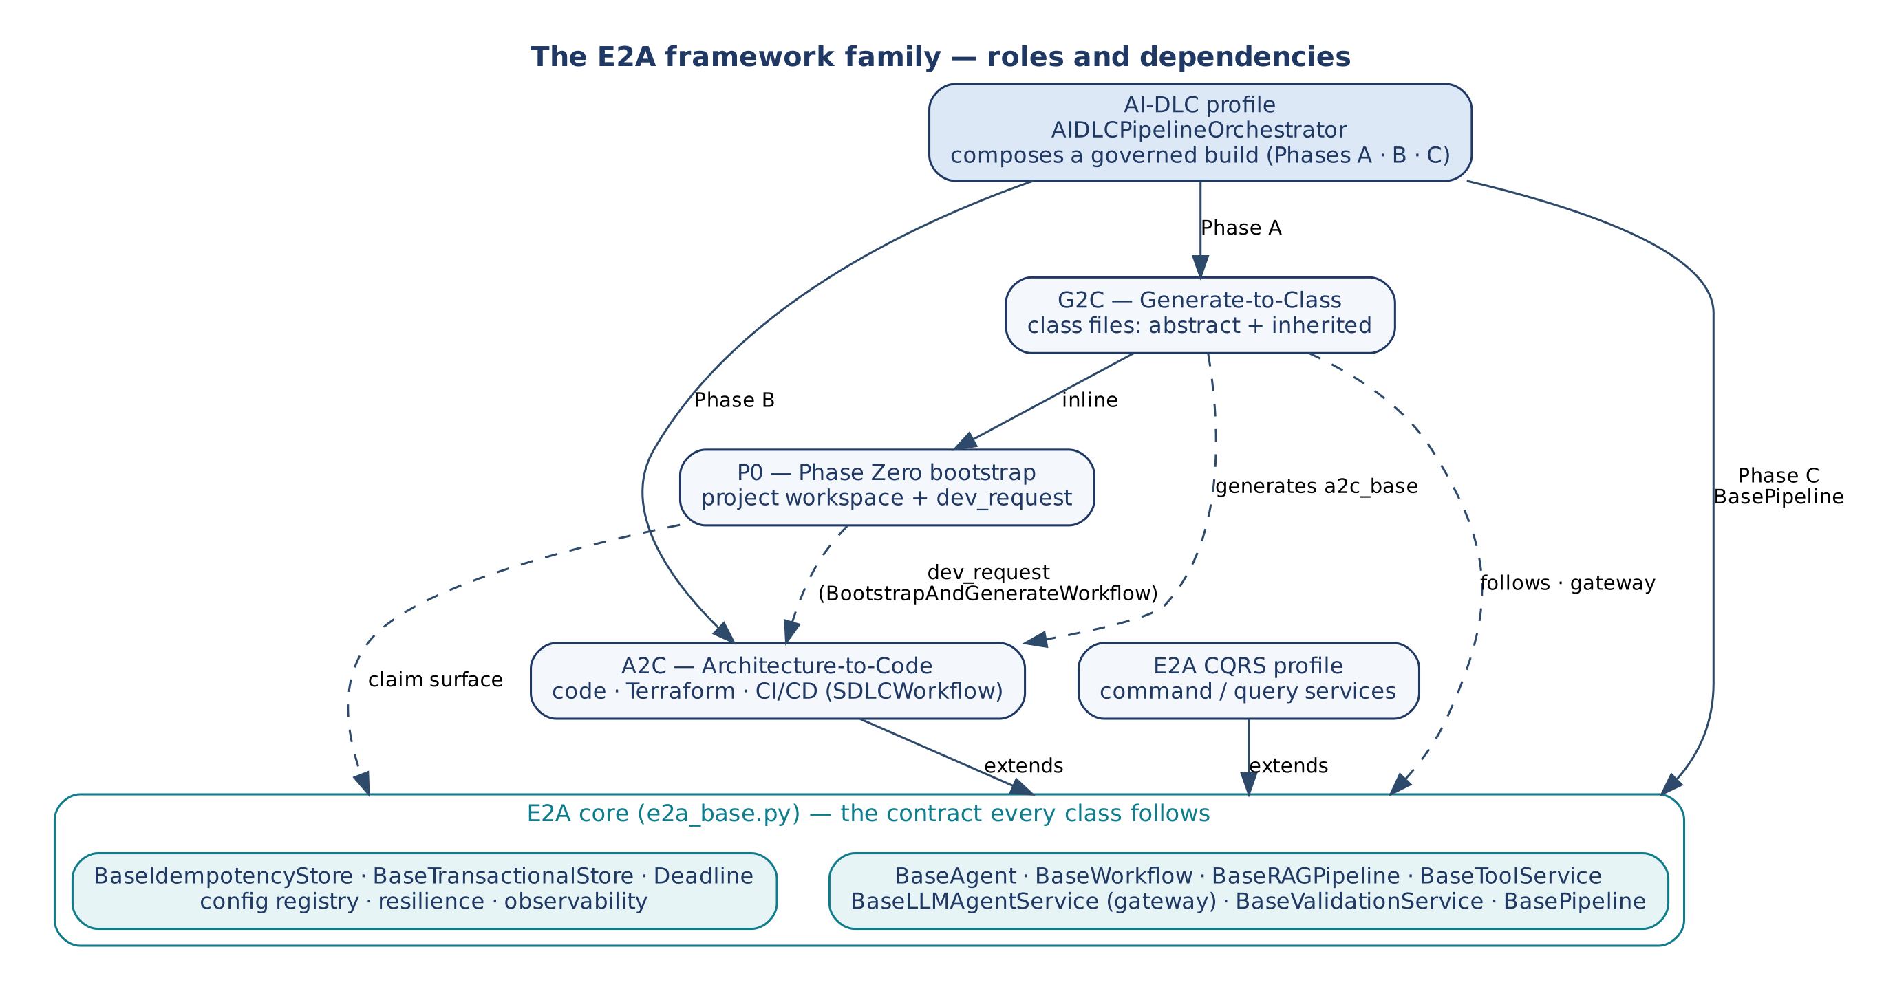
Figure 1 — The E2A framework family: roles and dependencies
Table 2 — Roles
Framework | Produces | Entry point | Depends on
E2A core | The contract and runtime of governed services | run(), execute(), retrieve(), process_inference(), run_pipeline() | —
CQRS profile | Command/query services with outbox | BaseOrchestrator, BaseCommandService, BaseQueryService | E2A core
P0 | A project workspace and a DevRequest | bootstrap() | Claim surface (shape only); optional gateway
G2C | Class files (abstract and inherited) | DeveloperPlatformWorkflow.generate(), generate() | Gateway, claim surface, P0
A2C | Code, Terraform, CI/CD in the workspace | SDLCWorkflow.execute() | E2A core (imports e2a_base)
AI-DLC | A governed, verified build | execute_pipeline() | G2C, A2C, E2A core

5.2 Who may call whom
Caller | May call | Never
AI-DLC | DeveloperPlatformWorkflow, SDLCWorkflow, BasePipeline.run_pipeline() | P0 directly (P0 runs inside G2C); protected hooks of any class
G2C inherited generators | P0 ProjectBootstrapperFactory / bootstrap(); abstract generators | A2C's workflow (the second phase belongs to the caller)
BootstrapAndGenerateWorkflow | P0, DevPlatformValidationService, SDLCWorkflow | G2C
A2C | Gateway, tools, writer | P0, G2C
Generated services | E2A core / CQRS | The generators

5.3 Composition patterns
Pattern | Composer | Chain | When
Standalone | — | One framework | A workspace (P0) or a class (G2C) alone.
Bootstrap and generate | BootstrapAndGenerateWorkflow | P0 → validate → A2C | Workspace plus artifacts without class generation.
Governed build | AIDLCPipelineOrchestrator | G2C (+P0) → A2C → verification | One request to a verified repository.

5.4 Deployment
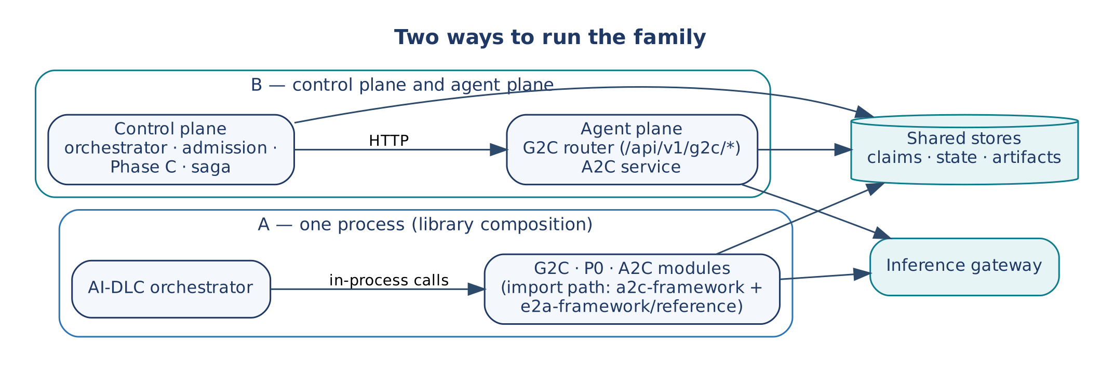
Figure 2 — Two ways to run the family
Two shapes are supported by the code. In-process composition imports the G2C, P0 and A2C modules next to the orchestrator; the import path holds a2c-framework and e2a-framework/reference. A split deployment keeps a control plane (orchestrator, admission, Phase C, saga — no model calls) apart from an agent plane (G2C behind its FastAPI router, A2C as a service), and the two talk over HTTP. Both share the claim, state and artifact stores and the inference gateway. Vendor bindings are in the companion documents.

6. End-to-End Build

6.1 Sequence
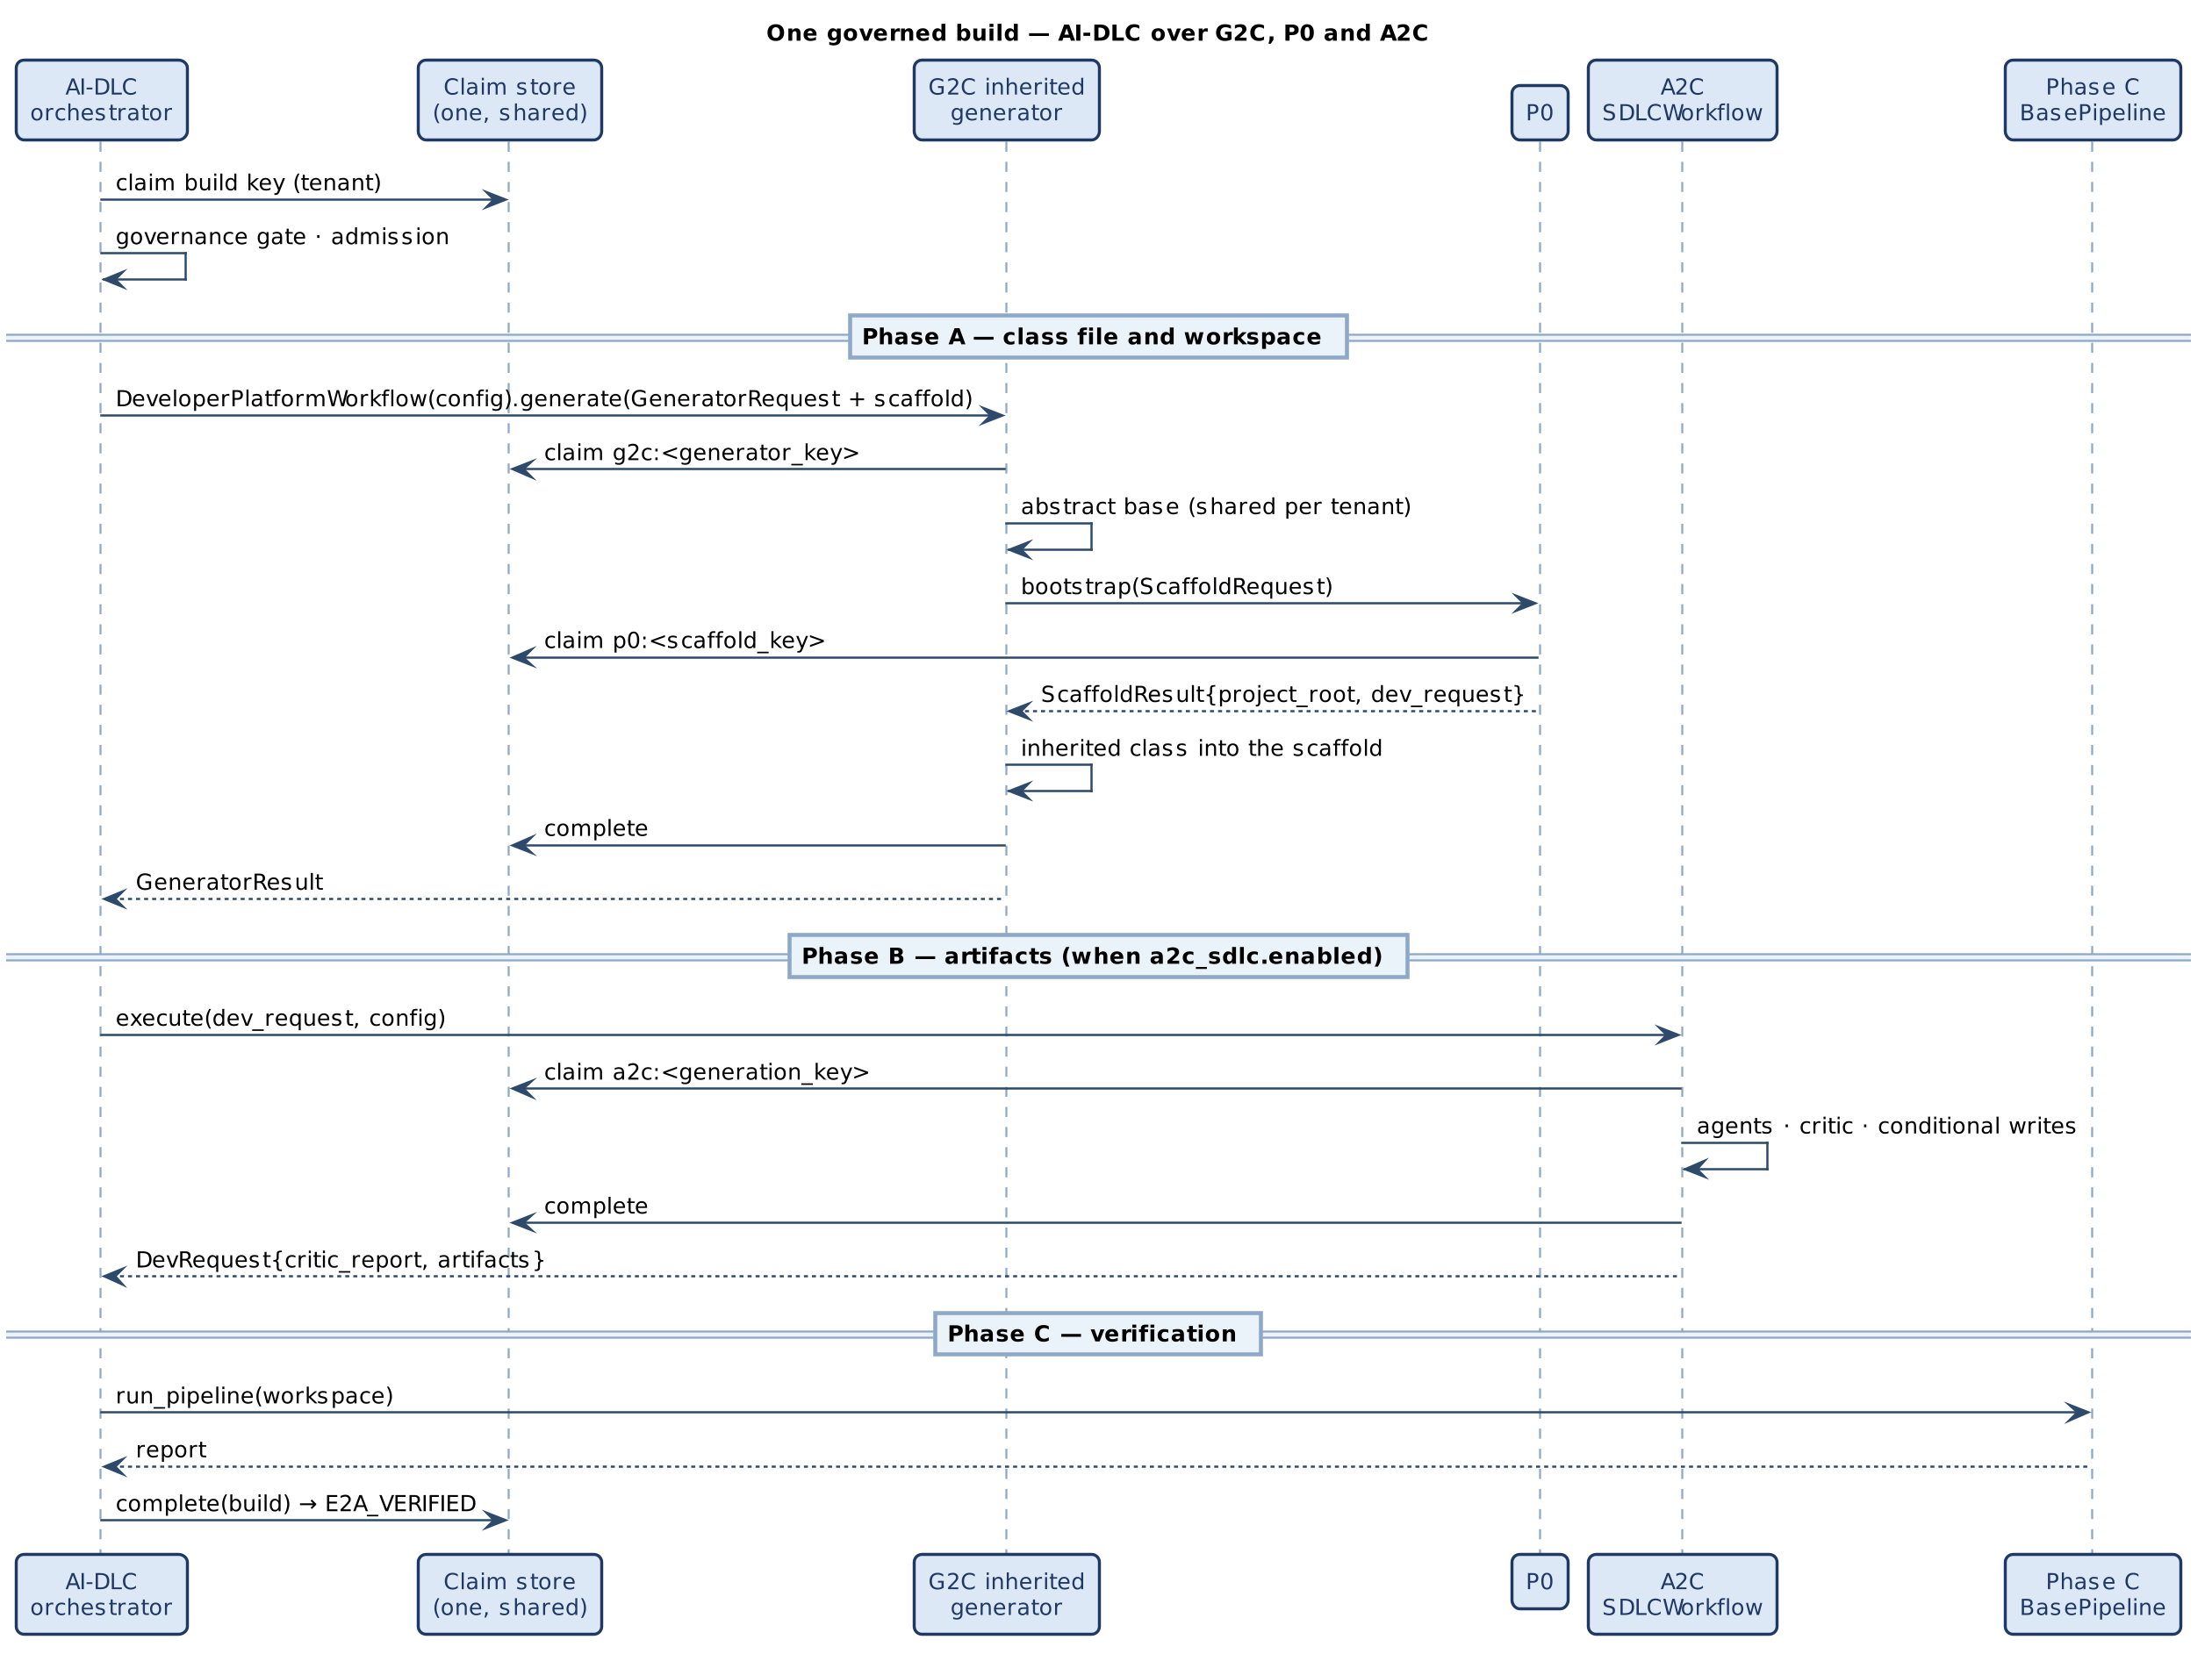
Figure 3 — One governed build over G2C, P0 and A2C

6.2 Step table
Table 3 — A full build, step by step
# | Step | Claim taken | Typed outcomes | Settled by
1 | AI-DLC governance gate, claim, admission | build key (tenant) | SKIPPED_IDEMPOTENT, SKIPPED_IN_PROGRESS, REJECTED_CONFLICT, REJECTED_OVERLOAD | AI-DLC, in finally
2 | Phase A: DeveloperPlatformWorkflow.generate() | g2c:<generator_key> | replay, in_progress, conflict, critic_threshold_not_met, scaffold_failed, … | BaseGeneratorAgent
2a | Abstract base (shared per tenant) | g2c:<base key> | as above | abstract generator
2b | P0 inline | p0:<scaffold_key> | replay, in_progress, conflict, recovery_required, failed_final | bootstrap()
2c | Inherited class written into the scaffold | — (inside 2) | — | —
3 | Phase B: SDLCWorkflow.execute(dev_request) | a2c:<generation_key> | REPLAYED, IN_PROGRESS, CONFLICT, CRITIC_THRESHOLD_NOT_MET, ARTIFACT_CONFLICT | BaseWorkflow
4 | Phase C: run_pipeline() | — | stage report | AI-DLC
5 | Build complete | build key → SUCCEEDED | E2A_VERIFIED | AI-DLC

Each inner claim is independent: a retried build re-enters step 2, where G2C replays if its key succeeded, and step 3, where A2C re-claims if its key failed retryably. This is what makes SG-4 possible.

7. Hand-off Contracts
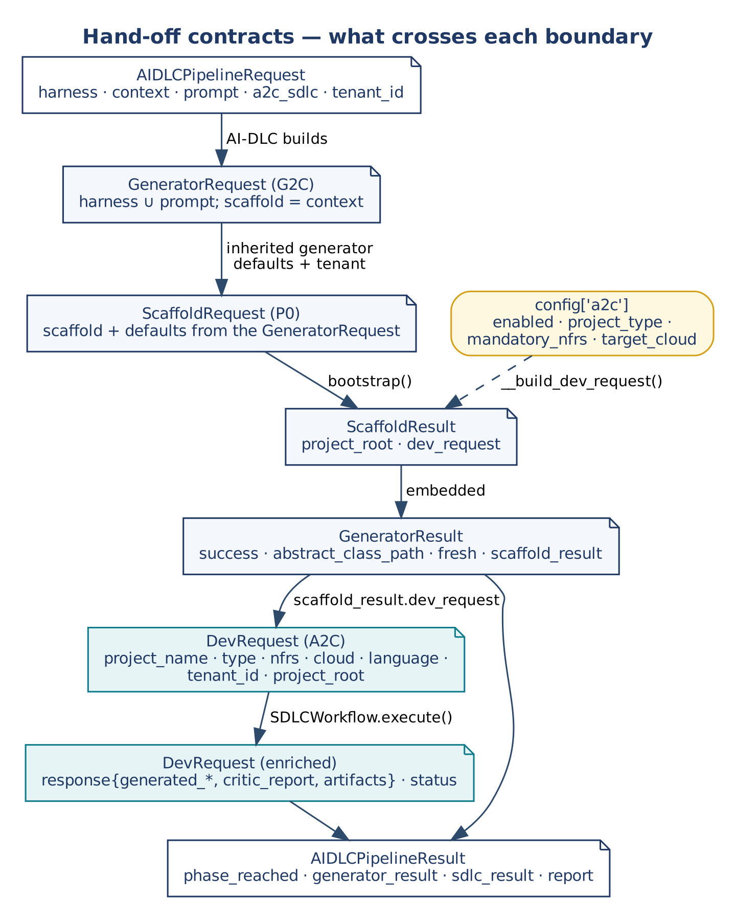
Figure 4 — What crosses each boundary

7.1 AI-DLC → G2C
GeneratorRequest field | Source in AIDLCPipelineRequest
everything in harness | harness (copied)
prompt fields (user_prompt, …) | prompt (merged over the harness)
scaffold | context
tenant_id | the build's tenant_id (unless the harness sets one)
deadline_ms | the build deadline's remaining milliseconds
config['a2c'] | built from a2c_sdlc (enabled, project_type, mandatory_nfrs, target_cloud)

config['artifact_registry'] is an adapter over the build's artifact_store, so G2C records its references in the build's ownership records. A request that enables A2C must use an inherited generator; otherwise it is REJECTED_INVALID before the claim. AI-DLC reads back success, generator_key, scaffold_result.dev_request, abstract_class_path, abstract_class_generated_fresh from the flat GeneratorResult.

7.2 G2C → P0
ScaffoldRequest field | Source
fields in scaffold | GeneratorRequest.scaffold (wins)
runtime, platform, output_path, tenant_id | GeneratorRequest defaults
build_tool | poetry / maven / npm / go_modules by runtime
project_name, Python package_name | <agent_name>Service, its snake case
Java group_id, artifact_id, project_type | must be supplied in scaffold

7.3 P0 → A2C
DevRequest field | Source
project_name, language, target_cloud | ScaffoldRequest (runtime → language, platform → cloud)
project_type, mandatory_nfrs, context | config['a2c'] (project type falls back to the scaffold's)
tenant_id | ScaffoldRequest.tenant_id, else config.tenant_id
project_root | P0's resolved workspace

A2C requires tenant_id. DevRequest and GeneratorRequest are never interchanged.

7.4 AI-DLC → A2C and back
AI-DLC sets the build's tenant_id on the dev_request, validates it with DevPlatformValidationService (or config['a2c_validation_service']), and passes A2C a deep copy. It reads errors and critic_report from the returned DevRequest. On a replay BaseWorkflow restores only response, so A2C keeps every artifact, the critic report and its status inside response as well. A consumer that must work on both paths reads response.

8. Identity, Keys and Idempotency

8.1 Key namespaces
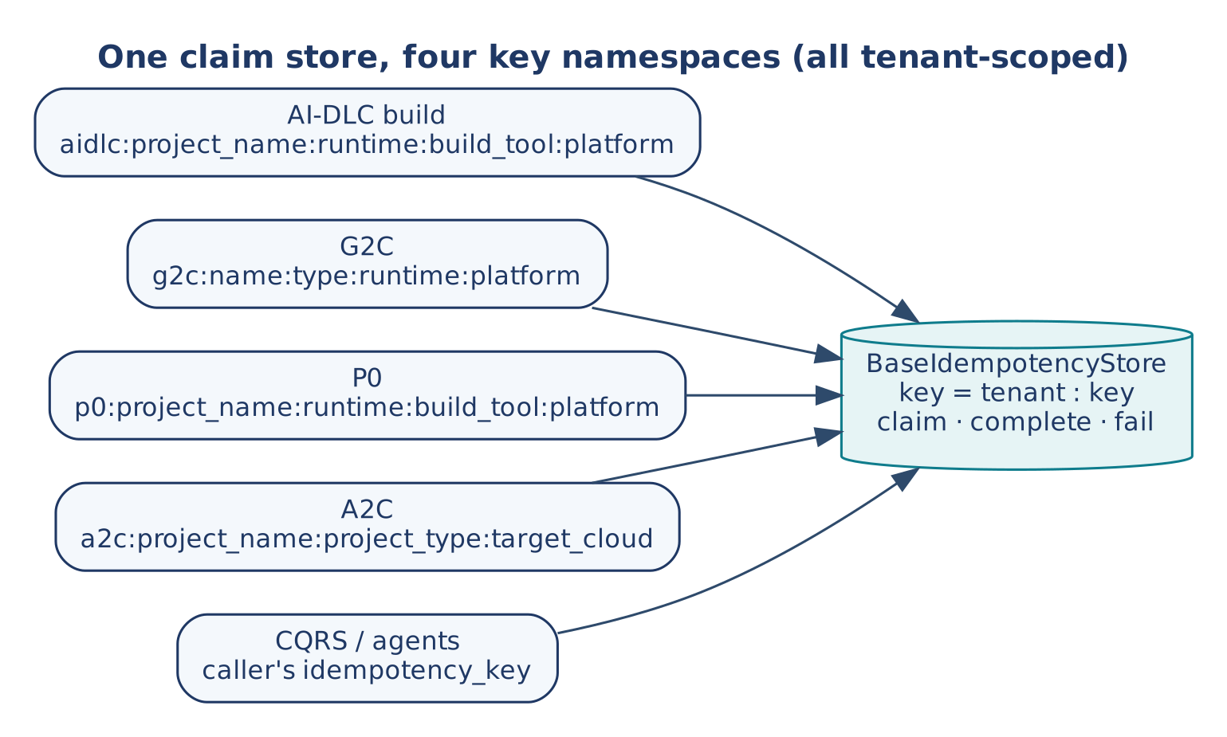
Figure 5 — One claim store, four key namespaces
Table 4 — Claim keys
Framework | Key | Fingerprint | Scope
AI-DLC | aidlc:<build_key>, where build_key = project_name:runtime:build_tool:platform | Build request | tenant
G2C | g2c:<name>:<type>:<runtime>:<platform> | Request minus volatile fields (abstract chain also minus output_path) | tenant
P0 | p0:<project_name>:<runtime>:<build_tool>:<platform> (#rescaffold for deliberate re-runs) | Request minus written fields | tenant
A2C | a2c:<project_name>:<project_type>:<target_cloud> | DevRequest | tenant

The P0 and AI-DLC keys have the same shape; before P0 was prefixed, P0's claim inside every real build returned CONFLICT against the orchestrator's own claim. All four namespaces now differ. The AI-DLC result exposes build_key; its generator_key field is a deprecated alias of the build key and is not G2C's generator_key.

8.2 Nested claims and replay
Situation | Outer (build) | Inner (G2C / P0 / A2C)
Duplicate while running | SKIPPED_IN_PROGRESS | not reached
Duplicate after success | SKIPPED_IDEMPOTENT | not reached
Retry after FAILED_A2C | re-claimed (retryable) | G2C and P0 replay; A2C re-claims
Retry after FAILED_G2C_P0 (critic) | re-claimed | P0 replays its workspace (kept by compensation); G2C regenerates if retryable, else failed_final
Replay of an output that was removed | — | recovery_required (P0: workspace missing; G2C: a generated file missing)
Worker lost | RECOVERY_REQUIRED | inner claims may be UNKNOWN; reconcile before rebuilding

Settled results are stored as deep copies, so a caller that enriches a returned object (A2C enriching dev_request) cannot change a later replay.

9. Shared Infrastructure
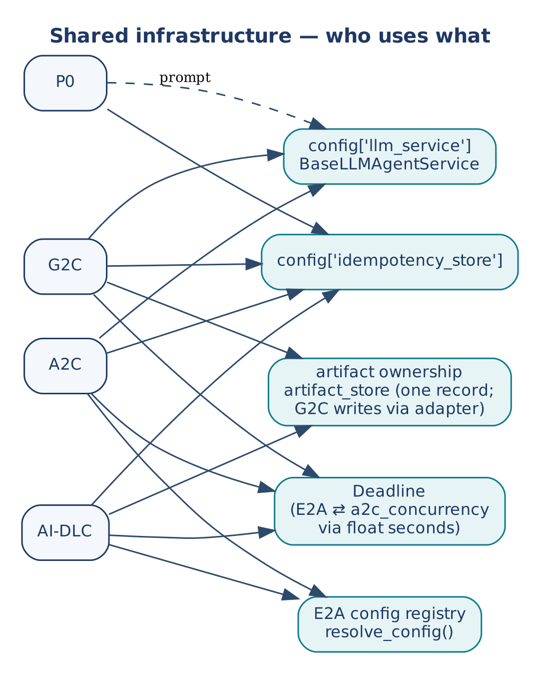
Figure 6 — Shared infrastructure: who uses what
Table 5 — Shared infrastructure
Concern | Owner | Rule across the family
Model calls | config['llm_service'] (E2A BaseLLMAgentService) | The only path to a model: generation (G2C), prompt resolution (P0), every A2C agent. Tenant/pod permits, RPM/TPM quota and per-call timeouts live here; no framework adds its own limiter.
Claims | config['idempotency_store'] | One store; claim/complete/fail surface; tenant-scoped; namespaced keys. P0 and G2C accept any object with the surface (a2c_concurrency mirrors E2A value-for-value).
Build capacity | AI-DLC _BuildAdmission | Per-tenant and per-instance build permits, bounded wait, typed overload.
Artifact ownership | AI-DLC artifact_store (G2C writes through _ArtifactRegistryAdapter) | One record per abstract class {refs, created_by, deleted}, compare-and-set, identity = G2C generator_key.
Configuration | E2A config registry | A2C registers its keys; P0 and G2C resolve config › env › default without importing E2A (they must run standalone).
Deadline | E2A Deadline; a2c_concurrency.Deadline | Bridged through float seconds (float(deadline) = remaining time), so either type can be passed to the gateway.

9.1 Propagation fields
Field | AI-DLC | G2C | P0 | A2C
tenant_id | request (JWT) | from the build | from G2C; into dev_request | from the build; required
correlation_id | minted / validated | trace_id per call | trace_id per call | from BaseWorkflow
deadline | request or config | deadline_ms from the build | — | from BaseWorkflow
idempotency_key | aidlc: key | g2c: key | p0: key | a2c: key
message_log, failed_keys | per build | — | — | per workflow run

10. Failure and Compensation
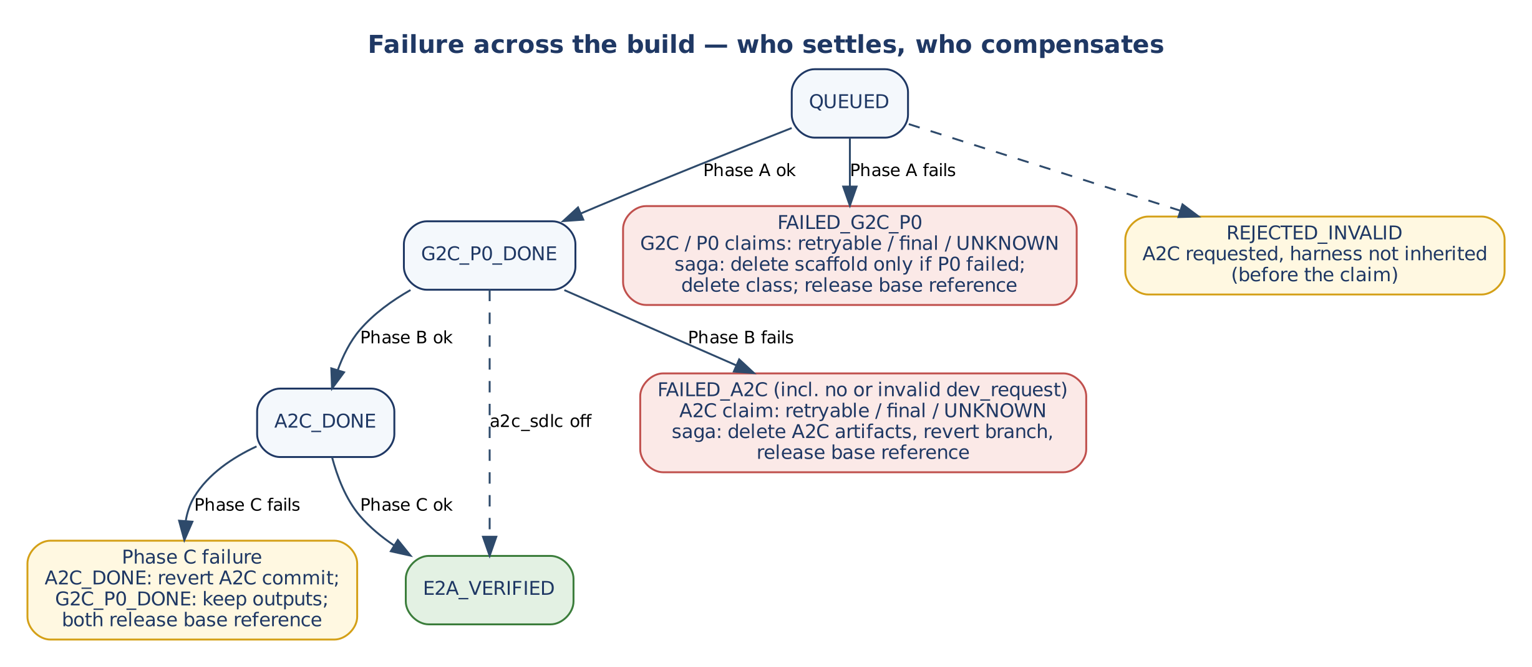
Figure 7 — Who settles, who compensates
Table 6 — Status mapping into the build
Inner outcome | phase_reached | Saga action (AI-DLC)
G2C generated | G2C_P0_DONE | —
G2C any failure, P0 failure (scaffold_failed) | FAILED_G2C_P0 | Delete the scaffold only if P0 did not succeed; delete the inherited class; release the base reference
A2C requested but impossible | REJECTED_INVALID (before the claim) | none
No dev_request, or invalid dev_request | FAILED_A2C | As below
A2C GENERATED | A2C_DONE | —
A2C errors (AGENT_FAILED, CRITIC_THRESHOLD_NOT_MET, ARTIFACT_CONFLICT) | FAILED_A2C | Delete A2C artifacts, revert branch, release the base reference
Phase C failure after A2C_DONE | A2C_DONE | Revert the A2C commit, release the base reference
Phase C failure after G2C_P0_DONE | G2C_P0_DONE | Release the base reference; keep scaffold and classes
Exception before Phase A completes | QUEUED | As FAILED_G2C_P0

Compensation never deletes an output whose producing claim settled SUCCEEDED. Deleting an orphaned abstract class is opt-in (compensation_delete_orphan_abstract) and allowed only to the build whose G2C key created it fresh, after the last reference is released; afterwards, any replay of that base returns recovery_required rather than a missing path.
Settlement and compensation are separate mechanisms: each framework settles its own claim (retryable, final, or UNKNOWN after a side effect), and AI-DLC compensates by phase. Section 14 lists where the two disagree.

11. System-Level Non-Functional Design

11.1 Time budget of one build
Table 7 — Upper bounds per phase (configured limits)
Step | Calls | Bound
G2C abstract base (first build of a tenant) | 1–3 model calls | 60 s SLO per generation (warning, not enforced)
G2C inherited class | 1–3 model calls | 60 s SLO (warning)
P0 | 0 (inline), 1 (prompt source) | 10 s SLO (warning)
A2C, NFR-first | 7 agent calls; up to 11 with 2 regenerations | 30 s per agent call (enforced) → up to 330 s
Phase C | stage hooks | deployment-specific

The AI-DLC build claim lease defaults to 300 s, below A2C's own worst case. When the build has a deadline the orchestrator now leases for at least the deadline plus 60 s; without a deadline the configured lease applies, so set request_deadline_seconds (X-7).

11.2 Capacity
Build concurrency is bounded once, by _BuildAdmission; model concurrency is bounded once, by the gateway. Every phase draws from the same gateway quota, so fleet sizing must include G2C regenerations and A2C's 7–11 calls per build.

11.3 Security
Tenant isolation rests on tenant_id reaching every claim and every gateway call (SI-03). Credentials exist only at the gateway and the stores. Validation and entitlement run in BaseValidationService before workflows (SI-07).

12. Rules for Changing an Interface
# | Rule
1 | A new framework or phase namespaces its claim key (<name>:) and scopes it by tenant.
2 | It accepts tenant_id and a deadline, and passes both to every inner call.
3 | It returns a flat, typed result; duplicates, overload and conflict are statuses, not exceptions.
4 | It settles its claim on every exit path and stores a deep copy.
5 | It keeps no semaphore, rate limiter or provider SDK; capacity comes from the gateway and admission.
6 | A composer validates the next framework's input with its BaseValidationService before calling it.
7 | A field added to a hand-off is added to Section 7 and to the integration test.
8 | Compensation that undoes a step also invalidates that step's settled claim.

13. Verification
Table 8 — Cross-framework evidence
Evidence | Result
smoke_test_aidlc_integration.py (15 checks) | AI-DLC over the real G2C, P0 and A2C: flat result; P0 inline without claim collision; A2C writes six artifacts; E2A_VERIFIED; tenant given only on the build request reaches G2C, P0 and A2C; one ownership record under G2C's key; aidlc: build claim; A2C works on a copy; abstract-only harness with A2C → REJECTED_INVALID; Phase C failure keeps the scaffold; opt-in deletion of the creator's orphaned base; retry replays truthfully; a new project gets recovery_required for the deleted base.
smoke_test_a2c.py (P0 → A2C part) | BootstrapAndGenerateWorkflow validates and runs SDLCWorkflow; artifacts land in the workspace.
Per-framework suites | e2a-framework: AI-DLC (26), concurrency (48), CQRS (9), LLM service (37), multimodal (6). a2c-framework: P0/G2C concurrency (55), G2C contract (35), A2C (25). All passing.
Reproduction X-1 (fixed) | a2c_sdlc.enabled, abstract-only harness → was E2A_VERIFIED with A2C never run; now REJECTED_INVALID.
Reproduction X-2 (fixed) | tenant_id only at the top of the AI-DLC request with a gateway → Phase A failed ("tenant_id is required when generating through llm_service"); now the build is verified.
Reproduction (fixed) | Before namespacing, P0's claim inside a real build returned CONFLICT; before deep copies, a replay returned A2C's later edits.

All evidence uses in-memory stores and a gateway test double.

14. Cross-Framework Gaps and Design Observations
Fixed on the current branches: the missing a2c_concurrency module; DeveloperPlatformWorkflow constructor and result shape; the missing a2c_base; the P0/AI-DLC claim collision; replay aliasing; and, in the AI-DLC orchestrator, X-1 (silent Phase B skip), X-2 (tenant and deadline not carried into Phase A), X-3 (no validation before Phase B), X-4 (unprefixed build key), X-5 (two ownership registries), X-6 (compensation vs replay), X-8 (A2C enriching the build's dev_request) and X-11 (no compensation after G2C_P0_DONE); X-7 is fixed when the build has a deadline. The orchestrator's earlier orphan rule, which let any build releasing the last reference delete a base it did not create, is replaced by the creator-only rule.
Table 9 — Remaining cross-framework gaps
ID | Gap | Effect | Recommendation
X-6a | A replay whose output was removed returns recovery_required, but nothing reconciles it. | After an opt-in orphan deletion, new projects of that tenant cannot generate the base until an operator intervenes. | Add a reconciler that re-opens a claim whose recorded output is gone (needs a store operation beyond claim/complete/fail), or keep orphan deletion off.
X-7 | Without a request deadline the build lease is the configured 300 s, below A2C's worst case. | A long build can lose its claim. | Set request_deadline_seconds, or raise idempotency_lease_seconds for AI-DLC deployments.
X-9 | A governance violation inside an agent settles retryable (E2A workflow settlement); AI-DLC also settles every failed build retryable. | Redelivery repeats a request that cannot pass. | Classify GovernanceViolationError and validation failures as final.
X-10 | Business keys do not line up: P0 and the build include build_tool, A2C omits runtime, G2C is per class. | Python and Java variants of one project share an A2C key. | Add language to A2C's key; document the mapping in Table 4.
X-12 | Two Deadline types, bridged by float seconds. | Works, but two implementations of one concept. | Use E2A's type when e2a_base is present.
X-13 | The AI-DLC result keeps generator_key as an alias of the build key. | Readers can still confuse it with G2C's key. | Remove the alias after consumers move to build_key.

Appendix A. Glossary
Term | Definition
Build | One AIDLCPipelineOrchestrator.execute_pipeline() call.
Phase A / B / C | G2C + P0; A2C; verification by BasePipeline.
Hand-off | A request or result that crosses a framework boundary.
Namespace | The prefix that separates one framework's claim keys from another's.
Nested claim | An inner framework's claim taken while the build's claim is held.
Derived | Follows from the contracts; not reproducible with the reference hooks.

Appendix B. Where each concern is specified
Concern | Specified in
Method contracts of a class | That framework's design document, Section 8
Claim mechanics (state machine, settlement) | E2A design document; a2c_concurrency in the G2C document
Key namespaces, nested claims, hand-offs | This document, Sections 7–8
Admission, phases, saga | AI-DLC design document
Generation order, critic rules | A2C and G2C design documents
Cross-framework gaps | This document, Section 14

