SOFTWARE DESIGN DOCUMENT
E2A AI-DLC Profile
High-Level and Low-Level Design

This document describes the E2A AI-DLC (AI-assisted Software Development Life Cycle) profile from problem statement to method-level contract: the composed, saga-governed build service that turns one developer request into a governed, verified repository by running G2C, P0, A2C and E2A in sequence. It is written so that a reader can form a complete mental model of the profile without opening the Python source, which remains the reference for line-level detail.
Framework | E2A — Enterprise-to-Agentic Architecture Framework (AI-DLC profile composing G2C, P0 and A2C)
Document type | Design Document (HLD + LLD)
Author | Subham Gupta, Principal Platform Architect
Source baseline | subhamviky/e2a-framework v1.2.0 — reference/ai_dlc_pipeline.py and the shared contracts it imports through e2a_base from the e2a package; composes subhamviky/a2c-framework v1.2.0 (G2C, P0 and A2C implementations)
Date | 13 November 2026 (E2A v1.2.0, A2C v1.2.0; baseline 8 November 2026)
Status | Aligned to the current reference implementation

Contents
1. Introduction 4
1.1 Purpose 4
1.2 Audience 4
1.3 Status labels 4
1.4 Related documents 5
2. Problem Statement and Motivation 6
2.1 The problem 6
2.2 Why a composing class 6
2.3 Design goals 6
3. Core Use Cases 7
3.1 Actors 7
3.2 Use-case catalogue 7
3.3 Non-goals 8
4. Design Principles and Invariants 9
4.1 Principles 9
4.2 Invariants 9
5. High-Level Design 11
5.1 System context 11
5.2 Zones and tiers 11
5.3 Framework composition 13
5.4 The unified request 14
5.5 End-to-end flow 15
5.6 Capacity, admission and durable state 15
5.7 Vendor mapping 16
6. Data and Propagation Contracts 17
6.1 Request — AIDLCPipelineRequest 17
6.2 Result — AIDLCPipelineResult 17
6.3 Durable records 18
6.4 phase_reached vocabulary 18
6.5 Propagation fields 19
6.6 Configuration 19
7. Low-Level Design — Class Model 21
7.1 Classes this profile adds 21
7.2 Dependencies 22
7.3 Data contracts 23
8. Low-Level Design — Class Contracts 24
8.1 AIDLCPipelineOrchestrator 24
8.2 _BuildAdmission 25
8.3 AIDLCStaticPipeline 25
8.4 AIDLCSagaCompensator 27
8.5 Reused contracts 28
9. Dynamic Behaviour 29
9.1 execute_pipeline() internals 29
9.2 Phase state machine 30
9.3 Duplicates and overload 31
9.4 Compensation 32
9.5 Shared artifact ownership 33
10. Concurrency and Saga Model 34
10.1 Risk ownership 34
10.2 What compensation preserves 34
10.3 Error routing 35
11. Non-Functional Design 36
11.1 Latency budgets 36
11.2 Capacity sizing 36
11.3 Security 36
11.4 Observability 36
12. Extension Guide 37
13. Verification 38
14. Implementation Reality, Gaps and Design Observations 40
15. E2A v1.2 and A2C v1.2 in the Pipeline 42
Appendix A. Glossary 43
Appendix B. Traceability 44

1. Introduction

1.1 Purpose
The E2A framework has three execution profiles. The agentic profile runs a governed agent; the deterministic CQRS profile runs a command/query service; the AI-DLC profile runs the framework stack that generates such services. A developer fills three panels in a UI — context, harness and prompt — and clicks Execute; the platform produces an abstract class (if needed), a project scaffold, an inherited domain class, and optionally Terraform, CI/CD and business-logic code, then statically verifies the result and commits or compensates.
The profile adds exactly one composing class, AIDLCPipelineOrchestrator, plus two supporting classes and three data contracts. Everything else is reused unmodified through its own public entry point: G2C's DeveloperPlatformWorkflow.generate(), P0's BaseProjectBootstrapper.bootstrap() (invoked inline by G2C, never by the orchestrator), A2C's SDLCWorkflow.execute(), and E2A's BasePipeline.run_pipeline(), stores, governance, observability and inference gateway.
This document covers the problem and motivation (Section 2), use cases (Section 3), principles and invariants (Section 4), the HLD (Section 5), data contracts (Section 6), the LLD class model and contracts (Sections 7–8), dynamic behaviour (Section 9), the concurrency and saga model (Section 10), NFRs (Section 11), extension (Section 12), verification (Section 13) and known gaps (Section 14).

1.2 Audience
Reader | Read first | Use the document to
Platform architect | Sections 2–5, 10, 11 | Place the build service in the landing zone; size build capacity and model quota.
Platform engineer | Sections 6–9, 12 | Bind stores, compensator hooks and the static pipeline; operate the orchestrator.
Framework author (G2C / P0 / A2C) | Sections 5.4, 6.1, 8.1 | Understand exactly which entry points and fields the profile relies on.
SRE | Sections 5.6, 10, 11, 13 | Understand duplicate, overload and failure outcomes and what compensation touches.
Reviewer | Sections 4, 13, 14, Appendix B | Check invariants, evidence and gaps.

1.3 Status labels
Label | Meaning
Implemented | In reference/ai_dlc_pipeline.py and exercised by smoke_test_aidlc_concurrency.py (26 checks, stubbed G2C/A2C) and by smoke_test_aidlc_integration.py in a2c-framework (15 checks, real G2C, P0 and A2C modules).
Hook | A protected method with a reference body that a deployment overrides (compensation actions, object deletion, static-pipeline stages).
Reused | A G2C, P0, A2C or E2A class called through its published entry point.
Runtime obligation | Provided by the platform (push delivery, status stream, saga engine, Git operations).

> Phase B entry point SDLCWorkflow.execute(dev_request, config) → DevRequest is implemented in a2c_base.py and is validated by DevPlatformValidationService before the orchestrator calls it. A2C enriches the request it is given, so the orchestrator passes a deep copy and keeps its own dev_request unchanged.

1.4 Related documents
Document | Relationship
E2A Framework — Agentic Core Design Document | Defines BasePipeline, store ports, governance, observability, BaseLLMAgentService and the concurrency vocabulary used here.
E2A Deterministic CQRS Profile — Design Document | Sibling profile; same tier numbering and propagation conventions.
G2C Framework Design Document | DeveloperPlatformWorkflow, GeneratorRequest, GeneratorResult, GeneratorCriticAgent — Phase A.
P0 Framework Design Document | BaseProjectBootstrapper, ScaffoldRequest, the a2c config block and dev_request handoff — Phase A/B boundary.
A2C Framework Design Document | SDLCWorkflow, DevRequest, DevPlatformValidationService, CodeCriticAgent — Phase B.
E2A Family System Design Document | Cross-framework claim namespaces, shared-artifact ownership and open system-level gaps.
AI-DLC Landing Zone (HLD) and Implementation Playbook | Infrastructure view and full scaffold listing.

2. Problem Statement and Motivation

2.1 The problem
Each generation framework solves one slice of building a governed service:
- G2C produces classes — an abstract base (E2A or A2C) and an inherited domain class — and, inline, a P0 project scaffold. By contract it writes class and scaffold files, never Terraform or CI/CD YAML.
- P0 produces a compilable, policy-shaped workspace and, when asked, the DevRequest that A2C consumes.
- A2C produces infrastructure-as-code, CI/CD workflows and the remaining business logic from a DevRequest.
- E2A defines what a compliant result looks like and how to verify it.
Run by hand, these steps fail in predictable ways: a developer re-submits and two builds race on one repository; one tenant's burst consumes every build slot and the shared model quota; a later phase fails and a naive cleanup deletes a shared abstract class that other, already-completed builds depend on; a crash mid-build leaves nobody knowing which phase finished; and verification is skipped because it lives in a different tool.

2.2 Why a composing class
No existing class closes the gap between G2C's output (classes and scaffold) and A2C's input (a DevRequest), and none owns the cross-phase concerns: one idempotency claim per build, bounded build admission, durable phase state, phase-aware compensation and a single telemetry trail. P0's BootstrapAndGenerateWorkflow already composes P0 and A2C for the P0-only case; AIDLCPipelineOrchestrator is the G2C-inclusive superset of the same pattern — and deliberately nothing more. There are no phase-service wrapper classes: the orchestrator calls DeveloperPlatformWorkflow.generate() and SDLCWorkflow.execute() directly.

2.3 Design goals
ID | Goal | Mechanism
G-1 | One build per business request | Atomic tenant-scoped claim on aidlc:<build_key> with a request fingerprint; invalid requests are rejected before the claim.
G-2 | Fair, bounded build capacity | _BuildAdmission: per-tenant and per-instance permits with a bounded wait; overload is a typed, retryable rejection.
G-3 | Durable progress | Phase state written by conditional commit after each phase.
G-4 | Safe compensation | Phase-aware saga that never deletes outputs a settled claim vouches for; shared abstract classes protected by compare-and-set reference records.
G-5 | Reuse without modification | Every composed framework called through its own public entry point; the static pipeline is a BasePipeline subclass, not a call into its hooks.
G-6 | Shared model governance | Every LLM call in every phase goes through the Tier 2b inference gateway.
G-7 | Smaller valid deliverables | Phase B is optional; G2C + P0 alone is a valid pipeline; later-phase failures keep earlier valid artifacts.

3. Core Use Cases

3.1 Actors
Actor | Description
Developer | Fills the context, harness and prompt panels and triggers a build; watches the live build console.
Edge (T0/T1) | Gateway and BaseValidationService; checks entitlement (create-repository rights); returns 202.
Orchestrator (T2) | AIDLCPipelineOrchestrator running Phases A–C.
Inference gateway (T2b) | Serves every model call from G2C generators, A2C agents and critics.
Saga edge (T5) | Commits (merge, tag, webhook) or compensates.
Downstream systems | Chat-ops, ticketing, service catalogue (via T4 webhooks and events).

3.2 Use-case catalogue
ID | Use case | Flow | Outcome
UC-1 | Minimal build | Context + prompt; a2c_sdlc unset → Phase A → Phase C | Abstract class (if needed), scaffold, one inherited class; E2A_VERIFIED
UC-2 | Full build | a2c_sdlc.enabled → Phase A → Phase B (five agents) → Phase C | Repository with IaC, CI/CD and business logic; E2A_VERIFIED
UC-3 | Duplicate submission | Second claim on the same build_key | SKIPPED_IN_PROGRESS while running, SKIPPED_IDEMPOTENT (success) after completion
UC-4 | Changed request, same key | Fingerprint differs | REJECTED_CONFLICT; nothing built
UC-5 | Tenant at build cap | Admission wait expires | REJECTED_OVERLOAD; claim released; caller retries
UC-6 | Phase B fails | No dev_request, failed validation, or critic below threshold after retries | FAILED_A2C; A2C files and branch reverted; scaffold and classes kept
UC-7 | Phase C fails after A2C | Static scan / tests / contract check fails | Staged A2C commit reverted; scaffold and classes kept
UC-8 | Phase A fails | Generator or scaffold failure | Unsettled scaffold and inherited class deleted; this build's reference on the shared abstract class released
UC-9 | Concurrent builds share an abstract class | G2C registers a reference per build | Artifact survives while any referrer remains; deleted at most once, only if deletion is enabled and the creating build releases last
UC-10 | Worker lost mid-build | Claim lease expires | RECOVERY_REQUIRED; last phase reached is in durable state; no blind rebuild
UC-11 | A2C requested without an inherited generator | a2c_sdlc.enabled with harness.generator_type not e2a_inherited or a2c_inherited | REJECTED_INVALID before any claim or side effect

3.3 Non-goals
- No live deployment. The pipeline verifies statically; the generated project's own CI/CD (produced by A2C's CICDAgent) compiles, scans and deploys on its first commit.
- No phase fan-out. Phases are sequential by data dependency; concurrency exists only across builds.
- No interruption of a running phase. The deadline is checked between phases; model calls inside a phase are bounded by the gateway.
- No modification of G2C, P0, A2C or E2A classes.

4. Design Principles and Invariants

4.1 Principles
- Compose through public entry points only — generate(), execute(), run_pipeline(); never protected hooks from outside a class.
- P0 is inline — bootstrap() runs inside G2C's inherited-class generator; the orchestrator never calls it and never rebuilds the dev_request.
- Duplicates and overload are outcomes, not failures — they never reach the DLQ or the compensator.
- Settle after cleanup — the claim is settled only after compensation, so a key is never claimable while its artifacts are being removed.
- Compensate only what this build produced — scoped by build, phase-aware; never delete an output whose producing step settled as succeeded; shared artifacts protected by compare-and-set ownership.
- Model access is shared and governed — every phase reaches models only through config['llm_service'].
- Fail a requested phase loudly — a phase the caller asked for that cannot run is a rejected request or a failed build, never a silent skip.

4.2 Invariants
ID | Invariant | Enforced by
INV-01 | At most one build runs per tenant-scoped aidlc:<build_key>; other frameworks claim under g2c:, p0: and a2c:, so keys never collide. | BaseIdempotencyStore.claim()
INV-02 | A changed request under the same key is never treated as a replay. | __fingerprint() over context and a2c_sdlc
INV-03 | No tenant holds more than tenant_build_max_inflight build slots; no instance more than build_max_inflight. | _BuildAdmission
INV-04 | Admission never waits beyond min(permit_timeout, deadline). | _BuildAdmission.acquire()
INV-05 | Overload and duplicate outcomes produce no compensation and no DLQ entry. | Dedicated branches before the generic except
INV-06 | Phase state is never silently overwritten. | put_if_version in __persist_state() → ConcurrencyConflict
INV-07 | A shared abstract class is deleted only if deletion is enabled, the releasing build created it fresh, no reference remains, and only by the single CAS winner. | G2C registration through _ArtifactRegistryAdapter / _delete_abstract_class_if_orphaned()
INV-08 | A completed build never loses its artifacts to a sibling's compensation. | Completed builds keep their reference; a failed build releases only its own
INV-09 | The claim is settled after compensation. | Order inside finally
INV-10 | Phase B runs only when requested; when requested, a valid dev_request must exist or the build fails as FAILED_A2C. | Guard and validation before SDLCWorkflow.execute()
INV-11 | A request that enables A2C without an inherited generator is rejected before the claim. | __request_problem()
INV-12 | Compensation never deletes the output of a step whose claim settled as succeeded. | compensate() phase branches

5. High-Level Design

5.1 System context
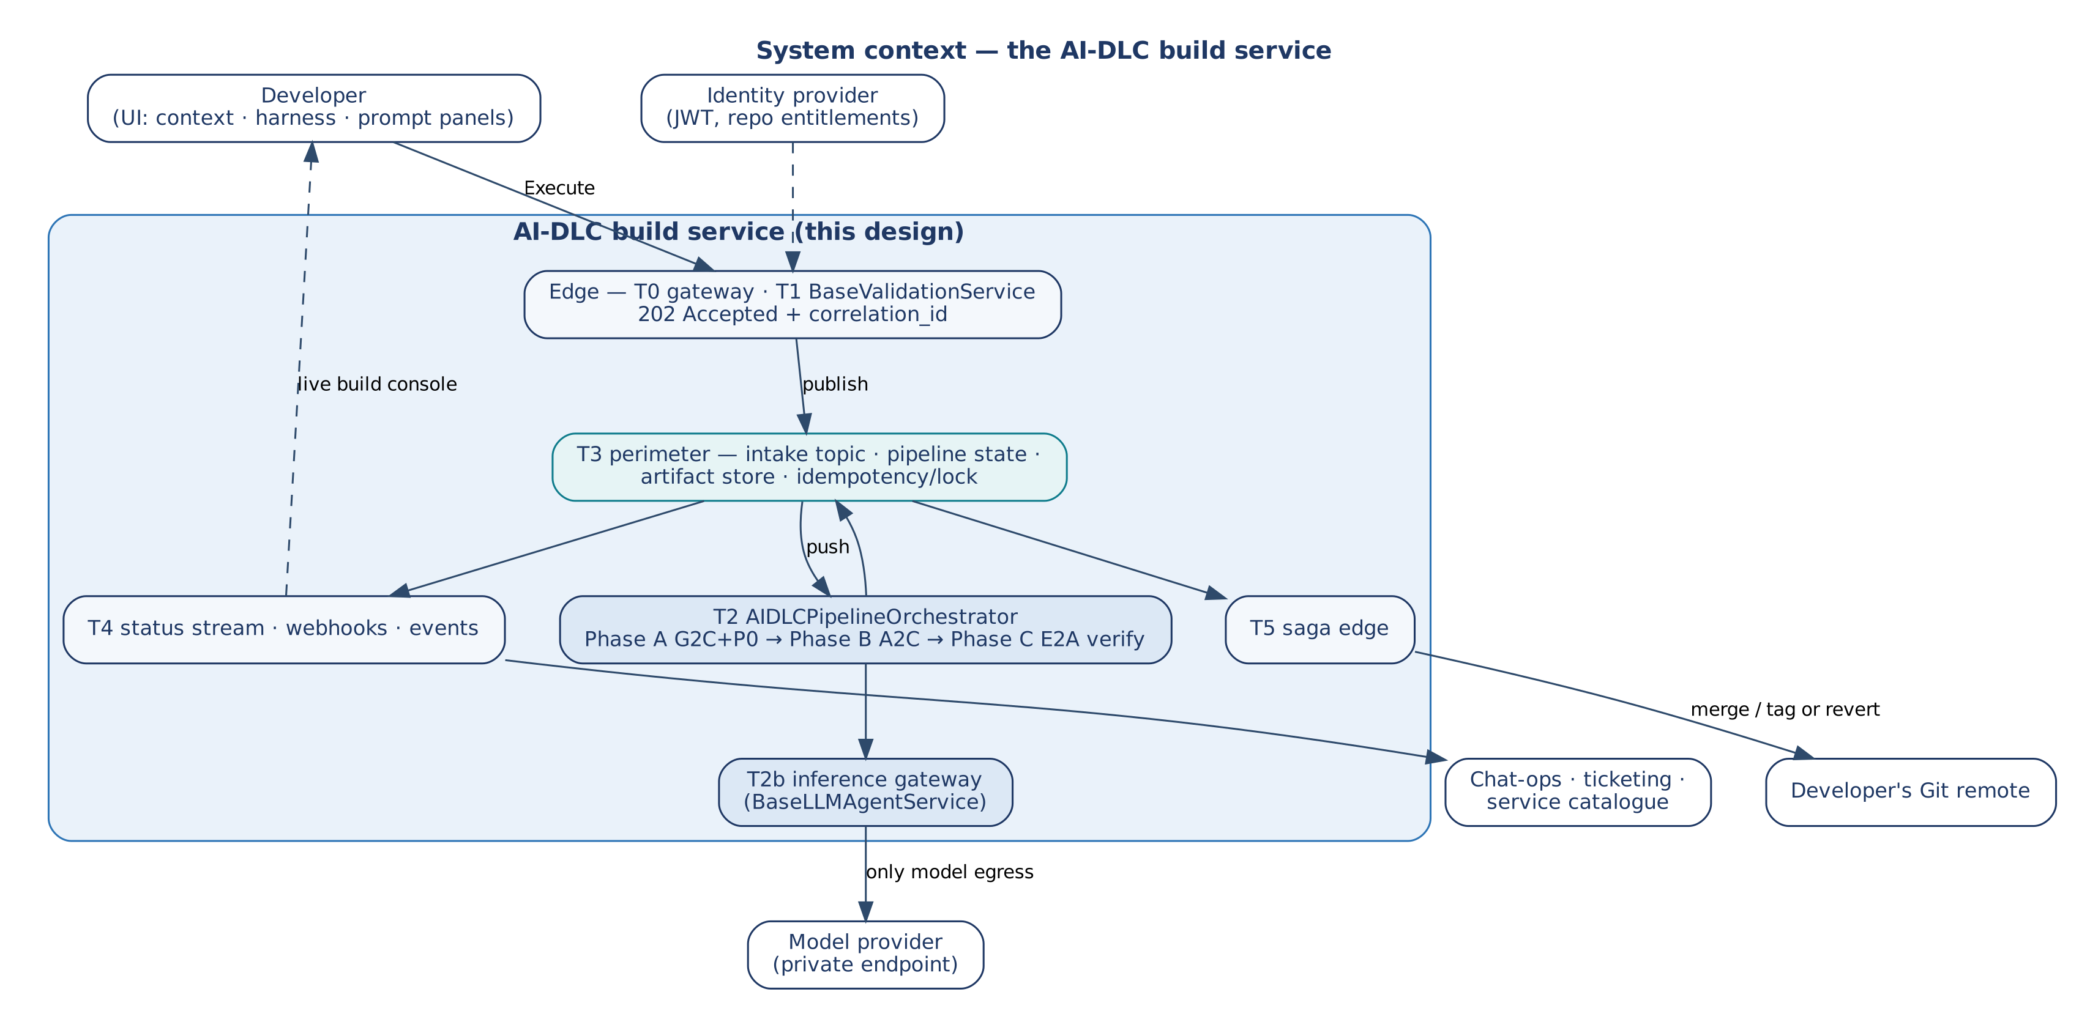
Figure 1 — System context of the AI-DLC build service

5.2 Zones and tiers
The profile reuses the three zones and tier numbering of the other profiles. Only Tier 2's internal composition changes: it runs a multi-phase, long-running saga instead of one agent run or a command/query split.
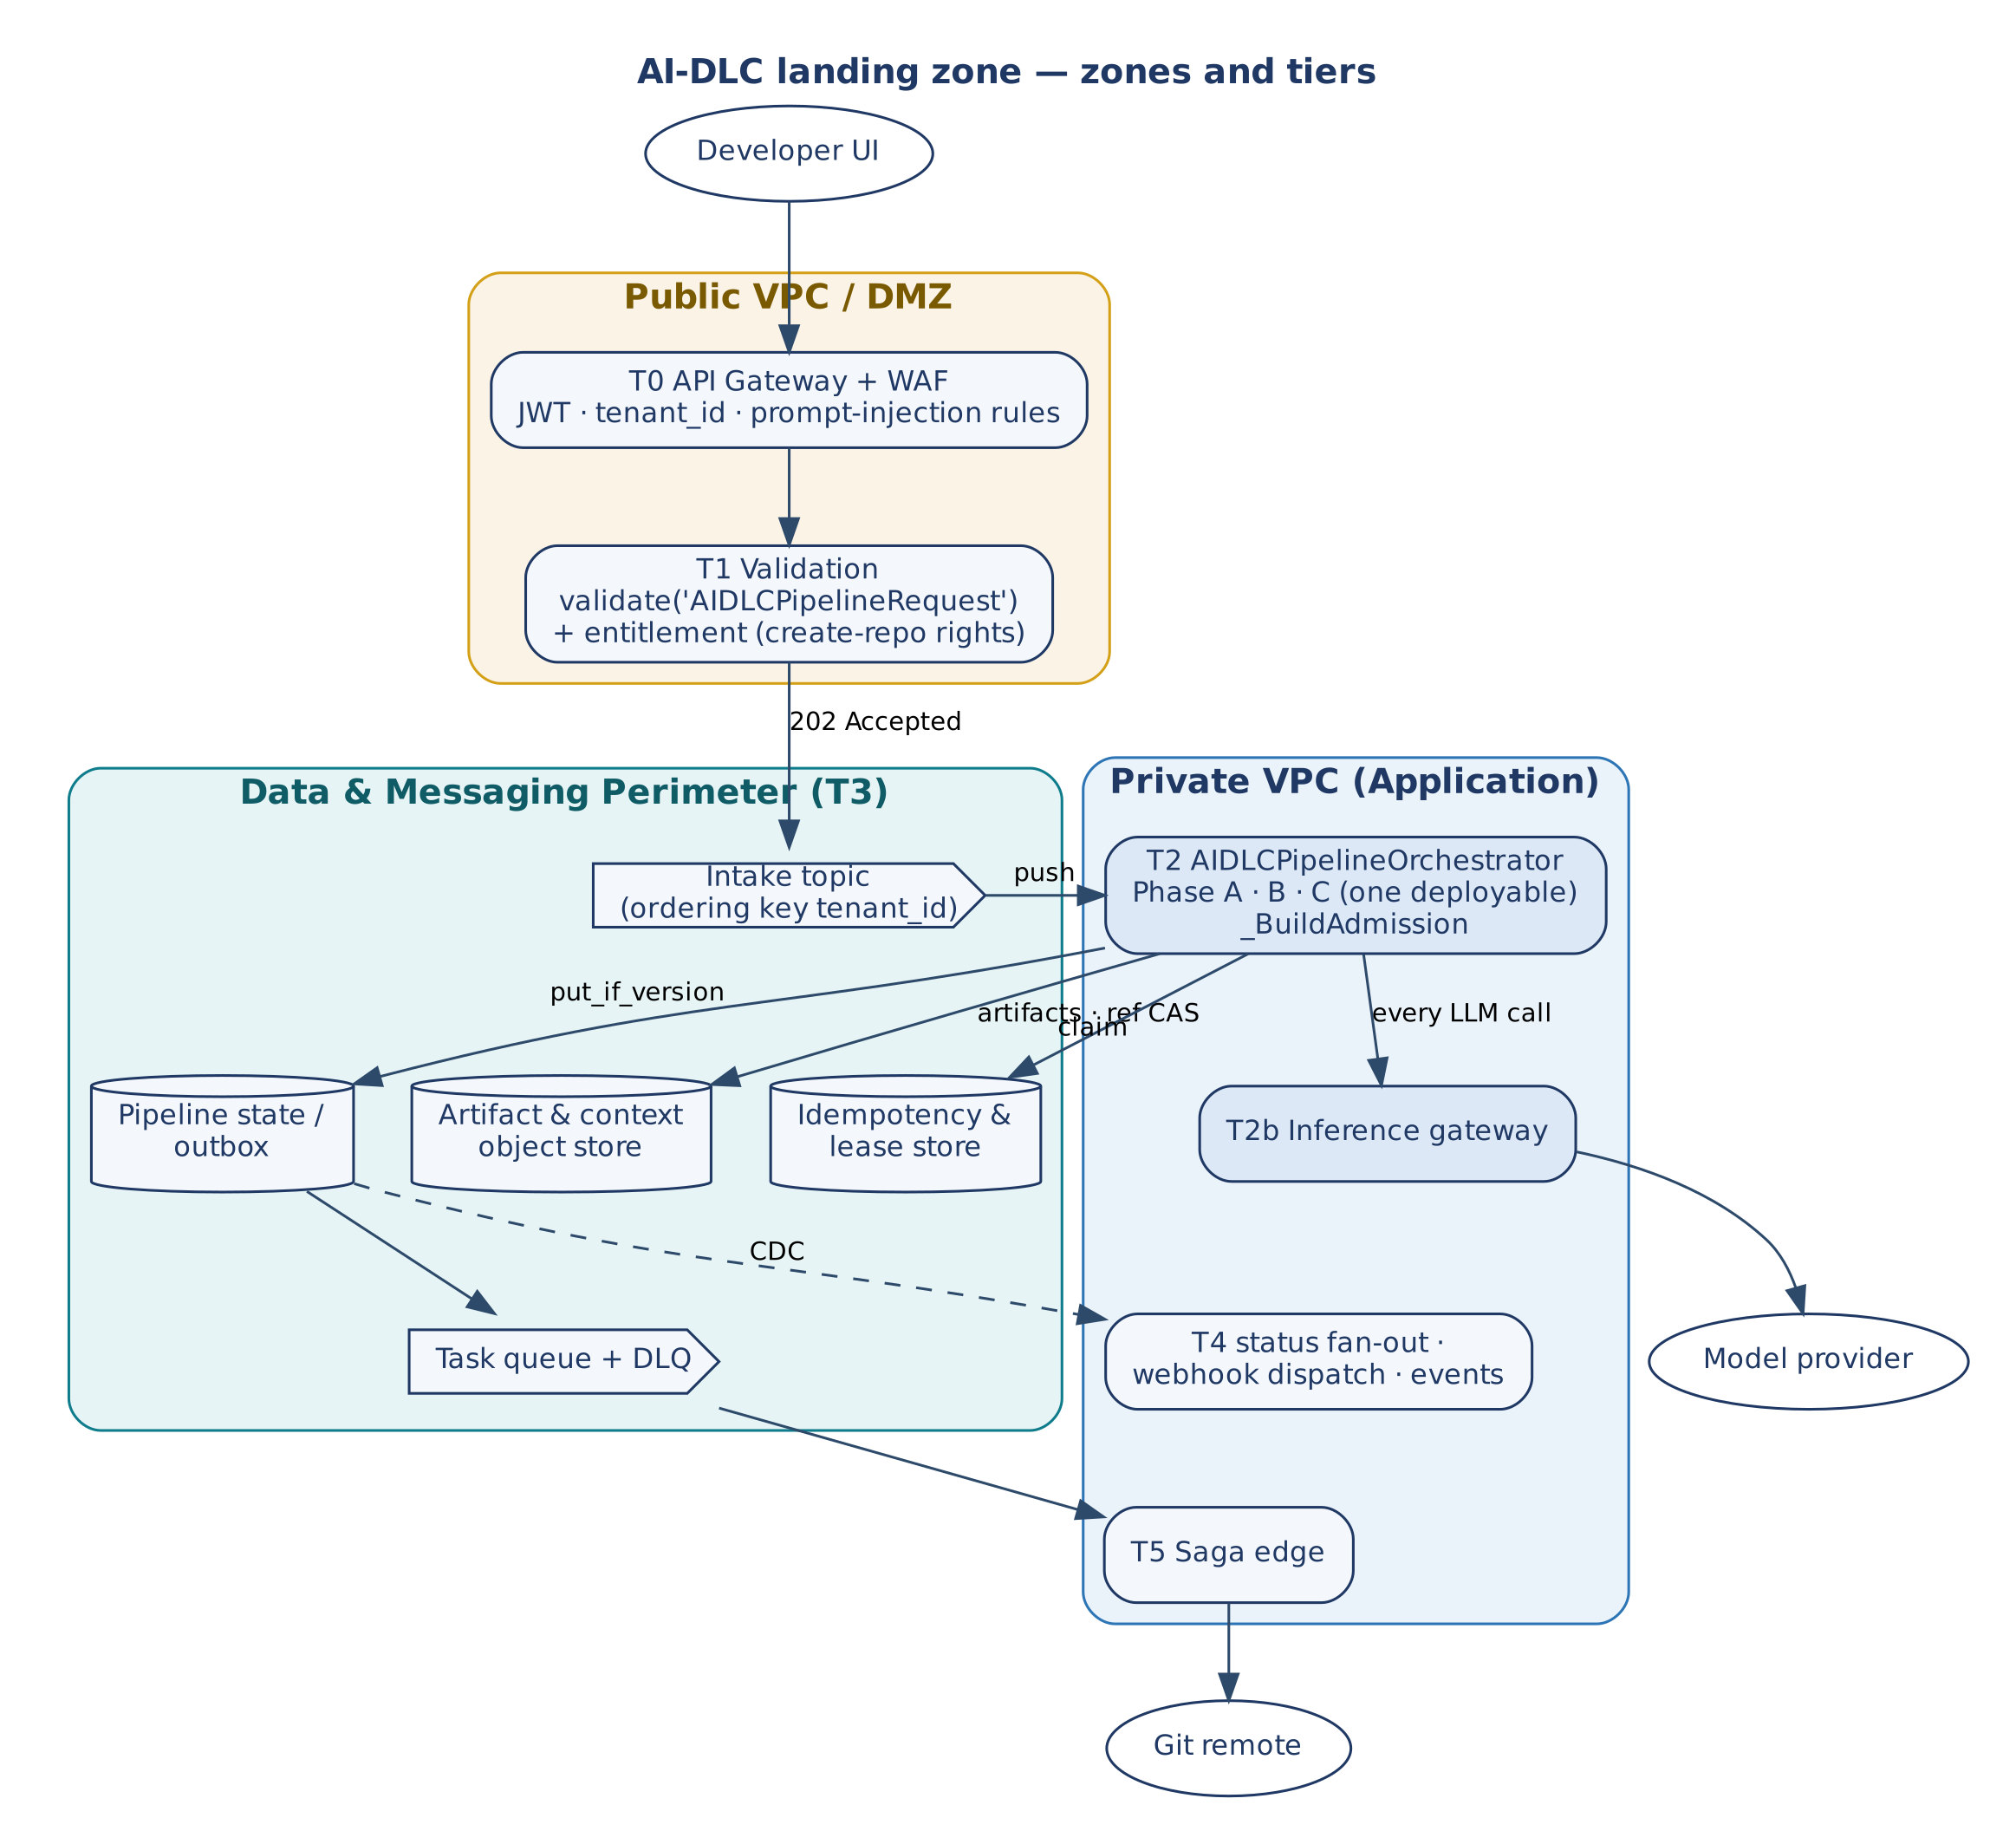
Figure 2 — AI-DLC landing zone: zones and tiers
Tier | Component | Responsibility in this profile
T0 | API gateway + WAF | JWT, tenant_id and developer_id; rate limit; prompt-injection rules on user_prompt, system_prompt_additions, class_description; mints correlation_id and trace_context.
T1 | Validation | validate('AIDLCPipelineRequest', state), entitlement (create-repository rights), publish to intake, 202. Never invokes T2 synchronously — builds take minutes.
T2 | Pipeline compute | AIDLCPipelineOrchestrator running all three phases in one process; one deployable, scaled by concurrent builds (admission limits), not by phase.
T2b | Inference gateway | Every model call from G2C generators, A2C agents and critics; absorbs the bursty, LLM-bound load.
T3 | Data & messaging perimeter | Intake topic (ordering key tenant_id); pipeline state/outbox table; artifact and context object store; idempotency and lease store; task queue and DLQ.
T4 | Fan-out consumers | Live status stream (WebSocket/SSE), webhook dispatch (BaseWebhookDispatcher), "service scaffolded" domain events.
T5 | Saga edge | Commit (merge, tag, completion webhook) or compensate.

Network placement: the DMZ holds no repository content and no model credentials; the perimeter has no route from the DMZ or internet, protecting generated source and CI/CD secrets; the only external egress is model traffic from T2b and Git traffic from T5, both through allow-listed NAT.

5.3 Framework composition
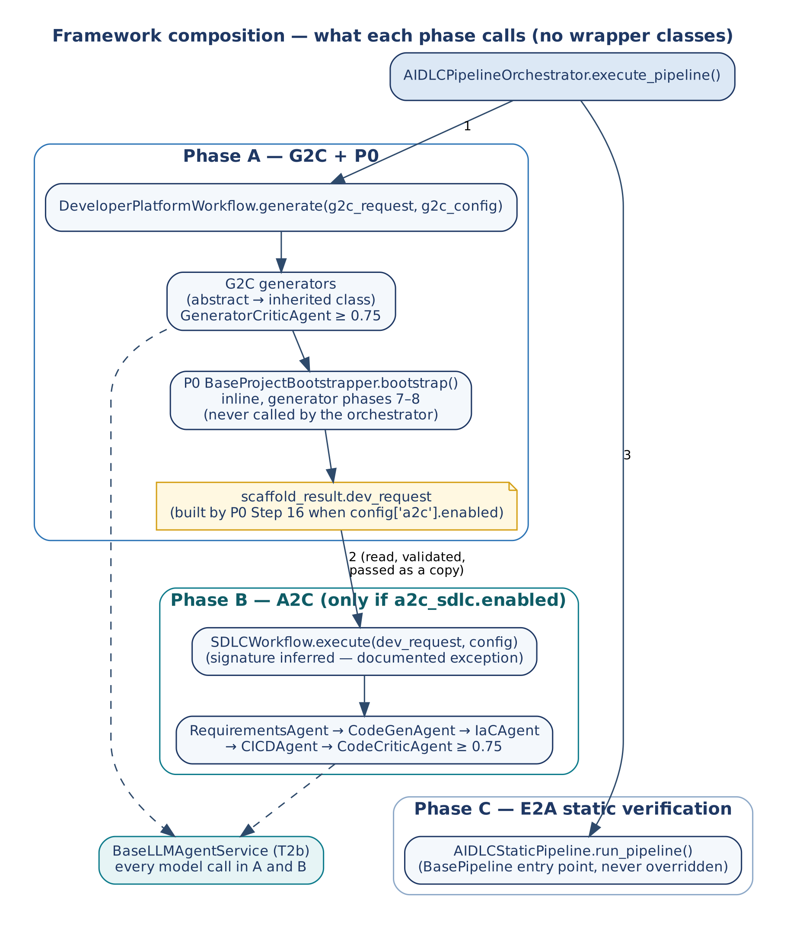
Figure 3 — What each phase calls
Phase | Framework | Entry point | Quality gate | Artifacts
A | G2C | DeveloperPlatformWorkflow.generate() | GeneratorCriticAgent ≥ 0.75 (structure: access modifiers, abstract methods, inheritance) | Abstract base (common/e2a_base.py or a2c_base.py) if generated; inherited class. Since A2C v1.2.0 a Python service on E2A v1.2 generates no base: it depends on the e2a package
A | P0 (inline) | BaseProjectBootstrapper.bootstrap() inside G2C's generator phases 7–8 | _validate_output() — manifest, README, Docker, Makefile present | Build manifest, directory tree, Dockerfile, Makefile, .env.example, .gitignore; dev_request when config['a2c'].enabled
B | A2C (optional) | SDLCWorkflow.execute(dev_request, config) after DevPlatformValidationService | CodeCriticAgent ≥ 0.75 (mandatory NFR patterns present in code) | Terraform, CI/CD workflow, business-logic source written into the P0 workspace
C | E2A | AIDLCStaticPipeline.run_pipeline() | Static security, test suite, scaffold-contract compliance | Scan report, test results, compliance report

5.4 The unified request
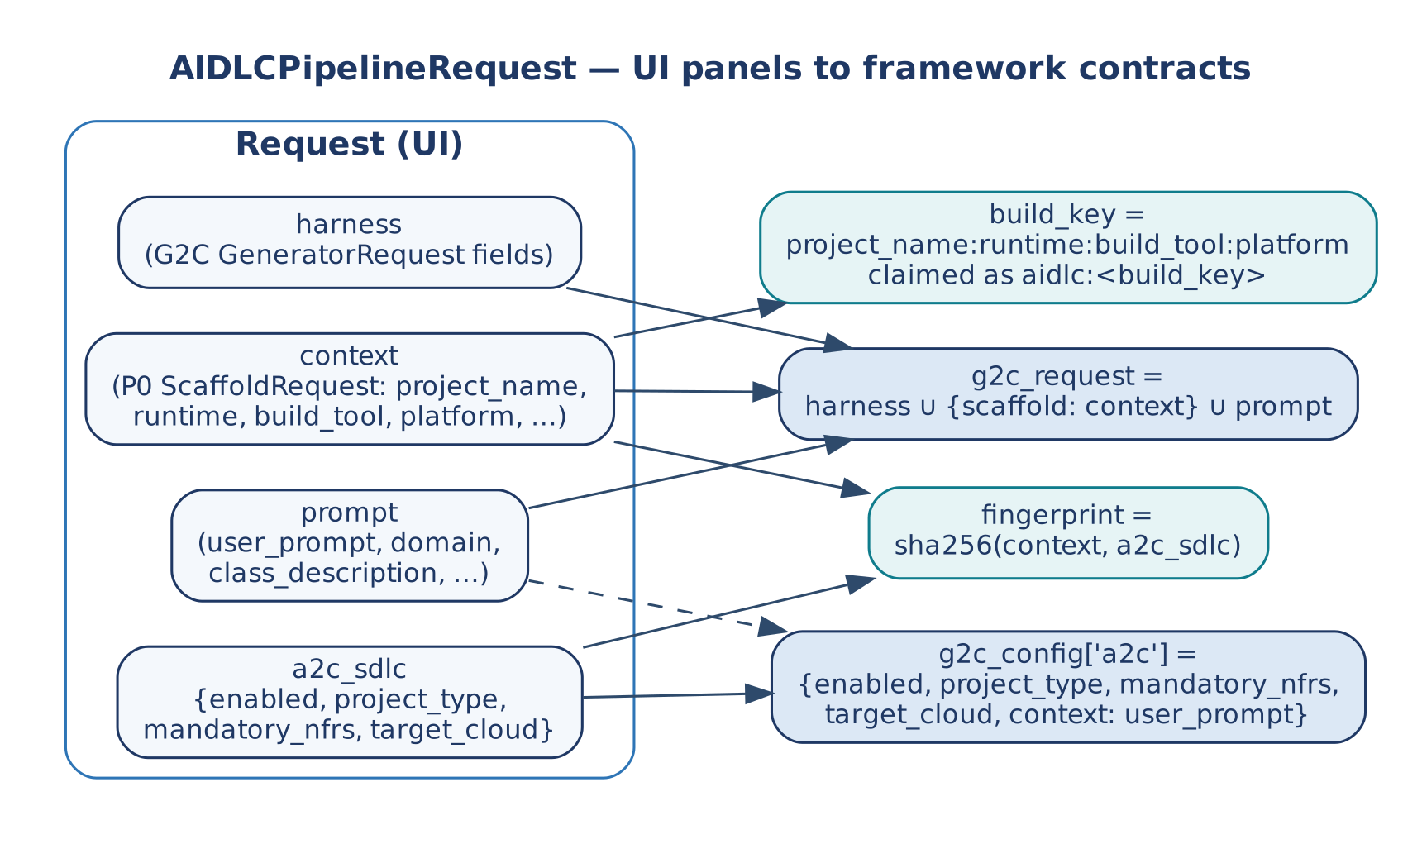
Figure 4 — UI panels mapped onto existing framework contracts
No new field vocabulary was invented: the context panel is P0's ScaffoldRequest, the harness panel is G2C's GeneratorRequest, the prompt panel carries G2C's free-text fields, and a2c_sdlc mirrors P0's existing a2c config block under a disambiguating name.

5.5 End-to-end flow
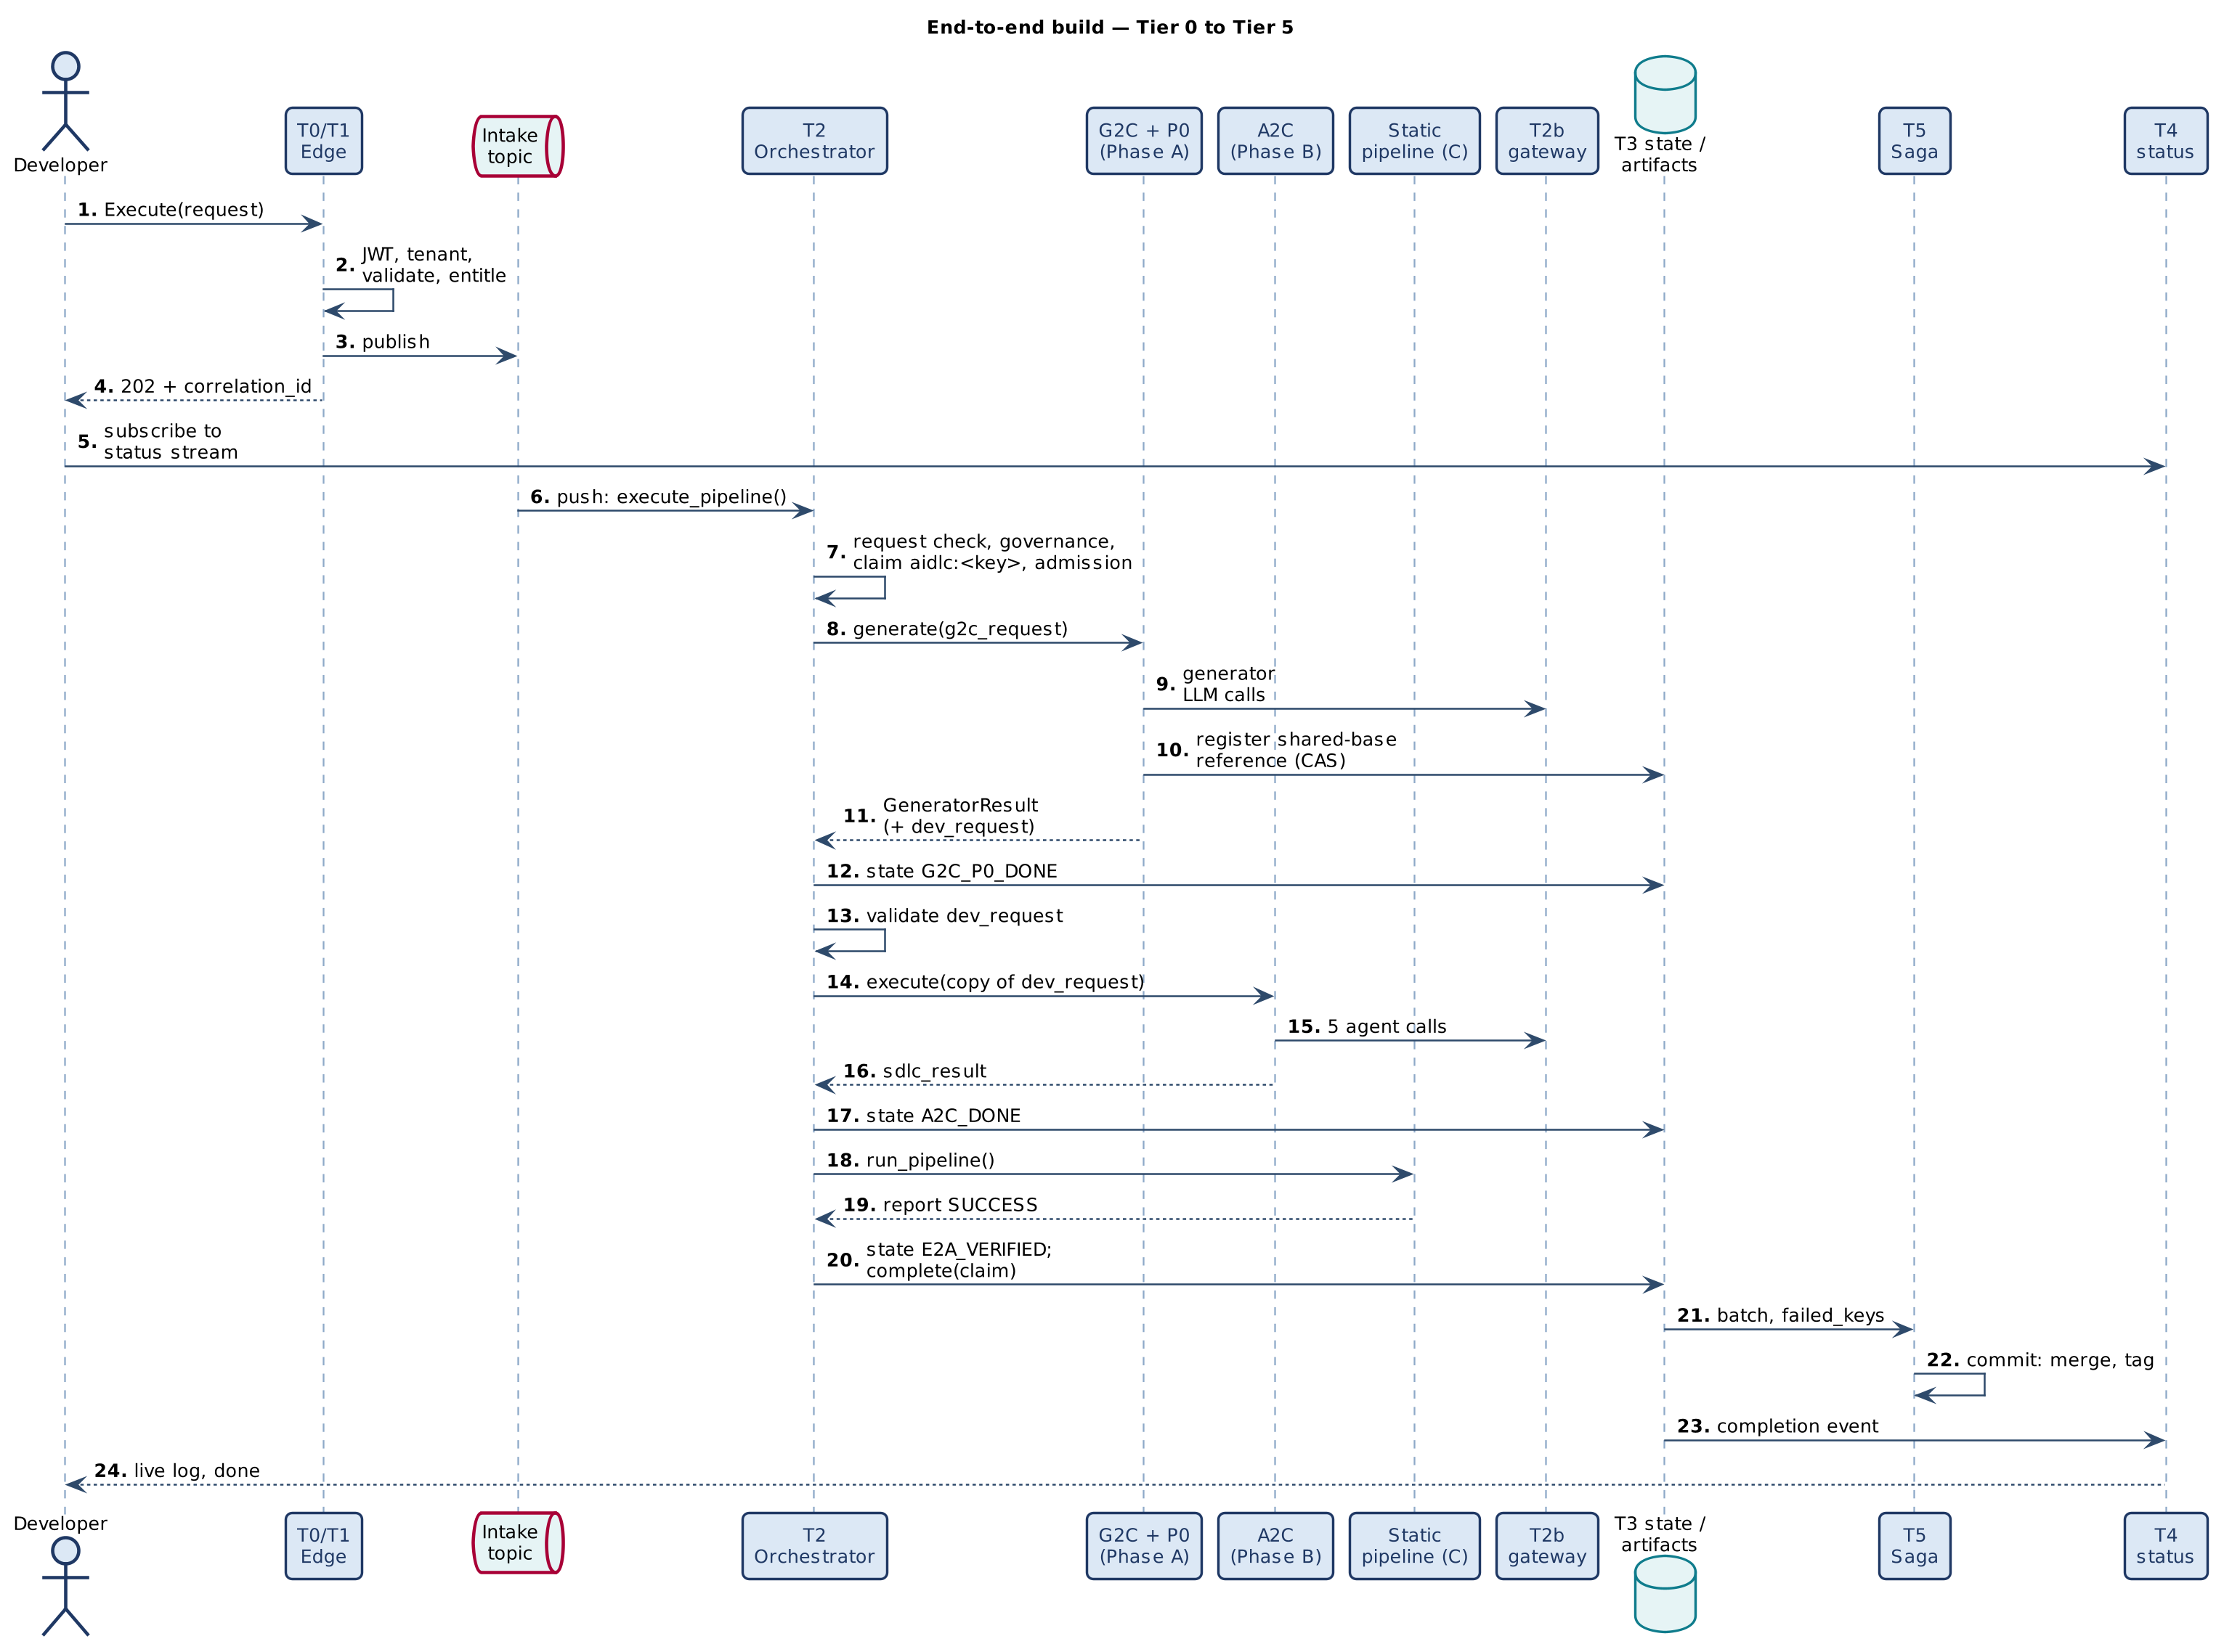
Figure 5 — End-to-end build, Tier 0 to Tier 5

5.6 Capacity, admission and durable state
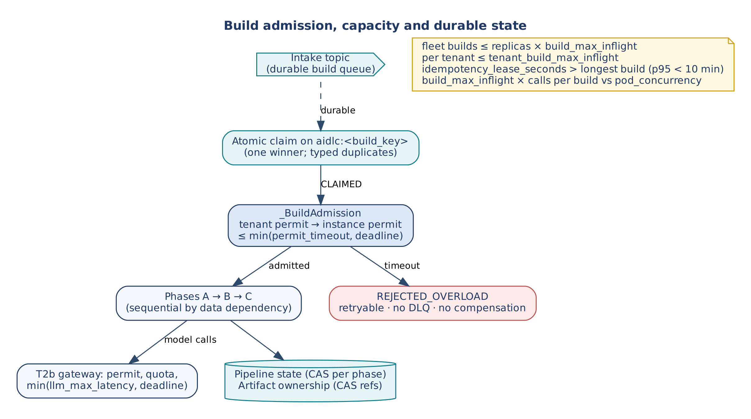
Figure 6 — Build admission, capacity and durable state
Concern | Mechanism | Bound | When saturated
Build queue | T3 intake topic (durable, DLQ, ordered by tenant) | Retention; consumer concurrency | Builds wait durably; the caller already has 202
Build admission | T2 _BuildAdmission (synchronous bounded wait) | build_max_inflight, tenant_build_max_inflight, permit_timeout, deadline | REJECTED_OVERLOAD; claim released; no compensation, no DLQ
Duplicate builds | T3 atomic claim on aidlc:<build_key> | max(idempotency_lease_seconds, deadline + 60 s) | Typed duplicate outcomes, no side effect
Durable phase state | T3 pipeline state, conditional commit | One record per correlation_id | Concurrent writer gets ConcurrencyConflict
Shared artifacts | T3 artifact store, CAS ownership record written by G2C | ≤ 8 CAS attempts | Reference never lost; at most one deletion, once, opt-in
Model quota | T2b permit, quota, min(llm_max_latency, deadline), circuit | Gateway config | Bounded rejection; quota refunded; fails the phase
Completion delivery | T4 webhook and status fan-out after commit | At-least-once | Receivers dedupe on correlation_id

5.7 Vendor mapping
Component | AWS | GCP | Azure
T0 gateway + WAF | API Gateway + WAF | External HTTPS LB + Cloud Armor / Apigee | API Management + Front Door WAF
T1 validation | Lambda | Cloud Run functions | Azure Functions
T2 orchestrator | ECS Fargate service | Cloud Run service | Container Apps
T2b gateway → model | Fargate service → Bedrock (VPC endpoint) | Cloud Run → Vertex AI | Container Apps (KEDA) → Azure OpenAI / AI Foundry
Intake topic | SNS / SQS FIFO | Pub/Sub (ordering key) | Service Bus topic
Pipeline state | DynamoDB conditional writes | Firestore preconditions | Cosmos DB ETag If-Match
Artifact store + ownership CAS | S3 (or DynamoDB item) conditional write | GCS generation precondition | Blob ETag condition
Idempotency and lease store | DynamoDB / ElastiCache | Firestore / Memorystore | Cosmos DB / Azure Cache for Redis
T4 status stream / webhooks | API Gateway WebSocket + Lambda / EventBridge API destination | Cloud Run + Firestore listeners / Cloud Tasks | Web PubSub / Logic Apps HTTP
T5 saga + DLQ | Step Functions + SQS DLQ | Workflows + Pub/Sub DLQ | Durable Functions + Service Bus DLQ
Generated CI/CD target | GitHub Actions + OIDC → ECR/ECS | GitHub Actions + OIDC → Artifact Registry/Cloud Run | GitHub Actions + OIDC → ACR/AKS
Telemetry | CloudWatch + X-Ray | Cloud Monitoring + Trace | Azure Monitor + App Insights

This mapping is vendor-neutral by design; a vendor-specific binding (for example language placement of control plane versus agent plane on one cloud) belongs in a separate companion document, not in this one.

6. Data and Propagation Contracts

6.1 Request — AIDLCPipelineRequest
Field | Meaning
context | P0 ScaffoldRequest (project_name, runtime, build_tool, platform, dependencies, license, include_docker, include_makefile, group_id, artifact_id, project_type, …); embedded verbatim as scaffold in the G2C request.
harness | G2C GeneratorRequest fields (generator_type, agent_name, mandatory_nfrs, abstract_class_source, …).
prompt | user_prompt, system_prompt_additions, domain, class_description; merged into the G2C request.
a2c_sdlc | {enabled, project_type, mandatory_nfrs, target_cloud} — Phase B switch; absent or disabled means Phase B is skipped, not failed.
tenant_id, model_id, critic_model_id | Tenant and per-call model choices (passed through, never config mutations). tenant_id is copied into the G2C request and the dev_request.
deadline | Optional Deadline or seconds; else request_deadline_seconds. Its remaining time is passed to G2C as deadline_ms.
build_key, correlation_id | Written by the orchestrator. generator_key is kept as a deprecated alias of build_key; it is not G2C's generator_key.

6.2 Result — AIDLCPipelineResult
Field | Meaning
success | True only for E2A_VERIFIED and SKIPPED_IDEMPOTENT.
phase_reached | See Table in Section 6.4.
generator_result | G2C GeneratorResult (includes abstract_class_path, abstract_class_generated_fresh, scaffold_result).
dev_request, sdlc_result | A2C input and returned DevRequest (with critic_report, errors).
pipeline_report | BasePipeline report from Phase C.
message_log, failed_keys, errors | Telemetry, failure keys, error messages.
build_key, generator_key (alias), correlation_id, trace_id, latency_ms | Identity and timing (trace_id = correlation_id).

6.3 Durable records
Record | Store | Shape | Written by
PipelineStateRecord | pipeline_state_store (BaseTransactionalStore, collection pipeline_state), key correlation_id | correlation_id, build_key, generator_key (alias), phase, updated_at (TypedDict also declares tenant_id, artifact_pointers, created_at) | __persist_state() after Phase A attempt, Phase A done, Phase B done, Phase C done
Artifact ownership | artifact_store (BaseTransactionalStore), key artifact:<path> | {refs: [G2C generator_key…], created_by: G2C generator_key \| None, deleted: bool} | G2C's DeveloperPlatformWorkflow through _ArtifactRegistryAdapter; released by _delete_abstract_class_if_orphaned()
Idempotency record | idempotency_store, key aidlc:<build_key> (tenant-scoped) | Claim state machine; result {phase_reached} | execute_pipeline()

6.4 phase_reached vocabulary
Value | Meaning | success | Compensation
QUEUED | Initial; also the value if an exception occurs before Phase A completes | — | Unsettled scaffold, inherited class, this build's reference
G2C_P0_DONE | Phase A succeeded | — | Keep scaffold and classes; release this build's reference
A2C_DONE | Phase B succeeded | — | Revert staged A2C commit; release reference
E2A_VERIFIED | Phase C passed | True | —
FAILED_G2C_P0 | Phase A reported failure | False | As QUEUED
FAILED_A2C | Phase B requested but impossible (no dev_request), invalid, or returned errors | False | Delete A2C artifacts, revert branch, release reference
SKIPPED_IDEMPOTENT | Claim REPLAY | True | none
SKIPPED_IN_PROGRESS | Claim IN_PROGRESS | False | none
REJECTED_CONFLICT | Claim CONFLICT | False | none
RECOVERY_REQUIRED, FAILED_FINAL | Claim outcomes | False | none
REJECTED_INVALID | A requested phase cannot run; checked before the claim | False | none
REJECTED_OVERLOAD | Admission timeout | False | none

6.5 Propagation fields
Field | Origin | Purpose here
correlation_id | T1 validate(), else minted | Joins logs across phases; claim owner; state key; trace_id.
tenant_id | JWT at T0 | Claim scope, admission fairness, object-store prefix, repository namespace.
build_key | __generate_key() = project_name:runtime:build_tool:platform | Business idempotency key, claimed as aidlc:<build_key>; identity in failed_keys and the DLQ.
G2C generator_key | G2C (name:type:runtime:platform) | Artifact ownership identity; claimed by G2C as g2c:<key>.
io_config | config['io_config'] | Passed to the governance gate.
message_log, failed_keys | Empty per build | Live build console; saga input.
deadline | Request or request_deadline_seconds | Checked before each phase; bounds admission and the claim lease; passed to G2C as deadline_ms.
trace_context | W3C traceparent at T0 | Correlates phases in the tracing backend.

6.6 Configuration
Key | Default | Used by
idempotency | True | Enables the claim step.
idempotency_store | — | BaseIdempotencyStore for claims.
idempotency_lease_seconds | 300 | Claim lease. With a deadline the lease is max(configured, deadline remaining + 60); without one, raise it above the longest build (full pipeline p95 < 10 min).
pipeline_state_store | — | BaseTransactionalStore for phase state.
artifact_store | — | BaseTransactionalStore for ownership records; bind only if it offers atomic conditional writes. Handed to G2C as config['artifact_registry'] through _ArtifactRegistryAdapter.
compensation_delete_orphan_abstract | False | Allows the compensator to delete an orphaned shared abstract class (creating build only).
a2c_validation_service | DevPlatformValidationService() | Validates the dev_request before Phase B.
governance_engine, observability_engine, llm_service | — | E2A engines and the inference gateway.
static_pipeline | AIDLCStaticPipeline() | Phase C implementation.
saga_compensator | AIDLCSagaCompensator() | Compensation implementation.
build_max_inflight, tenant_build_max_inflight | 4, 2 | Admission caps.
permit_timeout | 5.0 s | Admission wait (shared key with the gateway permit).
request_deadline_seconds | 0 (none) | Deadline origin.
dlq_queue_url | — | DLQ dispatch.
io_config | {} | Governance gate input.

7. Low-Level Design — Class Model

7.1 Classes this profile adds
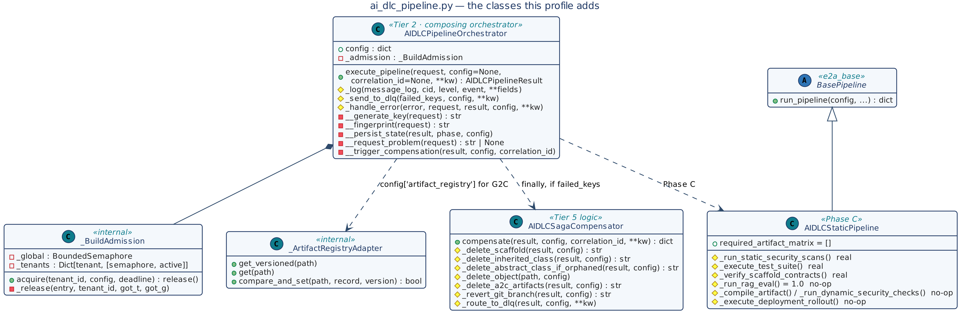
Figure 7 — The classes this profile adds
Class | Status | Role
AIDLCPipelineOrchestrator | Implemented | Tier 2 composing orchestrator; single entry point execute_pipeline().
_BuildAdmission | Implemented (internal) | Per-tenant and per-instance build permits with bounded wait.
_ArtifactRegistryAdapter | Implemented (internal) | Presents artifact_store as the registry G2C expects, in the AI-DLC record schema.
AIDLCStaticPipeline | Implemented | BasePipeline subclass for Phase C; three real stages, four no-ops.
AIDLCSagaCompensator | Implemented with hooks | Phase-aware compensation; reference release and opt-in, creator-only orphan deletion by CAS.
AIDLCPipelineRequest, AIDLCPipelineResult, PipelineStateRecord | TypedDict | Data contracts.

7.2 Dependencies
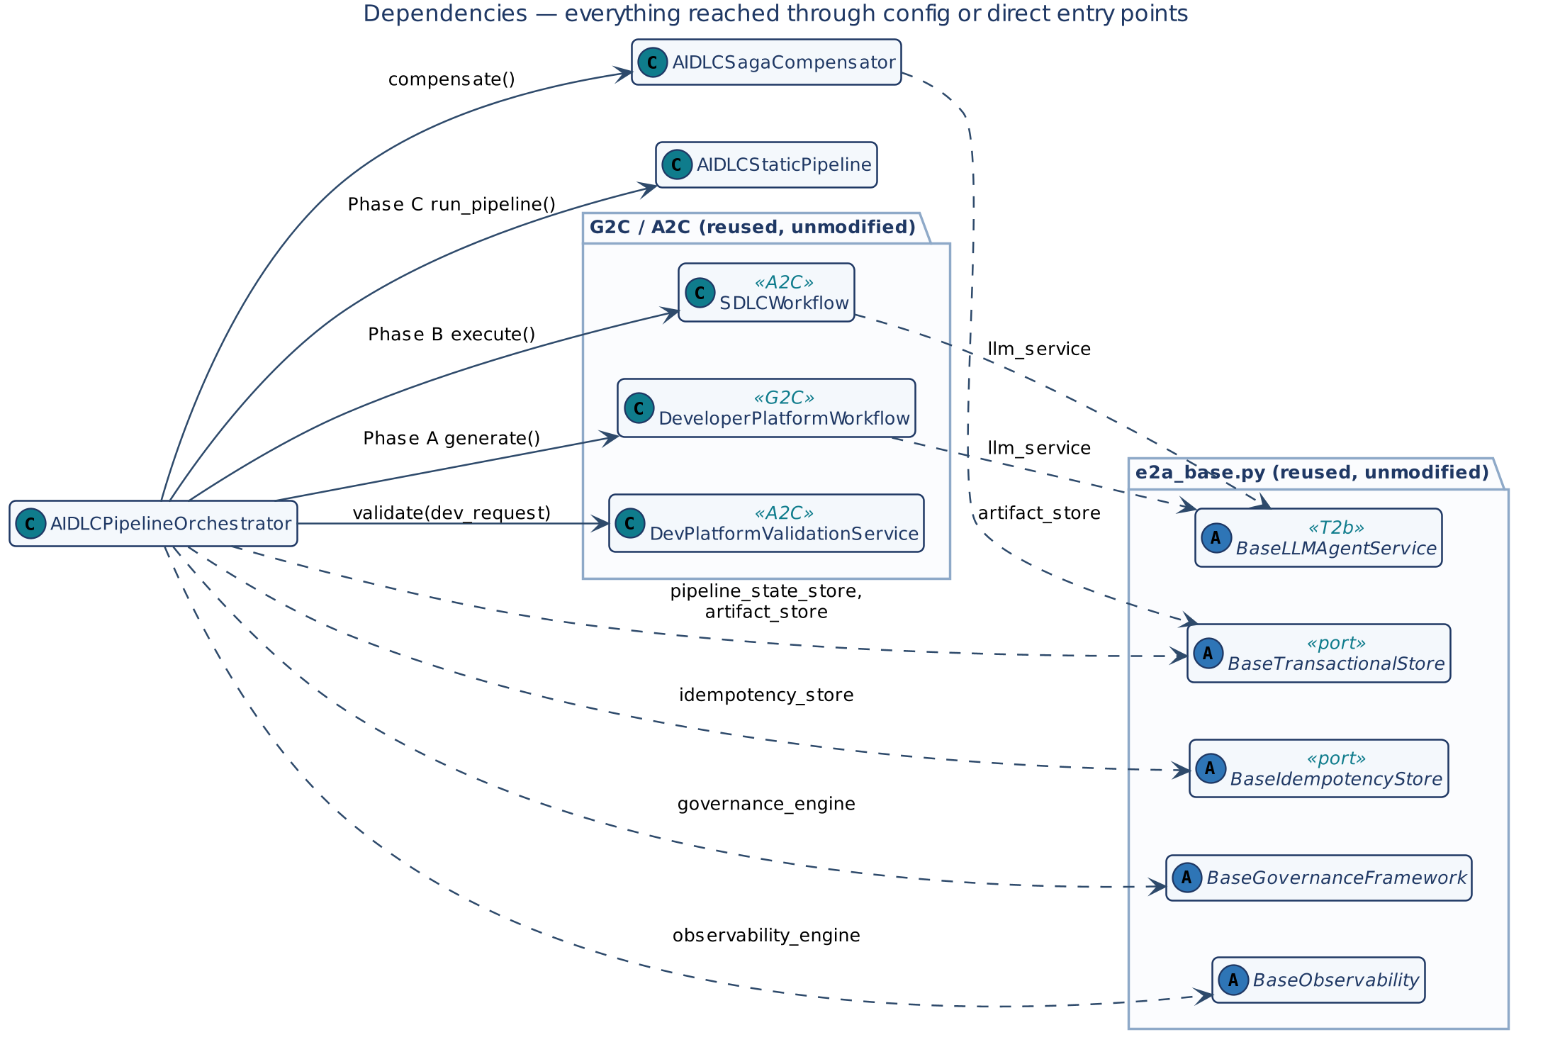
Figure 8 — Dependencies reached through config or direct entry points

7.3 Data contracts
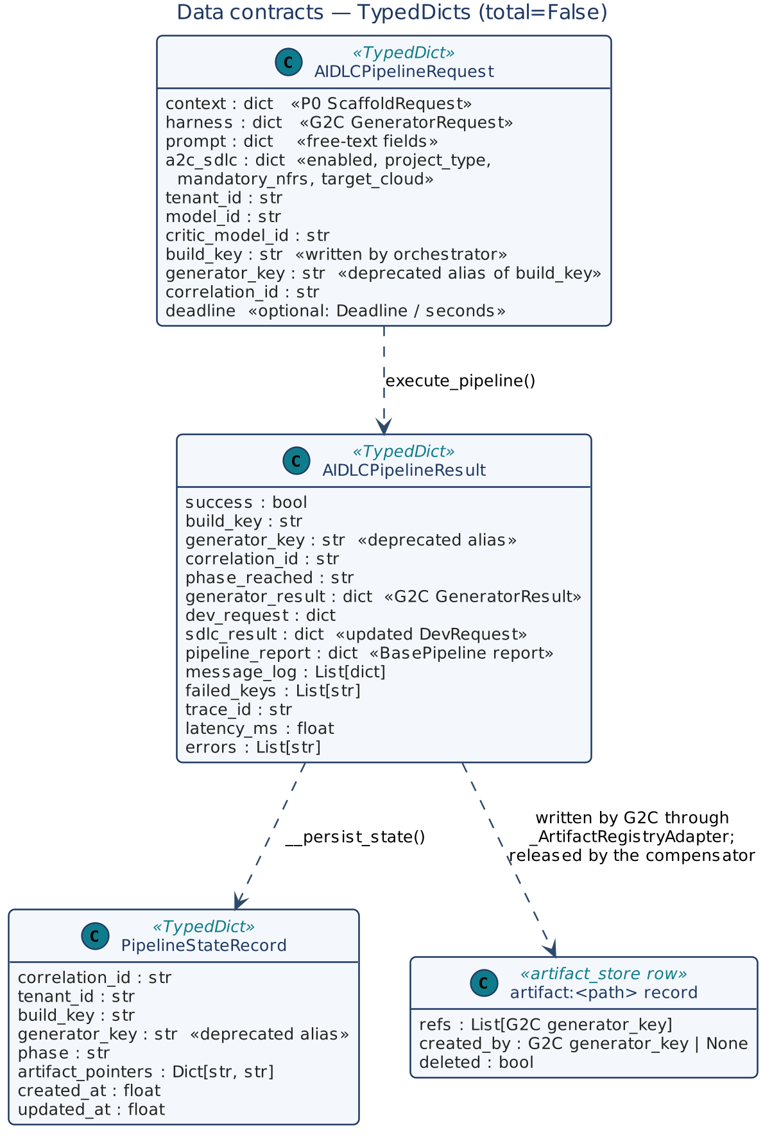
Figure 9 — TypedDicts and the artifact ownership record

8. Low-Level Design — Class Contracts

8.1 AIDLCPipelineOrchestrator
Aspect | Detail
Stereotype | Tier 2 composing orchestrator; plain class (not an ABC) — subclass only at the request/config level
State | config (default config), _admission (one _BuildAdmission per instance)
Collaborators | DeveloperPlatformWorkflow, SDLCWorkflow, DevPlatformValidationService, AIDLCStaticPipeline, AIDLCSagaCompensator, _ArtifactRegistryAdapter; stores and engines from config
Invariants | INV-01 to INV-12

Table 1 — AIDLCPipelineOrchestrator methods
Method | Kind | Signature → returns | Contract
execute_pipeline | entry | (request, config=None, correlation_id=None, **kw) → AIDLCPipelineResult | Fixed sequence (Section 9.1): resolve IDs, build key, tenant, deadline → request check (REJECTED_INVALID) → governance gate → claim aidlc:<build_key> (typed short-circuits) → admission → Phase A → Phase B (conditional, validated) → Phase C → E2A_VERIFIED. AdmissionTimeout → REJECTED_OVERLOAD; other exceptions → failed_keys, errors. finally: release slot; if failed_keys: DLQ + compensation; settle claim (complete on success, else retryable fail); telemetry; latency. Never raises.
_log | helper | (message_log, cid, level, event, **fields) | Structured log entry.
_send_to_dlq | helper | (failed_keys, config, **kw) | Dispatch to dlq_queue_url.
_handle_error | default | (error, request, result, config, **kw) | Log and append to result['errors'].
__generate_key | template | (request) → str | build_key: project_name:runtime:build_tool:platform from context (? for missing parts).
__fingerprint | template | (request) → str | SHA-256 of context and a2c_sdlc.
__persist_state | template | (result, phase, config) | Read version, put_if_version the record; not committed → ConcurrencyConflict. No-op without a store.
__request_problem | template | (request) → str \| None | Returns a message when a2c_sdlc.enabled and harness.generator_type is not e2a_inherited or a2c_inherited; the build then ends as REJECTED_INVALID before the claim.
__trigger_compensation | template | (result, config, correlation_id) | config['saga_compensator'] or default → compensate().

Phase A request construction: g2c_request = harness ∪ {scaffold: context} ∪ prompt, plus tenant_id and deadline_ms (the deadline's remaining time). When artifact_store is bound, g2c_config['artifact_registry'] is an _ArtifactRegistryAdapter over it, so G2C registers shared-class references in the build's own store; the orchestrator registers nothing itself. When a2c_sdlc.enabled, g2c_config['a2c'] = {enabled, project_type, mandatory_nfrs, target_cloud ('aws' default), context: prompt.user_prompt} so P0's bootstrap() builds the dev_request inline. Phase B reads generator_result.scaffold_result.dev_request. If A2C is enabled and there is none, the build ends as FAILED_A2C. Otherwise the request gets the build's tenant_id, is validated by a2c_validation_service (default DevPlatformValidationService, failure → FAILED_A2C), and SDLCWorkflow.execute() receives a deep copy.

8.2 _BuildAdmission
Table 2 — _BuildAdmission methods
Method | Signature → returns | Contract
acquire | (tenant_id, config, deadline=None) → release() | Lazily create the instance semaphore (build_max_inflight); per-tenant semaphore (tenant_build_max_inflight). Total wait ≤ min(permit_timeout, deadline): tenant permit first, then instance permit; either timeout → AdmissionTimeout after releasing what was taken. Returns a zero-argument release function.
_release | (entry, tenant_id, got_t, got_g) | Release held permits; decrement the tenant's active count; evict idle tenant entries once the table exceeds 1,024.

8.3 AIDLCStaticPipeline
run_pipeline() is inherited from BasePipeline and never overridden; this subclass only fills the seven stage hooks.
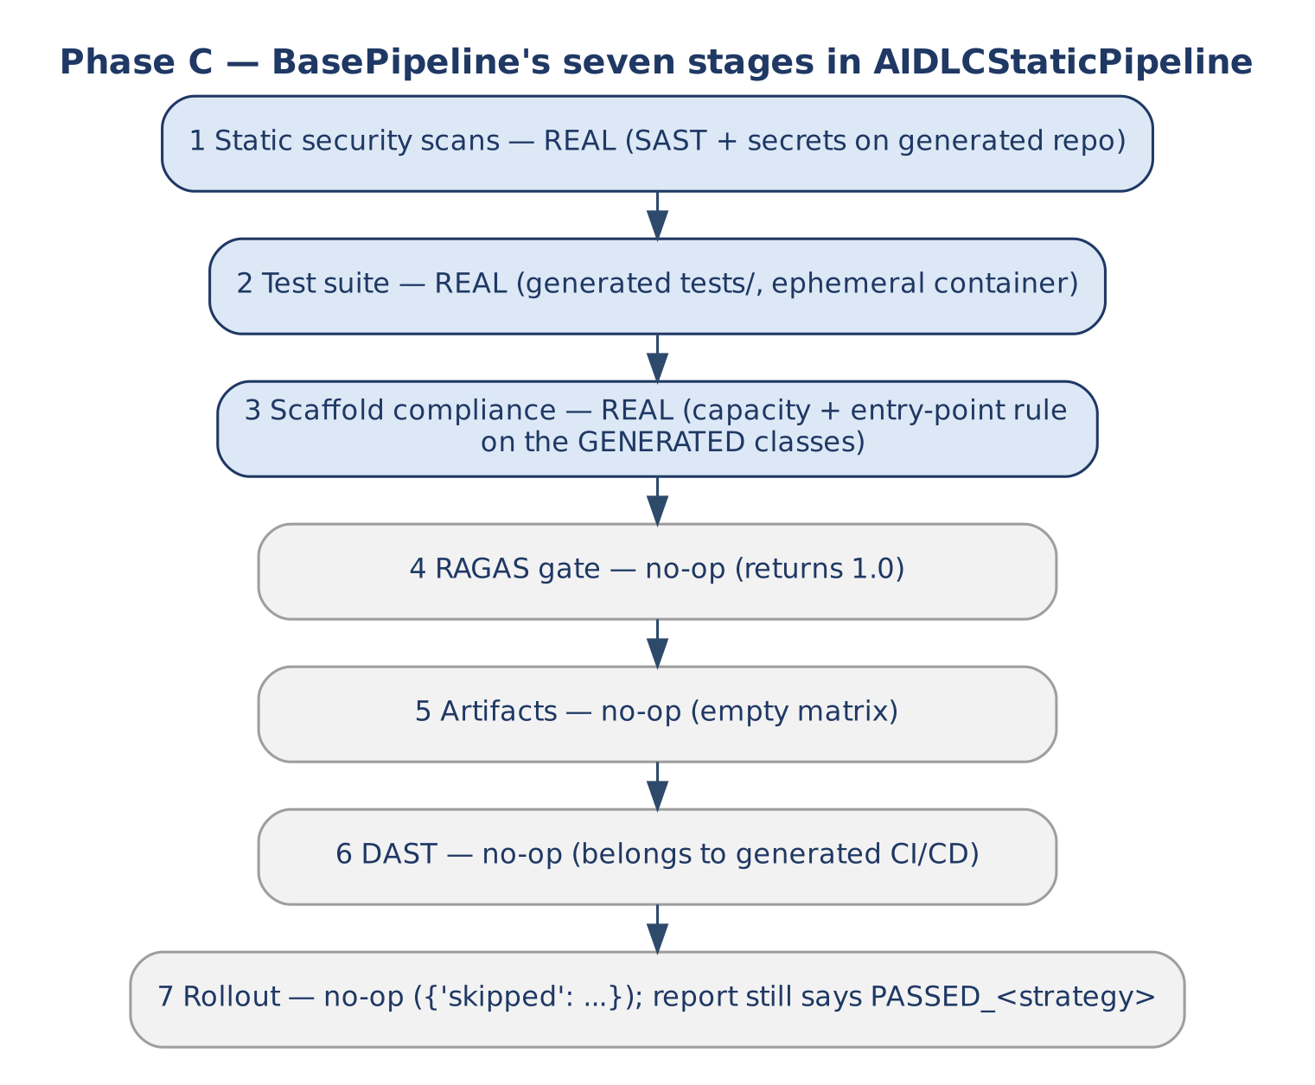
Figure 10 — Phase C stages: three real, four no-ops
Table 3 — AIDLCStaticPipeline stage hooks
Hook | Reference behaviour | Deployment duty
_run_static_security_scans | True | SAST and secret detection on the generated repository in the object store.
_execute_test_suite | True | Run the generated project's tests/ in an ephemeral build container.
_verify_scaffold_contracts | True | Since v1.2 the base default runs the e2a.conformance rules over conformance_paths (findings in self.conformance_findings); it no longer requires one public method per class.
_run_rag_eval | 1.0 | No-op — no RAG on this profile's path.
_compile_artifact | True | No-op — required_artifact_matrix is empty.
_run_dynamic_security_checks | True | No-op — DAST belongs to the generated CI/CD.
_execute_deployment_rollout | {'skipped': …} | No-op — no live deploy.

> Reading the report BasePipeline still records artifact_compilation, dynamic_security and deployment_rollout = PASSED_<strategy> for the no-op stages. Consumers must treat only static_security, test_execution and scaffold_compliance as meaningful for this profile. The capacity check inside stage 3 (validate_capacity()) runs against the pipeline's own config.

8.4 AIDLCSagaCompensator
Aspect | Detail
Stereotype | Tier 5 compensation logic; single public method compensate()
Scope | Only artifacts this build produced; never the output of a step whose claim settled as succeeded; a shared abstract class only through the CAS ownership protocol

Table 4 — AIDLCSagaCompensator methods
Method | Kind | Signature → returns | Contract
compensate | entry | (result, config=None, correlation_id=None, **kw) → dict | By phase_reached: QUEUED/FAILED_G2C_P0 → delete the scaffold only if P0 did not succeed, delete the inherited class, release the reference; G2C_P0_DONE → keep scaffold and classes, release the reference; FAILED_A2C → delete A2C artifacts, revert branch, release the reference; A2C_DONE → revert branch, release the reference. Always _route_to_dlq(). Returns {phase_compensated, actions}.
_delete_abstract_class_if_orphaned | template | (result, config) → str | CAS loop (≤ 8): remove this build's key — G2C's generator_key — from refs. Orphan = compensation_delete_orphan_abstract is set, refs empty, created_by equals this build's key, not yet deleted; deleted is committed in the same write and only the committing caller calls _delete_object(). Returns abstract_class_orphan_deleted, abstract_reference_released or abstract_class_untouched (no record, or this build holds no reference); exhausted retries → ConcurrencyConflict.
_delete_object | hook | (path, config) | Delete from the object store.
_delete_scaffold, _delete_inherited_class, _delete_a2c_artifacts, _revert_git_branch | hook | (result, config) → str | Object-store deletes under the build_key prefix; Git branch revert. Reference bodies return action names.
_route_to_dlq | default | (result, config, **kw) | Dispatch the failed build_key.

> Deleting shared bases Deletion is off by default. A deleted shared base makes later replays of the same G2C key point at a missing file; G2C and P0 then return recovery_required rather than a false success, and a new project in the same tenant gets that result for the base until its claim record is reconciled (Section 14, O-11).

8.5 Reused contracts
Class | Entry point used | Notes
DeveloperPlatformWorkflow (G2C) | generate(request, config) → GeneratorResult; constructed with config= | Must embed scaffold so P0 runs inline and idempotently; claims g2c:<key>; registers shared-class references in config['artifact_registry']; returns success, generator_key, abstract_class_path, abstract_class_generated_fresh, scaffold_result.
BaseProjectBootstrapper (P0) | bootstrap() — inline only | Claims p0:<key>; builds dev_request (Step 16) with tenant_id and project_root when config['a2c'].enabled.
SDLCWorkflow (A2C) | execute(dev_request, config) → DevRequest | Claims a2c:<key>; writes into the P0 workspace; returns critic_report and errors.
DevPlatformValidationService (A2C) | validate('SDLCWorkflow', dev_request, config, correlation_id=…) | Gate before Phase B; failure ends the build as FAILED_A2C.
BasePipeline (E2A) | run_pipeline(config, correlation_id, message_log, failed_keys) | Shares the build's message_log and failed_keys.
BaseIdempotencyStore | claim, complete, fail | Tenant-scoped claim on aidlc:<build_key>.
BaseTransactionalStore | get_versioned, put_if_version | Phase state and artifact ownership.
BaseGovernanceFramework | enforce_governance_gate(request, io_config, config, …) | Agentic form — capacity, budget, firewall on prompt fields.
BaseObservability | record_telemetry(message_log, cid, config, tenant_id) | One trail per build.
BaseLLMAgentService | via config['llm_service'] inside G2C and A2C | Shared quota across builds.

9. Dynamic Behaviour

9.1 execute_pipeline() internals
Figure 5 shows the end-to-end path across tiers; Figure 11 shows the orchestrator's own sequence, including every early return and the order of the finally block.
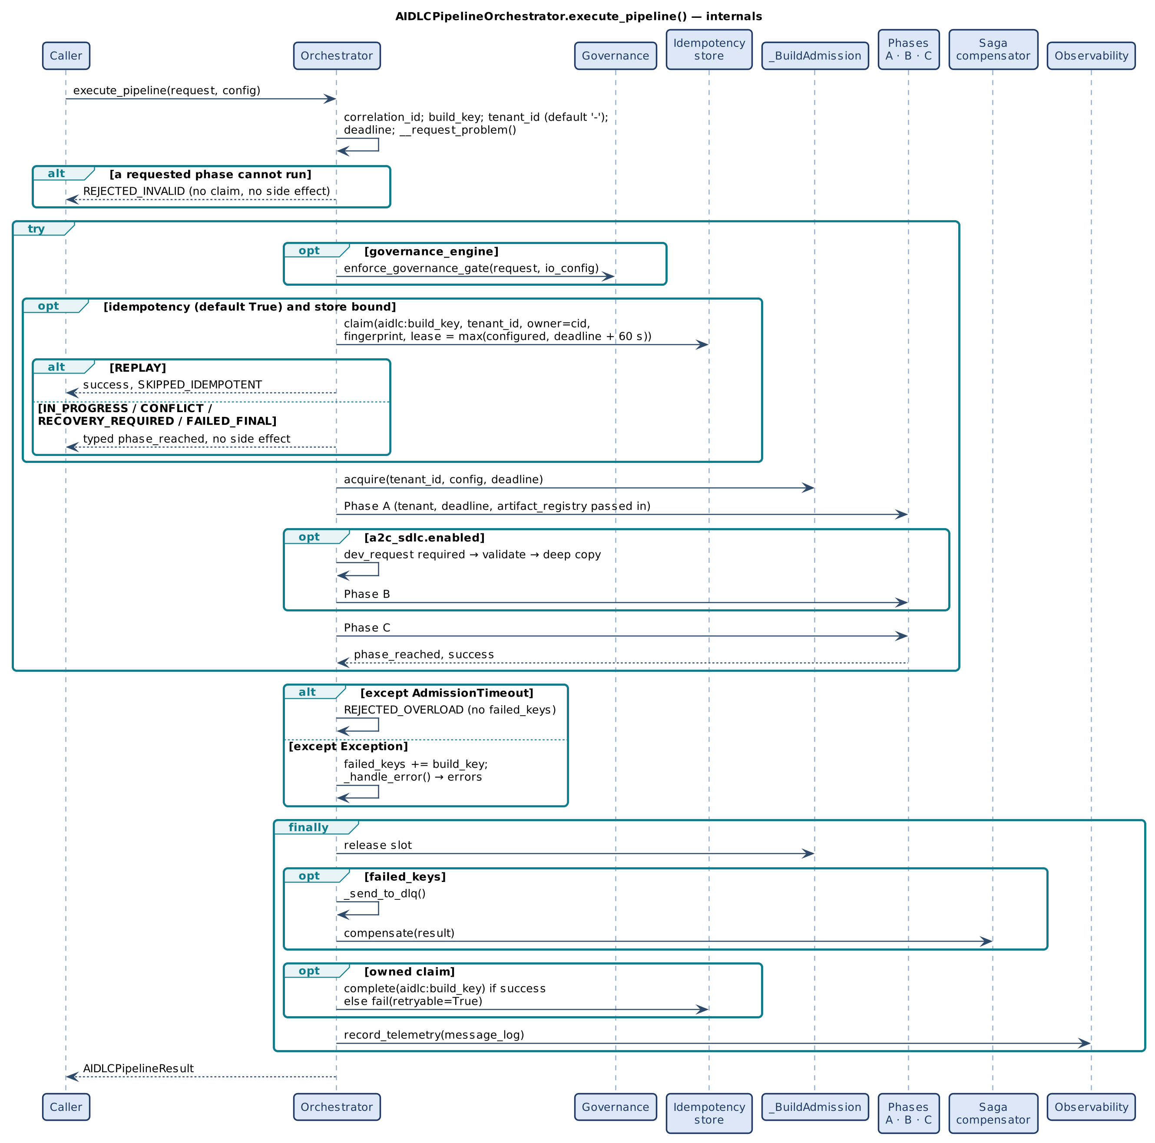
Figure 11 — execute_pipeline() internals

9.2 Phase state machine
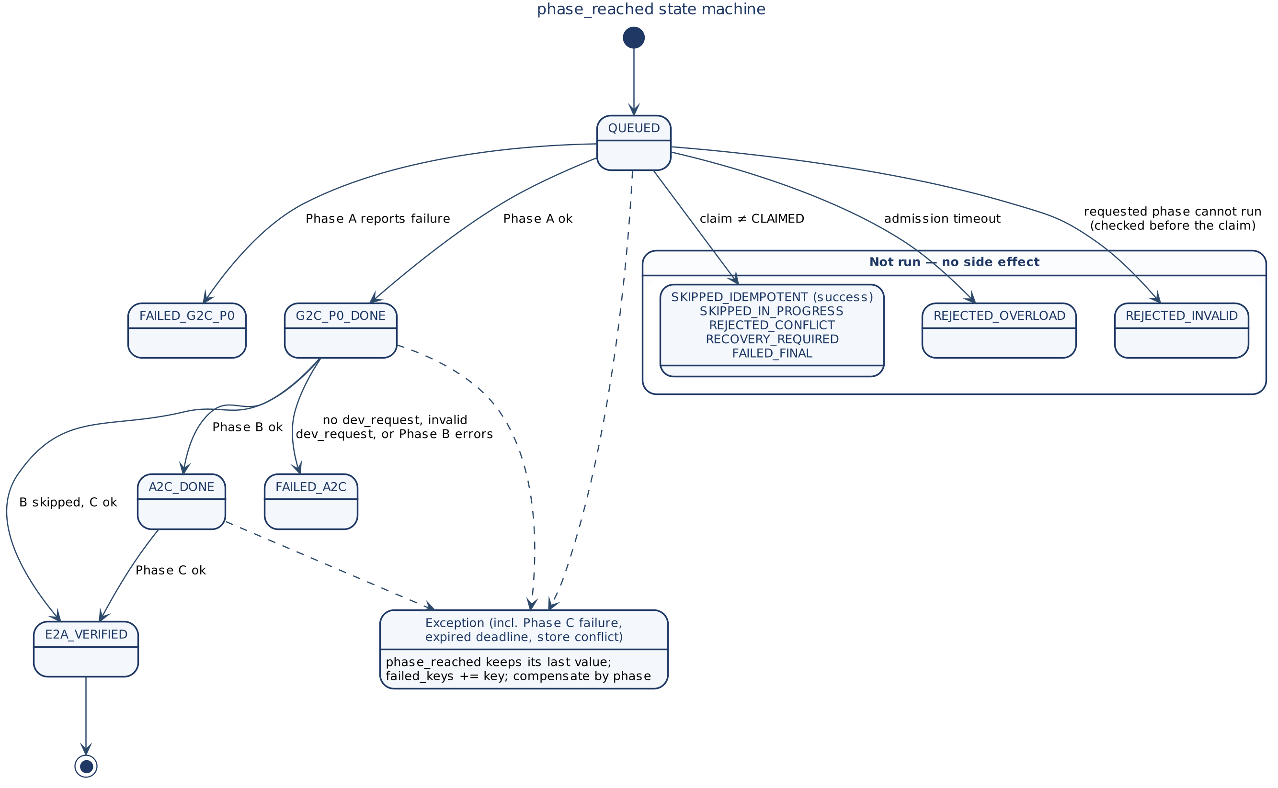
Figure 12 — phase_reached state machine

9.3 Duplicates and overload
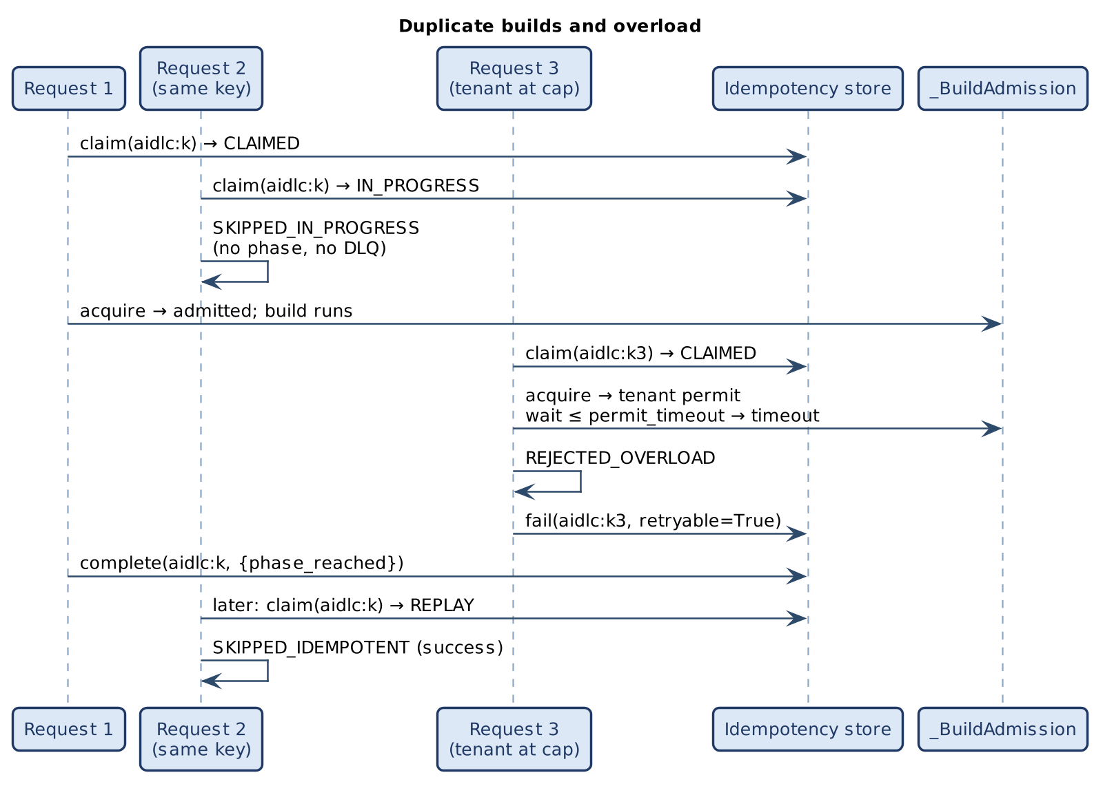
Figure 13 — Duplicate builds and overload
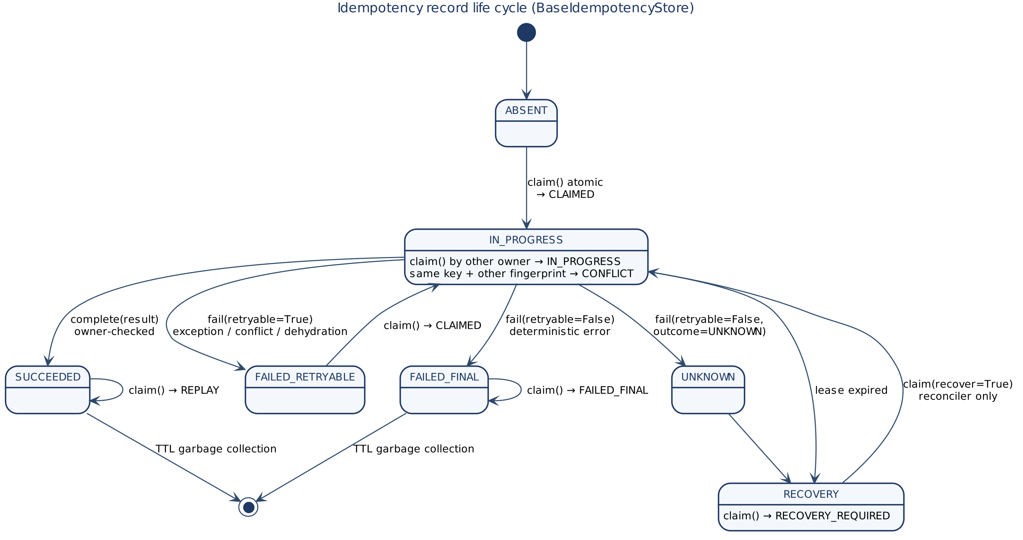
Figure 14 — Idempotency record life cycle (shared contract)

9.4 Compensation
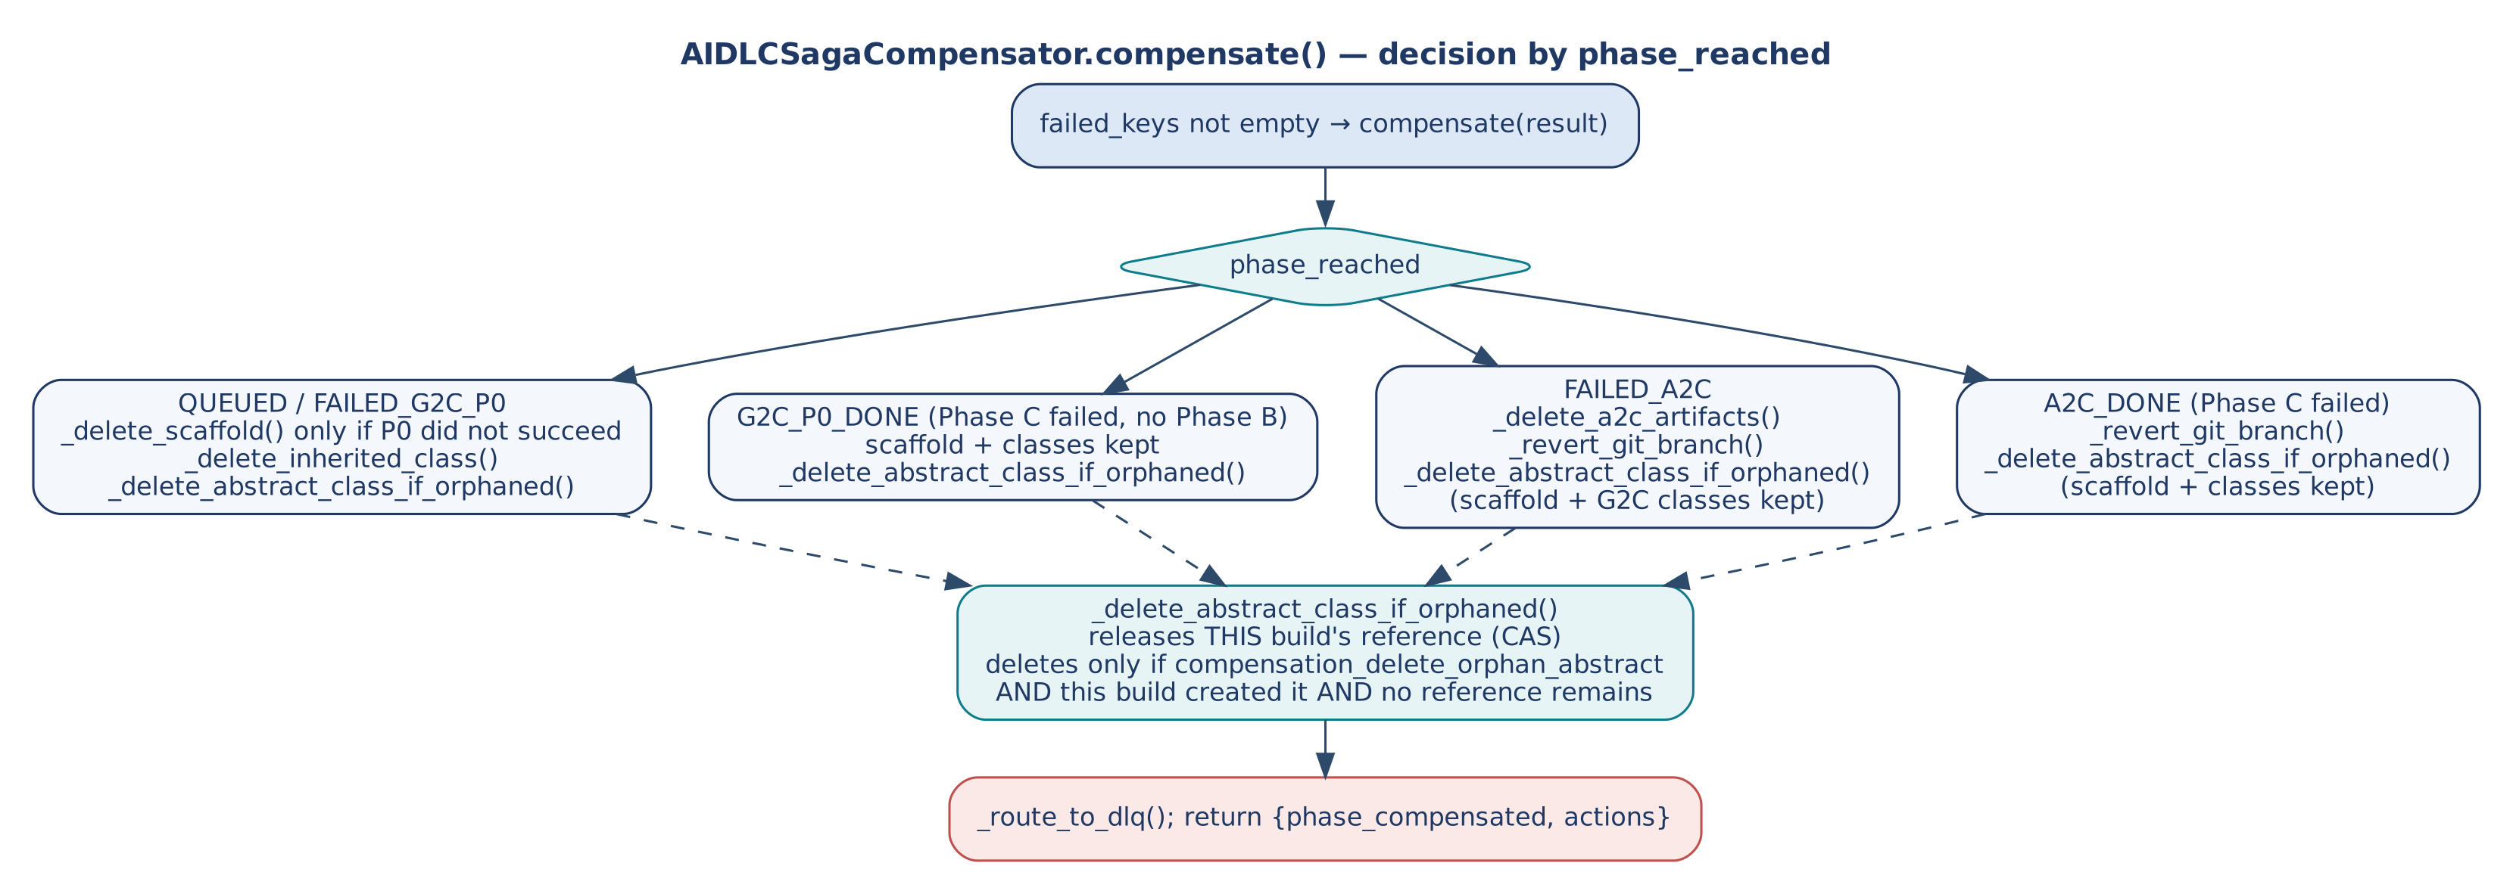
Figure 15 — Compensation decision by phase

9.5 Shared artifact ownership
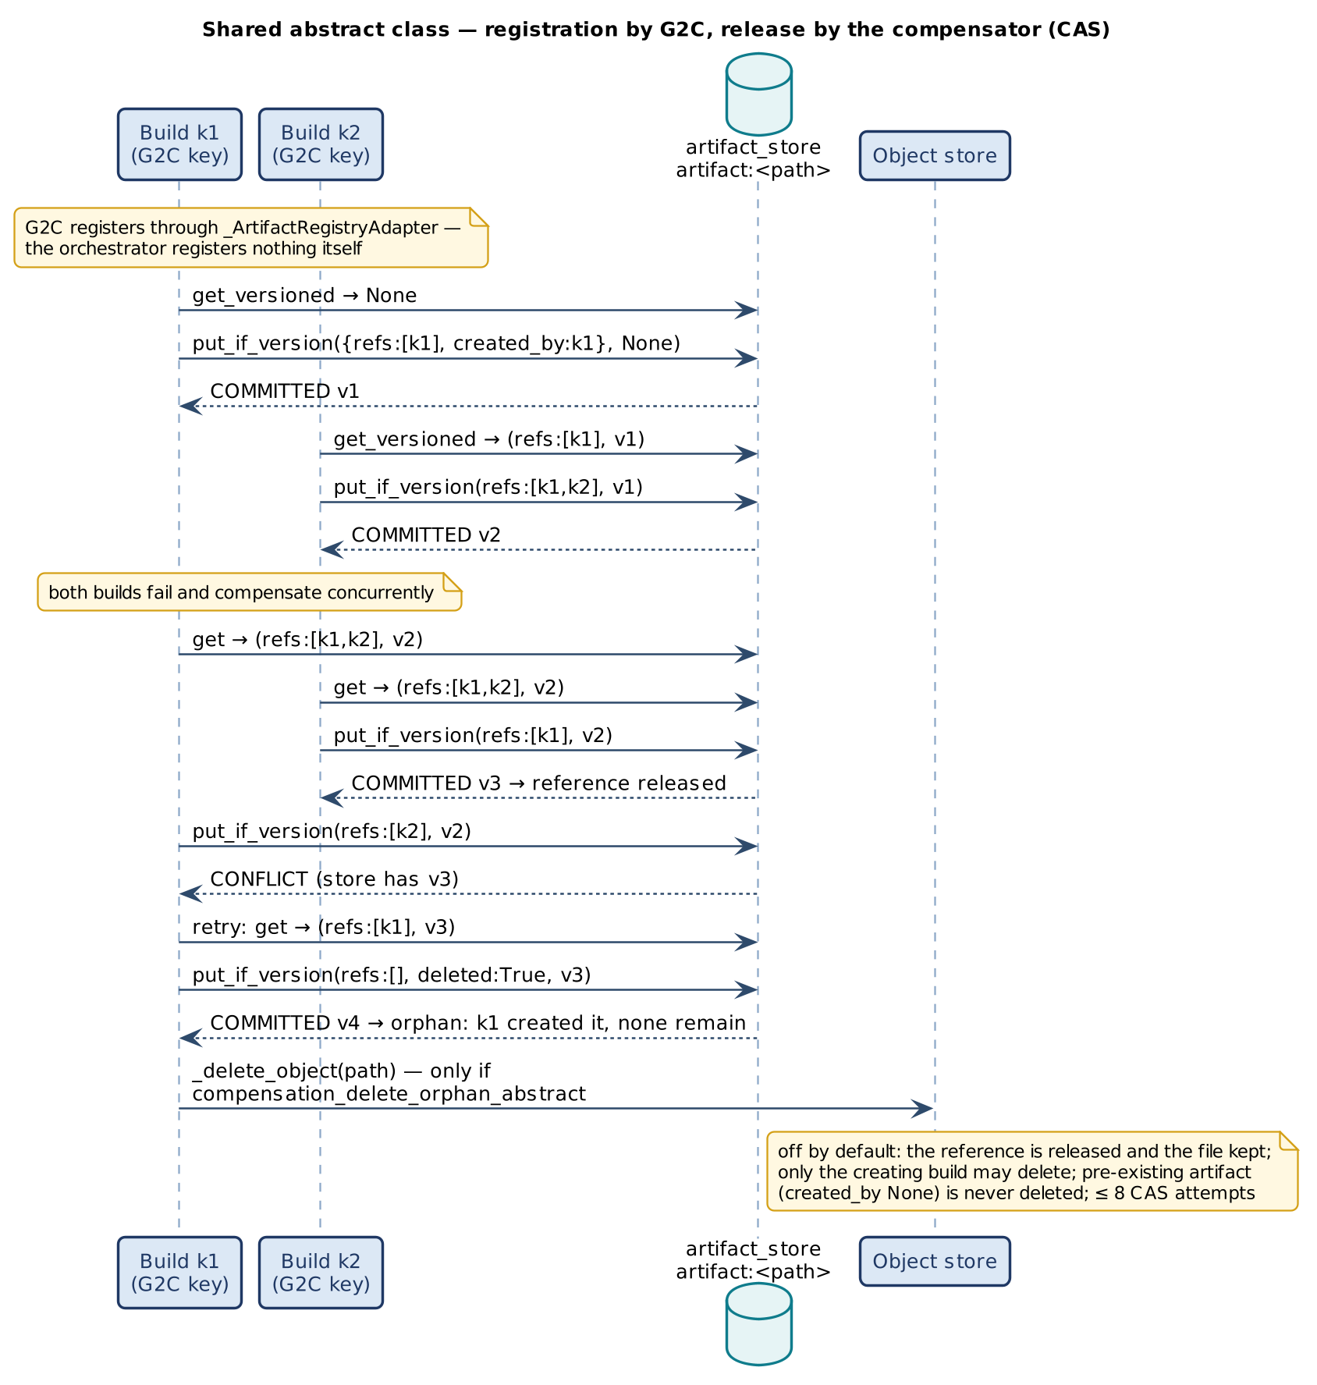
Figure 16 — Reference registration and orphan deletion by compare-and-set

10. Concurrency and Saga Model

10.1 Risk ownership
Risk | Owner | Mechanism
Duplicate builds | Orchestrator + BaseIdempotencyStore | Atomic claim on aidlc:<build_key>; typed outcomes.
Claim collisions across frameworks | Namespaced keys | aidlc:, g2c:, p0:, a2c:.
A requested phase that cannot run | __request_problem(), Phase B guard | REJECTED_INVALID or FAILED_A2C; never a silent skip.
Changed request under a known key | __fingerprint() | REJECTED_CONFLICT.
Tenant monopolising capacity | _BuildAdmission | Per-tenant cap with bounded wait.
Instance overload | _BuildAdmission | Per-instance cap; overload rejected, not queued.
Lost phase progress | __persist_state() | Durable, conditional phase record.
Two builds on one shared artifact | Artifact ownership record (G2C writes, compensator releases) | CAS reference counting; single, opt-in deleter.
Shared model quota | T2b gateway | Bounded permits and quota, refund.
Lost worker | Claim lease | RECOVERY_REQUIRED; reconciler decides.

10.2 What compensation preserves
Artifact | When this build fails | Why
Scaffold whose P0 step did not succeed; inherited class of a failed generation (QUEUED, FAILED_G2C_P0) | Deleted | Partial output of an invalid build.
Scaffold that P0 reported as succeeded | Kept | A settled claim would replay a path that no longer exists.
Scaffold and classes when Phase C fails with no Phase B (G2C_P0_DONE) | Kept | Valid, replayable output; only the reference is released.
Scaffold and G2C classes (FAILED_A2C, A2C_DONE) | Kept | Valid on their own — the smaller deliverable.
A2C files (FAILED_A2C) | Deleted with the ephemeral branch | Uncommitted output of the failed phase.
Staged A2C commit (Phase C failed after A2C) | Reverted | Rejected by verification.
Shared abstract class still referenced | Kept | A sibling depends on it.
Shared abstract class, no references, created here, deletion enabled | Deleted exactly once | Orphaned by the creating build as last referrer.
Shared abstract class, no references, deletion not enabled (default) | Kept; reference released | Deleting a base that settled claims point at leaves them replaying a missing file.
Pre-existing abstract class (created_by None) | Kept | Not this system's to delete.
Artifacts of completed builds | Kept | Completed builds keep their reference; a failed build releases only its own.
Overload / duplicate / conflict outcomes | Nothing to do | No side effect occurred.

10.3 Error routing
__request_problem() returns REJECTED_INVALID before the claim. AdmissionTimeout is caught first and is overload, not failure. Non-CLAIMED claims return before any phase. Everything else — G2C or A2C failure, a missing or invalid dev_request (FAILED_A2C), Phase C failure (raised as ValueError with the report's error), an expired deadline (DeadlineExceeded at a phase boundary), a ConcurrencyConflict from the state or artifact store — appends generator_key to failed_keys, is dead-lettered and compensated by phase. The claim is then settled retryable, so a corrected retry starts from a clean slate.

11. Non-Functional Design

11.1 Latency budgets
Budget | Target (p95) | Notes
T0/T1 synchronous | < 300 ms | 202 Accepted; the UI never blocks beyond this.
Phase A (G2C + P0) | < 3 min | Two generator LLM calls plus scaffold writes.
Phase B (A2C) | < 6 min | Five sequential agent calls; dominant cost.
Phase C | < 1 min | No LLM; static scans and tests.
Minimal pipeline | < 4 min | G2C + P0 + verification.
Full pipeline | < 10 min | Includes one critic retry as the expected case.
Critic retry ceiling | 2 per gate | Same as the G2C and A2C critics.

11.2 Capacity sizing
Fleet build capacity = replicas × build_max_inflight; per-tenant capacity = tenant_build_max_inflight; size both against peak simultaneous builds, not request rate. Admitted builds multiply into model calls: build_max_inflight × concurrent calls per build must fit the gateway's pod_concurrency and the provider quota, because the quota is shared by every build. Gateway pods = peak in-flight LLM calls ÷ per-pod semaphore (Little's Law); autoscale on in-flight > 25 or backlog > 100 (min 3, max 60). With a deadline the claim lease is at least the deadline plus 60 s; without one, idempotency_lease_seconds must exceed the longest expected build, because the 300 s default is too short for a full pipeline.

11.3 Security
Control | Where
Developer identity and tenant | JWT at T0.
Repository entitlement | _enforce_entitlement_gate() at T1 (create-repository rights).
Prompt injection | T0 rule group on free-text fields; governance semantic firewall; gateway sanitiser.
Model credentials | Only at T2b.
Generated source and secrets | Perimeter object store with no DMZ/internet route.
Git access | Only from T5 through allow-listed egress.
Generated code quality | Critics (≥ 0.75) and Phase C static scans and contract checks.

11.4 Observability
One message_log per build, streamed live to the developer through T4 and shipped once to record_telemetry(). Key events: pipeline_skipped_idempotent, pipeline_duplicate (with claim status), pipeline_rejected_overload (WARN), pipeline_rejected_invalid (WARN), phase_a_complete (success), phase_b_complete (critic score), plus the static pipeline's stage events and the gateway's inference events under the same correlation_id.

12. Extension Guide
- Bind stores: an idempotency_store, a pipeline_state_store and an artifact_store with atomic conditional writes (otherwise leave artifact_store unbound — G2C then keeps its own in-memory registry and the saga never touches the shared abstract class).
- Set a deadline on every request, or raise idempotency_lease_seconds above the longest expected build.
- Subclass AIDLCStaticPipeline to implement real SAST/secret scanning, generated-test execution and contract verification against the object store.
- Subclass AIDLCSagaCompensator to implement object-store deletes (_delete_scaffold, _delete_inherited_class, _delete_a2c_artifacts, _delete_object) and _revert_git_branch. Leave compensation_delete_orphan_abstract unset unless a reconciler for recovery_required replays exists (Section 14, O-11).
- Pass both through config (static_pipeline, saga_compensator); never override execute_pipeline() or run_pipeline().
- Bind E2A engines (governance_engine, observability_engine) and the inference gateway (llm_service) used by G2C and A2C.
- Host the orchestrator behind a push subscription on the intake topic; host the status stream and webhook dispatch in T4; implement the saga engine in T5.
class RepoCompensator(AIDLCSagaCompensator):
def _delete_object(self, path, config): object_store.delete(path)
def _delete_scaffold(self, result, config): object_store.delete_prefix(f"{result['build_key']}/scaffold/"); return 'scaffold_deleted'
def _revert_git_branch(self, result, config): git.delete_branch(result['correlation_id']); return 'git_branch_reverted'

config = {'idempotency_store': idem, 'pipeline_state_store': state, 'artifact_store': artifacts,
'static_pipeline': RepoStaticPipeline(), 'saga_compensator': RepoCompensator(),
'llm_service': gateway, 'governance_engine': gov, 'observability_engine': obs,
'idempotency_lease_seconds': 1200}
result = AIDLCPipelineOrchestrator(config).execute_pipeline(request, config)

13. Verification
Two suites cover the profile. smoke_test_aidlc_concurrency.py in e2a-framework passes 26 checks with G2C and A2C stubbed to the real contracts. smoke_test_aidlc_integration.py in a2c-framework passes 15 checks against the real G2C, P0 and A2C modules. Both use in-memory stores and a deterministic template mode, with no live gateway, store or load. Gateway behaviour is proven in the core smoke tests.
ID | Scenario | Evidence
T-13 | Six concurrent duplicates → one build; five SKIPPED_IN_PROGRESS; winner verified | smoke_test_aidlc_concurrency.py
T-13 | Later duplicate → SKIPPED_IDEMPOTENT, nothing rebuilt | smoke_test_aidlc_concurrency.py
— | Failed build is retryable and the retry succeeds | smoke_test_aidlc_concurrency.py
T-14 | One ownership record under G2C's identity; a failed build releases its reference; a referenced base is not deleted | smoke_test_aidlc_concurrency.py
T-14 | By default the creator releasing last keeps the file; with deletion enabled it deletes once; a non-creator never deletes; racing releases delete at most once | smoke_test_aidlc_concurrency.py
— | Admission: tenant over cap rejected within bound; slot reusable; other tenant unaffected | smoke_test_aidlc_concurrency.py
— | Overload → REJECTED_OVERLOAD, no failed keys; claim released; retry succeeds | smoke_test_aidlc_concurrency.py
T-10 | Expired deadline → no build started | smoke_test_aidlc_concurrency.py
X-1 | A2C requested with an abstract-only harness → REJECTED_INVALID, nothing runs | both suites
X-2 | tenant_id and deadline_ms reach the G2C request; the tenant reaches P0 and A2C | both suites
X-3 / X-8 | dev_request validated, carries the tenant; A2C runs on a copy, so the build result is not enriched | both suites
X-4 | Build claim is aidlc:<key>; inner claims are g2c:, p0:, a2c: and do not collide | both suites
X-7 | Build lease outlives the deadline | smoke_test_aidlc_concurrency.py
X-11 | Phase C failure after Phase A releases the reference, keeps scaffold and classes; with deletion enabled the sole creator deletes the orphaned base once | both suites
— | End to end: build reaches E2A_VERIFIED; P0 ran inline; A2C artifacts are in the P0 workspace; one ownership record written by G2C | smoke_test_aidlc_integration.py
— | Retry of the same build replays outputs that still exist; a new project never replays a deleted shared base (typed recovery_required) | smoke_test_aidlc_integration.py
T-04 / T-10 | Gateway permit/quota bounds; cancellation releases permits and refunds quota | smoke_test_concurrency.py (gateway)
— | Fleet build burst; crash mid-build then reconciliation | load environment (not claimed)

Recommended additions: two tenants with the same project do not share artifact ownership (O-2); requests without tenant_id are rejected (O-3).

14. Implementation Reality, Gaps and Design Observations
Table 5 records every observation with its current status. Resolved items are kept so the reasoning behind each behaviour stays traceable.
Table 5 — Design observations
ID | Status | Observation | Effect | Recommendation
O-1 | Resolved | compensate() had no branch for G2C_P0_DONE. | When A2C is disabled and Phase C fails, the reference was never released. | G2C_P0_DONE keeps scaffold and classes and releases the reference.
O-2 | Open | build_key and G2C's generator_key omit the tenant; artifact ownership records use G2C's key as the reference identity. | Claims are tenant-scoped, but two tenants building the same agent share one reference entry, so one tenant's compensation can release the other's. | Prefix references (and object-store paths) with tenant_id.
O-3 | Open | tenant_id is optional; a missing tenant becomes '-'. | Builds without a tenant share one admission bucket. | Require tenant_id like the other profiles' entry points.
O-4 | Open | The claim is always settled fail(retryable=True) on failure. | Deterministic failures (governance or validation rejections) never become FAILED_FINAL; every redelivery rebuilds. | Classify ValueError/TypeError/PermissionError as final, as BaseWorkflow does.
O-5 | Open | The governance gate runs before the claim. | Duplicates consume governance capacity checks and quota before being short-circuited. | Claim first, as BaseWorkflow and BaseOrchestrator do.
O-6 | Resolved with a limit | claim() used the configured lease (300 s) against a < 10 min pipeline. | With a deadline, the lease is now max(configured, deadline remaining + 60). Without a deadline, healthy long builds can still be taken for lost. | Always set a deadline, or raise the lease or renew it between phases.
O-7 | Open | __persist_state() writes only correlation_id, build_key, generator_key, phase, updated_at; tenant_id, artifact_pointers, created_at are declared but never written. | Recovery tooling cannot locate artifacts from state alone. | Populate the declared fields.
O-8 | Open | observability_engine and governance_engine are not type-checked, unlike in BaseWorkflow. | A misbound object fails at call time inside the build. | Use isinstance checks.
O-9 | Open | The landing-zone HLD shows one Tier 2 service per phase in its vendor table but one deployable in its tier text; its generator_key formula (name:generator_type:runtime:platform) differs from the code (project_name:runtime:build_tool:platform). | Documentation drift. | This document follows the code: one deployable, code formula.
O-10 | Resolved | SDLCWorkflow.execute() had no published method contract. | The Phase B call is now an implemented, validated interface. | —
O-11 | Open | With compensation_delete_orphan_abstract set, deleting a shared base leaves settled G2C claims pointing at a missing file. | Replays return recovery_required; a new project in the tenant gets that result for the base until its claim record is reconciled. The claim store cannot reopen a completed record. | Keep deletion off, or add a reconciler for recovery_required outcomes.
O-12 | Open | The AI-DLC Deadline and A2C's Deadline are separate types; G2C receives milliseconds (deadline_ms). | The remaining time is converted at the boundary and each framework runs its own checks. | Share one Deadline type.
O-13 | Open | generator_key in the build result is a deprecated alias of build_key and differs in meaning from G2C's generator_key. | Consumers can confuse the two. | Remove the alias after consumers move to build_key.

15. E2A v1.2 and A2C v1.2 in the Pipeline
The pipeline's phases, claims and Saga are unchanged. What changed underneath:
Table 6 — v1.2 changes seen by AI-DLC
Change | Effect on a build
G2C generates E2A v1.2 code (A2C v1.2.0, harness.e2a_contract, default "1.2" for Python) | Phase A writes no abstract base for such a service; it generates the agents (several, from harness.agents), the declared workflow, the governance stages, the validation and tool stubs, and AgentContract and conformance tests. Java stays on 1.1.
No application-service module (A2C v1.2.0) | Phase B's A2C chain runs six agent steps; the critic reviews the NFR module.
Declarations (A2C v1.2.0: settings, contracts, Maven coordinates, monorepo layout) | Part of the request that reaches P0 and A2C; the build key covers them because the request is fingerprinted as a whole.
.a2c/manifest.json and aidlc-build --upgrade | A rebuilt project can be upgraded instead of rescaffolded; the pipeline itself still builds new projects.
BasePipeline._verify_scaffold_contracts runs e2a.conformance | Phase C's contract check reports R1–R3 findings instead of counting public methods.

The A2C, G2C and P0 Framework Design Documents (v1.2.0) describe these in full.

Appendix A. Glossary
Term | Definition
AI-DLC | AI-assisted software development life cycle: the profile that runs G2C, P0, A2C and E2A as one build.
Build | One execute_pipeline() run for one build_key.
build_key | Business idempotency key project_name:runtime:build_tool:platform, claimed as aidlc:<build_key>; generator_key in the build result is a deprecated alias.
G2C generator_key | G2C's own key name:type:runtime:platform; the identity in artifact ownership records.
Phase A / B / C | G2C + P0 generation; A2C SDLC generation; E2A static verification.
Overload | Admission refused within the bound; retryable, not a failure.
Orphaned artifact | A shared abstract class created by a build in this system whose reference set became empty. Deleted only when deletion is enabled and the creating build releases last.
Smaller valid deliverable | Scaffold plus G2C classes kept when a later phase fails.

Appendix B. Traceability
Goal / invariant | Element | Anchor (reference/ai_dlc_pipeline.py)
G-1, INV-01/02 | Claim key and fingerprint | L236, L270–281
G-2, INV-03/04 | _BuildAdmission.acquire | L157–200
INV-05 | Overload and duplicate branches | L275–290, L398–405
G-3, INV-06 | __persist_state | L443
G-4, INV-07/08/12 | _ArtifactRegistryAdapter, compensate, _delete_abstract_class_if_orphaned | L498, L542, L586
INV-09 | Settlement after compensation in finally | L408–420
INV-10 | Phase B guard, validation and copy | L347–372
INV-11 | __request_problem and early return | L247, L463
G-5 | AIDLCStaticPipeline (no run_pipeline override) | L108
Phase A request construction | g2c_request, artifact_registry, g2c_config['a2c'] | L298–326

