SOFTWARE DESIGN DOCUMENT
E2A Framework — Agentic Core
High-Level and Low-Level Design

This document describes the agentic core of the E2A framework from problem statement to method-level contract — the scaffold every E2A service, the CQRS profile and the AI-DLC profile build on. It is written so that a reader can form a complete mental model of the framework: what it is for, how it is deployed, how every class collaborates and what every method guarantees, without opening the Python source. The source files remain the reference for line-level implementation.
Framework | E2A — Enterprise-to-Agentic Architecture Framework
Document type | Design Document (HLD + LLD)
Author | Subham Gupta, Principal Platform Architect
Source baseline | subhamviky/e2a-framework v1.2.0 — the e2a package (reference/e2a/, 19 modules, 5,159 lines), reference/e2a_base.py (compatibility module), reference/multimodal_orchestrator.py, reference/e2a_inmemory_adapters.py; baseline of the v1.1 sections: main 32c99c0
Date | 13 November 2026 (v1.2.0; baseline 7 November 2026)
Status | Aligned to E2A v1.2.0 and its test suite (design notes 01–05)

Contents
1. Introduction 4
1.1 Purpose 4
1.2 Audience 4
1.3 Status labels 5
1.4 Source of truth and related documents 5
2. Problem Statement and Motivation 6
2.1 The problem 6
2.2 The E2A answer 6
2.3 Design goals 6
3. Core Use Cases 8
3.1 Actors 8
3.2 Use-case catalogue 8
3.3 Non-goals 9
4. Design Principles and Invariants 10
4.1 Principles 10
4.2 Invariants 10
5. High-Level Design 12
5.1 System context 12
5.2 The three-layer contract 12
5.3 Zones and tiers 13
5.4 Structural isomorphism 15
5.5 The inference gateway (Tier 2b) 15
5.6 Capacity and backpressure at tier boundaries 16
5.7 Saga edge (Tier 5) 17
5.8 Multimodal ingestion 17
5.9 Vendor mapping by neutral contract 17
5.10 Deployment and delivery 18
6. Data and Propagation Contracts 19
6.1 Propagation fields 19
6.2 Request state keys used by the base classes 19
6.3 Inference payload contract 20
6.4 Tool result contract 20
6.5 Configuration 20
6.6 Request context and accessors (v1.2) 21
7. Low-Level Design — Class Model 22
7.1 Module structure 22
7.2 Class catalogue 22
7.3 Request path 24
7.4 Knowledge and integration tiers 27
7.5 Foundation and cross-cutting classes 28
7.6 Stores, leases and value types 29
7.7 Resilience primitives 30
7.8 Control plane 30
7.9 Reference multimodal orchestrator 31
7.10 Configuration and exceptions 31
8. Low-Level Design — Class Contracts 33
8.1 BaseWorkflow 33
8.2 BaseAgent 35
8.3 LLMOnlyAgent 36
8.4 BaseLLMAgentService 37
8.5 Knowledge tier 39
8.6 Integration tier 40
8.7 BaseGovernanceFramework 41
8.8 BaseObservability 43
8.9 BaseValidationService 43
8.10 Other foundation classes 44
8.11 Stores, lease and value types 44
8.12 Resilience primitives 45
8.13 _PropagationMixin and bridge 45
8.14 Control plane 46
8.15 Configuration functions 47
8.16 Reference orchestrator (multimodal_orchestrator.py) 48
8.17 Test doubles 48
8.18 Conformance kit (v1.2) 48
9. Dynamic Behaviour 50
9.1 Workflow execution 50
9.2 Agent run 52
9.3 Human-in-the-loop dehydration 54
9.4 Inference gateway 56
9.5 Tool calls and resilience 59
9.6 MCP server 62
9.7 Knowledge tier 63
9.8 Reference multimodal orchestration 64
9.9 Scheduled repair 65
9.10 Delivery and provisioning 66
10. Concurrency, Consistency and Failure Model 68
10.1 Ownership of concurrency risks 68
10.2 Error handling at each boundary 68
10.3 Consistency model 69
11. Non-Functional Design 70
11.1 Capacity sizing 70
11.2 Latency budgets 70
11.3 Security and governance controls 70
11.4 Observability 71
12. Extension Guide 72
12.1 Building a service 72
12.2 Skeletons 72
12.3 Rules and anti-patterns 73
13. Verification 75
14. Implementation Reality, Gaps and Design Observations 76
15. What v1.2 Changes 78
Appendix A. Configuration Reference (generated from E2A_CONFIG) 79
Appendix B. Metric Catalogue (generated from E2A_METRICS) 85
Appendix C. Glossary and Traceability 86

1. Introduction

1.1 Purpose
E2A (Enterprise-to-Agentic) is an architecture framework for building multi-tenant, governed, AI-enabled enterprise services. It ships as the e2a package (installed as e2a-framework; until v1.1 a single scaffold file, reference/e2a_base.py, which remains as a compatibility module) of base classes that a project imports and subclasses, and never modifies. Each base class owns a fixed lifecycle behind governed entry points, one public method per genuine capability; projects fill in protected hooks with domain or vendor logic; private, base-owned methods enforce the invariants that must not vary between teams: idempotency, tenant isolation, bounded waits, typed outcomes, governance and telemetry.
This document is the design reference for that agentic core. It covers:
- the problem E2A solves and the motivation for its shape (Section 2);
- the core use cases and non-goals (Section 3);
- the design principles and invariants (Section 4);
- the high-level design: context, the three-layer contract, zones and tiers, the inference gateway, capacity boundaries, deployment and vendor mapping (Section 5);
- the propagation, payload and configuration contracts (Section 6);
- the low-level design: module structure, class model and a contract card for every class (Sections 7 and 8);
- dynamic behaviour as sequence, state and activity models (Section 9);
- the concurrency, consistency and failure model (Section 10);
- non-functional design: capacity, security, observability (Section 11);
- how to extend the framework (Section 12), how it is verified (Section 13) and known gaps (Section 14);
- what v1.2 changes, gathered in one place (Section 15).
The deterministic CQRS profile and the AI-DLC profile have their own design documents; both import the shared contracts described here.
> v1.2. E2A v1.2 keeps every v1.1 contract and adds a second, declarative style for new code: a frozen request context (ctx) and two accessors (io_read, io_modify) that a hook receives only if it declares them; governance as an ordered list of stages with typed refusals; workflows declared as steps, with resume() for a paused step; ports for RAG; and a conformance kit. A v1.1 subclass runs unchanged, with one DeprecationWarning per class. Section 15 summarises the changes; the sections they touch carry a v1.2 note.

1.2 Audience
Reader | Read first | Use the document to
Platform / solution architect | Sections 2–5, 10, 11 | Understand the tiers, isolation boundaries and capacity model; size a landing zone.
Service developer | Sections 6–9, 12 | Implement workflows, agents, RAG pipelines, tool services and an inference binding correctly.
SRE / operations | Sections 5.6–5.8, 10, 11, 13 | Understand saturation behaviour, failure semantics, metrics, repair jobs and graceful shutdown.
Security / governance | Sections 4, 5.9, 8.9–8.10, 11.3 | Check where admission, firewall, DLP, entitlements and egress controls live.
Reviewer | Sections 4, 13, 14, Appendix C | Verify invariants, traceability and the implemented-versus-runtime boundary.

1.3 Status labels
Table 1 — Status labels
Label | Meaning
Implemented | Present in the reference files and exercised by the smoke tests.
Abstract hook | @abstractmethod: the scaffold defines the contract, a subclass supplies the body; a missing hook fails at instantiation with TypeError.
Default (v1.2) | A protected hook that was abstract in v1.1 and now has a safe default (for example BaseAgent._apply_policy, BaseWorkflow._get_agent); a subclass overrides it only to specialise.
Deprecated (v1.2) | Kept for v1.1 code with a DeprecationWarning; removed in v1.3 (the v1.1 hook signatures, BaseToolService.get_endpoint).
Reference | Concrete, generic implementation shipped for reuse or as an example (e.g. RestToolService, GCPInfraProvisioner, the multimodal orchestrator).
Test double | In-memory adapter used by the smoke tests; not for production.
Runtime obligation | Behaviour the platform around the scaffold must provide (consumer loops, schedulers, the HTTP/gRPC server hosting a class).

1.4 Source of truth and related documents
Where this document and the code disagree, the code is authoritative and Section 14 records the difference. Configuration names, defaults and environment variables in Appendix A are generated directly from the registry (E2A_CONFIG in e2a/config.py).
Table 2 — Related documents
Document | Relationship
E2A Implementation Playbook | Narrative method listings and the full scaffold source.
E2A Cloud Landing Zone (HLD/LLD) | Infrastructure view; Sections 5 and 11 here summarise it.
E2A Deterministic CQRS Profile — Design Document | Replaces the Tier 2 workflow/agent layer with command/query services; imports the contracts in Section 8.6.
E2A AI-DLC — Design Document | Pipeline profile that composes G2C and A2C; uses the same idempotency, lease and capacity contracts.
E2A Master Abstraction Reference | Framework-wide taxonomy and naming rules.
reference/smoke_test_*.py, tests/ | Executable evidence for Section 13.
E2A v1.2 design notes 01–05 (o2c-platform-hub, roadmap/design/) | Rationale for the v1.2 contracts in Section 15: entry points, request context, agent lifecycle, governance stages, workflows and structure.

2. Problem Statement and Motivation

2.1 The problem
Enterprises moving from deterministic services to AI-enabled ones hit a recurring set of failures that are not about model quality:
- Every team wires the model differently. Prompt handling, retries, rate limits, credentials and logging are reinvented per service, so platform-wide controls — cost caps, DLP, egress policy — cannot be applied.
- Narrative is mistaken for fact. An agent says "I processed the refund"; nobody checks whether the downstream API committed.
- Duplicate and ambiguous side effects. At-least-once delivery and timeouts cause tool calls to run twice, or to be dead-lettered after they actually succeeded.
- Unbounded waits and noisy neighbours. One tenant's burst, one slow tool or a throttled model provider exhausts shared threads, pools and quota for everyone.
- Tenant leakage. Caches, vector indexes and prompt caches are keyed globally rather than per tenant.
- Governance as an afterthought. Prompt-injection screening, PII redaction, human approval and sandboxing are bolted on after the fact, inconsistently.
- Architecture drift. Code structure stops matching the deployed topology, so security zones, scaling units and ownership become guesswork.

2.2 The E2A answer
E2A addresses these structurally rather than by guidance:
- One capacity-governed boundary to the model. No agent calls a model SDK. Every inference goes through BaseLLMAgentService, deployed as its own Tier 2b inference gateway — the only tier with provider credentials and model egress.
- Template methods with fixed lifecycles. Each class's public method runs the same steps in the same order for every subclass; projects only fill hooks.
- An explicit propagation contract. correlation_id, tenant_id, idempotency_key, io_config, message_log, failed_keys (plus the additive deadline, trace_context, expected_version, fencing_token) travel as arguments across every class boundary — never as instance state.
- Typed physical outcomes. Tools return physical_success and outcome (COMMITTED / NOT_COMMITTED / UNKNOWN); workflows settle idempotency claims on that evidence, not on model text.
- Concurrency owned by invariant. Atomic claims, conditional commits, single-flight caches, leases with fencing, bulkheads, circuits and retry budgets — each owned by exactly one class.
- Structural isomorphism. Class boundaries map one-to-one onto cloud tiers, so the class diagram is the deployment diagram.

2.3 Design goals
Table 3 — Design goals
ID | Goal | Mechanism
G-1 | Single governed model boundary | BaseLLMAgentService; agents reach it only through _infer() with config['llm_service'].
G-2 | Effectively-once material effects | Atomic tenant-scoped claim in BaseWorkflow.execute(); settlement from typed PhysicalOutcome.
G-3 | Bounded everything | Deadline propagated everywhere; bounded permit, quota, bulkhead and cache-fill waits; typed AdmissionTimeout.
G-4 | Tenant fairness and isolation | Per-tenant permits, tenant-scoped claims, cache keys, KV handles and index namespaces.
G-5 | Governance before compute, redaction after | enforce_governance_gate() pre-execution; redact_response() and egress DLP post-execution.
G-6 | Honest outcomes | physical_success / outcome are ground truth; UNKNOWN is reconciled, never blindly retried.
G-7 | Vendor neutrality | Model, store, cache, lock, telemetry and IaC are ports; vendors live in subclasses.
G-8 | Code-to-cloud isomorphism | Each class has exactly one tier; tier numbers are shared across all E2A profiles.
G-9 | Configuration without drift | One registry (E2A_CONFIG); docs and .env.example generated from it.

3. Core Use Cases

3.1 Actors
Table 4 — Actors
Actor | Description
Tenant user / client system | Calls the platform through the gateway with a JWT.
Edge (T0/T1) | Gateway plus BaseValidationService: schema, rules, entitlements; mints correlation_id.
Workflow (T2) | Concrete BaseWorkflow that routes to an agent.
Agent (T2) | Concrete BaseAgent or LLMOnlyAgent.
Inference gateway (T2b) | Concrete BaseLLMAgentService binding for one provider.
Knowledge / integration workers (T4) | RAG retrieval, indexing, REST and MCP tools.
Approver | Human who approves a dehydrated request.
Platform jobs | Outbox sweeper, reconciler, CI/CD pipeline, landing-zone provisioner.

3.2 Use-case catalogue
Table 5 — Use cases
ID | Use case | Main flow | Guarantee
UC-1 | Answer a grounded question | Edge → workflow → RAGAgent → retrieve() (hybrid, tenant namespace) → _infer() → faithfulness check → response | Tenant-isolated retrieval; low-faithfulness answers degrade to fallback
UC-2 | Perform an action through an API tool | Workflow claims key → APIToolAgent._apply_policy() → BaseToolService.execute() → typed outcome → settle claim | At most one effect per key; outcome is physical truth
UC-3 | Call a tool over MCP | _resolve_tool_call() finds the tool in mcp_server_registry → MCPToolService JSON-RPC tools/call | Same resilience and outcome typing as REST
UC-4 | Expose an existing API as an MCP tool | BaseMCPServer.wrap_api_as_tool(handler, …); clients call serve() | No per-tool transport code
UC-5 | Model-only request (text, audio, image, document) | GenericLLMOnlyAgent: detect modality → transcribe / extract / pass image → _infer() | Size limits checked before paid preprocessing
UC-6 | Unknown or low-confidence intent | Router score < min_confidence → FallbackAgent → degraded answer | No model or tool spend on unroutable input
UC-7 | Stream a response | process_inference_stream() with hold-back DLP | Sensitive values split across chunks are redacted
UC-8 | Human approval | Governance raises DehydrationInterrupt after persisting state; resume via webhook | AWAITING_WEBHOOK, no DLQ; key reclaimable on resume
UC-9 | Duplicate or retried request | Claim returns REPLAY / IN_PROGRESS / CONFLICT | No second execution; stored, redacted result replayed
UC-10 | Keep the index in sync | CDC → BaseIndexingPipeline.ingest() | Per-document isolation; idempotent writes
UC-11 | Repair parked or stuck work | BaseOutboxSweeper.sweep(), BaseReconciliationService.reconcile() under a lease | Confirm physical truth before any replay
UC-12 | Ship a change safely | BasePipeline.run_pipeline(): security, tests, capacity + contract gate, RAGAS, images, DAST, rollout | No deploy that violates capacity equations
UC-13 | Stand up a tenant landing zone | BaseInfraProvisioner.provision_landing_zone(tenant, POOL\|SILO, tier) | Fixed step order; per-tier IAM
UC-14 | Run several agents as one request (v1.2) | _build_workflow(ctx) returns Steps(Step(...), Route(...)); one context, one deadline, one claim before the first material step | Each step recorded in state['steps']; a fallback or refusal ends the workflow; a repeat of a material request is REPLAYED as a whole
UC-15 | Approve a paused step days later (v1.2) | ApprovalStage pauses; the checkpoint is stored; resume(checkpoint_id, decision) | Decided once, by an allowed decider; an approval continues at the paused step under the original key; a rejection executes nothing
UC-16 | Check a codebase against the contract (v1.2) | python -m e2a.conformance src/ --strict; AgentContract tests | Framework-owned methods are not overridden; hooks are not called from outside

3.3 Non-goals
- Model quality. E2A governs how models are called, not which prompt or model is best.
- Exactly-once delivery. The guarantee is effectively-once material effects under at-least-once delivery.
- A global concurrency manager or service mesh. Each primitive is owned by the class guarding the resource.
- Vendor SDK wrappers. Bindings are thin subclasses written per project.
- Hosting. The scaffold defines classes; HTTP/gRPC servers, consumer loops and schedulers that host them are runtime obligations.

4. Design Principles and Invariants

4.1 Principles
- Governed entry points (v1.2; was "single public entry point per class"): a public method per genuine capability, checked by e2a.conformance (R1–R3); v1.2 adds BaseWorkflow.resume, BaseMCPServer.serve_async and BaseRAGPipeline.evaluate_answer. The entry points: execute, run, retrieve, ingest, serve, process_inference (plus its streaming sibling), record_telemetry, enforce_governance_gate (plus redact_response), validate, sweep, reconcile, run_pipeline, provision_landing_zone, dispatch.
- Three-layer method contract — public (fixed lifecycle), protected (domain / vendor hooks), private (name-mangled base-owned invariants).
- Propagate, never store — request-scoped data are arguments, so one instance safely serves concurrent requests.
- Errors become data at class boundaries — public methods catch failures, append to failed_keys and call _handle_error(); only DehydrationInterrupt (and, by design, the latency SLO in BaseAgent.run()) crosses upward.
- Logical versus physical — physical_success and outcome are ground truth; model narrative never is.
- Owned concurrency — each risk is owned by one class, contract or config key.
- Central configuration — resolve_config(): kwargs › config › environment › default.
- Isomorphism — one class, one tier; tier numbers never change.

4.2 Invariants
Table 6 — Invariants
ID | Invariant | Enforced by
INV-01 | No request runs without tenant_id. | BaseWorkflow.execute(), process_inference(), ingest() raise ValueError.
INV-02 | No agent holds model credentials or calls a model directly. | _infer() → config['llm_service']; Tier 2b is the only model egress.
INV-03 | One owner per tenant-scoped idempotency key; same key with a different payload is CONFLICT. | BaseIdempotencyStore.claim() + _request_fingerprint().
INV-04 | A claim is settled once, by its owner, from typed evidence. | __settle_claim() + _physical_outcome().
INV-05 | An UNKNOWN outcome is never retried or replayed blindly. | fail(retryable=False, outcome=UNKNOWN); reconciler confirms first.
INV-06 | DehydrationInterrupt never reaches _handle_error() or the DLQ. | Dedicated branches in run() and execute().
INV-07 | Every wait is bounded by min(own timeout, remaining deadline). | Deadline.bound() in permits, quota, bulkhead, cache fill, upstream call, bridge.
INV-08 | Permits and quota are always released, including on cancellation. | __concurrency_permit context manager; synchronous __settle_quota.
INV-09 | A timed-out non-idempotent write is never re-sent. | ResiliencePolicy retries timeouts only when idempotent; tool returns UNKNOWN.
INV-10 | Prompts are screened on ingress and outputs on egress. | __sanitize_prompts, semantic firewall, _redact_sensitive, redact_response.
INV-11 | Cache, KV handle, index and claim keys are tenant-scoped. | Hook contracts and _apply_kv_caching.
INV-12 | No deploy violates the capacity equations. | validate_capacity() in the scaffold-compliance gate.
INV-13 | Scheduled repair runs with one leader and fenced writes. | BaseDistributedLock lease + fencing_token.
INV-14 | A v1.2 hook receives exactly the parameters it declares, from those its step offers. | BaseAgent.run / BaseWorkflow hook dispatch; declaring io_modify in _prepare is an error.
INV-15 | A material effect goes only through io_modify, always with an idempotency key; io_read refuses material tools. | ReadAccess / ModifyAccess; tool material = True; allowed_tools, tool_policy.
INV-16 | A request is screened before anything is read, and nothing material runs after the deadline or before an accepted evaluation. | phase='screen' stages before _prepare; _act only after evaluation, never after the deadline.
INV-17 | A declared workflow takes one claim, before its first material step; a paused step is decided once. | Steps.claim_at; BaseCheckpointStore.decide; ResumeRefused.

5. High-Level Design

5.1 System context
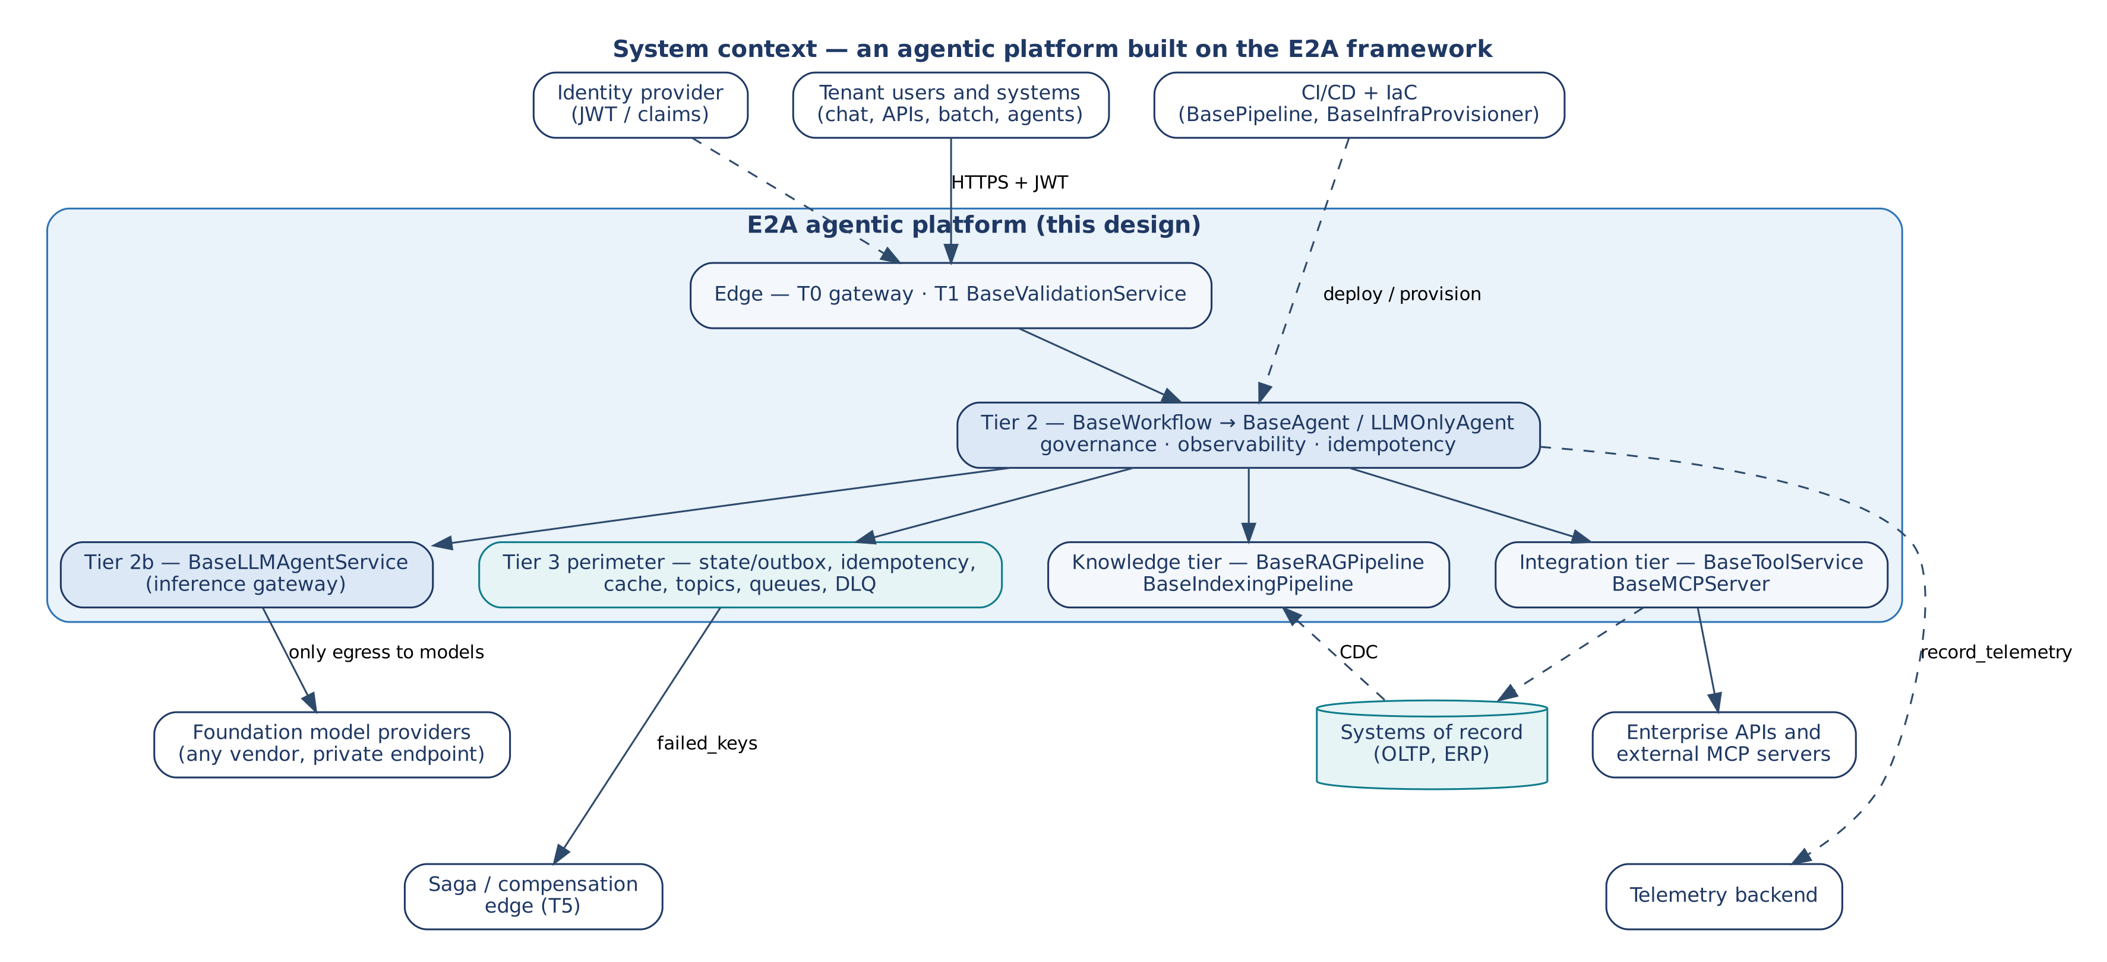
Figure 1 — System context of a platform built on the E2A framework

5.2 The three-layer contract
Every E2A class has the same three layers, and each layer has a landing-zone counterpart. This is the basis of the isomorphism thesis: the runtime changes, the architecture does not.
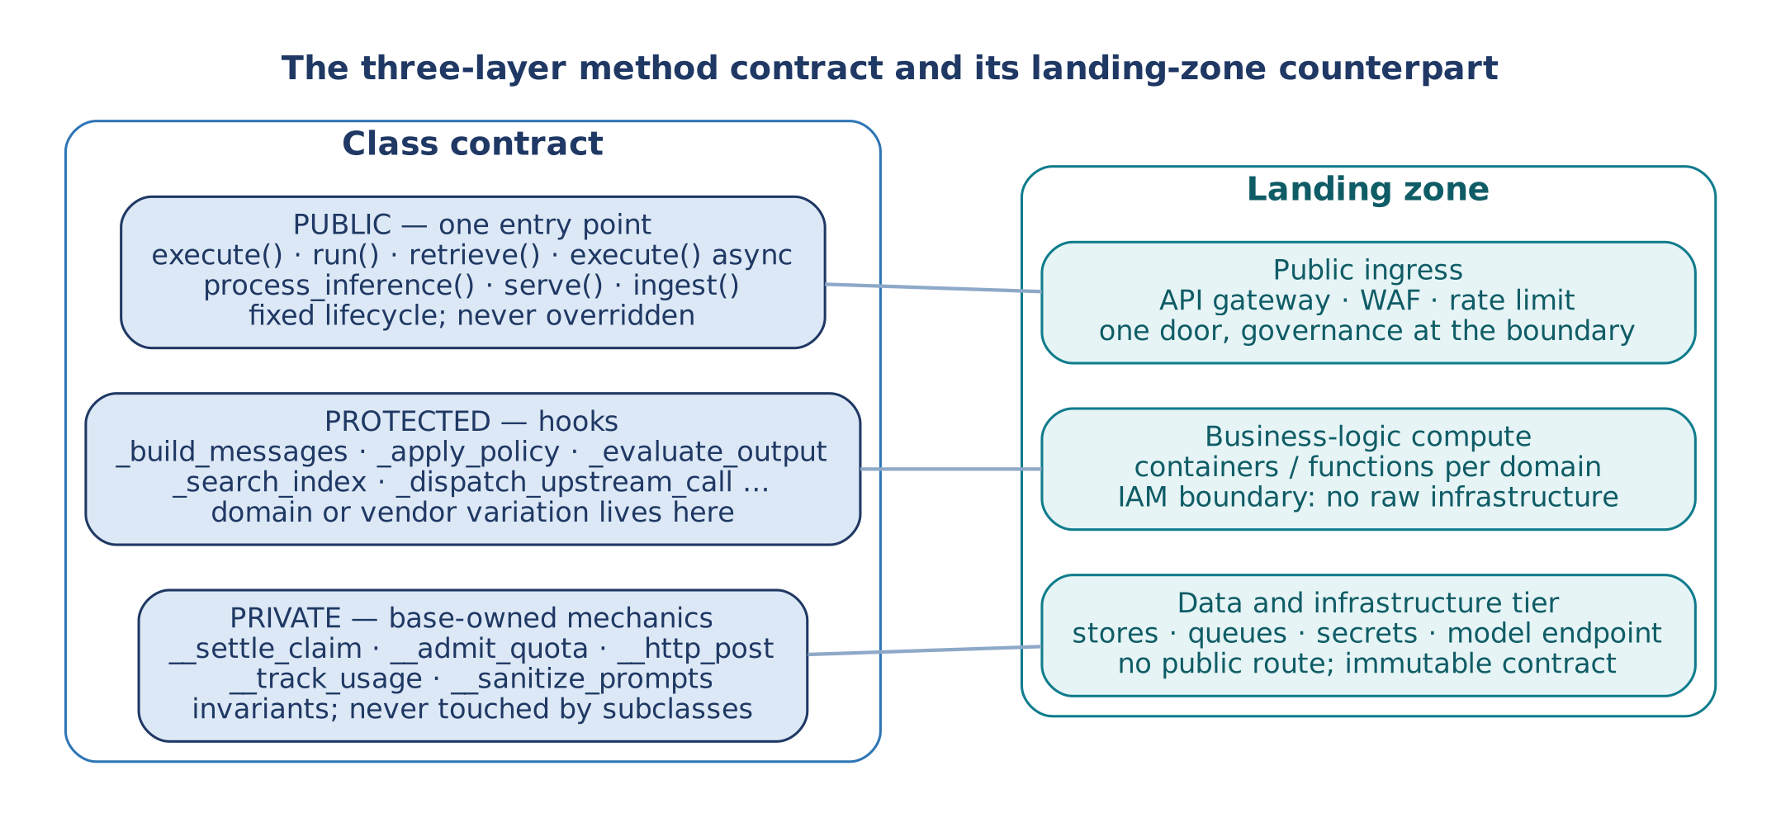
Figure 2 — The three-layer method contract and its landing-zone counterpart

5.3 Zones and tiers
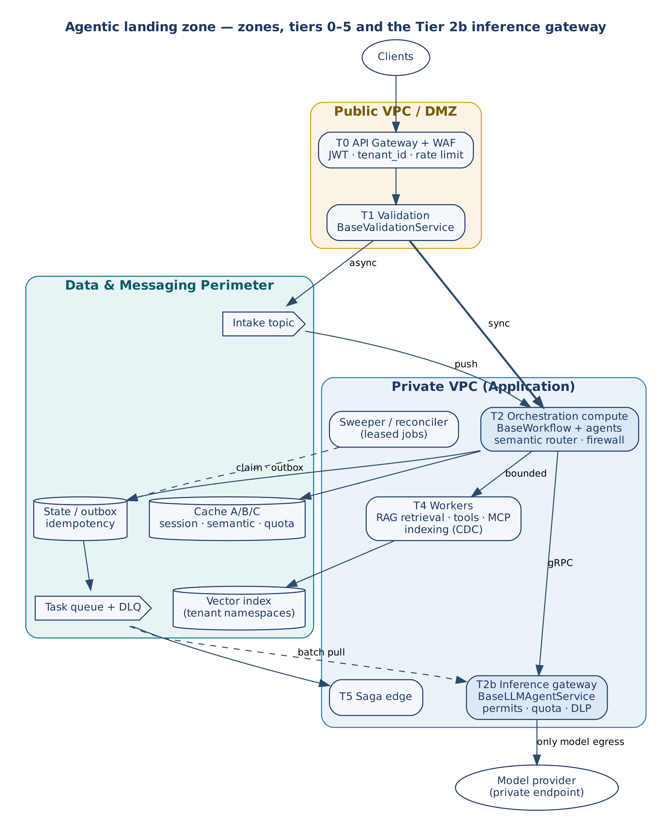
Figure 3 — Agentic landing zone: zones, tiers 0–5 and the Tier 2b inference gateway
Table 7 — Tier responsibilities
Tier | Component | Responsibility
T0 | API gateway + WAF | JWT verification, tenant extraction, rate limiting, edge prompt-injection rules.
T1 | Validation function | BaseValidationService.validate() — schema, business rules, ABAC entitlements; mints correlation_id; async work to the intake topic, sync work to T2.
T2 | Orchestration compute | BaseWorkflow and agents; semantic router; governance gate; idempotency claim; telemetry hand-off.
T2b | Inference gateway | BaseLLMAgentService — permits, RPM/TPM quota, context budget, caching, DLP; dual ingress (gRPC from T2, queue for batch); only model egress.
T3 | Data & messaging perimeter | State/outbox and idempotency records, cache keyspaces (session, semantic, shared quota), vector index, topics, task queue, DLQ, multimodal intake bucket.
T4 | Workers | RAG retrieval, REST and MCP tools, CDC indexing; pull-based, autoscaled on depth; one bulkhead per dependency.
T5 | Saga edge | Commit or isolate / compensate / dead-letter on failed_keys.
— | Control plane | Leased sweeper and reconciler; CI/CD (BasePipeline); IaC (BaseInfraProvisioner).

5.4 Structural isomorphism
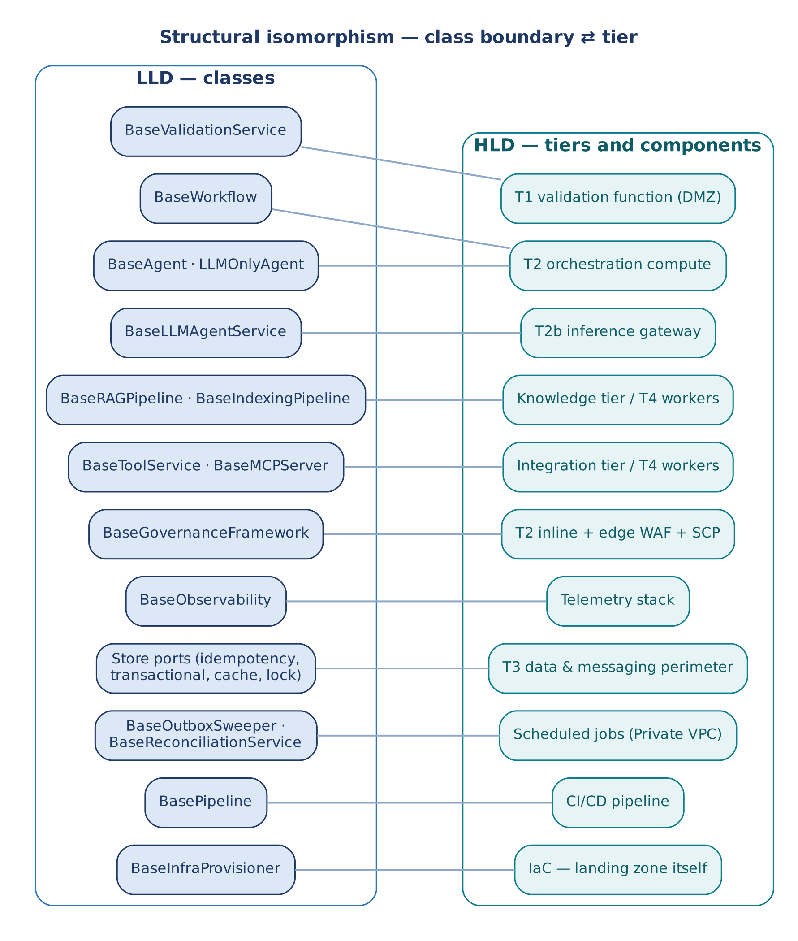
Figure 4 — Class boundary to tier mapping

5.5 The inference gateway (Tier 2b)
BaseLLMAgentService is deployed as its own tier between orchestration and the model provider. It is vendor-neutral: only the two _dispatch_upstream_* hooks in a binding subclass know the provider. Its admission order is fixed and every wait is bounded: tenant permit → pod permit (permit_timeout) → RPM/TPM quota (quota_timeout) → upstream call under min(llm_max_latency, remaining deadline) behind a circuit breaker. Quota is an estimate reserved before the call and refunded to actual usage on success, failure and cancellation. Rate state is per pod and in memory (fleet limit ÷ llm_replica_count); a fleet-wide hard cap is an optional hook (_acquire_shared_quota) a subclass binds to a shared cache keyspace. The tier scales on in-flight requests and queue backlog, not CPU.

5.6 Capacity and backpressure at tier boundaries
Every boundary is either a synchronous bounded wait (timeout, deadline-capped, typed rejection) or a durable backlog (redelivery, DLQ). Mixing the two is what turns a slow dependency into an outage.
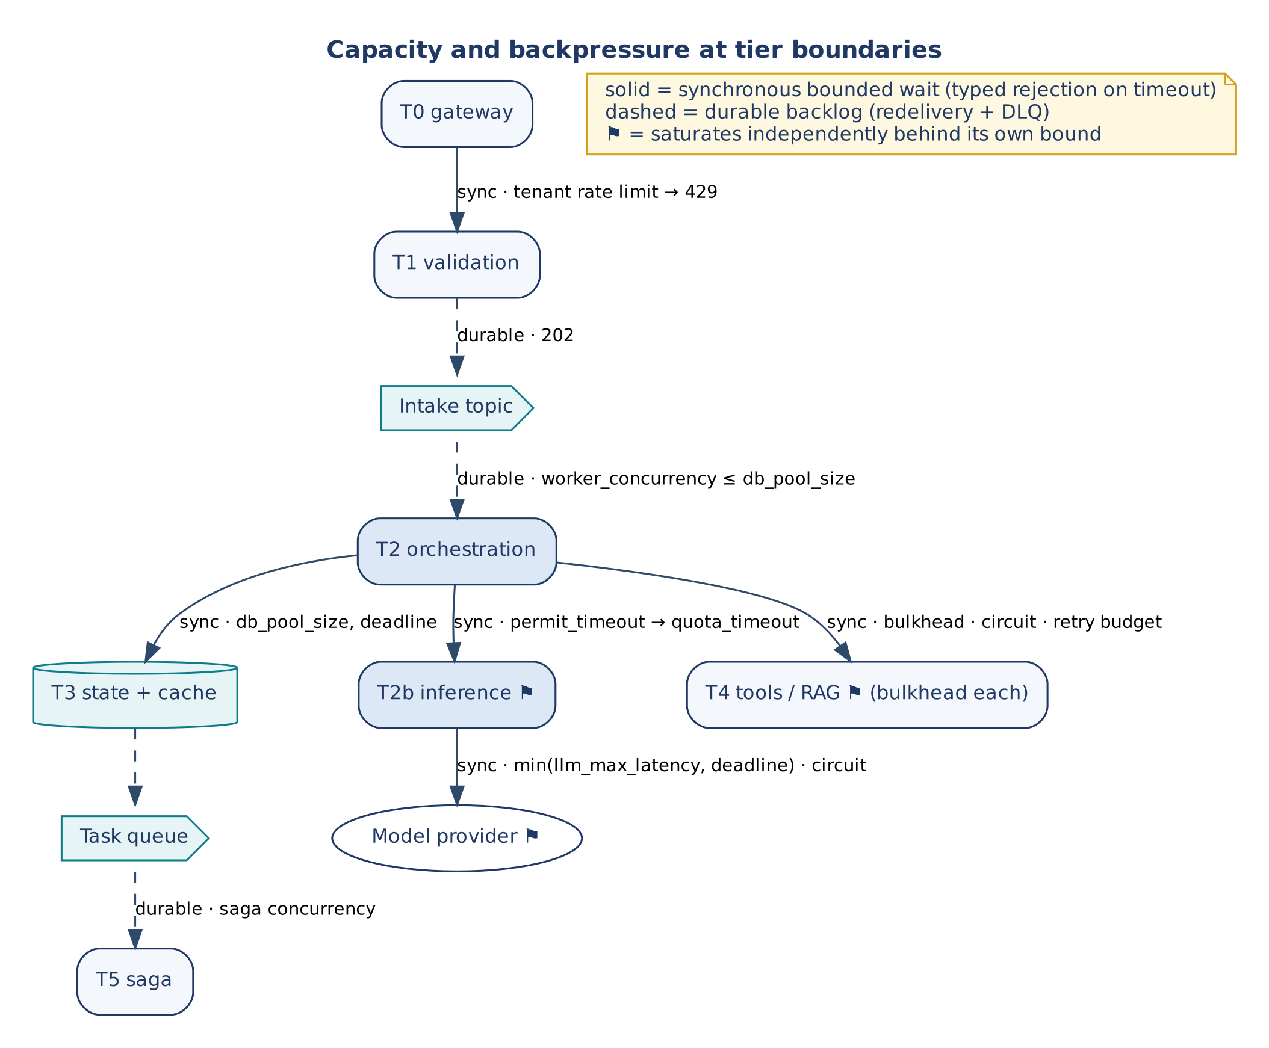
Figure 5 — Capacity and backpressure at tier boundaries
Table 8 — Boundary bounds and saturation behaviour
Boundary | Wait type | Bound (config) | When saturated
T0 → T1 | Sync | Per-tenant gateway rate limit | HTTP 429; nothing reaches T2
T1 → intake topic | Durable | Topic retention | 202 accepted; latency moves to backlog
Intake → T2 | Durable | worker_concurrency ≤ db_pool_size, worker_prefetch | In-flight bounded; poison → DLQ
T2 → T3 state/cache | Sync | db_pool_size, deadline | Bounded pool wait; claim/commit conflicts are typed
T2 → T2b | Sync | permit_timeout, quota_timeout; tenant_concurrency ≤ pod_concurrency | AdmissionTimeout; one tenant cannot hold all permits
T2b → provider | Sync | min(llm_max_latency, deadline); circuit; refund | Typed failure; retries from a shared budget
T2 → T4 tools/RAG | Sync | bulkhead_max_concurrent, bulkhead_acquire_timeout, circuit, retry budget | BulkheadFullError / CircuitOpenError; timed-out write → UNKNOWN
Task queue → T4/T5 | Durable | Depth-driven autoscale; saga concurrency | Backlog grows; consumers stay within pools

5.7 Saga edge (Tier 5)
T5 consumes the batch result and failed_keys. An empty list leads to a standard commit; otherwise the batch is isolated and split into parallel tracks — commit successful items, compensate, route failed items to the DLQ — before a final webhook. Inference failures arrive as data (FAILED payloads and keys in failed_keys), not exceptions. BaseInfraProvisioner._generate_saga_orchestrator() emits the AWS States Language skeleton by default; GCPInfraProvisioner overrides it with GCP Workflows YAML of the same logical shape.

5.8 Multimodal ingestion
Clients upload audio, documents and images by presigned URL to an isolated intake bucket in T3; only the object reference reaches T2. Transcription and extraction run as T2 preprocessing on a worker pool sized apart from inference permits, with duration and page limits (max_audio_duration_seconds, max_document_pages) checked before any paid call. Vision-capable models take the image reference directly.

5.9 Vendor mapping by neutral contract
Table 9 — Neutral contract to provider example
Neutral contract | AWS | GCP | Azure | Semantics that differ
Atomic claim (claim) | DynamoDB conditional put | Firestore create-if-absent | Cosmos DB create | TTL is GC only; expiry is an explicit field
Conditional commit (put_if_version) | Condition expression on version | Update-time precondition | ETag If-Match | Single-item / single-partition scope
Lease + fencing (LeaseHandle) | Versioned item + expiry | Versioned document | Blob lease or versioned item | No native fencing token; adapter supplies it
Durable queue + DLQ | SQS + redrive | Pub/Sub + dead-letter topic | Service Bus | At-least-once everywhere
Ordered partition | SQS FIFO group | Ordering key | Session | Poison handling differs
Model endpoint (T2b) | Bedrock via VPC endpoint | Vertex AI via PSC | Azure OpenAI / Foundry via Private Link | Quota accounting differs; not assumed
Vector index | OpenSearch Serverless | Vector Search / AlloyDB AI | AI Search | Hybrid scoring options differ
Compute | ECS Fargate / EKS | Cloud Run / GKE | Container Apps / AKS | Termination grace: ~30 s / ~10 s / 30 s
Saga engine | Step Functions | Workflows | Logic Apps | Syntax only; same logical shape
Telemetry | CloudWatch + X-Ray | Cloud Monitoring + Trace | Azure Monitor + App Insights | —

5.10 Deployment and delivery
BasePipeline.required_artifact_matrix defines five images — e2a-ingress-validator (T1), e2a-orchestration-engine (T2), e2a-rag-retrieval-worker, e2a-rest-tool-worker and e2a-mcp-server-worker (T4). T0 is a managed gateway and T5 is IaC-defined, so neither has an image. The inference gateway binding is deployed as its own service per provider. Environments are promoted by configuration (DEV → QA → PROD), never by subclass changes.

6. Data and Propagation Contracts

6.1 Propagation fields
Table 10 — Propagation fields
Field | Dir. | Origin | Purpose
correlation_id | In | validate() at T1; else execute() mints one | Joins logs, metrics and traces; also the claim owner.
tenant_id | In | Verified JWT at T0; required in state | Scopes claims, permits, caches, KV handles, indexes, routing.
idempotency_key | In | Client key, else _generate_idempotency_key() | Claim key; appended to failed_keys on failure.
io_config | In | _resolve_io_config() — config keys with the io_ prefix | Endpoint / quota configuration separate from behaviour.
message_log | Out | Empty list per request | Ordered structured events; shipped once to observability.
failed_keys | Out | Empty list per request | Failures for the DLQ and the Saga edge.
deadline | In | Inbound Deadline or x-e2a-deadline-ms, else request_deadline_seconds | Bounds every wait; crosses processes as remaining milliseconds.
trace_context | In | W3C traceparent from the edge | Forwarded by _export_traces(); excluded from fingerprints.
expected_version | In | Caller | Advisory OCC in _commit_gate(); authority is put_if_version.
fencing_token | In | Lease holder | Lets a store reject a stale writer.

BaseWorkflow.execute() is the origin of the first six; it writes tenant_id, correlation_id and idempotency_key back into state and passes everything to agent.run() as keyword arguments.
> v1.2. The inbound fields travel together as one frozen RequestContext (Section 6.6); the outbound ones as MessageLog and FailedKeys. A v1.2 agent receives the context as ctx=; a v1.1 agent still receives the keywords above.

6.2 Request state keys used by the base classes
Table 11 — State keys
Key | R/W | Meaning
tenant_id, correlation_id, idempotency_key | R/W | Propagation fields (written back by execute() and run()).
intent | R | Passed to _get_agent().
requires_human_approval, approval_granted | R | Trigger dehydration in the governance gate.
pending_mcp_tool_execution | R | Triggers _verify_sandbox_profile().
cumulative_tokens_used | R/W | Accumulated by run(); compared with max_token_budget by governance.
response | W | The (fallback-replaced, redacted) model response.
outcome | R | PhysicalOutcome from a tool result; read by _physical_outcome().
status | W | REPLAYED, IN_PROGRESS, CONFLICT, RECOVERY_REQUIRED, FAILED_FINAL, AWAITING_WEBHOOK.
idempotency_status, replayed | W | Raw claim status and replay marker.
message_log, failed_keys | W | Always written on exit.
steps | W | v1.2: one record per declared step (name, agent, status DONE / SKIPPED / FALLBACK / REFUSED / PAUSED, latency).
refusal | W | v1.2: a typed governance refusal (code, stage, reason, retryable).
evaluation, errors | W | v1.2: ACCEPTED / FALLBACK; errors recorded by the default _handle_error.
slo_breached | W | v1.1.2: latency breach recorded, not raised.
checkpoint_id, approved_by | R/W | v1.2: set on a paused step and by resume().

6.3 Inference payload contract
process_inference() never raises a request failure (except ValueError for a missing tenant and the re-raised DehydrationInterrupt / CancelledError); it always returns a payload.
Table 12 — Inference payload fields
Field | Meaning
status | SUCCESS or FAILED.
physical_success | True on success; False on failure or unparsable structured output.
text | Model text after egress DLP.
tool_calls, action | Present when the model requested tools (action = TOOL_CALL_DETECTED).
structured_output | Parsed JSON when response_schema was requested.
tokens_used, metadata | Provider-reported or estimated usage; metadata.model_id.
model_executed, cached_kv_hit, cached_semantic_hit | Routing and cache evidence.
dlp_redactions | Number of values redacted.
error, error_type | On failure.
correlation_id, tenant_id | Echoed propagation fields.

6.4 Tool result contract
Every BaseToolService.execute() result carries physical_success: bool and outcome: PhysicalOutcome. COMMITTED when the call succeeded, NOT_COMMITTED when it definitively did not, and UNKNOWN (status = 'UNKNOWN') when a timeout occurred after the request may have been committed. A commit-gate rejection returns {'status': 'blocked', 'reason': 'commit_gate'}. Callers act only on these fields.

6.5 Configuration
All keys live in the E2A_CONFIG registry (106 keys in 18 groups) and resolve through resolve_config(key, config, kwargs, scope) in the order kwargs › config › environment › default. scope selects per-class defaults (for example max_latency is 2.0 s by default, 5.0 s for BaseToolService and 1.0 s for CQRS). Projects add keys with register_config_key() at start-up; unknown_config_keys() guards typos; config_reference_markdown() and env_example() generate documentation and .env.example from the registry. The full generated reference is Appendix A.
Object references are also passed in config: llm_service (required for any agent that infers), governance_engine, observability_engine, idempotency_store, cache_store, transactional_store, pipeline_state_store.

6.6 Request context and accessors (v1.2)
A v1.2 hook declares only what it uses, from this set. The framework passes exactly the declared parameters; declaring one the step does not offer is an error.
Table 13 — v1.2 hook parameters
Parameter | Type | Contents
state | dict | The business request, as in v1.1.
ctx | RequestContext (frozen) | tenant_id, correlation_id, idempotency_key, deadline, settings (every registry key and application key, resolved once through resolve_config), trace; ctx.setting(key), ctx.child(...), ctx.expired(). Created once by RequestContext.begin() at the outermost entry point.
io_read | ReadAccess | call(tool, payload) for replay-safe tools; resource(name) for named resources (retrievers, stores). Refuses a material tool.
io_modify | ModifyAccess | call(tool, payload, idempotency_key=None) for material tools; always sends a key (derived from the request when none is given); a transport failure is UNKNOWN. Refuses a replay-safe tool.
messages | MessageLog | info / warn / error(event, **fields).
failed_keys | FailedKeys | add(key).
outcomes | list | The typed results _act returned, offered to _confirm.

Table 14 — What each step offers
Hook | Offered
_prepare | state, ctx, io_read, messages
_build_messages | state, ctx, messages (return None for no model step)
_evaluate_output, _fallback | response (evaluate only), state, ctx, messages
_act | state, ctx, io_modify, messages, failed_keys
_confirm | state, ctx, io_read, outcomes, messages
_handle_error | error, state, ctx, messages, failed_keys

An agent's allowed_tools, and the governance class's tool_policy ({agent: [tools]}), limit both accessors.

7. Low-Level Design — Class Model

7.1 Module structure
Table 15 — Modules
Module | Contents
reference/e2a/ (v1.2) | The e2a package, one module per contract area: core (exceptions, Deadline, outcomes), config (E2A_CONFIG, resolve_config), resilience, observability, governance, stages, validation, llm, context, agents, workflows, rag, tools, ports (stores, locks, BaseCheckpointStore, sweeper, reconciler), pipeline, infra, conformance. Imports between modules are explicit; each public name has one home.
reference/e2a_base.py | Compatibility module since v1.2: re-exports every name it defined in v1.1.x (the same objects). Until v1.1: the scaffold. Exceptions and concurrency value types; configuration registry; resilience primitives; _PropagationMixin; foundation classes (observability, governance, validation); BaseLLMAgentService; BaseAgent, BaseWorkflow, LLMOnlyAgent; BaseRAGPipeline, BaseIndexingPipeline; BaseToolService, RestToolService, MCPToolService, BaseMCPServer, tool routing; BasePromptRegistry, BaseMemoryManager, BaseSchemaTransformer, BaseWebhookDispatcher; store and lock ports; BaseOutboxSweeper, BaseReconciliationService; BasePipeline; BaseInfraProvisioner, GCPInfraProvisioner. "Import and subclass. Never modify."
reference/multimodal_orchestrator.py | Reference MultiAgentOrchestratorWorkflow (LangGraph) with RAGAgent, APIToolAgent, MCPToolAgent, GenericLLMOnlyAgent, FallbackAgent, ModalityPreprocessor, OrchestratorState. Lives in src/workflows/.
reference/e2a_inmemory_adapters.py | Test doubles: InMemoryIdempotencyStore, InMemoryTransactionalStore, InMemoryCacheStore, InMemoryLease.
src/… (project) | Concrete workflows, agents, pipelines, tool services, inference binding, engines, store adapters, settings.py (project config keys).

7.2 Class catalogue
Table 16 — Classes by layer
Class | Status | Role
Request path
BaseWorkflow | Abstract | T2 entry point; origin of propagation; claim, routing, settlement.
BaseAgent | Abstract | Governance → inference → evaluation → fallback → redaction.
LLMOnlyAgent | Abstract | Modality-dispatching peer of BaseAgent (no tools, no retrieval).
BaseLLMAgentService | Abstract | T2b inference gateway; only model boundary.
_TenantPermit | Internal | Per-tenant semaphore entry in the gateway.
Knowledge and integration
BaseRAGPipeline | Abstract | Hybrid retrieval and rerank (read side).
BaseIndexingPipeline | Abstract | CDC-fed chunk/embed/write (write side).
BaseToolService | Abstract | Tool client with resilience and typed outcome.
RestToolService, MCPToolService | Reference | REST and MCP-over-HTTP transports.
BaseMCPServer | Abstract | Wraps tool services as an MCP server.
_resolve_tool_call(), _get_tool_service() | Function | MCP-first routing; cached tool-service resolution.
Foundation
BaseGovernanceFramework | Abstract | Admission, budget, dehydration, sandbox, firewall, egress redaction.
BaseObservability | Abstract | Enrich, derive metrics, ship logs/metrics/traces.
BaseValidationService, ValidationResult | Abstract / value | T1 validation and ABAC entitlement.
OrderOpsValidationService | Reference | Example validator registry.
BasePromptRegistry, BaseMemoryManager, BaseSchemaTransformer | Interface | Prompt store, history pruning, payload upcasting.
BaseWebhookDispatcher | Abstract | Signed outbound notifications.
Concurrency and resilience
Deadline, ClaimStatus, ClaimResult, CommitResult, LeaseHandle, PhysicalOutcome | Value | Shared concurrency vocabulary.
BaseIdempotencyStore, BaseTransactionalStore, BaseCacheStore, BaseDistributedLock | Abstract port | Claim, conditional commit, single-flight cache, lease.
_Flight, _FlightAborted | Internal | Single-flight bookkeeping.
RetryBudget, CircuitBreaker, Bulkhead, ResiliencePolicy | Implemented | Per-dependency resilience.
ConcurrencyConflict, AdmissionTimeout, DeadlineExceeded, CircuitOpenError, BulkheadFullError | Exception | Typed outcomes.
DehydrationInterrupt, NFRViolationError | Exception | HITL signal; NFR breach.
Control plane
BaseOutboxSweeper, BaseReconciliationService | Abstract | Leased, scheduled repair.
BasePipeline | Abstract | CI/CD gates and rollout.
BaseInfraProvisioner, GCPInfraProvisioner | Abstract / reference | Landing-zone provisioning.
Configuration
ConfigKey, E2A_CONFIG, resolve_config(), register_config_key(), unknown_config_keys(), config_reference_markdown(), env_example(), validate_capacity() | Implemented | Central registry and capacity rule.
Shared helpers
_PropagationMixin | Implemented | io_config, logging, DLQ, commit gate, LLM bridge.
_run_on_bridge_loop() | Function | One process-wide event loop for sync → async calls.
Reference orchestrator (multimodal_orchestrator.py)
MultiAgentOrchestratorWorkflow | Reference | LangGraph router over four peer agents + fallback.
RAGAgent, APIToolAgent, MCPToolAgent, FallbackAgent | Reference | BaseAgent subclasses.
GenericLLMOnlyAgent, ModalityPreprocessor | Reference | LLMOnlyAgent subclass; STT / extraction stubs.
OrchestratorState | TypedDict | Graph state schema.
Test doubles
InMemoryIdempotencyStore, InMemoryTransactionalStore, InMemoryCacheStore, InMemoryLease | Test double | Lock-based stand-ins for atomic store operations.

7.3 Request path
UML notation: + public, # protected, - private (name-mangled); italic members are abstract.
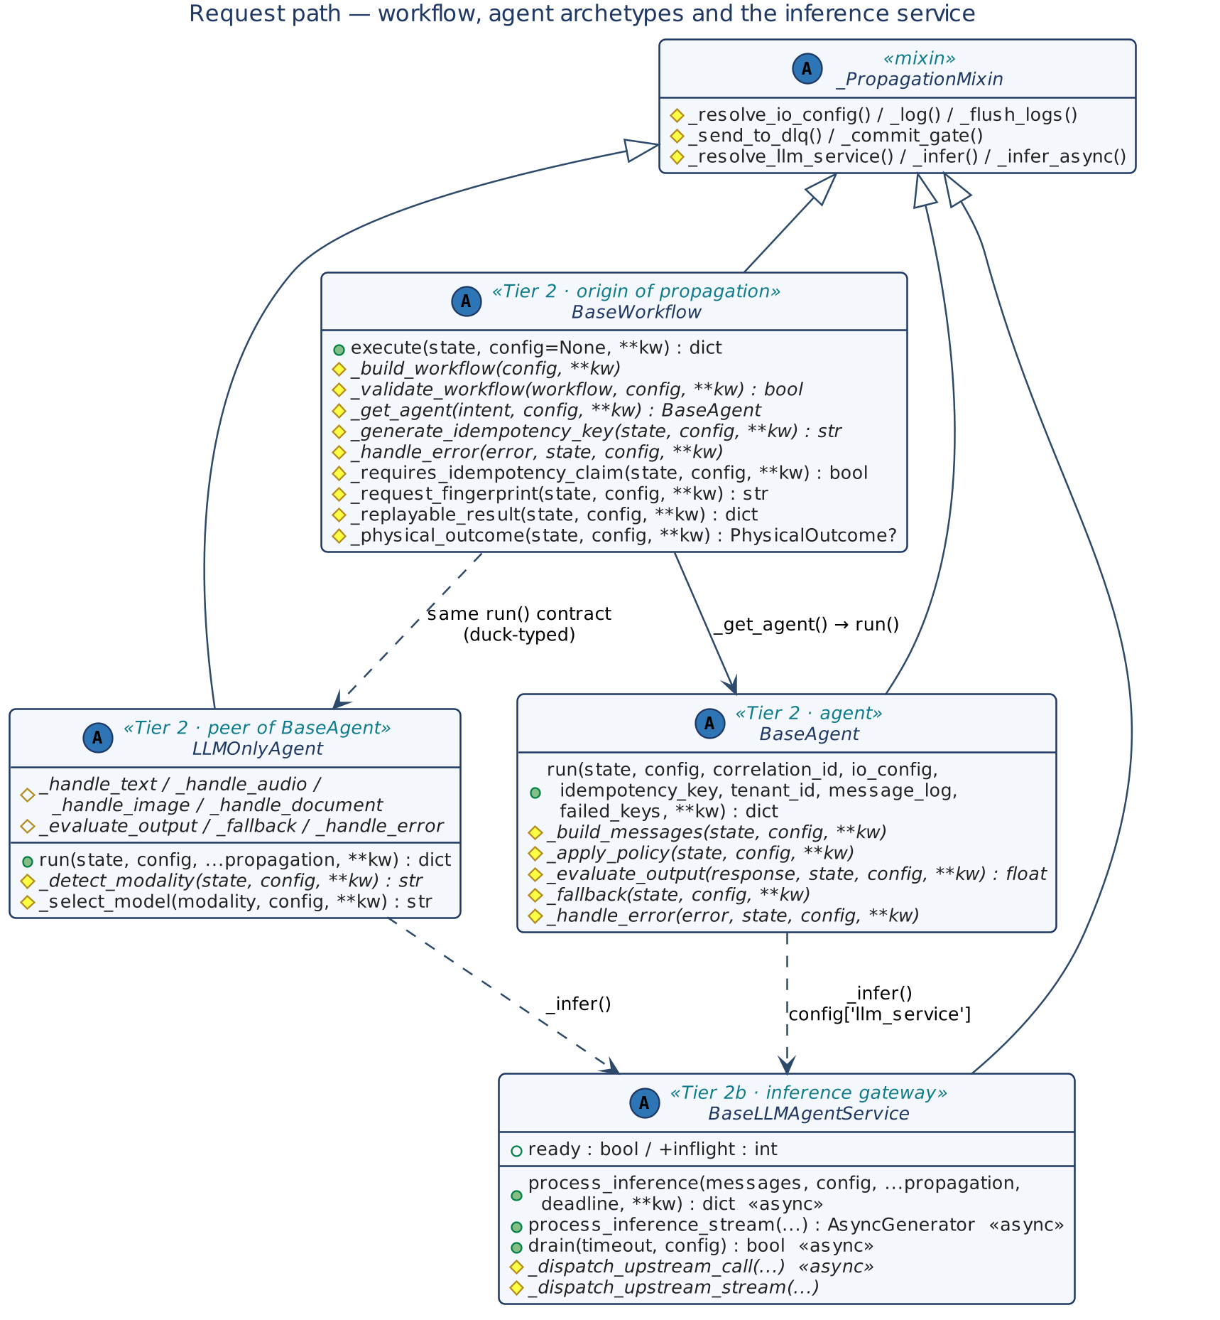
Figure 6 — Request path: workflow, agent archetypes and the inference service
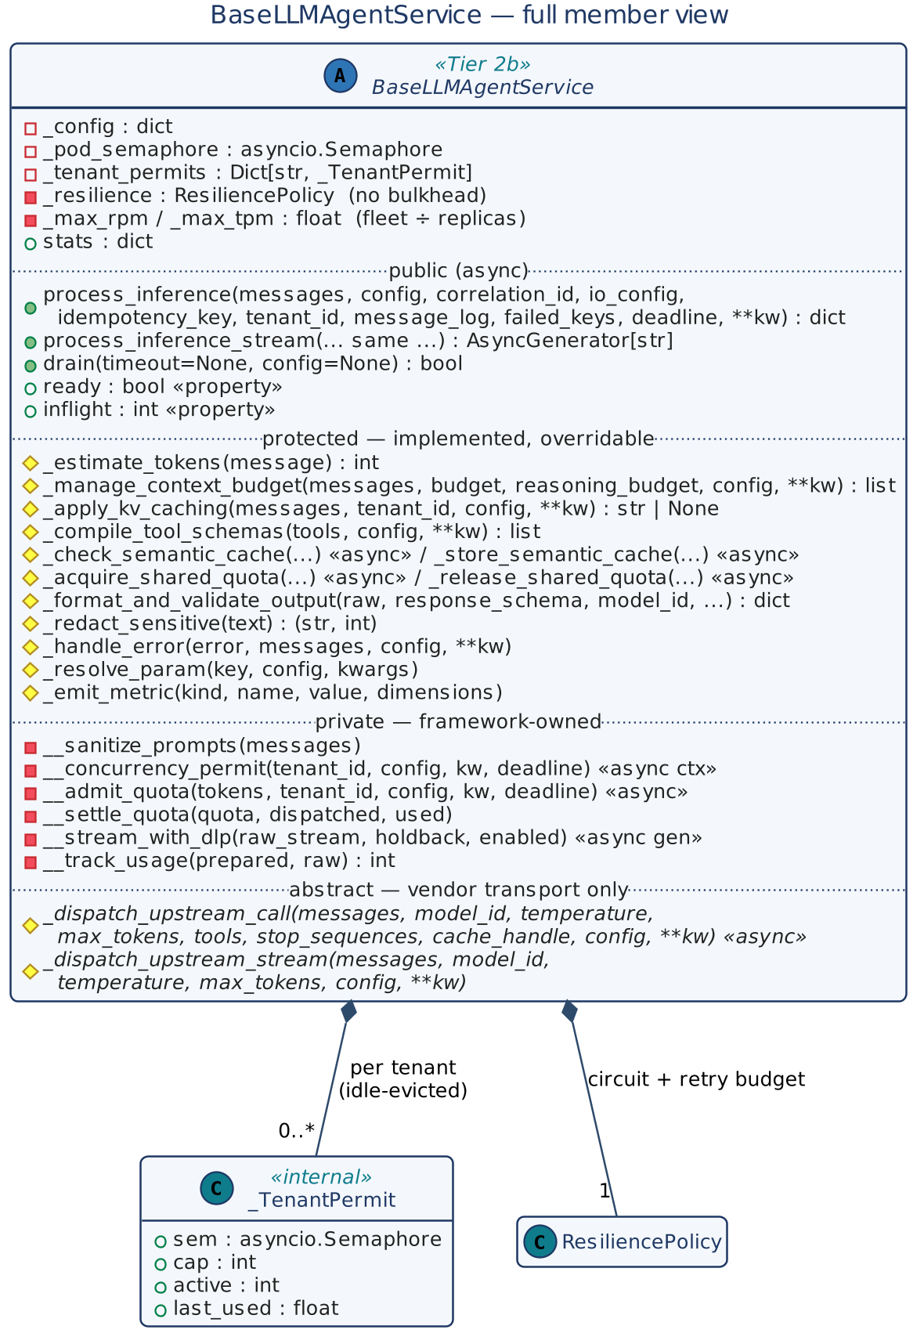
Figure 7 — BaseLLMAgentService member view

7.4 Knowledge and integration tiers
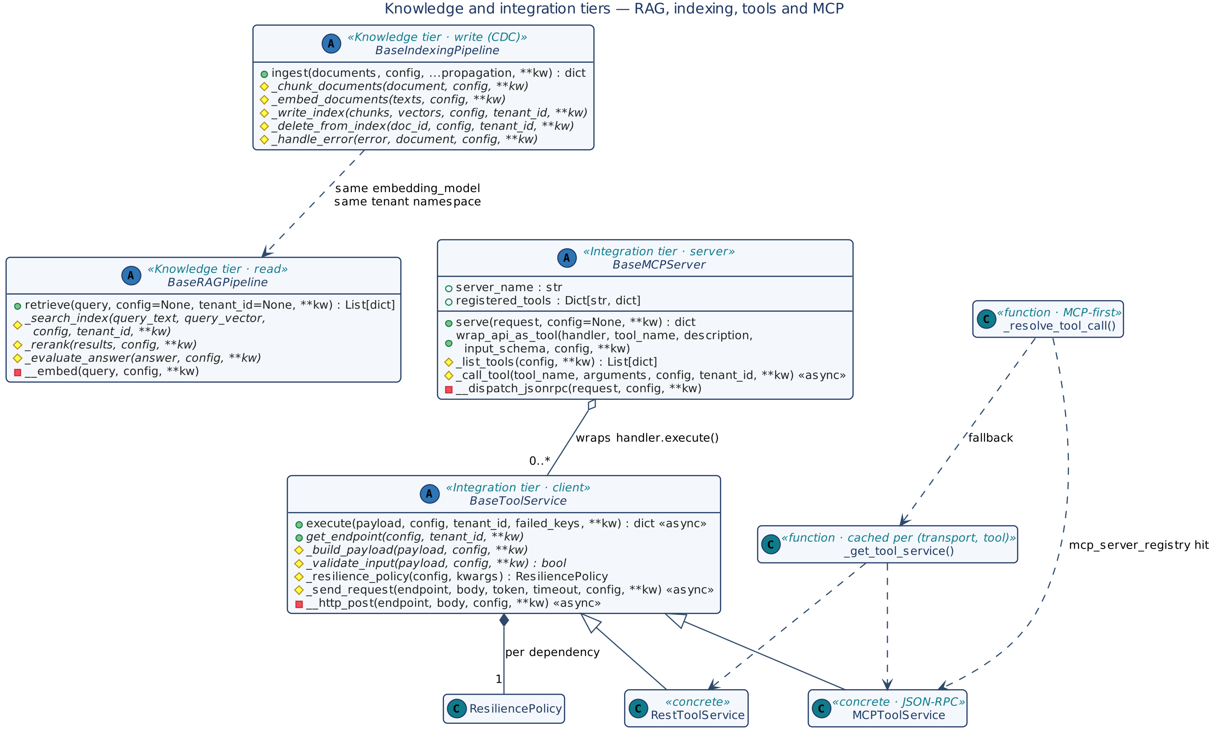
Figure 8 — RAG, indexing, tools and MCP

7.5 Foundation and cross-cutting classes
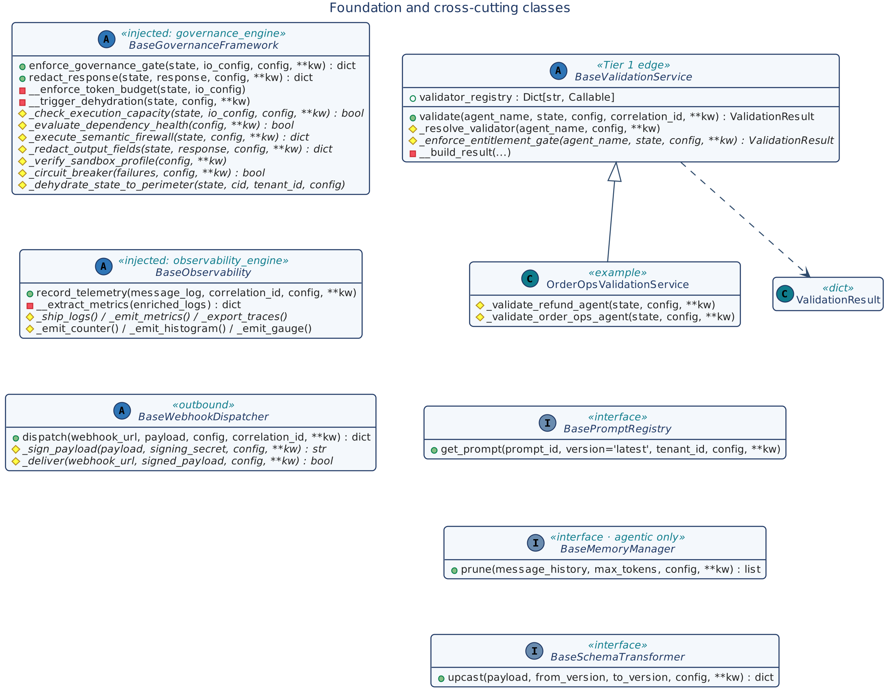
Figure 9 — Foundation and cross-cutting classes

7.6 Stores, leases and value types
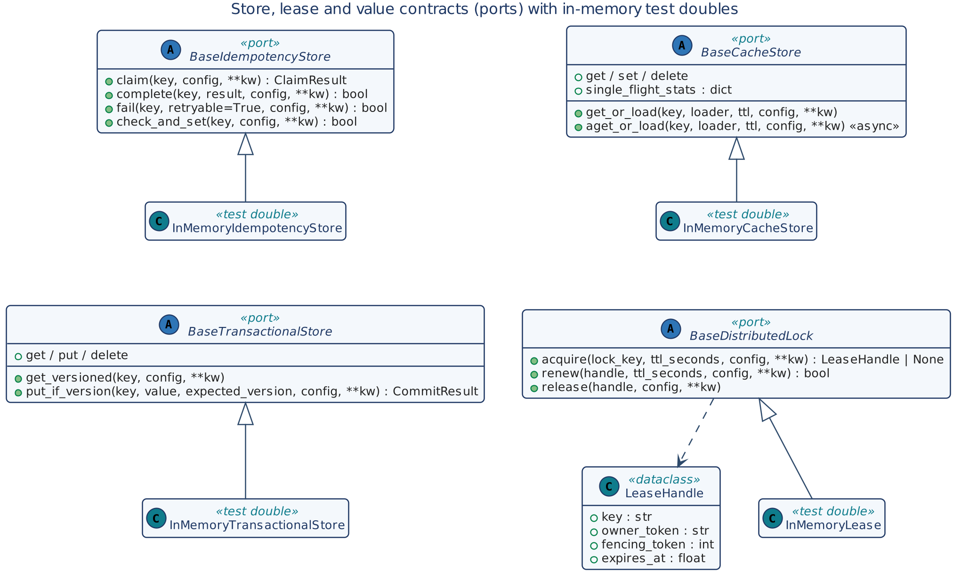
Figure 10 — Store, lease and value contracts with test doubles
The value types (Deadline, ClaimStatus, ClaimResult, CommitResult, PhysicalOutcome) are shared with the CQRS profile and are drawn in full in its design document; their contracts are in Section 8.6.

7.7 Resilience primitives
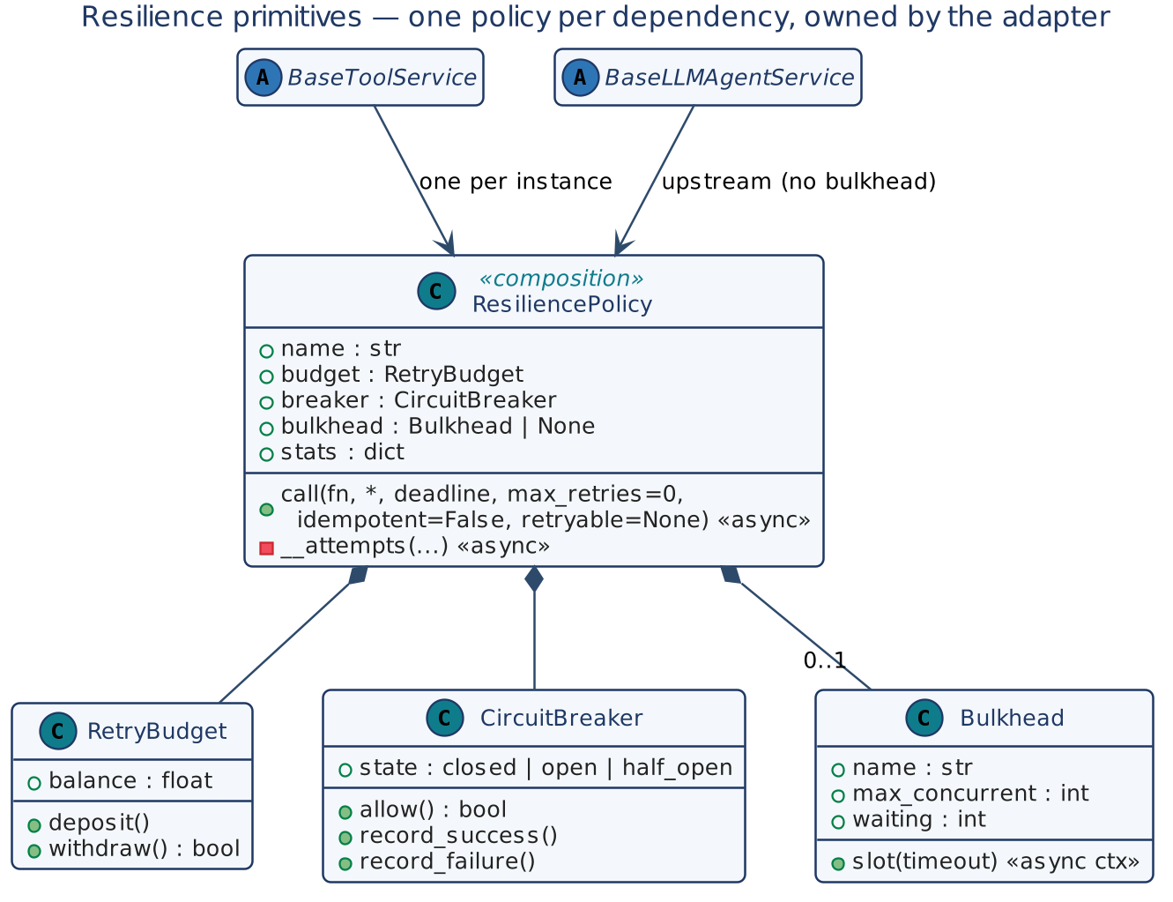
Figure 11 — Resilience primitives

7.8 Control plane
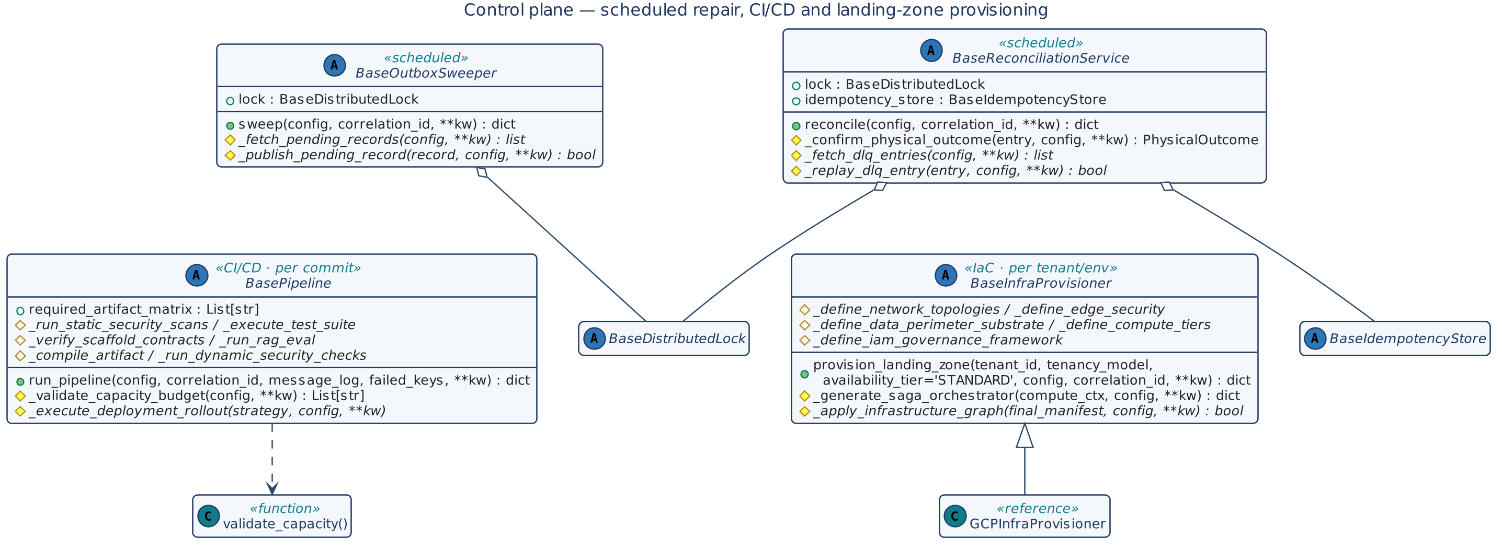
Figure 12 — Scheduled repair, CI/CD and provisioning

7.9 Reference multimodal orchestrator
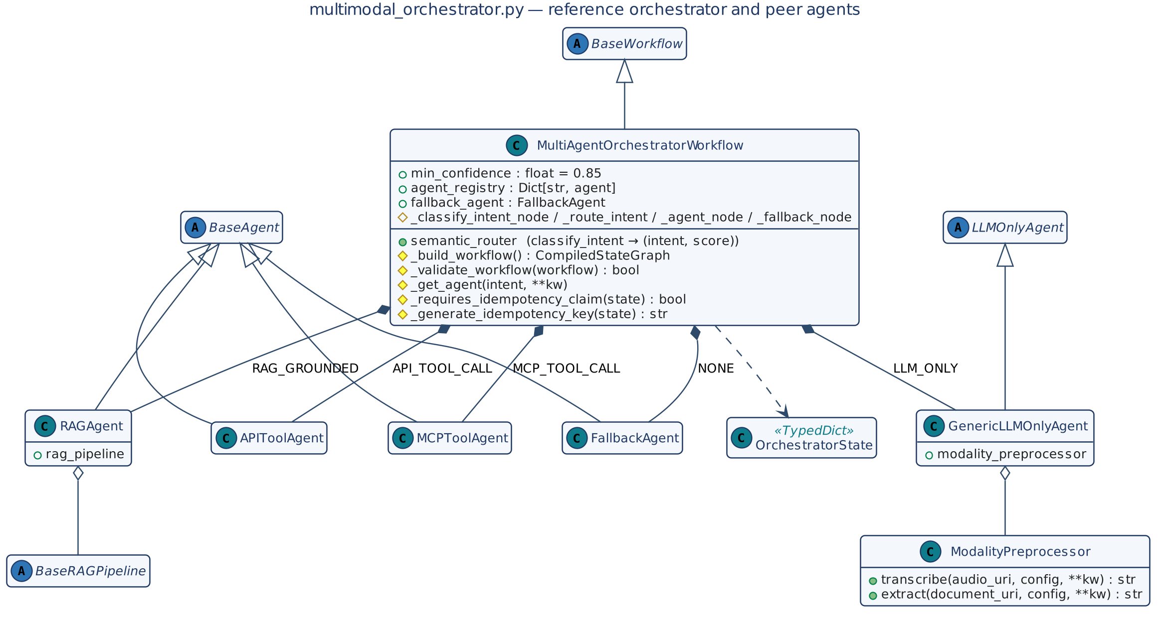
Figure 13 — multimodal_orchestrator.py

7.10 Configuration and exceptions
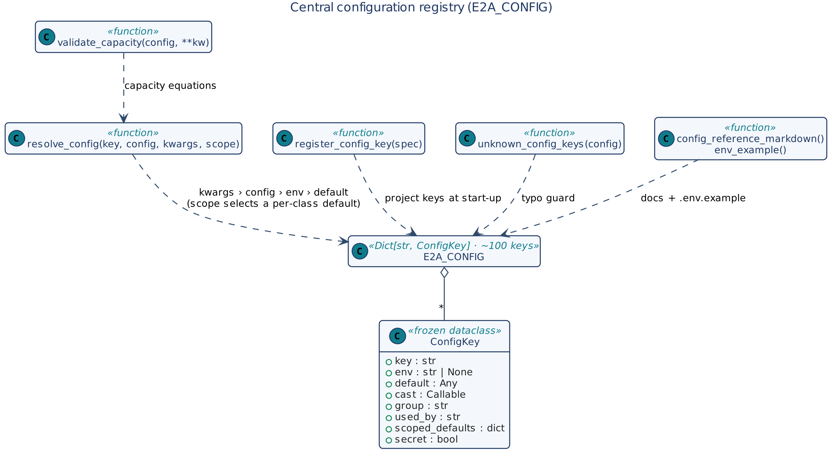
Figure 14 — Central configuration registry
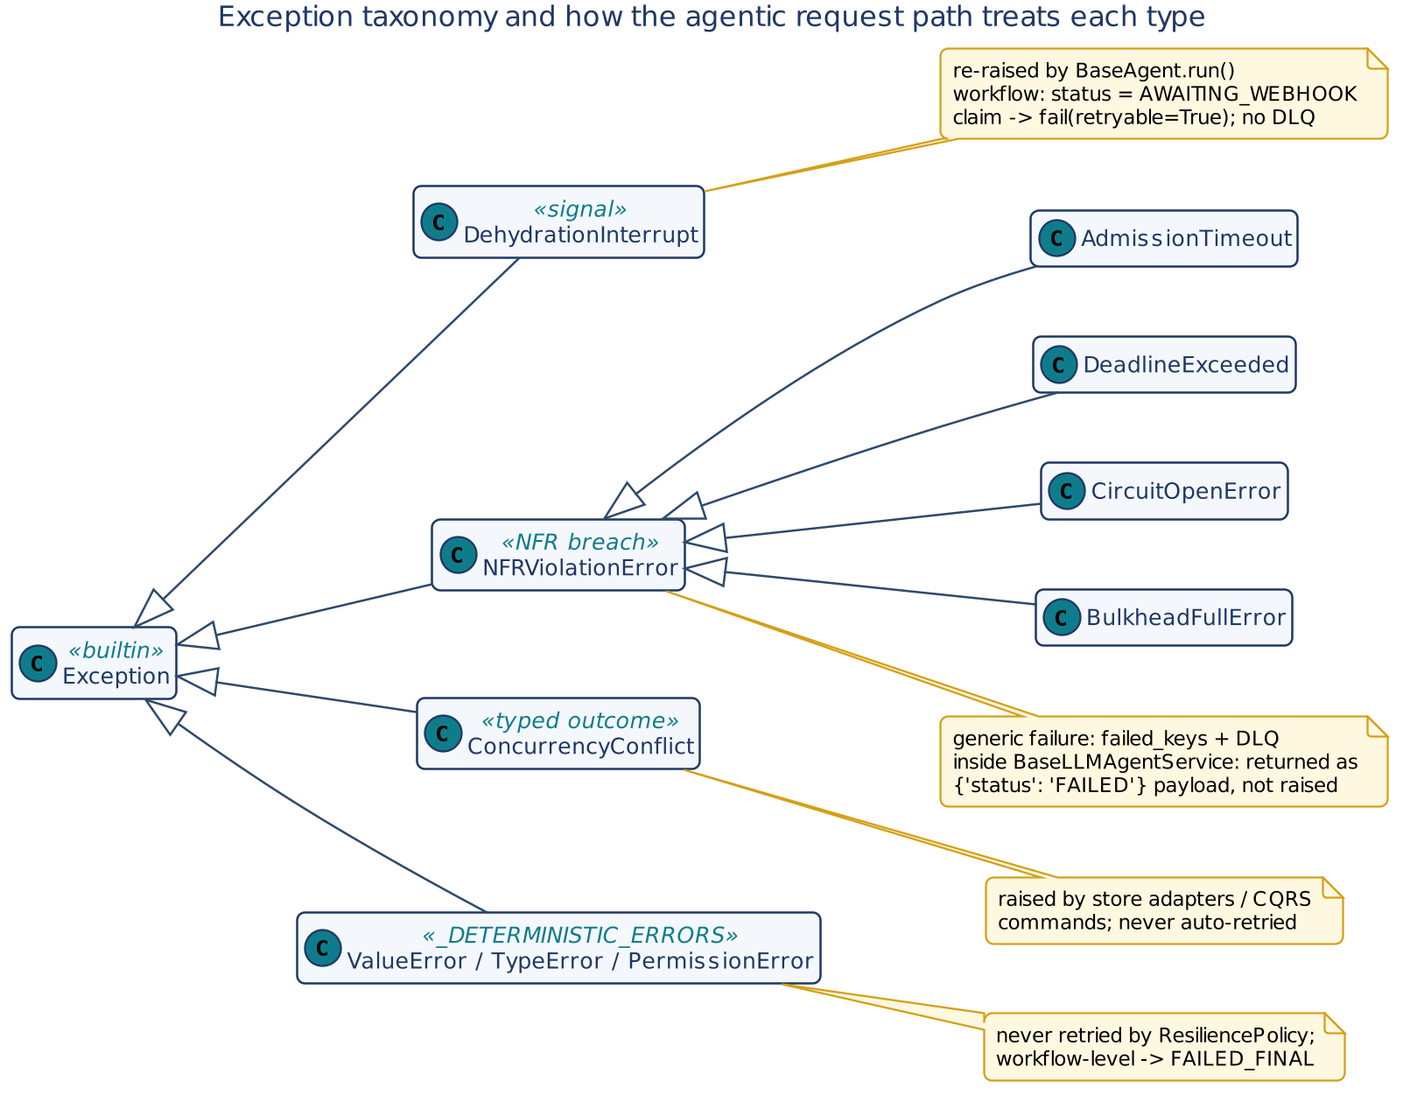
Figure 15 — Exception taxonomy

8. Low-Level Design — Class Contracts
Kind in the method tables: entry (public entry point), public (other public member), template (base-owned private step), hook (abstract), default (protected, overridable), helper (inherited utility).

8.1 BaseWorkflow
Aspect | Detail
Stereotype | Abstract; Tier 2 lifecycle manager; origin of every propagation field
Inherits | ABC, _PropagationMixin
Collaborators | Agent from _get_agent(); idempotency_store, observability_engine via config; Deadline
Invariants | INV-01, INV-03 to INV-06

Table 17 — BaseWorkflow methods
Method | Kind | Signature → returns | Contract
execute | entry | (state, config=None, **kwargs) → dict | tenant_id required. Mints correlation_id (kwargs › state › uuid4), io_config, deadline, idempotency_key; writes the three IDs into state. If an idempotency store is bound and _requires_idempotency_claim(): claim(); non-CLAIMED short-circuits. Then _build_workflow() → _validate_workflow() (else ValueError) → _get_agent(state['intent']) → agent.run(...) with all propagation fields and deadline. DehydrationInterrupt → AWAITING_WEBHOOK; other exceptions → failed_keys, _handle_error(). finally: telemetry (or _flush_logs), settle claim, DLQ, write back logs.
_build_workflow | hook | (config, **kw) | Build the orchestration graph (e.g. LangGraph).
_validate_workflow | hook | (workflow, config, **kw) → bool | Check required nodes; False aborts with ValueError.
_get_agent | hook | (intent, config, **kw) → BaseAgent | Registry lookup by intent; may return any object with the run() contract (e.g. LLMOnlyAgent).
_generate_idempotency_key | hook | (state, config, **kw) → str | Deterministic key from business content when the client sent none.
_handle_error | hook | (error, state, config, **kw) | Map a failure to the caller's error shape; must not raise.
_requires_idempotency_claim | default | (state, config, **kw) → bool | True; override to skip claims for read-only / generative intents.
_request_fingerprint | default | (state, config, **kw) → str | SHA-256 of state minus volatile keys (correlation_id, idempotency_key, message_log, failed_keys, deadline, status, response, outcome, cumulative_tokens_used, trace_context).
_replayable_result | default | (state, config, **kw) → dict | response, outcome, cumulative_tokens_used — taken after egress redaction.
_physical_outcome | default | (state, config, **kw) → PhysicalOutcome \| None | state['outcome'], else state['response']['outcome'].
__resolve_deadline | template | (config, kwargs) → Deadline \| None | Pops deadline; else request_deadline_seconds > 0.
__resolve_idempotency | template | (state, config, **kw) → str | Client key wins; derives only.
__short_circuit | template | (state, claim, log, cid, config) → dict | Map claim status; copy replayable keys on REPLAY; flush logs locally; empty failed_keys.
__settle_claim | template | (store, key, tenant, owner, state, failed_keys, dehydrated, error, config) | Dehydrated → fail(retryable=True); UNKNOWN → park; failures → fail(retryable = not deterministic); else complete().

v1.2 — declared steps and resume. A v1.2 workflow implements _build_workflow(self, ctx) and returns Steps(...); _validate_workflow and _get_agent then have defaults and are not needed.
Table 18 — BaseWorkflow v1.2 members
Member | Kind | Signature → returns | Contract
Step | value | (name, agent, when=None, stop_if=None, material=False) | One agent run. when(state) false → SKIPPED; stop_if(state) true after the run → the workflow ends.
Route | value | (name, by, agents, default=None, when=None, stop_if=None, material=False) | One agent chosen by state[by]; no match and no default → ValueError.
Steps | value | (*steps) | Ordered, unique names; claim_at = the first material step (else 0). No loops, parallel branches or graphs.
execute | entry | (state, config=None, ctx=None, **kw) → dict | With Steps: one context, one deadline, one log; the claim is taken before step claim_at, so a read-only request takes none and a repeat of a material one is REPLAYED as a whole; a fallback or refusal ends the workflow; state['steps'] records each step.
resume | entry | (checkpoint_id, decision, config=None, tenant_id=None, **kw) → dict | Needs config['checkpoint_store']. Refuses an unknown checkpoint or another tenant's (UNKNOWN_CHECKPOINT), a second or concurrent decision (ALREADY_DECIDED), a decider _authorize_decision rejects (DECIDER_REFUSED), each as ResumeRefused. Approved → continues at the paused step under the original key; rejected → status REJECTED, nothing executed.
_authorize_decision | default | (checkpoint, decision, ctx) → bool | Four eyes: a named decider who is not the requester.
_rehydrate_state | default | (checkpoint, decision, ctx) → dict | The stored state plus approval_granted, approved_by.
__execute_steps | template | (state, config, kwargs, ctx, start_at, fingerprint) | Runs the steps; on ApprovalRequired stores the checkpoint (the state at the pause, after the step's _prepare).

8.2 BaseAgent
Aspect | Detail
Stereotype | Abstract; Tier 2 agent
Inherits | ABC, _PropagationMixin
Collaborators | BaseLLMAgentService via _infer(); BaseGovernanceFramework via config['governance_engine']; tools via _resolve_tool_call() from _apply_policy(); optionally BasePromptRegistry and BaseMemoryManager composed into _build_messages()
Input assumption | state already passed BaseValidationService.validate(); there is no _validate_state hook

Table 19 — BaseAgent methods
Method | Kind | Signature → returns | Contract
run | entry | (state, config=None, correlation_id=None, io_config=None, idempotency_key=None, tenant_id=None, message_log=None, failed_keys=None, **kw) → dict | Self-originates missing propagation fields (usable standalone). Steps: _build_messages(); governance gate if bound else _apply_policy(); _infer(); accumulate cumulative_tokens_used; _evaluate_output() < min_confidence → _fallback(); redact_response() if bound; state['response']. DehydrationInterrupt re-raised; other exceptions → failed_keys, _handle_error() (not raised). Logs agent_run_complete; latency > max_latency → raises NFRViolationError.
_build_messages | hook | (state, config, **kw) → list | Compose model messages (prompt registry, memory pruning, grounding).
_apply_policy | hook | (state, config, **kw) | Fallback policy path when no governance engine is bound; also where a tool call runs (set state['outcome']).
_evaluate_output | hook | (response, state, config, **kw) → float | Confidence in [0, 1].
_fallback | hook | (state, config, **kw) → dict | Degraded response (fallback model, cache).
_handle_error | hook | (error, state, config, **kw) | Record the failure; failed_keys is in kwargs.
__track_usage | template | (messages, response, config, **kw) → int | Provider-reported tokens, else ≈ chars / 4.

v1.2 — the agent lifecycle (Figure 20). An agent whose hooks declare ctx runs the v1.2 order; one that does not runs exactly as in v1.1, with one DeprecationWarning per class.
Table 20 — BaseAgent v1.2 hooks
Hook | Kind | Declares (subset of) | Contract
_prepare | default | state, ctx, io_read, messages | Read facts or retrieve before the prompt; no side effects. Runs after the screen governance stages.
_apply_policy | default | state, ctx | Agent-specific policy (no-op by default); runs after the decide stages.
_build_messages | hook | state, ctx, messages | The prompt; None means no model step (a deterministic agent).
_evaluate_output | hook (model step only) | response, state, ctx, messages | Confidence in [0, 1]; below min_confidence → _fallback; records state['evaluation'].
_fallback | hook (model step only) | state, ctx, messages | Degraded response; nothing material follows.
_act | default | state, ctx, io_modify, messages, failed_keys | Material effects; only after an accepted evaluation and never after the deadline; returns the typed results.
_confirm | default | state, ctx, io_read, outcomes, messages | Sets state['outcome']: UNKNOWN › NOT_COMMITTED › COMMITTED; no outcomes, no verdict.
_handle_error | default | error, state, ctx, messages, failed_keys | Records state['errors']; the run does not raise.

A refused run records state['refusal']; a deterministic agent's response is what its steps put in state['response'].

8.3 LLMOnlyAgent
Aspect | Detail
Stereotype | Abstract; peer of BaseAgent (not a subclass) for model-only intents
Why separate | Its contract dispatches on modality to a distinct handler before any prompt is built; it still exposes the same run() shape so _get_agent() can return it.

Table 21 — LLMOnlyAgent methods
Method | Kind | Signature → returns | Contract
run | entry | same shape as BaseAgent.run | _detect_modality() → handler (TEXT, AUDIO, IMAGE, DOCUMENT) → _evaluate_output() → fallback below min_confidence → state['response']. Exceptions → failed_keys, _handle_error(). No governance gate, redaction or latency SLO in the base (Section 14).
_detect_modality | hook | (state, config, **kw) → str | One of the four modality names.
_handle_text / _handle_audio / _handle_image / _handle_document | hook | (state, config, **kw) → dict | Build messages and call self._infer(messages, config, model_id=self._select_model(m), …). Audio/document handlers transcribe/extract first, checking size limits.
_select_model | default | (modality, config, **kw) → str | model_capability_registry[modality] › ['default'] › model_id.
_evaluate_output, _fallback, _handle_error | hook | as BaseAgent | —

8.4 BaseLLMAgentService
Aspect | Detail
Stereotype | Abstract; Tier 2b inference microservice; the single model boundary
Inherits | ABC, _PropagationMixin
State | Per-instance, in memory: pod semaphore, per-tenant permits (idle-evicted), RPM/TPM buckets (fleet ÷ replicas), ResiliencePolicy (circuit, no bulkhead), stats, draining flag
Subclass duty | Implement the two _dispatch_upstream_* hooks for one provider — nothing else is vendor-specific
Concurrency | All waits bounded by min(timeout, deadline); permits always released; quota always settled

Table 22 — BaseLLMAgentService public and protected members
Member | Kind | Signature → returns | Contract
process_inference | entry (async) | (messages, config=None, correlation_id=None, io_config=None, idempotency_key=None, tenant_id=None, message_log=None, failed_keys=None, deadline=None, **kw) → dict | Fixed lifecycle: draining check → deadline check → sanitise → semantic cache → context budget → KV handle → tool schemas → permits → quota → upstream (circuit, min(llm_max_latency, deadline)) → format → usage → DLP → settle quota → store cache. Returns the payload in Table 12. Kwargs model_id, temperature, tools, stop_sequences, response_schema, reasoning_budget, bypass_cache, max_output_tokens take precedence.
process_inference_stream | entry (async gen) | same signature → AsyncGenerator[str] | Same admission; permit held for the stream; yields DLP-screened chunks; deadline checked per chunk; failure recorded then re-raised; quota settled in finally. Consumers must iterate to completion or aclose().
drain | public (async) | (timeout=None, config=None) → bool | Flip readiness, reject new work, wait ≤ drain_timeout_seconds for in-flight.
ready, inflight | property | → bool, → int | Readiness signal; current permit holders.
_estimate_tokens | default | (message) → int | ≈ chars / 4 + 4.
_manage_context_budget | default | (messages, budget, reasoning_budget, config, **kw) → list | Pinned (system / priority 0) + active (last turn, priority 1) must fit, else NFRViolationError; then newest history first; order preserved.
_apply_kv_caching | default | (messages, tenant_id, config, **kw) → str \| None | Pinned prefix ≥ min_cache_threshold → kvcache/{tenant}/{sha256[:32]}.
_compile_tool_schemas | default | (tools, config, **kw) → list | Canonical {name, description, parameters}; name required.
_check_semantic_cache / _store_semantic_cache | default (async) | (messages, …, tenant_id, **kw) | Hooks; default no cache.
_acquire_shared_quota / _release_shared_quota | default (async) | (tokens, tenant_id, config, **kw) | Optional fleet-wide quota; default admits.
_format_and_validate_output | default | (raw, response_schema, model_id, cached_hit, cid, tenant, config) → dict | Build payload; tool calls; JSON parse when a schema was requested.
_redact_sensitive | default | (text) → (str, int) | SSN, Luhn-valid card numbers, bearer tokens → [REDACTED_BY_E2A_DLP].
_handle_error | default | (error, messages, config, **kw) | Log llm_inference_failed.
_resolve_param | default | (key, config, kwargs) | resolve_config(…, scope='BaseLLMAgentService').
_emit_metric | default | (kind, name, value, dimensions) | No-op hook to forward catalogue metrics.
_dispatch_upstream_call | hook (async) | (messages, model_id, temperature, max_tokens, tools, stop_sequences, cache_handle, config, **kw) → dict | One provider call incl. provider-side cache and fallback cascade; return {text, metadata.tokens_used} and/or {tool_calls}.
_dispatch_upstream_stream | hook | (messages, model_id, temperature, max_tokens, config, **kw) → AsyncGenerator[str] | Raw provider chunks.

Table 23 — BaseLLMAgentService private (framework-owned) steps
Step | Contract
__sanitize_prompts | user / prompt / tool messages matching injection patterns → ValueError.
__concurrency_permit | Async context: tenant permit (if tenant_concurrency > 0) then pod permit, total wait ≤ min(permit_timeout, deadline); AdmissionTimeout or DeadlineExceeded; always released; counts in-flight and peak.
__admit_quota | Shared-quota hook, then dual token bucket refilled continuously; wait computed from refill rate ≤ min(quota_timeout, deadline); returns (rpm, tpm) reserved; returns shared quota on failure.
__settle_quota | Synchronous (runs on cancellation): RPM returned only if never dispatched; unused TPM refunded (all of it on failure).
__stream_with_dlp | Hold back dlp_holdback_chars so a split value is complete before release.
__track_usage | Reported tokens, else estimate over prompt + output.
__bounded_acquire, __tenant_entry, __observe_wait, __extras | Bounded semaphore acquire; tenant entry with idle eviction; wait histograms and slow-wait warnings; kwargs de-duplication for hooks.

8.5 Knowledge tier

BaseRAGPipeline
Table 24 — BaseRAGPipeline methods
Method | Kind | Signature → returns | Contract
retrieve | entry | (query, config=None, tenant_id=None, **kw) → List[dict] | Embed → _search_index(query_text, query_vector, …) (hybrid) → _rerank().
_search_index | hook | (query_text, query_vector, config, tenant_id, **kw) | Hybrid BM25 + vector in namespace {tenant_index_prefix}_{tenant_id}; kwargs top_k, hybrid_alpha.
_rerank | hook | (results, config, **kw) | kwargs rerank_top_n.
_evaluate_answer | hook | (answer, config, **kw) → float | Groundedness / faithfulness score; used by RAGAgent._evaluate_output().
__embed | template | (query, config, **kw) | Uses embedding_model; reference stub returns a placeholder vector.

BaseIndexingPipeline
Table 25 — BaseIndexingPipeline methods
Method | Kind | Signature → returns | Contract
ingest | entry | (documents, config, correlation_id, io_config, idempotency_key, tenant_id, message_log, failed_keys, **kw) → dict | tenant_id required. Per document: commit gate → delete or chunk → embed (count must match) → write. One failure appends the doc id and never blocks the batch. Returns {indexed, deleted, failed_keys, …}.
_chunk_documents | hook | (document, config, **kw) → [{text, metadata}] | kwargs chunk_size, chunk_overlap.
_embed_documents | hook | (texts, config, **kw) → List[List[float]] | Must use the retrieval-side embedding_model.
_write_index | hook | (chunks, vectors, config, tenant_id, **kw) | Idempotent on chunk id (CDC is at-least-once).
_delete_from_index | hook | (doc_id, config, tenant_id, **kw) | Remove all chunks of the doc in the tenant namespace.
_handle_error | hook | (error, document, config, **kw) | —

v1.2 — RAG ports and a façade. BaseEmbeddingModel (model_id, embed_documents, embed_query) and BaseVectorIndex (upsert, delete, search). With embedding_model / vector_index set, _embed_query, _search_index, _embed_documents, _write_index and _delete_from_index have working defaults (namespace f'{namespace_prefix}_{tenant}') and are no longer abstract. BaseRAGPipeline.evaluate_answer(answer, retrieved) is public and delegates to _evaluate_answer. RAGPipeline(indexing, retrieval) offers ingest / retrieve / evaluate_answer over the two pipelines and refuses different embedding models. retrieve(…, ctx=…) and ingest(…, ctx=…) take the tenant from the context and refuse a different tenant_id.

8.6 Integration tier

BaseToolService, RestToolService, MCPToolService
Table 26 — BaseToolService methods
Method | Kind | Signature → returns | Contract
execute | entry (async) | (payload, config=None, tenant_id=None, failed_keys=None, **kw) → dict | _validate_input() else ValueError; commit gate on idempotency_key else {status: blocked}; endpoint + payload; __http_post(). Result always has physical_success and outcome.
get_endpoint | hook (public) | (config, tenant_id, **kw) | Rest: tenant_routing_map[tenant] › base_url › tool_base_url. MCP: mcp_server_url.
_build_payload | hook | (payload, config, **kw) | Rest: as-is. MCP: JSON-RPC tools/call with mcp_tool_name.
_validate_input | hook | (payload, config, **kw) → bool | Reference: required_fields present.
_resilience_policy | default | (config, kwargs) → ResiliencePolicy | One policy per instance = per dependency.
_send_request | default (async) | (endpoint, body, token, timeout, config, **kw) → dict | Transport hook (aiohttp/httpx in a subclass); reference stub returns success.
__http_post | template (async) | (endpoint, body, config, **kw) | Timeout and retries from config; replay-safe only with an idempotency key or safe_to_retry; non-replay-safe calls get zero retries; timeout → {status: UNKNOWN, outcome: UNKNOWN}; else sets outcome from physical_success.

Tool routing functions
Function | Contract
_resolve_tool_call(tool_name, payload, config, tenant_id, **kw) | MCP-first: if mcp_server_registry[tool_name] exists, call MCPToolService.execute() with its URL and tool name; otherwise _get_tool_service() and execute.
_get_tool_service(tool_name, config, **kw) | Transport from kwargs › tool_registry[tool].transport › default_transport; returns one cached instance per (transport, tool) so its resilience state is shared by all calls to that dependency.

BaseMCPServer
Table 27 — BaseMCPServer methods
Method | Kind | Signature → returns | Contract
serve | entry | (request, config=None, **kw) → dict | JSON-RPC dispatch: tools/list, tools/call, else error −32601.
wrap_api_as_tool | public | (handler, tool_name, description, input_schema, config, **kw) | Register any BaseToolService as an MCP tool; no per-tool transport code.
_list_tools | default | (config, **kw) → List[dict] | {name, description, inputSchema} per tool; override for per-tenant visibility.
_call_tool | default (async) | (tool_name, arguments, config, tenant_id, **kw) → dict | Delegate to handler.execute(); MCP content shape; unknown tool → isError.
__dispatch_jsonrpc | template | (request, config, **kw) | Envelope handling.

v1.2. A tool declares material = True for an effect (reached only through io_modify). BaseToolService._get_endpoint is the protected hook; get_endpoint stays as a deprecated alias, and a v1.1 subclass that overrides it keeps precedence with one DeprecationWarning (conformance rule D1). execute(…, ctx=…) takes the tenant and the deadline from the context. BaseMCPServer.serve_async exposes the same JSON-RPC surface to async hosts.

8.7 BaseGovernanceFramework
Aspect | Detail
Stereotype | Abstract; template method; injected as config['governance_engine']
Two public methods | enforce_governance_gate() before execution; redact_response() after a response exists — kept separate because there is nothing to redact pre-execution

Table 28 — BaseGovernanceFramework methods
Method | Kind | Signature → returns | Contract
enforce_governance_gate | entry | (state, io_config, config=None, **kw) → dict | _check_execution_capacity() false → NFRViolationError; token budget; dehydration if requires_human_approval and not approval_granted; sandbox check if pending_mcp_tool_execution; semantic firewall → sanitised state.
redact_response | public | (state, response, config=None, **kw) → dict | Egress field masking via _redact_output_fields().
__enforce_token_budget | template | (state, io_config) | cumulative_tokens_used ≥ max_token_budget → ValueError (see Section 14).
__trigger_dehydration | template | (state, config, **kw) | Persist via _dehydrate_state_to_perimeter(), raise DehydrationInterrupt.
_check_execution_capacity | hook | (state, io_config, config, **kw) → bool | Consolidated load-shedding / backpressure admission.
_evaluate_dependency_health | hook | (config, **kw) → bool | Health input to capacity checks.
_execute_semantic_firewall | hook | (state, config, **kw) → dict | Ingress PII redaction and injection blocking with guard models.
_redact_output_fields | hook | (state, response, config, **kw) → dict | Egress masking.
_verify_sandbox_profile | hook | (config, **kw) | Assert isolated microVM before an MCP tool call.
_circuit_breaker | hook | (failures, config, **kw) → bool | Circuit transitions and metrics (not invoked by the base).
_dehydrate_state_to_perimeter | hook | (state, correlation_id, tenant_id, config) | Persist resumable state to T3.

v1.2 — governance as stages (e2a.stages). A subclass declares stages, an ordered list, and optionally tool_policy; the v1.1 hooks above are then not used, and are no longer abstract.
Table 29 — Built-in stages
Stage | Phase | Refusal (also the v1.1 exception type)
CapacityStage(limiter=InflightLimiter(n), breakers=…) | screen | CapacityRefusal (NFRViolationError)
TokenBudgetStage() — reads ctx.setting('max_token_budget') | screen | TokenBudgetRefusal (ValueError)
SandboxStage() | screen | SandboxRefusal (PermissionError)
FirewallStage(injection_patterns, redactions, max_length, fields) | screen | FirewallRefusal (PermissionError)
ApprovalStage(required=…) | decide | ApprovalRequired (a DehydrationInterrupt): the step pauses
RedactionStage(redactions, fields) | egress | — (masks the response)

Every refusal is a GovernanceRefusal with code, stage, reason and retryable; tool limits raise ToolRefusal. enforce_governance_gate(…, phase='screen' | 'decide') runs the stages of one phase: BaseAgent runs screen before _prepare (nothing unscreened reaches a retriever) and decide after it (approval needs the facts _prepare read). Custom stages subclass IngressStage.check(state, ctx, messages) or EgressStage.redact(response, state, ctx, messages); compile_redactions / redact_text load redaction rules from policy files.

8.8 BaseObservability
Table 30 — BaseObservability methods
Method | Kind | Signature → returns | Contract
record_telemetry | entry | (message_log, correlation_id, config=None, **kw) | Enrich entries (correlation_id, tenant_id, host_epoch_ms, framework_version); derive total_tokens, error_count; call the three hooks; on failure log locally. Never raises.
__extract_metrics | template | (enriched_logs) → dict | Sum tokens_used, count ERRORs.
_ship_logs / _emit_metrics / _export_traces | hook | (…, config, **kw) | Sink, metrics backend, trace export (forward W3C traceparent).
_emit_counter / _emit_histogram / _emit_gauge | default | (name, value, dimensions, config, **kw) | Typed OTel-style emitters; no-op by default.

8.9 BaseValidationService
Table 31 — BaseValidationService methods
Method | Kind | Signature → returns | Contract
validate | entry | (agent_name, state, config=None, correlation_id=None, **kw) → ValidationResult | Earliest point; mints correlation_id. No validator → invalid when strict_mode. Validator (state, config, **kw) → (valid, errors); invalid → result; valid → _enforce_entitlement_gate().
_resolve_validator | default | (agent_name, config, **kw) | validator_registry[agent_name] — one _validate_<agent_name> per agent.
_enforce_entitlement_gate | hook | (agent_name, state, config, **kw) → ValidationResult | ABAC on resolved claims; runs only after schema validation succeeded.
__build_result | template | (valid, errors, agent_name, cid) | ValidationResult dict (HTTP 400 body).

OrderOpsValidationService is the reference subclass: it registers _validate_refund_agent and _validate_order_ops_agent.

8.10 Other foundation classes
Table 32 — Interfaces and outbound dispatcher
Class | Method | Contract
BasePromptRegistry | get_prompt(prompt_id, version='latest', tenant_id=None, config=None, **kw) | Returns an object with render(**variables) → str; prompts change by GitOps without a rebuild.
BaseMemoryManager | prune(message_history, max_tokens, config=None, **kw) → list | Strategy is subclass-owned; composed into _build_messages(); agentic profile only.
BaseSchemaTransformer | upcast(payload, from_version, to_version, config=None, **kw) → dict | Structural version transform at deserialisation.
BaseWebhookDispatcher | dispatch(webhook_url, payload, config=None, correlation_id=None, **kw) → dict | Sign once, try _deliver() up to max_retries; returns DELIVERED / FAILED with attempt count. Hooks: _sign_payload(), _deliver().

8.11 Stores, lease and value types
Table 33 — Store and lease ports
Port | Methods | Contract
BaseIdempotencyStore | claim, complete, fail, check_and_set | ABSENT → IN_PROGRESS is one atomic conditional write, tenant-scoped, with fingerprint. claim returns CLAIMED, IN_PROGRESS, REPLAY (stored result), CONFLICT, RECOVERY_REQUIRED (expired lease or UNKNOWN; recover=True lets a reconciler take over), FAILED_FINAL. complete/fail are owner-checked. TTL is GC only.
BaseTransactionalStore | get, put, delete, get_versioned, put_if_version | put_if_version is the authority for competing writers: COMMITTED (new version), CONFLICT (current version) or FENCED (older fencing_token). expected_version=None = create-if-absent.
BaseCacheStore | get, set, delete, get_or_load, aget_or_load, single_flight_stats | Per-key single-flight inside a process; followers wait ≤ min(cache_fill_timeout_seconds, deadline) then load / stale / raise; loader failure propagates, not cached; cancelled leader degrades followers.
BaseDistributedLock | acquire, renew, release | Lease (not lock): time-bound, renewable, owner-checked; strictly increasing fencing_token per key; release of a lost lease is a no-op.

Table 34 — Value types
Type | Contract
Deadline | Absolute monotonic instant. after(s), from_remaining_ms(ms), coerce(v) (None, Deadline or seconds), remaining(), expired(), bound(timeout) = min(timeout, remaining), check(what) → DeadlineExceeded, to_remaining_ms(); header x-e2a-deadline-ms. Cancellation is not a field — it propagates through the runtime.
ClaimStatus / ClaimResult | Enum above; result carries status, stored result, owner.
CommitResult | status, version, current_version, committed.
LeaseHandle | key, owner_token, fencing_token, expires_at (monotonic).
PhysicalOutcome | COMMITTED, NOT_COMMITTED, UNKNOWN; outcome_of(result) derives it from outcome or physical_success.

8.12 Resilience primitives
Table 35 — Resilience classes
Class | Members | Contract
RetryBudget | deposit(), withdraw() → bool, balance | Each first attempt earns ratio tokens (capped at cap, starts at half); each retry spends one — retry amplification ≈ ratio of traffic.
CircuitBreaker | state, allow(), record_success(), record_failure() | Closed → open after failure_threshold consecutive failures → half-open after reset_seconds with exactly one probe.
Bulkhead | slot(timeout) (async ctx), waiting | In-flight cap with bounded wait; BulkheadFullError on timeout.
ResiliencePolicy | call(fn, *, deadline, max_retries=0, idempotent=False, retryable=None), stats | Deadline check → bulkhead → budget deposit → loop: circuit allow() else CircuitOpenError; call; success resets circuit; failure (non-deterministic, non-structural) counts; retry only if allowed (Figure 27) and the budget pays; full-jitter backoff never beyond the deadline.

8.13 _PropagationMixin and bridge
Table 36 — Shared helpers
Helper | Signature | Contract
_resolve_io_config | (config, **kw) → dict | Config entries with the io_config_prefix.
_log | (message_log, cid, level, event, **fields) | Append a structured entry with timestamp and class.
_flush_logs | (message_log, config, **kw) | Local fallback sink.
_send_to_dlq | (failed_keys, config, **kw) | Dispatch to dlq_queue_url (scaffold logs).
_commit_gate | (key, failed_keys, config, **kw) → bool | Batch isolation + advisory OCC; disabled by commit_gate_enabled.
_resolve_llm_service | (config, **kw) | llm_service must be a BaseLLMAgentService, else ValueError.
_infer_async | (messages, config, **kw) → dict (async) | Await process_inference; FAILED → RuntimeError.
_infer | (messages, config, **kw) → dict | Sync bridge on the shared loop; bounded by min(llm_max_latency + permit_timeout + quota_timeout + 1, deadline + 0.5).
_run_on_bridge_loop | (coro, timeout) | One daemon event loop per process; bounded wait cancels the coroutine (DeadlineExceeded), so permits and quota are cleaned up.

8.14 Control plane
Table 37 — Scheduled repair
Method | Kind | Signature → returns | Contract
BaseOutboxSweeper.sweep | entry | (config=None, correlation_id=None, **kw) → dict | Acquire lease outbox_sweeper (else SKIPPED_LOCKED); renew every lease_renew_interval_seconds (lost → LEASE_LOST, stop); publish each pending record with the fencing token; SWEPT with counts; release in finally.
_fetch_pending_records / _publish_pending_record | hook | (config, **kw) / (record, config, fencing_token, **kw) → bool | Read stuck outbox rows; publish (pass the fencing token to any store write).
BaseReconciliationService.reconcile | entry | (config=None, correlation_id=None, **kw) → dict | Lease reconciliation_service; for each DLQ entry: claim(recover=True); _confirm_physical_outcome(): COMMITTED → complete, UNKNOWN → stay parked, else replay once and complete (or fail(retryable=True)).
_confirm_physical_outcome | default | (entry, config, **kw) → PhysicalOutcome | Default UNKNOWN — safe never-replay default.
_fetch_dlq_entries / _replay_dlq_entry | hook | — | Replay through the same claim and governance path as live traffic.

Table 38 — BasePipeline and BaseInfraProvisioner
Method | Kind | Signature → returns | Contract
BasePipeline.run_pipeline | entry | (config, correlation_id, message_log, failed_keys, **kw) → dict | Seven gates in order (Figure 33); first failure → status FAILED, never raised; report includes stages, capacity_violations, rag_eval_score, deployment metadata.
_validate_capacity_budget | default | (config, **kw) → List[str] | validate_capacity(); override to add rules.
_run_static_security_scans, _execute_test_suite, _verify_scaffold_contracts, _run_rag_eval, _compile_artifact, _run_dynamic_security_checks, _execute_deployment_rollout | hook | — | SAST/secrets; tests; single-entry-point and no private-override check; RAGAS score; build and push one image; DAST; blue-green or canary.
BaseInfraProvisioner.provision_landing_zone | entry | (tenant_id, tenancy_model, availability_tier='STANDARD', config, correlation_id, **kw) → dict | POOL or SILO; STANDARD / HIGH / CRITICAL. Seven steps (Figure 34) into a manifest; any failure → status FAILED, error_trace; never raises.
_define_* (5), _apply_infrastructure_graph | hook | — | Networks (AZ/region count honoured), edge, data perimeter (per tenancy), compute, IAM per tier; apply via Terraform / Pulumi / CDK.
_generate_saga_orchestrator | default | (compute_ctx, config, **kw) → dict | AWS States Language skeleton; override syntax per cloud.

GCPInfraProvisioner is the reference implementation: per-tier service accounts (T1 publish-only), POOL vs SILO Firestore databases, GCP Workflows saga.

8.15 Configuration functions
Table 39 — Configuration API
Function | Contract
resolve_config(key, config=None, kwargs=None, scope=None) | Unregistered key → KeyError. kwargs › config › env (cast) › scoped default › default.
register_config_key(spec) | Idempotent for an identical spec; conflicting duplicate → ValueError.
unknown_config_keys(config) | Keys neither registered nor io_-prefixed.
config_reference_markdown(), env_example() | Generated docs and .env.example (secrets emitted empty).
validate_capacity(config, **kw) → List[str] | Violations of: worker_concurrency ≤ db_pool_size; pod_concurrency ≤ http_pool_size; tenant_concurrency ≤ pod_concurrency; worker_prefetch ≥ worker_concurrency; replicas × db_pool_size ≤ db_max_connections; replicas × pod_concurrency × (1 + retry_budget_ratio) ≤ model_max_inflight; lease renew < TTL; drain < termination grace.

8.16 Reference orchestrator (multimodal_orchestrator.py)
Table 40 — Reference orchestrator classes
Class | Behaviour
MultiAgentOrchestratorWorkflow | BaseWorkflow subclass. agent_registry: RAG_GROUNDED → RAGAgent, MCP_TOOL_CALL → MCPToolAgent, API_TOOL_CALL → APIToolAgent, LLM_ONLY → GenericLLMOnlyAgent; unknown intent or score below min_confidence (0.85) → FallbackAgent. _build_workflow() compiles a LangGraph StateGraph (classify → route → agent → END); _validate_workflow() checks six required nodes. Claims only tool intents above the threshold; key = SHA-256 of tenant and query.
RAGAgent | Grounds the prompt with rag_pipeline.retrieve(); confidence = rag_pipeline._evaluate_answer(); fallback reason faithfulness_threshold.
APIToolAgent / MCPToolAgent | _apply_policy() resolves the tool with transport pinned (http / mcp), runs it on the bridge loop (_run_tool, bounded by deadline or timeout × (retries + 1)), sets state['outcome']; confidence = physical_success.
GenericLLMOnlyAgent | Modality from audio_uri / image_uri / document_uri, else text; audio and documents through ModalityPreprocessor (stubs in the reference); image reference passed directly.
FallbackAgent | Confidence always 0 → degraded answer with reason no_intent_match.
ModalityPreprocessor | transcribe() and extract() with pre-flight duration/page checks; reference raises NotImplementedError.

8.17 Test doubles
InMemoryIdempotencyStore implements the full claim state machine per (tenant, key) with a lock standing in for the conditional write, plus state_of() for tests. InMemoryTransactionalStore keeps versioned rows and rejects stale fencing tokens. InMemoryCacheStore is a dict. InMemoryLease issues owner tokens and strictly increasing fencing tokens with expiry on an injectable clock.

8.18 Conformance kit (v1.2)
e2a.conformance checks the Governed Entry Point principle statically. The rule sets are read from the e2a classes, and subclasses are followed across files.
Table 41 — Conformance rules
Rule | Level | Finding
R1 | error | A subclass overrides a framework-owned public method or a framework-private (__) method.
R2 | warning (error with --strict; the default from v1.3) | Code outside a class calls that class's protected hook.
R3 | info | An extra public method: allowed if it is a capability (its own caller or trigger, its own guarantees). Framework data attributes (stages, tool_policy) are not findings.
D1 | warning | A subclass overrides a public method that became a hook in v1.2 (get_endpoint).

python -m e2a.conformance src/ [--strict] [--quiet] exits 1 on an error. AgentContract is a pytest kit: run() never raises on a hook error; a model step below min_confidence falls back and commits nothing; nothing material after the deadline; the request tenant reaches the result. BasePipeline._verify_scaffold_contracts runs the rules over conformance_paths (findings in self.conformance_findings) and no longer requires one public method per class.

9. Dynamic Behaviour

9.1 Workflow execution
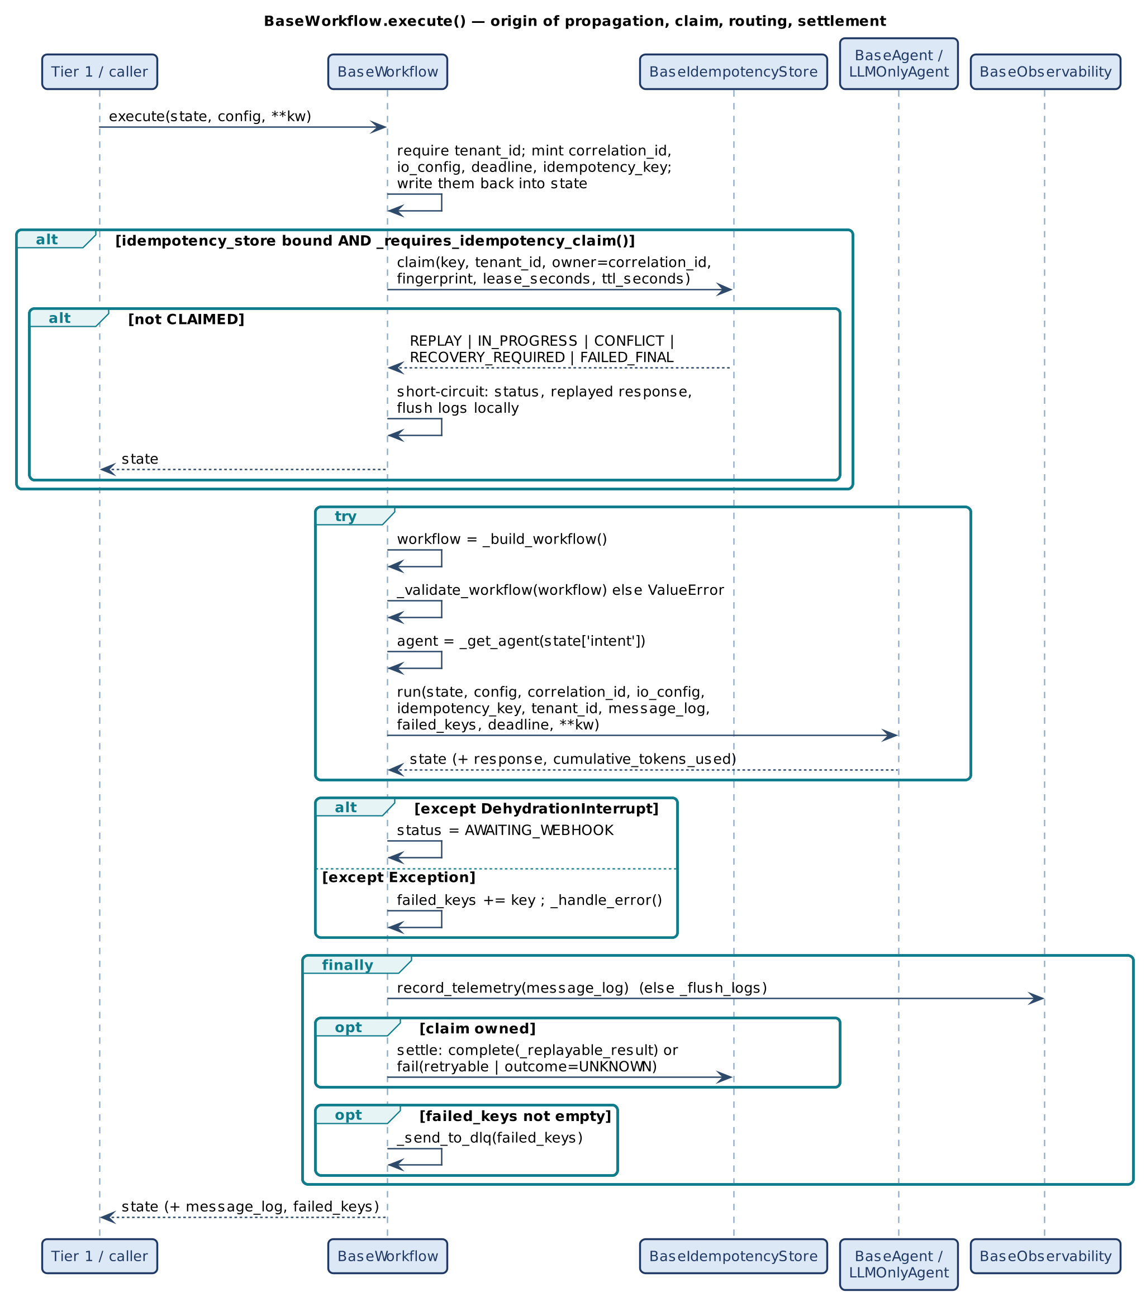
Figure 16 — BaseWorkflow.execute(): propagation, claim, routing, settlement
The claim precedes everything else, so a duplicate costs one store round trip and no model, tool or governance spend. A short-circuit returns before the try block: it flushes logs locally but does not call the observability engine or the DLQ.
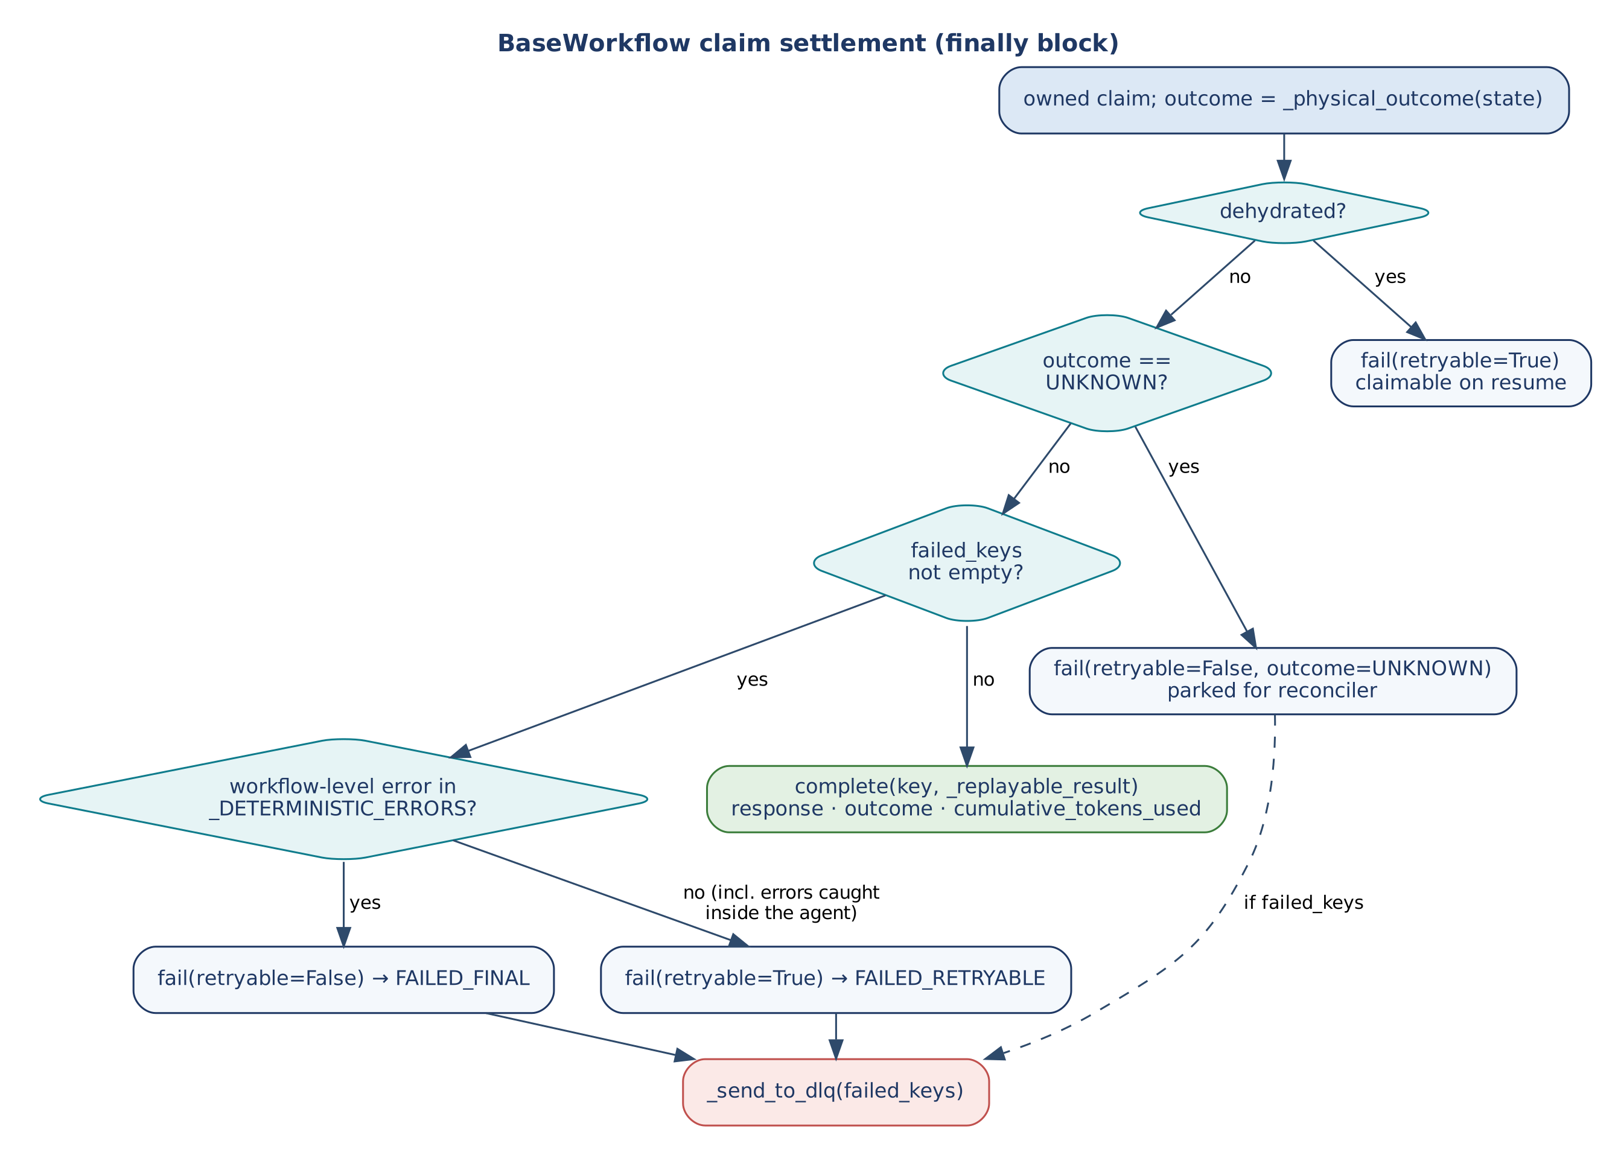
Figure 17 — Claim settlement in the workflow finally block
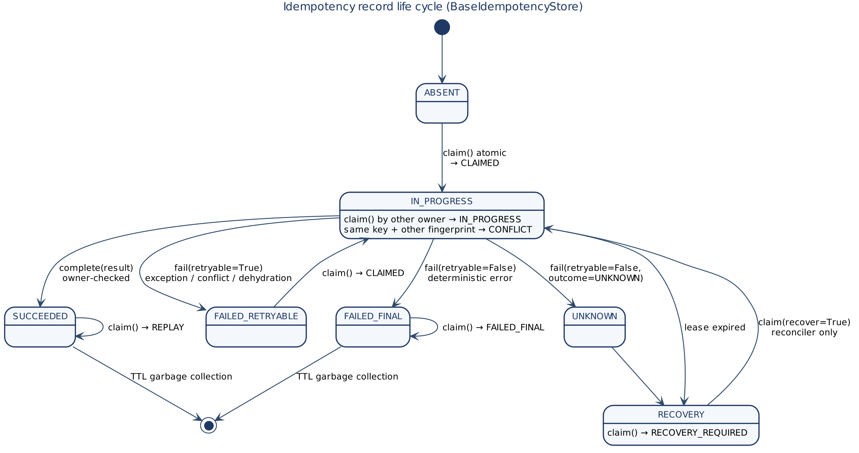
Figure 18 — Idempotency record life cycle

9.2 Agent run
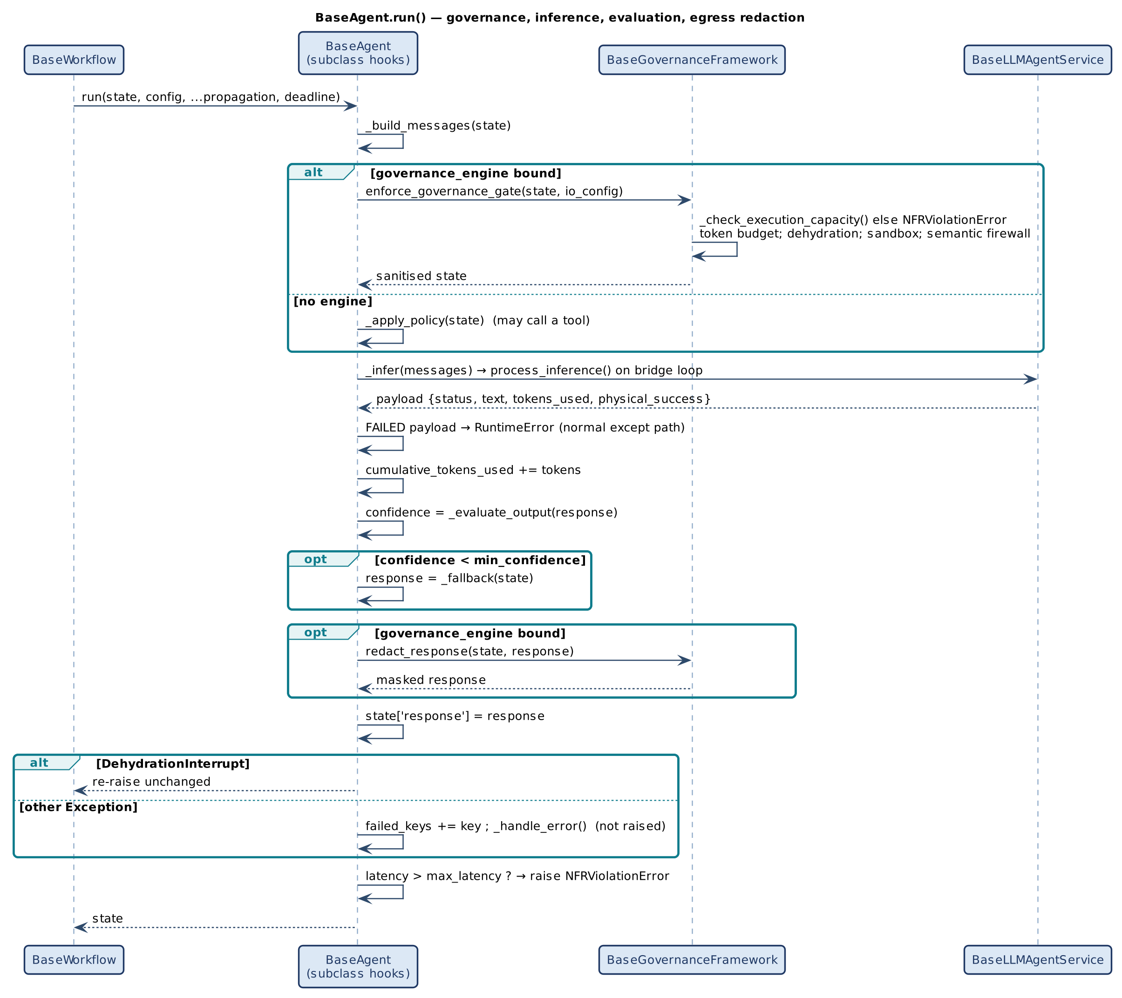
Figure 19 — BaseAgent.run(): governance, inference, evaluation, egress redaction
Ordering matters: messages are built before the governance gate (so the firewall sees the request state the prompt is built from), redaction happens after the fallback decision (so a fallback answer is also masked), and the stored replay result is taken from the redacted state.
v1.2. Figure 20 shows the v1.2 order: screening before reading, the decision stages after it, effects only after an accepted evaluation.
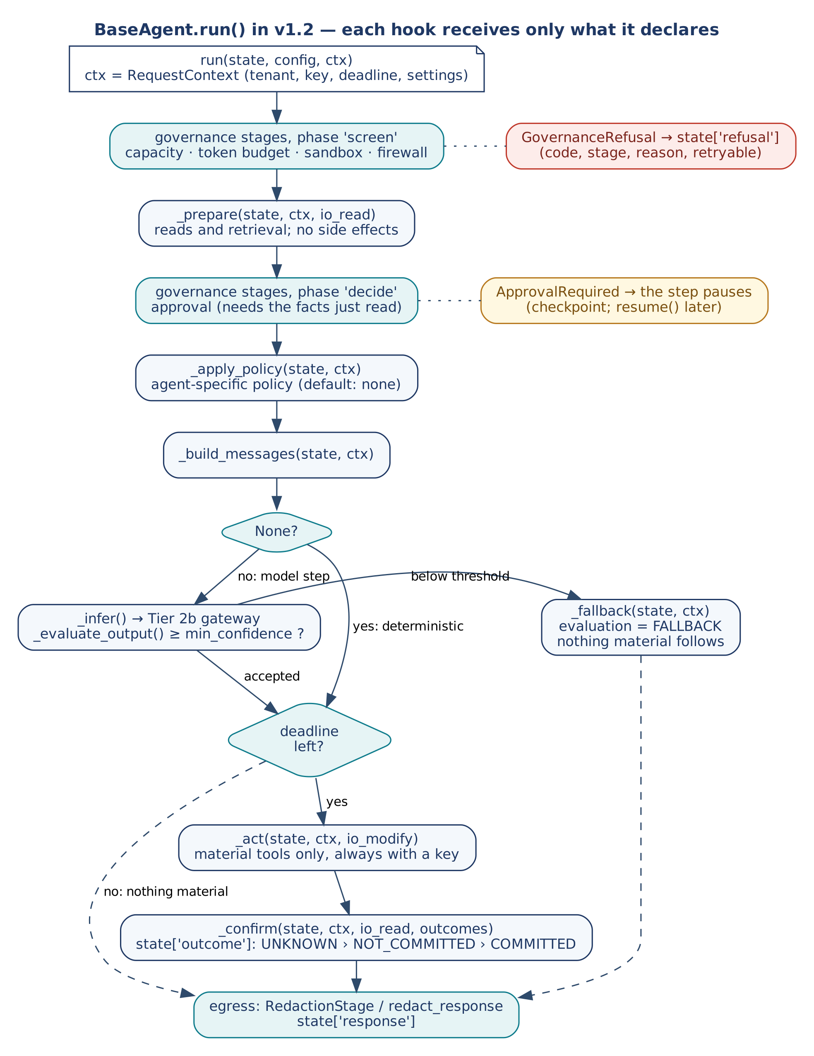
Figure 20 — BaseAgent.run() in v1.2: screen, prepare, decide, model step, act, confirm

9.3 Human-in-the-loop dehydration
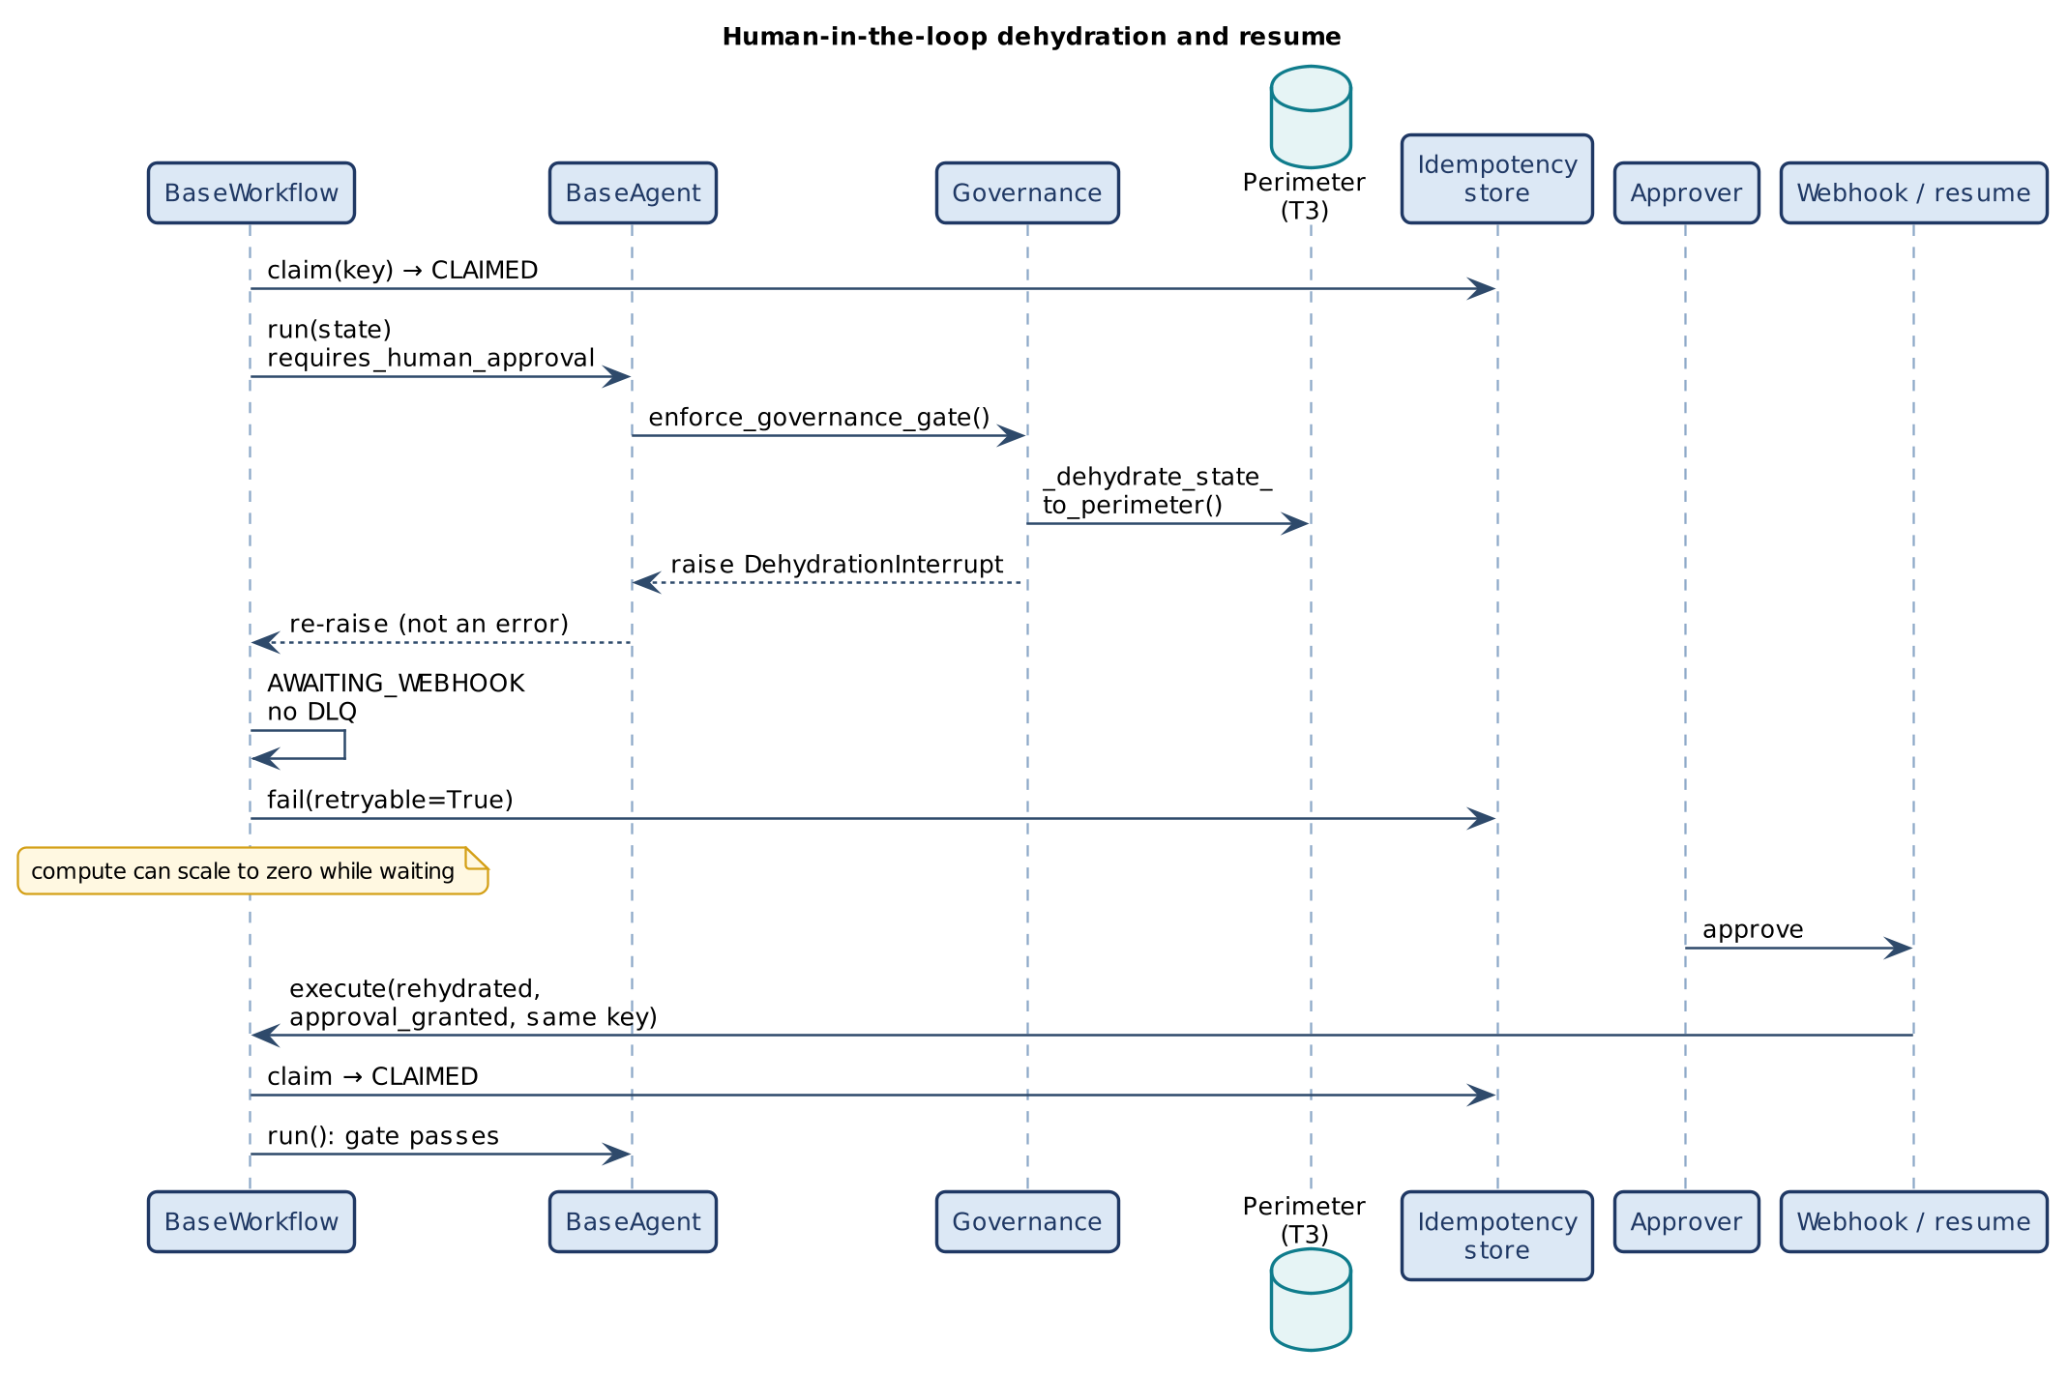
Figure 21 — Dehydration and resume
v1.2. With declared steps, ApprovalStage pauses the step and the workflow stores a checkpoint holding the state at the pause, so the approver sees what the decision is about; resume() continues at that step (Figure 22). A v1.1 workflow that pauses also gets a checkpoint and is resumed by running it again, approved.
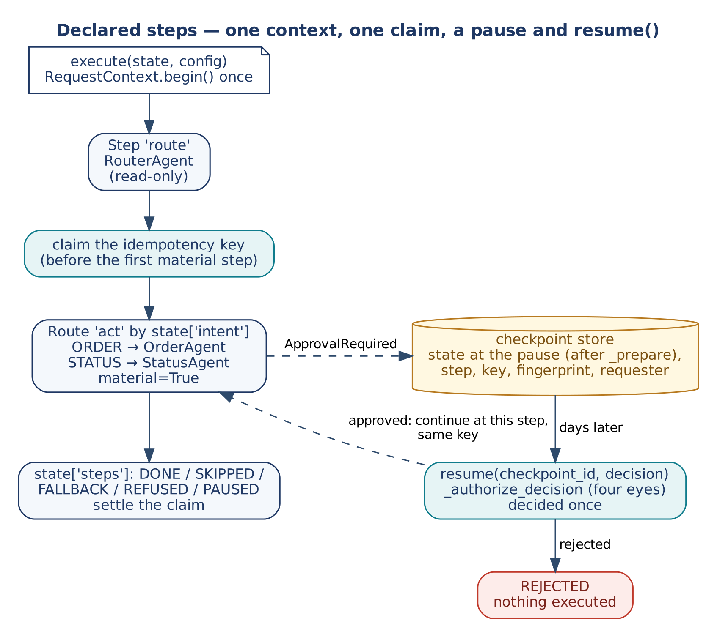
Figure 22 — Declared steps, one claim, a pause and resume()

9.4 Inference gateway
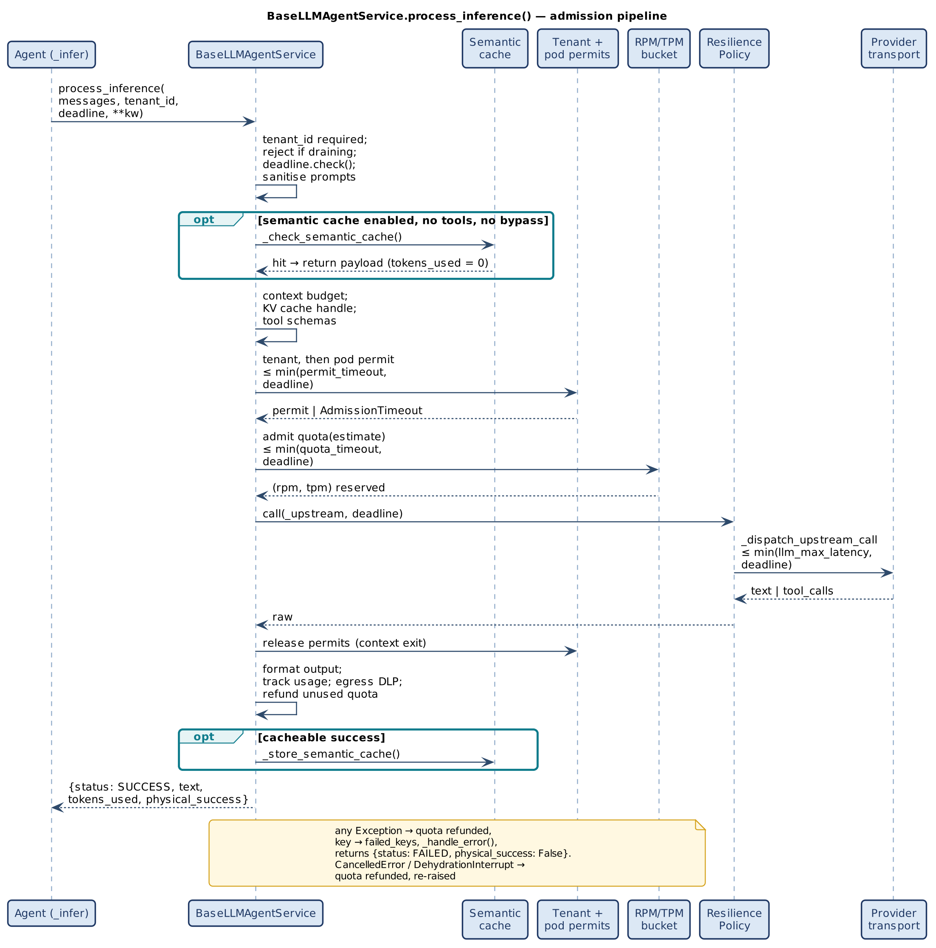
Figure 23 — process_inference(): the admission pipeline
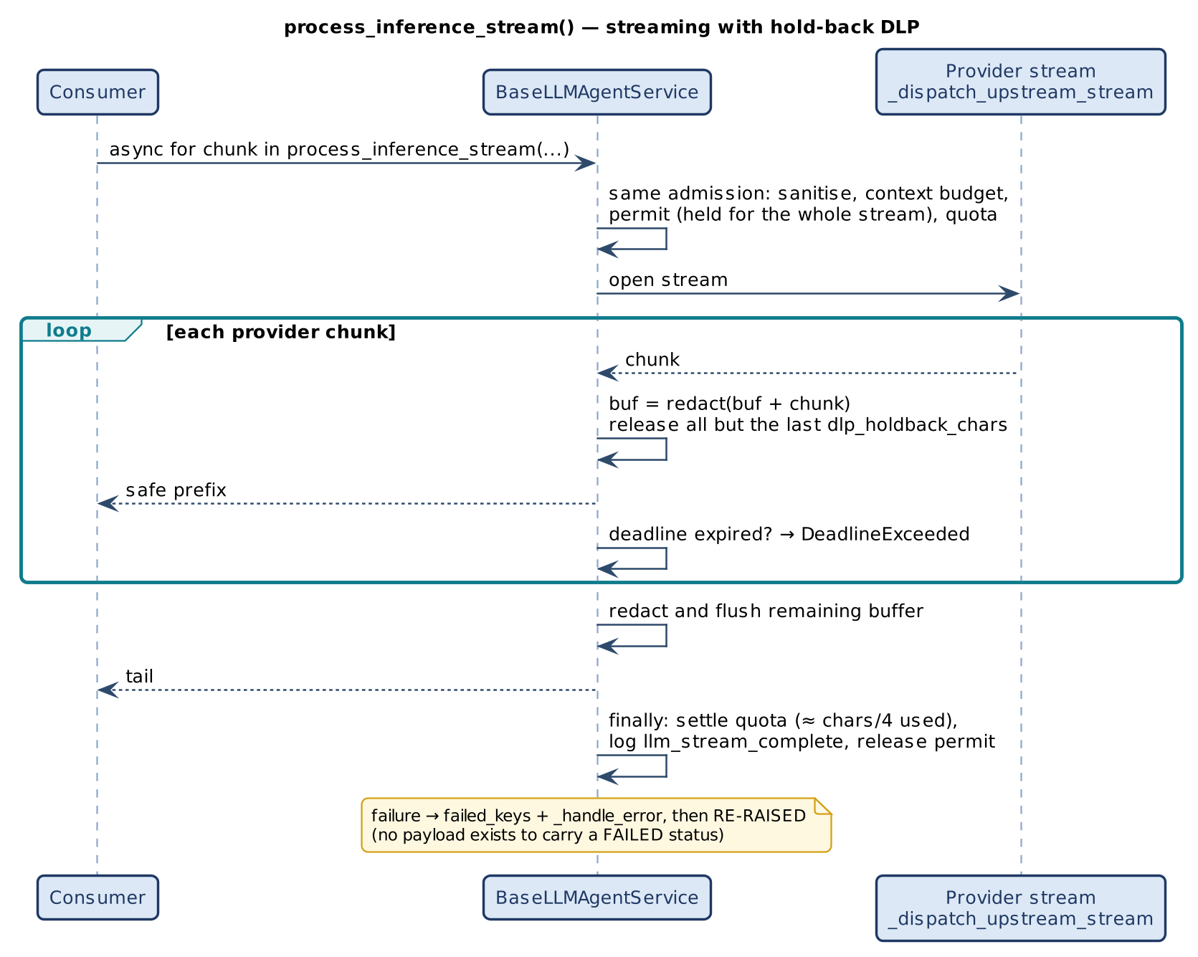
Figure 24 — process_inference_stream(): hold-back DLP
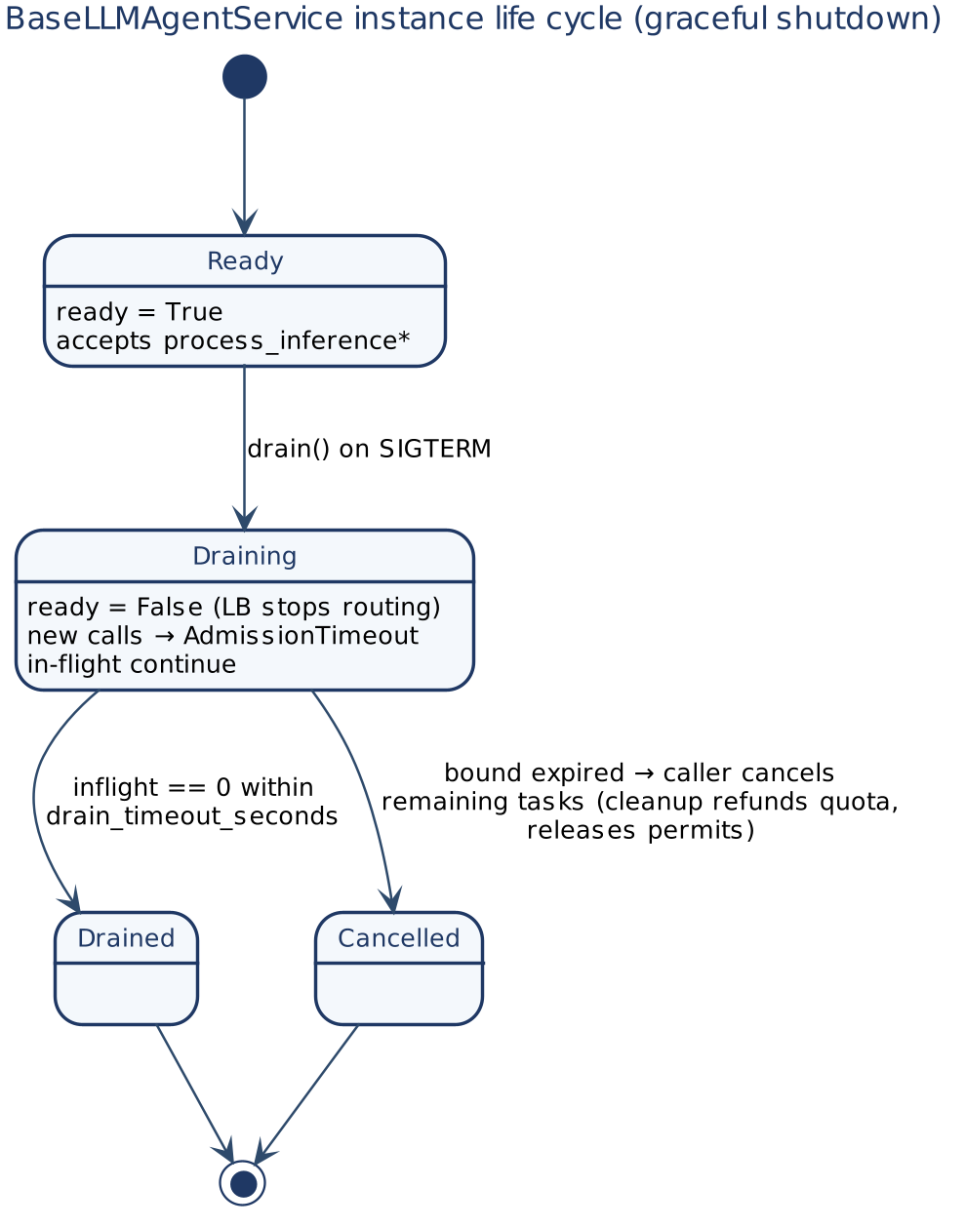
Figure 25 — Inference service life cycle and graceful shutdown

9.5 Tool calls and resilience
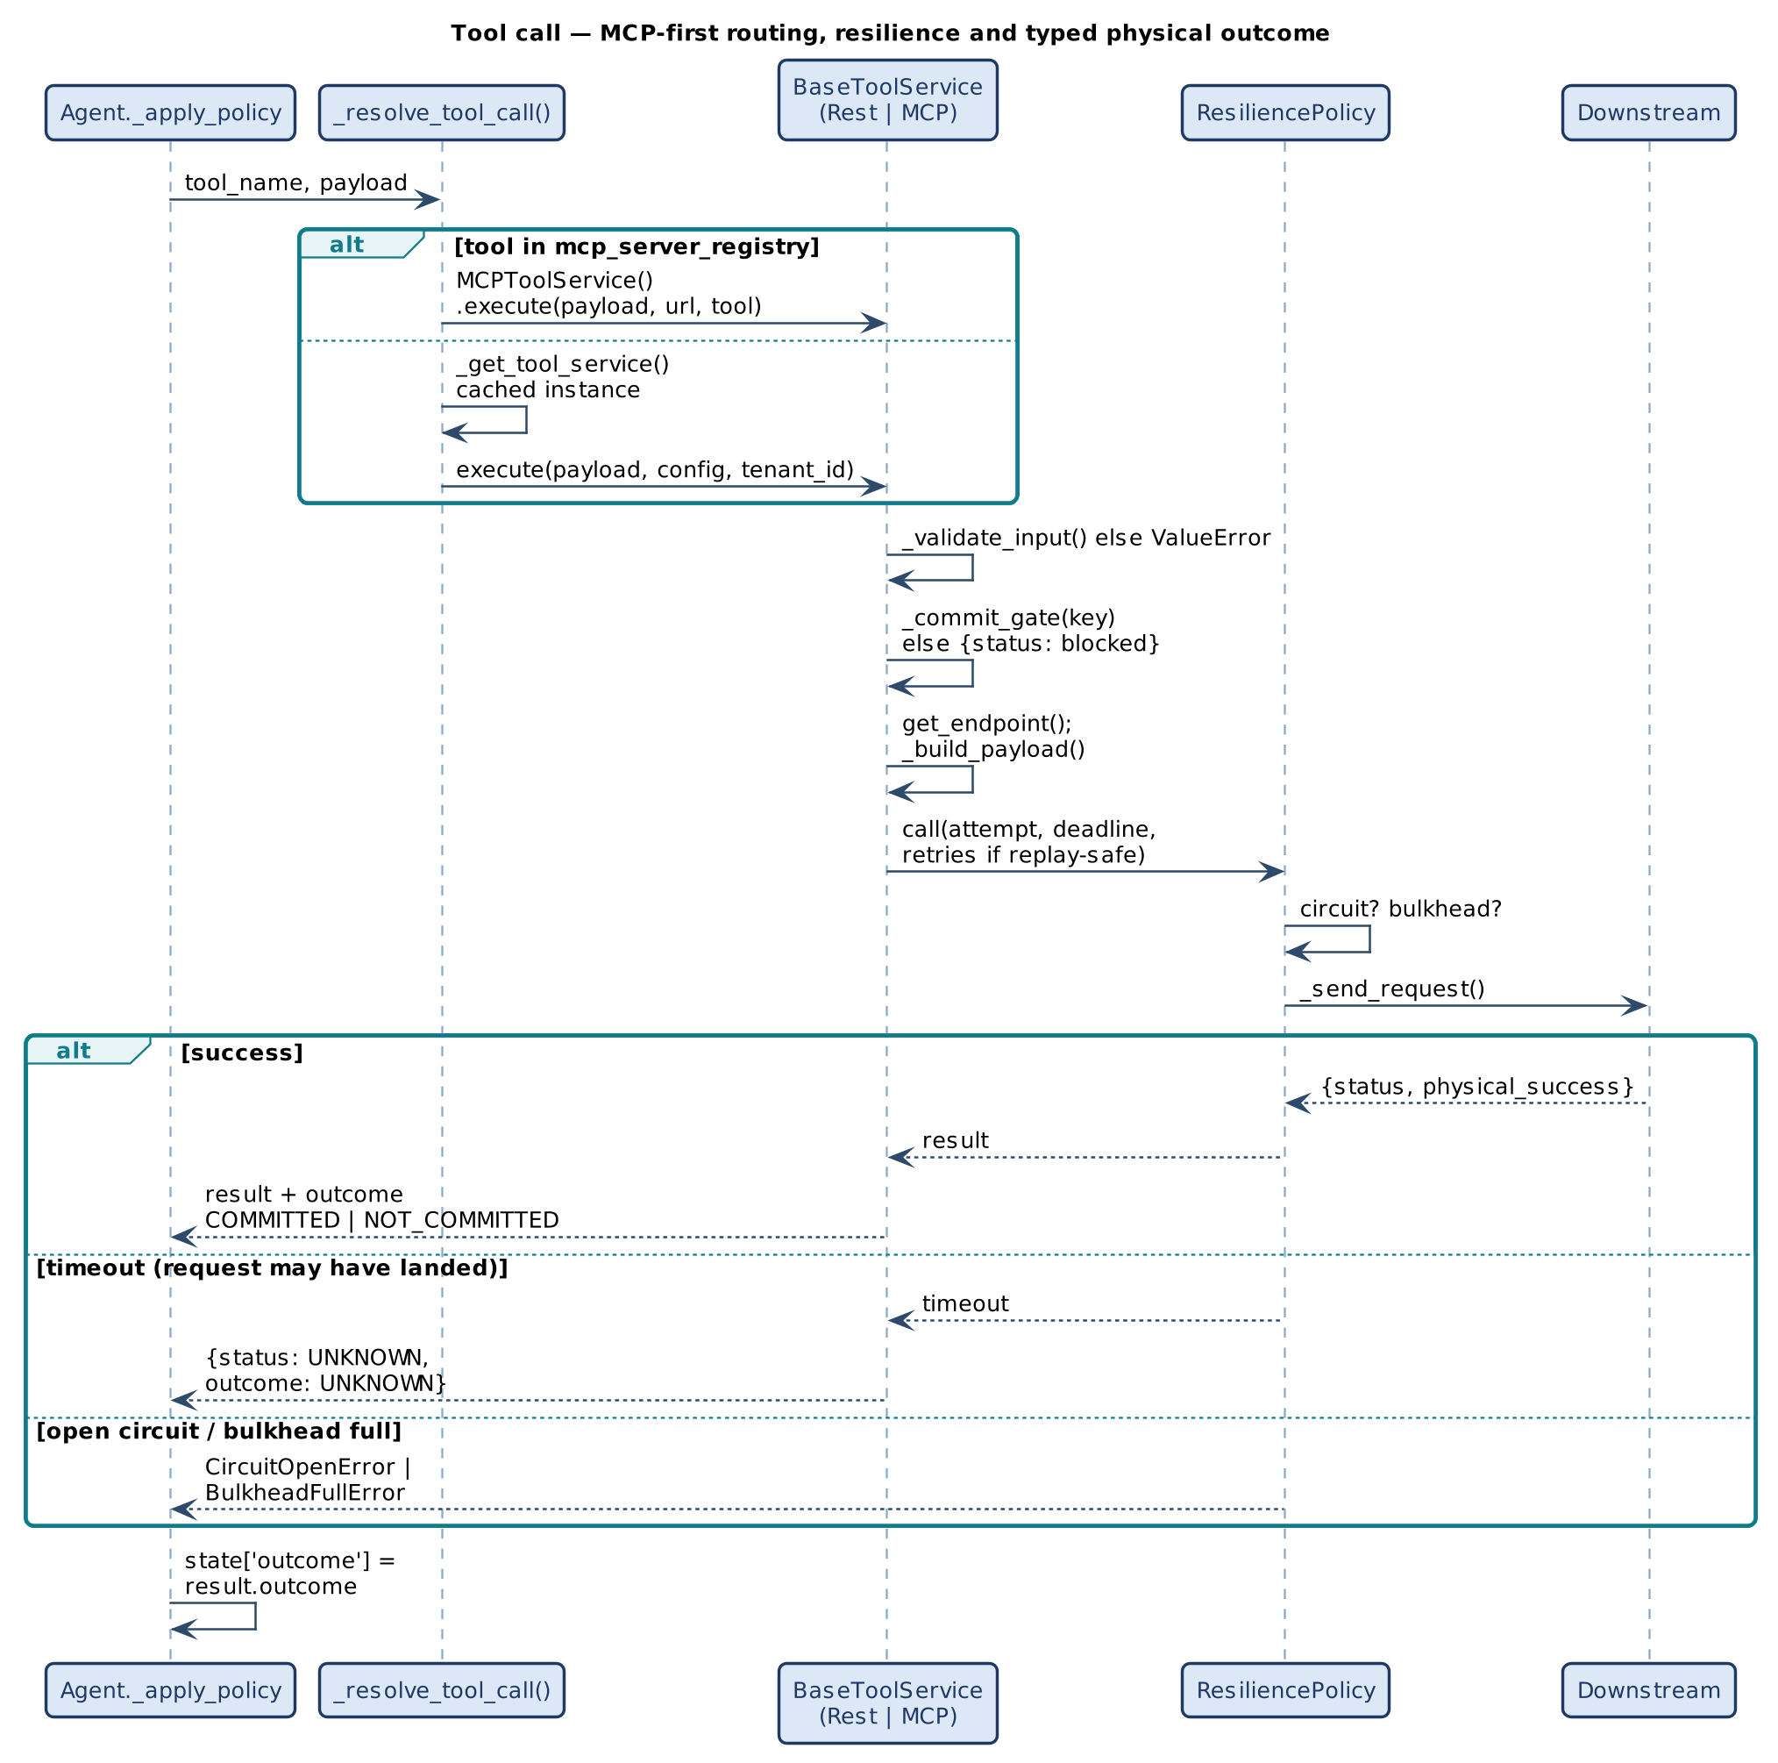
Figure 26 — Tool call: MCP-first routing, resilience and typed outcome
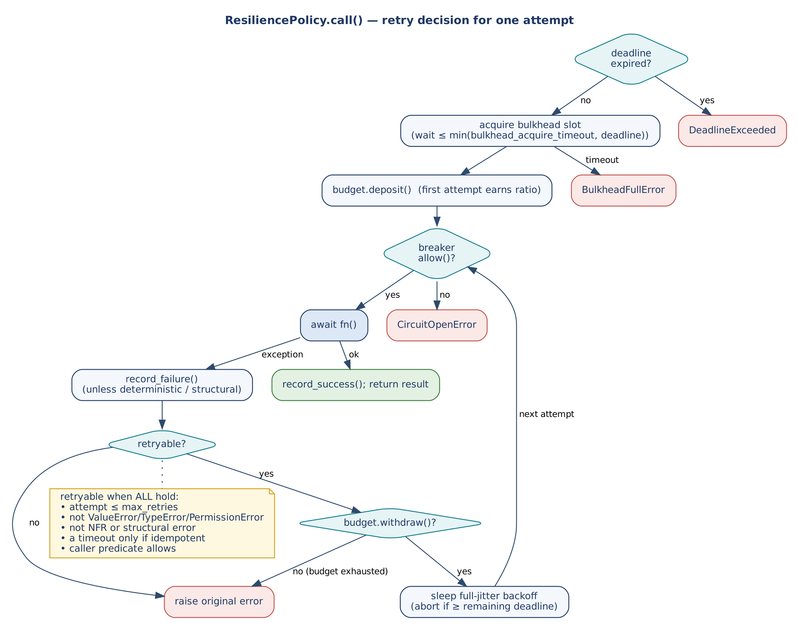
Figure 27 — ResiliencePolicy retry decision
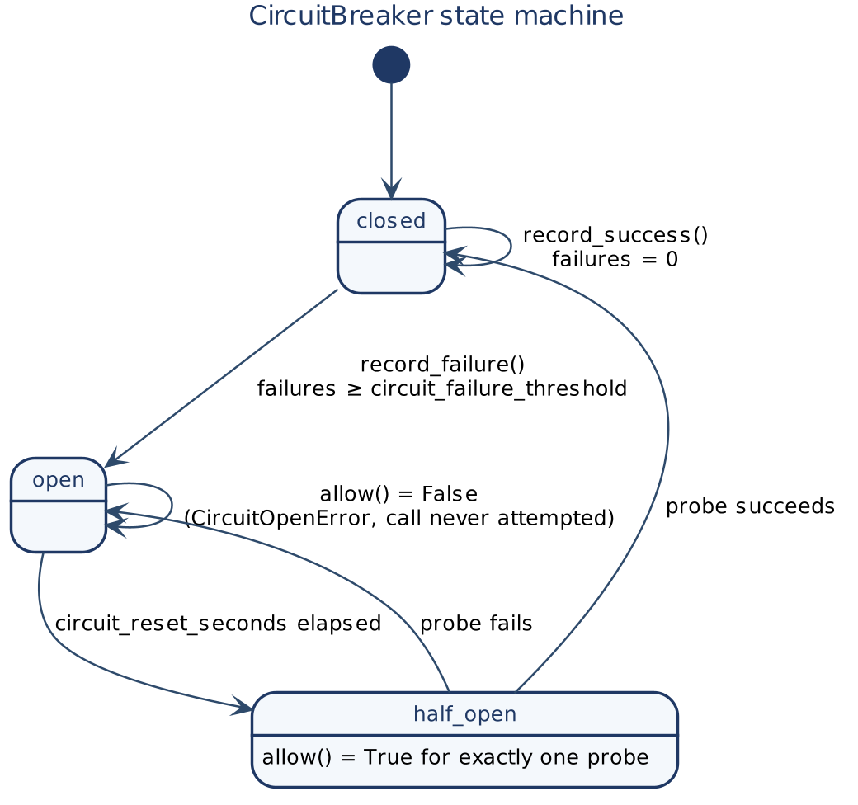
Figure 28 — CircuitBreaker state machine

9.6 MCP server
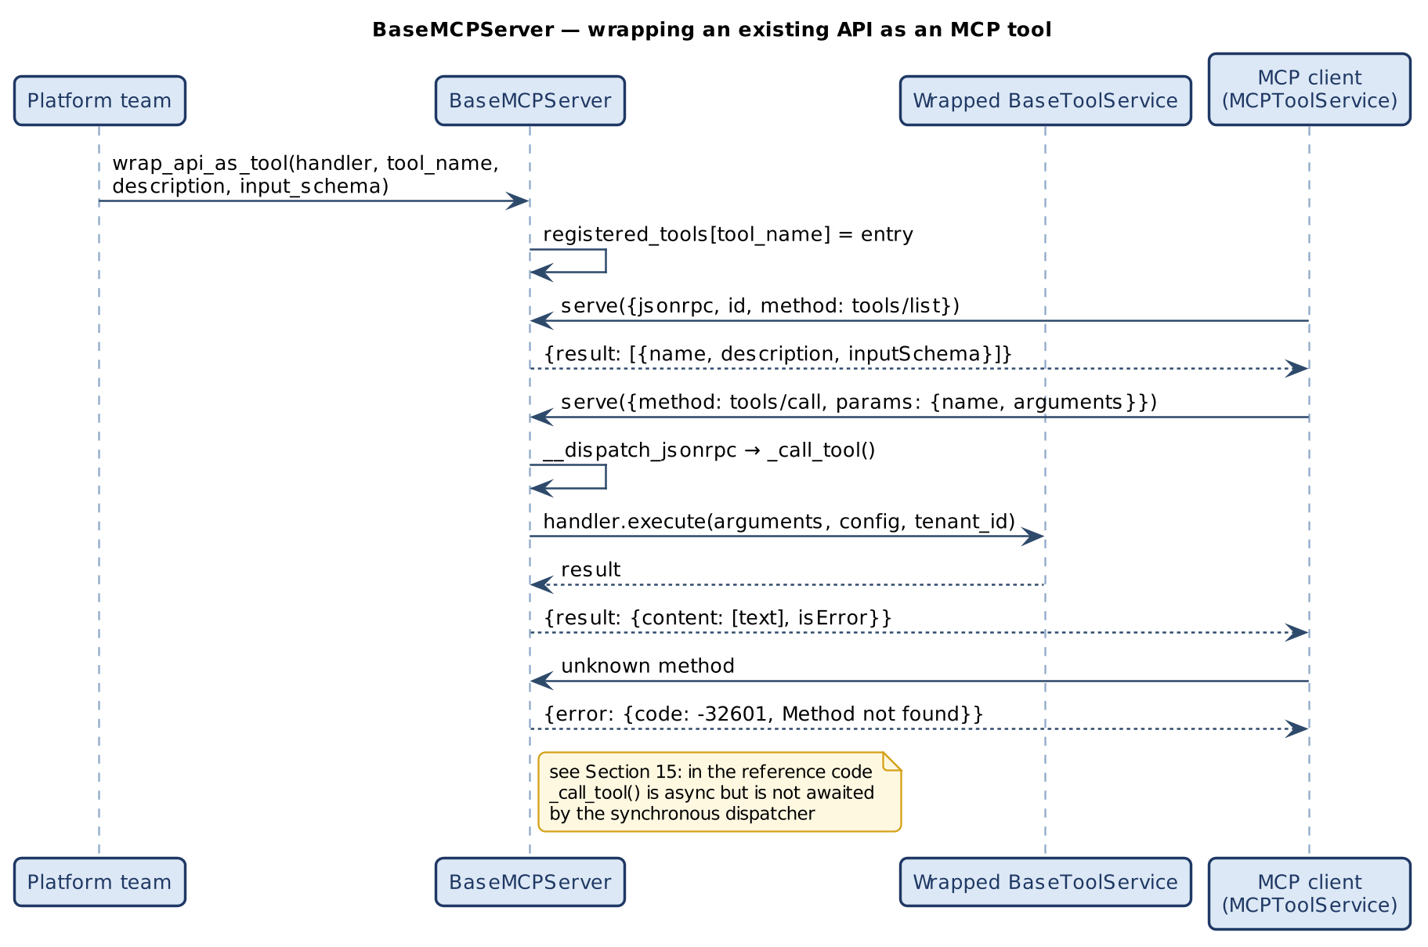
Figure 29 — Wrapping an existing API as an MCP tool

9.7 Knowledge tier
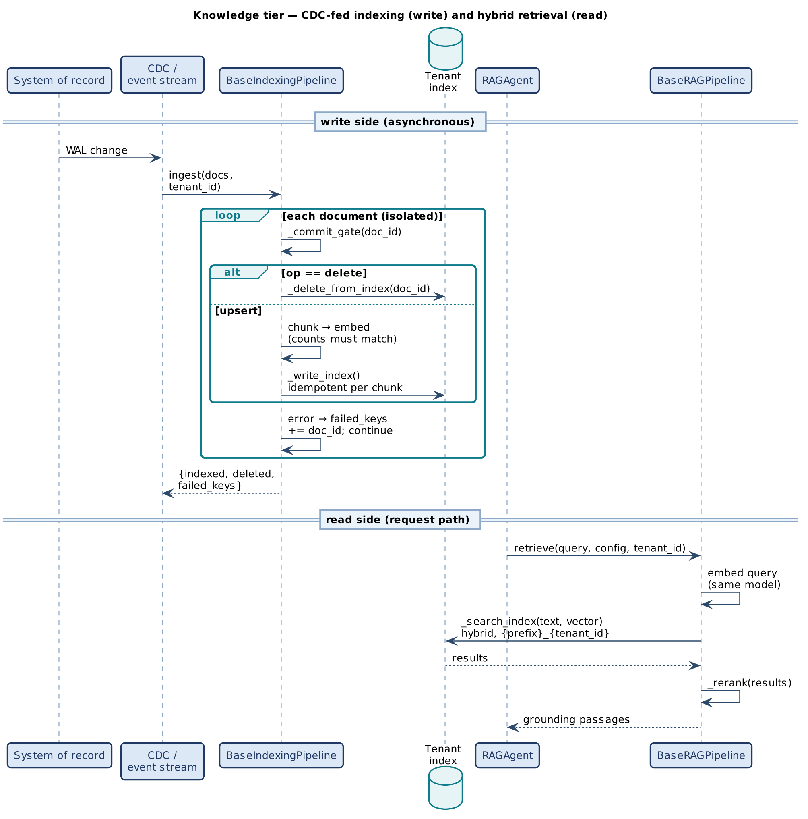
Figure 30 — CDC-fed indexing and hybrid retrieval

9.8 Reference multimodal orchestration
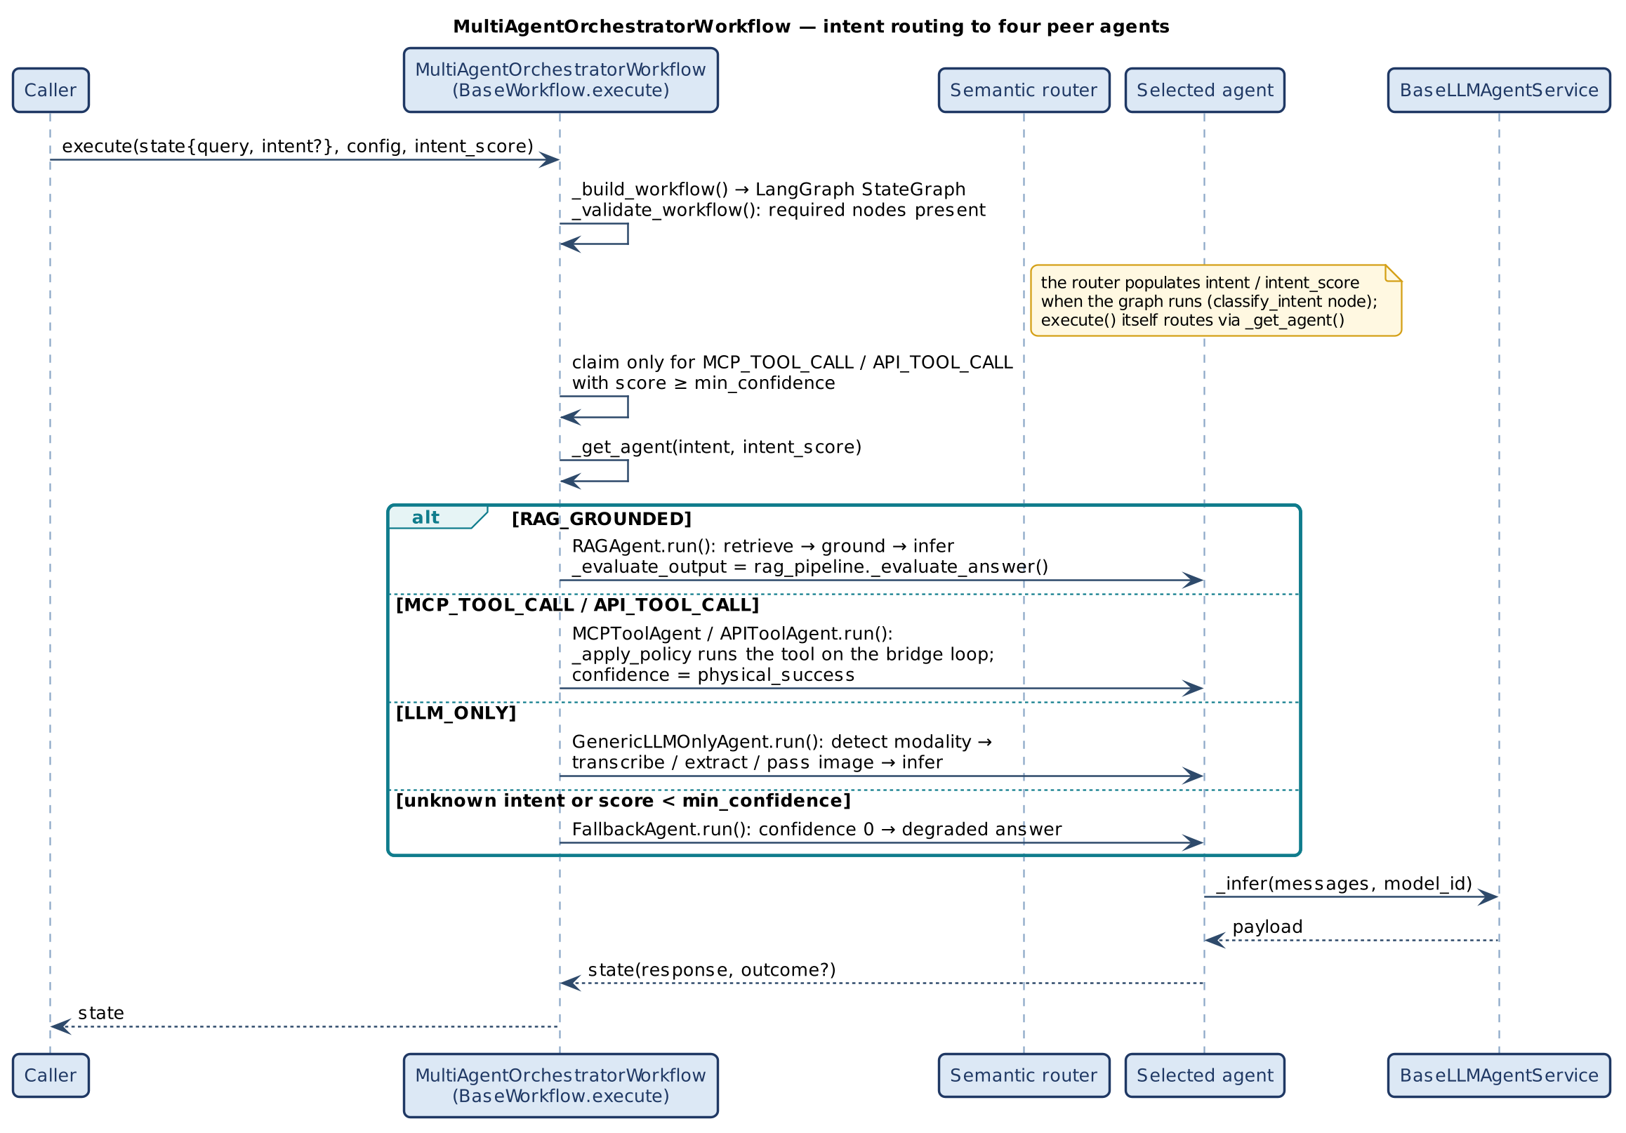
Figure 31 — Intent routing to four peer agents
Two routing paths exist in the reference: the compiled LangGraph (classify_intent → _route_intent → agent node) and BaseWorkflow.execute()'s own _get_agent() call. Both read the same registry and threshold so they cannot diverge; execute() builds and validates the graph but routes through _get_agent(), passing full propagation fields to run().

9.9 Scheduled repair
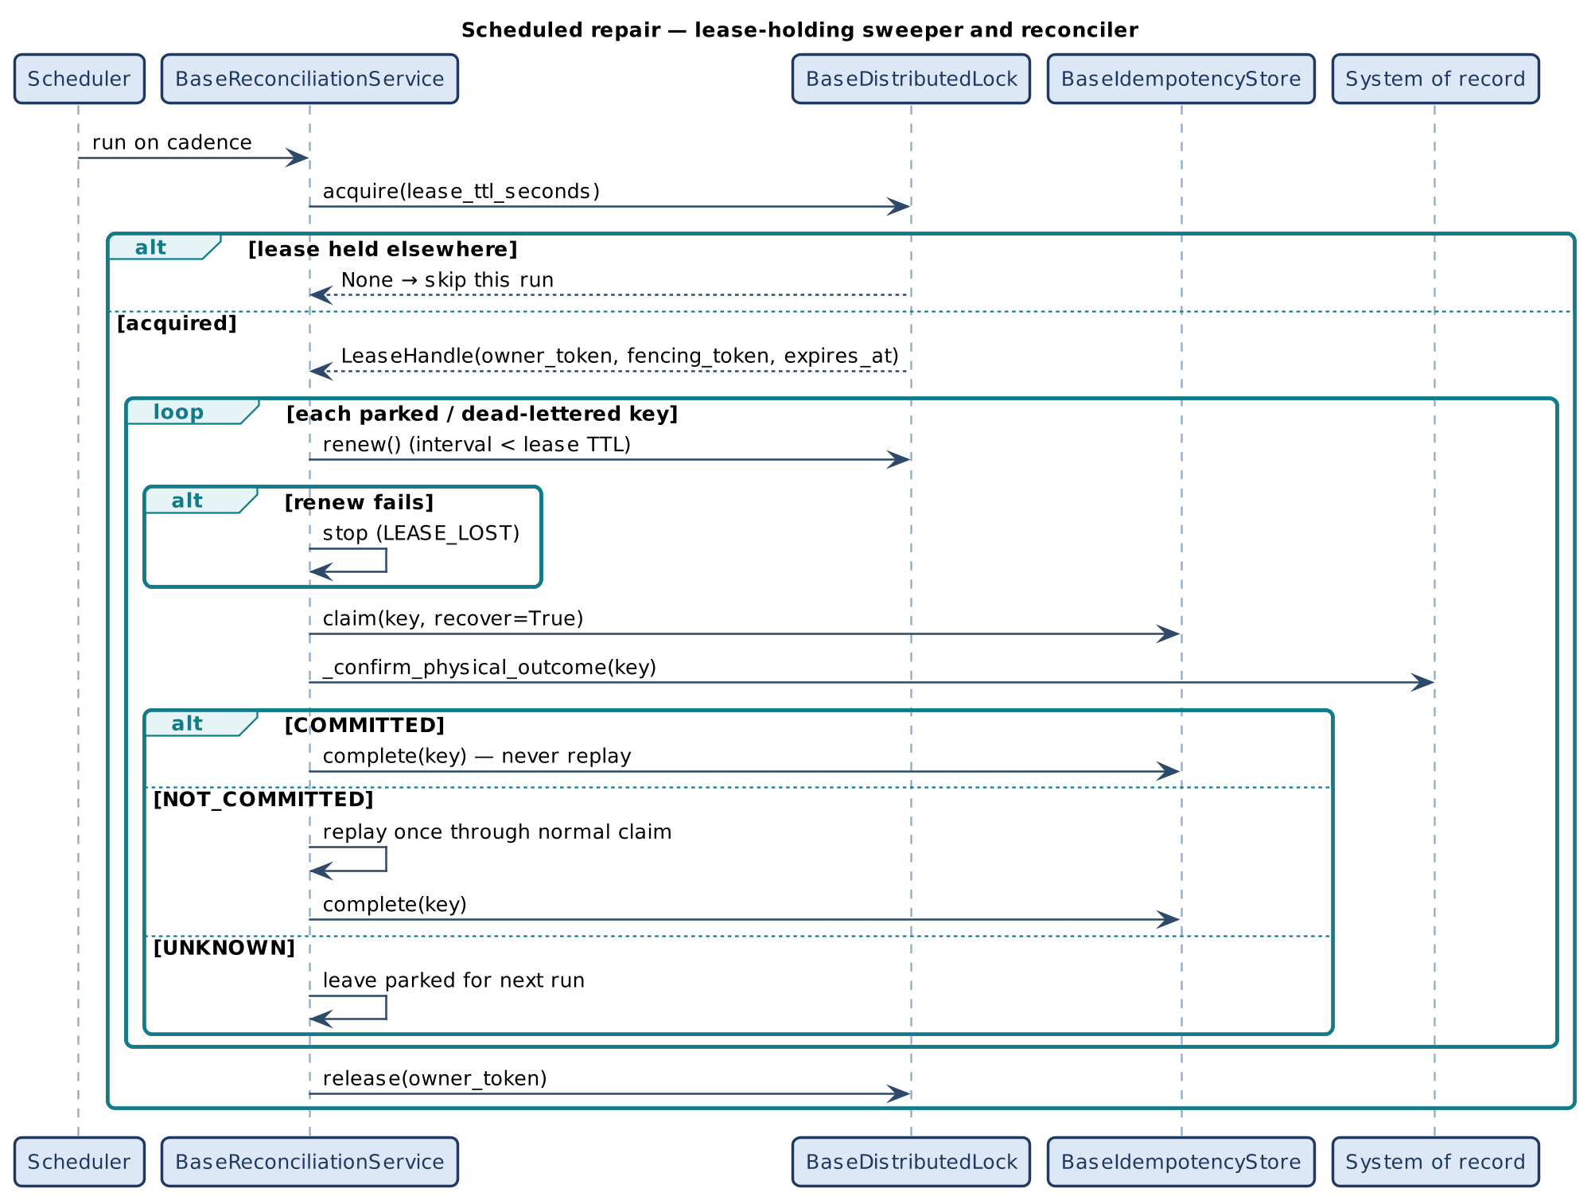
Figure 32 — Leased reconciliation

9.10 Delivery and provisioning
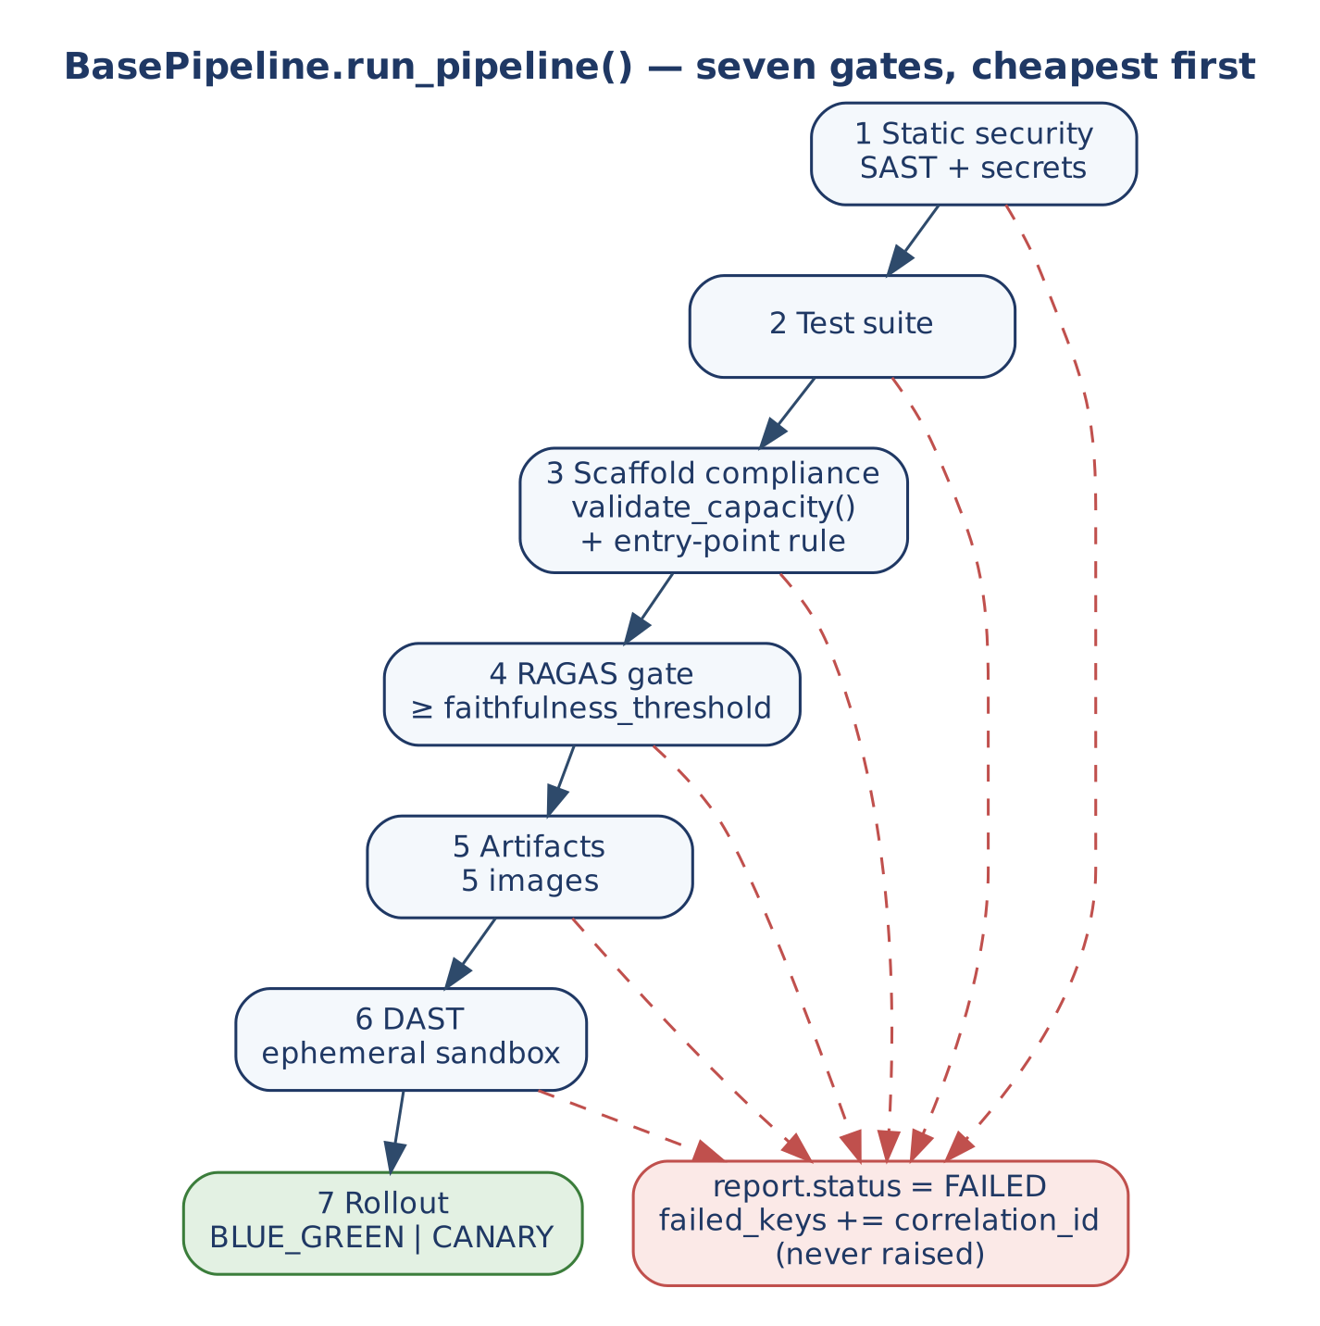
Figure 33 — BasePipeline.run_pipeline() gates
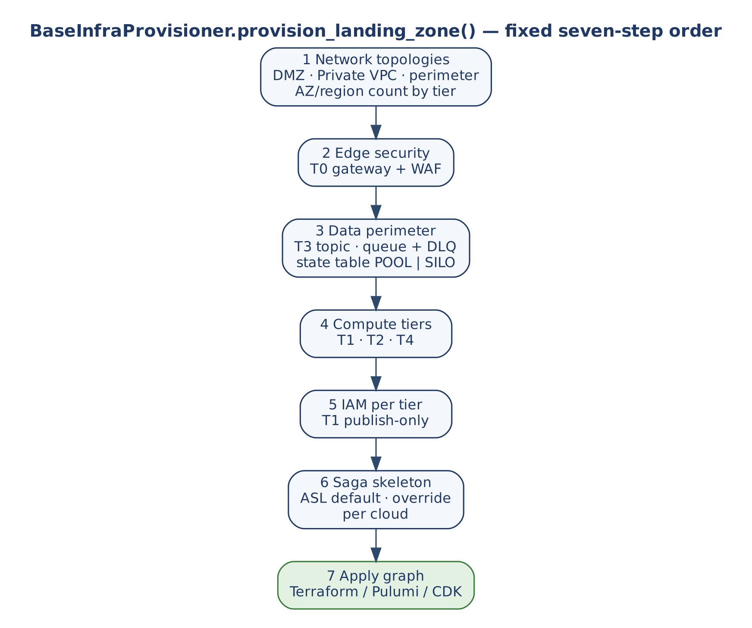
Figure 34 — provision_landing_zone() steps

10. Concurrency, Consistency and Failure Model

10.1 Ownership of concurrency risks
Table 42 — Risk ownership
Risk | Owner | Mechanism
Duplicate material request | BaseWorkflow + BaseIdempotencyStore | Atomic tenant-scoped claim, fingerprint, replay of redacted result.
Lost update | BaseTransactionalStore.put_if_version | Compare-and-set; typed CONFLICT / FENCED.
Stale writer after lease loss | LeaseHandle.fencing_token + store | Store rejects older tokens.
Model overload / noisy tenant | BaseLLMAgentService | Tenant permit, pod semaphore, RPM/TPM bucket, bounded waits.
Slow dependency | ResiliencePolicy per dependency | Bulkhead, circuit, retry budget.
Retry storms | RetryBudget | Retries ≈ retry_budget_ratio of traffic.
Ambiguous write | __http_post + PhysicalOutcome.UNKNOWN | Never re-sent; parked; reconciler confirms.
Cache stampede | BaseCacheStore.get_or_load | Per-key single-flight.
Orphaned work after timeout | _run_on_bridge_loop, __concurrency_permit, __settle_quota | Cancellation releases permits and refunds quota.
Pool and connection exhaustion | validate_capacity() | Checked in the scaffold-compliance gate.
Duplicate scheduled jobs | BaseDistributedLock | One leader per lease; renew < TTL.
Deploy-time kill of in-flight work | drain() + drain_timeout_seconds | Drain shorter than termination grace.

10.2 Error handling at each boundary
Table 43 — How each public method treats failures
Boundary | Behaviour
BaseValidationService.validate | Returns a ValidationResult; never raises for invalid input.
BaseWorkflow.execute | Raises only ValueError for a missing tenant. DehydrationInterrupt → status; other exceptions → failed_keys, _handle_error, DLQ; claim settled.
BaseAgent.run | Re-raises DehydrationInterrupt; swallows other exceptions into failed_keys; raises NFRViolationError on latency breach.
LLMOnlyAgent.run | Swallows all exceptions into failed_keys.
process_inference | Returns FAILED payloads; re-raises DehydrationInterrupt and CancelledError after refunding quota; raises ValueError for a missing tenant.
process_inference_stream | Records then re-raises every failure.
BaseToolService.execute | Raises ValueError on invalid input; returns blocked, UNKNOWN or a typed result; resilience errors propagate.
BaseIndexingPipeline.ingest | Per-document isolation; never raises for a document failure.
Sweeper, reconciler, pipeline, provisioner | Return a status report; never raise past the boundary (sweeper/reconciler propagate hook exceptions after releasing the lease).

10.3 Consistency model
- Material effects: effectively-once per tenant-scoped key, settled from physical evidence.
- Generative reads (RAG, LLM-only, fallback in the reference orchestrator): not claimed, never replayed from a stored answer.
- Index: eventually consistent with the system of record through CDC; writes idempotent per chunk.
- Caches: advisory; freshness by explicit expiry field; tenant-scoped keys.
- Quota: per-pod and approximate (estimate reserved, actual refunded); fleet-wide accuracy only with the shared-quota hook.

11. Non-Functional Design

11.1 Capacity sizing
Little's Law sizes every pool: in-flight = arrival rate × mean service time. For the inference tier, pod_concurrency per pod times replicas must stay below the provider's concurrent ceiling including retry amplification — exactly the equation in validate_capacity(). Autoscalers raise capacity only up to what the next tier can absorb (maxReplicaCount × per-pod cap ≤ downstream pool, quota or connection limit). Scale signals are in-flight requests and queue backlog. Baseline planning load from the landing zone: 20,000 daily active tenants × 5,000 operations ≈ 1,157 RPS average, ≈ 3,472 RPS design peak.

11.2 Latency budgets
Table 44 — In-code latency and wait bounds
Bound | Default | Where
max_latency | 2.0 s (tools 5.0 s, CQRS 1.0 s) | End of BaseAgent.run() — NFRViolationError.
llm_max_latency | 3.0 s | Upstream model call, capped by the deadline.
permit_timeout / quota_timeout | 5.0 s / 5.0 s | Inference admission waits.
timeout / retries (tools) | 5.0 s / 3 | Per attempt; retries only when replay-safe.
bulkhead_acquire_timeout | 1.0 s | Dependency slot wait.
cache_fill_timeout_seconds | 5.0 s | Single-flight follower wait.
request_deadline_seconds | 0 (none) | Origin of the request deadline.
drain_timeout_seconds | 20 s | Must be below termination_grace_seconds (30 s).

11.3 Security and governance controls
Table 45 — Controls by construction
Control | Where
Tenant identity | Verified JWT at T0; tenant_id mandatory at execute(), process_inference(), ingest().
Entitlements (ABAC) | _enforce_entitlement_gate() at T1 after schema validation.
Admission and load shedding | _check_execution_capacity() in the governance gate; gateway rate limits; inference permits.
Prompt injection | Edge WAF rules; __sanitize_prompts in Tier 2b; _execute_semantic_firewall() guard models.
Data loss prevention | _redact_sensitive on output and streams (hold-back); redact_response() field masking.
Model egress | Only Tier 2b has provider credentials and a route to model endpoints.
Tool sandboxing | _verify_sandbox_profile() before MCP tool execution.
Human approval | Dehydration with state persisted in the perimeter.
Tenant scoping | Claims, permits, KV handles, cache keyspaces and {prefix}_{tenant} index namespaces.
Least privilege | One IAM role per tier (_define_iam_governance_framework); T1 publish-only.
Supply chain | BasePipeline static scans, DAST, contract verification.

Policy-as-code derived from the abstract contracts (landing zone governance matrix): deny inference pods without autoscaler and semaphore settings; deny direct egress from compute pods to public model APIs; require tenant-tagged cache and KV handles; deny model credentials to any role except the inference gateway; deny promotion of a deployment that violates the capacity equations.

11.4 Observability
Every class logs structured events to the request's message_log; BaseWorkflow hands it once to record_telemetry(). The metric catalogue (E2A_METRICS) defines names, types and labels once; tenant_id is a high-cardinality label to aggregate or sample.
Table 46 — Key log events
Event | Emitter | Meaning
idempotent_short_circuit | BaseWorkflow | Duplicate, in-progress or conflicting request.
workflow_dehydrated | BaseWorkflow | Awaiting approval.
agent_run_complete | BaseAgent | Latency and cumulative tokens.
llm_semantic_cache_hit | BaseLLMAgentService | Served from semantic cache.
llm_inference_complete / llm_stream_complete | BaseLLMAgentService | Latency, tokens, KV hit, status / characters.
llm_inference_failed | BaseLLMAgentService | Error type.
llm_slow_wait (WARN) | BaseLLMAgentService | Permit/quota wait above slow_wait_threshold_seconds.
indexing_complete | BaseIndexingPipeline | Indexed, deleted, failed counts.
*_passed, pipeline_failed | BasePipeline | Gate results.

The full metric catalogue is Appendix B.

12. Extension Guide

12.1 Building a service
- Bind an inference provider. Subclass BaseLLMAgentService; implement _dispatch_upstream_call and _dispatch_upstream_stream (map canonical tool declarations to the provider format, create provider-side caches for cache_handle). Optionally implement the semantic-cache and shared-quota hooks and _emit_metric. Deploy as its own Tier 2b service.
- Implement validators on a BaseValidationService subclass (_validate_<agent_name> per agent, _enforce_entitlement_gate).
- Implement agents. BaseAgent subclasses for prompt + tool flows; LLMOnlyAgent subclasses for model-only, modality-aware flows; reuse the reference agents where generic.
- Implement knowledge and tools. BaseRAGPipeline + BaseIndexingPipeline with the same embedding model and tenant namespace; tools through RestToolService / MCPToolService or a custom _send_request; wrap internal APIs with BaseMCPServer.
- Implement the workflow. Graph, validation, agent registry, deterministic idempotency key, error mapping; override _requires_idempotency_claim for read-only intents. v1.2: declare Steps(...) instead, mark the material steps, and set checkpoint_store if a step can pause.
- (v1.2) Check conformance in CI: python -m e2a.conformance src/ --strict, and an AgentContract test per agent.
- Bind engines and ports in config: llm_service, governance_engine, observability_engine, idempotency_store, and store adapters.
- Register project config keys with register_config_key() in src/settings.py; run unknown_config_keys() at start-up.
- Wire the control plane: sweeper and reconciler with a lease adapter, a BasePipeline subclass, and a BaseInfraProvisioner per cloud.

12.2 Skeletons
class ProviderLLMService(BaseLLMAgentService):
async def _dispatch_upstream_call(self, messages, model_id, temperature, max_tokens,
tools, stop_sequences, cache_handle, config, **kw):
... # provider SDK call -> {'text': ..., 'metadata': {'tokens_used': n}} or {'tool_calls': [...]}
async def _dispatch_upstream_stream(self, messages, model_id, temperature, max_tokens, config, **kw):
async for chunk in ...: # provider stream
yield chunk

class RefundAgent(BaseAgent):
def _build_messages(self, state, config=None, **kw): ... # prompt registry + memory pruning
def _apply_policy(self, state, config=None, **kw): ... # optional tool call; set state['outcome']
def _evaluate_output(self, response, state, config=None, **kw): return 1.0 if response.get('physical_success') else 0.0
def _fallback(self, state, config=None, **kw): return {'text': '', 'metadata': {'degraded': True}}
def _handle_error(self, error, state, config=None, **kw): ...

class RefundWorkflow(BaseWorkflow):
def _build_workflow(self, config=None, **kw): ...
def _validate_workflow(self, wf, config=None, **kw): return True
def _get_agent(self, intent, config=None, **kw): return RefundAgent()
def _generate_idempotency_key(self, state, config=None, **kw): return f"{state['tenant_id']}:{state['order_id']}"
def _handle_error(self, error, state, config=None, **kw): ...

result = RefundWorkflow().execute(state, {'llm_service': ProviderLLMService(), 'idempotency_store': store,
'governance_engine': gov, 'observability_engine': obs})

The same service in the v1.2 style (from e2a import ...): each hook declares only what it uses.
class RefundAgent(BaseAgent):
def _prepare(self, state, ctx, io_read):
state['order'] = io_read.call('get_order', {'order_id': state['order_id']})
def _build_messages(self, state, ctx):
return None # deterministic: no model step
def _act(self, state, ctx, io_modify):
return [io_modify.call('issue_refund', {'order_id': state['order_id']})]

class RefundGovernance(BaseGovernanceFramework):
stages = [CapacityStage(InflightLimiter(50)), FirewallStage(), ApprovalStage()]
tool_policy = {'RefundAgent': ['get_order', 'issue_refund']}

class RefundWorkflow(BaseWorkflow):
def _build_workflow(self, ctx):
return Steps(Step('refund', RefundAgent(), material=True))
def _generate_idempotency_key(self, state, ctx):
return f"{ctx.tenant_id}:{state['order_id']}"
def _handle_error(self, error, state, ctx):
state['error_code'] = type(error).__name__

12.3 Rules and anti-patterns
Table 47 — Do and do not
Do | Do not
Reach the model only through _infer() / config['llm_service']. | Import a provider SDK in an agent or workflow.
Override protected hooks only. | Override execute(), run(), process_inference() or any __private step.
Pass request data as arguments. | Store correlation_id, tenant_id or keys on self.
Set state['outcome'] from the tool's typed result. | Infer success from model text.
Give writes an idempotency key so retries are safe. | Retry a timed-out write without a key.
Raise ValueError / TypeError / PermissionError for permanent errors. | Use generic exceptions for validation failures.
Keep one tool-service instance per dependency (_get_tool_service). | Create a new tool service (and resilience policy) per call.
Tenant-scope every cache, index and handle key. | Share a global namespace across tenants.
Register config keys centrally. | Read os.getenv() in subclasses or edit the scaffold.
(v1.2) Declare only the hook parameters you use; read settings with ctx.setting(). | Use **kwargs in a v1.2 hook, or call another class's protected hook (R2).
(v1.2) Mark material tools and steps. | Perform an effect in _prepare or through io_read.

13. Verification
The scaffold ships executable smoke tests against the in-memory doubles. At baseline 32c99c0 all pass: smoke_test_concurrency.py (48 checks), smoke_test_llm_service.py (37), smoke_test_multimodal_concurrency.py (6), and the multimodal_orchestrator.py self-test (six routing cases through the unmodified BaseWorkflow.execute()).
Table 48 — Selected evidence
ID | Scenario | Evidence
T-01 | 20 concurrent claimers; replay; conflict; tenant scoping | smoke_test_concurrency.py
— | Workflow: duplicate replays, agent ran once; changed payload → CONFLICT | smoke_test_concurrency.py
T-12 | UNKNOWN parks; duplicate not re-executed; reconciler confirms then replays once | smoke_test_concurrency.py
T-02 / T-09 | One same-version writer commits; stale owner rejected as FENCED | smoke_test_concurrency.py
T-03 | 30 async / 20 threaded concurrent misses → one load; loader failure not cached | smoke_test_concurrency.py
T-04 | Permit wait bounded; noisy tenant cannot starve a quiet one; idle tenant entries evicted | smoke_test_concurrency.py
T-10 | Deadline bounds upstream call; cancellation releases permits and refunds TPM | smoke_test_concurrency.py
T-11 | Drain: in-flight finishes, new work rejected, readiness flips | smoke_test_concurrency.py
T-06 / T-05 | Retry amplification bounded by budget; circuit opens; bulkhead rejects within bound | smoke_test_concurrency.py
T-12 | Timed-out non-idempotent write → UNKNOWN, sent once | smoke_test_concurrency.py
— | validate_capacity() and pipeline capacity gate | smoke_test_concurrency.py
— | Inference: tenant required, injection blocked, quota refund, latency SLO, pod and tenant caps, RPM exhaustion, context budget, KV handle, DLP incl. split-card streaming, semantic cache, tool schema | smoke_test_llm_service.py
— | Multimodal: request deadline bounds a tool call below the tool timeout | smoke_test_multimodal_concurrency.py

v1.2.0: pytest tests runs every smoke script above against the installed package, plus 51 tests of the v1.2 contracts: test_contract.py (14, context and accessors, the agent order), test_governance_stages.py (9), test_entry_points.py (9), test_workflow_steps.py (9), test_conformance.py (5) and test_package.py (5, every v1.1 name importable, one home per public name). 66 pass and 1 is skipped. CI also runs python -m e2a.conformance --strict over the framework and reference code. The O2C migration (39 tests and the three-service landscape demo) is the integration proof.
Recommended additions from Section 14: MCP tools/call returns a resolved result; token budget enforcement through io_config; agent-internal deterministic error settles FAILED_FINAL; latency breach after a committed side effect does not re-execute.

14. Implementation Reality, Gaps and Design Observations
These were found by reading the reference against this design. O-1 to O-4 were reproduced against the in-memory adapters at baseline 32c99c0. None changes a public signature. The status of the ones fixed since is given in the last column; O-14 to O-17 come from v1.2.
Table 49 — Design observations
ID | Observation | Effect | Recommendation
O-1 | BaseMCPServer.__dispatch_jsonrpc() calls the async _call_tool() without awaiting it. | tools/call returns a coroutine object in result (reproduced); the wrapped tool never runs. | Make serve() async and await, or run _call_tool() on the bridge loop. Status: Resolved in v1.1.2 (E-2): serve() completes the call; v1.2 adds serve_async.
O-2 | __enforce_token_budget reads max_token_budget from io_config, but _resolve_io_config() keeps only io_-prefixed keys. | The budget resolves to its default (infinity); token budgets are never enforced (reproduced). When the key is present it raises ValueError, not the documented NFRViolationError. | Read io_max_token_budget (or resolve from config) and raise NFRViolationError. Status: Resolved in v1.1.2 (E-1); v1.2 TokenBudgetStage reads the budget from the request context.
O-3 | BaseAgent.run() swallows exceptions into failed_keys; BaseWorkflow.__settle_claim() then sees no workflow-level error. | Deterministic errors inside the agent (validation, permission) settle as FAILED_RETRYABLE, so redeliveries retry them (reproduced). | Carry the agent's error type in state (e.g. state['error_type']) and use it in settlement.
O-4 | BaseAgent.run() raises the latency SLO after the response and any tool side effect. | A slow run whose tool committed is dead-lettered and settled retryable; a redelivery executes the side effect again (reproduced). | Record the breach without raising once outcome == COMMITTED, or settle by outcome before failures. Status: Resolved in v1.1.2 (E-3): the breach is recorded in state['slo_breached'], not raised.
O-5 | LLMOnlyAgent.run() has no governance gate, no redact_response() and no latency SLO. | Model-only requests bypass the semantic firewall and egress masking (the gateway's own sanitiser and DLP still apply). | Mirror the BaseAgent.run() governance wiring.
O-6 | _resolve_tool_call() creates a new MCPToolService() per call on the MCP path. | Each MCP call gets a fresh, empty circuit and retry budget, defeating per-dependency resilience. | Use the cached _get_tool_service(tool, transport='mcp').
O-7 | BaseRAGPipeline.retrieve() enforces no latency SLO, does not require tenant_id, and __embed is a placeholder. | Docs reference a retrieval SLO; an absent tenant reaches _search_index. | Add the SLO and tenant check; make embedding a hook. Status: Partly resolved: _embed_query is a hook (v1.1.2); v1.2 adds the embedding and index ports and takes the tenant from ctx. The retrieval SLO is still open.
O-8 | BaseToolService.execute() does not apply max_latency (scoped 5.0 s). | Only per-attempt timeouts bound tool calls. | Apply the scoped SLO or document it as per-attempt only.
O-9 | Several registry keys are not read by base classes: approved_agents, approved_tools, approved_models, max_tokens, shadow_mode_enabled, shadow_target_pipeline, idempotency_store_url, rag_top_k, hybrid_alpha, tool_filter, mcp_protocol_version; some used_by texts name retired methods (__lookup_idempotency_store). | Allow-lists and shadow mode look enforced but are subclass responsibilities. | Mark them "for subclass use" in the registry or wire them in.
O-10 | BaseWorkflow short-circuit flushes logs locally but does not call observability_engine. | Replays and conflicts are invisible in the telemetry backend. | Ship telemetry on the short-circuit path.
O-11 | _circuit_breaker() is abstract on governance but never called; ResiliencePolicy is the active circuit. | Two circuit concepts. | Document _circuit_breaker as a metrics/policy hook or remove it.
O-12 | BaseWebhookDispatcher.dispatch() retries immediately without backoff or deadline. | Hot retry loop against a failing receiver. | Route through ResiliencePolicy.
O-13 | In the reference orchestrator _route_intent/graph nodes call agent.run(state) without propagation fields; execute() routes via _get_agent() instead. | The compiled graph is validated but not executed by execute(). | Document the graph as the routing specification, or invoke it with propagation fields.
O-14 | v1.2 keeps the v1.1 hook signatures and get_endpoint as deprecated adapters. | Two styles coexist; each v1.1 class warns once. | Migrate (the O2C migration is the worked example); v1.3 removes the adapters.
O-15 | Conformance rule R2 is a warning by default. | A hook called from outside its class is reported but not blocking. | Run --strict in CI now; it becomes the default in v1.3.
O-16 | The v1.2 contracts exist for Python only. | Java services (A2C generates them) stay on the v1.1 shape. | e2a-java (deferred wave D).
O-17 | Steps has no loops, parallel branches or graphs. | A graph-shaped workflow keeps a v1.1 _build_workflow, or composes several workflows. | Intended: declared steps cover the projects so far; revisit on evidence.

15. What v1.2 Changes
Table 50 — E2A v1.2.0 at a glance
Area | v1.1 | v1.2 | Where
Packaging | One scaffold file, e2a_base.py | The e2a package, one module per contract area; e2a_base re-exports every v1.1 name | 7.1
Entry points | "One public method per class" | Governed entry points: a public method per genuine capability; adds resume, serve_async, evaluate_answer | 4.1, 8.18
Request data | Keyword arguments on every hook, **kwargs | One frozen RequestContext; hooks declare only what they use (ctx, io_read, io_modify, …) | 6.6
Agent order | build messages → gate → model → evaluate → redact | screen → _prepare → decide → _apply_policy → model step (optional) → evaluate → _act → _confirm → redact | 8.2, 9.2
Effects | A tool call anywhere, usually in _apply_policy | Only _act through io_modify, with a key, after an accepted evaluation and before the deadline | 6.6, 8.6
Governance | Abstract hooks on one class | Ordered stages, typed refusals, tool_policy | 8.7
Workflows | _build_workflow + _get_agent(intent) | Steps / Step / Route, one claim, state['steps'], resume() | 8.1, 9.3
Knowledge | Abstract embedding and index hooks | BaseEmbeddingModel, BaseVectorIndex, RAGPipeline façade | 8.5
Contract checks | None (one-public-method check in the pipeline) | e2a.conformance (R1–R3, D1), AgentContract | 8.18, 13
Defaults | Most hooks abstract | Safe defaults where a hook is optional | 1.3

Compatibility. Every v1.1 name imports from e2a_base; a v1.1 subclass runs unchanged with one DeprecationWarning per class; a v1.1 workflow that pauses gets a checkpoint. v1.3 removes the v1.1 adapters and makes R2 an error. The unmigrated O2C code (v1.1.2 style) passes its 39 tests on v1.2.

Appendix A. Configuration Reference (generated from E2A_CONFIG)
Resolution order for every key: call-time kwargs › config dict › environment variable › scaffold default (scoped defaults in parentheses). Object references (llm_service, engines, stores) are passed in config only.
Table C-1 — Common
Key | Environment variable | Default | Used by
io_config_prefix | IO_CONFIG_PREFIX | 'io_' | _resolve_io_config()
log_sink | LOG_SINK | 'stdout' | BaseObservability._ship_logs() / _flush_logs()
dlq_queue_url | DLQ_QUEUE_URL | (unset) | _send_to_dlq()
commit_gate_enabled | COMMIT_GATE_ENABLED | True | _commit_gate()
expected_version | — | (unset) | _commit_gate() — optional OCC version, caller-supplied per call
idempotency_store_url | IDEMPOTENCY_STORE_URL | (unset) | BaseWorkflow.__resolve_idempotency()
idempotency_ttl_seconds | IDEMPOTENCY_TTL_SECONDS | 86400 | __lookup_idempotency_store()
tenant_routing_map | TENANT_ROUTING_MAP | {} | get_endpoint() — per-tenant overrides

Table C-2 — Engines (object references)
Key | Environment variable | Default | Used by
observability_engine | — | (unset) | BaseWorkflow.execute() — BaseObservability instance
governance_engine | — | (unset) | BaseAgent.run() — BaseGovernanceFramework instance
llm_service | — | (unset) | BaseAgent / LLMOnlyAgent _infer() — the bound BaseLLMAgentService (required)
max_token_budget | — | inf | BaseGovernanceFramework.__enforce_token_budget() — io_config key
idempotency_store | — | (unset) | BaseWorkflow.execute() / BaseOrchestrator.execute() / AIDLCPipelineOrchestrator — the bound BaseIdempotencyStore (atomic claim)
cache_store | — | (unset) | BaseQueryService.fetch() — the bound BaseCacheStore (single-flight get_or_load)
transactional_store | — | (unset) | BaseCommandService._commit_versioned() — the bound BaseTransactionalStore (conditional commit)
pipeline_state_store | — | (unset) | AIDLCPipelineOrchestrator — the bound BaseTransactionalStore (durable phase state)

Table C-3 — Validation
Key | Environment variable | Default | Used by
schema_registry | VALIDATION_SCHEMA_REGISTRY_PATH | {} | BaseValidationService validators
strict_mode | VALIDATION_STRICT_MODE | True | BaseValidationService.validate()

Table C-4 — Agents
Key | Environment variable | Default | Used by
min_confidence | MIN_CONFIDENCE | 0.85 | BaseAgent.run(), LLMOnlyAgent.run() — fallback threshold
max_latency | MAX_LATENCY | 2.0 (5.0 for BaseToolService, 1.0 for CQRS) | BaseAgent.run(), BaseRAGPipeline.retrieve(), BaseToolService.execute() — latency SLO, NFRViolationError on breach
max_tokens | MAX_TOKENS | 5000 | BaseAgent.run() — token budget per call/workflow
prompt_template | PROMPT_TEMPLATE | (unset) | BaseAgent._build_messages() — default prompt template when no registry is used
cache_refresh_token | — | 'v1' | BaseAgent._build_messages() — mutate to force a context-cache miss

Table C-5 — Governance
Key | Environment variable | Default | Used by
approved_agents | APPROVED_AGENTS | [] | BaseAgent.run() — agent_name must be listed
approved_models | APPROVED_MODELS | [] | BaseRAGPipeline — embedding / reranker model allow-list
approved_tools | APPROVED_TOOLS | [] | BaseToolService — tool_name must be listed

Table C-6 — Multimodal
Key | Environment variable | Default | Used by
model_capability_registry | MODEL_CAPABILITY_REGISTRY_PATH | {} | LLMOnlyAgent._select_model()
stt_provider | STT_PROVIDER | (unset) | ModalityPreprocessor.transcribe()
document_extractor | DOCUMENT_EXTRACTOR_PROVIDER | (unset) | ModalityPreprocessor.extract()
max_audio_duration_seconds | MAX_AUDIO_DURATION_SECONDS | 600 | checked before transcribe() — NFRViolationError on breach
max_document_pages | MAX_DOCUMENT_PAGES | 50 | checked before extract() — NFRViolationError on breach

Table C-7 — LLM service
Key | Environment variable | Default | Used by
model_id | LLM_MODEL_ID | 'default' | _dispatch_upstream_call() — provider routing; LLMOnlyAgent._select_model() default
temperature | LLM_TEMPERATURE | 0.0 | _dispatch_upstream_call()
context_budget | LLM_CONTEXT_BUDGET | 8192 | _manage_context_budget() — input token budget
max_output_tokens | LLM_MAX_OUTPUT_TOKENS | 2048 | quota estimate and upstream limit
llm_max_latency | LLM_MAX_LATENCY | 3.0 | upstream call deadline — NFRViolationError on breach
pod_concurrency | LLM_POD_CONCURRENCY | 32 | pod semaphore — in-flight upstream calls
tenant_concurrency | LLM_TENANT_CONCURRENCY | 0 | per-tenant cap within the pod (0 = off)
llm_replica_count | LLM_REPLICA_COUNT | 1 | divides max_rpm / max_tpm into a per-pod share
max_rpm | LLM_MAX_RPM | 600 | fleet requests-per-minute limit
max_tpm | LLM_MAX_TPM | 300000 | fleet tokens-per-minute limit
quota_timeout | LLM_QUOTA_TIMEOUT | 5.0 | max wait for quota before NFRViolationError
enable_context_caching | LLM_ENABLE_CONTEXT_CACHING | True | _apply_kv_caching()
min_cache_threshold | LLM_MIN_CACHE_THRESHOLD | 1024 | _apply_kv_caching() — minimum static prefix tokens
enable_semantic_cache | LLM_ENABLE_SEMANTIC_CACHE | True | _check_semantic_cache() / _store_semantic_cache()
dlp_enabled | LLM_DLP_ENABLED | True | egress and stream redaction
dlp_holdback_chars | LLM_DLP_HOLDBACK_CHARS | 128 | stream holdback window
speculative_model | SPECULATIVE_MODEL | (unset) | _dispatch_upstream_call() io_config — speculative-decoding draft model
max_speculative_tokens | MAX_SPECULATIVE_TOKENS | (unset) | _dispatch_upstream_call() io_config — draft length
permit_timeout | LLM_PERMIT_TIMEOUT | 5.0 | bounded wait for the tenant + pod permit — AdmissionTimeout on expiry (also capped by the remaining deadline)
tenant_idle_evict_seconds | LLM_TENANT_IDLE_EVICT_SECONDS | 300.0 | idle per-tenant permit entries are evicted after this long

Table C-8 — RAG
Key | Environment variable | Default | Used by
faithfulness_threshold | FAITHFULNESS_THRESHOLD | 0.85 | BaseRAGPipeline._evaluate_answer(); BasePipeline RAG eval gate
rag_top_k | RAG_TOP_K | 5 | BaseRAGPipeline.retrieve() — result count
embedding_model | EMBEDDING_MODEL | 'amazon.titan-embed-text-v1' | BaseRAGPipeline.__embed()
hybrid_alpha | HYBRID_ALPHA | 0.5 | BaseRAGPipeline._search_index() — vector vs keyword weight
similarity_metric | SIMILARITY_METRIC | 'COSINE' | BaseRAGPipeline._search_index() io_config
index_name | INDEX_NAME | (unset) | BaseRAGPipeline._search_index() — index / collection
tenant_index_prefix | TENANT_INDEX_PREFIX | (unset) | BaseRAGPipeline._search_index() — f"{prefix}_{tenant_id}" namespace
rerank_top_n | RERANK_TOP_N | (unset) | BaseRAGPipeline._rerank()

Table C-9 — Tools / MCP
Key | Environment variable | Default | Used by
timeout | TOOL_TIMEOUT | 5.0 | BaseToolService.__http_post()
retries | TOOL_RETRIES | 3 | BaseToolService.execute()
tool_base_url | TOOL_BASE_URL | 'http://localhost' | RestToolService.get_endpoint()
auth_token | TOOL_AUTH_TOKEN | (unset) | BaseToolService.__http_post()
mcp_server_url | MCP_SERVER_URL | (unset) | MCPToolService.get_endpoint()
mcp_protocol_version | MCP_PROTOCOL_VERSION | '2025-06-18' | BaseMCPServer.serve()
mcp_server_name | MCP_SERVER_NAME | 'e2a-mcp-server' | BaseMCPServer — logging identity
tool_filter | MCP_TOOL_FILTER | (unset) | BaseMCPServer — exposed-tool allow-list
mcp_server_registry | MCP_SERVER_REGISTRY_PATH | {} | _resolve_tool_call() — checked first
tool_registry | TOOL_REGISTRY_PATH | {} | _get_tool_service() — fallback path
default_transport | DEFAULT_TOOL_TRANSPORT | 'http' | _get_tool_service() — final fallback
max_retries | WEBHOOK_MAX_RETRIES | 3 | BaseWebhookDispatcher.dispatch()
signing_secret | WEBHOOK_SIGNING_SECRET | (unset) | BaseWebhookDispatcher._sign_payload()

Table C-10 — Workflow / Pipeline
Key | Environment variable | Default | Used by
shadow_mode_enabled | SHADOW_MODE_ENABLED | False | BaseWorkflow.execute() — Blue-Green / shadow trials
shadow_target_pipeline | SHADOW_TARGET_PIPELINE | (unset) | BaseWorkflow.execute() — shadow target
prompt_store_url | PROMPT_STORE_URL | (unset) | BasePromptRegistry.get_prompt()
default_version | PROMPT_DEFAULT_VERSION | 'latest' | BasePromptRegistry.get_prompt()
deployment_strategy | DEPLOYMENT_STRATEGY | 'BLUE_GREEN' | BasePipeline._execute_deployment_rollout()

Table C-11 — Deadlines
Key | Environment variable | Default | Used by
request_deadline_seconds | REQUEST_DEADLINE_SECONDS | 0.0 | BaseWorkflow.execute() / BaseOrchestrator.execute() — origin of the additive deadline field (0 = none)

Table C-12 — Resilience
Key | Environment variable | Default | Used by
retry_base_backoff | RETRY_BASE_BACKOFF | 0.1 | ResiliencePolicy — full-jitter exponential backoff base (seconds)
retry_max_backoff | RETRY_MAX_BACKOFF | 2.0 | ResiliencePolicy — backoff ceiling (seconds)
retry_budget_ratio | RETRY_BUDGET_RATIO | 0.2 | ResiliencePolicy — retry tokens earned per first attempt (caps retry amplification)
retry_budget_cap | RETRY_BUDGET_CAP | 10.0 | ResiliencePolicy — maximum retry-token balance
circuit_failure_threshold | CIRCUIT_FAILURE_THRESHOLD | 5 | ResiliencePolicy — consecutive failures that open the circuit
circuit_reset_seconds | CIRCUIT_RESET_SECONDS | 30.0 | ResiliencePolicy — open duration before a half-open probe
bulkhead_max_concurrent | BULKHEAD_MAX_CONCURRENT | 16 | ResiliencePolicy — per-dependency in-flight cap (0 = off)
bulkhead_acquire_timeout | BULKHEAD_ACQUIRE_TIMEOUT | 1.0 | ResiliencePolicy — bounded wait for a bulkhead slot

Table C-13 — Pools / capacity
Key | Environment variable | Default | Used by
db_pool_size | DB_POOL_SIZE | 20 | store adapters — per-instance database connection pool
http_pool_size | HTTP_POOL_SIZE | 50 | tool / upstream adapters — per-instance HTTP connection pool
retrieval_pool_size | RETRIEVAL_POOL_SIZE | 20 | BaseRAGPipeline._search_index() adapters — per-instance index connection pool
fleet_replica_count | FLEET_REPLICA_COUNT | 1 | validate_capacity() — replicas of this service (multiplies per-instance concurrency)
db_max_connections | DB_MAX_CONNECTIONS | 0 | validate_capacity() — database connection ceiling for the whole fleet (0 = unchecked)
model_max_inflight | MODEL_MAX_INFLIGHT | 0 | validate_capacity() — provider-side concurrent request ceiling for the whole fleet (0 = unchecked)
termination_grace_seconds | TERMINATION_GRACE_SECONDS | 30.0 | validate_capacity() — platform SIGTERM-to-SIGKILL window; drain_timeout_seconds must be shorter

Table C-14 — Async workers
Key | Environment variable | Default | Used by
worker_concurrency | WORKER_CONCURRENCY | 8 | consumer runtime — in-flight messages per instance
worker_prefetch | WORKER_PREFETCH | 16 | consumer runtime — broker prefetch / max in-flight window per instance
drain_timeout_seconds | DRAIN_TIMEOUT_SECONDS | 20.0 | consumer runtime / services — graceful-shutdown drain bound

Table C-15 — Leases
Key | Environment variable | Default | Used by
lease_ttl_seconds | LEASE_TTL_SECONDS | 60 | BaseOutboxSweeper / BaseReconciliationService — BaseDistributedLock lease TTL
lease_renew_interval_seconds | LEASE_RENEW_INTERVAL_SECONDS | 20 | BaseOutboxSweeper / BaseReconciliationService — renew cadence (must be < lease_ttl_seconds)
fencing_enabled | FENCING_ENABLED | True | lease holders pass LeaseHandle.fencing_token to downstream commits
idempotency_lease_seconds | IDEMPOTENCY_LEASE_SECONDS | 300 | BaseIdempotencyStore.claim() — IN_PROGRESS claim expiry; an expired claim needs reconciliation, never blind re-execution

Table C-16 — Cache
Key | Environment variable | Default | Used by
cache_fill_timeout_seconds | CACHE_FILL_TIMEOUT_SECONDS | 5.0 | BaseCacheStore.get_or_load() — follower wait for the in-flight fill
cache_fill_on_timeout | CACHE_FILL_ON_TIMEOUT | 'load' | BaseCacheStore.get_or_load() — follower policy on fill timeout: load \

Table C-17 — Build (AI-DLC)
Key | Environment variable | Default | Used by
build_max_inflight | BUILD_MAX_INFLIGHT | 4 | AIDLCPipelineOrchestrator — concurrent builds per instance
tenant_build_max_inflight | TENANT_BUILD_MAX_INFLIGHT | 2 | AIDLCPipelineOrchestrator — concurrent builds per tenant

Table C-18 — Concurrency observability
Key | Environment variable | Default | Used by
slow_wait_threshold_seconds | SLOW_WAIT_THRESHOLD_SECONDS | 0.5 | permit / pool / bulkhead waits above this are logged at WARN
queue_age_slo_seconds | QUEUE_AGE_SLO_SECONDS | 60.0 | oldest-message age above this is an SLO breach signal

Appendix B. Metric Catalogue (generated from E2A_METRICS)
Table M-1 — Metric catalogue (E2A_METRICS)
Metric | Type | Unit | Labels
e2a.llm.inflight | gauge | requests | pod
e2a.llm.permit_wait_seconds | histogram | s | tenant_id
e2a.llm.quota_wait_seconds | histogram | s | tenant_id
e2a.admission.rejected_total | counter | 1 | reason
e2a.retry.attempts_total | counter | 1 | dependency
e2a.retry.budget_exhausted_total | counter | 1 | dependency
e2a.circuit.state | gauge | 0=closed,1=half,2=open | dependency
e2a.bulkhead.wait_seconds | histogram | s | dependency
e2a.occ.conflicts_total | counter | 1 | store
e2a.idempotency.replays_total | counter | 1 | status
e2a.lease.lost_total | counter | 1 | lease
e2a.fencing.rejections_total | counter | 1 | store
e2a.cache.single_flight_followers_total | counter | 1 | cache
e2a.queue.depth | gauge | messages | queue
e2a.queue.oldest_age_seconds | gauge | s | queue
e2a.cancellation.cleanup_total | counter | 1 | owner

Appendix C. Glossary and Traceability
Table G-1 — Glossary
Term | Definition
Scaffold | The base classes a project subclasses and never modifies: the e2a package since v1.2 (e2a_base is its compatibility module); e2a_base.py until v1.1.
Request context (ctx) | v1.2: the frozen identity and settings of one request (RequestContext), created once at the outermost entry point.
io_read / io_modify | v1.2: the accessors for replay-safe and material tools; a hook receives one only if it declares it.
Stage | v1.2: one governance check in an ordered list (screen, decide or egress); a failure is a typed GovernanceRefusal.
Steps / Step / Route | v1.2: a workflow's declared agent runs, under one context and one claim.
Checkpoint | v1.2: the stored state of a paused step, decided once through resume().
Governed entry point | v1.2 principle: a public method per genuine capability, delegating to hooks; checked by e2a.conformance.
Propagation fields | Request-scoped arguments threaded through every class: correlation_id, tenant_id, idempotency_key, io_config, message_log, failed_keys, plus deadline, trace_context, expected_version, fencing_token.
Inference gateway (Tier 2b) | The deployed BaseLLMAgentService binding; the only model egress.
Physical outcome | Whether a material effect committed in the system of record: COMMITTED, NOT_COMMITTED, UNKNOWN.
Logical vs physical rule | Model narrative is never ground truth; only physical_success / outcome are.
Claim | Atomic tenant-scoped ownership of an idempotency key.
Dehydration | Persisting state and pausing (compute can scale to zero) until an approval webhook.
Single-flight | One loader call per cache key for concurrent misses.
Lease / fencing token | Time-bound renewable ownership; a monotonic token that lets a store reject a stale owner.
Retry budget | Token bucket that caps retries to a fraction of first attempts.
Bulkhead | Per-dependency in-flight cap with a bounded wait.
Structural isomorphism | One-to-one mapping between class boundaries and landing-zone tiers.

Table G-2 — Traceability: goal or invariant → class → code anchor (`reference/e2a/` at v1.2.0)
Goal / invariant | Class · method | Anchor
G-1, INV-02 | _PropagationMixin._infer → BaseLLMAgentService.process_inference | _propagation.py L98, llm.py L117
G-2, INV-03/04 | BaseWorkflow.execute, __settle_claim, _physical_outcome | workflows.py L131, L535, L336
INV-05 | __settle_claim UNKNOWN branch; BaseReconciliationService.reconcile | workflows.py L535, ports.py L496
INV-06 | BaseAgent.run / BaseWorkflow.execute dehydration branches | agents.py L35, workflows.py L131
G-3, INV-07 | Deadline; __concurrency_permit; __admit_quota; ResiliencePolicy.call; _run_on_bridge_loop | core.py L64, llm.py L538, L576, resilience.py L192, L38
INV-08 | __concurrency_permit finally; __settle_quota | llm.py L538, L617
INV-09, G-6 | BaseToolService.__http_post; ResiliencePolicy.__attempts | tools.py L98, resilience.py L203
G-4, INV-11 | __tenant_entry; _apply_kv_caching; _search_index contract | llm.py L527, L359, rag.py L89
G-5, INV-10 | enforce_governance_gate, redact_response; __sanitize_prompts; _redact_sensitive | governance.py L45, L71, llm.py L462, L426
G-9 | E2A_CONFIG, resolve_config, register_config_key | config.py L92, L231, L220
INV-12 | validate_capacity; BasePipeline._validate_capacity_budget | resilience.py L242, pipeline.py L116
INV-13 | BaseDistributedLock; BaseOutboxSweeper.sweep | ports.py L322, L433
INV-14, INV-15 | RequestContext; ReadAccess; ModifyAccess | context.py L37, L190, L198
INV-16 | IngressStage, FirewallStage; enforce_governance_gate(phase=…) | stages.py L61, L181, governance.py L45
INV-17, UC-14/15 | Steps; resume; __execute_steps; BaseCheckpointStore | workflows.py L91, L256, L376, ports.py L300
UC-16 | check_paths; AgentContract; _verify_scaffold_contracts | conformance.py L109, L231, pipeline.py L133
T1 edge | BaseValidationService.validate | validation.py L39
Knowledge tier | BaseRAGPipeline.retrieve; BaseIndexingPipeline.ingest; RAGPipeline | rag.py L67, L132, L204
Integration tier | BaseToolService.execute, _get_endpoint; _resolve_tool_call; BaseMCPServer.serve, serve_async | tools.py L32, L70, L261, L185, L197
Landing zone | BaseInfraProvisioner.provision_landing_zone | infra.py L32
Reference orchestrator | MultiAgentOrchestratorWorkflow | multimodal_orchestrator.py L274

