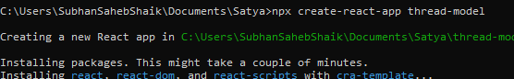

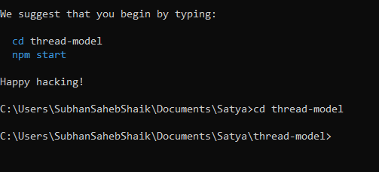

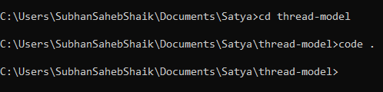

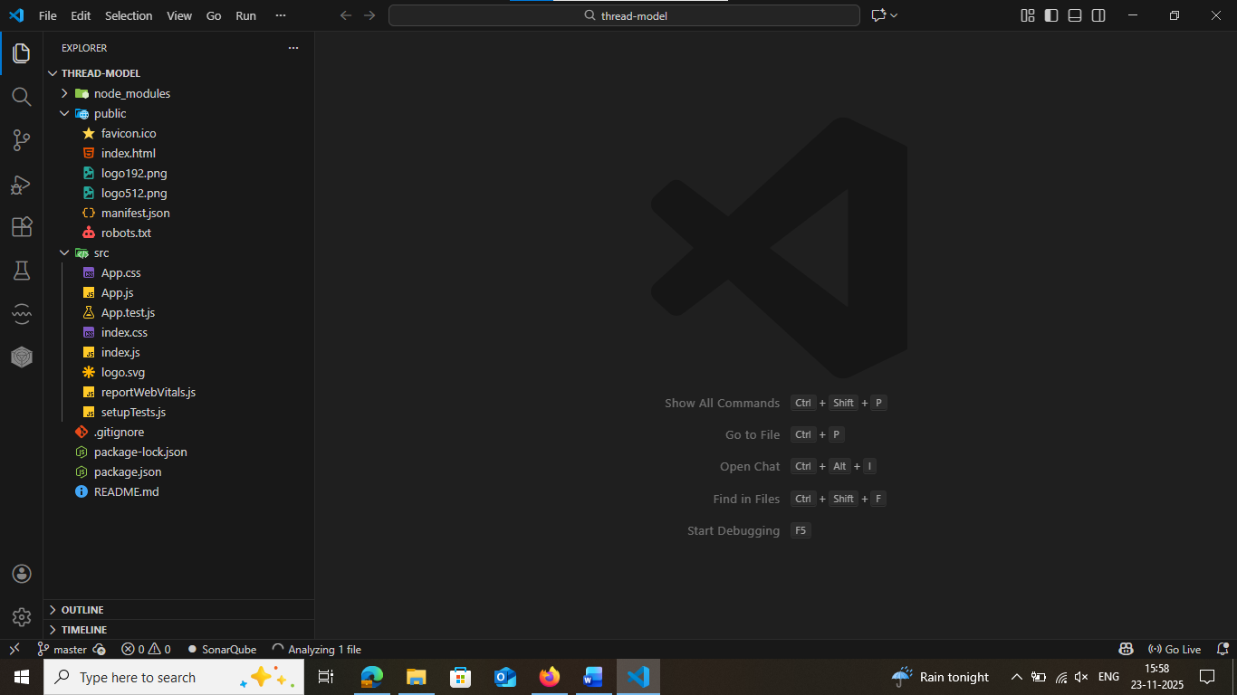

Django-admin startproject ThreadModel
Cd ThreadModel
Python manage.py startapp threadApp

npm install @mui/material @emotion/react @emotion/styled @mui/icons-material
npm install react-router-dom axios
npm install dagre
pip install djangorestframework-simplejwt django-cors-headers

