Simulation of Dopant Diffusion in Silicon during Microfabrication

Project Report

Subhasree Navya

241020039

# Abstract

This project simulates dopant diffusion in silicon wafers during the microfabrication process using MATLAB. Both limited-source and constant-source diffusion models are analyzed at different process temperatures (900 °C, 1000 °C, and 1100 °C). The study provides insights into concentration profiles, junction depth evolution, and the effect of temperature and time on dopant penetration. The results validate key diffusion mechanisms and their role in defining device performance.

# Introduction

Semiconductor device fabrication relies on precise control of dopant profiles in silicon. Diffusion is one of the most fundamental processes for introducing dopants such as boron or phosphorus. This report presents a MATLAB-based simulation of both constant-source and limited-source diffusion models. The objective is to study how diffusion time and temperature influence concentration depth profiles and junction depths.

# Methodology

The dopant diffusion process was modeled using Fick’s second law of diffusion. Two boundary conditions were considered:  
1. Constant-source diffusion: Surface concentration remains fixed during diffusion.  
2. Limited-source diffusion: A fixed total dopant dose is introduced.  
  
MATLAB was used to compute and visualize dopant concentration profiles at multiple temperatures (900 °C, 1000 °C, and 1100 °C) and diffusion times (10, 30, 60, and 120 minutes). Junction depths were extracted by finding intersections with the background doping concentration.

# Results and Discussion

The following figures present simulated dopant diffusion profiles and junction depth evolution:

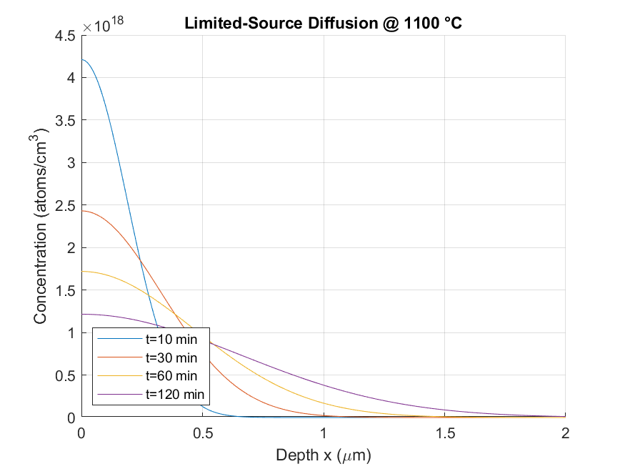

Limited-Source Diffusion at 1100 °C

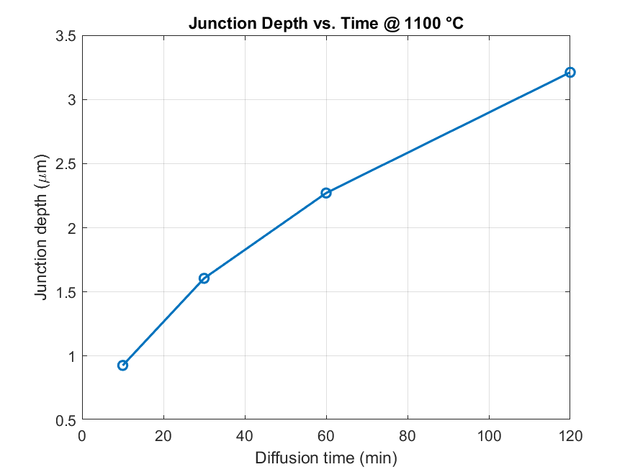

Junction Depth vs. Time at 1100 °C

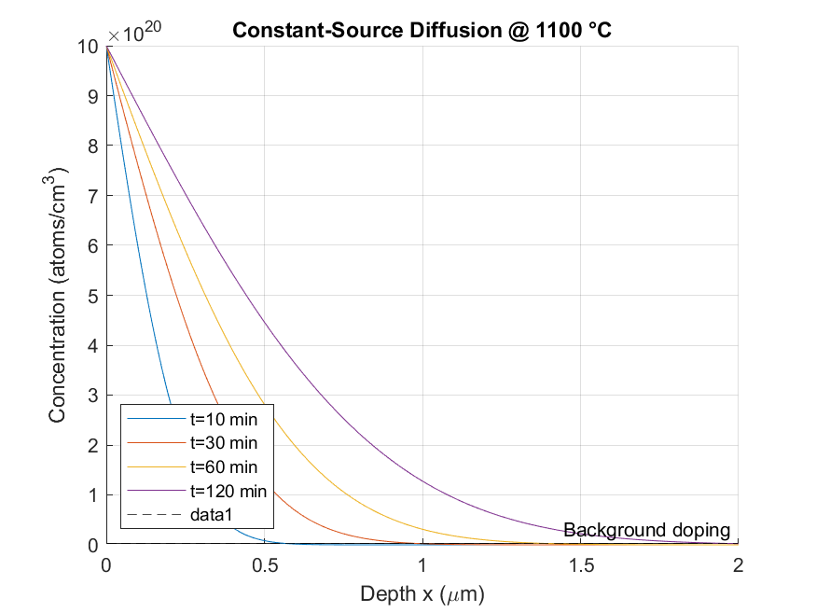

Constant-Source Diffusion at 1100 °C

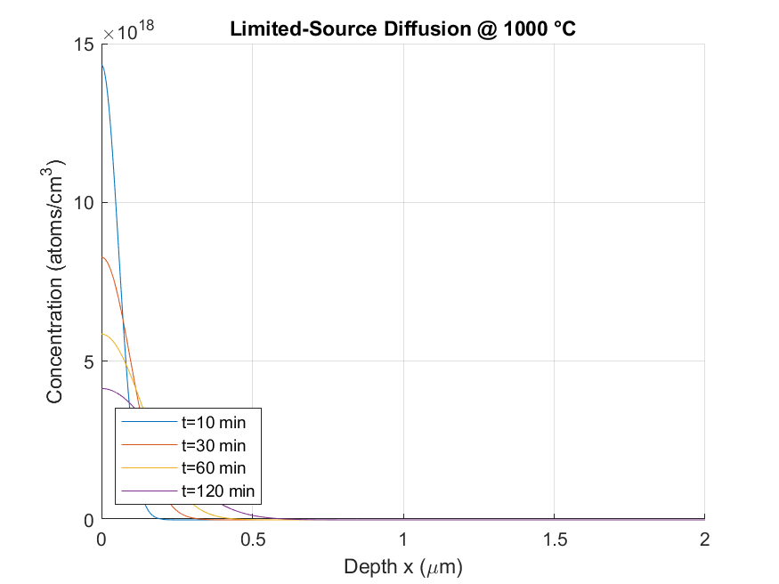

Limited-Source Diffusion at 1000 °C

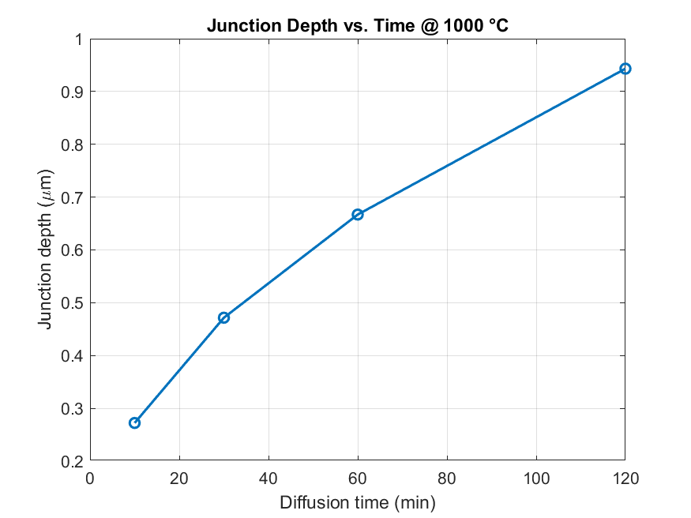

Junction Depth vs. Time at 1000 °C

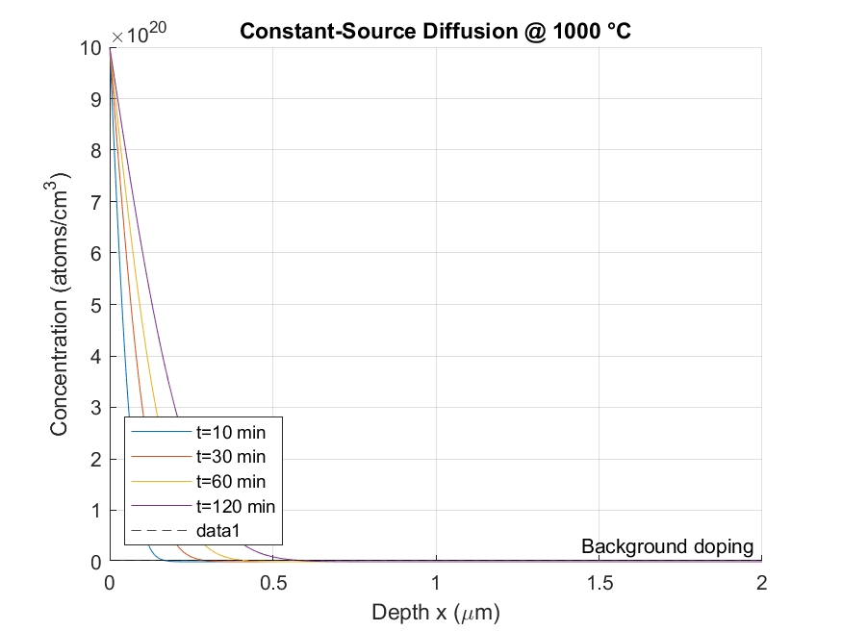

Constant-Source Diffusion at 1000 °C

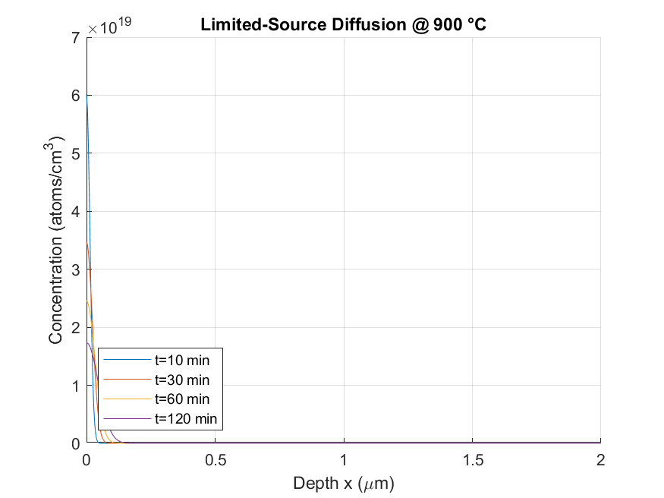

Limited-Source Diffusion at 900 °C

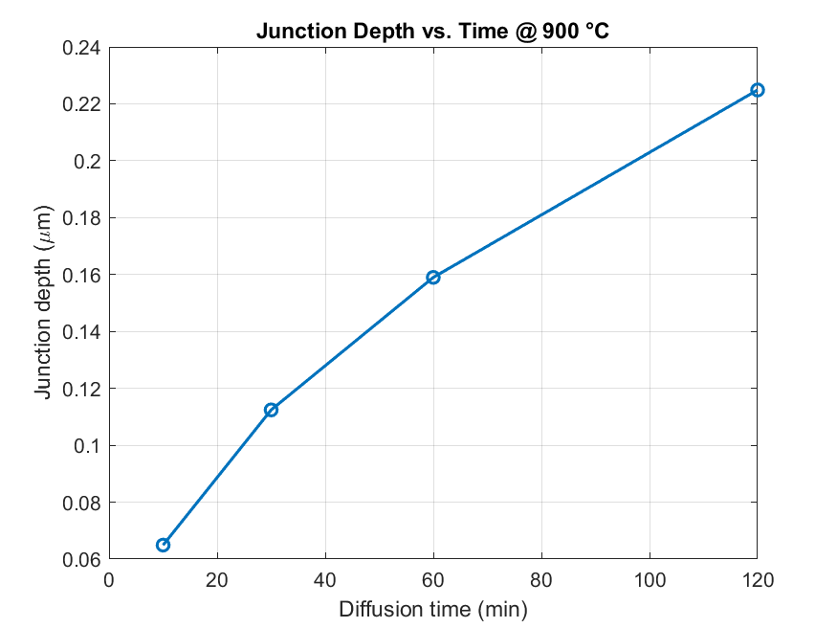

Junction Depth vs. Time at 900 °C

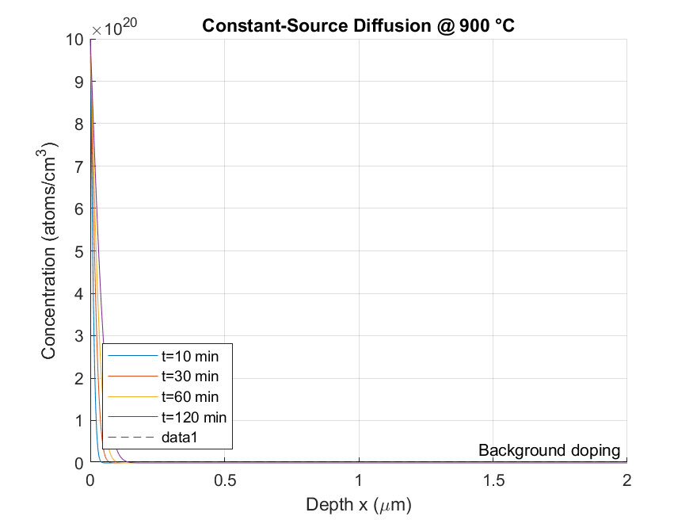

Constant-Source Diffusion at 900 °C

**Analysis of Dopant Diffusion Results**

**1. Constant-Source Diffusion (900 °C, 1000 °C, 1100 °C)**

* At all temperatures, dopant concentration near the surface remains close to the **constant source level (~10²¹ atoms/cm³)**.
* With increasing temperature:
  + The **diffusion front penetrates deeper** into the silicon.
  + At **1100 °C**, the concentration tail extends the farthest, indicating **higher diffusivity (D)**.
* This behavior matches **Arrhenius-type dependence** of diffusion, where diffusivity increases exponentially with temperature.

Higher process temperature results in deeper dopant penetration while maintaining surface concentration.

**2. Limited-Source Diffusion (900 °C, 1000 °C, 1100 °C)**

* Unlike constant-source diffusion, the **total dopant dose is fixed**.
* At higher temperatures:
  + The dopant **spreads more widely**, reducing **peak surface concentration**.
  + The profile becomes **flatter** as dopants move deeper.
* At **900 °C**, the dopant stays concentrated near the surface; at **1100 °C**, dopants spread across a much larger depth, but surface concentration is significantly reduced.

Limited-source diffusion trades off **shallower, high-concentration doping** for **deeper, lower-concentration doping** as temperature rises.

**3. Junction Depth vs. Time (900 °C, 1000 °C, 1100 °C)**

* Junction depth grows approximately as **√t**, confirming theoretical predictions from **Fick’s second law**.
* For the same diffusion time:
  + **1100 °C** gives the **deepest junction**, followed by **1000 °C**, then **900 °C**.
  + Junction depth differences are significant — at 120 minutes, the depth at 1100 °C is roughly **2× that at 900 °C**.
* This highlights the **strong temperature dependence of D**, which dominates junction formation.

Process engineers can tune **junction depth** by adjusting both **temperature** and **time**, giving flexibility in device design.

# Conclusion

The simulation confirms that dopant diffusion in silicon strongly depends on both temperature and diffusion time. Higher temperatures accelerate dopant penetration, leading to deeper junctions in shorter times. Constant-source diffusion results in a more extended profile, while limited-source diffusion shows sharper gradients. These results align with theoretical expectations and demonstrate how MATLAB can be effectively used to simulate semiconductor fabrication processes.

# References

1. S. M. Sze and K. K. Ng, 'Physics of Semiconductor Devices,' Wiley, 3rd Edition.  
2. Richard C. Jaeger, 'Introduction to Microelectronic Fabrication,' Pearson.  
3. MATLAB Documentation - Diffusion Equation Modeling.