Project name: skyProject

Application name: skyTestApp

Developed by: Subhani Shaik

Final Result

127.0.0.1:8000/tasks

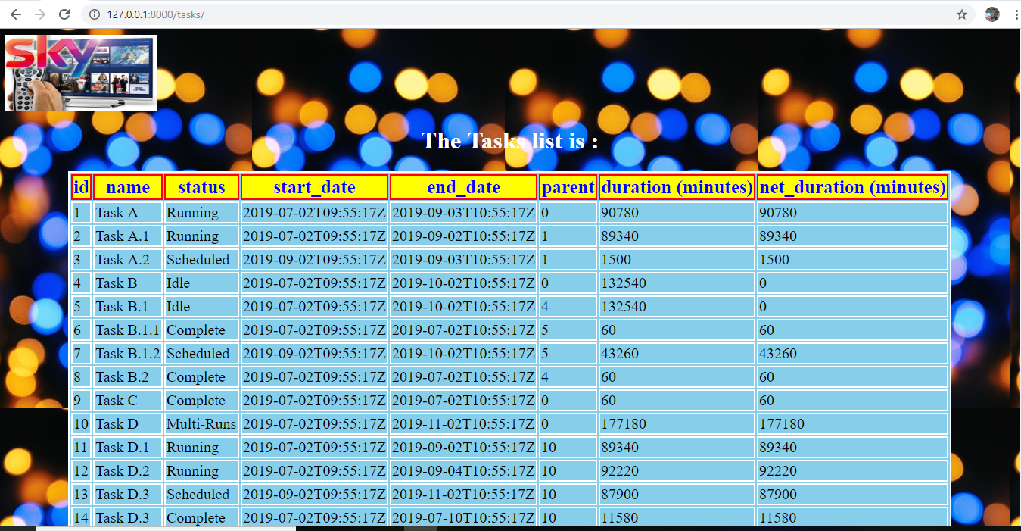

API for ID=1

Successful search HTTP 200 OK

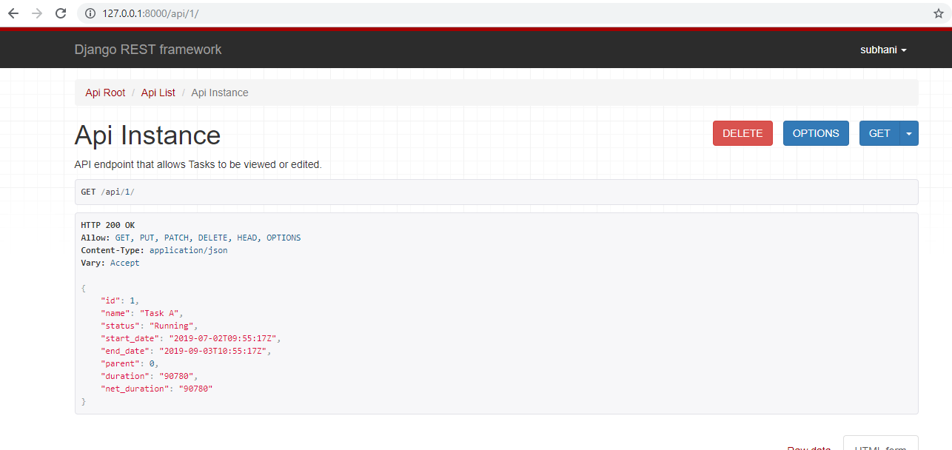

API ID=20 (Does not exist)

Status code : 404 Not Found

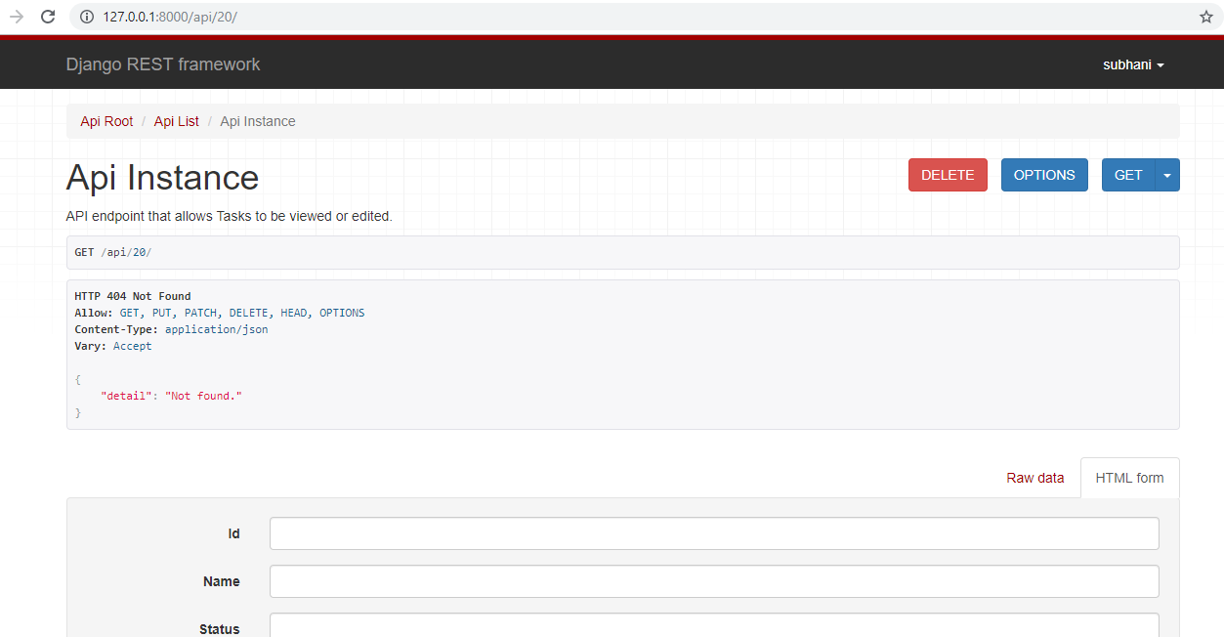

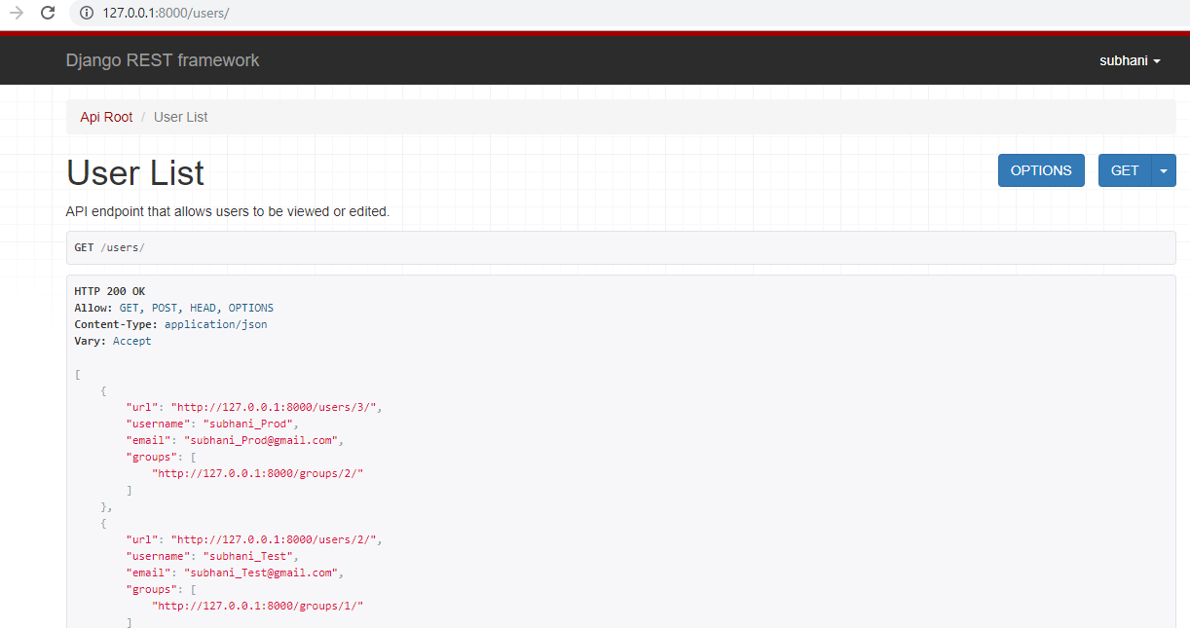

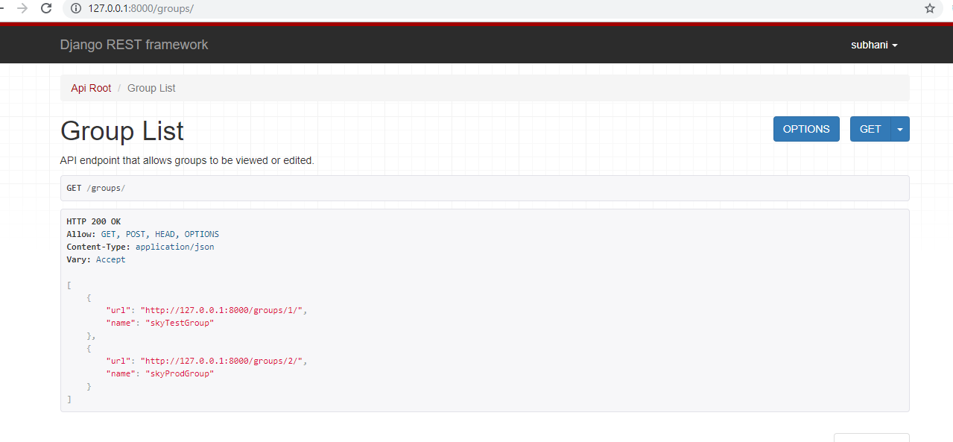

Project Folder Structure through IDE : Atom

