AI-Assisted Python Code Quality & Documentation Analyzer
Capstone project overview — how the system works

1. What this project does
This is a tool that checks Python files for basic quality and documentation problems, and then uses an AI coding assistant to suggest fixes and write tests. A developer gives it one or more .py files. The tool reads them, checks for issues like missing docstrings, missing type hints, unclear variable names and overly complex code, and gives each file a quality score out of 10. It then asks an AI assistant to suggest improvements and generate test cases.
In short: scan → check → score → get AI help → produce a report.

2. How it works, step by step
Figure 1 shows the five steps the tool follows for every file.
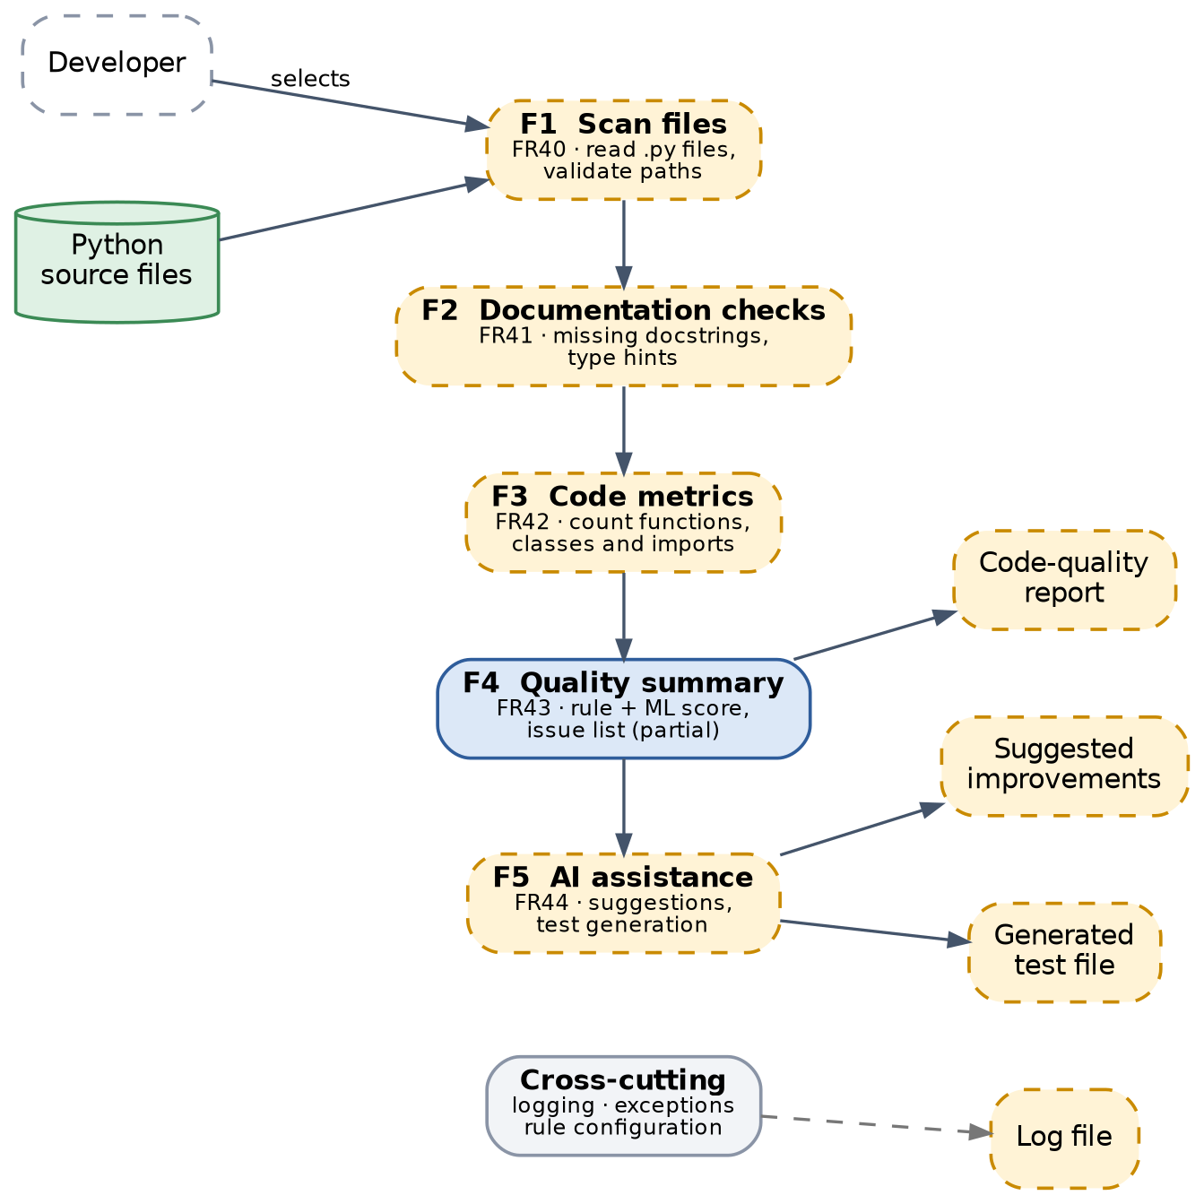
Figure 1 — The five main steps of the analyzer.

- Step 1 — Scan files: read the Python file(s) the developer selects.
- Step 2 — Check documentation: look for missing docstrings and missing type hints.
- Step 3 — Count code metrics: count how many functions, classes and imports the file has.
- Step 4 — Build a quality summary: combine simple rules with a small machine-learning model to give an overall score.
- Step 5 — Ask the AI assistant: send the findings to an AI coding assistant, which suggests fixes and writes test cases.
Throughout all five steps, the tool keeps a log file and handles errors gracefully — for example, if a file can't be read or has a syntax error, it records that and moves on to the next file instead of crashing.

3. The building blocks (architecture)
The system is organised into three simple layers, shown in Figure 2:
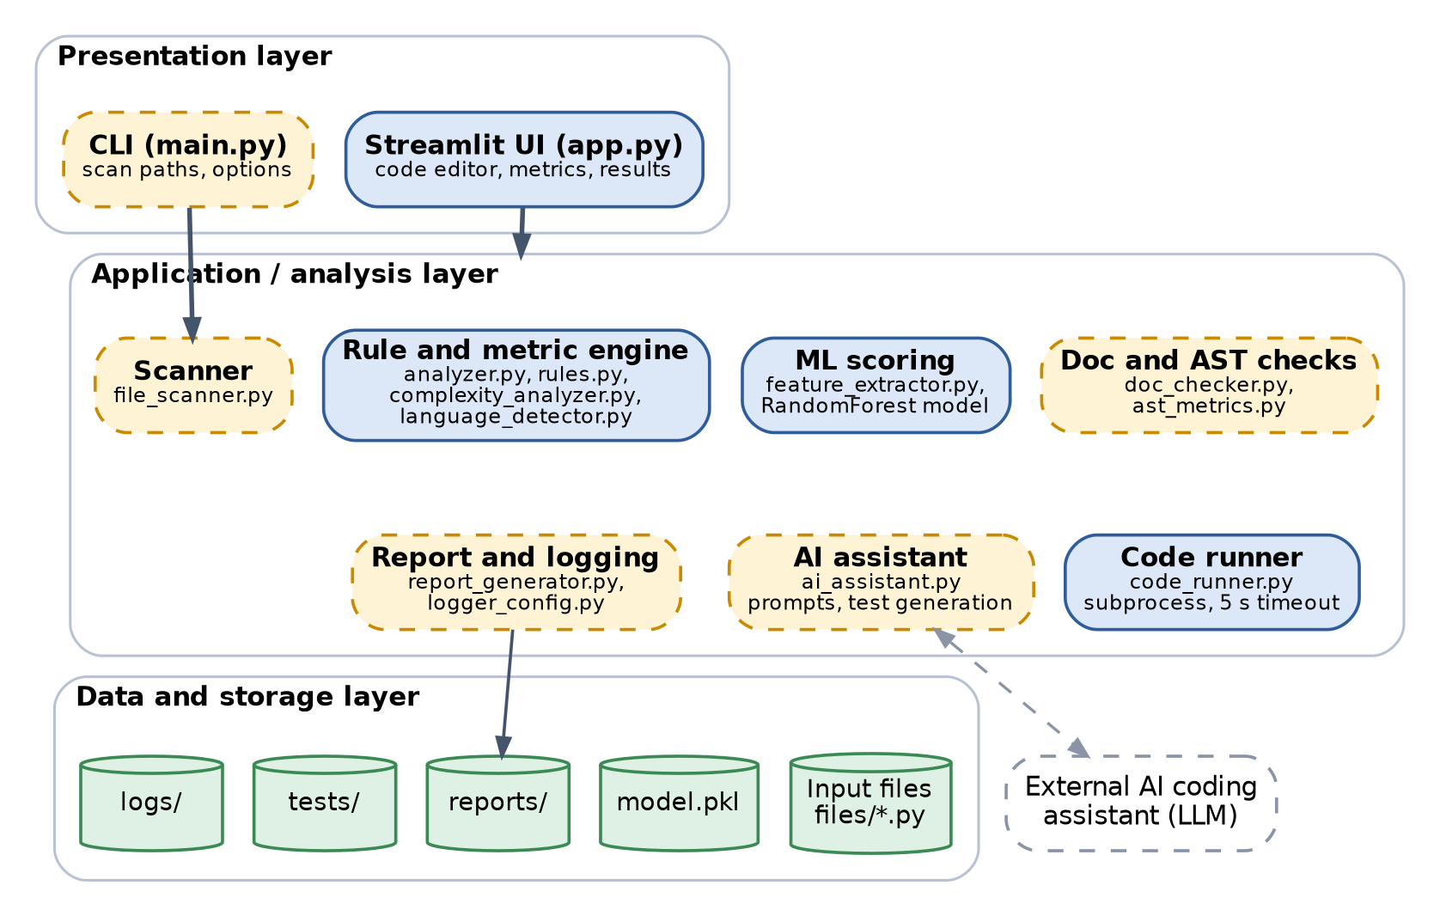
Figure 2 — The three layers of the system.
- Interface layer: what the developer sees and uses — a web page (built with Streamlit) to paste or upload code, plus a command-line option for scanning many files at once.
- Analysis layer: the actual "brain" of the tool — the rules engine, the machine-learning scorer, the documentation checker, and the part that talks to the AI assistant.
- Storage layer: where everything is saved — the input files, the trained model, the generated reports, the generated tests, and the log file.

4. How the pieces connect (components)
Figure 3 shows how the code modules depend on each other. Modules in blue already exist in the project; modules in amber (dashed) still need to be added to fully meet the brief.
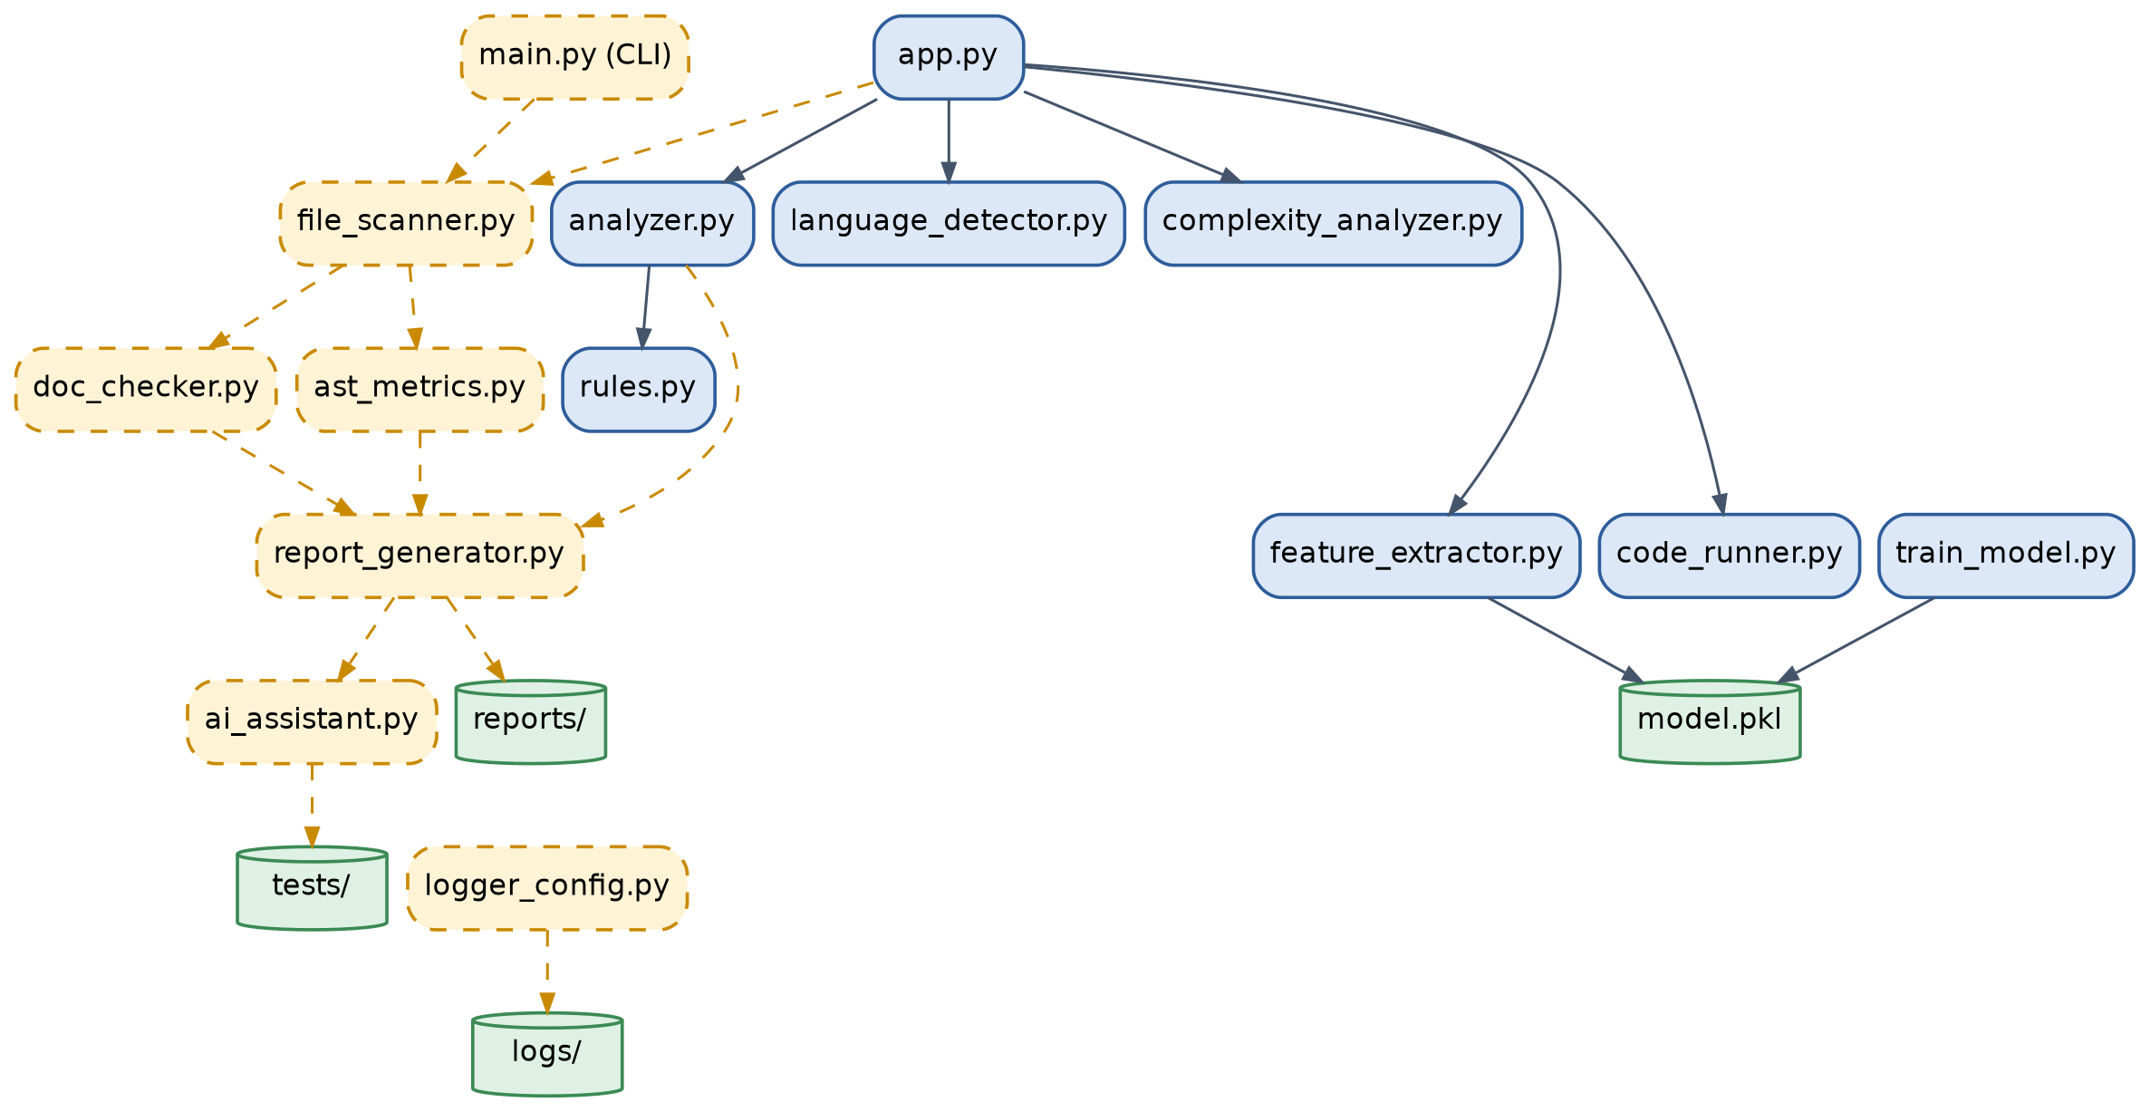
Figure 3 — How the modules connect to each other.

Module | What it's responsible for
app.py | The main screen — lets the developer paste code and see results
analyzer.py / rules.py | Checks the code against simple quality rules
feature_extractor.py + model.pkl | Machine-learning score, trained ahead of time
file_scanner.py (planned) | Reads real .py files instead of just pasted code
doc_checker.py (planned) | Checks for missing docstrings and type hints
report_generator.py (planned) | Builds the final quality report
ai_assistant.py (planned) | Talks to the AI assistant for suggestions and tests

5. How the data flows
Figure 4 follows a single file all the way through the system — from raw source code to a finished report.
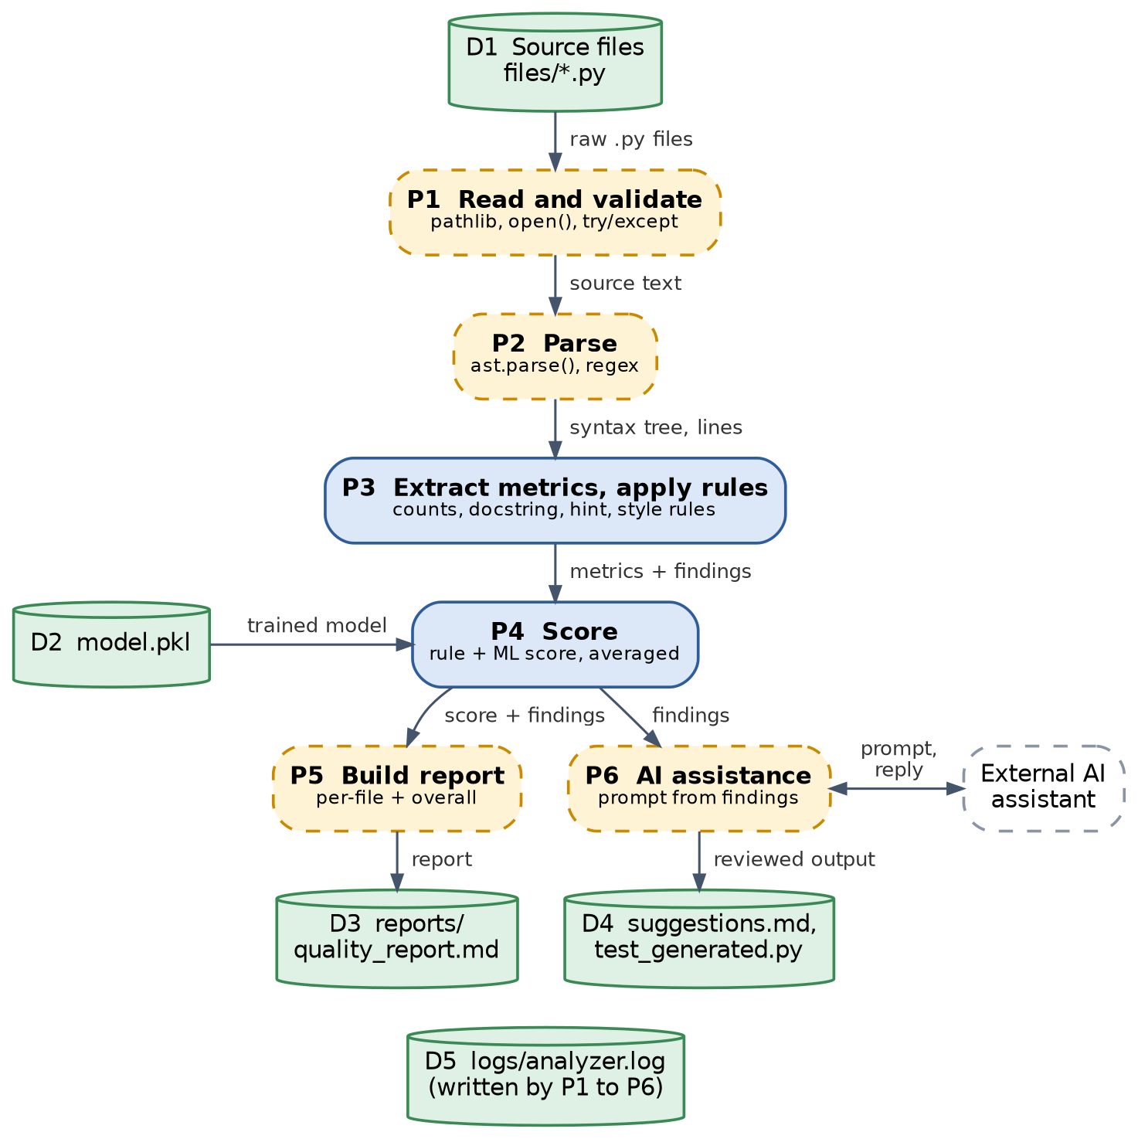
Figure 4 — The journey of one file through the system.
In plain terms: the file's text is read, turned into a structure the computer can analyse, checked against the rules and scored, and the results are written into a report. In parallel, the AI assistant looks at the same findings and produces suggestions and test code.

6. Why this is useful
- Saves a developer time on a first-pass code review.
- Catches simple, common problems (bad names, missing docs, overly complex code) automatically.
- Combines simple, explainable rules with an AI assistant — so the score is not a "black box", and the AI's suggestions are a bonus on top.
- Produces artifacts a developer actually keeps: a report, a suggestions file, and a ready-to-run test file.

7. Quick recap for the demo
A one-page summary you can read straight off during a demo or viva: what each step does, in one line, and which file does it.
Step | In one line | Key file
1. Scan | Read the developer's Python file(s) | file_scanner.py (planned) / app.py
2. Check docs | Flag missing docstrings and type hints | doc_checker.py (planned)
3. Count metrics | Count functions, classes, imports | ast_metrics.py (planned)
4. Score | Combine simple rules with a small ML model | analyzer.py, rules.py, feature_extractor.py, model.pkl
5. AI help | Ask an AI assistant for fixes and tests | ai_assistant.py (planned)
Always on | Log every step, handle errors without crashing | logger_config.py (planned)
If asked "what's the one thing that makes this different from a linter?", the answer is: it blends transparent rules with an AI assistant, so you get both an explainable score and a second opinion with ready-to-use suggestions and tests.

