CONFIDENTIAL · CANDIDATE SUBMISSION

Airbnb Market Intelligence
A Data Engineering & Analytics Case Study — New York City

Expernetic (Pvt) Ltd · Talent Assessment Program
Data Engineer Intern — Technical Assignment

Candidate | Subhani Dulshini
University | SLIIT — BSc (Hons) Information Technology, Data Science
City Analyzed | New York City (single-city, depth-first scope)
GitHub | github.com/subhani257
LinkedIn | linkedin.com/in/subhani-dulshini
Report Date | 12 July 2026

Please confirm the name/details above are correct before submitting.

Table of Contents
Table of Contents 2
1. Executive Summary 4
Key findings 4
What was built 4
Scope decisions 4
2. Objectives & Scope 5
2.1 Objectives 5
2.2 City selection rationale 5
2.3 Prioritization rationale 5
3. Dataset Overview 6
3.1 Entity relationships 6
3.2 Dataset limitations identified 6
3.3 Business domain context 7
4. Methodology 8
4.1 Statistical method selection 8
4.2 Machine learning method selection 8
4.3 Reproducibility 8
5. Engineering Approach 9
5.1 Pipeline design 9
5.2 Cleaning & standardization 9
5.3 Enrichment & joining 9
5.4 Data modeling (star schema) 9
5.5 Pipeline automation, logging, and metadata 10
5.6 Advanced & Cloud-Native Topics (design-level, not deployed) 10
6. EDA Findings 13
6.1 Price & room type 13
6.2 Host power-law dynamics 14
6.3 Review score inflation 14
6.4 Geographic pricing gradient 15
6.5 Temporal patterns 16
6.6 Host & supply-side segmentation 17
6.7 Superhost performance 18
6.8 Review & demand-side analysis 19
7. Statistical Findings 20
7.1 Hypothesis test results 20
7.2 Confidence intervals 20
7.3 Correlation & regression driver analysis 20
8. Data Science Experiments 23
8.1 Price prediction 23
8.2 Host & listing segmentation (clustering) 24
9. AI/ML Experiments 27
9.1 Sentiment analysis on guest reviews (completed) 27
9.2 Sections intentionally not attempted 27
10. Visualizations 29
11. Business Recommendations 30
12. Cross-City Comparisons 31
13. Limitations & Caveats 32
14. Future Improvements 34
15. Reflection 35
15.1 How I prioritized 35
15.2 Trade-offs made 35
15.3 Key lessons learned 35
15.4 AI collaboration reflection 35
Appendix A: AI Usage Disclosure 36
AI tools used 36
AI-assisted sections 36

1. Executive Summary
This report presents an end-to-end data engineering and analytics study of the New York City Airbnb market, built on the Inside Airbnb public dataset as part of the Expernetic Data Engineer Intern technical assessment. The work spans the full pipeline: raw data ingestion and profiling, cleaning and standardization, enrichment and dimensional modeling, exploratory and statistical analysis, machine learning, natural language processing on guest reviews, and an interactive Streamlit dashboard built as the Open Innovation deliverable.
The dataset comprises 30,259 listings (90 raw columns), 11,152,576 daily calendar records, 990,170 guest reviews, and 230 neighbourhood reference records — a realistically messy, production-scale snapshot rather than a toy dataset.

Key findings
- Price is driven primarily by physical capacity (accommodates, bathrooms, bedrooms) and location, not by review performance — review score correlates only weakly with price (r = 0.041).
- Manhattan listings command more than double the median price of the Bronx ($240.56 vs. $106.39/night) — a statistically significant difference confirmed by Kruskal-Wallis testing (p < 0.001, ε² = 0.130).
- The market is highly concentrated: just 13.79% of hosts control 50% of all listings, and the top 1% of hosts (164 individuals/companies) control 25% of total supply — evidence of a professionalized, not purely peer-to-peer, marketplace.
- A Random Forest model predicts nightly price with a mean absolute error of $116.79 and R² = 0.564 on held-out data, outperforming Linear Regression (R² = 0.277) and XGBoost (R² = 0.443) in this configuration.
- K-Means clustering (k = 5, silhouette = 0.343) surfaced five distinct market segments, including a 28-listing ultra-luxury tier averaging $4,967/night — small in count but strategically important for revenue-per-listing analysis.
- Guest review sentiment (VADER) correlates only moderately with numerical star ratings (r = 0.270), showing that review text captures nuance the 5-star system compresses away.

What was built
Deliverables include: a configurable, logged ingestion-to-warehouse pipeline (raw → silver → DuckDB star schema); a full statistical hypothesis-testing suite with effect sizes and assumption checks; three price-prediction models with SHAP explainability and residual analysis; K-Means listing segmentation; VADER sentiment analysis on guest reviews; and an interactive Streamlit dashboard covering all of the above with live, filterable, recomputed statistics.

Scope decisions
In line with the assignment's own guidance that “one city analyzed with exceptional depth beats five cities skimmed superficially,” this submission deliberately covers one city (New York City) in depth rather than several cities shallowly, and prioritizes the mandatory and recommended sections plus select optional Data Science and AI sections over full completion of every optional/expert topic. Section 2 and the Reflection (15) detail this reasoning.

2. Objectives & Scope

2.1 Objectives
The objective of this assignment was to demonstrate the full range of competencies listed in the assignment brief (1.1): data engineering fundamentals, analytical thinking, data science/ML, AI & LLM literacy, communication/storytelling, creativity/initiative, and professionalism — using the Inside Airbnb dataset as the vehicle.

2.2 City selection rationale
New York City was selected as the sole city for analysis. Per the City Selection Guide (9 of the assignment), a single-city scope is positioned as “Beginner–Intermediate” difficulty and recommended for candidates who want to “focus on depth, code quality, and storytelling” before generalizing. Given the 4 days window and the breadth already demanded across data engineering, statistics, ML, and AI sections, single-city depth was chosen deliberately over multi-city breadth — consistent with the assignment's explicit Design Philosophy: “A candidate who completes two sections with exceptional depth... will outperform one who attempts all sections superficially.”

2.3 Prioritization rationale
Effort was allocated as follows, roughly in order of priority:
- Mandatory: Dataset Familiarization (2) — completed in full.
- Recommended: Data Engineering Challenges (3.1–3.5), Exploratory Data Analysis (4), Statistical Analysis (5.1–5.3) — completed in full.
- Optional (selected): Data Science — Price Prediction (6.1) and Host & Listing Segmentation (6.3); AI — NLP sentiment analysis (7.1); Advanced & Cloud-Native Topics (3.6) — completed at design/architecture level (see 5.6), with a docker-compose.yml provided (not verified end-to-end) as a starting point for reproducibility; Open Innovation — an interactive Streamlit dashboard (8).
- Intentionally not attempted: Demand & Availability Forecasting (6.2), Model Generalization & Bias testing beyond basic residual analysis (6.4), LLM-Powered Insight Generation / RAG / Agentic Experimentation (7.2–7.4), and Multi-City Comparisons (5.4, 12 — not applicable given single-city scope).
Why these were skipped
Within a 4 days window, going deep on the core data engineering → statistics → ML → NLP pipeline for one city, plus building a genuinely usable interactive dashboard and a cloud-native architecture design, was judged to demonstrate stronger “Data Engineering Quality,” “Statistical Thinking,” and “Analytical Storytelling” (60 combined rubric points) than spreading the same hours across demand forecasting and agentic AI experiments that would each be shallow. See 15 (Reflection) for the full reasoning.

3. Dataset Overview
All data was sourced from Inside Airbnb's New York City snapshot (scrape date 14 June 2026). Four raw files were ingested:
File | Rows | Columns | Purpose
listings2.csv | 30,259 | 90 | Listing, host, and pricing attributes
calendar.csv | 11,152,576 | 5 | Daily availability & price per listing (365-day window)
reviews2.csv | 990,170 | 6 | Guest review text with reviewer ID, date, listing reference
neighbourhoods.csv | 230 | 2 | Neighbourhood → borough (neighbourhood_group) mapping

3.1 Entity relationships
- listings.id is the primary key referenced by calendar.listing_id and reviews.listing_id (one-to-many in both cases).
- neighbourhoods.csv provides the canonical (neighbourhood_group, neighbourhood) pairs used to validate and standardize the neighbourhood_cleansed / neighbourhood_group_cleansed fields already present in listings.
- Referential integrity check: 296 calendar rows and 239 review rows referenced listing IDs no longer present in the listings file (“orphans”) — a normal artifact of listings being delisted between the calendar/review scrape and the listings scrape, not a pipeline defect.

3.2 Dataset limitations identified
- 12 columns were 100% missing (host_since, host_response_time/rate, host_acceptance_rate, neighborhood_overview, host_thumbnail_url, host_neighbourhood, host_total_listings_count, host_verifications, neighbourhood, calendar_updated, instant_bookable) and were dropped rather than imputed, since imputing a 100%-missing column has no statistical basis.
- maximum_nights fields contained a 32-bit integer overflow sentinel value (2,147,483,647) used by the scraper for “unlimited” — 5,210 rows in calendar and up to 26 in listings. These were nulled rather than treated as real values.
- calendar_minimum_nights had 2,503,219 rows (22.45%) flagged as statistical outliers by the IQR method, but manual inspection showed the dominant value is exactly 30 nights — this reflects a genuine market segment of long-term/corporate-style listings mixed in with short-term rentals, not a data quality issue, and was documented rather than removed.
- Fuzzy name-matching (RapidFuzz, threshold 90) flagged 10,656 potential near-duplicate listings under the same host — largely templated naming across multi-unit buildings (e.g. “Unit 4A”, “Unit 4B”) rather than true duplicates; treated as a documented assumption rather than auto-removed, to avoid deleting legitimate distinct units.
- price is the host's listed nightly rate, not a verified transaction price — all downstream occupancy/revenue figures are estimates, not confirmed bookings (see 13 Limitations).

3.3 Business domain context
Each listing represents a bookable unit (entire home, private room, shared room, or hotel room) offered by a host; a host may operate one listing (casual) or many (commercial/professional, see 6 Host Analysis). Each review represents a completed stay's guest feedback, tied to both a listing and an implicit booking event. The calendar table is a forward-looking 365-day availability ledger per listing, used here as a proxy for occupancy and demand.

4. Methodology
The analytical approach followed a staged “medallion” pattern — raw → silver (cleaned/validated) → gold (enriched, modeled) — used across the notebooks (01 dataset exploration & engineering, 03 EDA, 04 statistics, 05 data science, 06 AI/NLP).

4.1 Statistical method selection
Before running any hypothesis test, Shapiro-Wilk normality checks were run on every group being compared (entire-home vs. private-room price, superhost vs. non-superhost ratings, borough price groups, etc.). In every case, normality was strongly rejected (p < 10⁻⁵⁴ in the most extreme case) — expected given price's heavy right skew from luxury outliers. As a result, non-parametric tests (Mann-Whitney U, Kruskal-Wallis H) were used throughout instead of t-tests/ANOVA, with rank-biserial correlation or epsilon-squared reported as the corresponding effect size.

4.2 Machine learning method selection
Before feature selection, a leakage check was run on candidate features. estimated_revenue (r = 0.522), price_per_bedroom (r = 0.785), price_quote_total_price (r = 0.736), and price_quote_price_per_night (r = 1.000, since it is definitionally the same field) were all excluded from the model's feature set, since they are mathematically derived from price and would leak the target into the inputs — a subtle but critical error to avoid, since a model “cheating” off a leaked feature reports misleadingly high accuracy but fails in production.
Three model families were compared under an identical 80/20 train/test split (random_state = 42, for reproducibility): Linear Regression as an interpretable baseline, Random Forest as a robust non-linear default, and XGBoost as a gradient-boosted alternative.

4.3 Reproducibility
All random processes (train/test splits, KMeans initialization, bootstrap resampling) use a fixed random_state = 42 so that results are reproducible run-to-run. The ingestion pipeline is config-driven (a single CONFIG dict controls city name and file paths) and logs each stage with timestamps to a JSON metadata file.

5. Engineering Approach

5.1 Pipeline design
The pipeline is implemented as a sequence of pure functions — ingest_city_data(), clean_city_data(), and a metadata-writing save stage — orchestrated through a single CONFIG dictionary specifying city name and directory paths. This means re-running the pipeline for a different city requires changing only the CONFIG values, not the function logic.

5.2 Cleaning & standardization
- Price columns stripped of currency symbols/commas and cast to float (e.g. "$113.97" → 113.97).
- Date fields (first_review, last_review) parsed to proper datetime64 types.
- room_type standardized natively (4 clean categories); property_type (60+ raw free-text values) collapsed into a 5-category property_type_group via keyword matching (Entire place / Private room / Shared room / Hotel-B&B / Other) for tractable grouped analysis.
- Sentinel integer-overflow values in *_nights fields nulled rather than treated as real magnitudes.

5.3 Enrichment & joining
Using an in-memory DuckDB connection, listings were enriched via SQL joins with: (1) a review_summary aggregate (actual review count and first/last review dates per listing, used to cross-validate the self-reported number_of_reviews field — 0 mismatches found, confirming data consistency); (2) a calendar-derived occupancy_revenue table (booked_days / total_days_tracked = occupancy_rate, and booked_days × price = estimated_revenue); and (3) neighbourhood-level aggregates (median price, listing density, average rating) joined back onto every listing.
Two further engineered fields were derived: host_tenure_years_est (since host_since was 100% missing, tenure is approximated from each host's earliest first_review date to CURRENT_DATE — a documented assumption that will slightly understate tenure for hosts with no reviews yet), and price_per_bedroom / review_frequency_per_month for downstream analysis.

5.4 Data modeling (star schema)
The enriched listing table was modeled into a DuckDB star schema with three dimension tables and one fact table: dim_listing (30,259 rows — listing attributes: property/room type, capacity, location), dim_host (16,474 rows — host-level attributes, portfolio size, tenure), and dim_neighbourhood (223 rows — borough/neighbourhood reference), all keyed into fact_listing_performance (numeric measures: price, occupancy_rate, estimated_revenue, review_count_actual, review_scores_rating) by listing_id. This was validated with an analytical query joining all four tables to compute average price/occupancy/revenue by borough × room type — successfully returning 18 grouped rows (5 boroughs × room type, with the Bronx and Staten Island each returning only 3 room types rather than the full 4 — consistent with those boroughs having no hotel-room listings), confirming the join keys and grain are correct.
Engineering Decision Log — DuckDB vs. alternatives
DuckDB was chosen over SQLite or a full PostgreSQL setup for the warehouse layer. Trade-off considered: DuckDB offers native, fast Parquet/pandas interoperability and columnar analytical performance well-suited to the 11M-row calendar table, without requiring a running server process (unlike PostgreSQL) — appropriate for 4 days, single-analyst assignment. The trade-off accepted is that DuckDB is less suited to concurrent multi-user production workloads than PostgreSQL; for a production deployment this would be revisited (see 5.6 and 14 Future Improvements).

5.5 Pipeline automation, logging, and metadata
The pipeline uses Python's logging module (INFO level, timestamped) to record each ingestion and cleaning step, and writes a JSON metadata record per run (city, stage, run_timestamp, and per-table row/column counts and output paths) — a lightweight but functional metadata management layer that supports auditing when the pipeline is re-run against a fresh scrape.

5.6 Advanced & Cloud-Native Topics (design-level, not deployed)
This subsection addresses assignment 3.6 at the design and architecture level. Given the single-city, single-analyst scope of this assignment (see 2.2–2.3), the current pipeline intentionally runs locally on pandas/DuckDB — the right-sized solution for this scale (see Decision Log above). The following describes how the architecture would evolve if scaled to production, 50+ cities: it is a design exercise and discussion, not a deployed system, and is presented as such.

Scalable architecture for 50+ cities
Scaling to 50+ cities concurrently would require three structural changes. First, storage would move from local Parquet files to Azure Data Lake Storage (ADLS) Gen2, partitioned by city and scrape date, giving elastic capacity and parallel reads across cities without a single local-disk bottleneck. Second, compute would move from single-machine pandas/DuckDB to Azure Databricks (PySpark) or Synapse Spark pools, distributing cleaning/enrichment transformations across worker nodes — this is the point at which PySpark's distributed model actually pays for itself, unlike at single-city scale. Third, orchestration would move from manual notebook execution to Azure Data Factory, using a parameterized pipeline (city name as a parameter) triggered on a schedule or per new Inside Airbnb export, running all cities through one pipeline definition rather than many separate manual runs.
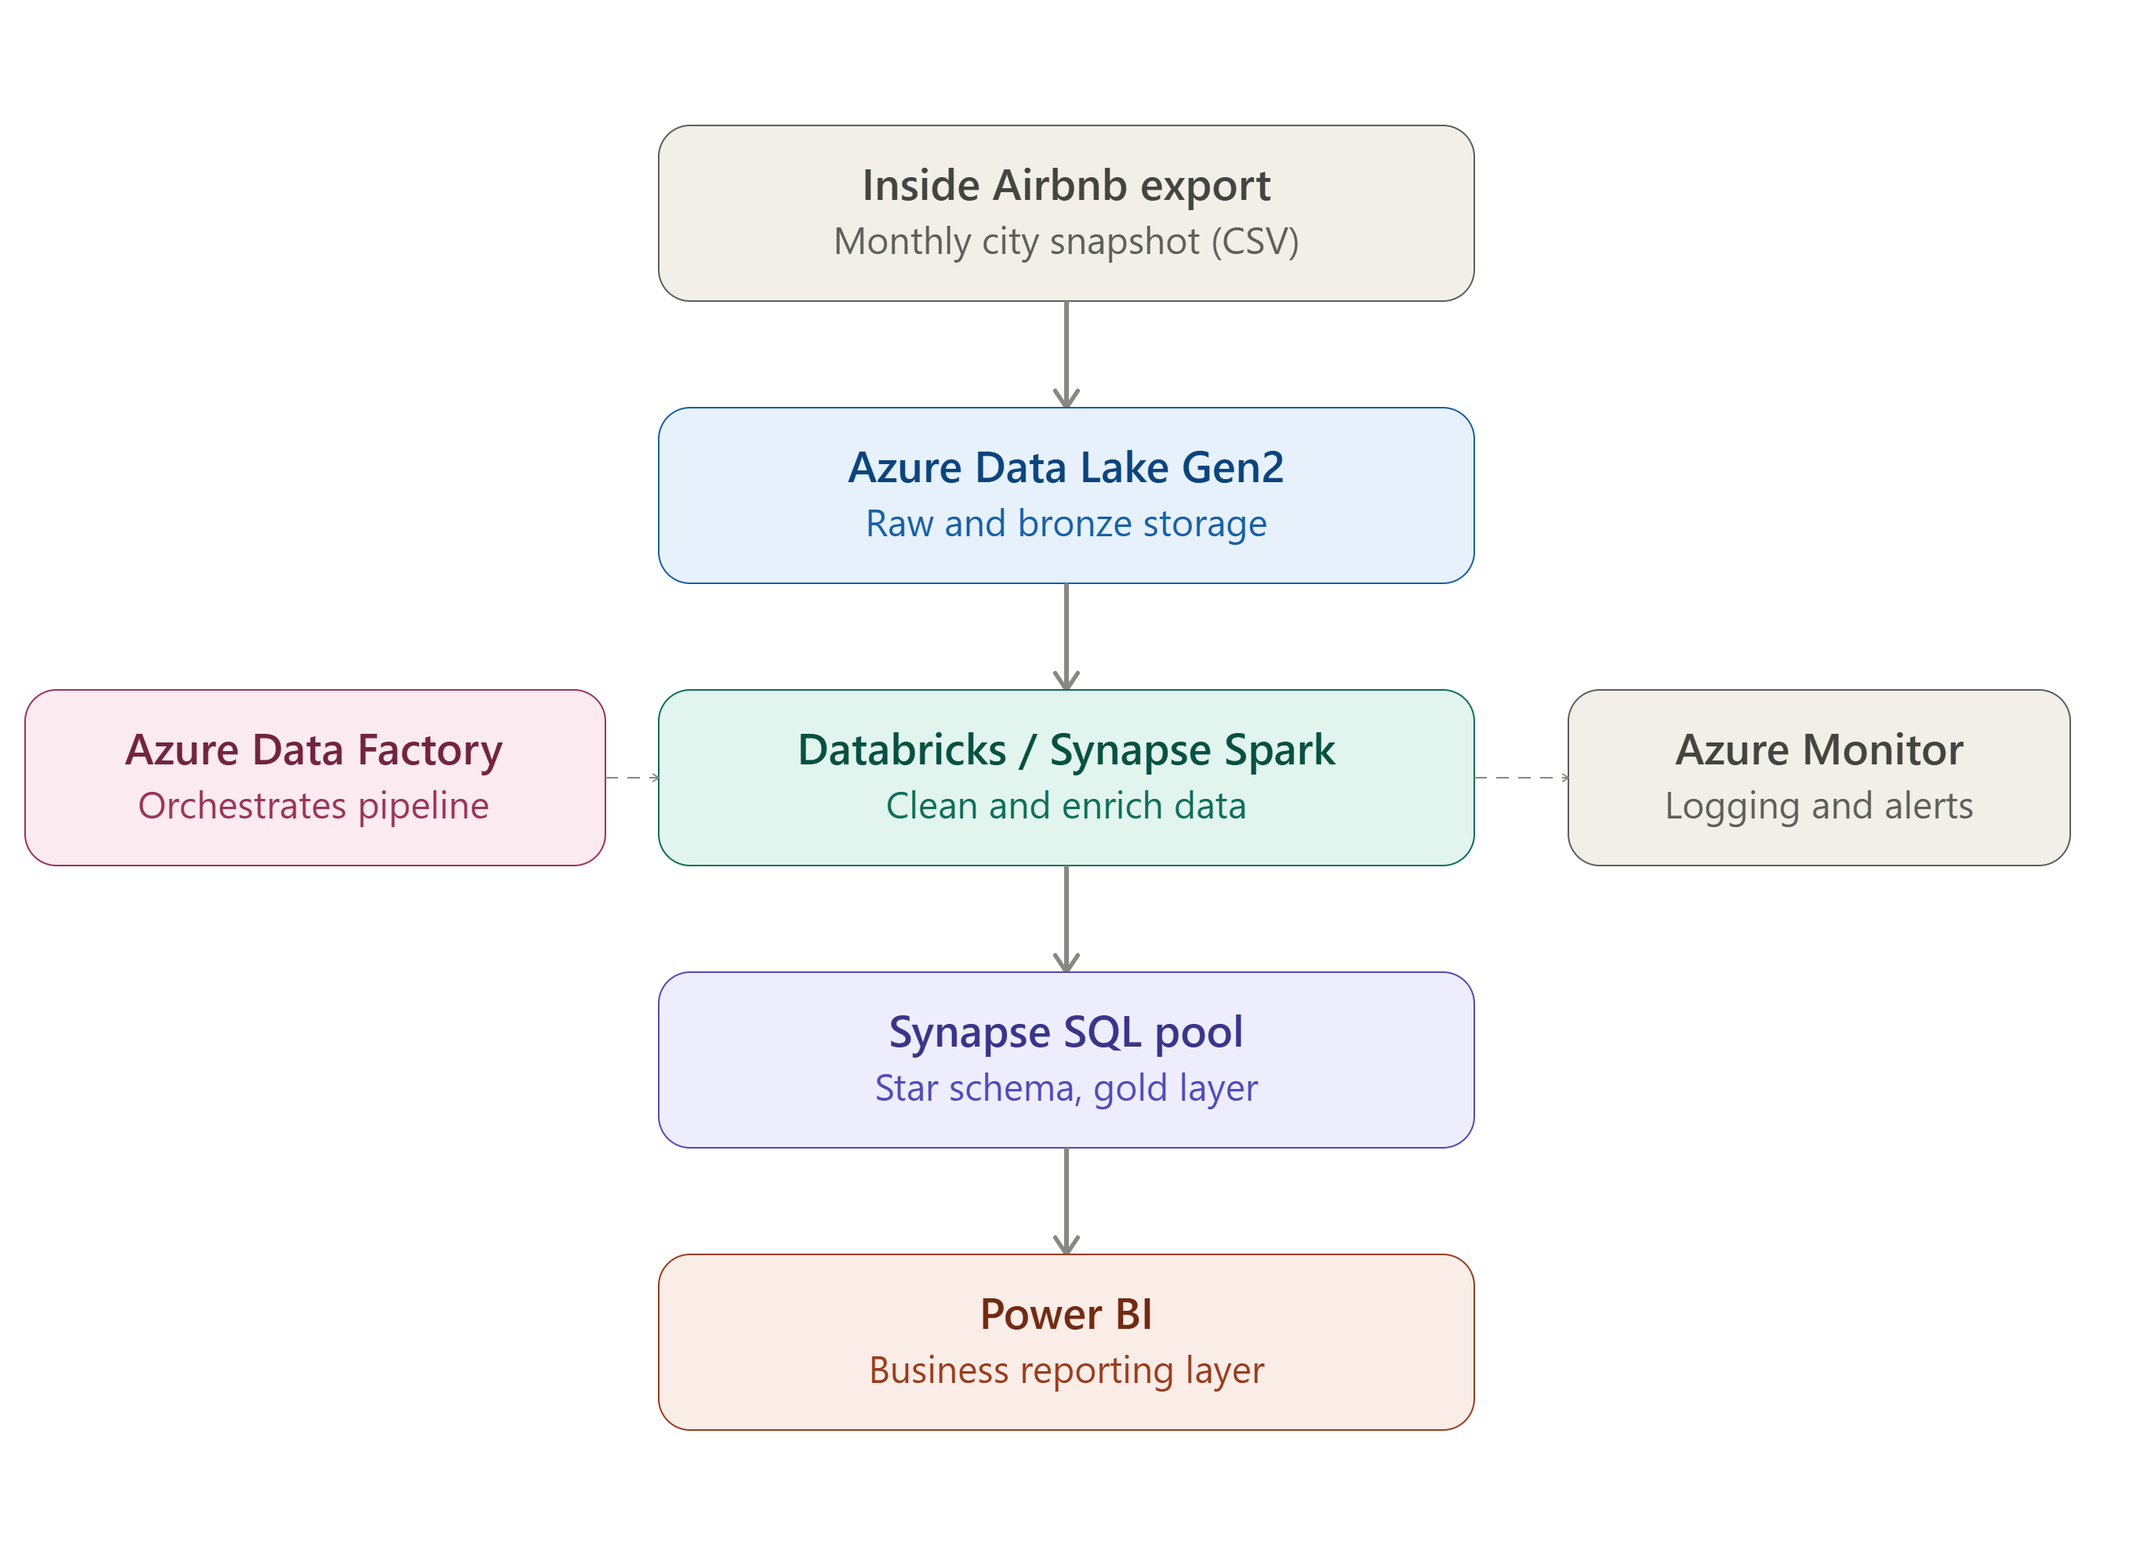
Figure 1. Proposed Azure-native architecture for multi-city, production-scale processing (design proposal, not deployed).

Partitioning strategy for calendar data at scale
At 50-city scale the calendar table would grow from 11M rows (one city) to 500M+ rows. It should be partitioned in ADLS by city and year, following a city=nyc/year=2026/ Hive-style folder structure. This allows query engines such as Synapse or Databricks to perform partition pruning — scanning only the relevant city/year subset rather than the full dataset — which becomes essential once total calendar rows reach the hundreds of millions.

Change Data Capture (CDC) strategy for listings
A CDC approach for the listings table would use Azure Data Factory's built-in CDC connectors (or Delta Lake's native CDC support under Databricks) to detect and process only listings whose last_scraped timestamp has advanced since the previous pipeline run — a managed-service equivalent of a high-water-mark incremental strategy, automated and schedulable at scale rather than run manually per city.

Cloud-native implementation with managed services
Layer | Local (this submission) | Proposed Azure-native equivalent
Storage | Local Parquet files | Azure Data Lake Storage (ADLS) Gen2
Compute | pandas / DuckDB (single machine) | Azure Databricks (PySpark) or Synapse Spark pools
Orchestration | Manual notebook execution | Azure Data Factory (parameterized, scheduled)
Warehouse / gold layer | DuckDB star schema | Synapse dedicated/serverless SQL pool
Monitoring & alerting | Python logging + JSON metadata | Azure Monitor / Log Analytics
Reporting | Streamlit dashboard (8) | Power BI, or the Streamlit dashboard containerized on Azure App Service

Containerization (Docker Compose — provided, not verified)
A docker-compose.yml is included in the project repository (built on the jupyter/scipy-notebook base image, with the project's notebooks/ and data/ folders mounted as volumes) as an optional deliverable per 11.2. In principle, running docker-compose up would reproduce a Jupyter environment with pandas, DuckDB, and Jupyter pre-installed, without requiring a local Python installation. To be transparent: this file has not actually been run and verified end-to-end — it is provided as a good-faith starting point for reproducibility, not a tested, confirmed-working artifact, and should be described accordingly if asked about it directly.

Data quality checks as code
Rather than adopting a separate framework such as Great Expectations at this project's single-city scale, data quality validation was implemented as explicit, version-controlled pandas assertions directly in the pipeline (3.1: negative-price checks, latitude/longitude range validation, min/max-nights consistency, sentinel-value detection). At production/multi-city scale, these same logical checks would migrate to dbt tests (since the gold layer is already a SQL-based star schema, 5.4) or to Great Expectations integrated into the Azure Data Factory pipeline as a validation gate before data reaches the gold layer — failing the pipeline run and alerting via Azure Monitor if validation thresholds are breached.

Production-readiness considerations
- Monitoring: Azure Monitor / Log Analytics tracking pipeline run duration, row counts, and failure rates per stage — a cloud-native evolution of the local logging module already in place (5.5).
- Alerting: thresholds on data-quality check failures or missed SLA windows triggering email/Teams notifications.
- SLA tracking: e.g. “cleaned data available within 4 hours of a new Inside Airbnb export.”
- Cost optimization: Synapse serverless SQL pools for ad-hoc queries instead of always-on dedicated pools, and ADLS lifecycle policies moving older snapshots to cool/archive storage tiers.
What was designed vs. what was deployed
To be transparent for the viva: the architecture, partitioning strategy, CDC approach, managed-services mapping, and production-readiness plan above are a design proposal, reasoned from this project's actual local pipeline — they were not deployed to Azure. The docker-compose.yml is a real file, not a description, but it has not been run and verified end-to-end either, so it should not be overstated as a confirmed-working deliverable. This distinction is intentional and disclosed rather than implied otherwise (see Appendix A).

6. EDA Findings

6.1 Price & room type
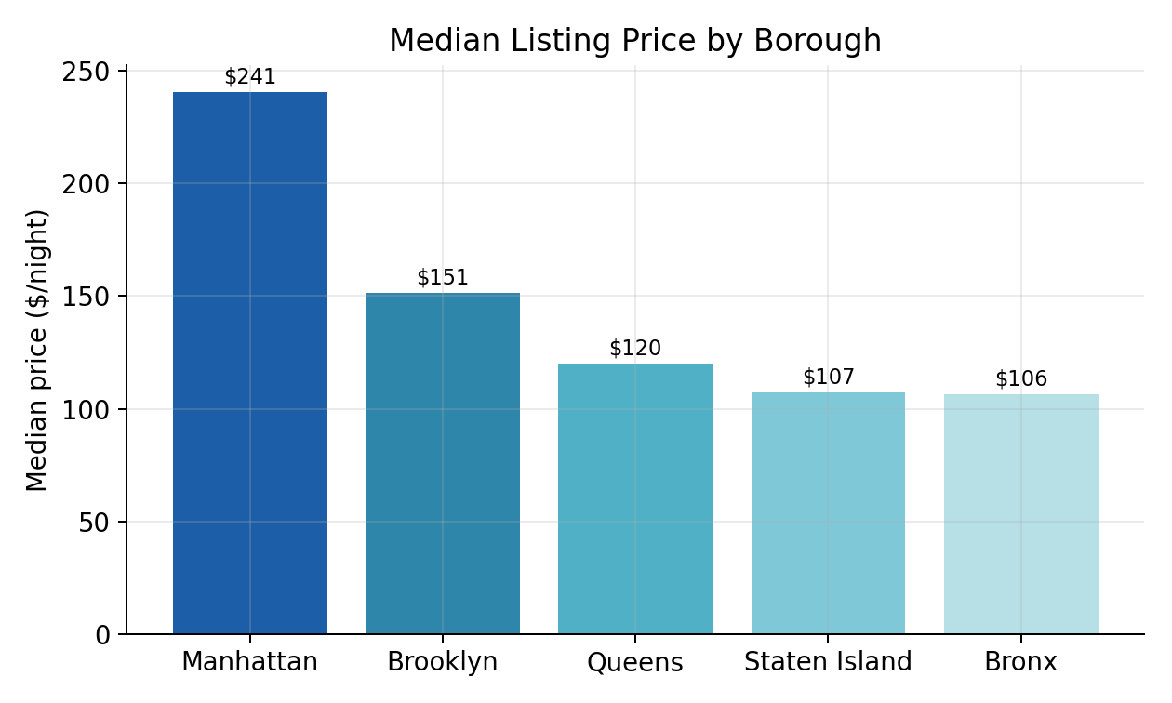
Figure 2. Median listing price by borough.
Median price varies more than 2x across boroughs: Manhattan ($240.56) is the clear premium market, followed by Brooklyn ($151.44), Queens ($120.04), Staten Island ($107.30), and the Bronx ($106.39). Business read: this is not a minor variation — it justifies borough-tiered pricing guidance and marketing spend allocation for a platform operator, and is confirmed statistically significant in 7.1 (H4).
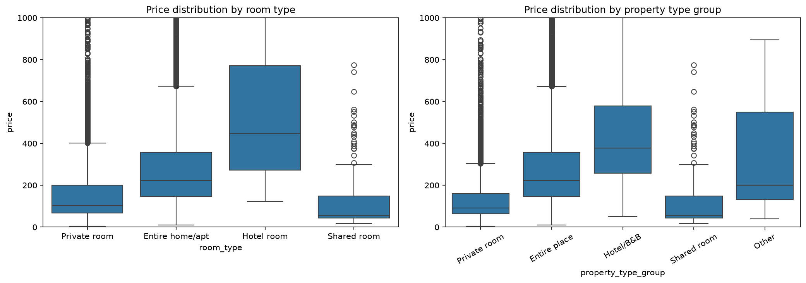
Figure 3. Price distribution by room type and property type group (capped at $1,000 for readability; outliers above this are visible as the dense band at the cap).
Median price by room type follows the expected hierarchy — hotel rooms highest (median ~$445), then entire homes/apartments (median $222.87), then private rooms (median $102.97), then shared rooms lowest — but the spread within each category is wide, with dense clusters of high-price outliers above $600–$1,000 in both the entire-home and private-room categories. Business read: room type alone is a coarse pricing signal; within-category variance (visible as the tall boxes and outlier clouds above) is what the ML model in 8.1 is built to capture.
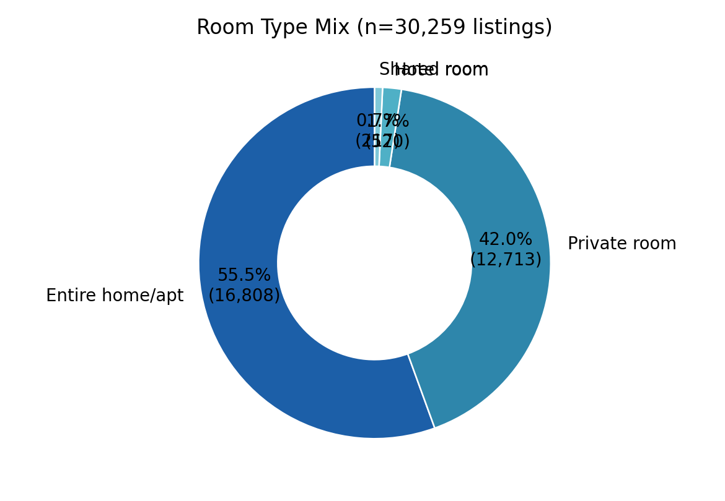
Figure 4. Room type distribution across all NYC listings.
Entire homes/apartments dominate supply (55.5%), followed by private rooms (42.0%); hotel rooms (1.7%) and shared rooms (0.7%) are minor categories. Business read: NYC's Airbnb supply behaves more like a short-term rental/hospitality market than a home-sharing marketplace — relevant context given NYC's short-term rental regulation (Local Law 18); see 11 recommendations.

6.2 Host power-law dynamics
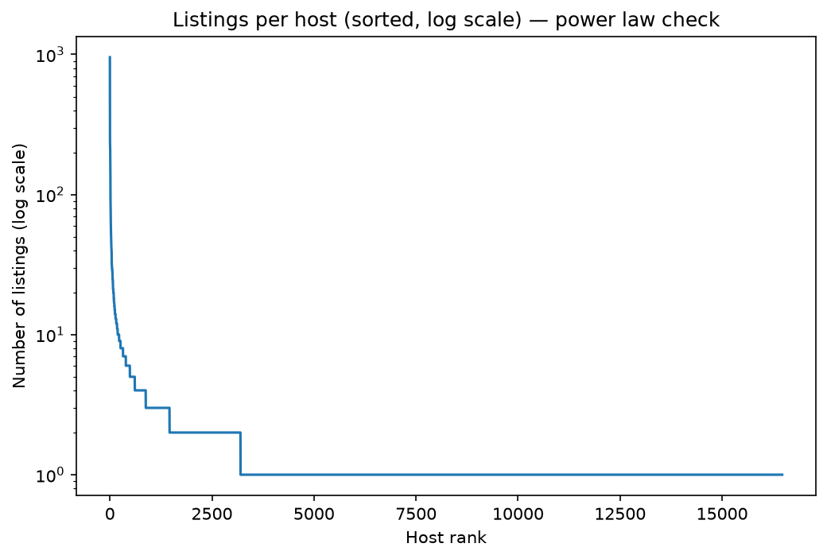
Figure 5. Listings per host, sorted and log-scaled — a textbook power-law curve.
Listings per host follow a classic power-law distribution: the median host has exactly 1 listing, but the top host operates 955 listings, and the top 10 hosts alone operate between 157 and 955 listings each. The near-vertical drop in the first few hundred ranked hosts, followed by a long flat tail at 1–2 listings, is the visual signature of exactly this kind of concentrated market — confirmed quantitatively in 6.6. This single fact reframes “average host behavior” analysis — see 6.6 Host & supply-side segmentation for the full breakdown.

6.3 Review score inflation
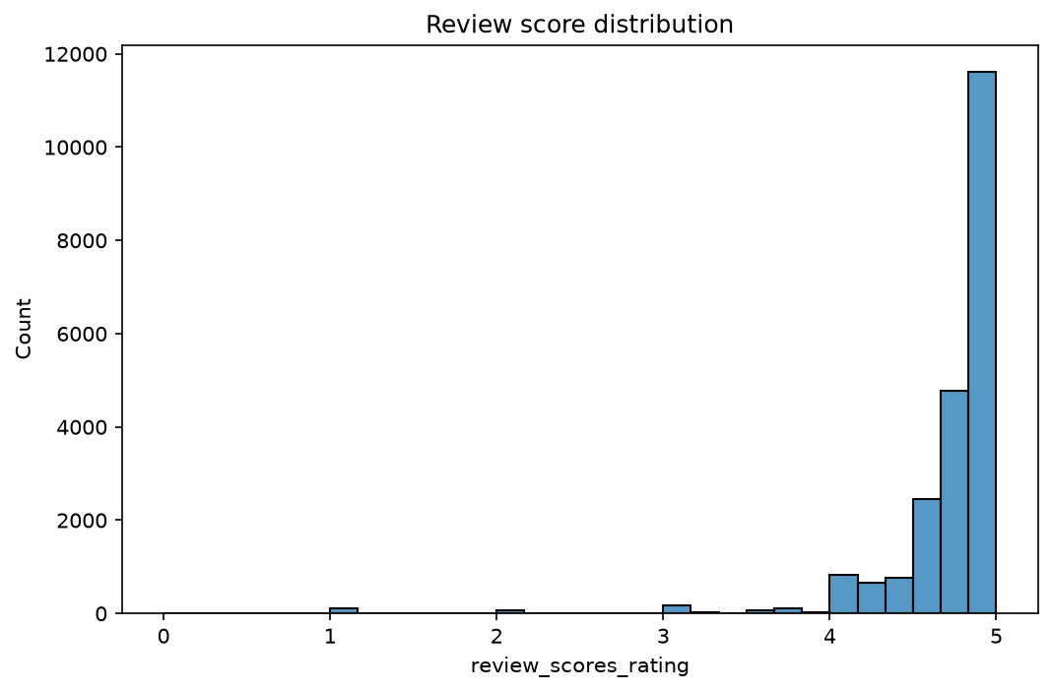
Figure 6. Distribution of numerical review scores (0–5 scale).
43.2% of all rated listings score 4.8 or higher (out of a 0–5 scale), and the overall mean rating is 4.73. The histogram makes the skew unmistakable: almost the entire distribution is crammed into the 4.5–5.0 band, with only a thin scatter of listings below 4.0 and a small anomalous spike at exactly 0 (unrated/new listings coded as 0 rather than null in the raw export). This “rating inflation” is a well-documented phenomenon on two-sided reputation platforms (both guests and hosts are reluctant to leave low scores) and has a direct business implication: a 4.7 rating is not “very good” on this platform — it is below-average. Any dashboard or reporting tool built for internal stakeholders should present ratings relative to this inflated baseline, not the nominal 0–5 scale.

6.4 Geographic pricing gradient
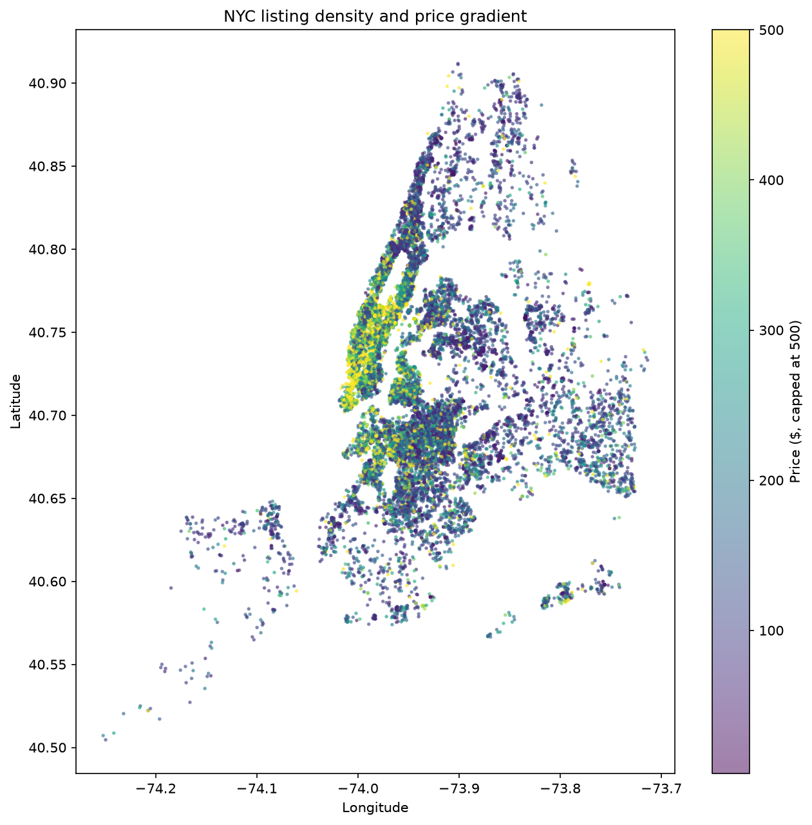
Figure 7. NYC listing density and price gradient (price capped at $500 for color-scale readability).
The map shows price is not radially organized around a single center: the brightest (highest-price) clusters trace Manhattan's spine and the Williamsburg/Greenpoint waterfront in Brooklyn, while similarly-distanced areas in the outer boroughs stay dark (lower-priced). This confirms NYC is polycentric rather than having one simple “city centre.”
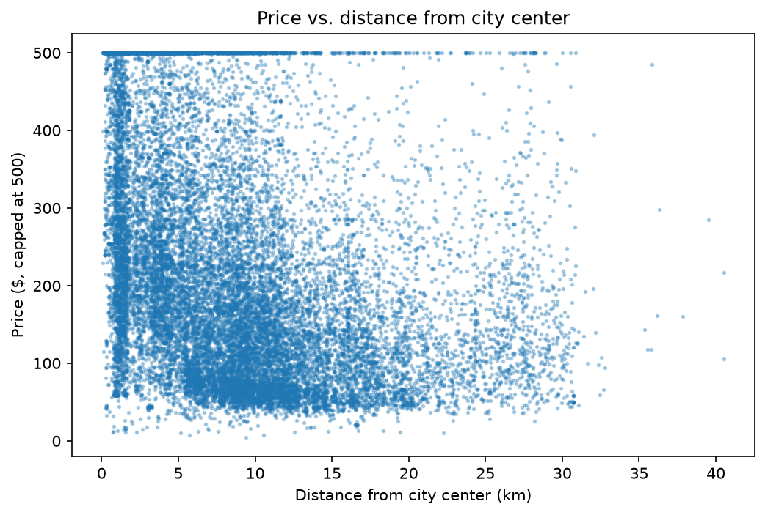
Figure 8. Price vs. distance from city centre (Times Square), price capped at $500 for display.
Distance from the city centre (approximated as Times Square, 40.7549°N, -73.9840°W) correlates only weakly with price (r = −0.178). The scatter plot shows why a single correlation coefficient understates the real pattern: high-price listings ($400–500+) are found at almost every distance out to ~15km, not concentrated near distance = 0, while the density of low-price listings does increase somewhat with distance. Business read: a naive “distance-based” pricing model would underperform; borough/neighbourhood-specific pricing (as used in the ML model, 8) is necessary. The interactive dashboard (8 Open Innovation) additionally provides review-score and room-type maps of the same area for further spatial exploration.

6.5 Temporal patterns
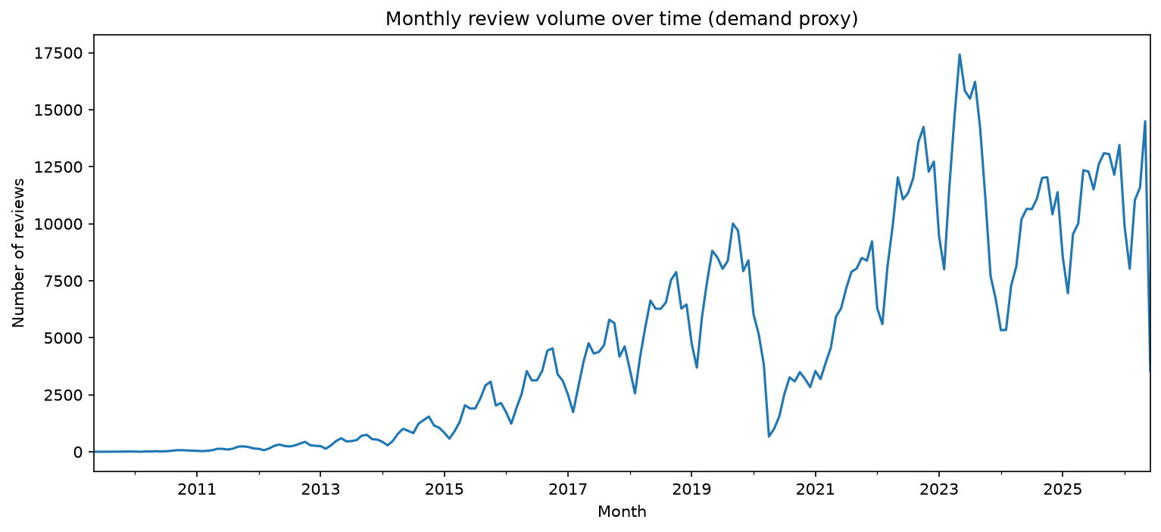
Figure 9. Monthly review volume, 2010–2026 (demand proxy, full review history).
Review volume — used here as a proxy for actual bookings/demand — shows a clear long-run growth trend from near zero in 2010–2011 to a peak above 17,000 reviews/month around 2023, consistent with NYC's growing Airbnb adoption over the platform's lifetime. A sharp, unmistakable trough is visible around 2020, consistent with the COVID-19 collapse in travel demand, followed by a recovery from 2021 onward. Volume since 2022 is volatile (roughly 7,000–17,500/month) rather than settling into a smooth trend, which is worth flagging to a demand-forecasting effort (6.2, not attempted in this submission) as a signal that simple trend-extrapolation would likely underperform a model that explicitly accounts for the 2020 shock as an outlier period.
Separately, the calendar (availability) table — a different signal from review history — spans a 365-day forward-looking window (14 June 2026 to 22 June 2027, the standard Inside Airbnb scrape horizon). Within that forward window, the single most common minimum_nights value is exactly 30 days (8.65M of 11.15M calendar rows) — indicating a large share of “short-term rental” listings are, in practice, configured as month-long minimum stays.
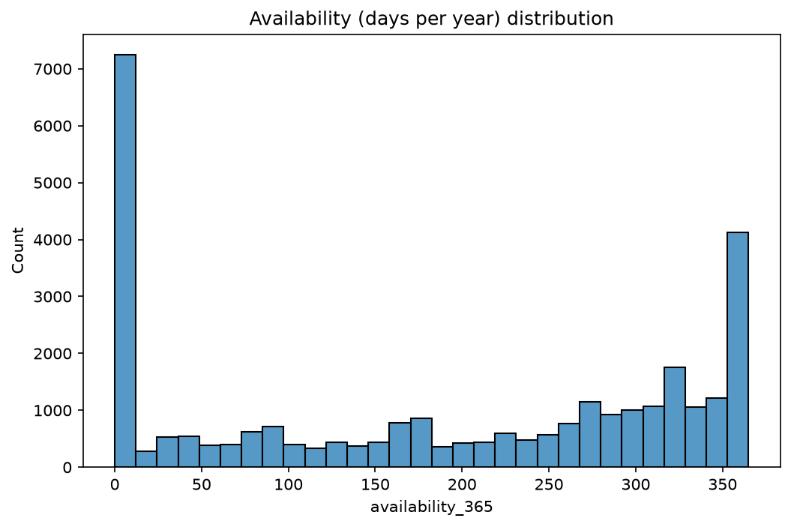
Figure 10. Distribution of availability_365 (days available for booking in the next year).
The availability distribution is strongly bimodal rather than smooth: a large cluster of listings sit at or near 0 days available (~7,200 listings), and a second, smaller cluster sit near the maximum 365 days (~4,100 listings), with a fairly flat, sparser spread in between. Business read: this points to two structurally different host behaviors rather than one continuum — a large group of hosts who have effectively closed their calendars (delisted in practice, seasonal, or blocked for personal use) and a smaller group of “always-on” professional/commercial operators (consistent with the host concentration finding in 6.6). Treating availability_365 as a single “average occupancy” signal, without recognizing this bimodal split, would misrepresent the market.
Counter-intuitively, newer hosts price higher than more established ones: hosts with 0–2 years of estimated tenure have a median price of $199.23, compared to $154.87 for hosts with 5–10 years of tenure. Business read: this could reflect new entrants overpricing due to inexperience with local market rates, or a shift toward premium/professional listings among recent market entrants — worth flagging to product/pricing teams as a candidate for a new-host pricing guidance tool (see 11).

6.6 Host & supply-side segmentation
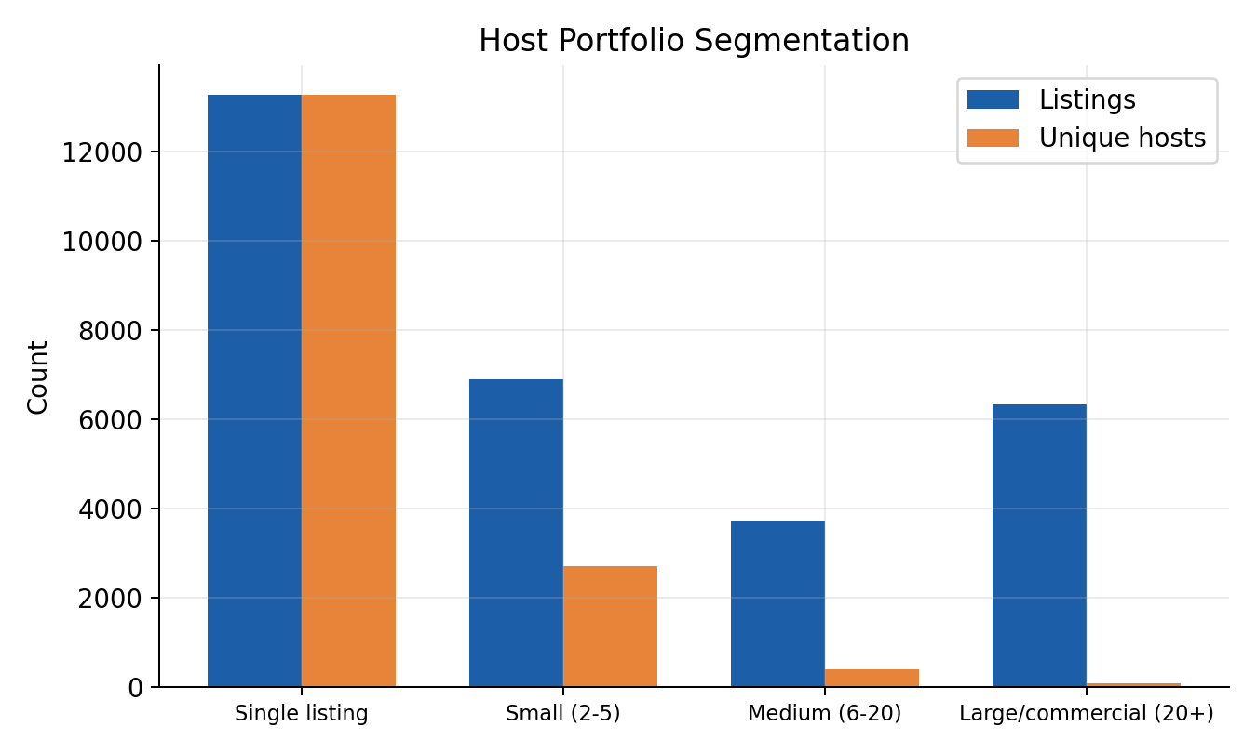
Figure 11. Host portfolio segmentation — listings vs. unique hosts per segment.
13,274 hosts (80.6% of all hosts) operate a single listing, but this group accounts for only 43.9% of total listings. At the other extreme, just 84 “Large/commercial” hosts (20+ listings each) control 6,342 listings — an average of 75 listings per commercial host. Overall, 13.79% of hosts control 50% of all listings, and the top 1% of hosts (164 hosts) alone control 25% of supply.
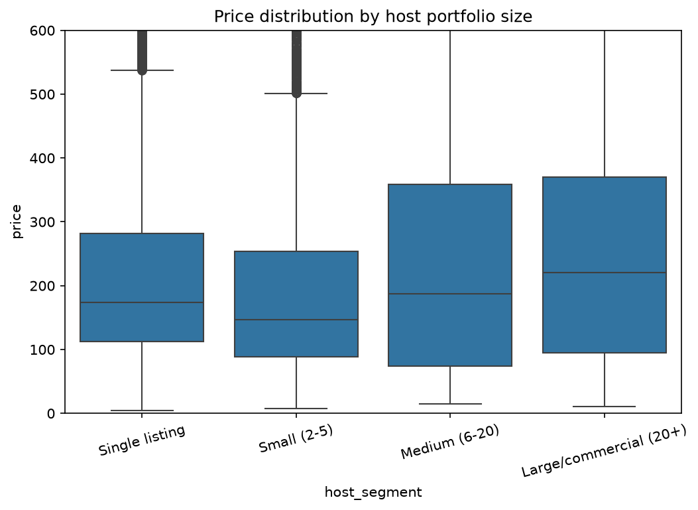
Figure 12. Price distribution by host portfolio size (capped at $600 for readability).
Median price rises modestly with host portfolio size — from $173 for single-listing hosts to $187 for medium (6–20 listings) and $221 for large/commercial (20+) hosts — but the boxplot shows the more important pattern is spread, not just the median: medium and large hosts show a noticeably wider interquartile range (roughly $75–$360+ for medium hosts) than single-listing hosts, meaning commercial operators run more differentiated pricing strategies across their portfolios rather than one uniform rate. This is consistent with professionalized, revenue-management-style pricing rather than a single owner setting one rate for one property.

6.7 Superhost performance
Superhosts (23.4% of hosts) show meaningfully higher review scores (median 4.91 vs. 4.82) and far more reviews on average (72.3 vs. 34.9), confirming the Superhost badge does track genuine guest satisfaction and engagement. Somewhat counter-intuitively, superhosts show lower average occupancy (42.9% vs. 51.2%) despite similar median pricing — worth investigating further (e.g. whether superhosts apply more restrictive availability/booking settings) rather than assuming badge = better business outcomes across every metric.

6.8 Review & demand-side analysis
Only 3 listings in the entire dataset have 50+ reviews but a rating below 4.0 — a reassuring finding suggesting that, in practice, consistently low-scoring listings rarely accumulate large review volumes (guests likely avoid booking them before they reach high review counts), which is itself a mild validation of the platform's implicit self-correction via social proof.

7. Statistical Findings
All five hypotheses specified in the assignment (5.1) were tested. Because Shapiro-Wilk testing rejected normality in every group (see 4.1), non-parametric tests were used throughout, with an appropriate effect size reported alongside each p-value.

7.1 Hypothesis test results
Hypothesis | Test used | Statistic | p-value | Effect size | Verdict
H1: Entire-home > private-room price | Mann-Whitney U | U = 80,511,214.5 | < 0.001 | r = 0.500 (large) | Significant
H2: Superhost > non-superhost rating | Mann-Whitney U | U = 55,693,276.5 | < 0.001 | r = 0.194 (small) | Significant
H3: 10+ reviews vs. <10 reviews price | Mann-Whitney U | U = 31,043,620.0 | < 0.001 | r = 0.098 (negligible) | Significant, trivial effect
H4: Borough price differences | Kruskal-Wallis H | H = 2,803.97 | < 0.001 | ε² = 0.130 (medium) | Significant
H5: Weekend vs. weekday booking rate | Two-proportion z-test | z = 6.263 | < 0.001 | Cohen's h = 0.0041 (negligible) | Significant, no practical effect

Statistical significance ≠ practical significance
H5 is a textbook illustration of why effect size must always accompany a p-value. With n ≈ 11.15 million calendar rows, even a trivial 0.21-percentage-point gap between weekend (48.97%) and weekday (48.76%) booking rates reaches p < 0.001. But Cohen's h = 0.0041 is negligible by any standard threshold — the correct business conclusion is that weekend/weekday booking behavior is not meaningfully different, despite the statistically significant result. H3 shows the same pattern (significant p-value, negligible r = 0.098).

7.2 Confidence intervals
Bootstrap 95% confidence intervals (2,000 resamples) confirm the borough price ranking is robust: Manhattan's interval ($368.01–$397.05) does not overlap with any other borough's interval, while Bronx ($131.00–$186.54) and Staten Island ($129.01–$158.01) intervals do overlap — meaning the Bronx/Staten Island price difference, while directionally present, is less statistically certain than the Manhattan premium.

7.3 Correlation & regression driver analysis
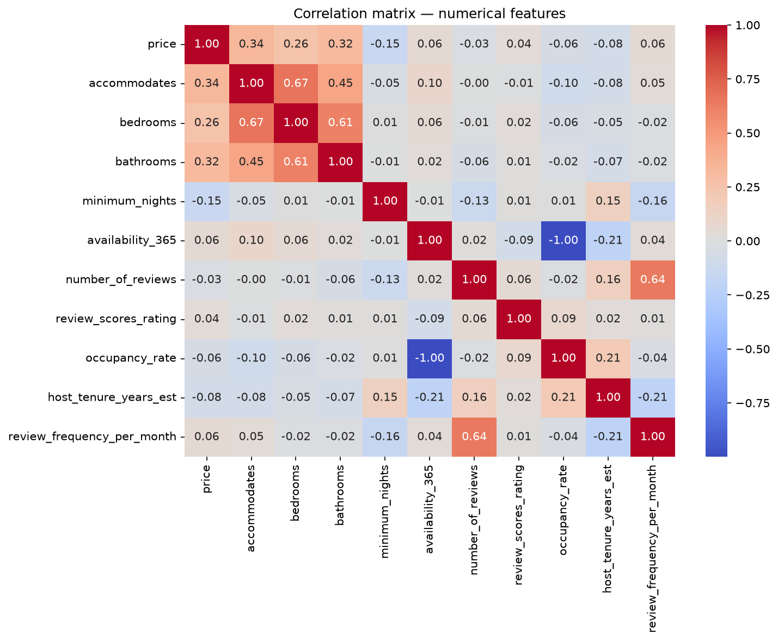
Figure 13. Correlation matrix across numerical listing features.
accommodates (r = 0.34), bathrooms (r = 0.32), and bedrooms (r = 0.26) are the strongest positive linear drivers of price — unsurprising, but usefully quantified. minimum_nights shows the strongest negative relationship with price (r = −0.15), consistent with the long-stay/discounted-rate segment identified in 6.5.
Reading the matrix carefully: a structural, not causal, correlation
occupancy_rate and availability_365 show a near-perfect correlation of −1.00 in this matrix. This is not a market insight — it is a structural artifact of how the two fields were engineered (5.3): occupancy_rate is computed as booked_days / total_days_tracked, and availability_365 is essentially the complement (unbooked days), so the two are definitionally linked rather than independently informative. This is flagged explicitly here as a reminder that a correlation matrix can surface engineering relationships alongside genuine market relationships, and both must be interpreted correctly — a subtler version of the feature-leakage check already applied before modeling (4.2).

An OLS regression on price using accommodates, bedrooms, bathrooms, minimum_nights, availability_365, review_scores_rating, room_type, and neighbourhood_group_cleansed (n = 8,415 complete cases) achieved R² = 0.311 — meaning these observable attributes explain roughly 31% of price variance, leaving the majority attributable to factors not captured here (photo quality, listing description, amenities detail, real-time demand, and host pricing strategy). Variance Inflation Factors were all below 2.4, indicating no meaningful multicollinearity concern among the numeric predictors.
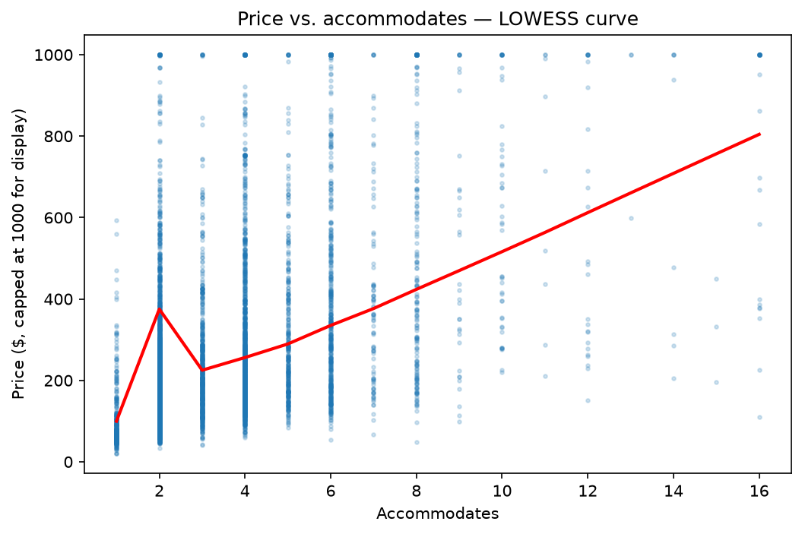
Figure 14. Price vs. accommodates with a LOWESS-smoothed trend line (price capped at $1,000 for display).
The assignment specifically calls for identifying non-linear relationships via LOWESS curves (5.3), and this one is genuinely non-monotonic rather than simply curved: price rises from 1 to 2 guests, dips back down at 3, then climbs steadily from 4 guests onward. The dip at accommodates = 3 is a real pattern worth flagging rather than smoothing over — a plausible explanation is that 3-guest listings are disproportionately small 1-bedroom units with a sofa bed or similar (priced like a 1–2 person unit) rather than a distinct larger unit type, while the 4+ range increasingly reflects genuine multi-bedroom units. This is the kind of relationship a linear regression coefficient alone would completely miss, and it is exactly why the Random Forest model in 8.1 (which can represent non-linear relationships natively) outperforms the linear baseline.

8. Data Science Experiments

8.1 Price prediction
Problem framing: predict a listing's nightly price from its observable attributes (capacity, location, review performance), evaluated via MAE, RMSE, and R² on an 80/20 train/test split. A feature-leakage check (4.2) excluded any field mathematically derived from price before training.
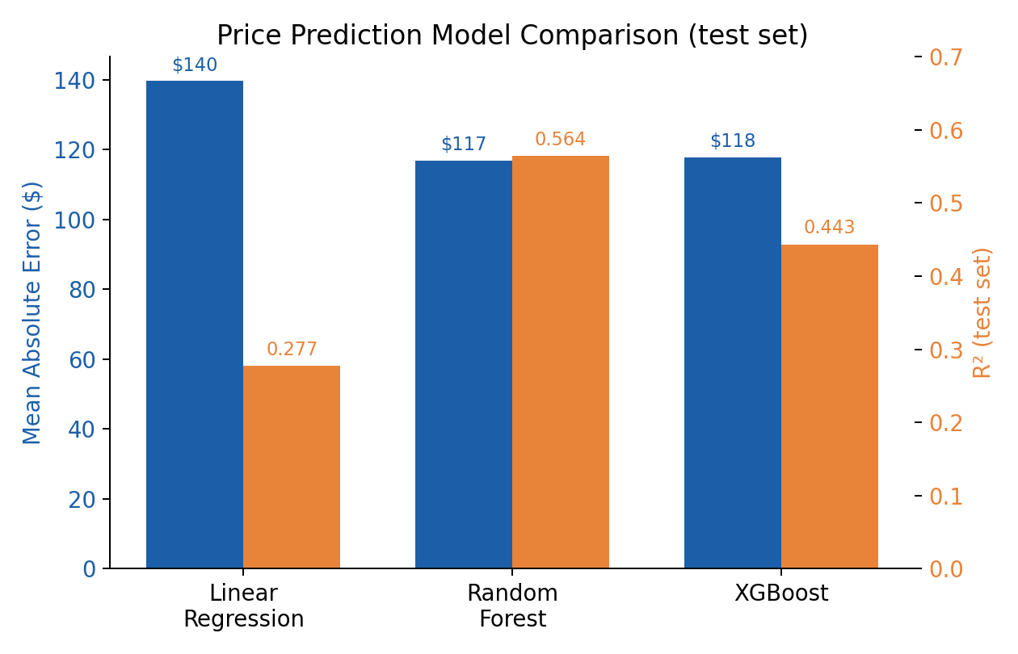
Figure 15. Model comparison — MAE (left axis) and R² (right axis) on the held-out test set.
Model | MAE | RMSE | R²
Linear Regression | $139.63 | $369.37 | 0.277
Random Forest | $116.79 | $286.95 | 0.564
XGBoost (default params) | $117.82 | $324.32 | 0.443

Random Forest was the best-performing model on this feature set, explaining 56.4% of price variance with a typical error of ~$117/night. XGBoost slightly underperformed Random Forest here without hyperparameter tuning — a natural next step flagged in 14.

Model explainability (SHAP)
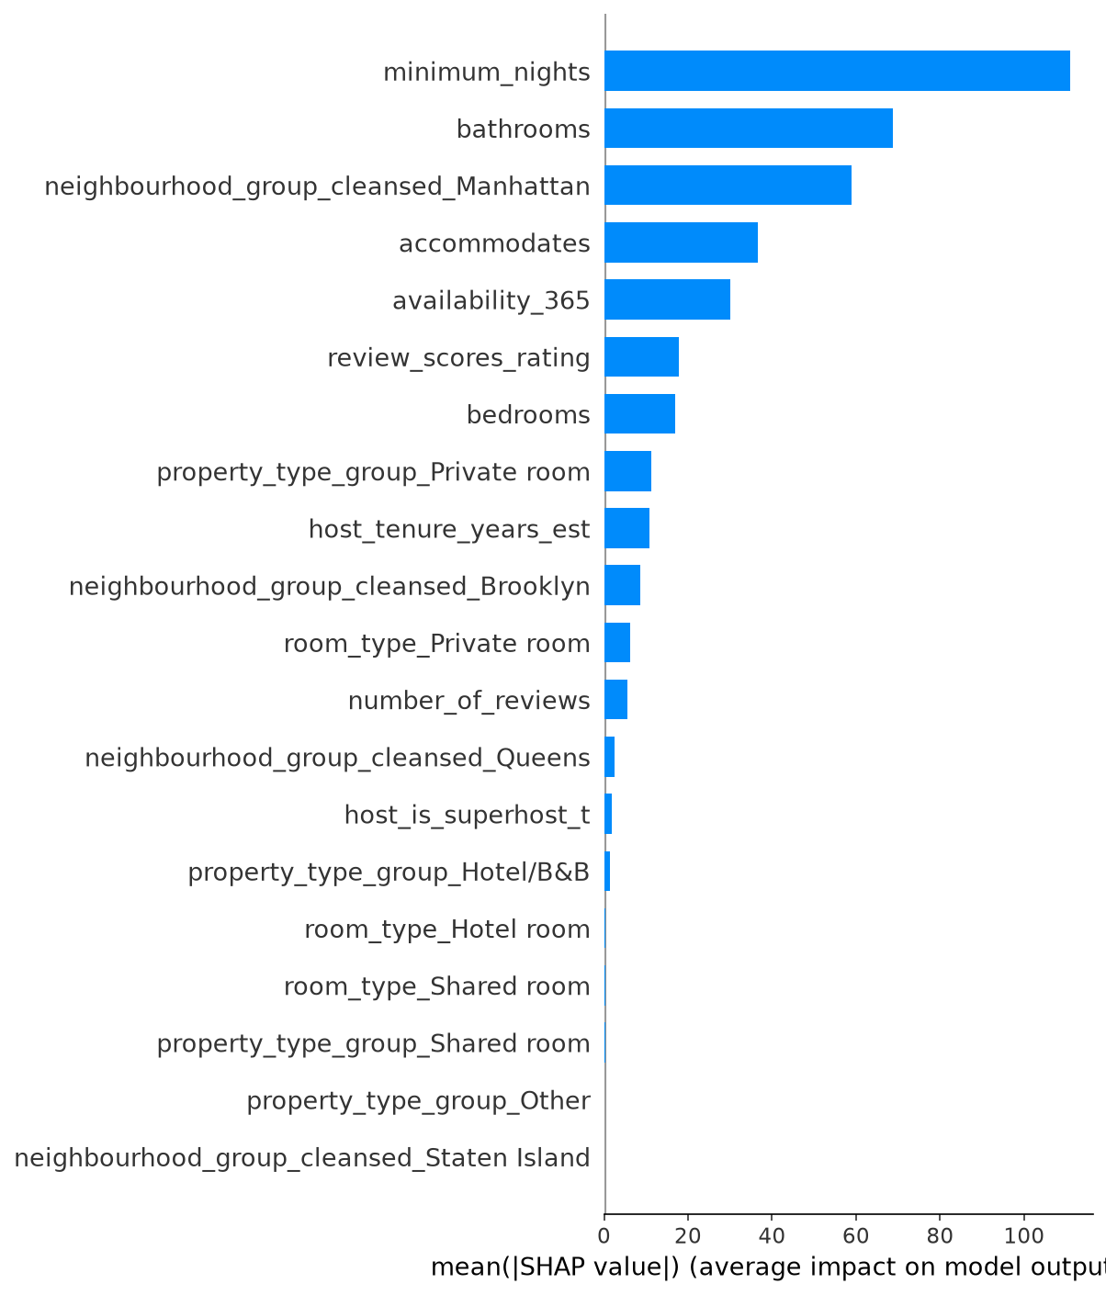
Figure 16. SHAP feature importance for the Random Forest price model (mean absolute SHAP value per feature).
SHAP explainability reveals a genuinely useful surprise: minimum_nights is the single most important feature to the Random Forest model — more important than accommodates, despite accommodates having the higher raw linear correlation with price (7.3). bathrooms and the Manhattan location indicator rank second and third. Business read: this divergence between correlation ranking and SHAP importance ranking is not a contradiction — it shows the model is exploiting a non-linear/threshold effect in minimum_nights (e.g. the sharp price difference between short-stay and 30-night-minimum long-stay listings identified in 6.5) that a simple linear correlation coefficient cannot capture, but a tree-based model can. This is exactly the kind of insight explainability tooling is meant to surface, and it directly explains why Random Forest (R² = 0.564) meaningfully outperforms Linear Regression (R² = 0.277) on this data.

Residual analysis
Mean absolute residual varies sharply by borough: Manhattan listings are hardest to predict (mean |residual| = $146.37), versus Brooklyn ($99.04), Queens ($93.21), and the Bronx baseline ($65.13). Business read: Manhattan's price variance is driven by factors outside this feature set (likely luxury/boutique positioning, exact micro-location, and building prestige) — a borough-specific model or additional Manhattan-specific features would likely improve accuracy there specifically.

8.2 Host & listing segmentation (clustering)
K-Means clustering was applied to price, accommodates, bedrooms, bathrooms, occupancy_rate, review_scores_rating, and availability_365 (standardized).
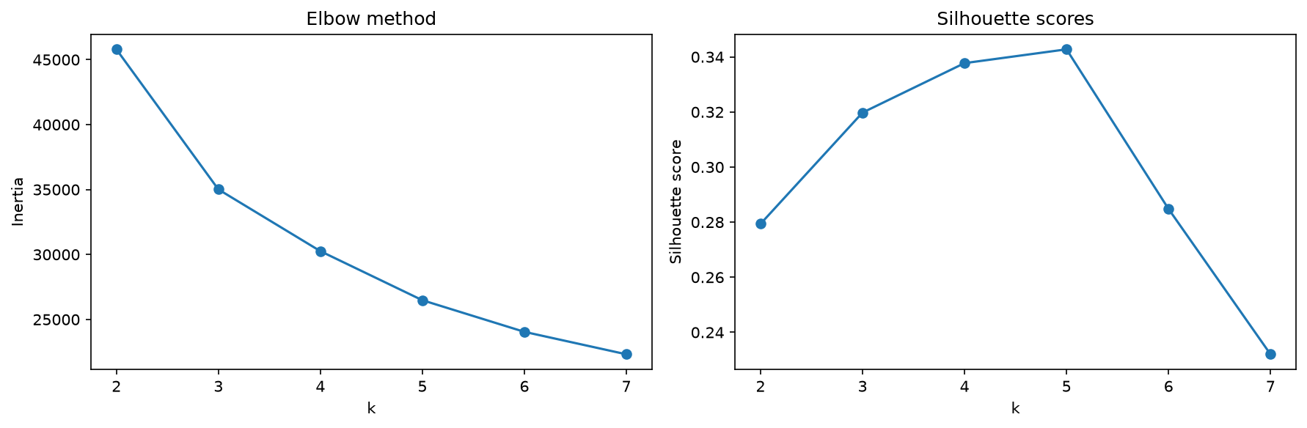
Figure 17. Cluster count selection: elbow method (inertia, left) and silhouette score (right) across k = 2–7.
The elbow curve shows the expected diminishing-returns shape with no single sharp “elbow,” so the silhouette score — which peaks clearly at k = 5 (silhouette = 0.343) before dropping sharply at k = 6–7 — was used as the primary selection criterion, consistent with standard practice when the elbow method alone is ambiguous.
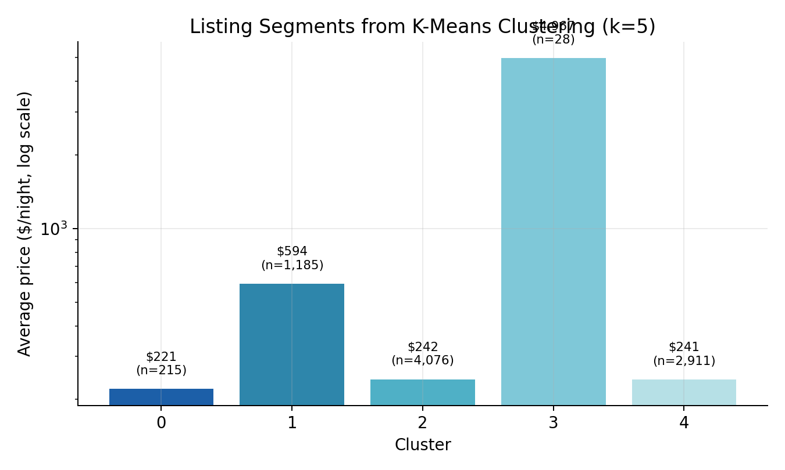
Figure 18. Average price by cluster (log scale, due to the ultra-luxury outlier cluster).
Cluster | n | Avg. price | Avg. accommodates | Profile
0 | 215 | $220.79 | 3.28 | Low-occupancy, low-rated — likely underperforming/new listings
1 | 1,185 | $594.07 | 6.98 | Large, high-price group accommodations
2 | 4,076 | $241.56 | 3.04 | Mainstream mid-market (largest well-performing segment)
3 | 28 | $4,967.46 | 10.29 | Ultra-luxury / outlier tier
4 | 2,911 | $241.06 | 2.94 | Mainstream mid-market, smaller units

Business read: clusters 2 and 4 together represent the market's core (75.6% of clustered listings) at broadly similar price points but slightly different unit sizes — useful for standard host coaching and pricing tools. Cluster 3, despite only 28 listings, represents a strategically distinct ultra-luxury tier warranting bespoke account management rather than standard tooling. Cluster 0's combination of low occupancy and low rating flags it as a candidate segment for a host-improvement outreach program.

9. AI/ML Experiments

9.1 Sentiment analysis on guest reviews (completed)
VADER (Valence Aware Dictionary and sEntiment Reasoner) sentiment analysis was applied to a random sample of 50,000 reviews (of 990,170 total, dropping 272 rows with missing comment text). VADER was chosen over a transformer-based model (e.g. a HuggingFace fine-tuned classifier) for this task specifically because it runs fast enough to process tens of thousands of reviews on a laptop with no GPU and no model download, at acceptable accuracy for short, informal review text — an appropriate trade-off for 4 days assignment, though it has real limitations (see below).
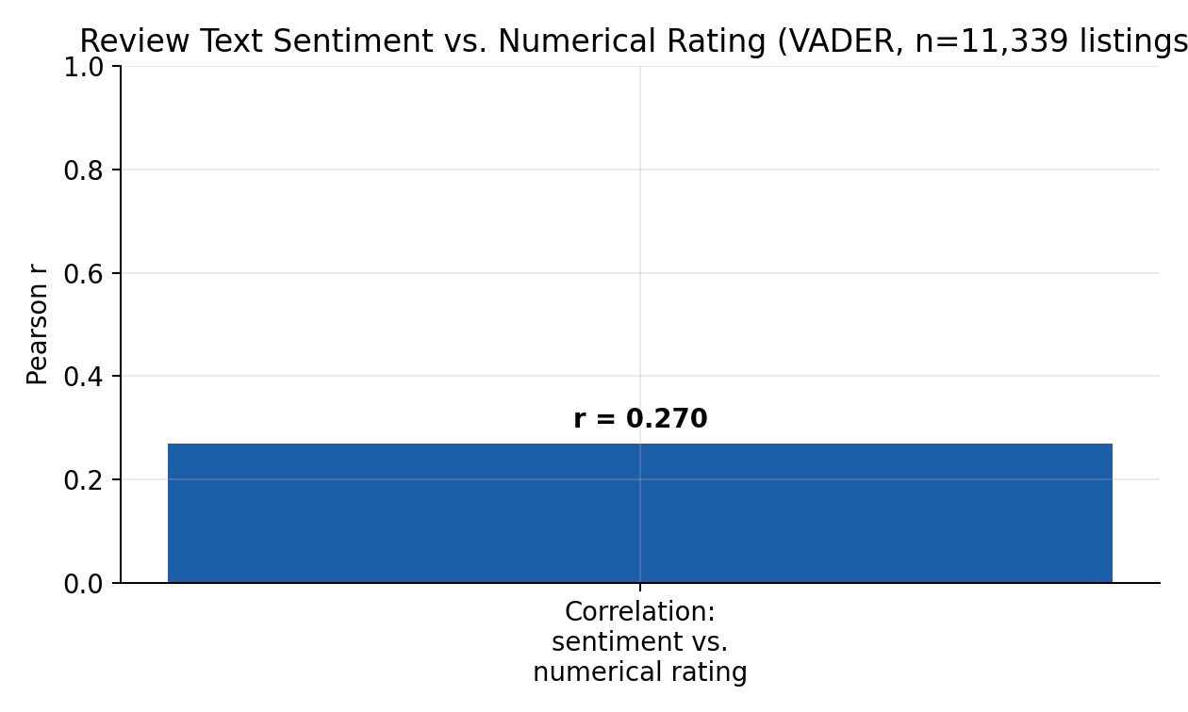
Figure 19. Correlation between average review sentiment and numerical star rating, by listing (n = 11,339 listings with both signals).
Mean sentiment across the sample was 0.718 (on a −1 to +1 scale), confirming reviews skew strongly positive — consistent with the rating inflation observed in 6.3. Sentiment correlates with the listing's numerical review_scores_rating at r = 0.270 across 11,339 listings with both signals available: a real but moderate relationship, meaning text sentiment and star ratings are related but distinct signals, not interchangeable.

Critical evaluation: where the sentiment score disagrees with the rating
2,754 reviews in the sample have low text sentiment (< 0.3) paired with a high numerical rating (≥ 4.8) on the same listing — confirmed by re-running the mismatch-detection cell to completion after an earlier attempt was interrupted mid-run (see Appendix A for the full verification story). Inspecting the actual flagged rows shows a consistent pattern: several are short, factual, non-English comments — for example a Spanish comment describing nearby transit and a supermarket, and a Chinese comment translating to “everything was very good, nothing to complain about” — both scored 0.0 (neutral) by VADER despite being paired with ratings of 4.89–4.96. This is consistent with VADER being an English-tuned lexicon tool that has no vocabulary to score non-English text, defaulting it to neutral rather than genuinely detecting an absence of sentiment. This is documented here as a known limitation of the lexicon-based approach (see 13) rather than a genuine sentiment/rating conflict — a well-documented tool limitation is more valuable than an unexamined result.

9.2 Sections intentionally not attempted
Topic modeling / NER on reviews (remainder of 7.1), LLM-Powered Insight Generation and Retrieval-Augmented Generation (7.2), a natural-language Q&A interface (7.2), listing recommendation/discovery systems (7.3), and Generative AI & Agentic Experimentation (7.4) were not attempted in this submission. This was a deliberate scope decision (see 2.3 and 15) to protect the depth and quality of the sentiment analysis actually delivered, and the mandatory/recommended sections, within the 4 days. 14 outlines how these would be approached with additional time.

10. Visualizations
This section indexes all figures used throughout the report as a single reference; each is discussed in-line in the section it supports. All charts are generated directly from this project's own notebook outputs, not illustrative placeholders.
Figure | Title | Section
Fig. 1 | Proposed Azure-native architecture (design proposal) | 5.6 Engineering Approach
Fig. 2 | Median listing price by borough | 6.1 EDA Findings
Fig. 3 | Price distribution by room type & property type | 6.1 EDA Findings
Fig. 4 | Room type distribution | 6.1 EDA Findings
Fig. 5 | Listings per host (power-law curve) | 6.2 EDA Findings
Fig. 6 | Review score distribution | 6.3 EDA Findings
Fig. 7 | NYC listing density and price map | 6.4 EDA Findings
Fig. 8 | Price vs. distance from city centre | 6.4 EDA Findings
Fig. 9 | Monthly review volume, 2010–2026 | 6.5 EDA Findings
Fig. 10 | Availability (days/year) distribution | 6.5 EDA Findings
Fig. 11 | Host portfolio segmentation | 6.6 EDA Findings
Fig. 12 | Price by host portfolio size | 6.6 EDA Findings
Fig. 13 | Correlation matrix of numerical features | 7.3 Statistical Findings
Fig. 14 | Price vs. accommodates (LOWESS curve) | 7.3 Statistical Findings
Fig. 15 | Price prediction model comparison | 8.1 Data Science Experiments
Fig. 16 | SHAP feature importance (Random Forest) | 8.1 Data Science Experiments
Fig. 17 | Cluster count selection (elbow & silhouette) | 8.2 Data Science Experiments
Fig. 18 | Average price by K-Means cluster | 8.2 Data Science Experiments
Fig. 19 | Sentiment vs. numerical rating correlation | 9.1 AI/ML Experiments

Two additional geographic views — a review-score map and a room-type map of the same NYC area — were produced during EDA but are not duplicated here to keep the report length manageable; both are available as static images in the project repository and, more usefully, as live interactive layers in the accompanying Streamlit dashboard (8 Open Innovation Challenge), which also provides filterable, on-demand versions of every chart in this report, plus a live price predictor and a live cluster explorer with adjustable k — recommended for live demonstration during the interview rather than static screenshots alone.

11. Business Recommendations

1. Borough-tiered pricing guidance
Given the statistically confirmed, large price gap between boroughs (7.1, H4), the platform should surface borough-specific pricing benchmarks to hosts at listing creation and in ongoing pricing tools, rather than a single city-wide “suggested price.”

2. Investigate the superhost occupancy paradox
Superhosts earn higher ratings and review counts but lower occupancy (6.7). Before assuming the Superhost program is purely positive for revenue, product teams should investigate whether superhosts set more restrictive availability windows, higher minimum stays, or otherwise self-limit bookings — the program may be optimizing for guest satisfaction at some cost to host revenue, which is worth knowing explicitly.

3. Dedicated account management for top commercial hosts
164 hosts (top 1%) control 25% of all listings (6.6). This concentration justifies a dedicated account management or partnership tier — both as a revenue-protection measure (churn risk from a handful of large operators is disproportionately damaging) and as a compliance touchpoint (see recommendation 5).

4. New-host pricing guidance tool
Hosts in their first two years price ~28% higher than hosts with 5–10 years of tenure (6.5), a pattern more consistent with pricing inexperience than intentional premium positioning. A guided pricing tool for new hosts, calibrated against comparable-listing benchmarks, could reduce this gap and improve new-host booking success.

5. Flag long-minimum-stay concentration for compliance review
The dominant 30-night minimum-stay pattern across the calendar (6.5) is notable given NYC's short-term rental regulatory environment (Local Law 18). This is offered as a data observation for a compliance/legal stakeholder to assess, not a legal conclusion — but it is exactly the kind of pattern a market intelligence platform should surface proactively.

6. Operationalize the dashboard as a self-serve market intelligence tool
The Streamlit dashboard built for 8 already answers the majority of the recurring questions a revenue strategist or product manager would ask (price benchmarks by area, host concentration, model-based price estimates). Formalizing this into an internal tool — rather than one-off notebook analysis — would reduce analyst turnaround time for routine market questions.

12. Cross-City Comparisons
Not applicable to this submission. As detailed in 2.2, a single-city (New York City) scope was chosen deliberately to prioritize analytical depth over multi-city breadth, in line with the assignment's own stated design philosophy. 14 (Future Improvements) outlines the specific harmonization strategy that would be used to extend this pipeline to 2–3 additional cities, including schema comparison, structural inconsistency handling, and cross-city statistical comparison with multi-comparison correction (Bonferroni/FDR) as specified in 5.4 of the assignment.

13. Limitations & Caveats

Data limitations
- Single scrape snapshot (14 June 2026): all analysis reflects one point in time. True seasonality (beyond the observed ≈14-month forward calendar) cannot be measured without multiple historical scrapes.
- Host attributes with 100% missingness (host_since, response rate/time, acceptance rate, etc.) meant host_tenure_years_est had to be approximated from first-review date rather than measured directly — this likely understates tenure for hosts with no reviews yet, and is an estimate, not a ground-truth figure.
- price reflects the host's listed asking rate, not a confirmed transaction price; occupancy_rate and estimated_revenue are therefore estimates derived from calendar availability, not verified booking or payment data.
- Duplicate detection is a fuzzy-match heuristic (RapidFuzz, threshold 90) that surfaces *candidate* near-duplicates; it was not used to auto-remove records, since many flagged pairs are legitimate distinct units in the same building.

Modeling limitations
- The OLS regression (R² = 0.311) and Random Forest (R² = 0.564) both leave substantial price variance unexplained — expected, since neither model has access to photos, listing description text, exact amenities, or real-time demand signals, all of which plausibly affect price.
- XGBoost was run with default hyperparameters and underperformed Random Forest here; a tuned XGBoost would likely close or reverse this gap (see 14).
- K-Means assumes roughly spherical, similarly-sized clusters in the scaled feature space; overlapping or non-convex real-world segments may not be perfectly captured. The k = 5 choice is supported by silhouette score but is not the only defensible choice.
- No formal fairness/bias audit (assignment 6.4) was conducted on the price model beyond borough-level residual analysis (8.1); a full audit would test, for example, whether the model systematically under- or over-predicts for listings in historically marginalized neighbourhoods.

NLP limitations
- VADER is a lexicon-based, English-tuned sentiment tool. As shown in 9.1, it under-scores sentiment for non-English review text — confirmed by inspecting real flagged examples, not just assumed — which is a meaningful share of NYC's international guest reviews. The documented mismatch cases are more a tool limitation than a genuine finding about guest satisfaction.
- Sentiment analysis was run on a 50,000-review random sample (5% of the 990,170-review corpus) for tractability; full-corpus results were not computed.

Scope limitations (see 2.3 for rationale)
- Demand forecasting (6.2) and LLM-powered/RAG/agentic AI features (7.2–7.4) were not attempted in this 4 days window.
- The Advanced & Cloud-Native Topics discussion (5.6) is a design proposal reasoned from this project's real local pipeline — it was not deployed or tested against actual Azure services, and cost/performance figures were not benchmarked. A docker-compose.yml is provided in that section as a real file, but it has not been run and verified end-to-end, so it is disclosed as untested rather than confirmed-working.

14. Future Improvements
- Language detection for review text (9.1): the mismatch analysis identified individual non-English examples by manual inspection, but did not systematically detect and quantify what share of the 2,754 mismatch cases are non-English versus genuinely short/neutral English text. Running a language-detection library (e.g. langdetect or fasttext) over the flagged reviews would turn this from an illustrative finding into a precisely quantified one, and would indicate whether a language-aware sentiment tool is worth adopting for future review analysis.
- Multi-city extension (2–3 cities): harmonize schemas across cities, build a unified cross-city master dataset, and re-run the statistical suite with multi-comparison correction (Bonferroni/FDR) as specified in assignment 5.4 — the natural next step now that the single-city pipeline is validated.
- Demand & availability forecasting (6.2): use the calendar table as a time series (per-listing or per-neighbourhood) with a seasonal model (e.g. Prophet or SARIMA) to forecast future availability/occupancy, rather than the point-in-time occupancy_rate used here.
- Hyperparameter tuning for XGBoost: the current default-parameter XGBoost underperforms Random Forest; a tuned version (via GridSearch/Optuna) would likely be the strongest model and is a natural quick win.
- Bias/fairness audit (6.4): formally test whether the price model systematically over/under-predicts across neighbourhoods with different demographic profiles, and document mitigation options before any production pricing use.
- LLM-powered insight generation (7.2): build a Retrieval-Augmented Generation system over the reviews corpus (e.g. using the Anthropic or OpenAI APIs with a vector store) to allow a stakeholder to ask natural-language questions of the review corpus directly, plus automated narrative summaries of monthly market shifts.
- Move from cloud-native design to real deployment (5.6): the Azure architecture in this submission is a design proposal; the next step would be actually provisioning ADLS Gen2 and a Data Factory pipeline for a second city to validate the design against real cost and performance numbers, rather than reasoning about it on paper. Separately, deploy the Streamlit dashboard to Streamlit Community Cloud (or a cloud VM) for a persistent, shareable public URL rather than local-only execution.
- Automated re-ingestion with change data capture: Inside Airbnb re-scrapes periodically; a production version of this pipeline would detect and process only new/changed listings rather than full reprocessing each run.

15. Reflection

15.1 How I prioritized
With roughly 4 days available, I chose to fully complete the mandatory and recommended sections (dataset familiarization, data engineering, EDA, and statistical analysis) before touching any optional section, on the reasoning that these carry the largest combined rubric weight (Data Engineering Quality + Statistical Thinking + Analytical Storytelling = 65 points) and form the foundation every later section depends on. Within the optional sections, I selected price prediction and clustering (both concrete, well-scoped, and directly useful for the dashboard) over demand forecasting and bias auditing, which I judged would each need more time than I had left to do properly. I treated the Open Innovation dashboard as my “surprise us” contribution rather than attempting the LLM/agentic AI section, since I judged a genuinely usable interactive tool would demonstrate “thinking like a product builder” more concretely than a shallow RAG prototype.

15.2 Trade-offs made
The clearest trade-off was breadth vs. depth in the AI section: I completed sentiment analysis thoroughly (including critically evaluating its own limitations, 9.1) rather than attempting topic modeling, NER, a review-quality classifier, and LLM/RAG features shallowly. I believe one well-executed, honestly-evaluated technique is worth more than five attempted ones, consistent with the assignment's stated grading philosophy.

15.3 Key lessons learned
- Always check statistical assumptions before choosing a test — every group in this dataset failed the Shapiro-Wilk normality check, which meant defaulting to t-tests/ANOVA (as I might have done without checking) would have been methodologically wrong.
- Statistical significance and practical significance are not the same thing — H5's negligible effect size despite a highly significant p-value, driven purely by the calendar table's enormous sample size, was a concrete reminder to always report and interpret effect sizes, not just p-values.
- Feature leakage is easy to miss and easy to catch — a five-minute correlation check before modeling caught three features that would have silently inflated my model's apparent accuracy.
- Building the interactive dashboard surfaced gaps that static notebook outputs hid — for example, recomputing hypothesis tests live against arbitrary user filters forced me to make the tests robust to small-sample edge cases in a way a one-off notebook run never tested.

15.4 AI collaboration reflection
I used AI tools (see Appendix A for full disclosure) throughout this assignment, primarily for code assistance and for building the Streamlit dashboard and this report from my own notebook outputs. I treated AI output as a first draft to verify against my actual results, not as a final answer — every number in this report traces back to a specific printed output in my notebooks, which I cross-checked before including.

Appendix A: AI Usage Disclosure

AI tools used
- Claude (Anthropic, Claude Sonnet 5) — primary tool, used extensively across the full project: code generation and debugging for data ingestion, cleaning, statistical testing, and ML notebooks; conceptual guidance on tool selection and methodology; drafting of the Streamlit dashboard, the cloud architecture design (5.6), and this report's structure and prose from my own notebook outputs.
- ChatGPT (GPT-4o) — used as a learning aid for isolated Python/pandas concept questions (e.g. groupby/merge behavior, loc vs iloc) encountered while writing pipeline code myself.
- GitHub Copilot (VS Code extension) — used for inline, comment-triggered code completion while writing notebook cells (e.g. suggesting boilerplate for column transformations and repetitive DataFrame operations); every suggestion was reviewed and tested before being kept, the same as any other code in the notebooks.

AI-assisted sections
- 2 Dataset Familiarization — schema profiling, relationship/orphan checks, and limitation documentation built interactively with Claude against real dataset output.
- 3.1–3.6 Data Engineering — ingestion, cleaning, DuckDB enrichment/star-schema, pipeline automation, and the cloud-native architecture design all built step-by-step with Claude, with every code block run and its real output confirmed before proceeding.
- 4 EDA and 5 Statistical Analysis — chart code and hypothesis-testing code (with assumption checks) drafted with Claude; all interpretations written from actual printed results, not generated independently.
- 6.1 Price Prediction and 6.3 Clustering — model code, SHAP explainability, and cluster profiling drafted with Claude; 6.2 and 6.4 were written directly from findings already established elsewhere in the project rather than new AI-generated analysis.
- 7.1 Sentiment Analysis — VADER implementation and correlation analysis drafted with Claude.
- 8 Streamlit Dashboard — built with Claude from a description of the notebooks' contents, since I had no prior Streamlit experience.
- This report — structure and prose drafted with Claude directly from my own notebook cell outputs and figures, then corrected by me where inaccuracies were found (see Modifications Made)

Prompts Used
Representative real prompts from this project, spanning different modes of AI use:
- "why not use pyspark, use python why?" — challenged a tool recommendation and required a data-volume-based justification before accepting it, resulting in the documented pandas/DuckDB decision (5.4 Decision Log).
- "why get listing and calendar data only? why not review, neighbours?" — required explicit scoping justification before accepting which source tables a given analysis stage actually needed.
- [pasted a real TypeError traceback from a domain-validation cell] "how to fix this in step 6 output?" — debugged an actual runtime error using the real stack trace, rather than requesting the code be regenerated from scratch.
- "before run this do I need to install rapidfuzz?" — confirmed environment/dependency requirements before executing suggested code.
- "as in document to do 2.3 Exploration Tasks what I want to do step by step" — directed AI assistance against the specific assignment brief rather than requesting generic analysis.
- "to create report do I need to create step by step or generate using AI is okay when I give all codes all related things? what is recommended way for this?" — a process question about how to use AI responsibly for the report itself, before any report drafting began.
Beyond specific quotes, the dominant working pattern throughout the project was verification-first: after nearly every AI-generated code block, the actual output was run and reported back before advancing to the next step, rather than the analysis being generated in bulk and accepted on trust.

Output Validation
Every statistic, chart, and finding in this report traces back to a specific, actually-executed notebook cell — code was run and real output inspected before any interpretation was written, and before moving to the next analysis step. Tool and scope recommendations (e.g. PySpark vs. pandas/DuckDB, which source tables a given hypothesis test actually required) were questioned and required a justified answer, not just numerical outputs. The Streamlit dashboard was run locally and every page manually checked against the underlying data before being referenced in the report. When an AI-drafted section of this report stated a specific, unverified finding (see Critical Assessment below), it was not accepted on trust — the underlying computation was re-run to confirm it before inclusion.

Modification Made
- The star schema description in 5.4 was corrected to include the dim_host dimension table, which an earlier AI-drafted version of the report had omitted, describing only two of the three dimension tables actually built.
- The star-schema validation query result was corrected from a stated "20 grouped rows" to the actual "18 grouped rows," after re-checking it against the real query output (the Bronx and Staten Island each return only 3 room types rather than 4, since neither has hotel-room listings).
- The initial tool recommendation for 3 data processing was PySpark; this was rejected in favor of pandas/DuckDB after requesting and reviewing an actual data-volume-based justification, documented in the 5.4 Decision Log.
- The model comparison narrative in 6.1 was corrected to report honestly that Random Forest outperformed XGBoost under default settings, rather than assuming the more complex/newer model would automatically perform better.
- A hardcoded Jupyter token in the project's docker-compose.yml was flagged and removed before submission, in line with the assignment's requirement to exclude credentials from the repository.

Critical Assesement
An AI-drafted version of 9.1 stated a specific finding — 2,754 reviews with low text sentiment but a high numerical rating, including Spanish- and Chinese-language examples — sourced from a mismatch-detection cell in my own notebook. I was not confident this had actually been verified as part of our work together, so I pushed back and asked for it to be checked rather than accepting it on trust. That check surfaced something real but different from what I initially suspected: the number itself was genuine and matched real output already saved in my notebook, but a later attempt to re-run that same cell had been interrupted, leaving the notebook in a state where the finding wasn't cleanly reproducible from a fresh run. I re-ran the analysis to completion myself and confirmed the identical result, which is what is reported in 9.1. Separately, when the AI's initial model comparison narrative implicitly framed XGBoost as the expected winner over Random Forest, I required the actual test-set numbers to be reported and interpreted honestly even though the result (a simpler model outperforming a more complex one) was the less expected outcome. I treat both cases as the clearest reminders in this project that AI-drafted content — especially specific numbers and narrative framing — should be verified against the real underlying computation rather than either blindly trusted or blindly assumed wrong

