Hotel Booking Data Analysis
Final Project Report
Course: Data Processing with Python
Submission date: 20.10.2026
Member | Full name | Main contribution
A | Aurelija Putnaite | Inspection and cleaning
B | Mohammad Ruhan Zahif Akhter Ghantiwala | Transformations and stay length
C | Subhanjan Shah | Cancellations and consistency checks
D | Eusabious Jacob | Prices and monthly patterns

1 Introduction
We analyzed 1,000 hotel booking records to compare cancellations, booked stay lengths, daily rates and arrival patterns. City Hotel had a higher cancellation rate and higher positive daily rates. Resort Hotel had longer booked stays. These findings describe the sample and do not explain what caused the differences.
Each row represents one booking, including canceled and non-canceled bookings. The course dataset contains 20 original variables. It comes from two hotels in Portugal: a city hotel in Lisbon and a resort hotel in the Algarve. Observed arrival dates run from 1 July 2015 to 31 August 2017. The source is the Hotel Booking Demand dataset described by António, de Almeida and Nunes (2019).

Research questions
- Do cancellation rates differ between the city and resort hotels?
- How do average daily rates and booked stay lengths differ between the hotels?
- How do booking counts and daily rates vary by arrival month, and do the hotels show the same pattern?
Our aim was to produce clear comparisons that could help hotel management decide what to investigate next. We used Python, Pandas and Matplotlib for preparation, calculations and charts.

2 Data preparation and methods
We checked the data shape, column names, types, category counts, missing values, duplicates and numerical ranges. We kept the original DataFrame unchanged and created a separate cleaned copy. All 1,000 records were retained in the full dataset.

Cleaning decisions
Missing country: Two missing values were filled with “Unknown”. No country was guessed.
Exact duplicates: We found 26 repeated rows across the original 20 columns. We retained them because no booking identifier was available to show whether they were errors or separate bookings. We checked cancellation rates again after removing them from a separate copy.
Dates and negative values: Full year-month-day conversion found no invalid dates. No negative numerical values were found. Stays longer than one week were not treated as errors.
Zero guests and nights: Three records had zero total guests; all three also had zero nights and zero daily rates. Five records in total had zero nights. We retained them in full-data counts but excluded zero-night records from positive-stay statistics.
Daily rates: Fifteen records had a zero daily rate. We retained them in the full dataset but excluded them from positive-rate analysis. Their meaning is unknown.
Unusual values: The 1.5-IQR rule flagged 28 lead times above 364 days and 25 daily rates above 209.64 EUR. The highest values were 542 days and 304 EUR. We retained these records because unusual values alone do not establish errors.

Derived variables
Variable | Calculation
Arrival date | Combined arrival year, month and day
Total nights | Weekend nights plus weekday nights
Total guests | Adults plus children plus babies
Estimated booking value | Average daily rate multiplied by total nights

We validated all four calculations. Estimated booking value describes a planned booking amount, not actual revenue. Bookings that were canceled remain in the analysis.
The cancellation and monthly-count analyses use 1,000 records. Positive-stay analysis uses 995 records, and positive-rate analysis uses 985. Numerical summaries include valid sample size, mean, median, sample standard deviation, minimum and maximum. Crosstab percentages use bookings within each hotel as their denominator.

3 Hotel types and booked stay lengths
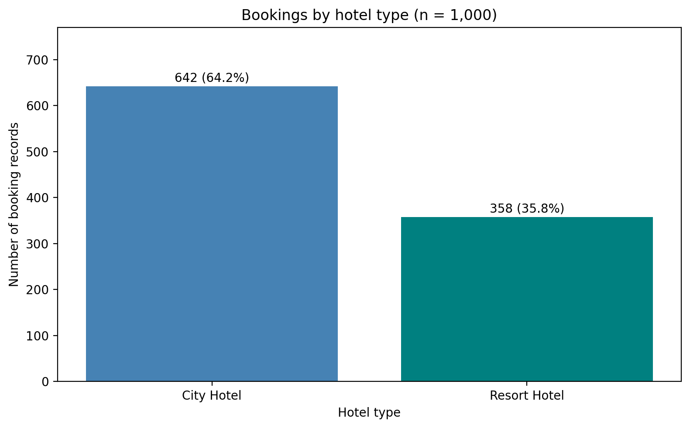
Figure 1. Hotel-type counts and percentages, n = 1,000.
City Hotel contributes 642 records (64.2%) and Resort Hotel contributes 358 (35.8%). The different counts make within-hotel percentages useful for comparisons. These counts do not measure hotel capacity or occupancy.
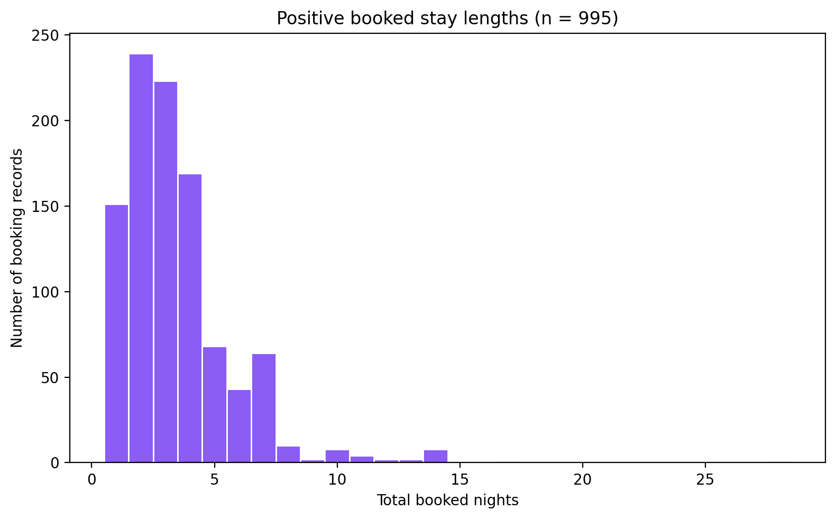
Figure 2. Positive booked stay lengths, n = 995.
Most positive booked stays are one to four nights. The mean is 3.47 nights, the median is 3, and the sample standard deviation is 2.37. Stays range from 1 to 28 nights. Five zero-night records are excluded. These are booked nights, not confirmed nights actually spent at the hotels.

4 Cancellation analysis
Overall, 366 of the 1,000 booking records were canceled (36.60%). The remaining 634 records were not canceled (63.40%). We compared hotel type and cancellation status using a crosstab of counts and within-hotel percentages.
Hotel | Not canceled | Canceled | Valid n | Canceled %
City Hotel | 363 | 279 | 642 | 43.46
Resort Hotel | 271 | 87 | 358 | 24.30
Overall | 634 | 366 | 1,000 | 36.60

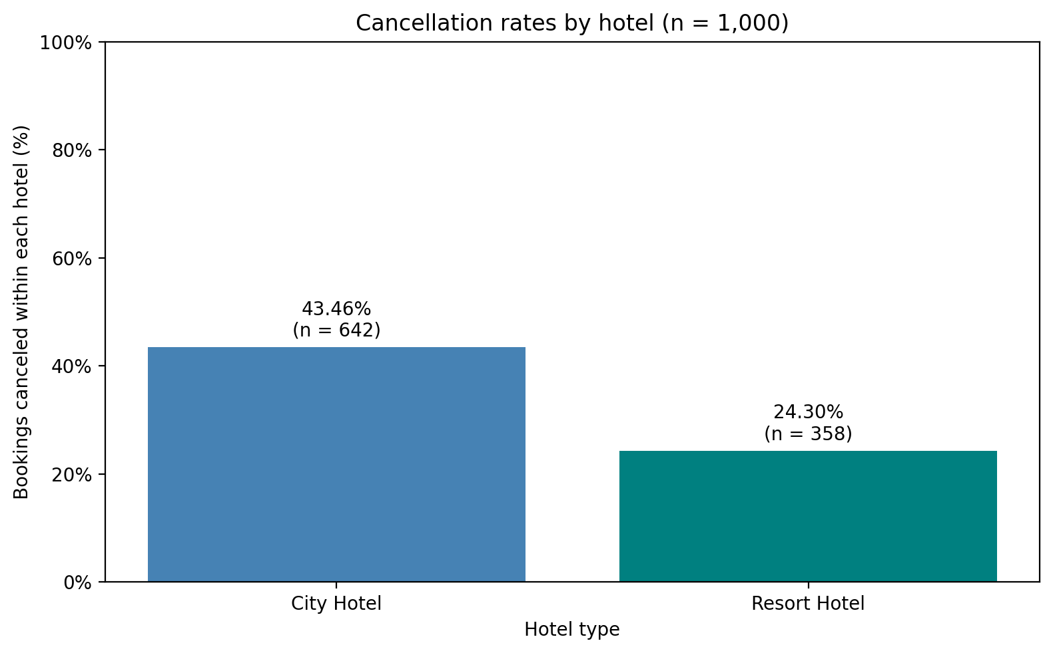
Figure 3. Canceled bookings as a percentage of all bookings within each hotel.
City Hotel has a cancellation rate of 43.46%, compared with 24.30% for Resort Hotel. The difference is 19.16 percentage points. This answers research question 1: the rates differ in this sample, with City Hotel higher. It does not establish that hotel type causes cancellations.

Duplicate sensitivity check
Removing 26 exact duplicate rows from a separate copy leaves 974 records. City Hotel’s cancellation rate becomes 42.23% and Resort Hotel’s becomes 23.88%. The direction of the finding remains the same. This does not establish which duplicate policy is correct, so the main analysis follows the documented decision to retain all records.
Consistency checks confirmed that the hotel counts match the overall total, cancellation counts match the source data, and percentages within each hotel add up to 100%.

5 Daily rates and stay length by hotel
Positive daily rates are compared using 985 records. Positive booked stay lengths are compared using 995 records. Each group includes canceled and non-canceled bookings.
Measure | City Hotel | Resort Hotel
Positive-rate records | 632 | 353
Mean daily rate in EUR | 107.23 | 94.74
Median daily rate in EUR | 100.40 | 78.95
Daily-rate standard deviation | 36.99 | 54.18
Daily-rate minimum to maximum | 6.00–284.20 | 6.00–304.00
Positive-stay records | 638 | 357
Mean booked nights | 3.03 | 4.24
Median booked nights | 3 | 4

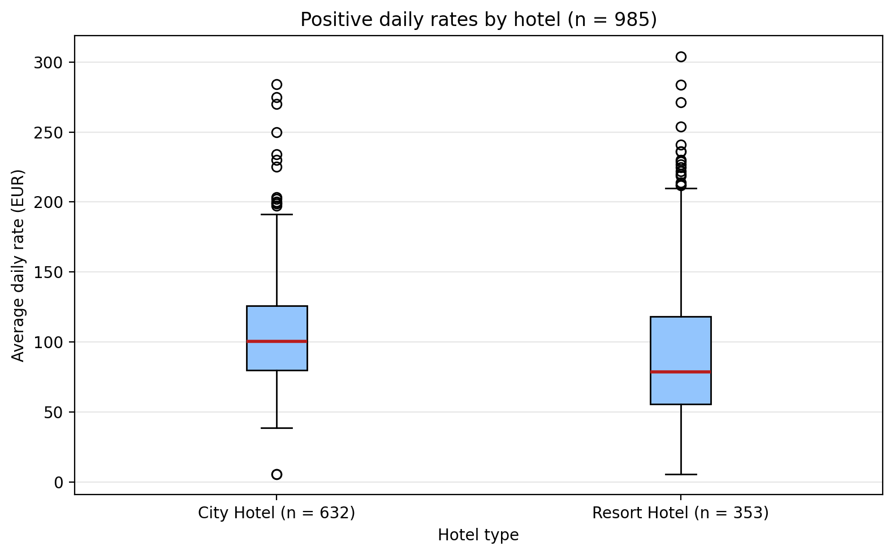
Figure 4. Distribution of positive daily rates by hotel, n = 985.
City Hotel has higher mean and median positive daily rates. Resort Hotel has a wider price spread and longer positive booked stays. This answers research question 2: the city hotel is more expensive per night in this sample, while resort bookings are longer on average.
Across all 985 positive rates, the mean is 102.75 EUR, the median is 95.00 EUR, the standard deviation is 44.31 EUR, and the range is 6–304 EUR. Among positive-rate bookings, mean estimated booking value is 406.32 EUR for the resort and 330.19 EUR for the city hotel. These are calculated values, not actual earnings.

6 Booking and price patterns over time
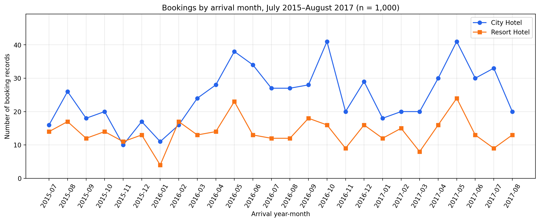
Figure 5. Booking records by arrival year-month, n = 1,000.
May 2017 has the highest combined count: 65 records, made up of 41 city and 24 resort bookings. City Hotel has more records in most months, but Resort Hotel is higher in November 2015 and February 2016. The lines do not move together in every month. Counts describe scheduled arrivals, including cancellations, rather than occupied rooms.
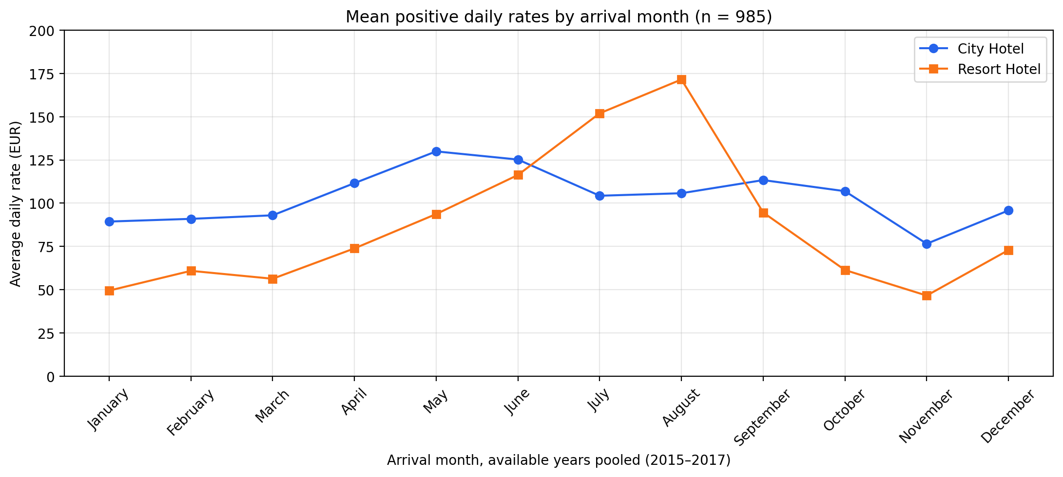
Figure 6. Mean positive daily rates by pooled arrival month, n = 985.
Resort Hotel’s monthly mean rate exceeds City Hotel’s only in July and August. Resort means range from 46.64 EUR in November to 171.44 EUR in August. City means range from 76.58 EUR in November to 129.92 EUR in May. Both hotels vary by month, with greater variation at the resort.
For research question 3, booking counts and rates vary across observed months, and the hotel price patterns differ. Pooled counts are highest in May (126) and lowest in January (45). July and August appear in three years, while other months appear in two. The notebook shows both this unequal coverage and the sample sizes behind monthly price means. These comparisons do not prove seasonal demand or a pricing strategy.

7 Conclusions and recommendation

Main findings
- City Hotel accounts for 64.2% of the sample.
- Overall, 36.6% of records are canceled. City Hotel’s cancellation rate is 19.16 percentage points higher than Resort Hotel’s.
- Among positive booked stays, the median is three nights and the mean is 3.47 nights.
- City Hotel has higher positive daily rates on average, while Resort Hotel has longer positive booked stays.
- May 2017 has the highest combined year-month booking count. Resort Hotel’s highest pooled monthly mean daily rate occurs in August.

Limitations
The sample comes from two specific hotels, and the supplied brief does not explain the sampling procedure in detail. We cannot generalize these findings to all hotels. The comparisons do not control for lead time, deposit type, market segment or other differences, so they do not establish causes.
Exact duplicates are retained, and the meaning of zero-guest, zero-night and zero-rate records is uncertain. Different analyses use different subsets. Only 2016 is a complete calendar year, and pooled months have unequal coverage. Booking records do not establish actual occupancy, payments or lost revenue.

Recommendation and next question
Management should investigate why City Hotel has a higher cancellation rate, starting with lead time and deposit type. Monthly counts and rates can help identify periods for closer review. This sample alone does not justify changing prices or cancellation policies.
A useful next question is: What reasons do guests give for canceling, and how long before arrival do they cancel? This requires cancellation reasons and timestamps, which are not supplied.

8 Exported results and verification
We exported hotel_bookings_cleaned.csv with 1,000 rows and 24 columns. We also exported hotel_booking_summary.csv with six descriptive statistics for positive booked stays and a label identifying that subset. Both files were read back into Python. Shape, column and content checks passed. The original DataFrame and source CSV remained unchanged.

Reference
António, N., de Almeida, A., & Nunes, L. (2019). Hotel booking demand datasets. Data in Brief, 22, 41–49. https://doi.org/10.1016/j.dib.2018.11.126

