eOppimisKeskus
Client Setup & User Guide | Windows and macOS
AI-assisted Finnish education news → English newsletter
This guide explains how to install Docker, start the application, and troubleshoot the Windows WSL setup. Screenshots are from an actual first-time Windows installation.

1 Before you begin
Windows: Docker Desktop is required. You do not need to install Python, Ollama, Git, or VS Code separately when using the supplied Windows .bat launcher.
macOS: Docker Desktop and a working Python 3 installation are needed to use the included Python startup script. Windows .bat files do not run on macOS.
Allow sufficient disk space, RAM, and internet access for the first download of Docker images and the Qwen3:4b model. AI processing may be slow on computers without strong hardware.

2 Download the project
- Open the project repository: https://github.com/subhanjanshah/Suomen_eOppimekeskus
- Select Code → Download ZIP, then extract the ZIP to a normal folder.
- Open the extracted folder. It should contain compose.yaml and the startup files. Do not launch files from inside the ZIP.

3 Windows: Install Docker Desktop
- Download Docker Desktop from https://www.docker.com/products/docker-desktop/ and run the installer.
- If the installer says “Virtual Machine Platform” is missing, follow Section 4 below.
- After installation, open Docker Desktop and wait until the Docker engine is running.
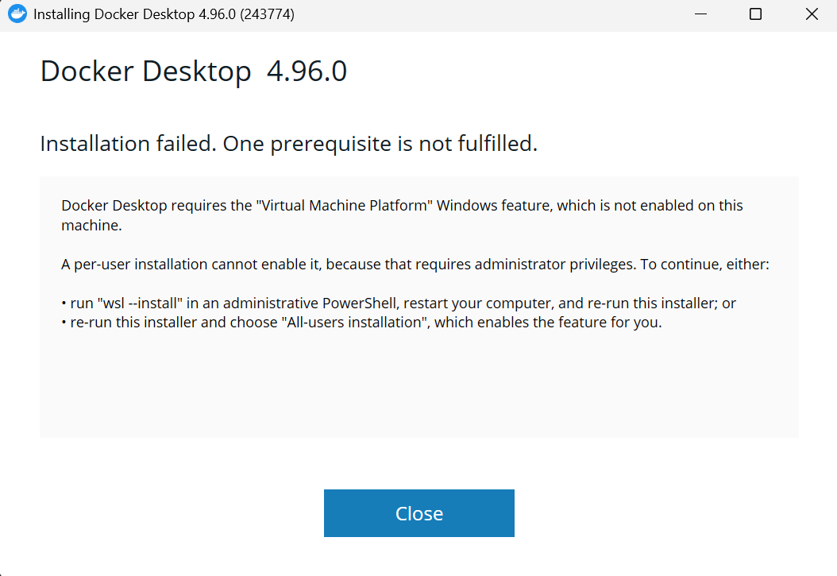
Figure 1. Docker Desktop installer error: Virtual Machine Platform is not enabled.

4 Windows: Fix the WSL / Virtual Machine Platform error
This section is only needed if Docker Desktop reports that a Windows prerequisite is missing.
- Close the Docker installer.
- Open Start, search for PowerShell, right-click it, and choose Run as administrator.
- Enter the command shown below and press Enter.
- Wait for installation to complete. If the download seems frozen, check whether the console is in “Select” mode; press Esc to exit selection mode.
- When the command says changes require a reboot, restart the computer.
- Run the Docker Desktop installer again and open Docker Desktop.
PowerShell command:
wsl --install
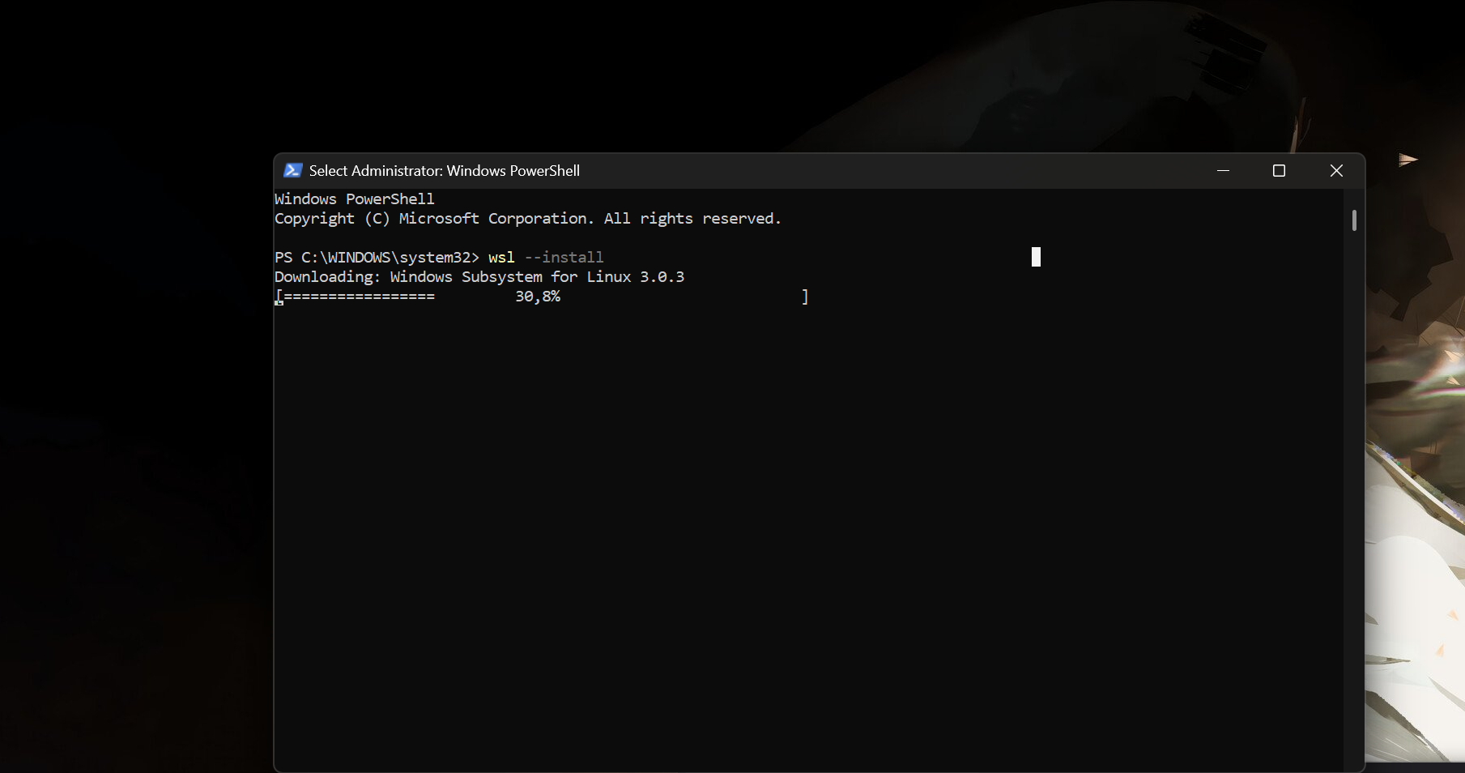
Figure 2. WSL downloading in administrator PowerShell. Wait for completion.
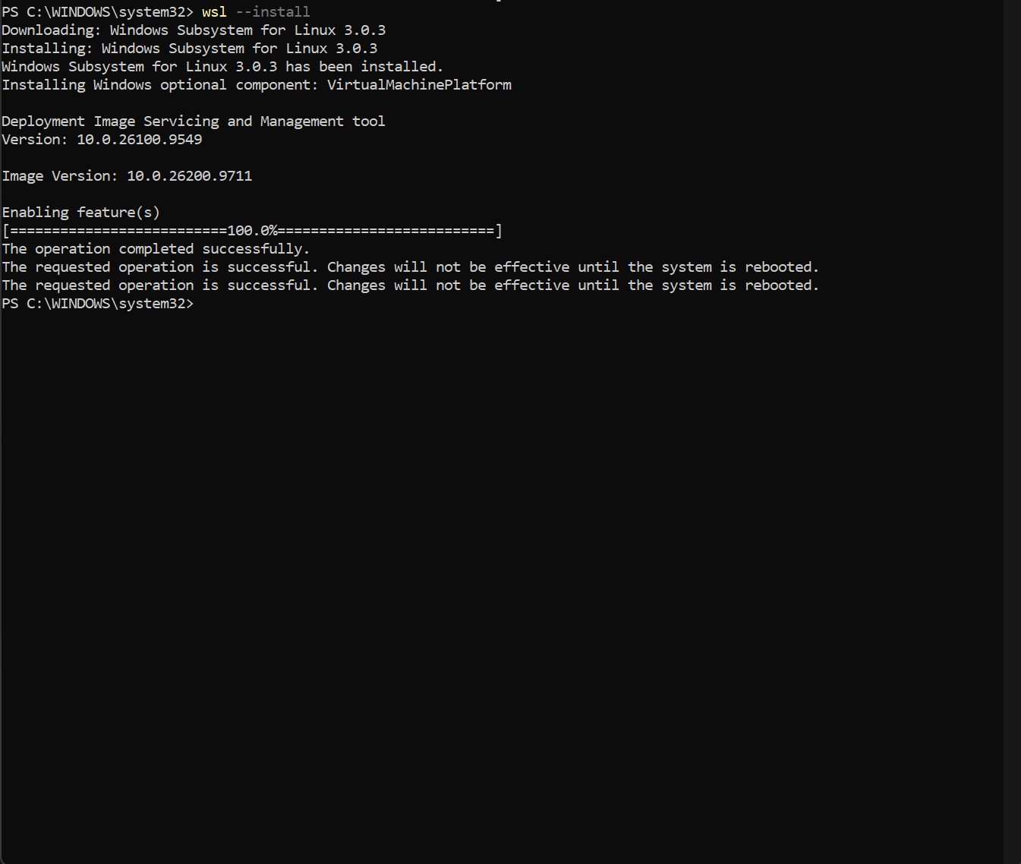
Figure 3. Successful WSL installation and Virtual Machine Platform activation; restart required.
If WSL download repeatedly fails, try “wsl --install --web-download” in administrator PowerShell. If installation still fails, ask your IT administrator to check Windows virtualization support and permissions.

5 Windows: Start the application
- Ensure Docker Desktop is installed and initialized.
- Double-click Start-eOppimisKeskus.bat inside the extracted project folder.
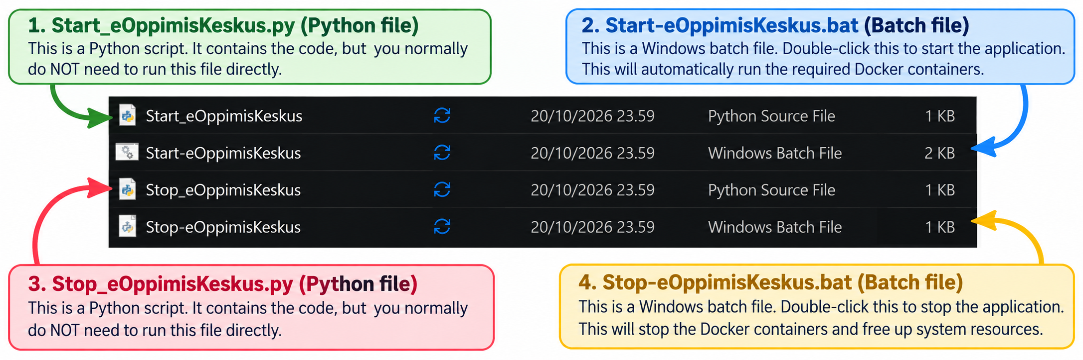
- The launcher starts Docker Desktop if needed, waits for it, builds/starts the containers, and opens the app in your browser.
- If the browser does not open(It takes a while the first time), visit http://localhost:8501 manually once startup finishes.
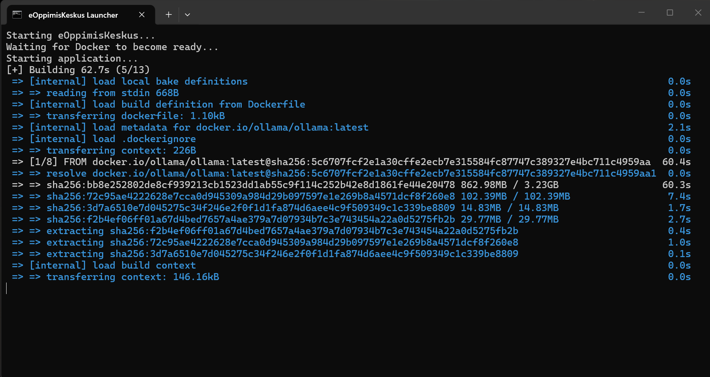
Figure 4. First startup: Docker downloads images and builds the application. Leave this window open.
Important: The first launch can take several minutes or longer. The AI model may still be downloading after the website appears. The first AI request can therefore take extra time.

6 macOS: Start the application
The .bat startup and stop files are Windows-only. On a Mac, use Start_eOppimisKeskus.py instead. The script requires Python 3 and Docker Desktop installed and running.
- Install Docker Desktop for Mac and complete its initial setup. Open Docker Desktop and wait until its engine is ready.
- Install Python 3 if it is not already available, then open Terminal.
- In Terminal, navigate to the extracted project folder using cd, for example: cd /path/to/Suomen_eOppimekeskus-main
- Run: python3 Start_eOppimisKeskus.py
- The script runs Docker Compose and opens http://localhost:8501 in a browser. If the page opens before the app is ready, wait and refresh.
To stop on macOS, from the same project folder run: python3 Stop_eOppimisKeskus.py
Note: The macOS Python script is a simple Docker Compose launcher, not a standalone app. Docker Desktop is still required. macOS startup has not been verified in the Windows test screenshots.

7 First-time account setup and everyday use
- When the app first opens, create the administrator account. Choose a password of at least 12 characters.
- Sign in. An administrator can add colleagues through Manage Accounts.
- Collect education articles by topic, URLs, or supported feeds.
- Review relevance scores and AI-generated English summaries. Edit and approve the articles you want to include.
- Generate the newsletter, check dates, links, text, and image permissions, then download the HTML file. The application does not email the newsletter automatically.

8 Stop and restart
Windows: Double-click Stop-eOppimisKeskus.bat. Closing the browser tab alone does not stop Docker containers.
macOS: In Terminal, from the project folder, run python3 Stop_eOppimisKeskus.py.
The normal stop procedure preserves Docker volumes containing accounts and the downloaded model. Avoid docker compose down -v unless you intentionally want to delete persistent volumes.

9 Troubleshooting
Docker installation says Virtual Machine Platform is missing — Follow Section 4, reboot, and rerun the installer. Administrator privileges may be needed.
Docker engine is not ready — Open Docker Desktop and wait until it finishes starting; retry the launcher.
Browser cannot connect — Wait for the first build, then open http://localhost:8501. Read any launcher error messages.
AI is unavailable or slow — The Qwen3:4b model may still be downloading; local inference can be slow on limited hardware.
Port 8501 is busy — Close another application using that port, or ask technical support.
macOS launcher does not start — Confirm Docker Desktop is running, Python 3 is installed, and the Terminal is in the project folder.

10 Technical support commands (optional)
Run these in a terminal inside the project folder:
docker compose ps
docker compose logs --tail 80 newsletter
docker compose down
Project source and updates: https://github.com/subhanjanshah/Suomen_eOppimekeskus

Made by Team Mazhar 2

