**[Sales Insights - Data Analysis using Power Bi & SQL](https://github.com/mrankitgupta/Sales-Insights-Data-Analysis-using-Tableau-and-SQL" \l "sales-insights---data-analysis-using-tableau--sql----)**

### About Project

* Performed India based company sales insights - A Data Analysis project.
* Raw data loaded into Mysql server then done some basic level of data analysis. After that I have created star schema on power bi to proceed further.
* Developed multiple power bi report to perform analysis, producing quantitative visualizations in power bi to draw valuable insights based on different parameters affecting the company.

**Used Tables:**

**Trnsactions:**

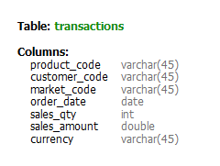

**Products:**

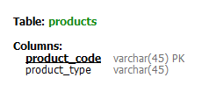

**Markets:**

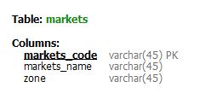

**Date:**

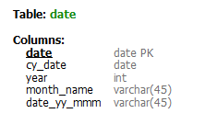

**Customers:**

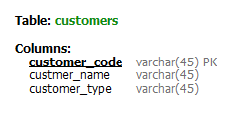

**Data Model**

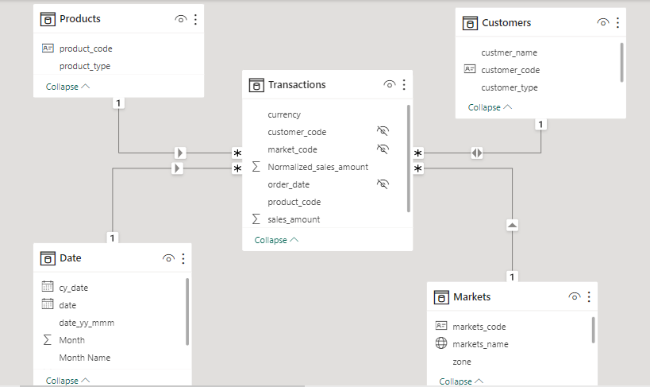

**Basic level analysis using sql:**

1. Distinct currency

select distinct t.currency from transactions t;

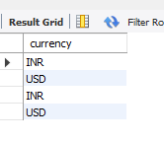

We are selecting currency as INR and USD as there are some bad characters hidden.

2.Total Products

select COUNT(distinct p.product_code) from products p;

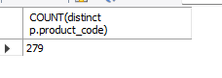

1. Total Customers

select COUNT(distinct c.customer_code) from customers c;

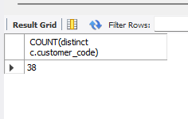

1. Different business zone

select distinct m.zone from markets m;

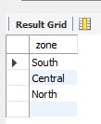

1. Sales amount <= 0 (Data quality issue)

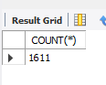

**Sql Quries:**

1. Normalised amount for USD

With trans as(

select t.* , case when t.currency='USD' then

t.sales_amount*75 else t.sales_amount end AS 'Normalised_amount' from transactions t

where t.sales_amount > 0)

select * from trans;

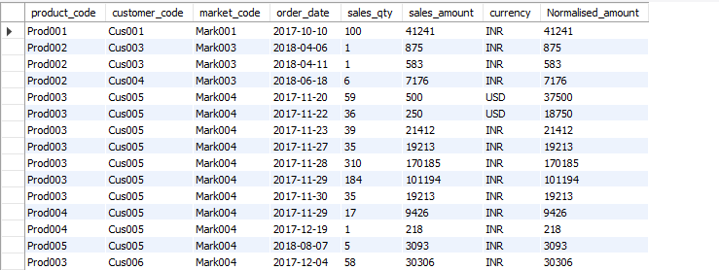

1. Total Revenue

With trans as(

select t.* , case when t.currency='USD' then

t.sales_amount*75 else t.sales_amount end AS 'Normalised_amount' from transactions t

where t.sales_amount > 0 and t.currency in ('USD','INR'))

select SUM(a.Normalised_amount*a.sales_qty) as 'Total_Revenue' from trans a;

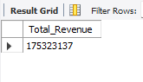

3.Total sales Quantity

With trans as(

select t.* , case when t.currency='USD' then

t.sales_amount*75 else t.sales_amount end AS 'Normalised_amount' from transactions t

where t.sales_amount > 0 and t.currency in ('USD','INR'))

select SUM(a.sales_qty) as 'Total_Revenue' from trans a;

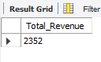

4.Zone wise revenue

With trans as(

select t.* , case when t.currency='USD' then

t.sales_amount*75 else t.sales_amount end AS 'Normalised_amount' from transactions t

where t.sales_amount > 0 and t.currency in ('USD','INR'))

select m.zone,SUM(a.Normalised_amount*a.sales_qty) as 'Total_Revenue' from trans a,

markets m where m.markets_code=a.market_code

group by m.zone;

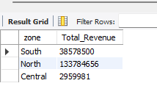

5. Top 50 product by revenue

With trans as(

select t.* , case when t.currency='USD' then

t.sales_amount*75 else t.sales_amount end AS 'Normalised_amount' from transactions t

where t.sales_amount > 0 and t.currency in ('USD','INR'))

select a.product_code,a.Normalised_amount*a.sales_qty as 'Total_Revenue' from trans a

order by Total_revenue desc limit 50;

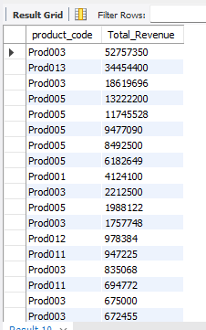

6.