Comparative study of Logistic Regression (LR), Feed forward network (FF) and LSTM. While we get as expected results in Prepayment AUC and 30 Days delinquency AUC, there seems to be some problem with the test loss.

Comparison of Test AUC for Prepayment
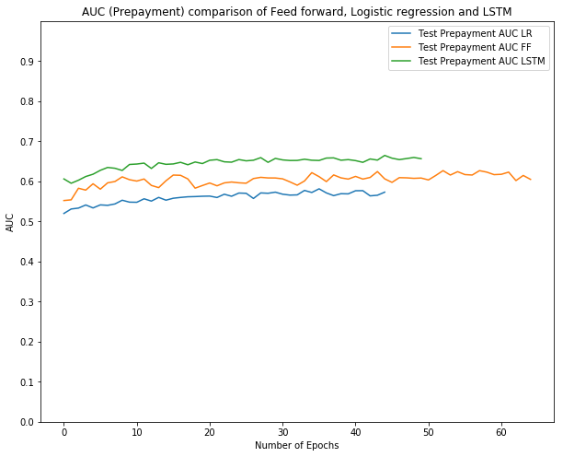

Comparison of Test AUC for 30DD
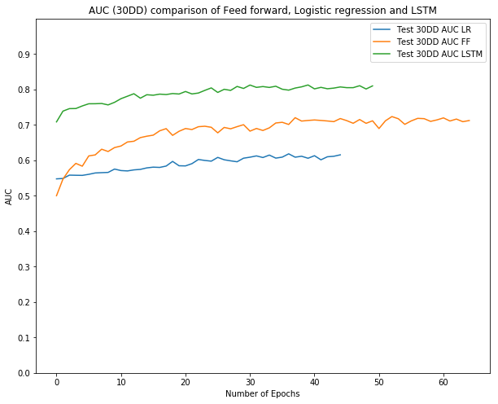

Training Loss Comparison
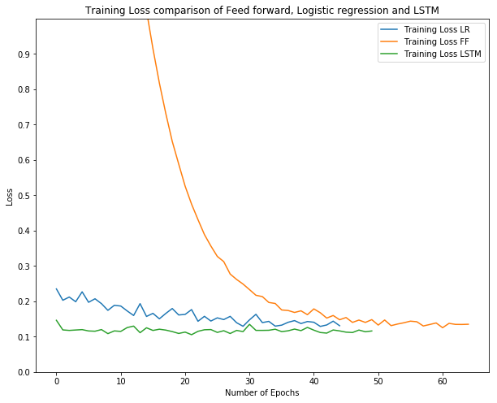

Testing Loss Comparison
