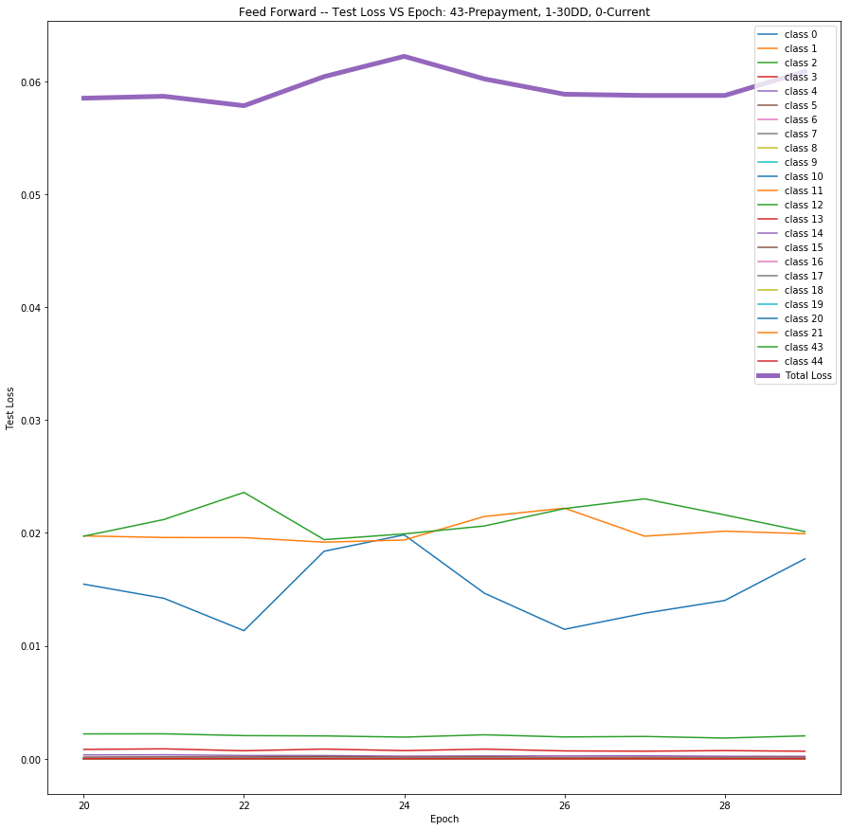
Investigation of Test Loss
I tried to explore the test loss by looking at the test loss for every class. Below is the plot for test losses of each individual class and Total Loss in violet. A magnified view is below.

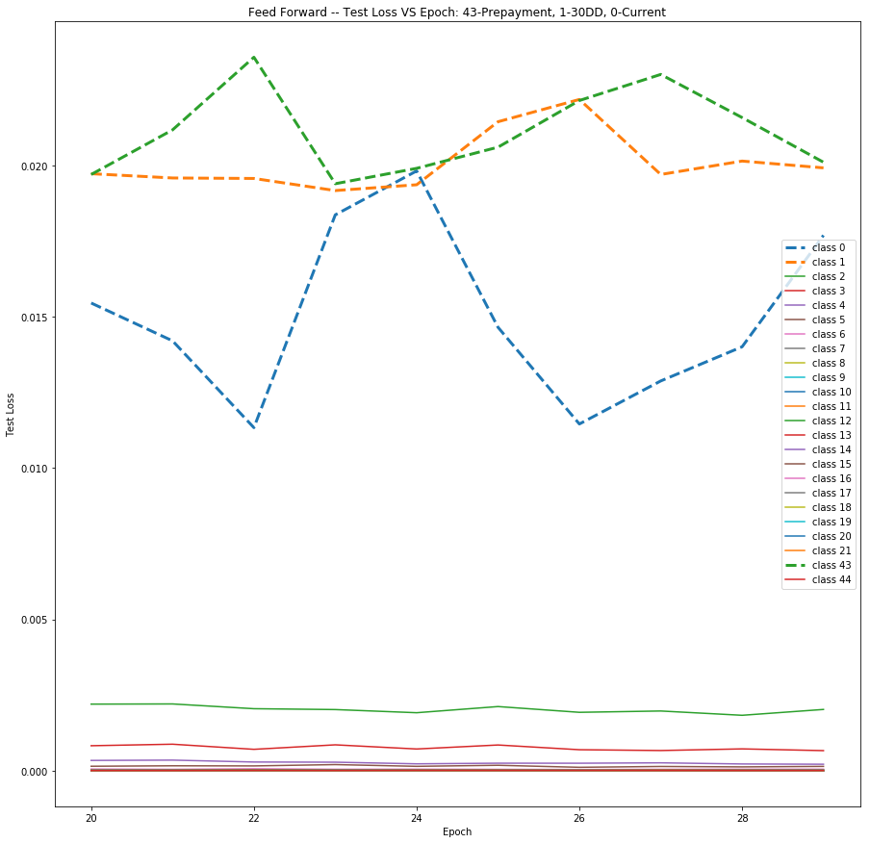

We can see the most dominating loss come from class 0 – Current, class 1 – 30DD and class 43 – Prepayment.
So there is some variation in the individual losses of the dominant classes. But when we sum them the variation smooths out.

Comparative study of Logistic Regression (LR), Feed forward network (FF) and LSTM. While we get as expected results in Prepayment AUC and 30 Days delinquency AUC, there seems to be some problem with the test loss.

Comparison of Test AUC for Prepayment
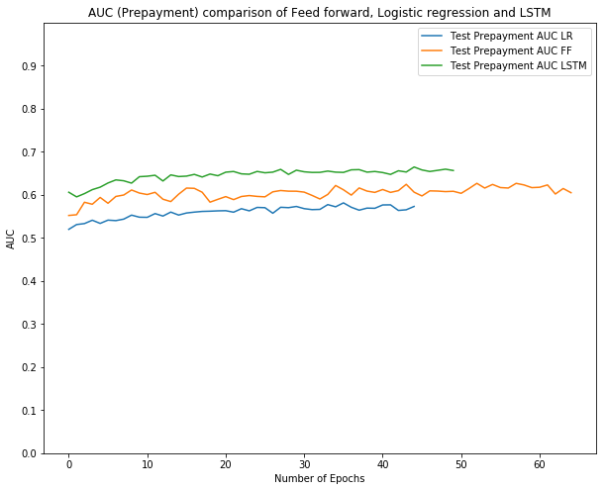

Comparison of Test AUC for 30DD
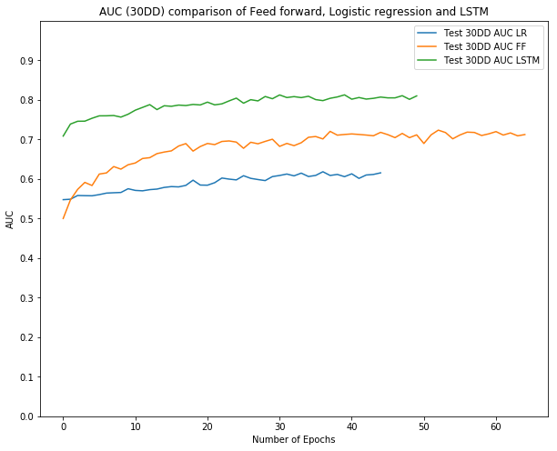

Training Loss Comparison
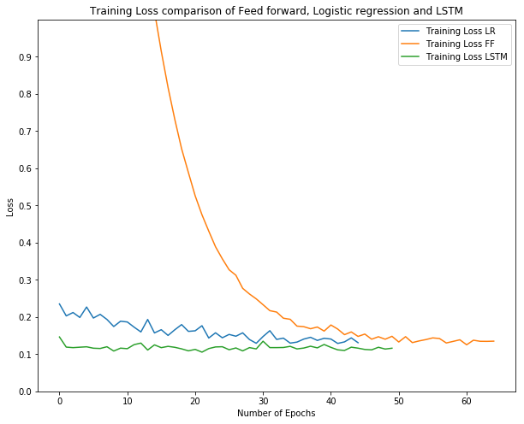

Testing Loss Comparison
