Optimizing AUC directly
According to this paper Optimizing Classifier Performance via an Approximation to the Wilcoxon-Mann-Whitney Statistic I used MultiMarginLoss in pytorch to train logistic regression and feed forward network. The results look noisy and the AUC is less compared to that when I trained with cross entropy loss.
This loss function has one hyper parameter margin, we plot the results for different values of margin.

Logistic Regression
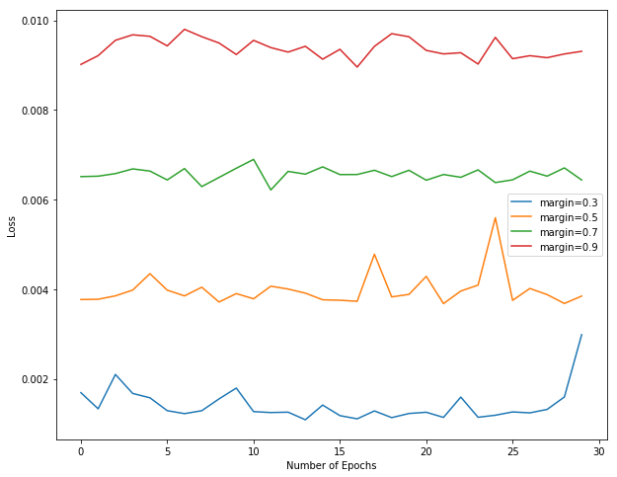

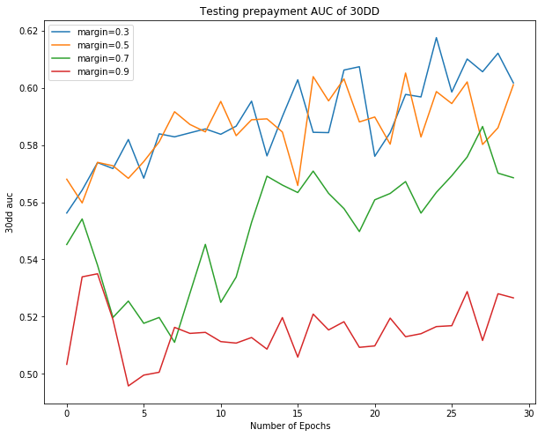

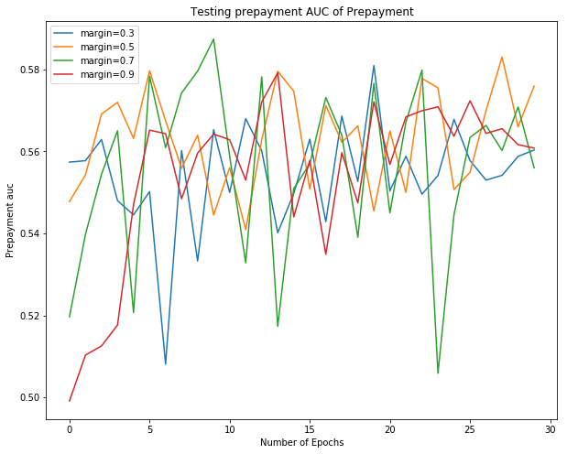

Feed forward network
