Data Analysis of the lifetime of loans

The following plot is for loans originating between 2006-2015. X-axis shows the lifetime and Y-axis the frequency. There is a very high frequency of loans with lifetime between 23-35 months. There is another small peak between 46 to 56 months.

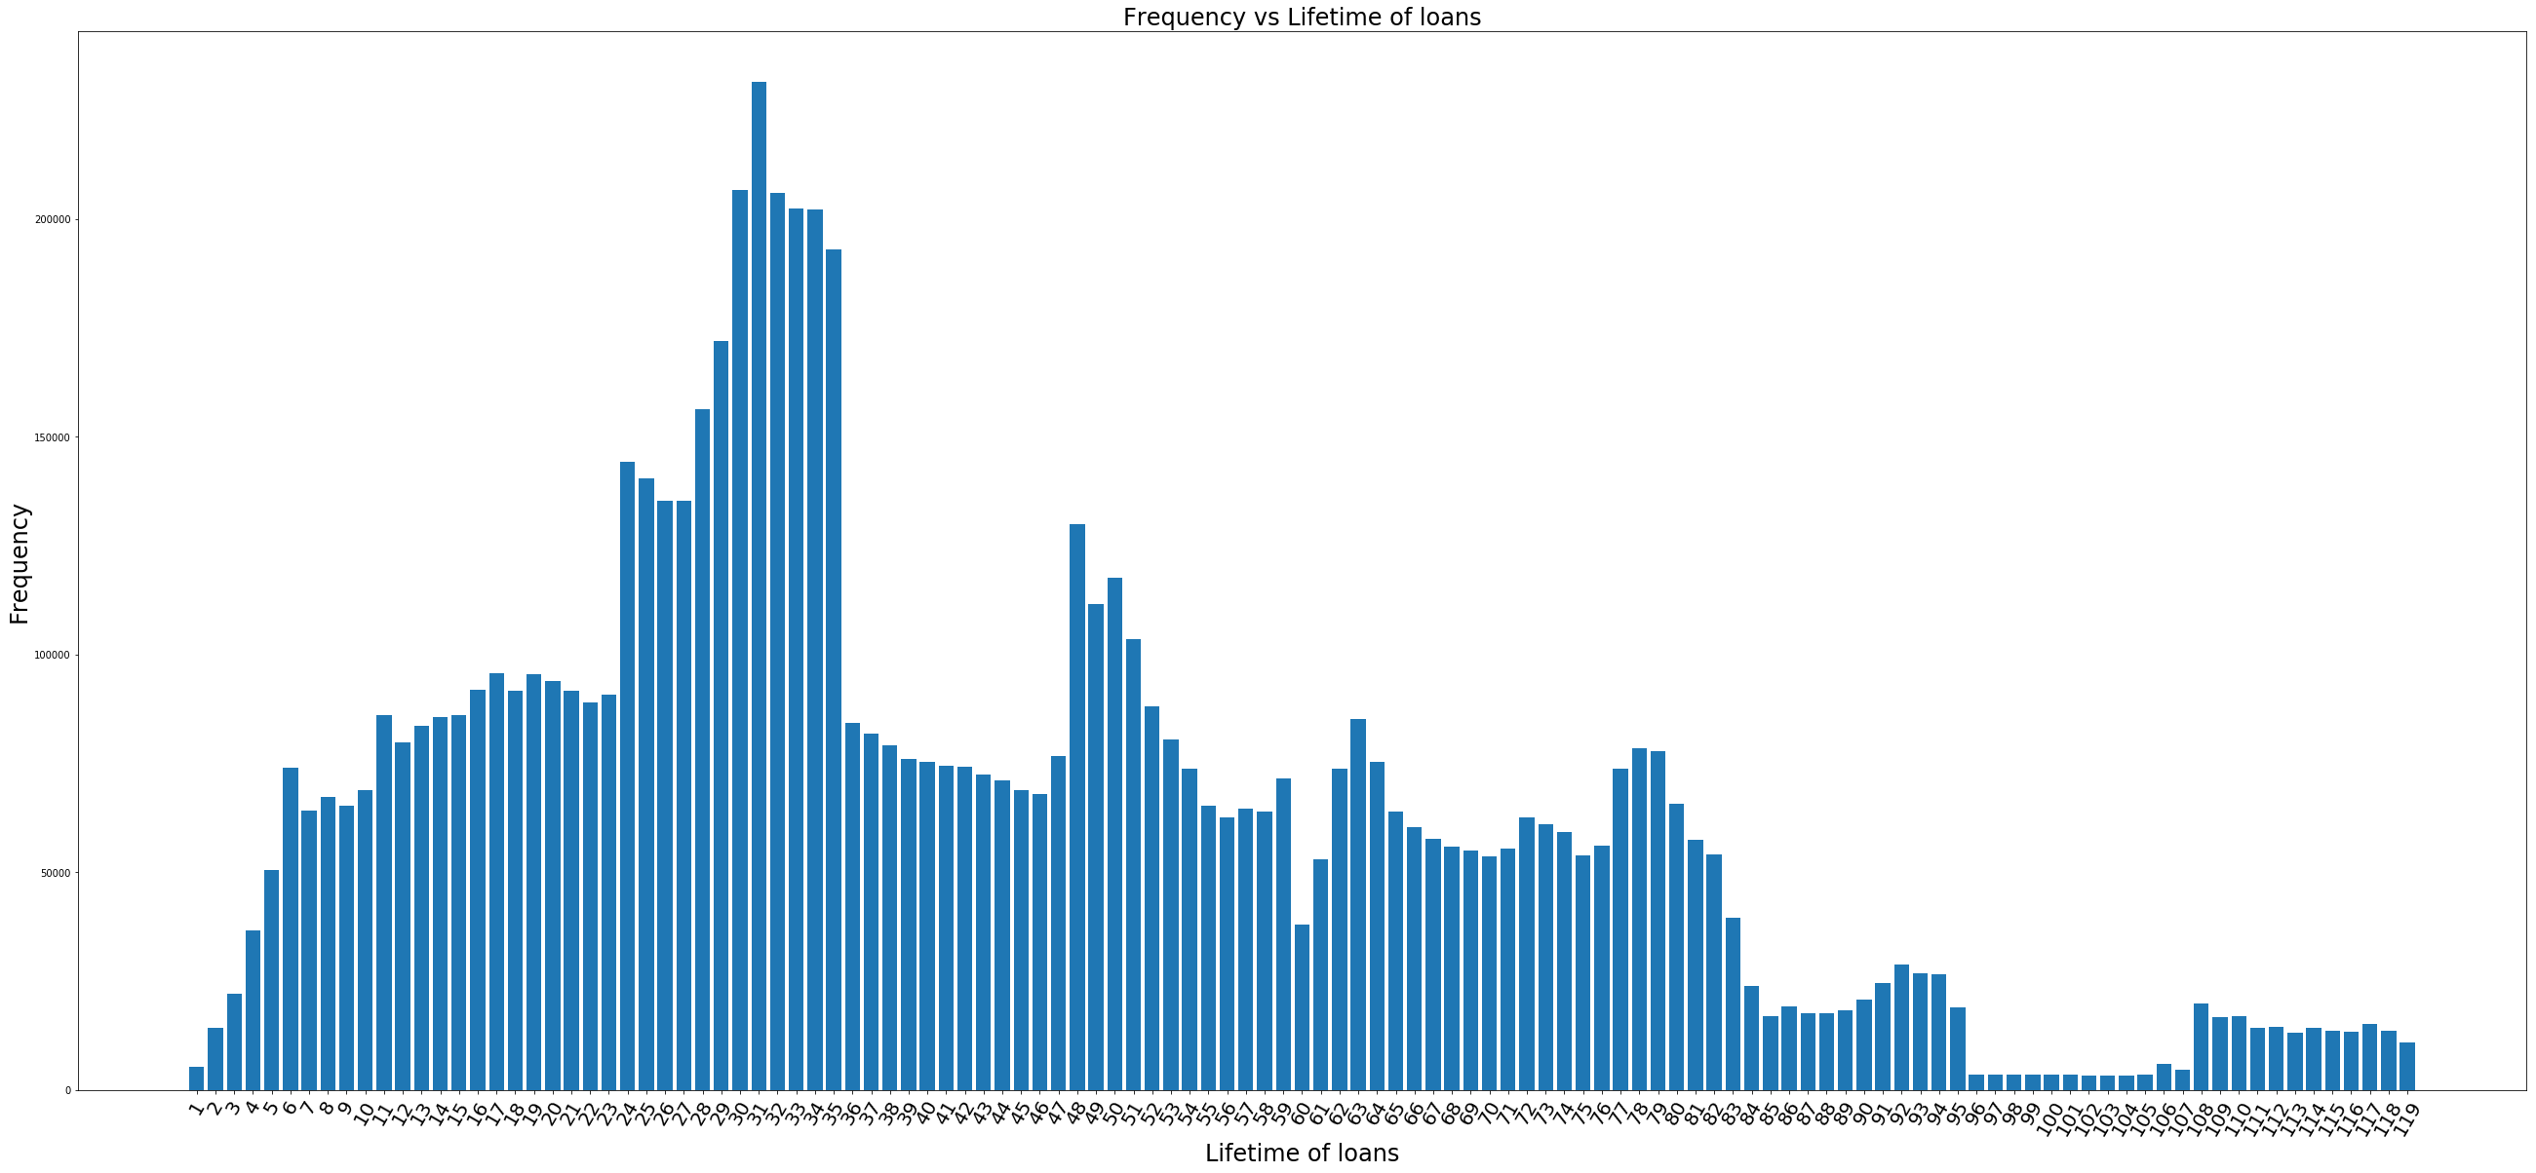

Frequency count of Prepaid loans vs total number of loans (2006-2015).

Prepaid = 4661120 and Total number of loans = 7640021

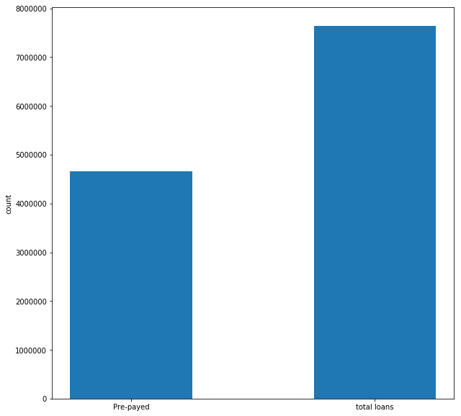

Frequency count of Current vs transition from current to 1 month delinquency (2006-2015).

Total current status = 321373698 and Total transition from current to 1 month delinquency status = 3330590

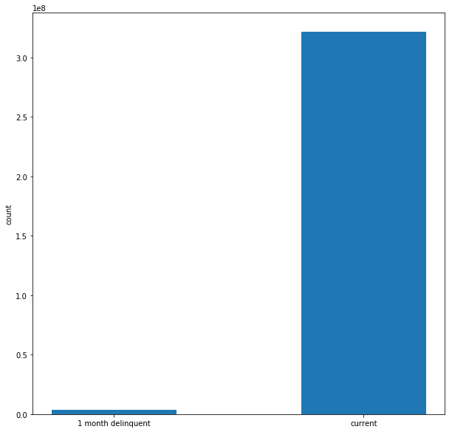

Results of AUC for prepayment transition (each experiment was run for 2 epochs)

LSTM 128 hidden units, dropout 0.5
training AUC: [0.9986, 0.9988]
testing AUC: [0.9999, 0.9999]
test loss: 0.08477056358854673

LSTM 128 hidden units, dropout 0.7
training AUC: [0.9983, 0.9302]
testing AUC: [0.99994007, 0.99989181]
test loss: 0.08764706851210553

LSTM 128 hidden units
training AUC: [ 0.9982352, 0.9984109 ]
testing AUC: [ 0.9996899, 0.9999358 ]
test loss: 0.11330115612528935

5 layer FF : Number of hidden units in each hidden layer = [90, 70, 60, 50]
training AUC: [0.9969, 0.9997]
testing AUC: [0.9999, 0.9999]
test loss: 1.0307769353191059

3 layer FF: Number of hidden units in each hidden layer = [ 90, 65 ]
training AUC: [ 0.99491358, 0.99719608 ]
testing AUC: [0.99995359, 0.99995515 ]
test loss: 0.9892662912607193

3 layer FF: Number of hidden units in each hidden layer = [ 80, 60 ]
training AUC: [ 0.9952, 0.9982 ]
testing AUC: [ 0.9999, 0.9999 ]
test loss: 0.9833346957133876

Logistic Regression
training AUC: [0.9277, 0.9978]
testing AUC: [0.9998, 0.9998]
test loss: 1.3246

Results of AUC for “current to 1 month delinquency” status (each experiment was run for 2 epochs)

LSTM
training AUC: [0.5103, 0.5299]
testing AUC: [0.5545, 0.5525]
test loss: 0.07993406848540341

5 layer FF: Number of hidden units in each hidden layer = [ 90, 70, 60, 50 ]
training AUC: [0.6466, 0.7082]
testing AUC: [0.5969, 0.6569]
test loss: 1.036030076030228

Logistic Regression
training AUC: [0.5080, 0.5791]
testing AUC: [0.5216, 0.5405]
test loss: 1.3246

