**PROJECT 10. WATER QUALITY ANALYSIS**

**Project Definition:**

( **DAC_Phase1** )

After many years of research, water quality standards are put in place to ensure the suitability of efficient use of water for a designated purpose. Water quality analysis is to measure the required parameters of water, following standard methods, to check whether they are in accordance with the standard.

**Why Water Quality Analysis is required?**

Water quality analysis is required mainly for monitoring purpose. Some importance of such assessment includes:

1. To check whether the water quality is in compliance with the standards, and hence, suitable or not for the designated use.

2. To monitor the efficiency of a system, working for water quality maintenance

3. To check whether upgradation / change of an existing system is required and to decide what changes should take place.

4. To monitor whether water quality is in compliance with rules and regulations.

Water quality analysis is of extremely necessary in the sectors of:

1. Public Health (especially for drinking water)

2. Industrial Use.

Procedures of Water Quality Analysis The general flow of procedures for water quality analysis is mentioned in Chart

**Design Thinking:**

**Analysis Objectives:**

The objective of water quality monitoring is to obtain quantitative information on the physical, chemical, and biological characteristics of water via statistical sampling

**Data Collection:**

Water quality analysis is also called hydrochemical analysis. That is to use chemical and physical methods to determine the content of various chemical components in water. Water quality analysis can be divided into three types: simple analysis, complete analysis and special analysis.

**Predictive Modeling:**

We can define predictive models as quantitative mathematical projections

that use statistical classifiers to determine the probability of a specific water quality event in the future. Predictive modelling can also be applied to an unknown water quality event, even after it has occurred.

**Project Steps** :

Common steps in involved in water quality analysis are data preprocessing, data splitting model training and testing, and results evaluation. These are the common steps involved in development in almost all ML methods.

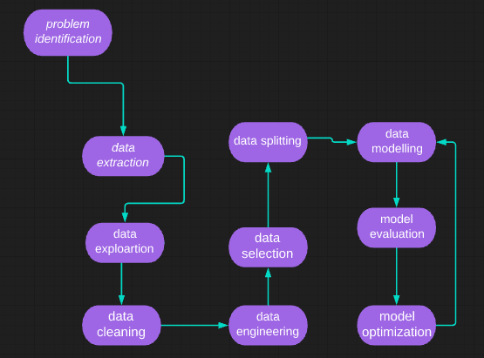

**CONCLUSION:**

The hydrobiological parameters and distribution of nutrients have a significant impact on aquatic organisms. Water quality analysis helps to detect whether the water is suitable for human consumption, fish health, etc., which is one of the criteria associated with outbreaks of fish diseases in aquatic organisms.