**Program for sales Tax**

The following attached is the code for sales tax:



Inputs and Outputs :

Input1:



Output1:

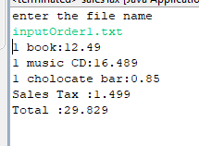

Input2:



Output2:

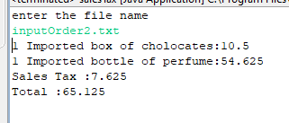

Input3:



Output3:

