RelayAI

V1 System Design

STATUS  Proposed |  | OWNER  Core Architecture |  | LAST UPDATED  July 20, 2026

Authors | Subharthi Saha
Reviewers | Project maintainers and security reviewers
Related docs | README.md · CONTEXT.md · DEPLOYMENT.md · pipeline.v1.schema.json
Scope | The policy-aware voice-routing core and the macOS-first V1 system boundary.

1. Abstract
RelayAI converts captured speech into previewable text and routes it to explicitly configured destinations. The design separates native desktop capabilities from a platform-neutral Python pipeline engine. Versioned pipeline definitions select transcription, context, optional refinement, policy, and destinations. The principal guarantee is that local-only policy is enforced before a network-exposed adapter receives audio or text.
V1 targets short-form dictation and approved developer automations on macOS. It must preserve raw transcription when optional refinement fails and require confirmation for protected side effects. Meetings, diarization, wake words, autonomous agents, sync, teams, mobile clients, and a marketplace are excluded. The current repository implements the Python core; desktop, audio, provider, keychain, and insertion adapters remain planned.

2. Goals and Non-Goals
Goals | Non-goals
Create private dictation, polished communication, and approved automation pipelines without changing code. | Meeting capture, system audio, diarization, and meeting-note chat.
Reject every network-exposed adapter before execution when a pipeline is local-only. | Wake-word listening and complete hands-free desktop control.
Preserve raw text on refinement or destination failure and expose an inspectable receipt. | Autonomous multi-step agents, team administration, and mobile keyboards.
Ship macOS first while isolating platform behavior behind typed adapters. | Direct support for every STT, LLM, and automation vendor in V1.

3. Background and Problem Statement
Voice products commonly combine capture, cloud processing, text cleanup, and actions behind opaque modes. Users cannot reliably determine which data leaves the device, why a transformation occurred, or whether spoken text may trigger a side effect. A provider checklist alone does not solve this trust and extensibility problem.
The Tauri shell owns native permissions, audio, hotkeys, keychain access, clipboard, and focused-field insertion. A typed local IPC boundary passes audio artifacts and pipeline IDs to the Python engine. The engine resolves only registered adapters, enforces policy, prepares a preview, then dispatches approved destinations. Imported configuration never determines trusted exposure or effect metadata.

4. Proposed Architecture

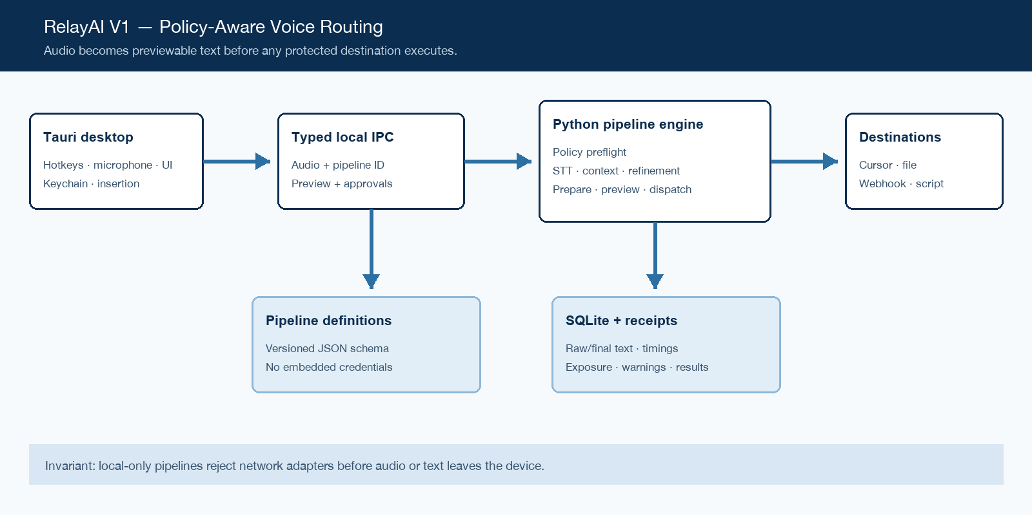
Figure 1. RelayAI V1 system boundary and critical flow.

Core components

Component | Responsibility | Primary storage | Failure behavior
Tauri desktop shell | Own native audio, hotkeys, permissions, approval UI, keychain, clipboard, and text insertion. | macOS APIs and OS keychain | Fail visibly; preserve recorded audio or prepared text when safe; provide retry and clipboard fallback.
Typed local IPC | Validate command/event payloads and carry audio, pipeline IDs, previews, approvals, and receipts. | Versioned IPC contracts | Fail closed on malformed or incompatible requests; never infer approval.
Python pipeline engine | Preflight policy, run STT/context/refinement, retain artifacts, and dispatch destinations. | Injected adapter registry | Refinement failure falls back to raw text; destination failures remain isolated and observable.
SQLite store | Persist secret-free pipeline definitions and transcript-bearing execution receipts. | Local SQLite with WAL | Return a recoverable storage error; do not erase in-memory prepared artifacts.
Registered adapters | Implement speech, refinement, context, or destination capability with trusted exposure metadata. | PipelineRun receipt; host-selected telemetry | Report stage timing, status, warnings, and effects without logging payload text by default.

5. Request Lifecycle
- The desktop captures microphone audio under a selected pipeline and retains the focused destination context for that recording session.
- IPC validates typed payloads. Pipeline import validates schema version, shape, stable destination IDs, and absence of credential-like fields.
- The engine loads the pipeline definition and resolves speech, context, refinement, and destination IDs through capability-specific registries.
- Preflight compares every adapter's trusted exposure with pipeline policy. If allowed, prepare produces raw text, optional refined text, context artifacts, exposure events, timings, warnings, and pending destinations.
- The desktop must present the prepared text and protected destination effects. The host may persist the prepared receipt before dispatch; approval is never inferred from persistence.
- Dispatch executes passive destinations and only approved network or executable destinations. Adapter implementations own bounded timeouts; failures create destination receipts and do not erase transcription.
- The completed PipelineRun records success, partial success, failure, or denial together with per-stage timing and destination results. The SQLite store persists the receipt according to user retention settings.

6. API and Data Contracts

Primary data contract

Field | Type | Required | Description
schema_version | Integer | Yes | Integer compatibility version; currently 1; unknown versions are rejected.
id / name | String | Yes | Stable ID and display name owned by the user or template author.
transcription | Object | Yes | Speech adapter reference with non-secret settings and optional credential reference.
context | Array | No | Zero or more approved context adapter references.
refinement | Object | No | Optional adapter and prompt reference; raw transcript remains separate.
policy | Object | No | Local-only and network/execute confirmation requirements.
destinations | Array | Yes | One or more stable destination instances resolved by registered adapter ID.

Contract guarantees

- Schema and policy preflight complete before a provider or destination receives data.
- Each run has a UUID; each destination has a stable pipeline-local instance ID.
- Capture schema version, pipeline ID, provider IDs, exposure events, timings, warnings, and destination receipts.
- Pipeline JSON is configuration, not trusted adapter metadata or a secret store. PipelineRun is an execution record, not authorization for replay.
The versioned schema or interface definition is published at
schemas/pipeline.v1.schema.json and update it with each contract release.

7. Consistency, Idempotency, and Replay

Prepare is free of destination side effects but may call configured providers. Dispatch is not globally idempotent because external destinations differ; callers must not replay a run without renewed approval and destination-specific idempotency. Parallel destination results are independent. The pipeline definition captured for a prepared run remains authoritative through dispatch.
Scenario | Expected behavior | Reasoning
Repeated dispatch is rejected after the prepared run leaves READY state. | A new capture creates a new run ID; replay requires a new explicit workflow. | Run state and future destination idempotency keys prevent accidental reuse; approval does not transfer.
Return a recoverable error or failed receipt while retaining available transcript artifacts. | Retry only the explicitly selected stage or create a new run; do not assume earlier external effects were absent. | Failure is recorded by stage and destination without deleting raw text.
Successful destinations remain successful; failed destinations are reported independently. | Refinement falls back to raw text; adapters use bounded timeouts; protected retries require confirmation. | The receipt records final status, warning, timing, and each destination result.
PreparedRun retains the PipelineDefinition used during prepare. | The captured definition and schema version remain authoritative until dispatch completes. | Dispatch does not reload mutable configuration between preview and action.

8. Security and Privacy Considerations

- V1 is single-user and local. Native permissions gate microphone and insertion. Destination approval is explicit and pipeline-scoped.
- Collect only configured context. Do not log audio, raw text, refined text, webhook payloads, or credentials by default.
- Pipeline files contain credential IDs only. The desktop resolves them from the OS keychain at call time.
- Reject unknown schemas and embedded secrets; require confirmation for network/execute effects; never interpret transcript text as shell code.
- History remains local in SQLite. Desktop release requires visible retention and deletion controls before transcript history is enabled broadly.

9. Operational Readiness
Signal | SLO or alert | Owner | Launch gate
Policy and destination contract tests pass | 100% on protected branches | Core maintainers | Required
Recording-ready and stage latency | Instrument in V1; set targets after real adapters exist | Core maintainers | Required
Refinement fallback and destination failure rate | Baseline during limited release before defining thresholds | Core maintainers | Required
Schema/example/package mismatch | Any example fails import or public schema diverges from runtime validation | Core maintainers | Required
Clean install, upgrade, rollback, and local-only isolation checks | Every release candidate | Core maintainers | Required
Rollout constraint: Release the core first, then a maintainer-only desktop build. Require permission recovery, local-only isolation, clean installation, update, and rollback tests before broader distribution.

10. Alternatives Considered

Alternative | Why it was considered | Why it was not selected
Opaque AI dictation modes | Simpler consumer-facing configuration. | Hides provider exposure, transformations, and side effects; weak fit for technical users.
One generic provider interface | Fewer types and registry concepts. | Conflates incompatible speech, refinement, context, and destination guarantees.
Desktop logic entirely in Python | Single-language implementation and direct ML integration. | Weaker native macOS packaging, permission, hotkey, insertion, and lifecycle integration.
Meetings in the first release | Larger apparent feature set and broader transcription use cases. | Adds system audio, consent, diarization, long-running storage, and a separate notes UX before routing is validated.

11. Open Questions
- Which final product name and macOS bundle identifier will replace the RelayAI working name?
- Which local STT model and distribution strategy meet first-run size, speed, and licensing requirements?
- Will the Python core ship as a sidecar runtime, a frozen executable, or be incrementally ported behind the same IPC contract?
- What transcript-history retention default and deletion UX should the desktop application ship with?

12. Decision and Next Steps
Proceed with the explicit, policy-enforced pipeline model and a macOS-first desktop shell. Build native capture and insertion around the tested Python core, then add one local STT adapter and one OpenAI-compatible refinement path. Validate with maintainers using the three V1 pipeline examples. Broader rollout requires recoverable permissions, local-only isolation, inspectable receipts, signed packaging, and tested rollback.
Milestone | Deliverable | Exit criteria
M1 | Core contracts, policy engine, safe destinations, schema, tests, and SQLite receipts | All policy, import, fallback, destination, and persistence tests pass
M2 | Tauri shell, typed IPC, audio/hotkeys, keychain, and focused-field insertion | Private dictation works locally; permission failures are recoverable
M3 | Local STT plus OpenAI-compatible refinement with three example pipelines | Maintainer pilot completes without policy bypass or transcript loss
M4 | Signed/notarized macOS release with update and rollback support | Release gates pass; latency baselines published; rollback verified

Use footnotes for definitions, assumptions, or terms that need precision without interrupting the main narrative.

