Superstore Sales Analysis
Exploratory Data Analysis Project Report
Prepared by
Subhas Chakraborty
Dataset: Sample Superstore
(https://www.kaggle.com/datasets/vivek468/superstore-dataset-final)
Date: September 2026

1. Introduction

1.1 Project Objective
This project performs an exploratory data analysis (EDA) on the Sample Superstore dataset — a set of order-level retail transactions from a US-based superstore chain — to understand sales and profit performance and to identify actionable opportunities for improving profitability. The analysis examines performance across product categories, sub-categories and individual products, geographic regions and states, customer segments, shipping modes, and discount levels, and studies how sales and profit have trended over time.

1.2 About the Dataset
The dataset contains 9,994 order-line records spanning January 2014 to December 2017, with 21 original fields describing the order (Order ID, Order Date, Ship Date, Ship Mode), the customer (Customer ID, Name, Segment), the location (Country, City, State, Region, Postal Code), the product (Product ID, Category, Sub-Category, Product Name), and the transaction (Sales, Quantity, Discount, Profit).

1.3 Tools & Technologies
The analysis was carried out in Python using Jupyter Notebook, with pandas and numpy for data manipulation, and matplotlib and seaborn for visualization (plotly was imported for optional interactive charting).

2. Methodology
The analysis followed a structured EDA workflow:
- Data loading and initial inspection (shape, columns, data types)
- Data quality checks — missing values and duplicate records
- Data cleaning and feature engineering — converting Order Date / Ship Date to datetime, and deriving Order Year, Order Month, Order Quarter, and Shipping Days (Ship Date − Order Date)
- Computation of overall key business metrics (KPIs)
- Group-wise aggregation and analysis by Category, Sub-Category, Product, Region, State, Segment, Ship Mode, and Discount level
- Identification of loss-making orders and their drivers
- Time-series analysis at monthly, quarterly, and yearly granularity
- Visualization of all key comparisons and trends
- Correlation analysis between Sales, Quantity, Discount, Profit, and Shipping Days

3. Data Quality Assessment
The raw dataset was found to be clean: there were no missing values in any of the 21 columns and no duplicate rows. Order Date and Ship Date were stored as text and were converted to proper datetime objects to enable time-based analysis. No records were dropped during cleaning.
Check | Result
Total rows | 9,994
Total columns (raw) | 21
Missing values | 0
Duplicate rows | 0
Date range (Order Date) | 2014-01-03 to 2017-12-30

4. Key Business Metrics
Metric | Value
Total Sales | $2,297,200.86
Total Profit | $286,397.02
Overall Profit Margin | 12.47%
Total Quantity Sold | 37,873 units
Total Orders | 5,009
Total Customers | 793
Total Distinct Products | 1,862
Average Order Value | $458.62
Average Profit per Order | $57.18

5. Category & Sub-Category Analysis
Technology is the strongest category by profitability despite generating slightly less revenue than Furniture, while Furniture is the weakest category by margin.
Category | Sales | Profit | Profit Margin %
Technology | $836,154.03 | $145,454.95 | 17.40%
Furniture | $741,999.80 | $18,451.27 | 2.49%
Office Supplies | $719,047.03 | $122,490.80 | 17.04%
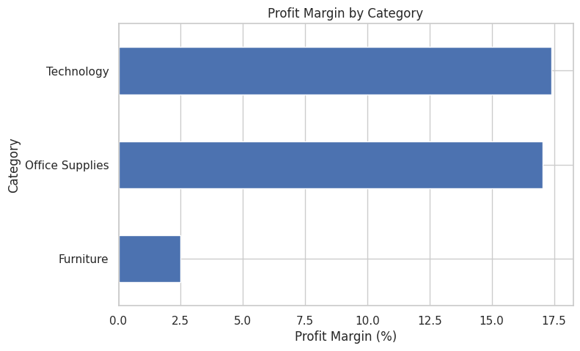
Figure 1: Profit Margin by Category
At the sub-category level, Tables and Bookcases (both within Furniture) are the only sub-categories that are net loss-making overall — Tables alone lost $17,725, despite $206,966 in sales. Phones, Chairs, and Copiers are the strongest sub-categories by profit.
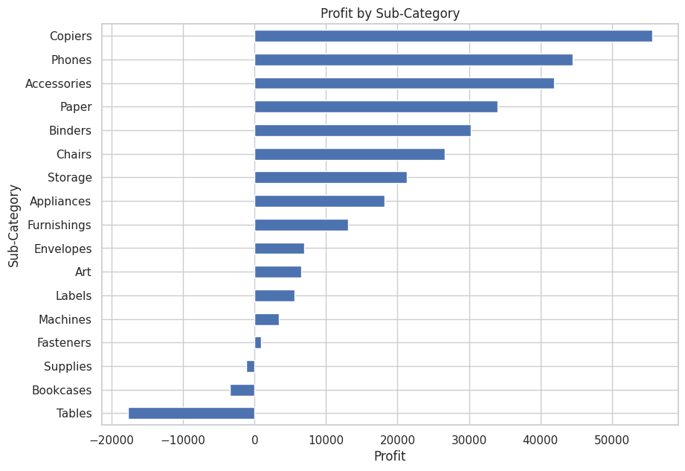
Figure 2: Profit by Sub-Category
Among individual products, the Canon imageCLASS 2200 Advanced Copier is the top performer by both sales ($61,599.82) and profit. Several 3D printers (Cubify CubeX models) and large conference tables appear among the least profitable products.

6. Regional, State & Segment Analysis

6.1 Regional Performance
Region | Sales | Profit | Profit Margin %
West | $725,457.82 | $108,418.45 | 14.94%
East | $678,781.24 | $91,522.78 | 13.48%
South | $391,721.91 | $46,749.43 | 11.93%
Central | $501,239.89 | $39,706.36 | 7.92%
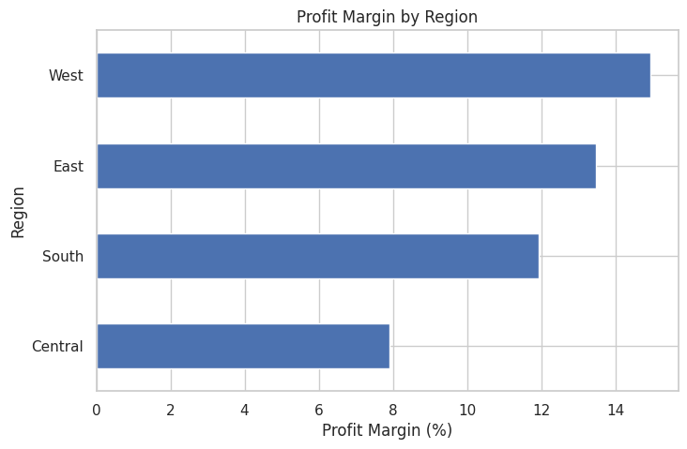
Figure 3: Profit Margin by Region

6.2 State-Level Outliers
California and New York are the top two states by both sales and profit. In contrast, Texas, Ohio, Pennsylvania, and Illinois post substantial sales volume but are net loss-making overall — Texas alone loses $25,729, making it the single least profitable state in the dataset.

6.3 Customer Segment Performance
Segment | Sales | Profit | Profit Margin %
Consumer | $1,161,401 | $134,119.21 | 11.55%
Corporate | $706,146 | $91,979.13 | 13.03%
Home Office | $429,653 | $60,298.68 | 14.03%
Consumer is the largest segment by volume, but Home Office customers are the most profitable per dollar of sales.

7. Shipping Mode & Discount Impact

7.1 Shipping Mode
Standard Class accounts for the majority of orders (2,994 of 5,009) and revenue, but also has by far the longest average shipping duration (5.0 days), compared to 3.2 days for Second Class, 2.2 days for First Class, and effectively same-day for Same Day shipping.

7.2 Discount vs Profitability
Discounting shows a clear negative relationship with profitability. At 0% discount, profit margin is 29.5%; margin turns negative once discounts exceed roughly 25–30%, and falls to -180% at the 80% discount level. This is one of the most actionable findings in the analysis.
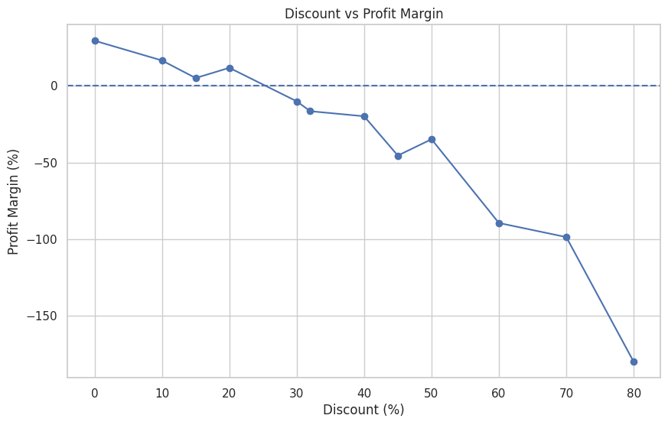
Figure 4: Discount vs Profit Margin

8. Loss-Making Orders
1,871 of the 9,994 order lines (about 18.7%) were sold at a loss, totaling -$156,131.29 in losses. By category, Furniture contributed the largest share of losses (-$60,936), followed by Office Supplies (-$56,615) and Technology (-$38,580) — notable because Technology and Office Supplies are otherwise the most profitable categories overall, indicating losses are concentrated in specific heavily-discounted transactions rather than being category-wide.

9. Time-Series Trends
Both sales and profit grew year over year across the four-year window, with total annual sales rising from $484,247 in 2014 to $733,215 in 2017, and profit margin improving from 10.2% to a peak of 13.4% in 2016. At a finer grain, sales are highly seasonal: Q4 (October–December) is consistently the strongest quarter of every year, driven by November and December sales peaks, likely reflecting holiday-season demand.
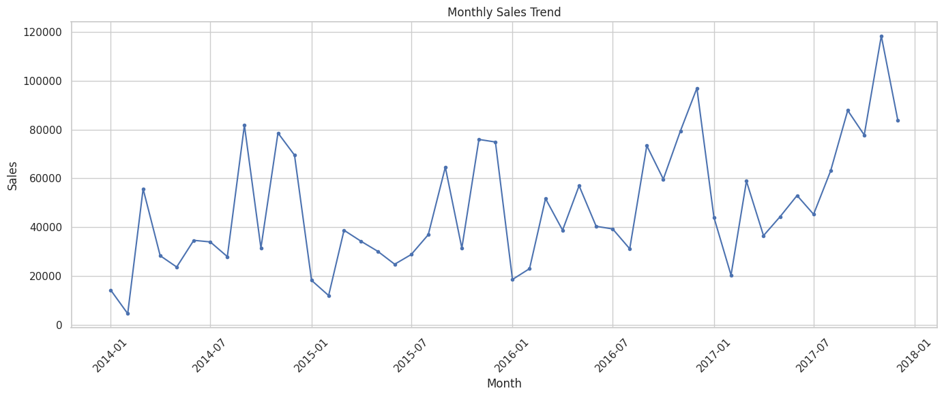
Figure 5: Monthly Sales Trend (2014–2017)

10. Correlation Analysis
A correlation matrix across Sales, Quantity, Discount, Profit, and Shipping Days shows that Sales has a moderate positive correlation with Profit (0.48), while Discount has a moderate negative correlation with Profit (-0.22). Quantity and Shipping Days show negligible correlation with Profit, suggesting order size and delivery speed are not meaningful profitability drivers — discounting is.
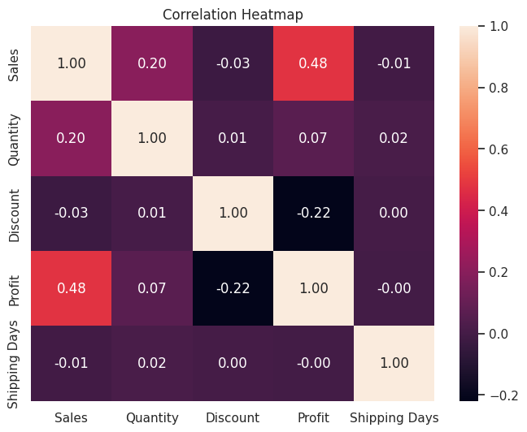
Figure 6: Correlation Heatmap

11. Key Findings
- Technology and Office Supplies are the most profitable categories (~17% margin); Furniture lags badly at 2.5% margin due to Tables and Bookcases.
- Deep discounting (>30%) is strongly associated with negative profit margins, reaching -180% margin at 80% discount.
- West and East regions outperform Central and South; Texas, Ohio, and Pennsylvania are chronic loss-makers despite healthy sales volume.
- Standard Class shipping dominates order volume but has by far the slowest average delivery time (5 days).
- Sales and profit trended upward from 2014–2017, with Q4 the strongest quarter every year.
- 18.7% of all order lines were sold at a loss, totaling over $156,000, concentrated in specific heavily discounted transactions.

12. Recommendations
- Cap or restructure discounts above ~30%, particularly on Furniture sub-categories (Tables, Bookcases), which are the most exposed to discount-driven losses.
- Investigate root causes of unprofitability in Texas, Ohio, Pennsylvania, and Illinois — potentially pricing, shipping cost allocation, or excessive discounting specific to these states.
- Increase inventory and marketing investment ahead of Q4 to capitalize on consistent seasonal demand.
- Review the cost and pricing of Standard Class shipping given its dominant volume and slow delivery time, to see if faster fulfillment can be offered without eroding margin.
- Prioritize retention and upsell efforts on Technology and Office Supplies, and on the Home Office segment, which shows the highest profit margin among customer segments.

13. Conclusion
This EDA shows that while the Superstore is profitable overall (12.47% margin), profitability is unevenly distributed: it is heavily concentrated in Technology and Office Supplies, in the West/East regions, and in low/no-discount transactions. Excessive discounting, specific underperforming states, and certain Furniture sub-categories are the primary drags on profitability. Addressing discount policy and investigating state- and product-level cost structures represent the clearest opportunities to improve overall margin without sacrificing revenue growth.

