AI-Powered Expense Audit System – Approach Document

1. Overview
An AI-powered system to automate expense claim validation using OCR, rule-based logic, and
RAG. Includes a Human-in-the-Loop for auditor overrides.

2. Solution Design
Pipeline: User Input → OCR → Extraction → Validation → RAG → Decision → Storage → UI

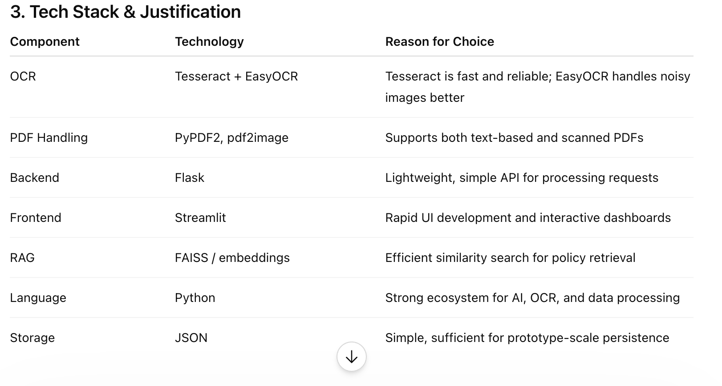

3. Future Improvements
With more time, the following enhancements can be implemented:

1. Advanced Extraction
- Use ML/NLP models (e.g., LayoutLM) for structured document understanding
- Improve merchant and amount detection accuracy

2. Improved OCR Pipeline
- Add image enhancement (deskewing, denoising)
- Use more advanced OCR models

3. Scalable Storage
- Replace JSON with a database (PostgreSQL / MongoDB)
- Enable multi-user support

4. Enhanced RAG System
- Better embeddings (OpenAI, Sentence Transformers)
- More precise policy matching

5. UI/UX Improvements
- Fully responsive mobile UI
- Better dashboards and analytics
- Real-time notifications

6. Production Readiness
- Authentication & role-based access
- API deployment (Docker / cloud)
- Logging and monitoring

