**Water Logging Project**

**Data Collection :**

Data has been collected by **simple image download** library. It downloads images from google based on the search parameter you pass. I searched **“water logging in school”** for water logging images and **“Indian government school campus”** for without water logging images. I collected a total of 50 images for each category. Then I split these image into train and test,

Train -> Logging image ->45 images

Train -> Not Logging Images -> 44 images

Test -> Logging images ->5 Images

Test -> Not Logging Images-> 5 Images

Link for the Dataset : <https://drive.google.com/file/d/1JafoAGXutDdRqSisxYRS6-f3I574U2dz/view?usp=sharing>

**Data Loader:** I used keras flow from directory to load the data where I resize each image **224*224** shape also takes the batch size as **32** and normalises the images.

**Model Architecture :** I used transfer learning for my model where I used a **VGG19** model with weights as **Imagenet** and including **top** layer. I freeze all the weights of the VGG16 model then I **flatten** the output layer and add a **dense layer** with 2 neurons and with **sigmoid activation** function. To build this architecture I use the Tensorflow framework.

So my model takes input as 224*224*3 gives output with 2 values.

My model architecture looks like this.

VGG19 --> Flatten → Dense(2, sigmoid)

**Model Training:** For training the model I used **sparse categorical crossentropy** as loss function, **Adam** as optimizer and **Accuracy** as metrics **batch size** as 32 and with **early stopping** where I used validation loss.

I trained my model for 30 **epochs**.

**Model Training Results:** After training the Model for 14 epochs due to early stopping I got:

**Training Accuracy** : 100%

**Training Loss** : 0.0094

**Validation Accuracy** : 90%

**Validation Loss** : 0.4737

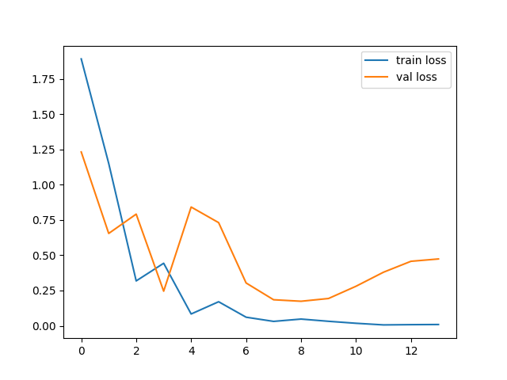

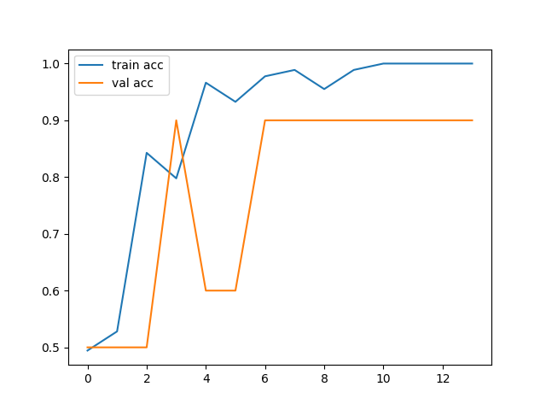

**Library and Framework used :**

**Tensorflow**

**Keras**

**Numpy**

**CV2**

**Matplotlib**

**Github link of the Project :** [**https://github.com/subhash9758964966/water_logging_project/tree/main**](https://github.com/subhash9758964966/water_logging_project/tree/main)

**Link of colab(Tensorflow) :** [**https://colab.research.google.com/drive/1bagBauI1LwpIsSBSedTd0_4YO-kDikHv?usp=sharing**](https://colab.research.google.com/drive/1bagBauI1LwpIsSBSedTd0_4YO-kDikHv?usp=sharing)

**I also done this project in Pytorch as but results are different there:**

**Link for colab(pytorch):**

[**https://colab.research.google.com/drive/1NO_T3UXpsE8KHoaBmlqTnAPrw1AQlOU7?usp=sharing**](https://colab.research.google.com/drive/1NO_T3UXpsE8KHoaBmlqTnAPrw1AQlOU7?usp=sharing)