CICD: Continuation Integration Continuation Deployment:

1. Open URL <https://www.jenkins.io/download/thank-you-downloading-windows-installer-stable/>
2. Download file
3. Click on Next

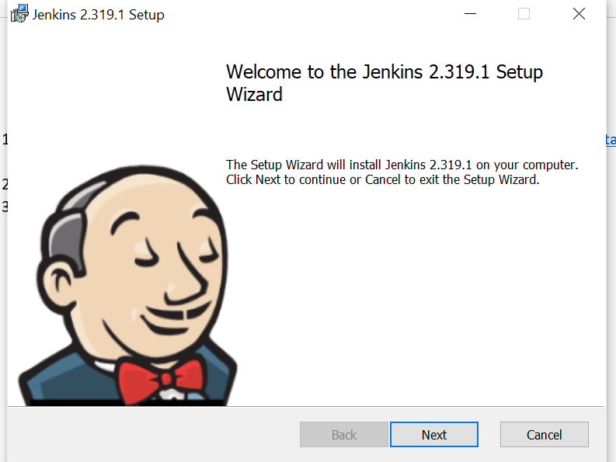

1. Click on Next

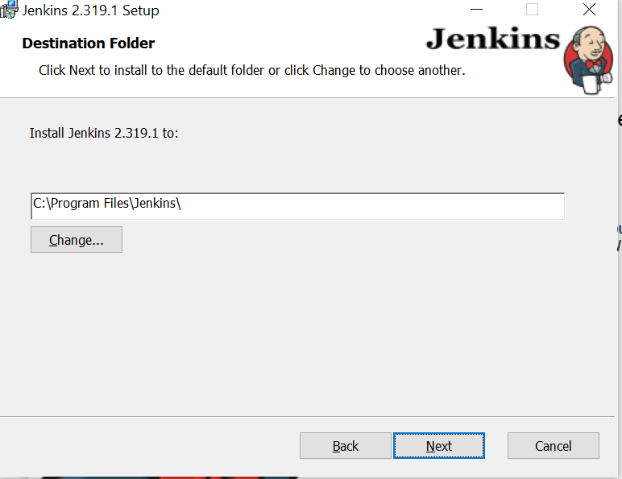

1. Select Log on type

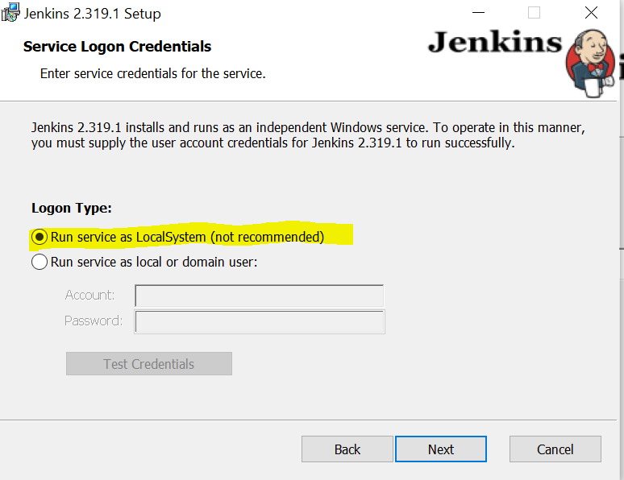

1. Click on Test Port

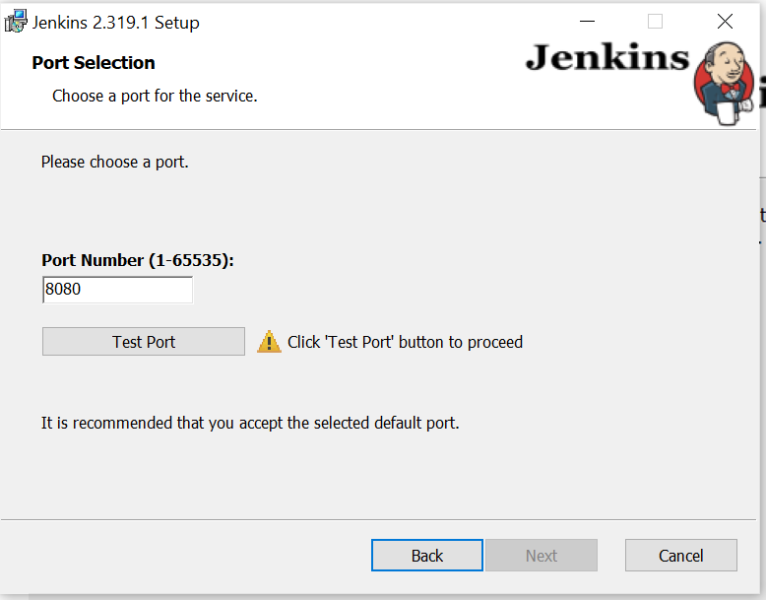

1. You should get mark as shown in below screen and click on next

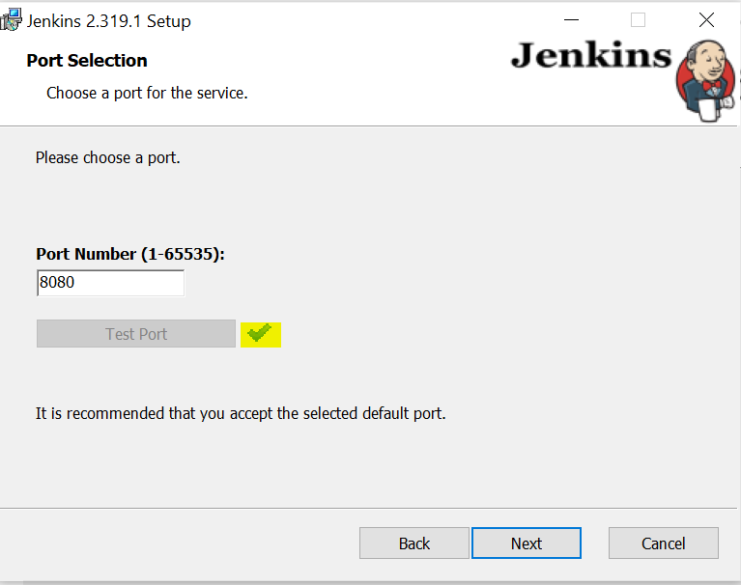

1. Click on Next

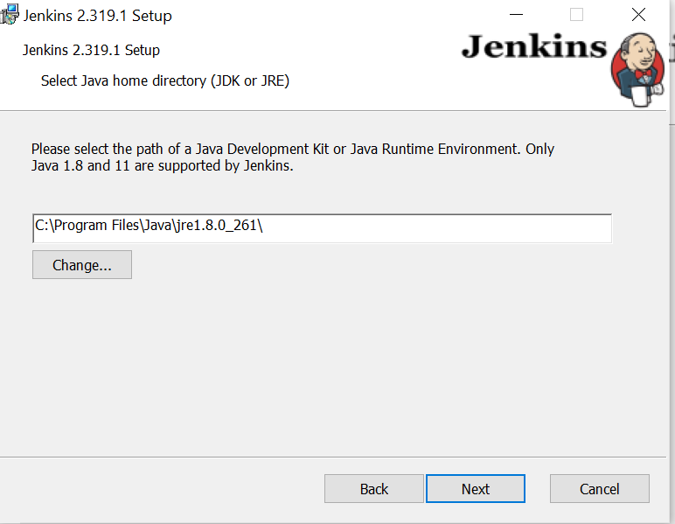

1. Click on Next

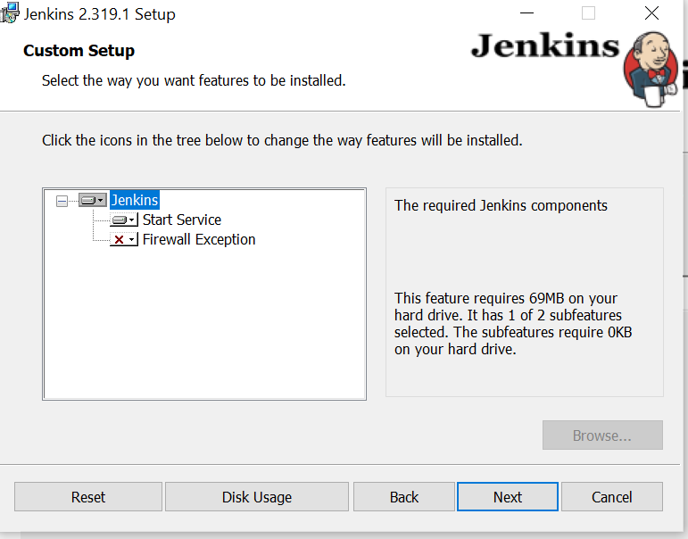

1. Click on Install

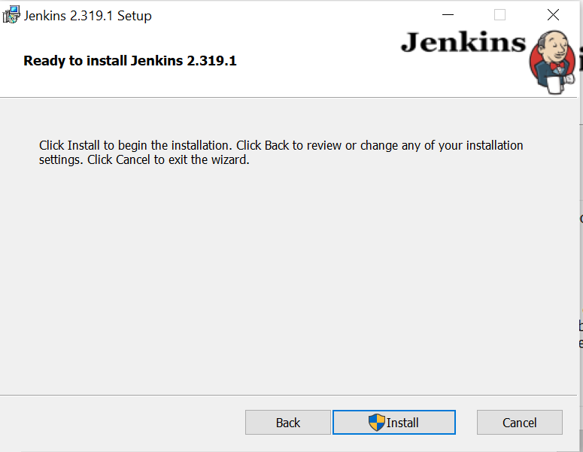

1. Click on Finish

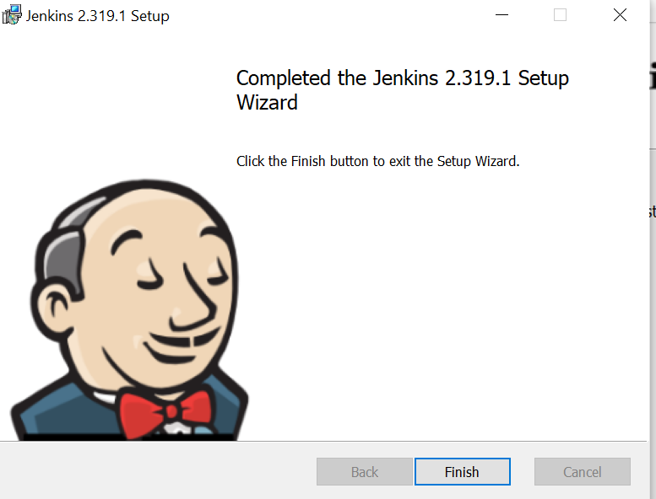

12l Open Jenkins using URL: <http://localhost:8080/> and click on Continue

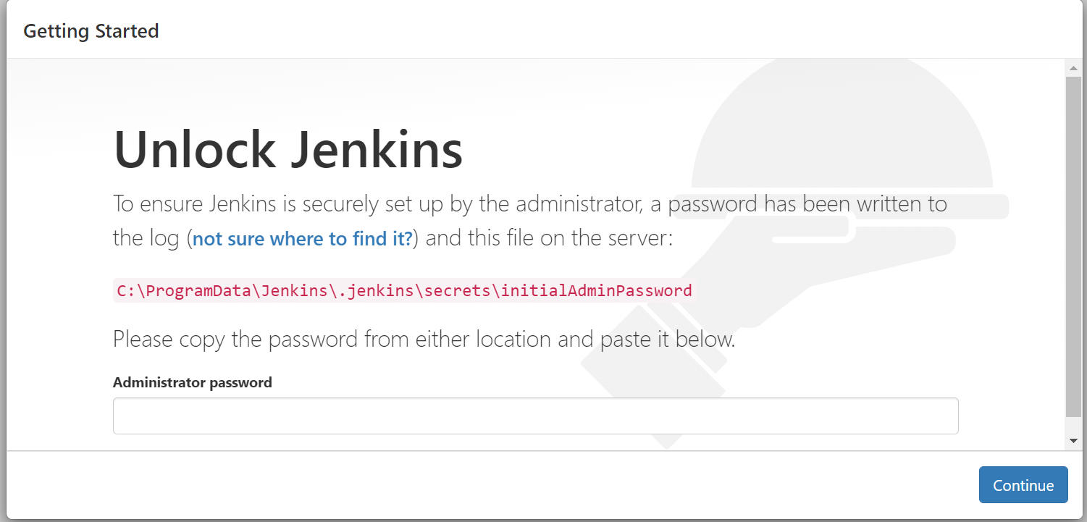

14. Navigate to local path which is given

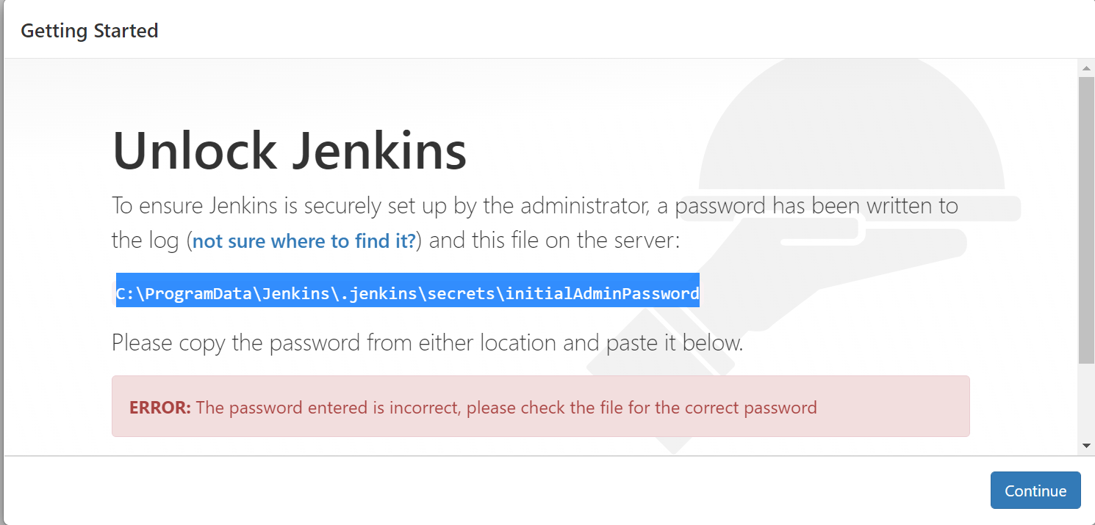

15. Open the file and copy the password

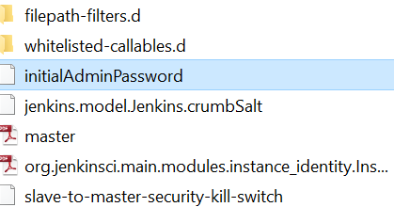

16. Enter copied password in field as shown below



17. You should see below window and click on Install suggested plugins

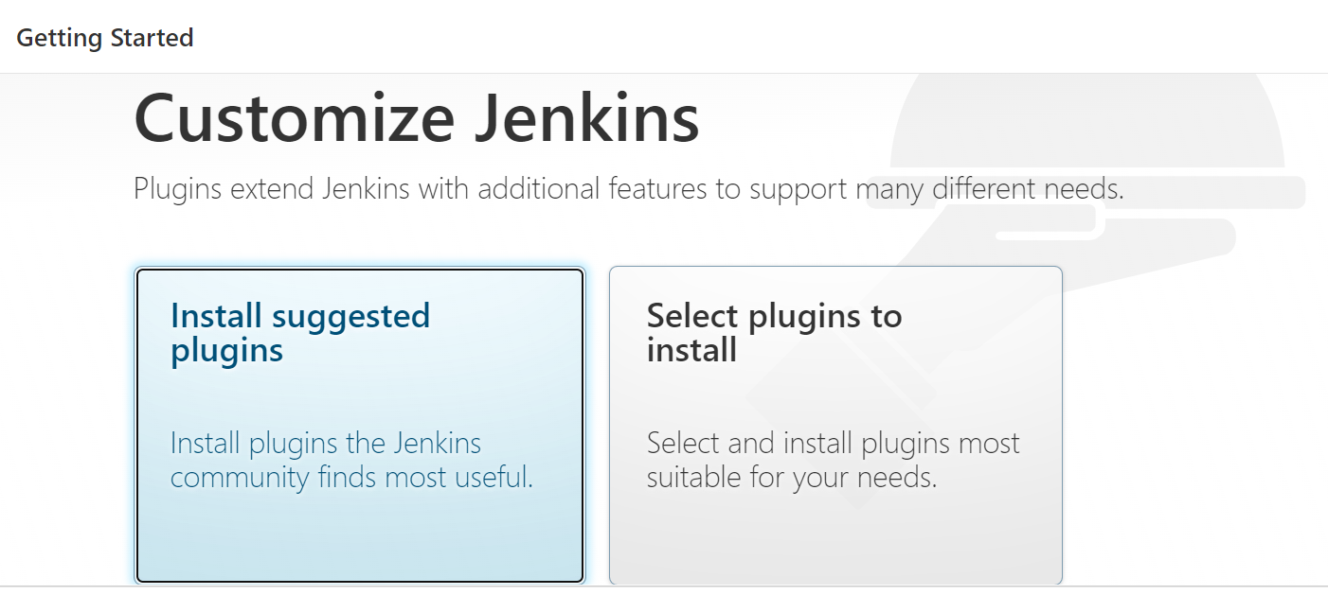

18. Enter all the details and click on Save and Continue

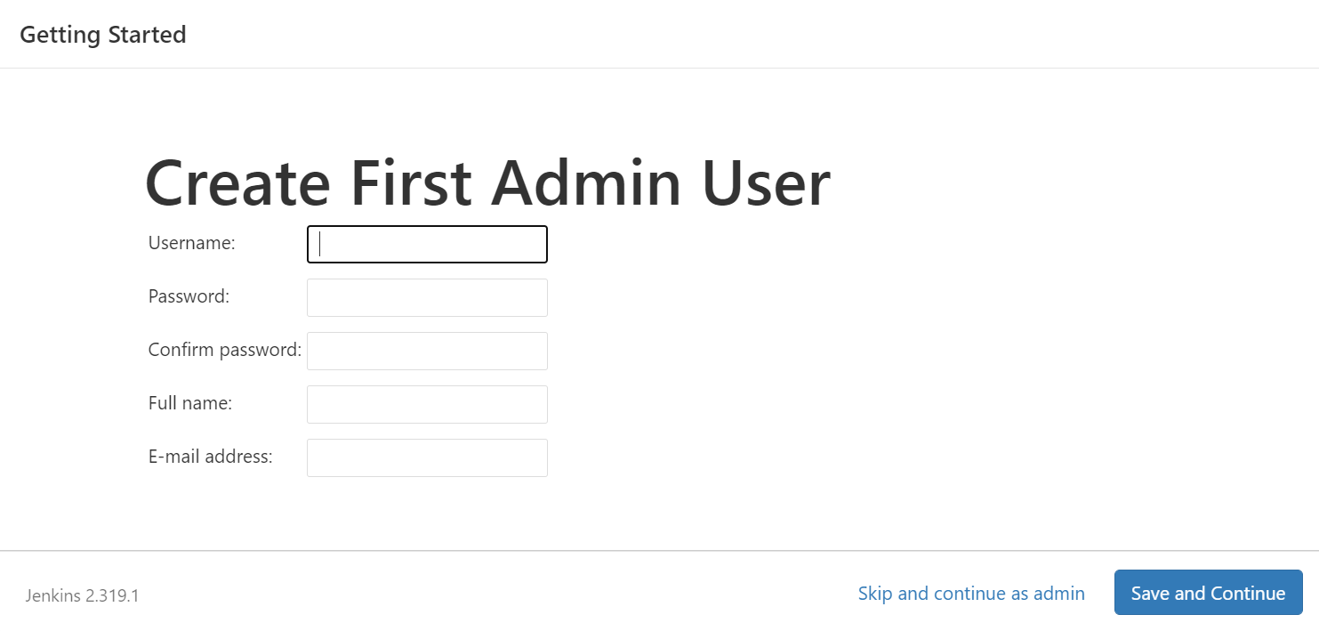

19. Click on Save and Finish

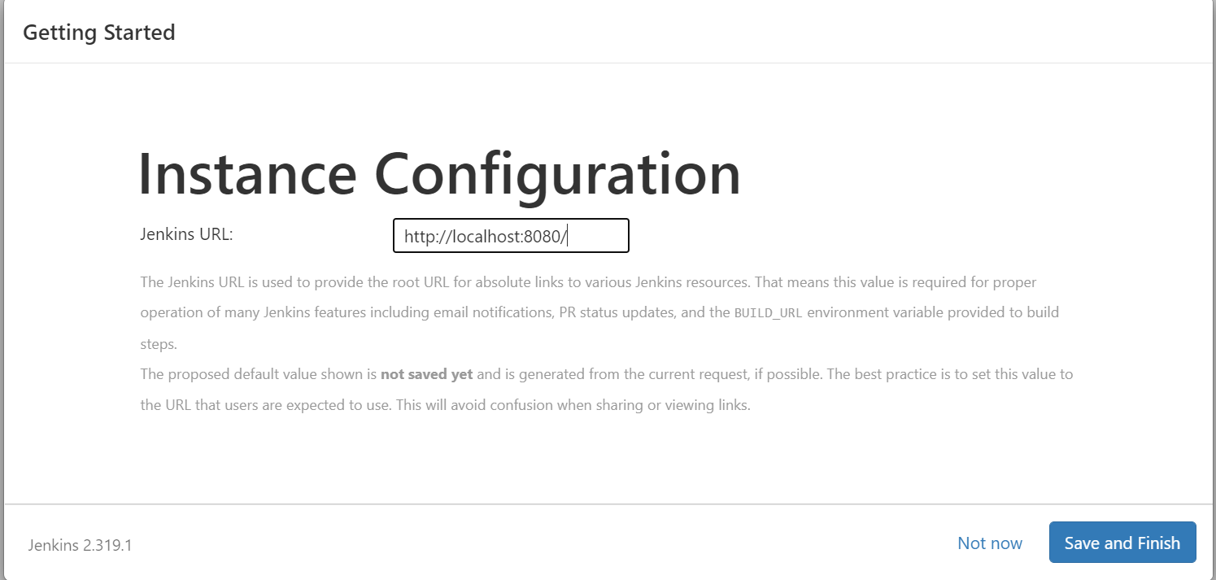

20. Click on Start using Jenkins

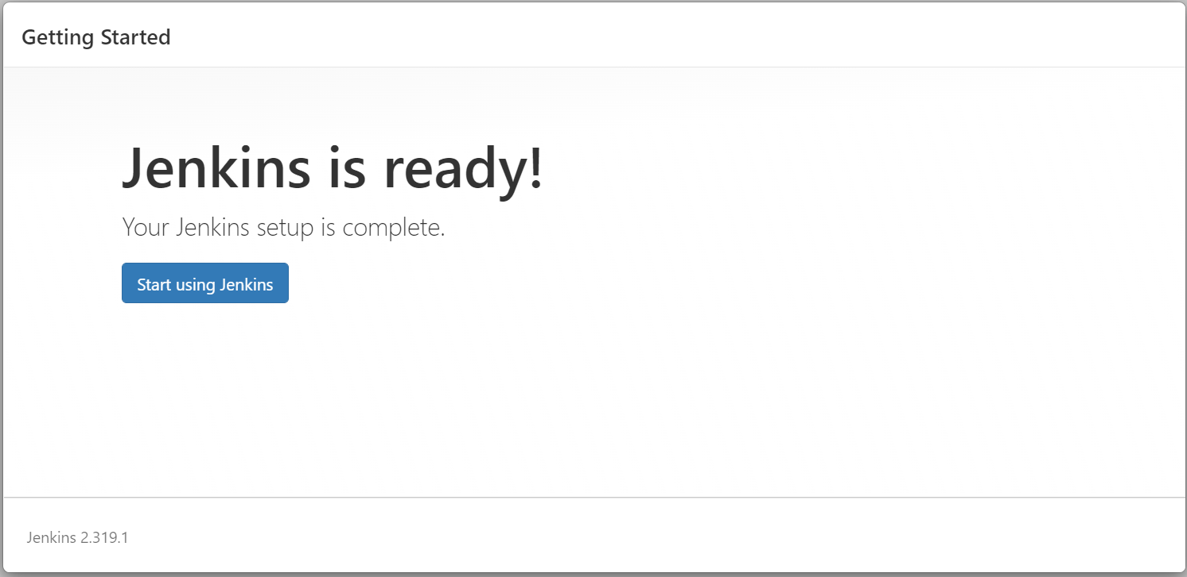

21. You should see below screen

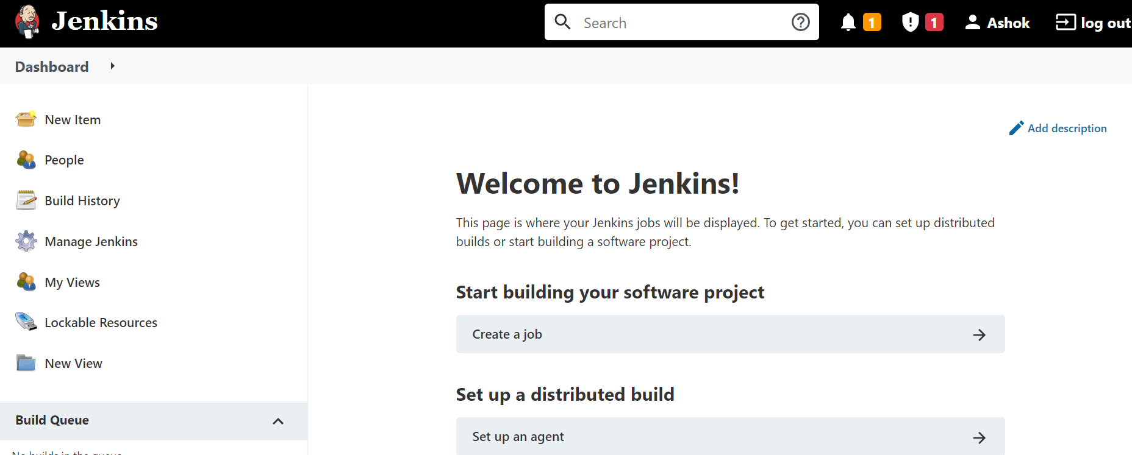

22. Click on New Item from above screen and you should see below screen,

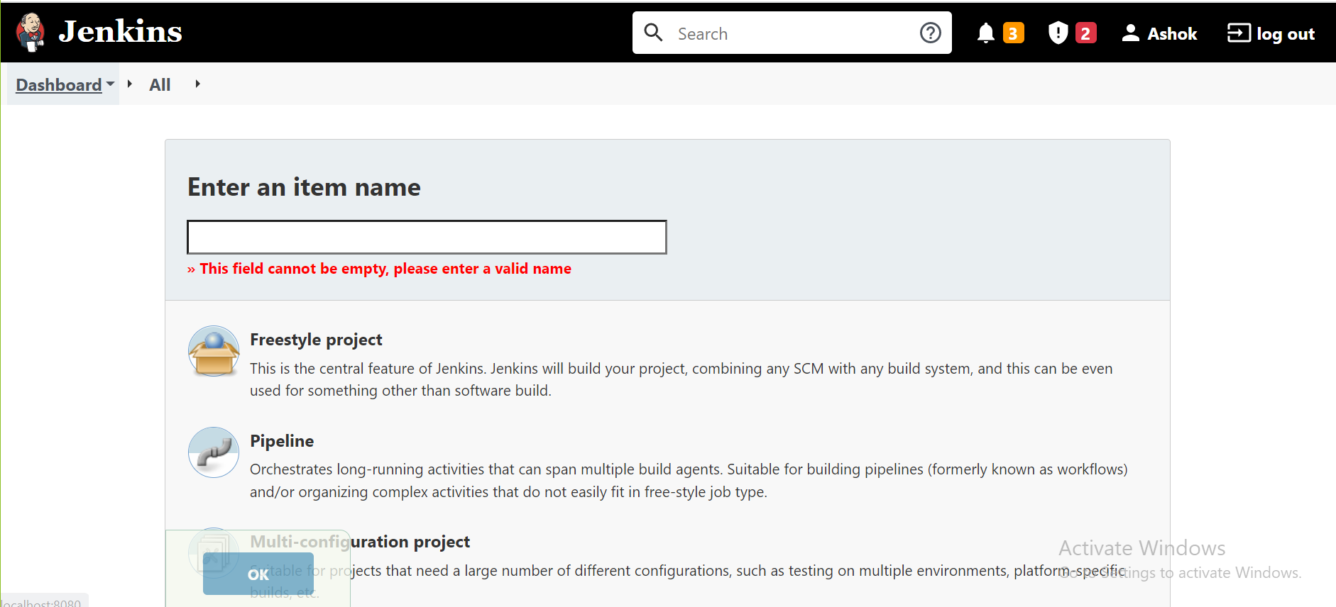

23. Enter your project name as shown below, select Freestyle project and click on Ok

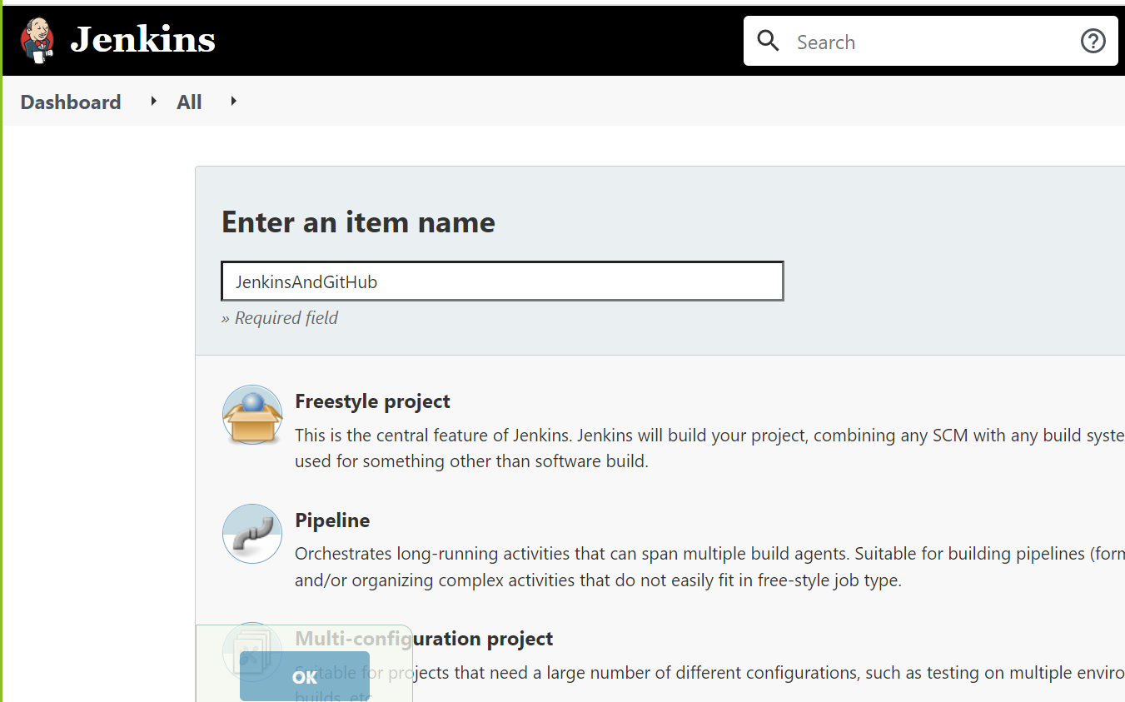

24. You should see below screen

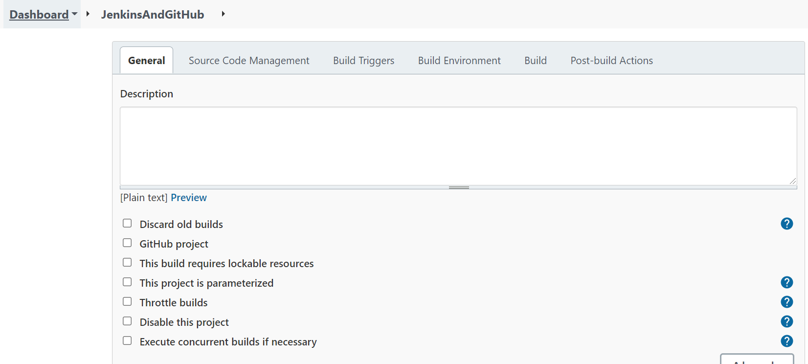

25. Click on Build tab and click on Add build step data as show below

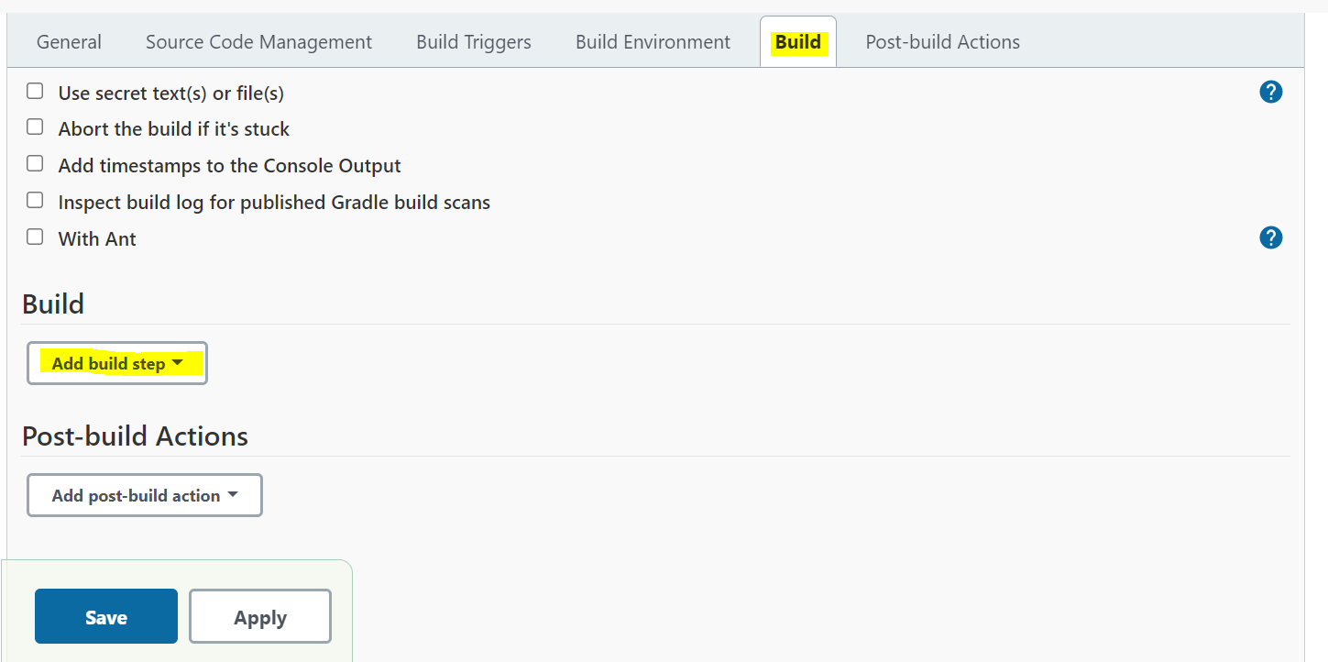

26. Select Apache Maven as shown below

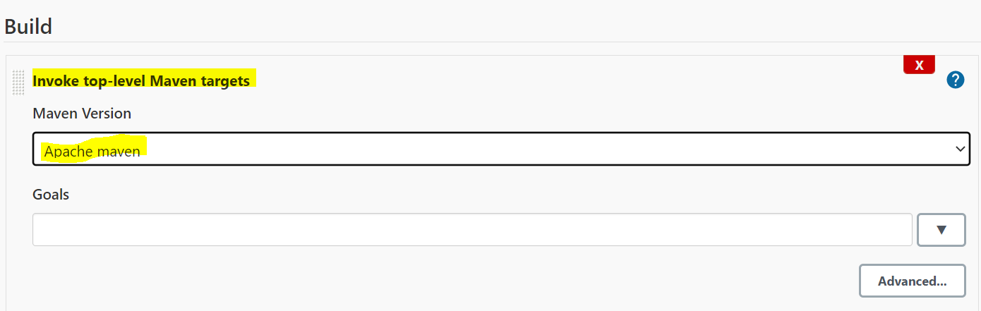

27. Click on Advanced tab and enter pom.xml file path

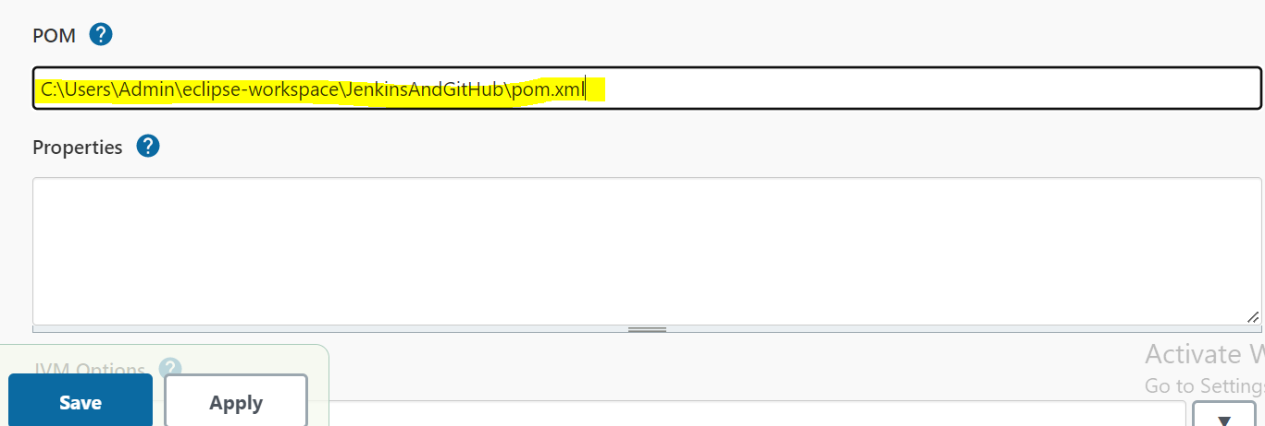

28. Navigate to Eclipse and create testNG.xml file as show below

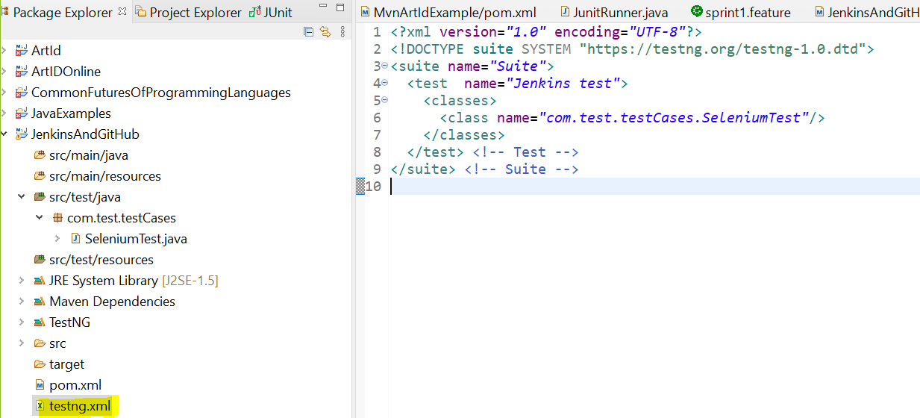

26. Open browser and search as shown below and also select link which is mentioned

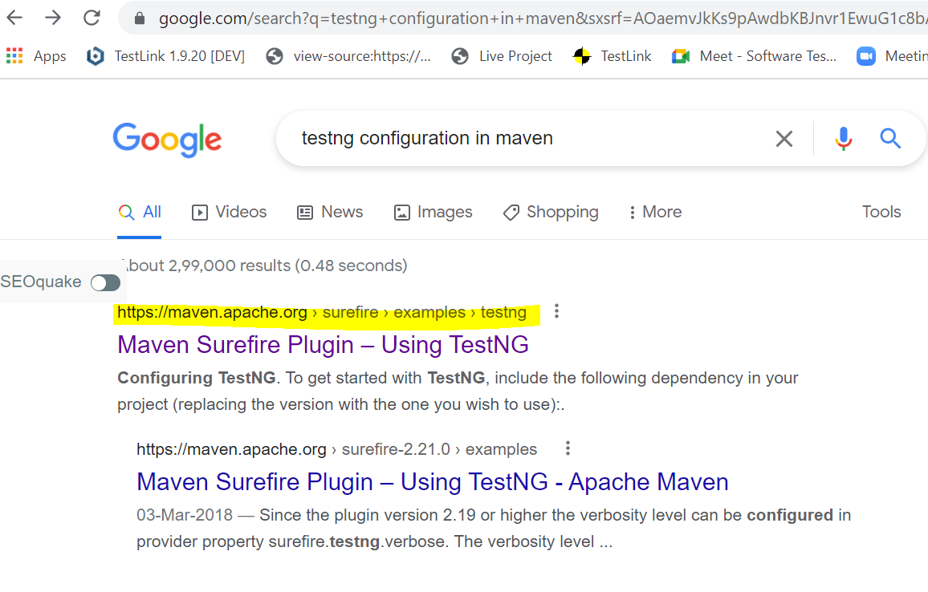

27. Copy and paste below in POM.xml as **plugin**

<plugin>

<groupId>org.apache.maven.plugins</groupId>

<artifactId>maven-surefire-plugin</artifactId>

<version>3.0.0-M4</version>

<configuration>

<suiteXmlFiles>

<suiteXmlFile>testng.xml</suiteXmlFile>

</suiteXmlFiles>

</configuration>

</plugin>

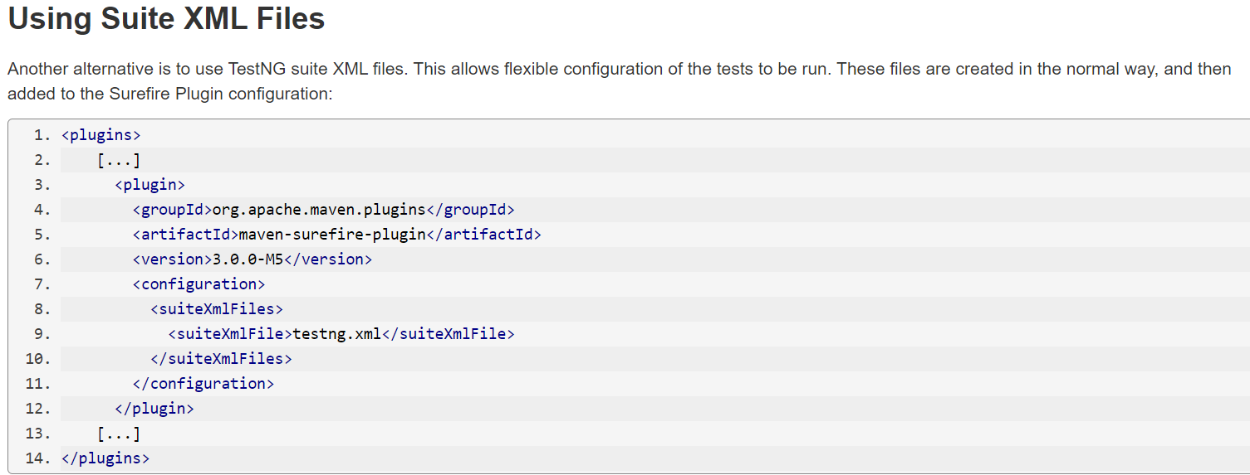

28. Navigate to Jenkins and click on Build tab and select / enter data as show below. 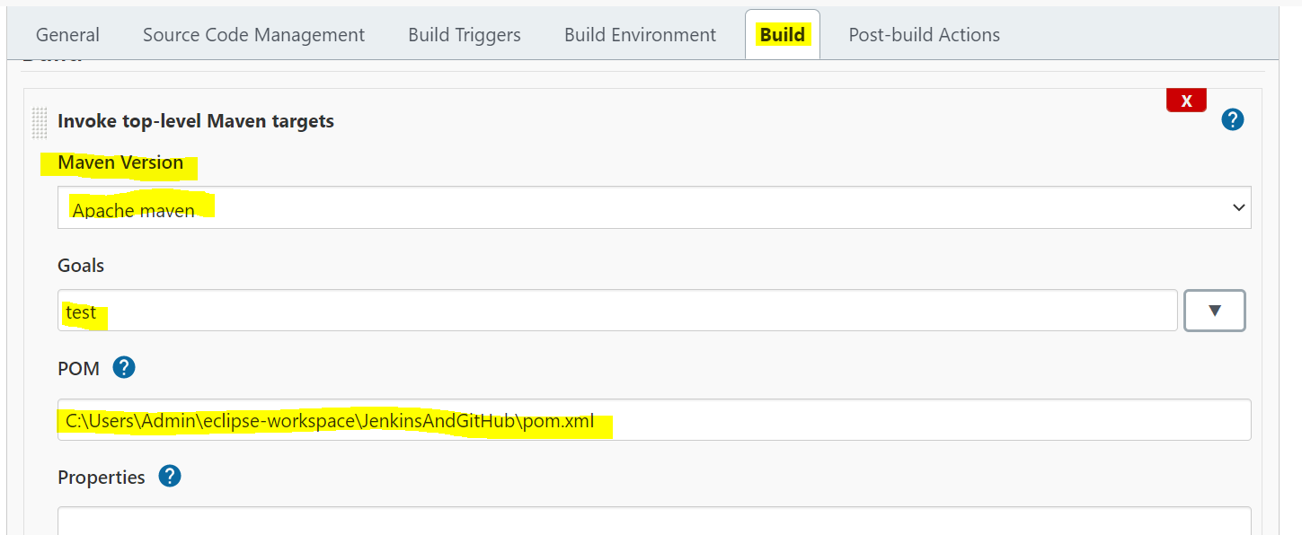

29. Click on Advanced button to enter POM.xml file path In POM provide your POM.xml file location as shown above

30. **Configuring email notifications:**

Click on Post –build actions and enter email id and click on Apply & Save.

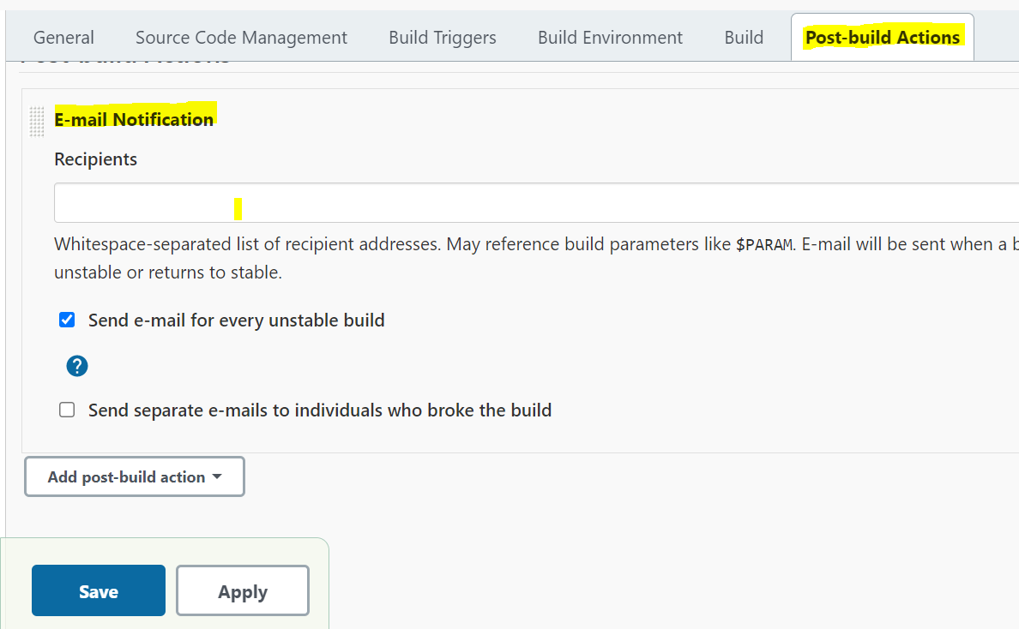

30. Click on Build Now

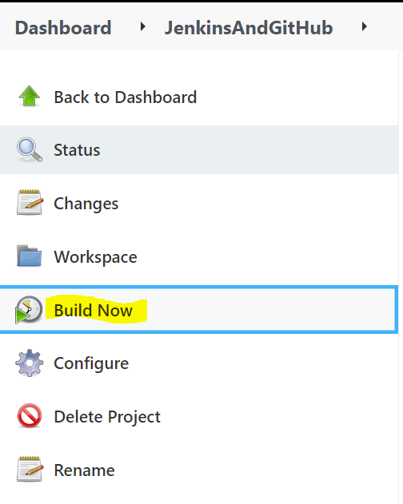

31. You can see build is in progress and it will execute all the test cases that are given in testng.xml file

