Download Test link test management tool:

Click on below link to download Testlink test management tool

<https://community.bitnami.com/t/how-to-get-bitnami-testlink-1-9-16-1-version-for-windows/101890>

1. Click on OK

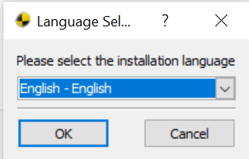

1. Click on Next

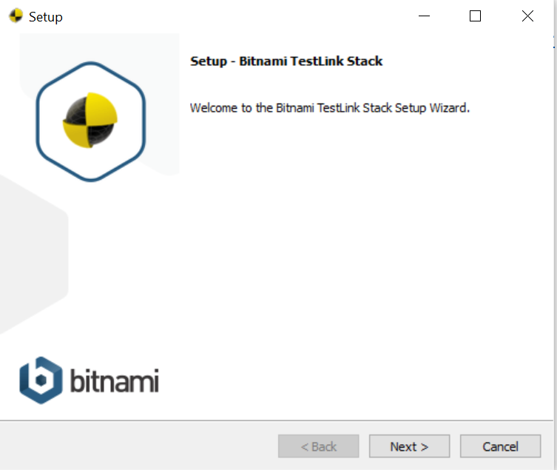

1. Click on Next

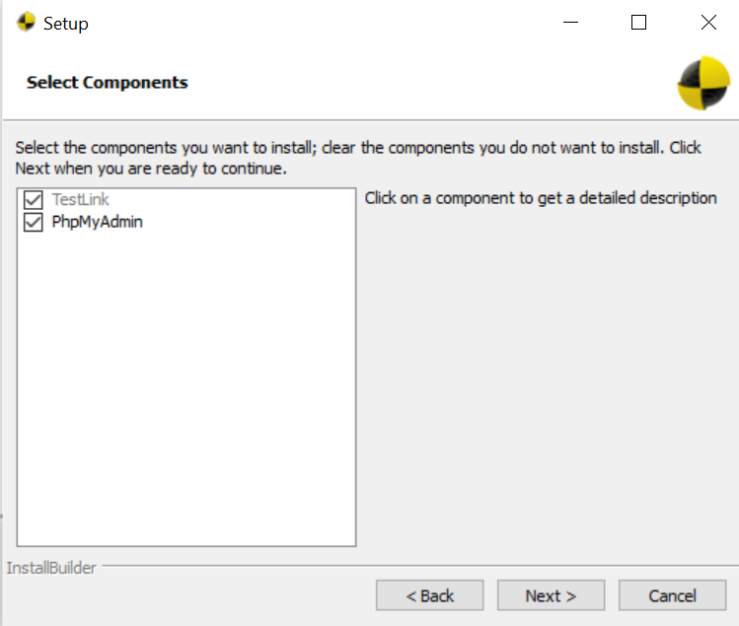

1. Click on Next

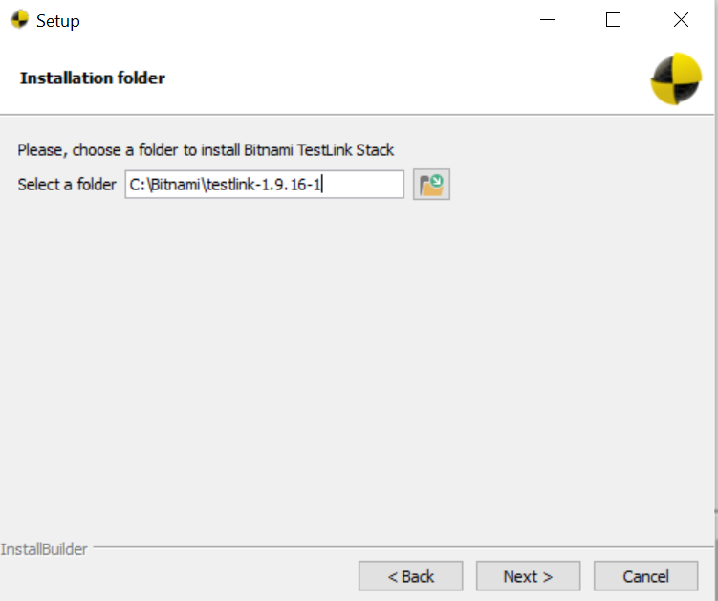

1. Enter all details as shown in below and click on next button

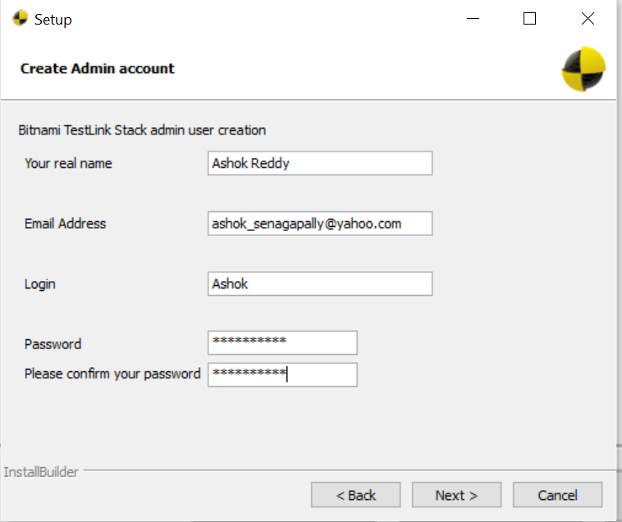

1. Click on Next

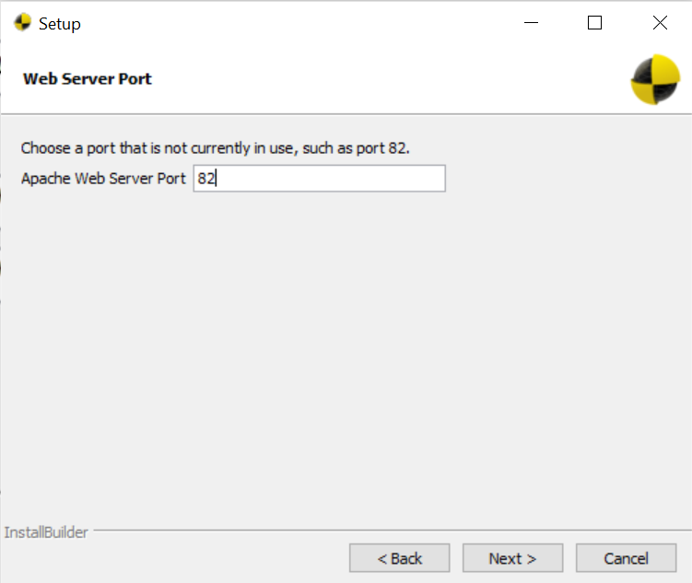

1. Click on Next

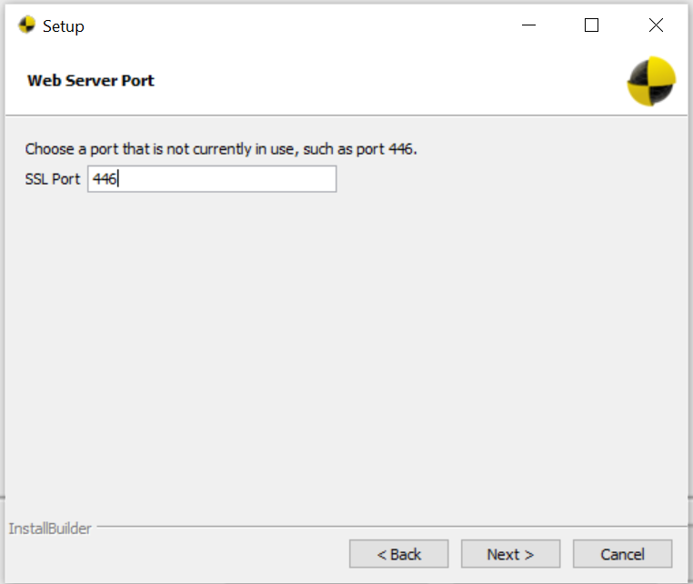

1. Do not check “Do you want to configure mail support”

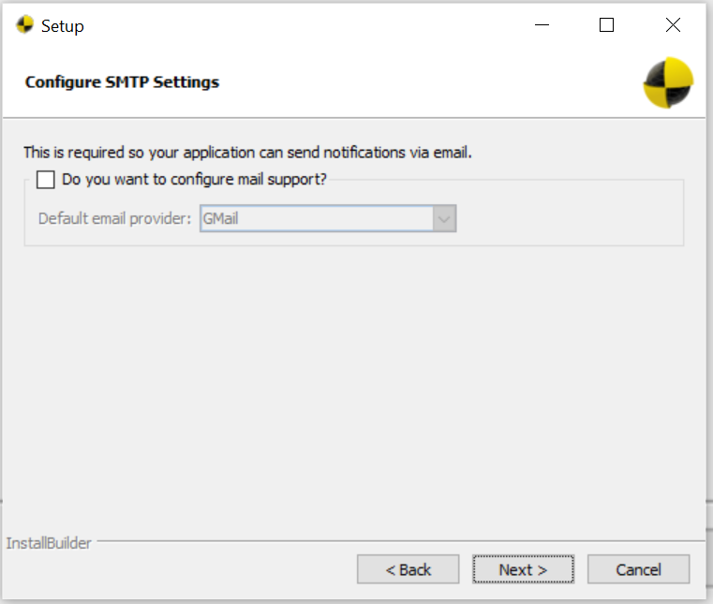

1. Click on Next

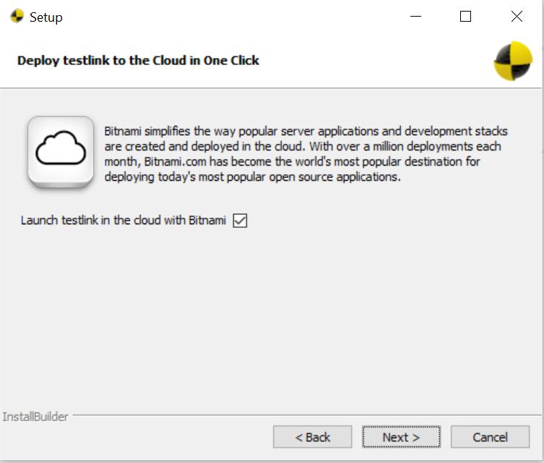

1. Click on Allow access if your firewall is blocked

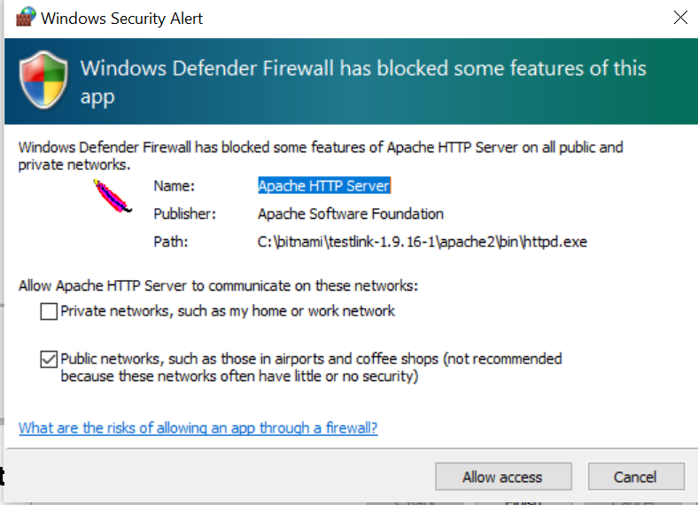

1. Click on Finish

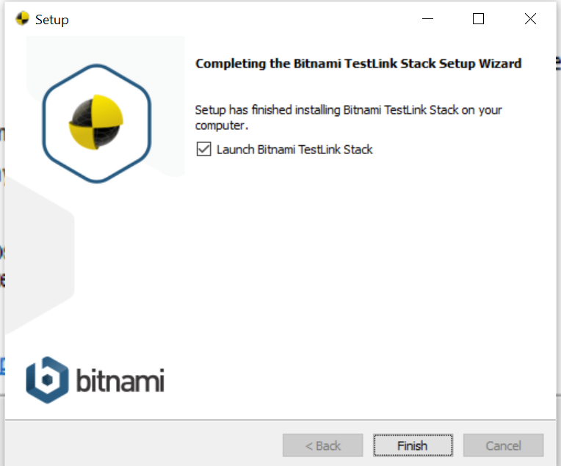

**12,** Click on “Go to application”

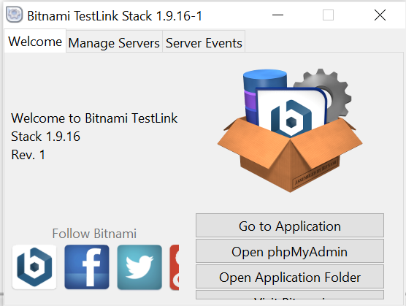

1. Click on Access Testlink and enter use id and password

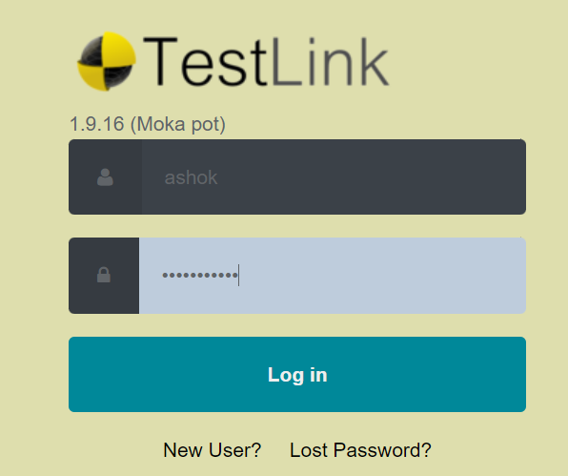

**Login to TestLink**

**Step 1 :** Open the Testlink home-page and enter the login details

1. Enter the userID – ashok
2. Enter the password
3. Click on the login tab

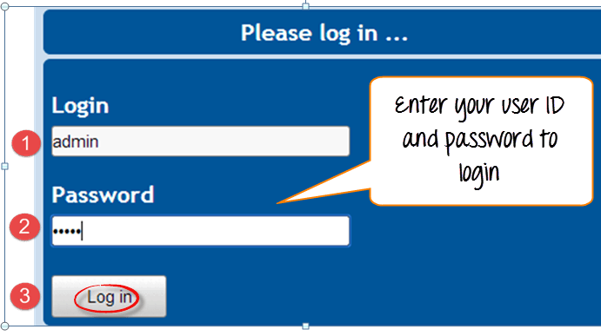

**Creating a Test Project**

**Step 1:** In the main window click on Test Project Management, it will open another window

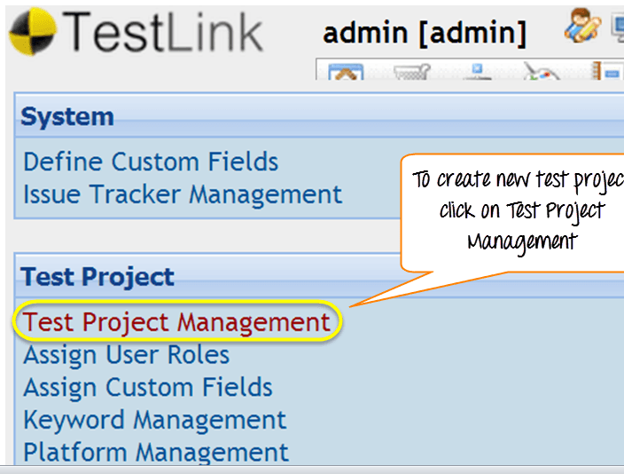

**Step 2:** Click on tab "create" to create a new project.

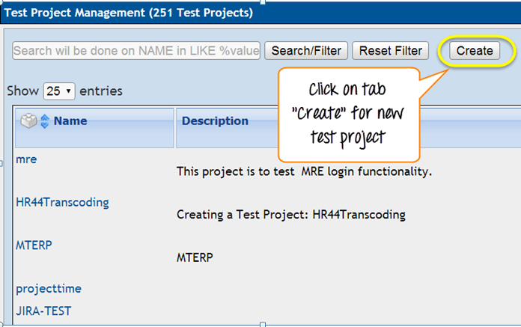

**Step 3:** Enter all the required fields in the window like category for test project, name of the project, prefix, description, etc. After filling all necessary details, click on tab "Create" at the end of the window.

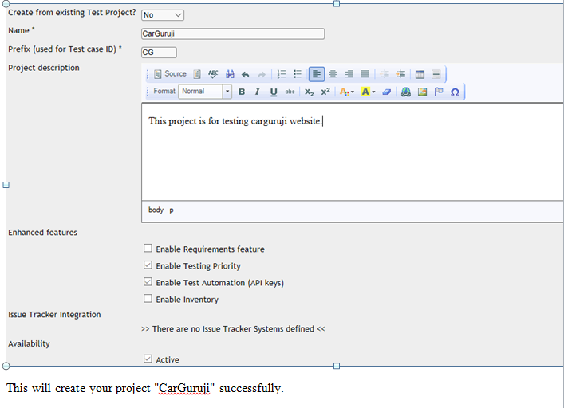

This will create your project "CarGuruji" successfully.

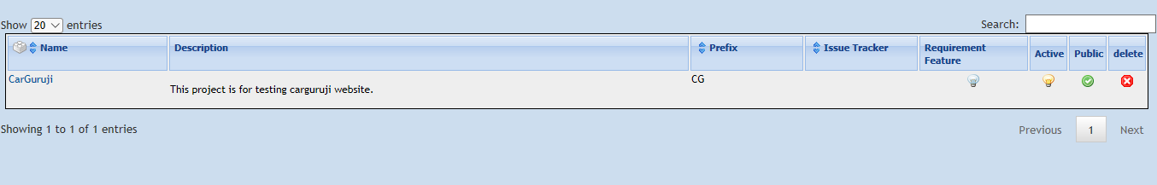

**Creating a Test Plan**

 Test plan holds the complete information like scope of Software testing, milestone, test suites and test cases. Once you have created a Test Project, next step is to create Test plan.

**Step 1:** From the home-page, click on Test Plan Management from home-page

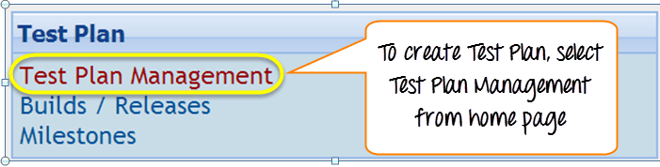

**Step 2**: It will open another page, at the bottom of the page click on a tab "Create"

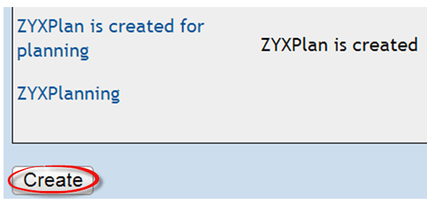

**Step 3**: Fill out all the necessary information like name, description, create from existing test plan, etc. in the open window, and click on "create tab"

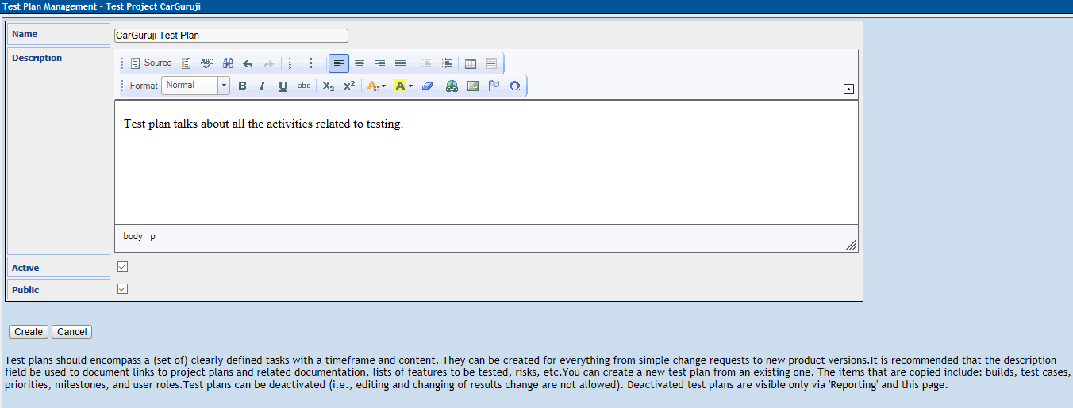

**Step 4:** CarGuruji Test Plan is created successfully

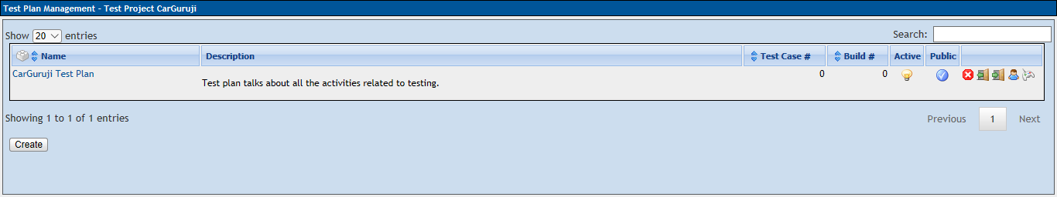

**Build Creation**

Build is a specific release of software

**Step 1:** Click on Builds/Releases under Test Plan from the home page

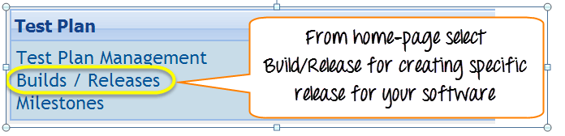

**Step 2:** In the next window, fill all necessary details for software release and click on create to save your release

1. Enter the title name
2. Enter the description about the software release
3. Mark the check-box for status- Active
4. Mark the check-box for status- Open
5. Choose the data of release
6. Click on create button

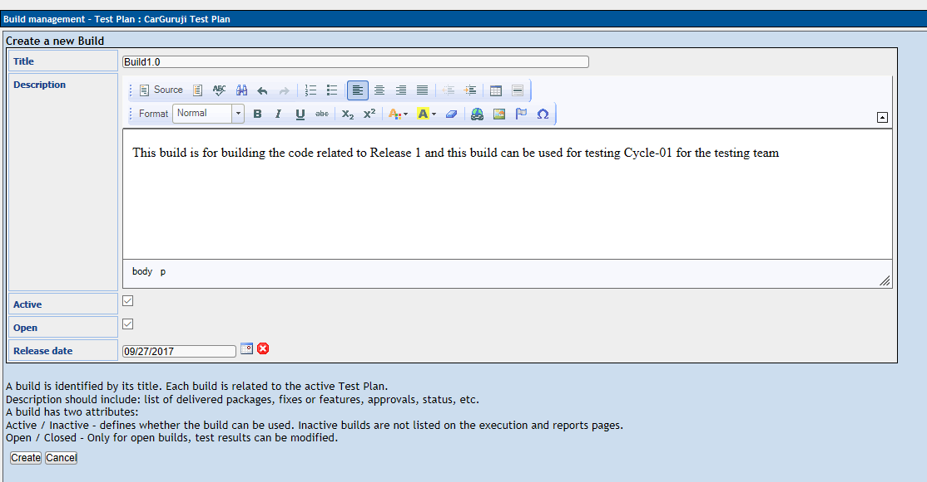

Once you have a release the software it, will appear like this

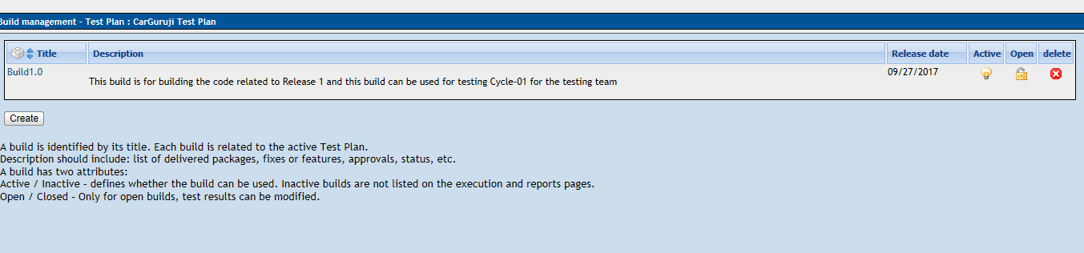

**Creating Test suite**

 Test suite is a collection of test cases which may be testing or validating the same component. Following steps will explain how to create test suite for your project.

**Step 1:** Click on test specification option from the home page.

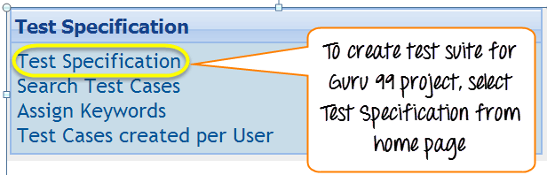

**Step 2:** On the right-hand side of the panel, click on the setting iconIt will display a series of test operation.

**Step 3:** Click on the "create" tab for the test suite

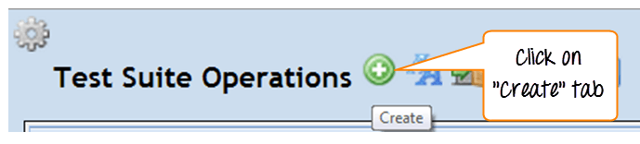

**Step 4:** Fill-up all the details for test-suite and click on save it tab.

1. Enter the test suite name
2. Enter the details about your test suite
3. Click on save button to save the details of test-suite

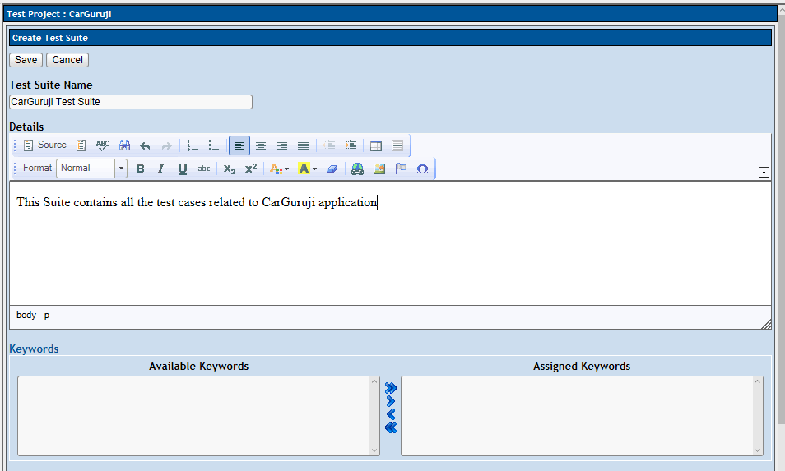

You can see test suite for CarGuruji is created

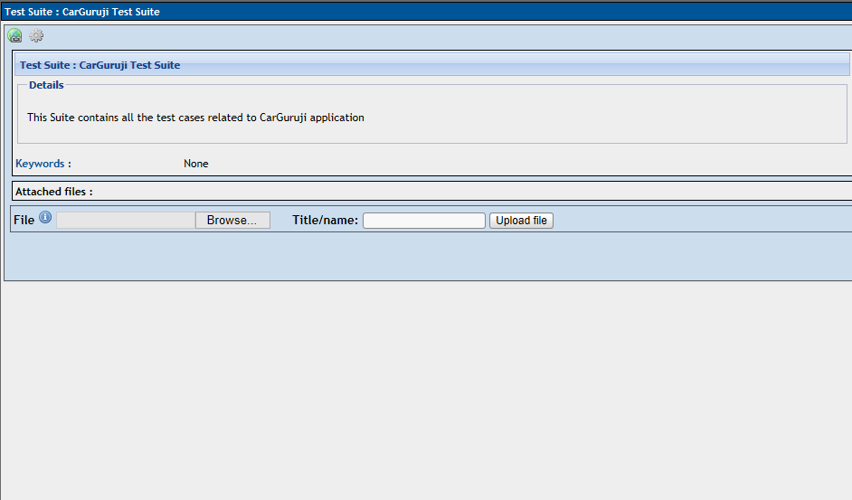

Your test suite appears on the left side of the panel under folder structure tree

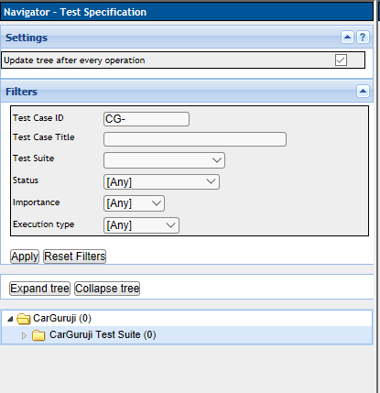

**Creating a Test case**

 Test case holds a sequence of test steps to test a specific scenario with expected result. Below steps will explain how to create a test-case along with test steps.

**Step 1**: Click on the test suite folder on the left side of the panel under folder tree structure 

**Step 2:** Click on the setting icon in the right side panel. List of test case operations will be displayed on the right side panel

20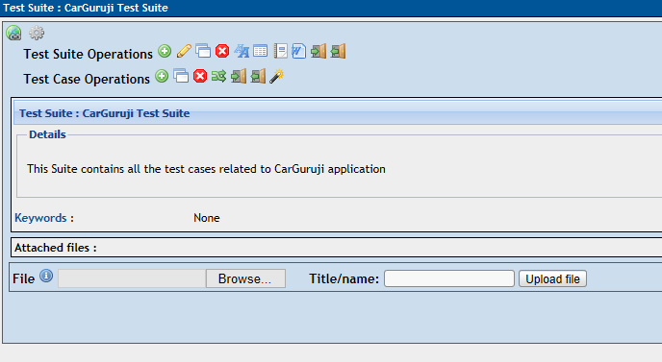

**Step 3:** New window will open, to create test cases click on create button in test-case operations

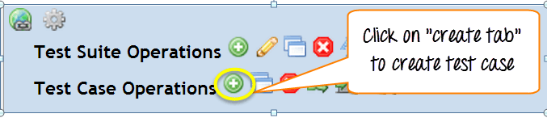

**Step 4:** Enter the details in the test case specification page

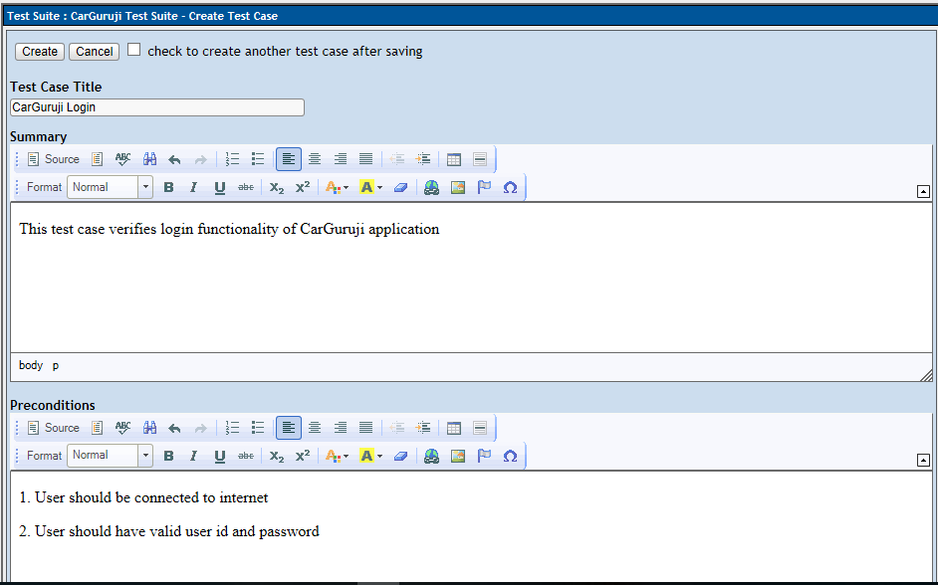

**Step 5:** After entering the details, click on "create" button to save the details. The test-case for CarGuruji Logn is created successfully

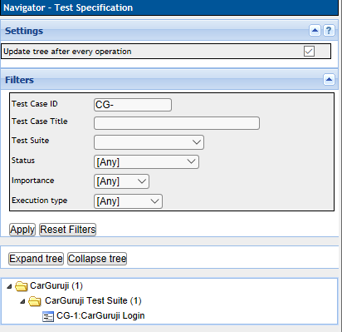

**Step 6:** Click on test-case from the folder as shown above, it will open a window. Click on "create steps" button in test case. It will open a test case step editor

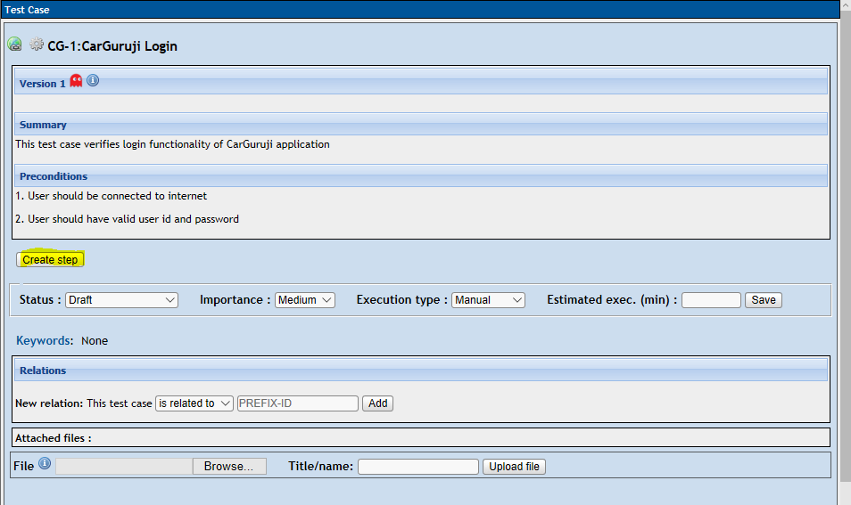

**Step 7)** It will open another window on the same page, in that window you have to enter the following details

1. Enter the step-action for your test case
2. Enter the details about the step action
3. Click save it and add another step action OR click save and exit tab if there is no more test step to add

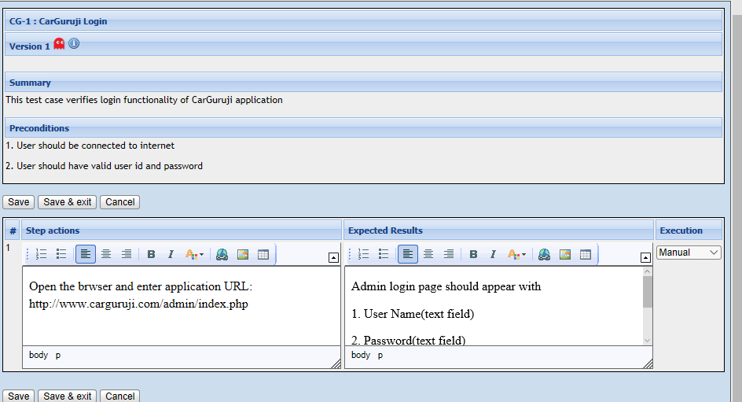

**Step 8)** Once you save and exit the test step, it will appear like this

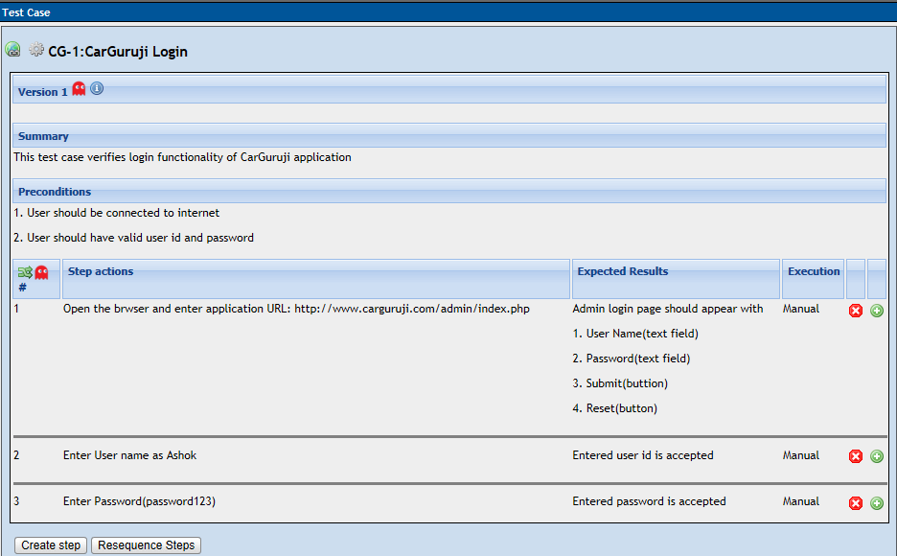

**Assigning test case to test plan**

 For test case to get execute, it should be assigned to test plan. Here we will see how we can assign a test-case to test plan.

**Step 1)** Click on the setting icon on the test panel. It will show the list of operations.

**Step 2)** Click on "Add to Test Plans"

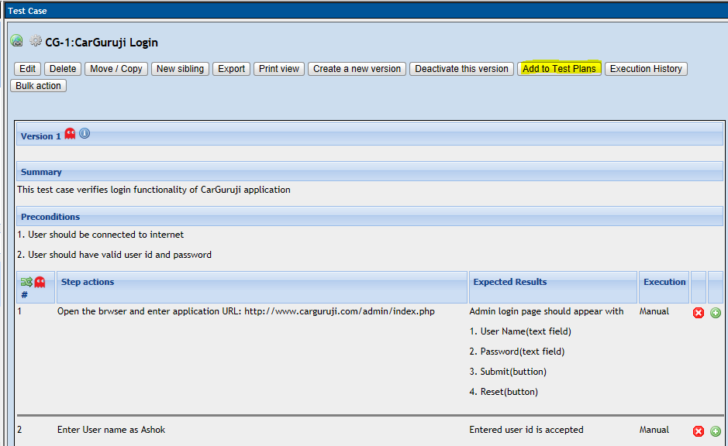

**Step 3)** New window will open, search your project "CarGuruji"

1. Mark the check box against your test plan
2. Click on add button

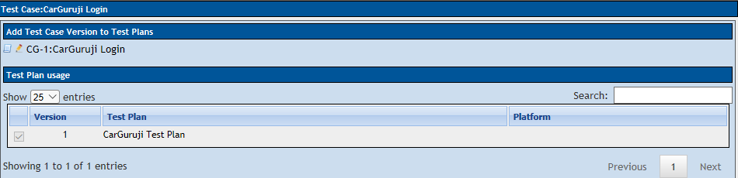

This will add your test case to your Test Plan.

**Creating Users and Assigning Roles in TestLink**

Testlink provides User management and authorization features.

Below is list of default roles in Testlink and their rights -

| **Role** | **Test Cases** | **Test Metrics** |
| --- | --- | --- |
| Guest | View | View |
| Tester | Execute | View |
| Senior Tester | Edit & Execute | View |
| Leader & Admin | Edit & Execute | Edit & Execute |

**Step 1:** From the Testlinks home-page, click on users/roles icon from the navigation bar

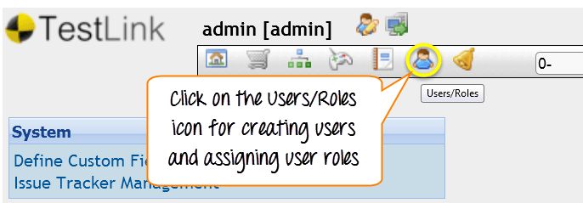

**Step 2:** Click Create

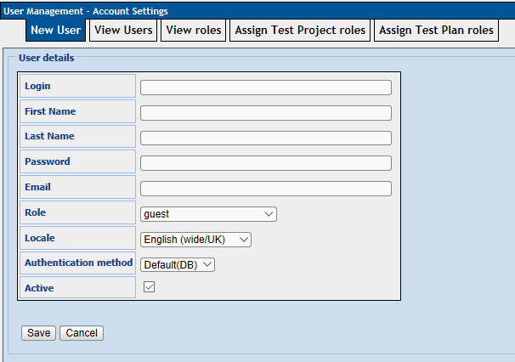

**Step 3**: Fill out all the users details and click the "Save" button

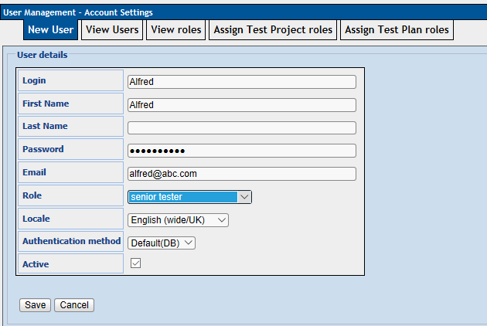

Here in the list we can see the users have been created

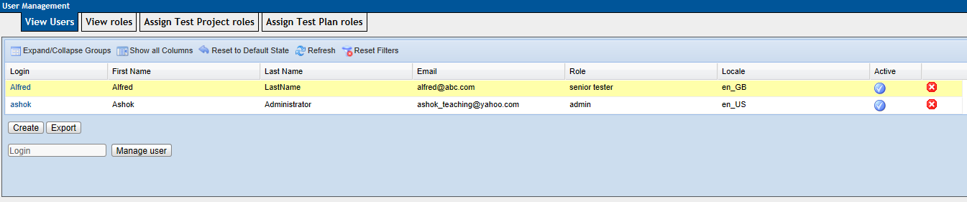

**Step 4**: Allotting test project role to the user,

1. Click on **"Assign Test Project Roles"** tab
2. Choose the project name
3. Select the users role from the drop down

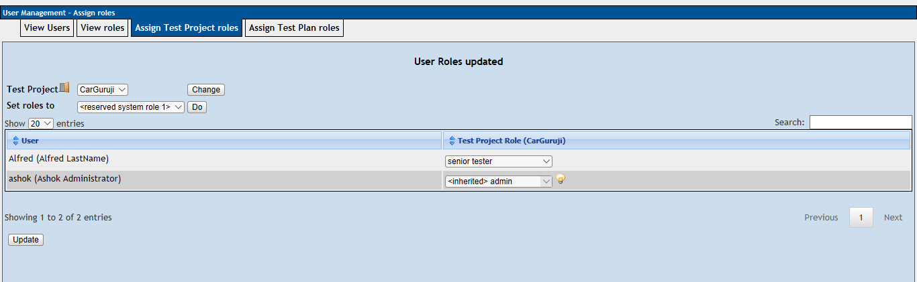

**Executing a test case**

In TestLink, we can run a test case and change execution status of a test case. Status of a test-case **can be set** to "blocked" "Passed", **or** "failed". Initially, **it will be in "not run"** status but once you h**ave** updated it, it cannot be altered to "not run" status again.

**Step 1:** From the navigation bar click on the "Test Execution" link. It will direct you to the Test Execution Panel.

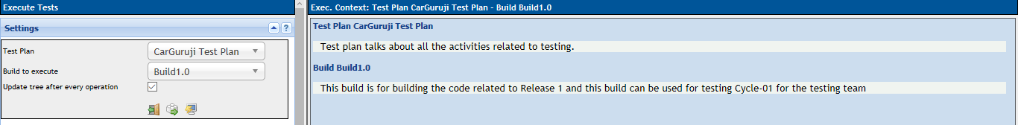

**Step 2:** Pick the Test case you want to run from the left side panel

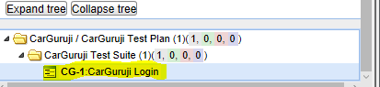

**Step 3**: Once you have selected the test cases, it will open a window.

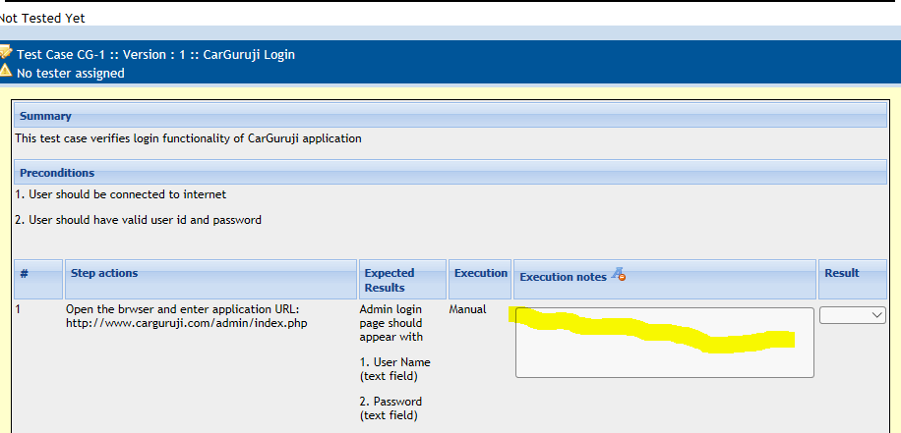

**Step 4**: Follow the following steps

1. Enter the notes related to test case executed
2. Select its Results

**Step 5:** On the same page, you have to fill similar detail about the execution of test-case. Fill the details, select the status and then click on "save execution".