Loan Default Probability & Statistics Project
Dataset: loan_applications.csv | Records: 5,000
Objective: Explain key statistical concepts and apply Python-based statistical and probability analysis to evaluate loan default risk.

Part A – Theory Short Answers

1. Mean, Median, Mode
Mean is the average income. Median is the middle income after sorting. Mode is the most frequently occurring income value.

2. Standard Deviation vs Variance
Variance is the average squared distance from the mean. Standard deviation is the square root of variance and is expressed in the same unit as the loan amount.

3. Random Variable
A random variable assigns a numerical value to an outcome of a random experiment. Example: the loan amount selected from a randomly chosen application.

4. Conditional Probability
Conditional probability measures the chance of an event when another event is already known. Example: P(Default | Credit_Score < 600).

5. Bayes Theorem
Bayes theorem updates the probability of an event using new evidence: P(A|B) = P(B|A)P(A) / P(B). It can be used to update default risk after observing a customer's credit-score category.

6. Empirical vs Theoretical Probability
Empirical probability is calculated from observed data. Theoretical probability is based on a mathematical model or known assumptions.

7. Eigenvalues and Eigenvectors
For a square matrix A, an eigenvector v satisfies Av = λv, where λ is the eigenvalue. In data analysis they are useful in PCA to find important directions of variation.

8. Eigenvalues and Eigenvectors
For a square matrix A, an eigenvector v satisfies Av = λv, where λ is the eigenvalue. In data analysis, eigenvalues and eigenvectors are important in PCA because they help identify the directions containing the most variation.

Part B – Practical Results
- Mean income = 99,495.31
- Median income = 99,872.00
- Mode of income = [19881, 21262, 22042, 27491, 33916, 34766, 38389, 40419, 42502, 46036] (the generated data has several tied modes)
- Loan amount range = 94,985
- Loan amount variance = 770,847,681.92
- Loan amount standard deviation = 27,764.14
- P(Default) = 0.2462 (24.62%)
- P(Default | Credit Score < 600) = 0.3571 (35.71%)
- Loan amount skewness = 0.0039
- Loan amount excess kurtosis = -1.2231
- Dot product of first two customer vectors = 27,779,754,544
- Angle between first two customer vectors = 14.25°

Contingency Table: Credit Score vs Default Status
Credit Range | No | Yes | Total | Default Rate
<600 | 468 | 260 | 728 | 35.71%
600-699 | 1688 | 600 | 2288 | 26.22%
700-799 | 1351 | 341 | 1692 | 20.15%
800-850 | 262 | 30 | 292 | 10.27%

Visualizations
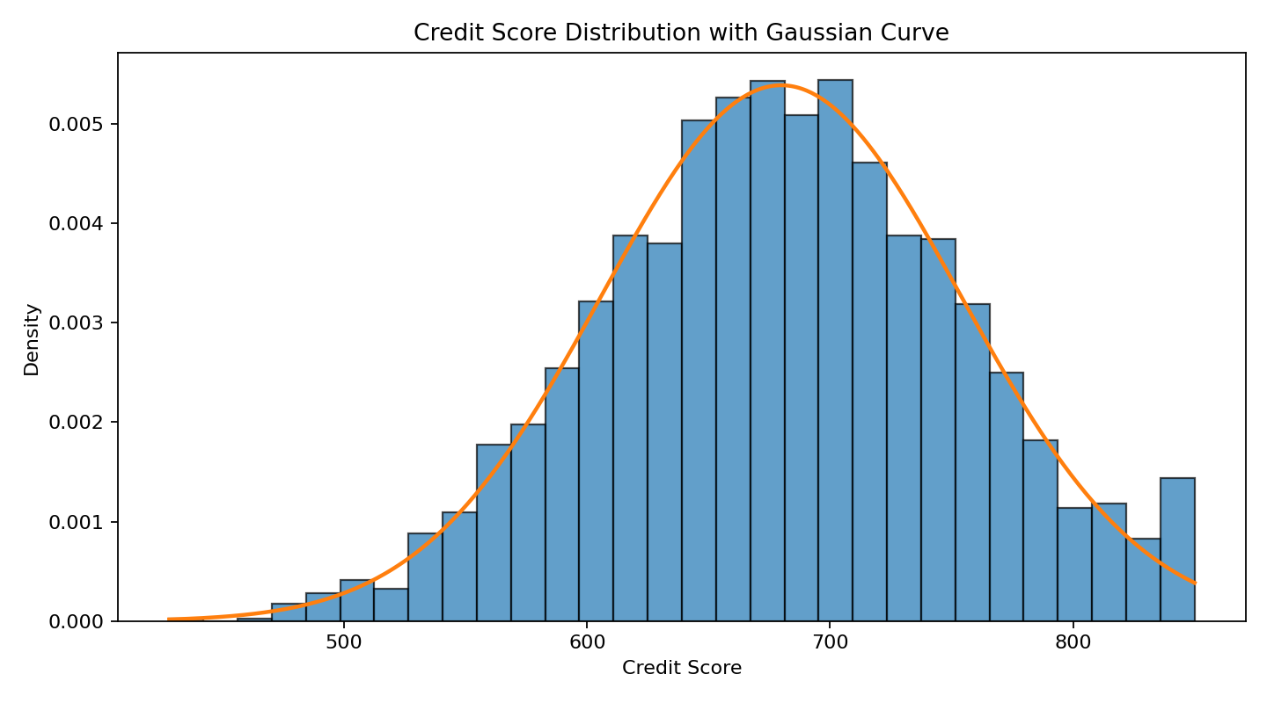
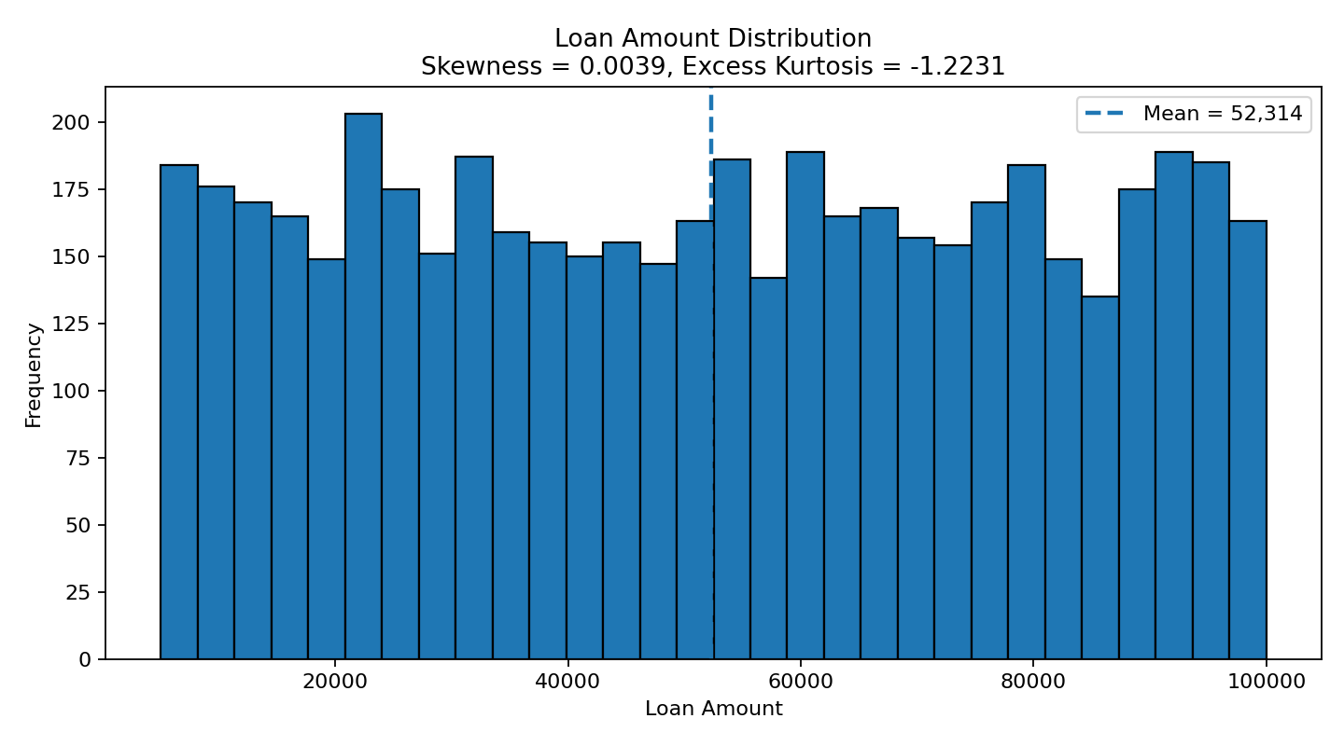
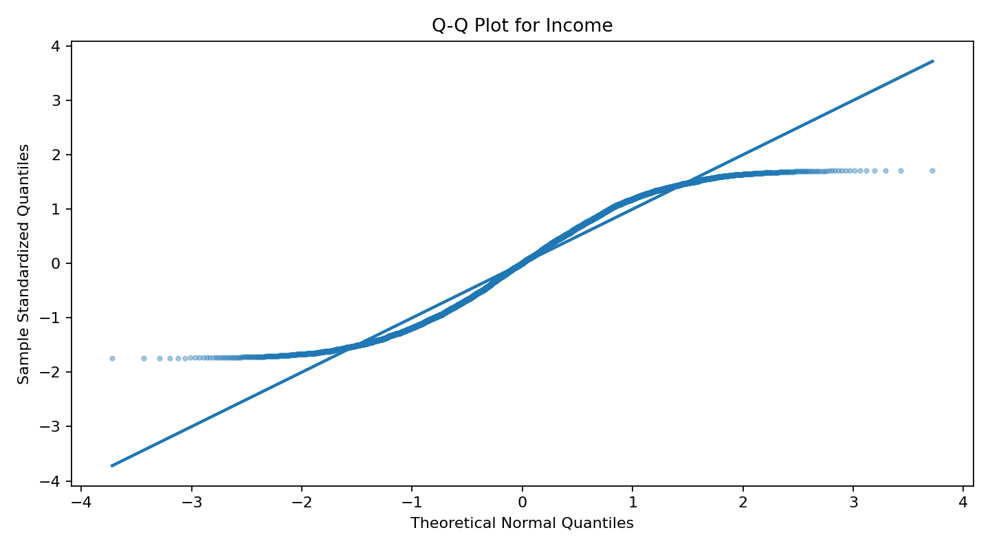
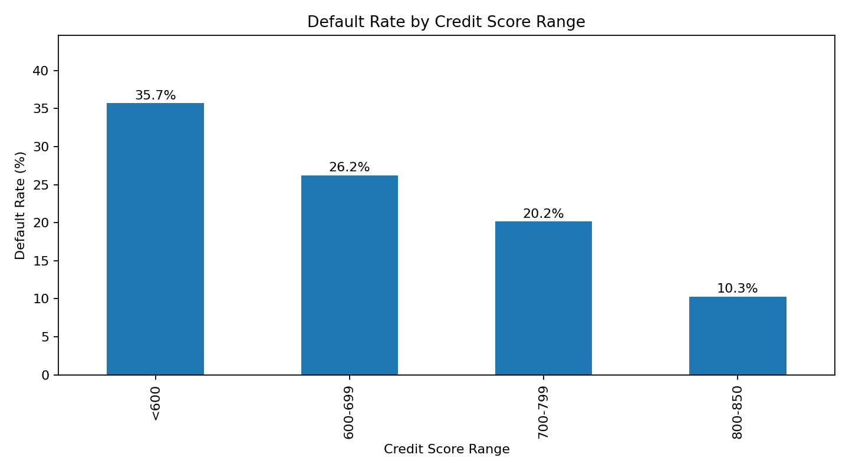

Key Insights
- The overall default rate is 24.62%, so roughly one in four applications is marked as default.
- Applicants with Credit Score < 600 have a 35.71% conditional default probability, which is higher than the overall default rate.
- Default rates decline as credit-score category improves, from about 35.7% for scores below 600 to about 10.3% for scores 800–850.
- Loan Amount skewness is 0.0039, which is very close to zero and suggests an approximately symmetric distribution.
- The Q-Q plot provides a visual check of how closely income follows a normal distribution.

