**AWS**

**Steps:**

* Search for the ‘AWS console’ in google, and select the first link, then do sign up first
* Then look for the ‘Elastic Beanstalk’ service

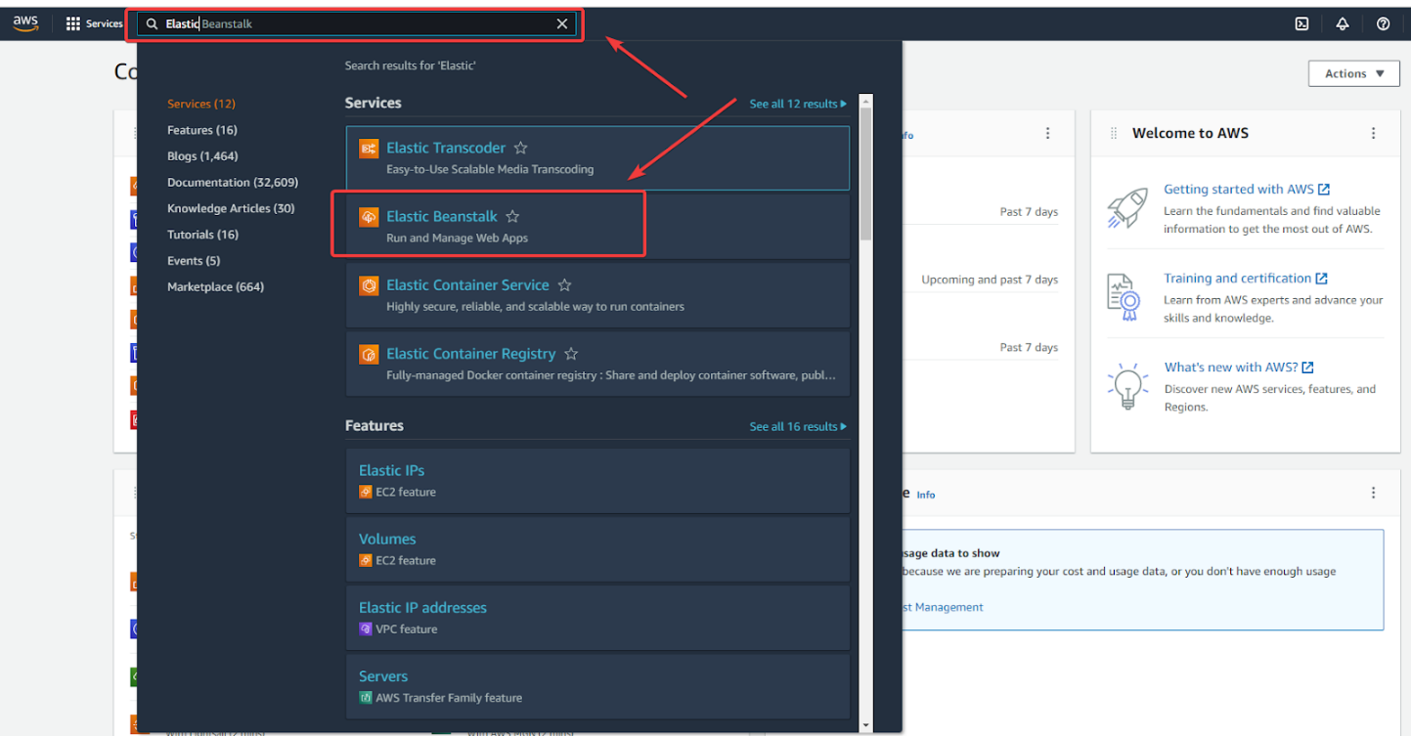

* Select ‘Elastic Beanstalk’, it’ll redirect you to the next page. Then, select ‘Create Application’

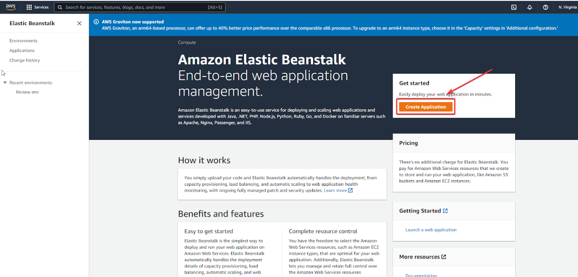

* Fill the required details in there, like ‘Application name’, ‘Platform’, choose Python 3.7 here. At last, we can ‘Create application’

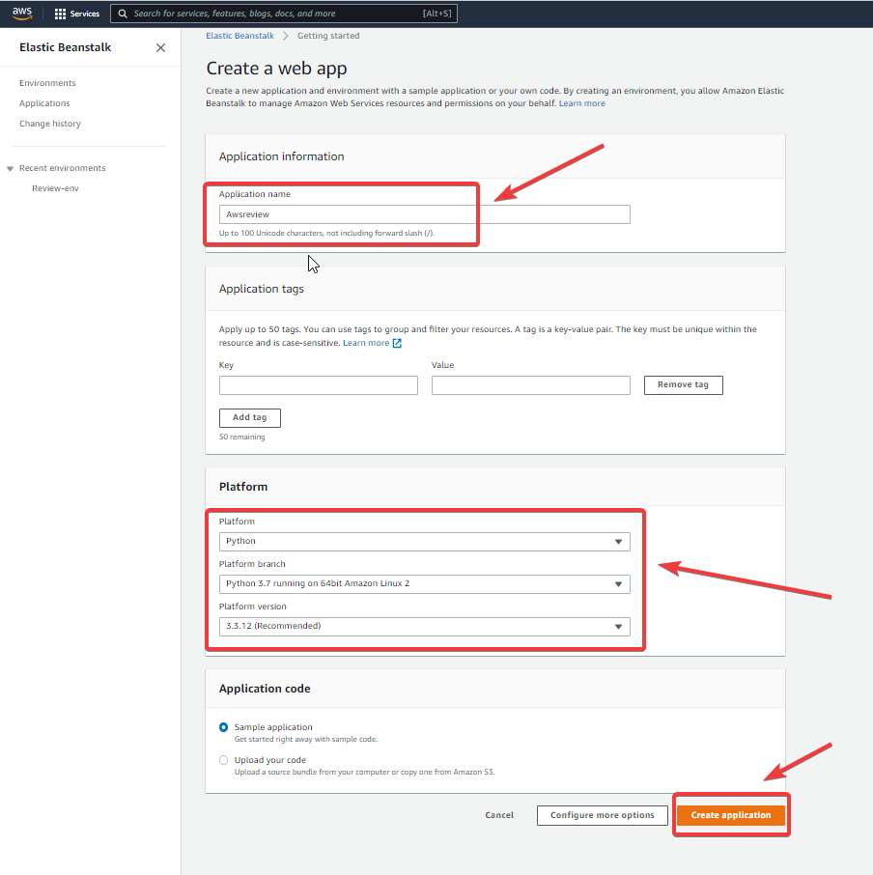

* After that, it’ll start creating a new environment

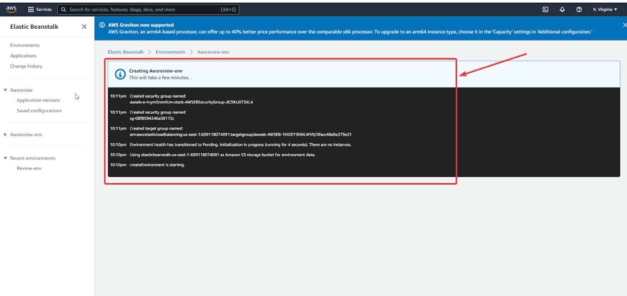

* Let it be completed, will now create a pipeline. Open a new tab and search for ‘Code Pipeline’ service in AWS console

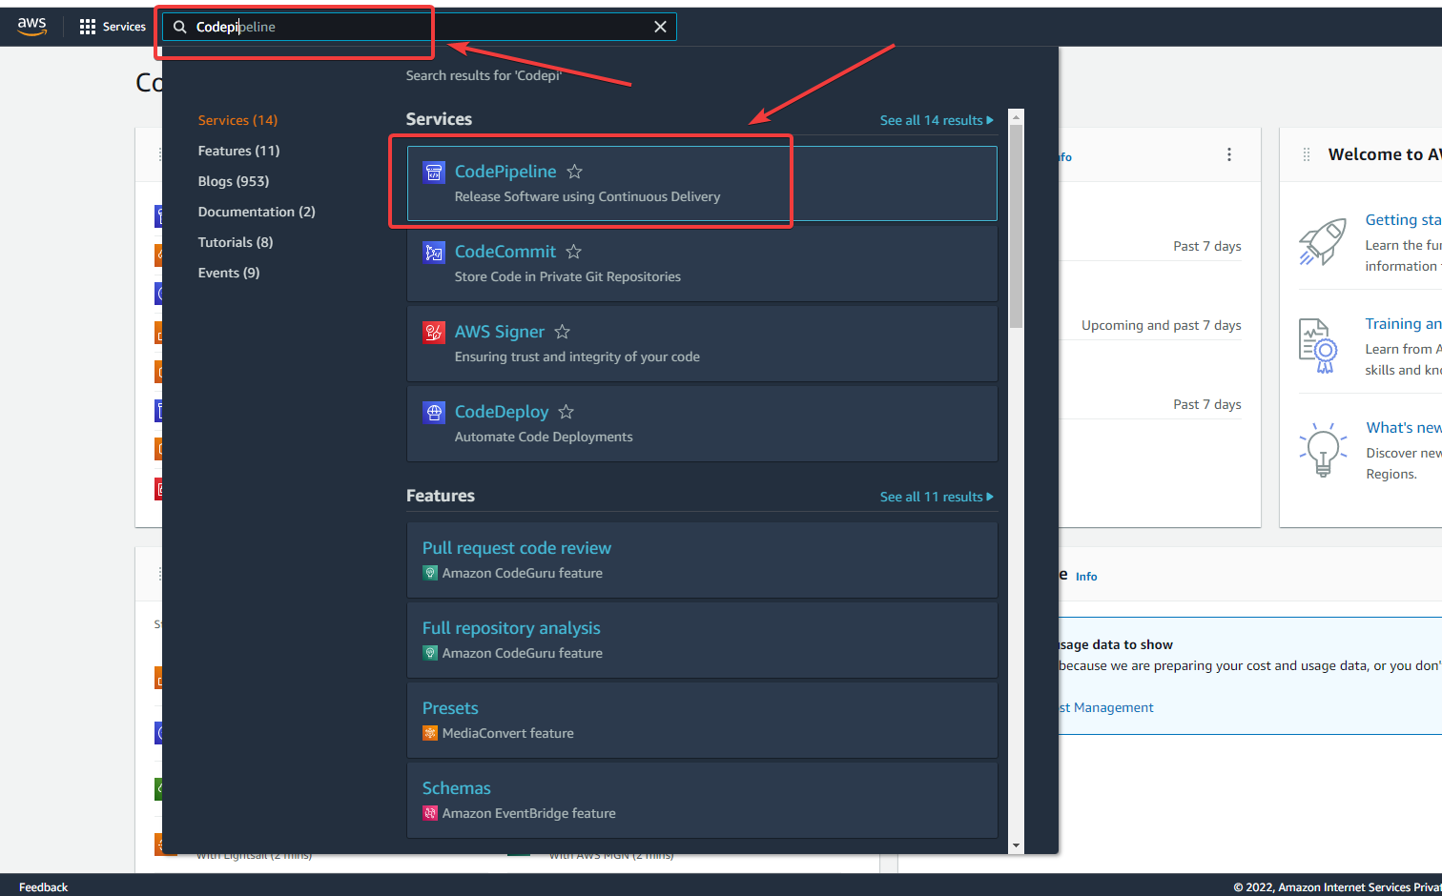

* Now, create a pipeline with ‘Create pipeline’

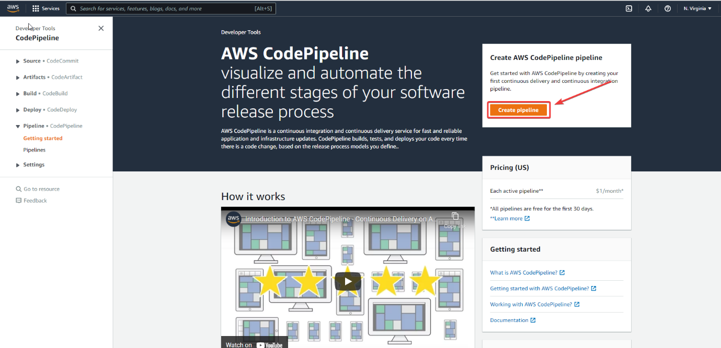

* Pick your pipeline name in here like I have given ‘awsrev’. Then click on ‘Next’

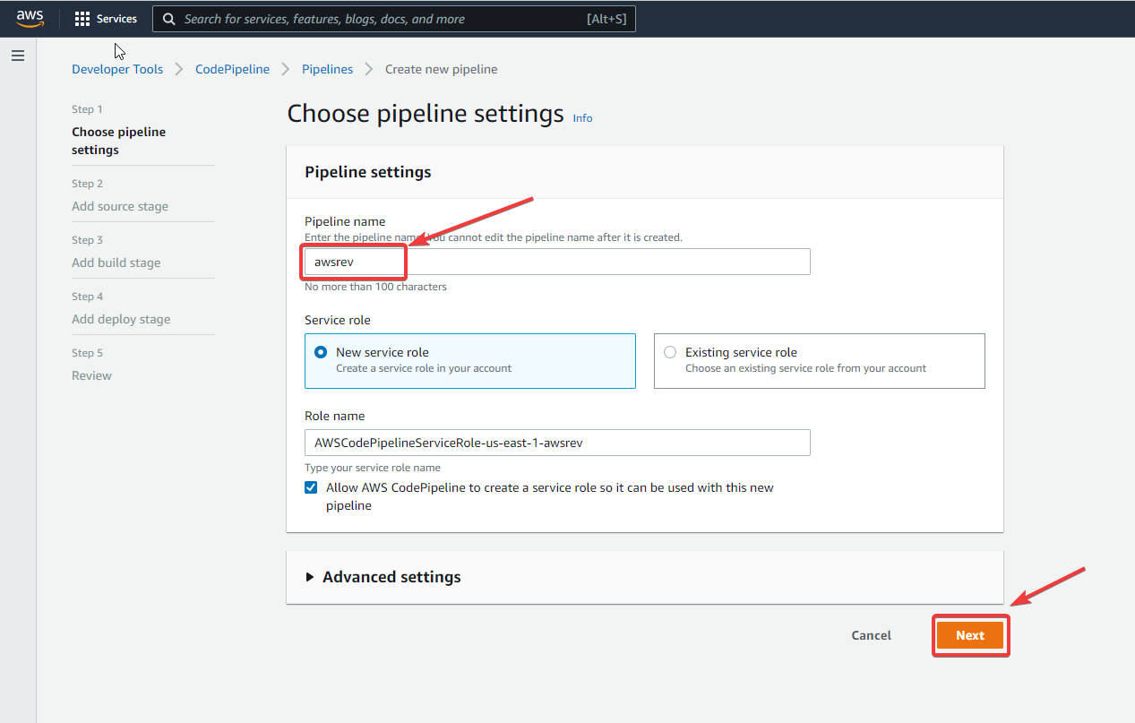

* In the next step, Select ‘GitHub(Version 2)’, then select ‘Connect to Github’, one pop-up will open in which, you have to add your ‘Connection name’ and then connect your github

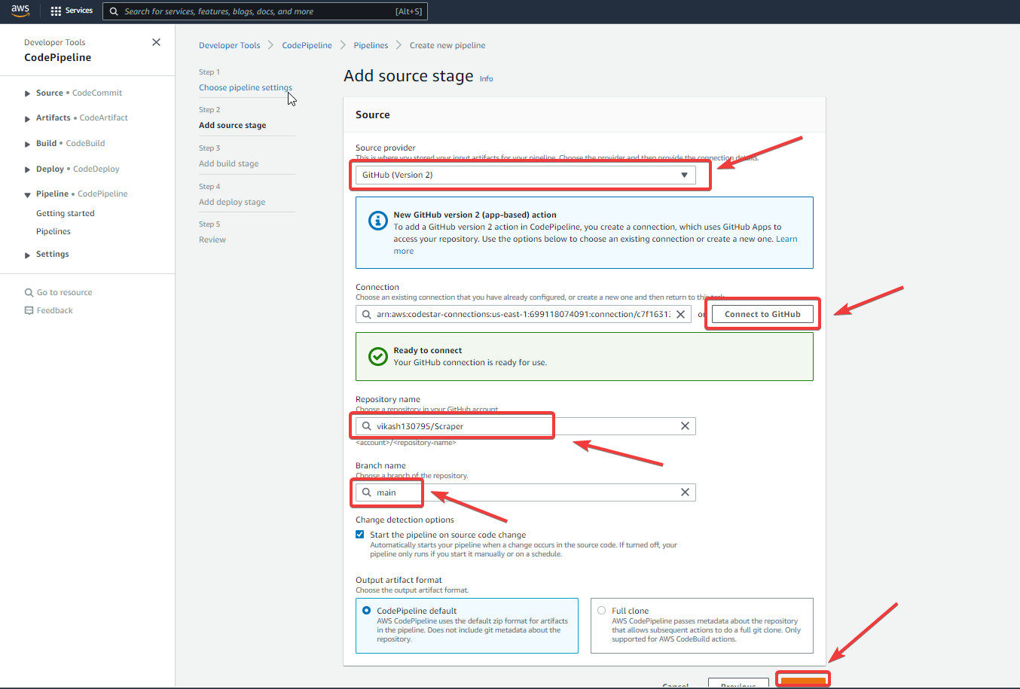

* Then, click on ‘Next’ for next steps
* We need to skip this Build stage

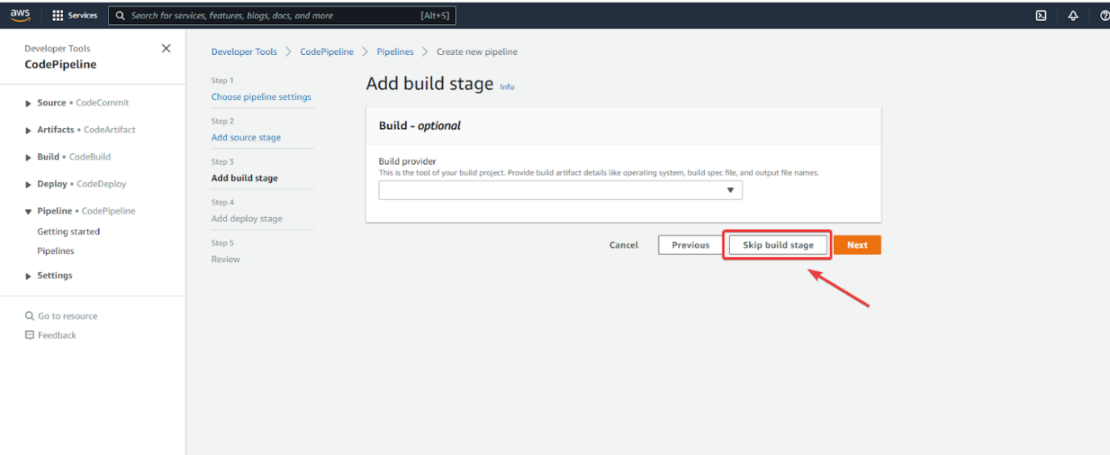

* In this step, we need to select the ‘Deploy provider’ as ‘AWS Elastic Beanstalk’ and then add ‘Application name’ which we had created in Elastic beanstalk. Now, move for the ‘Next’ step

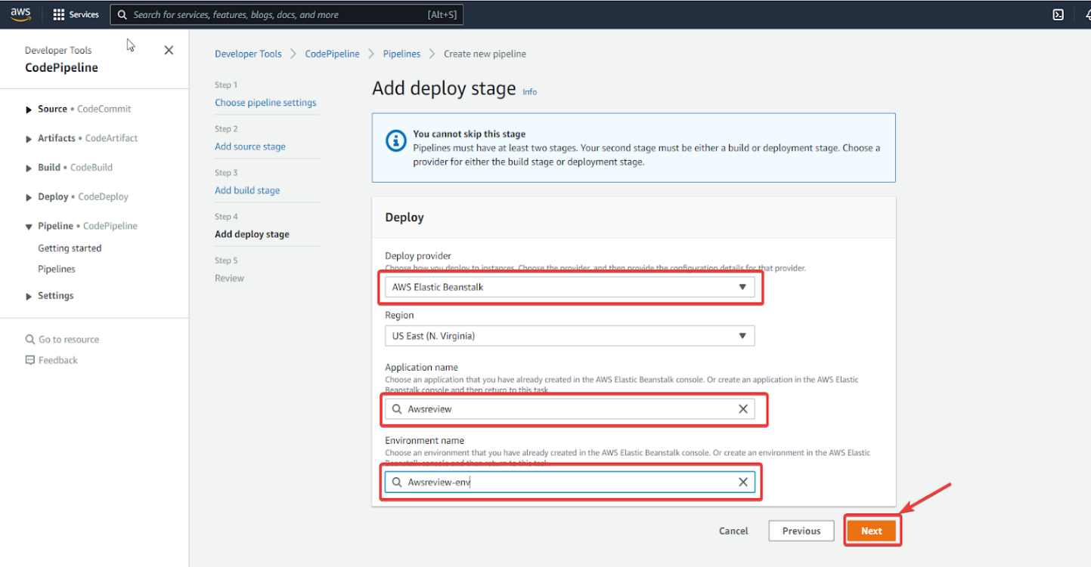

* In the next step, it’ll review it and start deploying your app

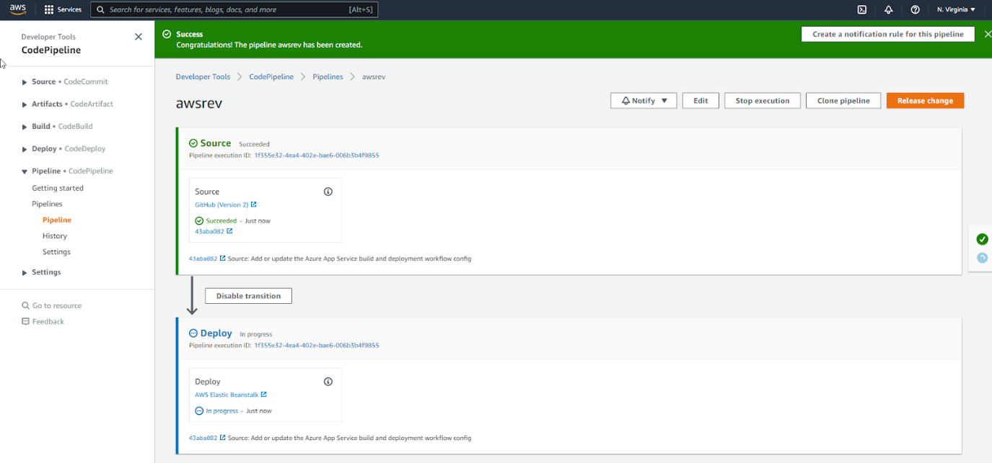

* Now, move to your “Elastic Beanstalk” select your app name and select the link for checking your app is deployed or not

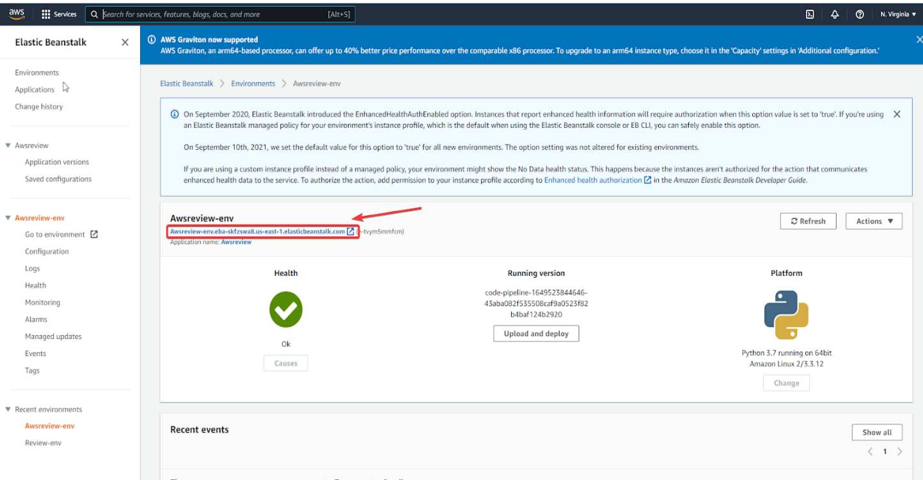

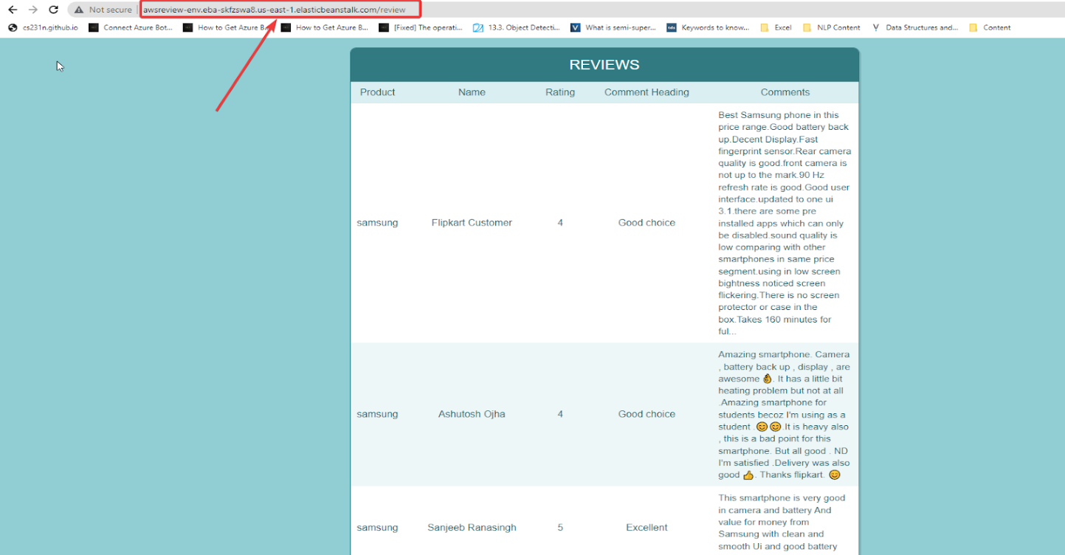

It’s working perfectly fine in here