**Azure**

**Steps:**

* Search for ‘Azure portal’ in google, then select the second link and do ‘sign in’. You’ll get the below interface. We need to select the ‘Create a resource’ option.

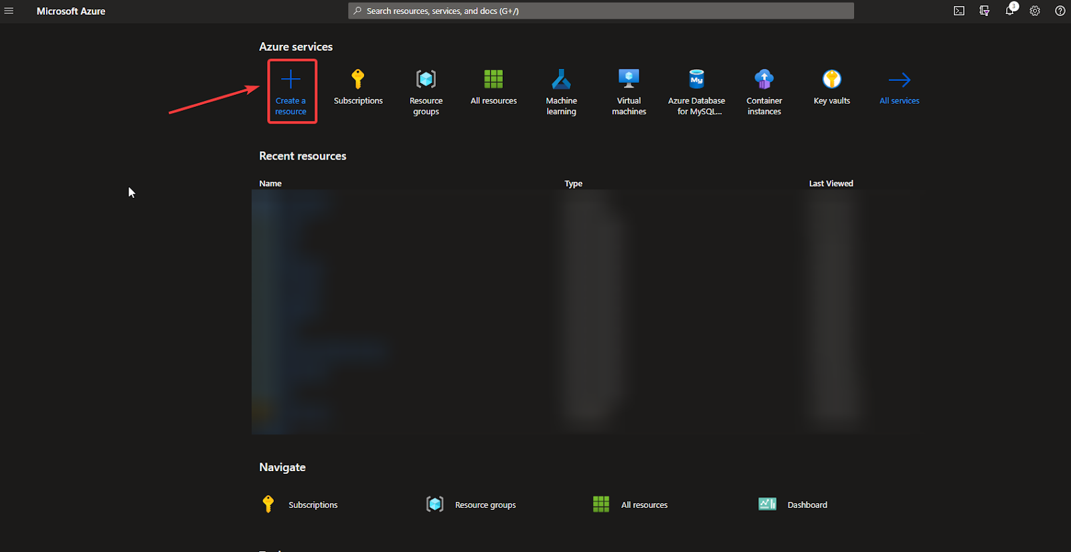

* Now, search for the ‘Web app’ here.

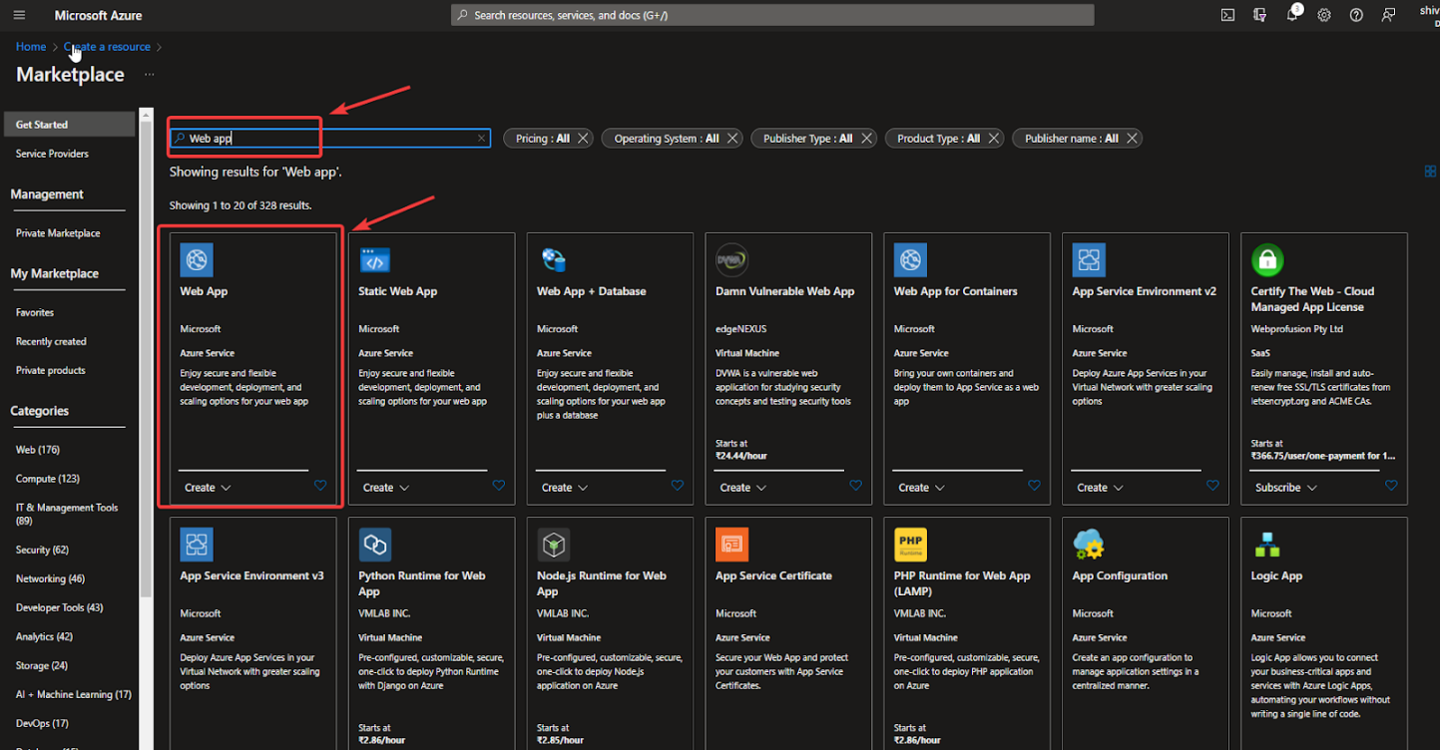

* Next, add the required details here. Then, select ‘Review+create’

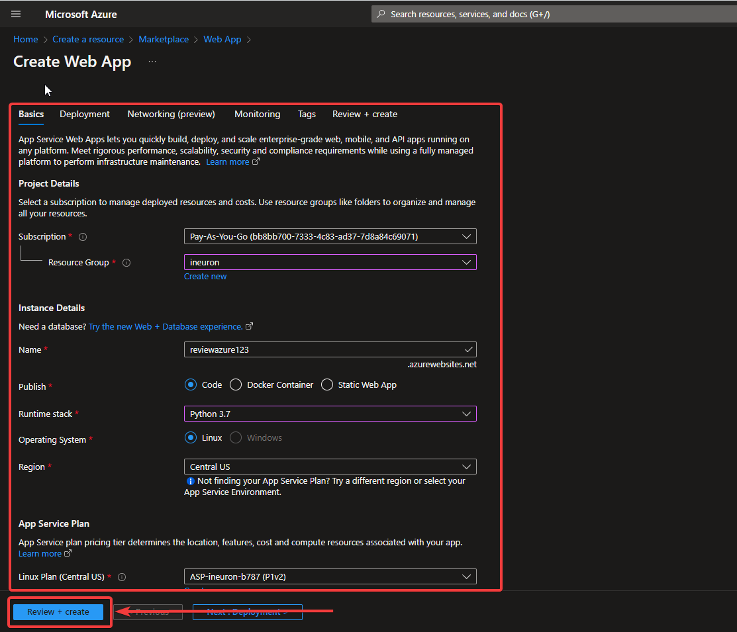

* Then, choose the ‘Create’ option here

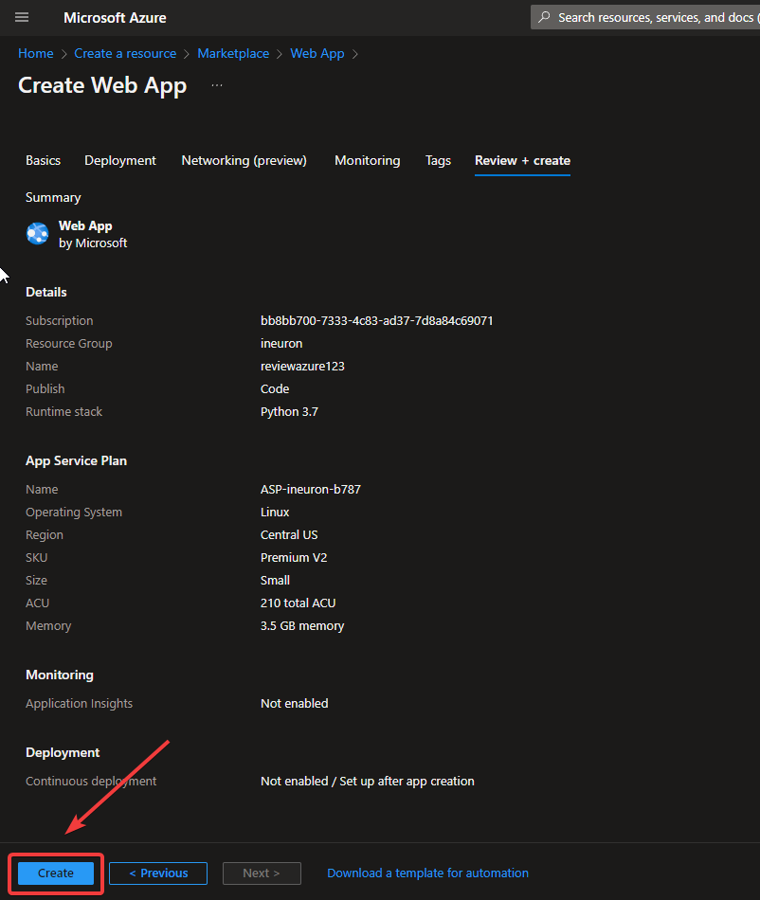

* It’ll start deploying your app. If it is done, it’ll show ‘Go to resource’ option

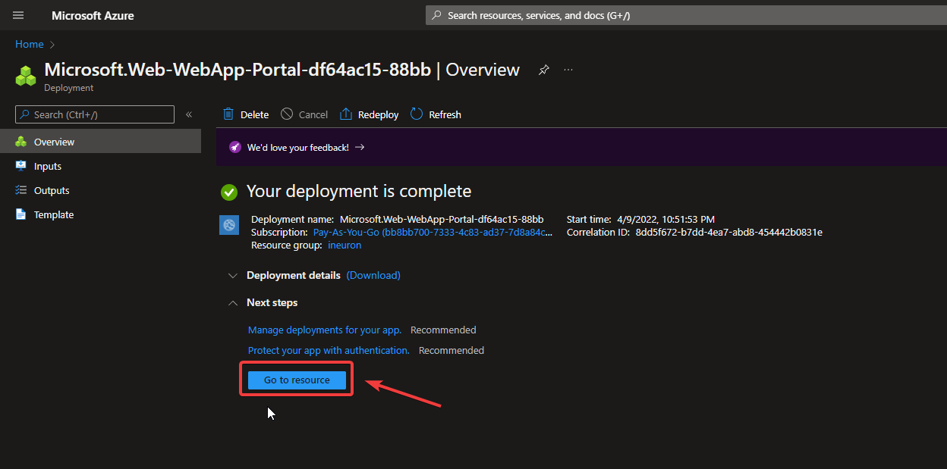

* On the left-hand side, you’ll get the option ‘Deployment Center’.

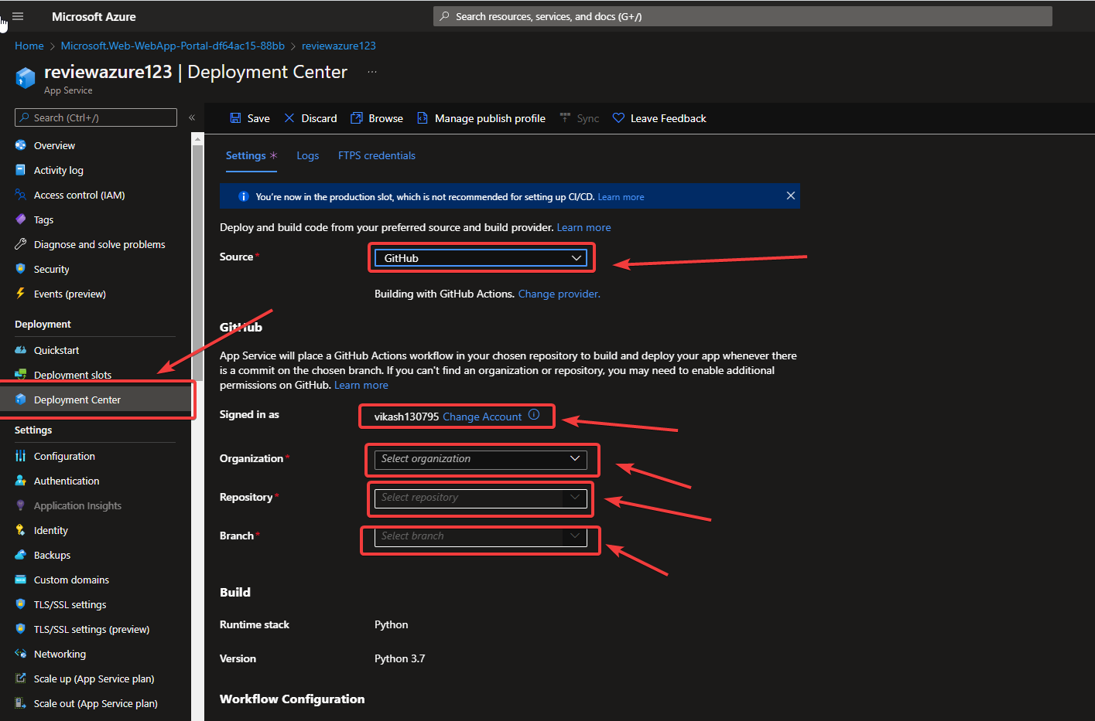

* Select ‘GitHub’ in ‘Source’ option and add your github here. Then select your github repository and ‘Save’ it. It’ll start deploying your app.
* Check-in your ‘Logs’, your app is in progress.

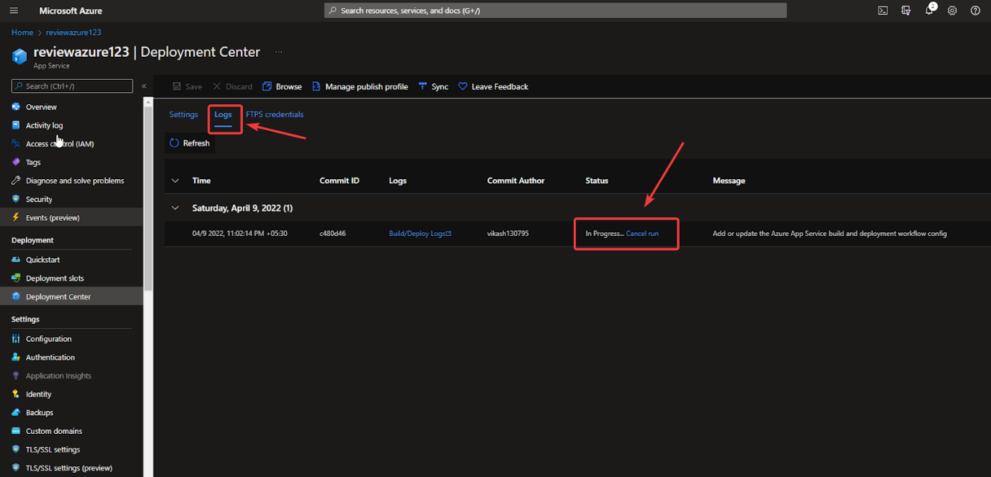

* If deployment is done, you can browse your app through the ‘Browse’ button.

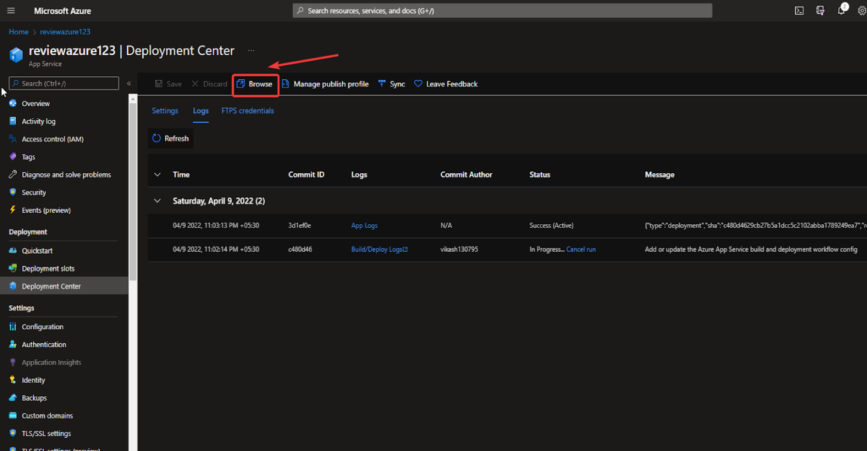

* It was successfully deployed, check the below screenshot.

