**PREDICTING PRODUCT SALES USING MACHINE LEARNING**

|  |  |
| --- | --- |
| **Date** | **26-10-2023** |
| **Team ID** | **8941** |
| **Project Name** | **Product Sales Analysis** |

**Phase 4**: Development Part-2

**Topic:**

In this part you will continue building your project.

* Continue building the analysis by creating visualizations using IBM Cognos and generating actionable insights.
* Use IBM Cognos to design interactive dashboards and reports that display insights such as top-selling products, sales trends, and customer preferences.
* Derive insights from the visualizations, such as identifying products with the highest sales, peak sales periods, and customer preferences for specific products.



**Introduction:**

In this phase 3, building a sales prediction model is a data driven process that Involves harnessing the power of machine learning to analyse historical sales data and make informed product sales predictions. This journey begins with the fundamental steps of data loading and preprocessing. The next step of the phase4 is continue to creating visualizations using IBM cognos and derive insights from the visualizations

**Data Visualization using IBM Cognos:**

IBM® Cognos® Analytics provides dashboards and stories to communicate your insights and analysis. You can assemble a view that contains visualizations such as a graph, chart, plot, table, map, or any other visual representation of data.

**Steps for creating a Dashboard:**

1. Click New icon, and click **Dashboard**, or click **Story**.
2. Select a template. Cognos Analytics provides templates that contain predefined layouts and grid lines for easy arrangement and alignment of the visualizations in a view.
3. Add visualizations to your view in one or more of the following ways:
   * If you know the type of visualization you want to use, select the visualization type and then add columns to it.
   * If you know the data that you want to see, but are not sure about how to present it, click Sources icon and add a source to the Selected sources pane. Then, drag columns onto the canvas. Cognos Analytics displays them in the appropriate visualization.
   * Drag your collected visualizations from the My pins panel to quickly build a story.
4. Limit the data that is displayed by filtering in one or more of the following ways:
   * You can filter individual visualizations or on all visualizations in the view.
   * You can even filter on a column that is not displayed in the visualization by using a context filter.
   * You can select a specific value or a range of values.
5. Enhance your view and draw attention to visualizations by adding media, web pages, images, shapes, and text.
6. Personalize your view by changing the theme. You can choose from default, light, or dark themes. You can also customize specific visualization properties such as fill and border color, and opacity.
7. Create more meaningful or complex visualizations by adding columns to an existing visualization. Drag another column onto a visualization and it changes to match the new data added.
8. You can undo and redo your last actions in succession. The ability to undo and redo previous actions is available until you close the view.
9. Test the view

**#Which is the most occurring month #Which is the most occurring year #Which is the most occurring day**

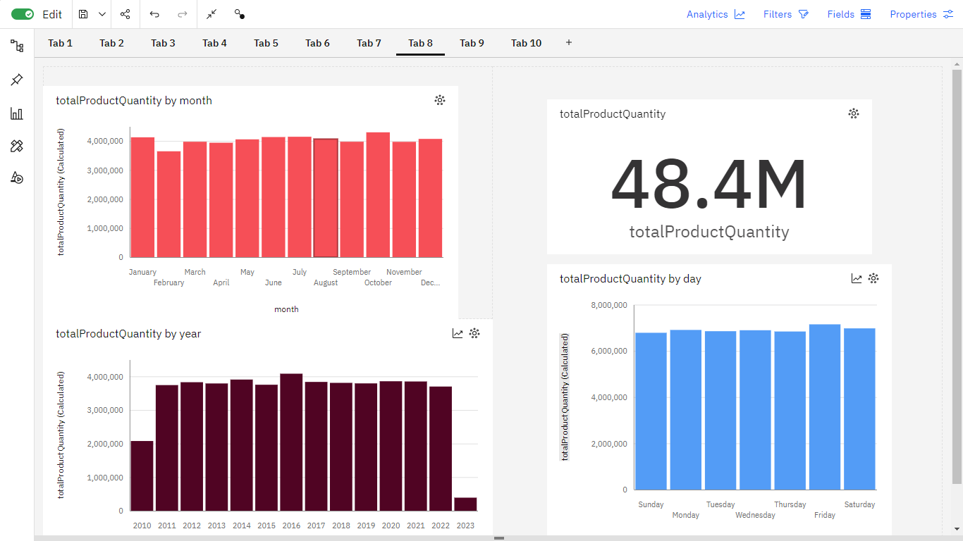

**#Monthly distribution of revenue**

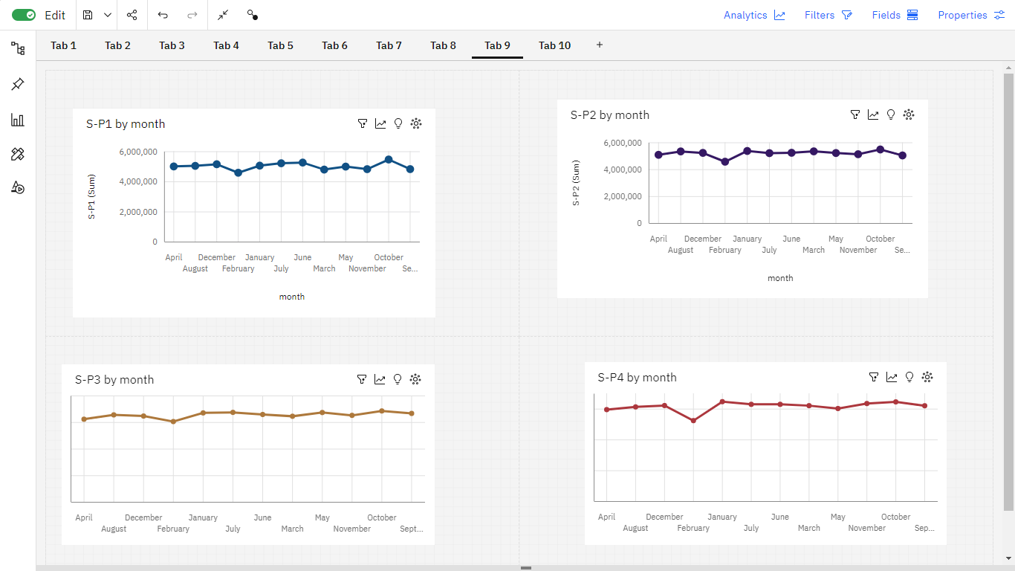

**## In which month revenue was it peak**

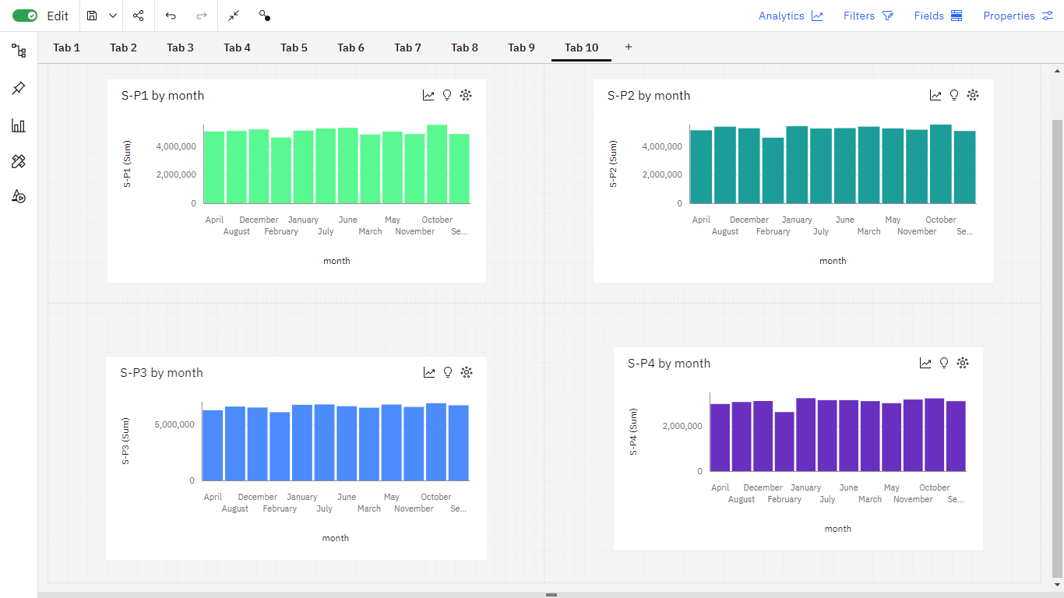

**##In which month unit sales were more in product 1,product2, product 3,product 4**

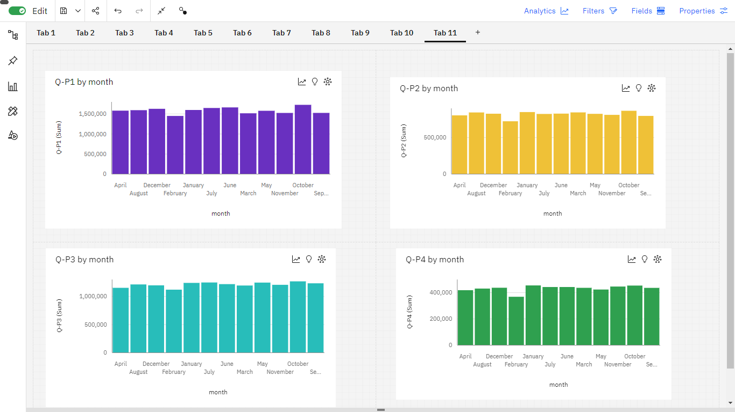

**# In which weekday revenue was it peak**

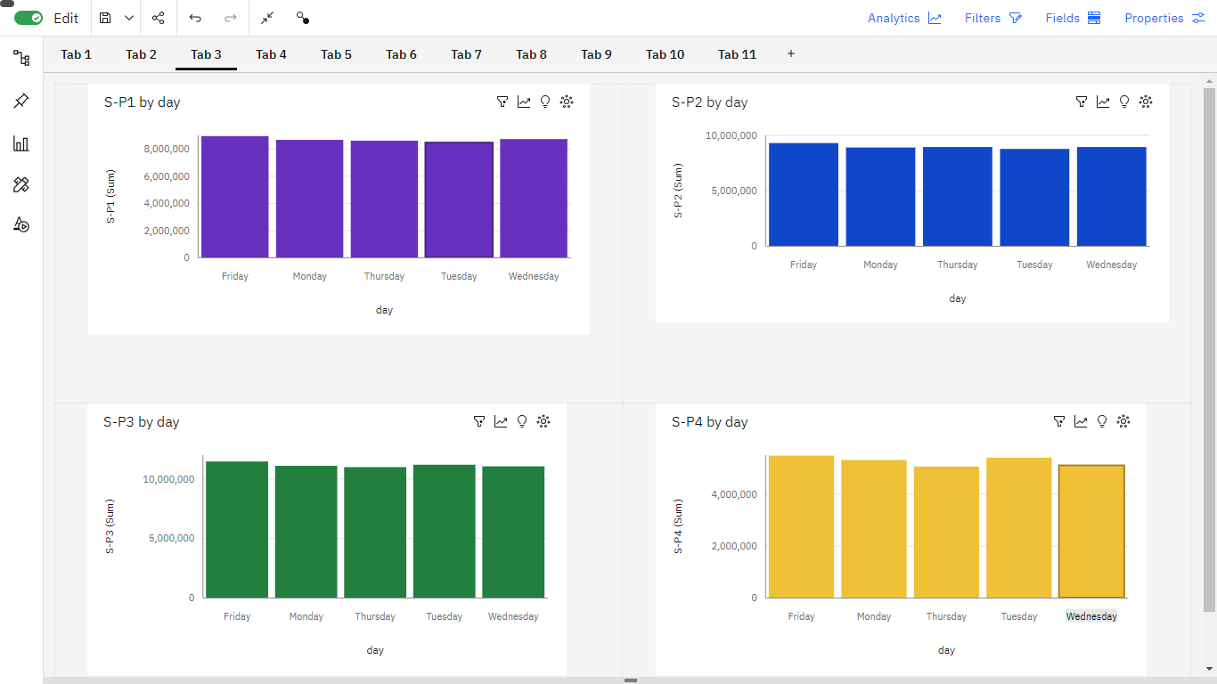

**#In which weekend revenue was it peak**

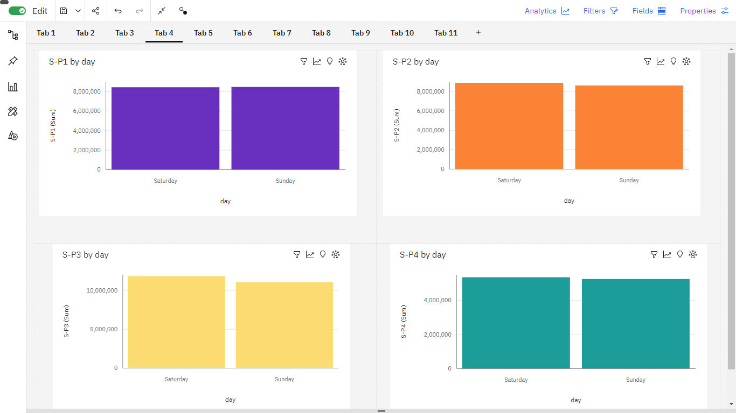

**#In which year revenue was the highest**

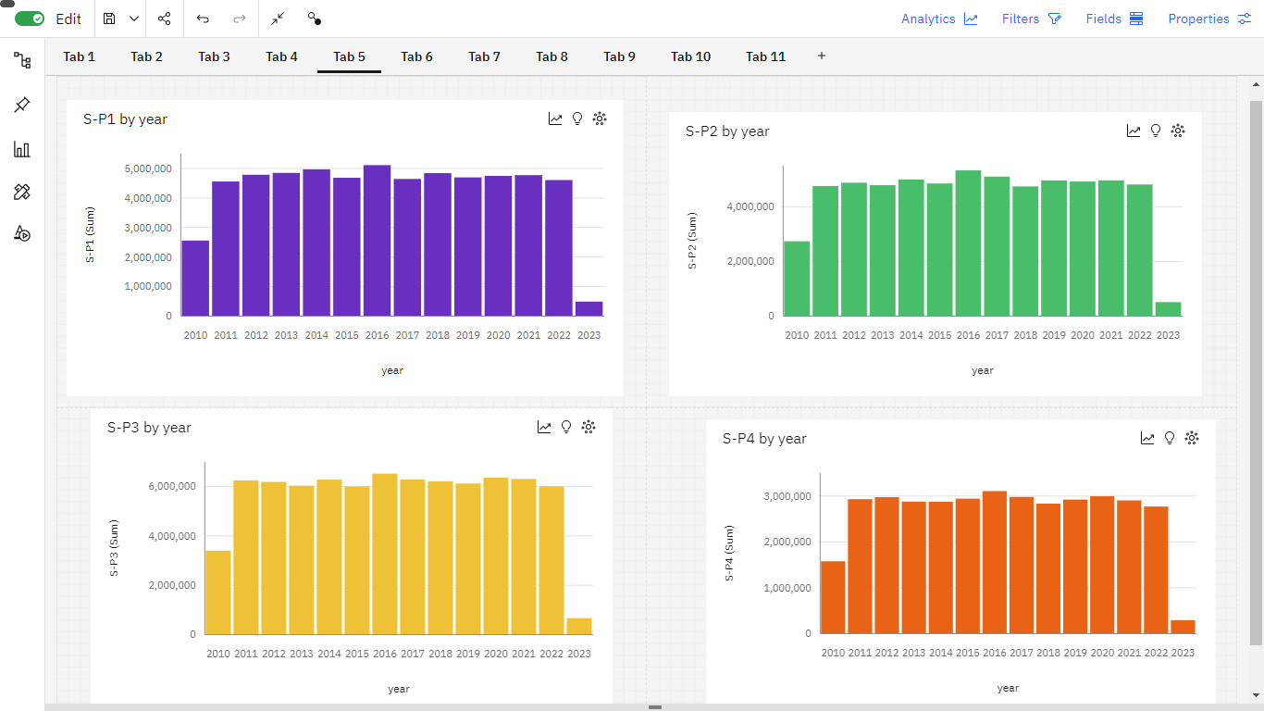

**##What was the avg revenue, maximum and minimum**

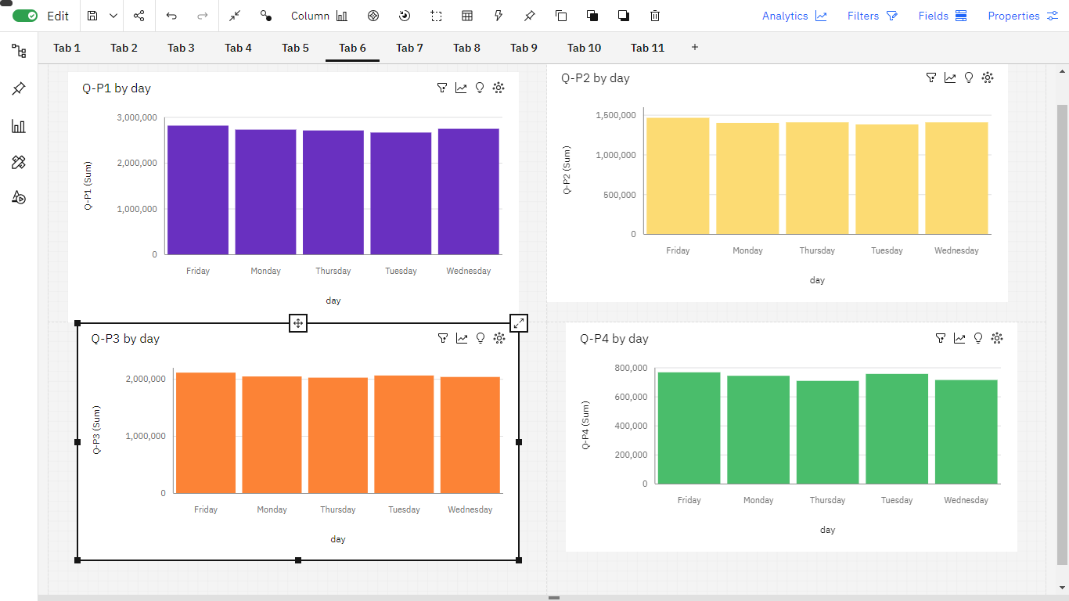

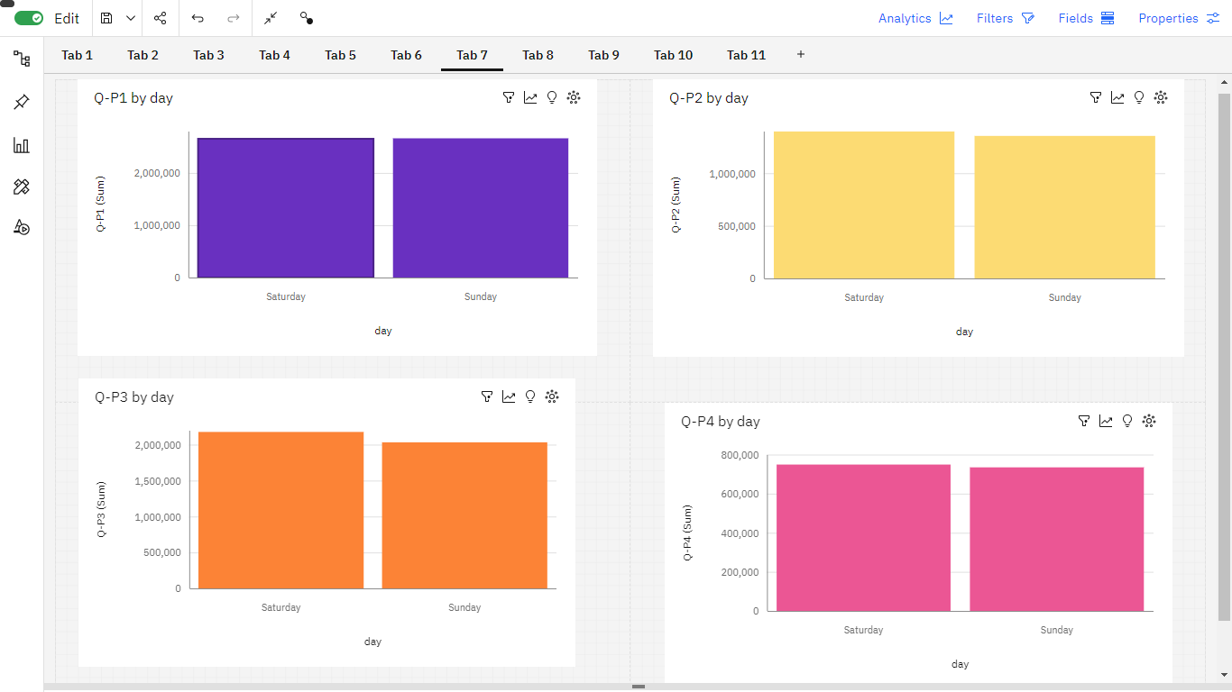

**Insights:**

* Added columns month, day and day of the week and changing the dtype of date from object to datetime64 through feature engineering.
* Drop columns unnamed as it was not providing any usefull information.
* S-P3 has gained the most revenue but the unit sale of Q-P1 is more.
* In 2016 most revenue most revenue generated and on fridays and saturdays most revenue generated.
* On Weekdays and weekend the S-P3 has the highest revenue whereas on weekend and weekday the Q-P1 has more unit sales.
* In month of October unit sale and revenue was at peak.

**Conclusion:**

In this phase we had completed the visualization using IBM Cognos and derived the insights using visualization. Futher process will be execute in phase 5 submission.