Software Requirements Specification
for
< Diabetes Detection System >
Version 1.0 approved
Prepared by <G. Zeba Fathima>
Introduction

  - Purpose: Define requirements and specifications for the development of the Diabetes Detection System.

  - Document Conventions: Consistent terminology and language throughout the document.

  - Intended Audience: Development team members, project stakeholders, software architects and designers, testers.

  - Project Scope: Provide a user-friendly application to measure blood glucose levels and blood pressure and determine the presence of diabetes.

  - Product Overview:

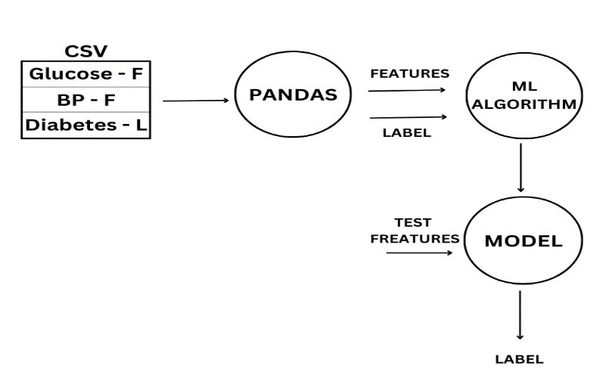

1.5 References: World Health Organization (WHO), Health Insurance Portability and Accountability Act (HIPAA) Privacy Rule, International Organization for Standardization (ISO), American Diabetes Association (ADA).

Overall Description
2.1 Product Perspective: Standalone software application.

2.2 Product Features:
Collecting glucose level and blood pressure data.
Analyzing data to determine likelihood of diabetes.
Displaying results and recommendations.

2.3 User Classes: General Users (basic computer knowledge) and Healthcare Professionals.

2.4 Operating Environment: Compatible with Windows, macOS, and Linux.

2.5 Design and Implementation Constraints: Regulatory compliance, user-friendly design, efficient performance.

2.6 User Documentation: Instructions and guides for software usage, result interpretation, and limitations.

2.7 Assumptions and Dependencies: Reliable data entry, functional user interface, access to data sources.

System Features

3.1 System Feature 1: Glucose Level Detection

REQ-1: Provide an input field for glucose level measurement.
REQ-2: Validate glucose level input.
REQ-3: Perform calculations and analysis on glucose level data.
REQ-4: Generate result indicating likelihood of diabetes.
REQ-5: Display result and recommendations.

3.2 System Feature 2: Blood Pressure Measurement
REQ-1: Provide an input field for blood pressure measurement.
REQ-2: Validate blood pressure input.
REQ-3: Incorporate blood pressure data into diabetes detection analysis.
REQ-4: Update result and recommendations based on blood pressure data.
REQ-5: Display updated result and recommendations.

External Interface Requirements

4.1 User Interfaces: Graphical User Interface (GUI) with input fields, result display, and recommendations.

4.2 Hardware Interfaces: Support for input devices (keyboard, mouse) and display devices (monitor, screen).

4.3 Software Interfaces: Compatibility with common operating systems and database for data storage.

4.4 Communications Interfaces: No specific communication requirements.

Other Nonfunctional Requirements

5.1 Performance Requirements: Fast and responsive system with quick result generation.

5.2 Safety Requirements: Accurate information, compliance with safety regulations.

5.3 Security Requirements: Protect user data, authorized access only, compliance with security standards.

5.4 Software Quality Attributes: Usability, reliability, maintainability, portability, testability, performance, robustness.

Other Requirements

Database: Store user data (glucose levels, blood pressure measurements).
Multiple Languages: Support for different languages.
Legal Compliance: Follow healthcare and data privacy regulations.
Flexibility for Future Integration: Easy integration with other healthcare systems, accommodate feature additions.
Accessibility: Support for users with disabilities.

