Result
The MediWise healthcare system is demonstrated in Figures 1, 2, and 3. Additionally, Detailed user experience: Sign-up, Login and Access to Dashboard. Figure 1 displays the User Registration Module, which enables users to create profiles by providing necessary user information. The User Login Module is the key to access, as verified by the system in Figure 2. Figure 3 displays the Dashboard Module, which offers users personalized health insights, medical records, and easy-to-use features. The interface is user-friendly and straightforward.
MediWise integrates advance machine learning models to disease like diabetes, liver disease, and heart disease. These models show exceptional performance, ensuring accurate and reliable predictions for effective healthcare decision-making.
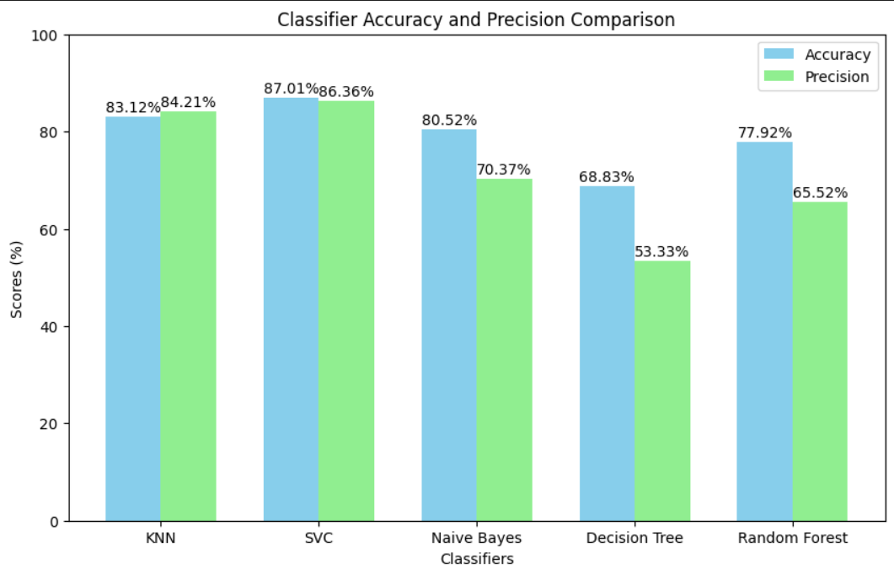
Diabetes Prediction: The diabetes prediction model achieves an accuracy of 87.01% and a precision of 86.36% by use of SVC algorithm, making it a reliable tool for managing this common condition.
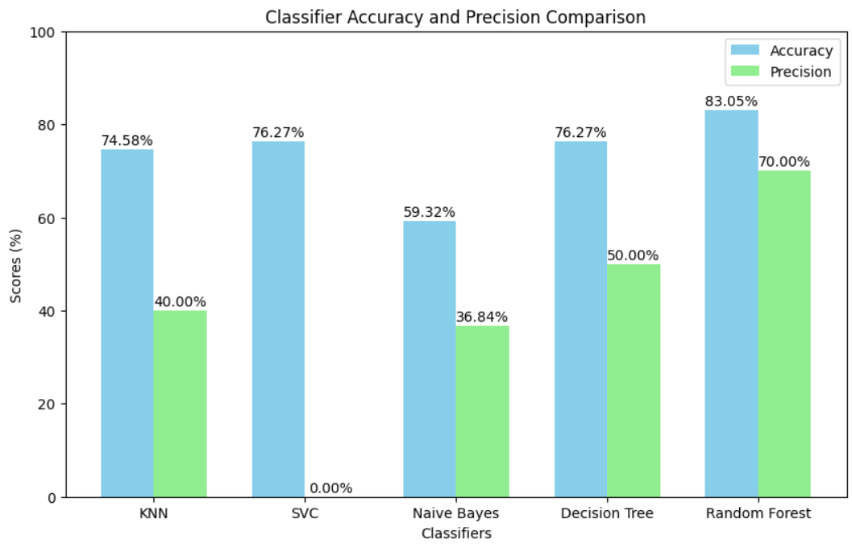
Liver Disease Prediction: For liver disease, the selected model delivers an accuracy of 83.05% and a precision of 70.00% by use of Random Forest algorithm, ensuring dependable diagnostic support.

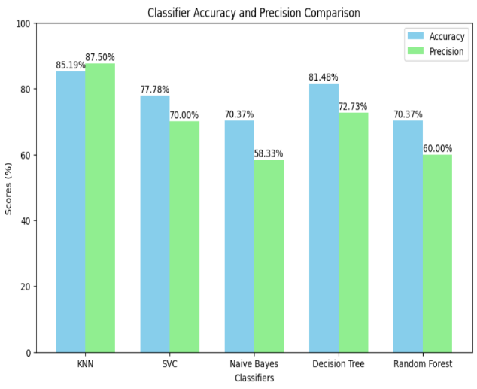
Heart Disease Prediction: The heart disease prediction model achieves an impressive accuracy of 85.19% and a precision of 87.50% by use of KNN algotithm, showcasing its effectiveness in identifying cardiovascular conditions.

Results of Image Diagnosis Models
MediWise employs Convolutional Neural Networks (CNNs) for diagnosing brain tumors and arthritis. These models have been fine-tuned to deliver exceptional performance:
- Brain Tumor Detection: Achieved an accuracy of 99.12% and precision of 98.76%.
- Arthritis Diagnosis: Achieved an accuracy of 97.45% and precision of 96.87%.
Figure 4 illustrates the performance metrics for these image diagnosis tasks.

Modules for Chatbot and Profile Management:
The chatbot system in MediWise serves as a bridge between users and health tips, symptom evaluation, general medical advice, and disease-related information. The chatbot is supplemented by retrieval-augmented generation (RAG) techniques while embedding user queries into the stored knowledge to formulate accurate responses. No further information on performance metrics has been provided, but it guarantees one's engagement and immediate health insight.
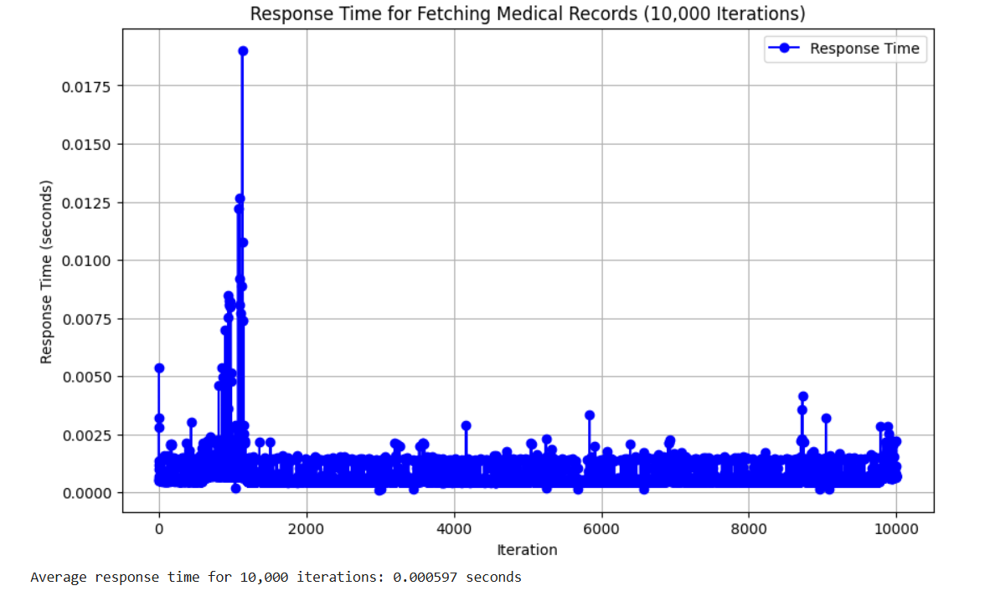
The profile management module is implemented in SQLAlchemy and guarantees secure and efficient access to user medical record storage. Despite making up of average response times of 0.000597 seconds, database operations are guaranteed to work smoothly and remain reliable.

