

A JAVA
Project Report
on
Identity and Access Management System
[IAM Project]

Submitted by
Subhash Ravindra SRIVATSA
(srivat_s)

Contents
1.Subject Description 3
[1.1]Introduction 3
[1.1.1]Overview: 3
[1.1.3]Motivation: 3
[1.1.4] Objective 3
[1.1.5] Development Environment 4
2.Subject analysis 5
[2.1] Major Features 5
[2.2] Application Feasibility 5
[2.3] Data Description 5
[2.4] Expected Results 6
[2.5] Scope and limitations 7
3.Conception 8
[3.1] Chosen Algorithm 8
[3.2] Data Structures 8
[3.3] Global Application Flow 9
[3.4] Detailed Application Flow 10
4.Console operation Description 11
5.Configuration 12
6.Screenshots 13
Bibliography 18

1.SUBJECT DESCRIPTION

[1.1]Introduction

[1.1.1]Overview:
This report contains all the detail from start to end of IAM project development.
[1.1.2] Background:
Keeping track of personal information disclosed on the Internet, as well as maintaining high standards of internal control and information security within companies has become increasingly complicated. Identity and Access Management applications lay at the core of resolving these types of problems.
Identity and Access Management (IAM) can be defined as following:
A comprehensive set of processes that enable end users to securely access a broad range of
internal and external IT systems that controls the digital representation of users and manage
information about identities.

[1.1.3] Motivation:

This report and its subject, namely IAM, has been greatly influenced by our will to learn the concepts of a new programming tool JAVA.
What we encountered is that
- Java is Easy to write and more readable and eye catching.
- Most of the concepts are drew from C++ thus making Java learning simpler.

[1.1.4] Objective

The main goal of this project is to develop an application using Java which can automatically connect to a database and store information in the database and also to retrieve, modify and delete the information in the database.
The following are the objectives that the application needs to satisfy:
- Authenticates a user
- Modify an Identity
- Delete an Identity
- List all identities

[1.1.5] Development Environment

PLATFORM USED : Windows 7
LANGUAGE USED : Core Java
IDE : Eclipse
DATABASE : SQLite

2.SUBJECT ANALYSIS

[2.1] Major Features
- Highly user-friendly
- Platform Independent
- Easy to use
- Robust
- Data entry restricted to avoid errors
- Clean separation of various components
- Easy Modification

[2.2] Application Feasibility
- This current application is a prototype of a system that can be created for employing a highly secured environment of Identity and access Management.
- The costs are much reduced as we do not depend on graphical interface, instead look for a high system performance
- Most of the components used such as the development platform, servers, and databases are open source.

[2.3] Data Description
The data description and data access objects are clearly specified below.
The Schema for data is <IDENTITY_UID, IDENTITY_DISPLAYNAME, IDENTITY_EMAIL>
IDENTITY_UID : STRING, Unique
IDENTITY_DISPLAYNAME : STRING
IDENTITY_EMAIL : STRING

DAOs
- Authenticate : This module takes user name and password. This module validates a user before login to IAM system
Input parameter : User name, password
Output parameters : Authentication Accepted / Denied

- createIdentity : This process is used to create a new identity in the database.
Input parameter : Uid , Name, Email
Output parameters : Entry added to database

- modifyIdentity : This process is used to change any record already present in the database and updates the database accordingly.
Input parameter : Uid,Name,Email
Output parameters : Identity modified in the database with reference to Uid.

- deleteIdentity : This process is used to delete an identity from the database.
Input parameter : Uid
Output parameters : Identity deleted from the database.

- listIdentity : This process is used to display all identity from the database.
Output parameters : Identity display from the database.

[2.4] Expected Results
- The end result of the application can be looked as a highly sophisticated, user friendly and secure tool created for Identity and access management.
- This tool is capable of authenticating the user, creating a new identity, display all identity, modifying an existing identity, and deleting an identity from the database.
- The database used is a SQLite database.
- The tool needs to communicate with the database and return with the results in quick time.

[2.5] Scope and limitations
Scope:
- Privacy: Online transaction, whether financial or exchange of information, could be greatly improved by the adoption of IDM solutions which focus on privacy.
- Improved user experience, Cost savings, security policy enforcement etc.
- Centralization of user administration.
Limitations:
- Possibility of decrypting the system password.
- Does not open the system to manage permissions and attributes of users.
- Lack of added feature like in modern address book.
Evolution:
- We are working to inhance the IAM as a complete web-based software, users and login and keep details, export details, import to new system, by incorporating an attractive GUI and also send SMS from there and save other information.

3.CONCEPTION

[3.1] Chosen Algorithm
The algorithm that we have used is the exact match algorithm. It can be seen below.
Searching is done with the uid and updated

[3.2] Data Structures
The data structures provided by the Java utility package are very powerful and perform a wide range of functions. These data structures consist of the following interface and classes:
However the data structure used in this project is LIST ,which is a collection of elements .List is used in the project to store the collection of identities.
String is also a widely used data structure in this project

[3.3] Global Application Flow

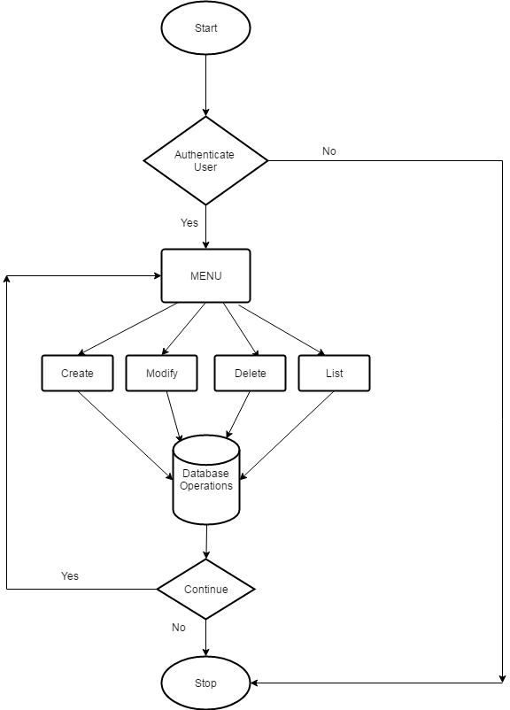

[3.4] Global Schema and major schema features

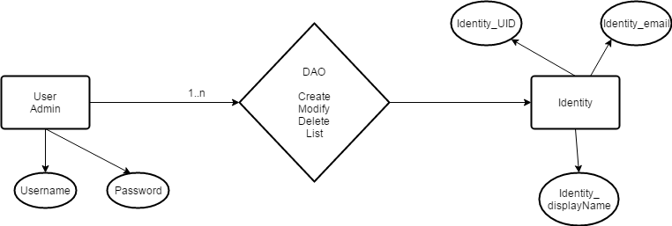

4.CONSOLE OPERATIONS DESCRIPTIONS

Console Operations Implemented in this Systems are
- Authenticate user
- Create an Identity
- Update an existing Identity
- Delete an Identity
- Display all dentities
Each Operations are explained below

Authenicate User

User authentication is done by an authenticate method , that takes input as username and password, and calls a validateUser method which connects to the database and authenticates the user if provided credentials are correct, else will not authenticate the user and system stops.

Create an Identity

This console operations allows an authenticated user to create a new identity. Identity Uid, name and email are provided by the user.The method used for creating a new identity is createIdentity.

Update an Identity

This console operation allows a user to update an existing identity. To update an identity the user must provide the uid of an identity, which is to be updated. The method used is updateIdentity

Delete an Identity
This console operation allows a user to delete an existing identity and the user is supposed toprovide the uid of the identity which is to be deleted. Method used is deleteIdentity

- Display all Identities
This console operation retrieves all the identities stored in the database and output them to the user. Method used is listIdentity.

5.CONFIGURATION

- Username : subhash(Case sensitive)
- Password : subhash(Case Sensitive)
- Database : SQLite
- Drivers : SQLite JDBC Driver

6.SCREENSHOTS
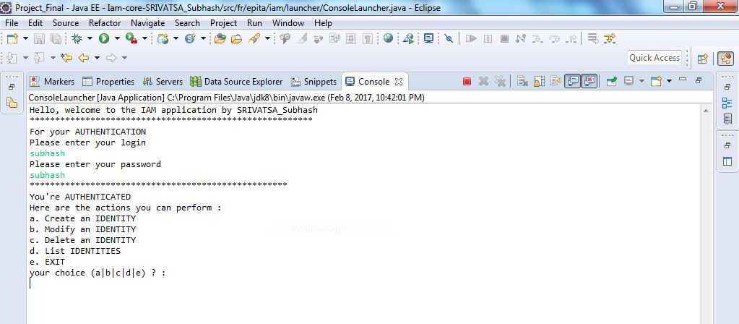
Fig 6.1: User Authentication
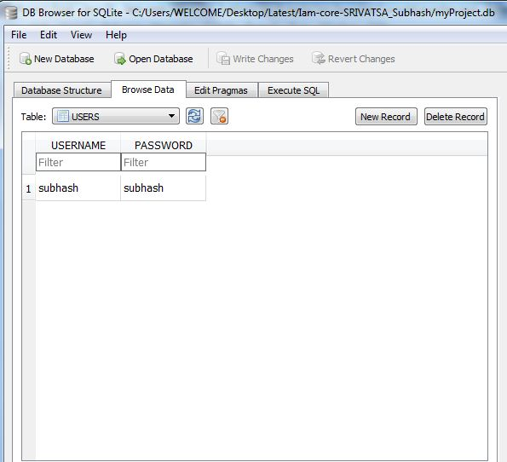
Fig 6.2: User Authentication at SQLite Database view.
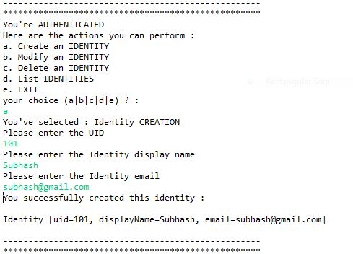
Fig 6.3: Creating an Identity with valid credentials.
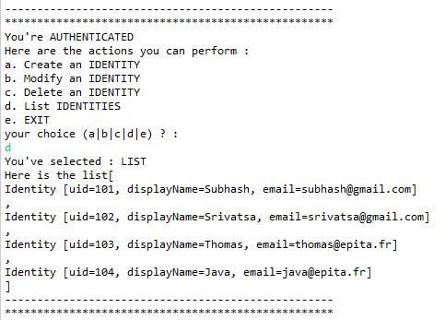
Fig 6.4: Creating 4 Identities with valid credentials.
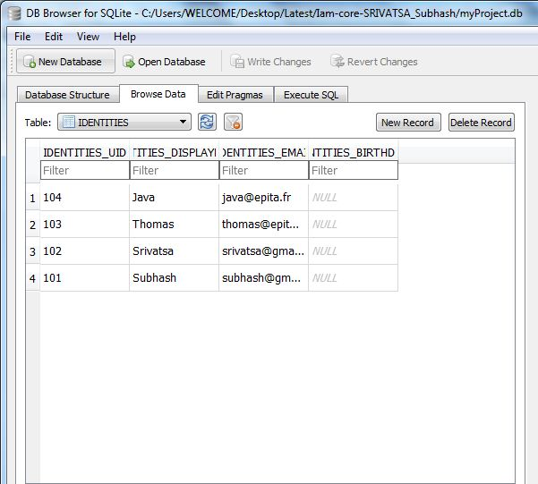
Fig 6.5 Identities created at SQLite Database.
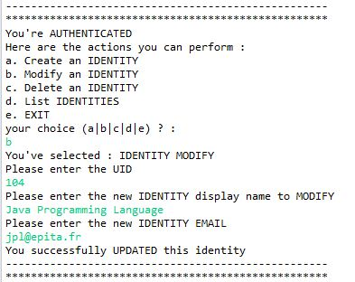
Fig 6.6: Modification of an Identity.
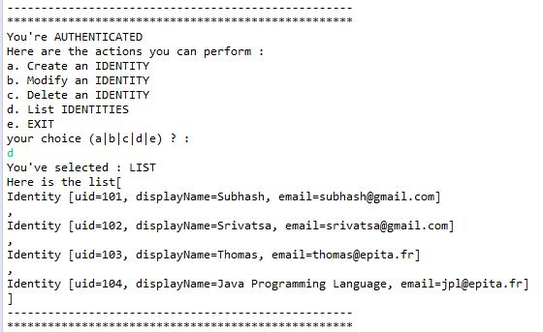
Fig 6.7: Modification of last two Identities
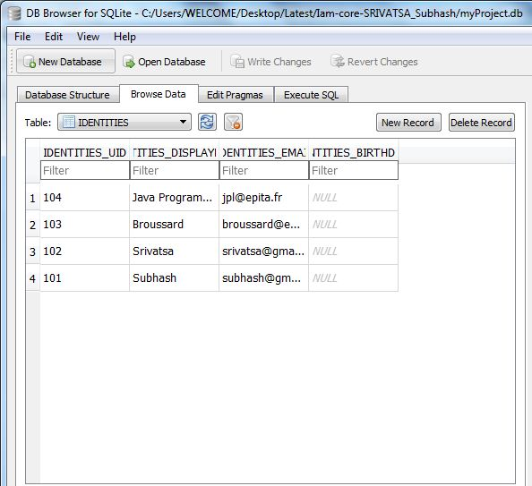
Fig 6.8: Modification of the Identities at SQLite Database
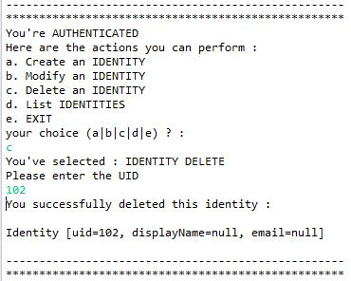
Fig 6.9: Deletion of Identities
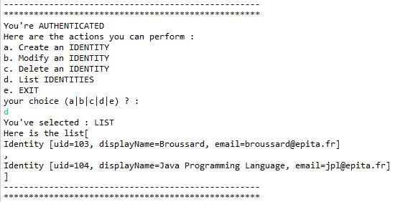
Fig 6.10: List of Identities after deletion.
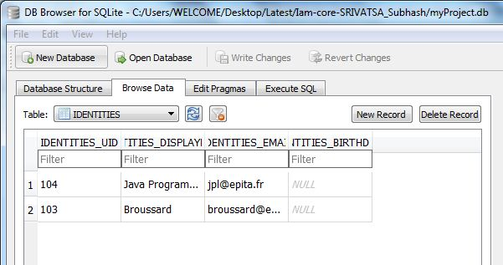
Fig 6.11: List of Identities after deletion at SQLite Database view.
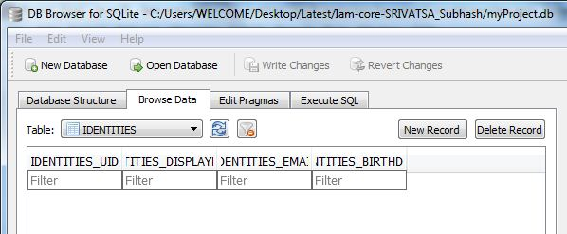
Fig 6.12: List after deletion of all the Identities at SQLite Database view.
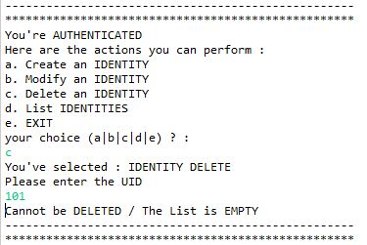
Fig 6.13: Trying to Delete a non existing Identity.

BIBLIOGRAPHY

- http://thomas-broussard.fr/
- http://www.tutorialspoint.com/java/java_data_structures.htm
- http://www.javabeginner.com/java-swing/java-swing-address-book
- http://www.tutorialspoint.com/

