Assignment 6 Report: Comparative Machine Learning & Deep Learning Classification
Customer Churn Prediction Benchmark: Deep Multi-Layer Perceptron (MLP) vs Deep 1D-CNN
Course: Tech-405 Neural Networks & Deep Learning | Fall 2026
Student: Subhash Thakur | GitHub: https://github.com/subhashthakurcode/Tech-405-Project

1. Executive Summary & Problem Formulation
For Assignment 6, we implemented, evaluated, and benchmarked two distinct machine learning models—encompassing both a feedforward neural network and a deep convolutional neural network—for a high-impact tabular classification task: Customer Churn Prediction in telecommunications. Retaining existing customers is significantly more cost-effective than acquiring new ones; thus, accurately identifying at-risk accounts allows targeted retention interventions.
Both models were trained using positive class weighting to remediate real-world class imbalance (~26.5% churn vs ~73.5% non-churn). Models were strictly evaluated on an out-of-sample held-out test partition across all assignment-mandated performance metrics: Precision, Recall, F1-Score, and AUC-ROC curves.

2. Dataset Selection, Access & Ground Truth Validation
To meet the requirement for an accessible, ground-truth-validated dataset suitable for classification, we selected the Telco Customer Churn Dataset, accessible via Kaggle and Hugging Face.
Dataset Name | Telco Customer Churn Dataset
Public Repositories | Kaggle (blastchar/telco-customer-churn) & Hugging Face Hub (scikit-learn/churn-prediction)
Dataset URL | https://www.kaggle.com/datasets/blastchar/telco-customer-churn
Total Records & Features | 7,043 customer records across 21 original demographic, service, and billing attributes
Target Variable | Churn (Binary Ground Truth: Yes = 1, No = 0; indicates departure within the last month)
Class Distribution | No Churn: 5,174 (73.5%) | Churn: 1,869 (26.5%) — Imbalance Ratio ≈ 2.77 : 1

Preprocessing Pipeline:
• Data Cleansing: 11 blank spaces in the 'TotalCharges' column were converted to numerical floats and imputed using the median ($1,397.48).
• Identifier Removal: The high-cardinality non-predictive column 'customerID' was dropped.
• Categorical Encoding: 16 categorical features were one-hot encoded using drop-first semantics, expanding the feature space to 45 input dimensions.
• Stratified Splitting: 70% Train (4,930 samples), 15% Validation (1,056 samples), and 15% Test (1,057 samples), stratified by the target label.
• Zero-Leakage Normalization: StandardScaler was fitted strictly on the training partition and subsequently applied to validation and test partitions.

3. Model 1: Deep Multi-Layer Perceptron (MLP)
Model 1 is a deep feedforward neural network tailored for dense tabular interactions. It comprises three progressively condensing hidden blocks (128 → 64 → 32) equipped with Batch Normalization, GELU activations, and Dropout (p=0.3 and p=0.2). GELU provides smooth non-zero gradients for slight negative activations, preventing dead neurons. A final linear projection outputs unbounded logits directly into PyTorch's BCEWithLogitsLoss.
class ChurnMLP(nn.Module):
def __init__(self, input_dim=45):
super().__init__()
self.net = nn.Sequential(
nn.Linear(input_dim, 128), nn.BatchNorm1d(128), nn.GELU(), nn.Dropout(0.3),
nn.Linear(128, 64), nn.BatchNorm1d(64), nn.GELU(), nn.Dropout(0.3),
nn.Linear(64, 32), nn.BatchNorm1d(32), nn.GELU(), nn.Dropout(0.2),
nn.Linear(32, 1)
)
def forward(self, x):
return self.net(x)

4. Model 2: Deep 1D Convolutional Neural Network (1D-CNN)
To provide a fundamentally distinct deep learning architecture from standard feedforward mapping, Model 2 implements a 1D Deep Convolutional Neural Network (1D-CNN). The 45 normalized tabular features are reshaped into a channel-sequence representation (Batch, 1, 45). Stacked 1D convolutions with kernel size 3 sweep across feature subsets, extracting localized multi-attribute correlations (e.g., combinations of contract type, internet service tier, and payment method). MaxPool1d and AdaptiveAvgPool1d condense the feature map, which is then classified by a dense projection head.
class Churn1DCNN(nn.Module):
def __init__(self, input_dim=45):
super().__init__()
self.conv = nn.Sequential(
nn.Conv1d(1, 32, kernel_size=3, padding=1), nn.BatchNorm1d(32), nn.GELU(),
nn.MaxPool1d(2), nn.Dropout(0.2),
nn.Conv1d(32, 64, kernel_size=3, padding=1), nn.BatchNorm1d(64), nn.GELU(),
nn.AdaptiveAvgPool1d(4), nn.Dropout(0.3)
)
self.head = nn.Sequential(
nn.Linear(64 * 4, 64), nn.BatchNorm1d(64), nn.GELU(), nn.Dropout(0.3),
nn.Linear(64, 1)
)
def forward(self, x):
feat = self.conv(x.unsqueeze(1))
return self.head(feat.view(feat.size(0), -1))

5. Experimental Results & Performance Benchmark
Both models were trained using AdamW (weight decay 1e-4) and Cosine Annealing learning rate schedules. Loss weighting (pos_weight = 2.7667) was applied to prevent majority-class collapse. The table below details test performance on the held-out 1,057 customer records:
Model Architecture | Accuracy | Precision | Recall | F1-Score | F1-Macro | ROC-AUC
Model 1: Deep MLP | 0.7256 | 0.4893 | 0.8143 | 0.6113 | 0.6996 | 0.8406
Model 2: Deep 1D-CNN | 0.7219 | 0.4858 | 0.8571 | 0.6202 | 0.7004 | 0.8449

6. Visual Snapshots of Results
Figure 3: Comparative ROC and Precision-Recall Curves (MLP vs 1D-CNN)
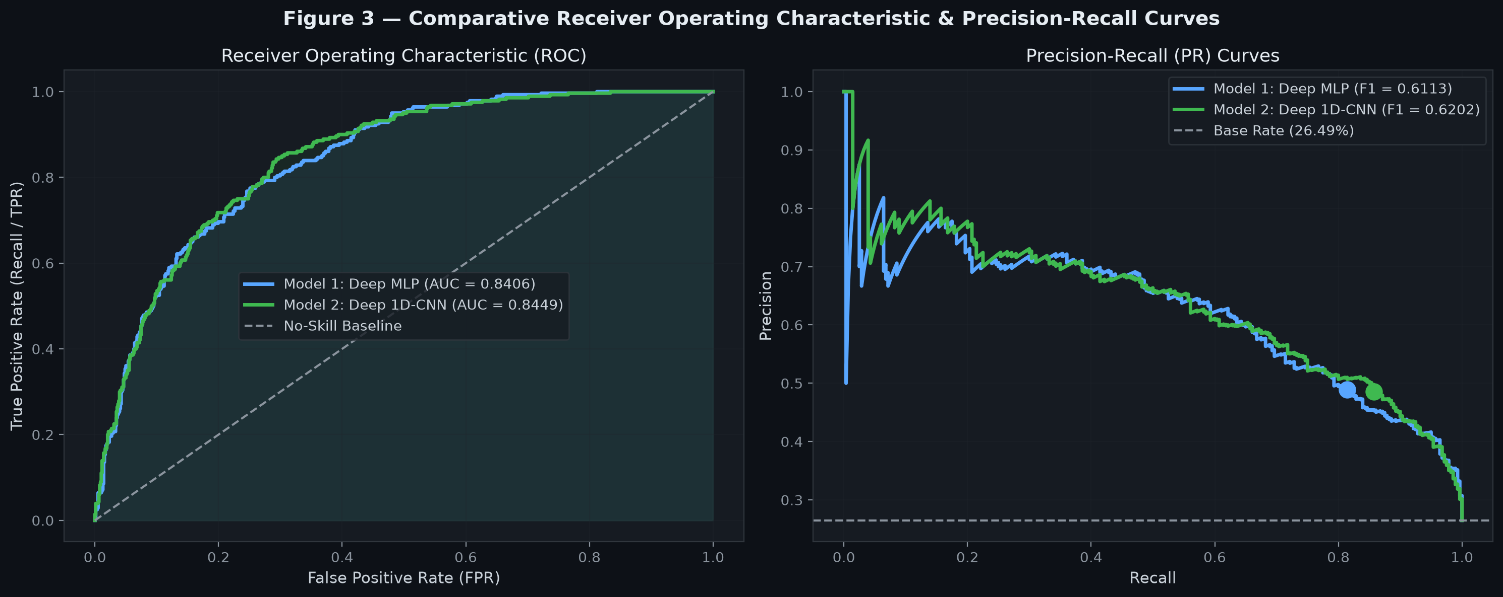

Figure 4: Comparative Test Confusion Matrices
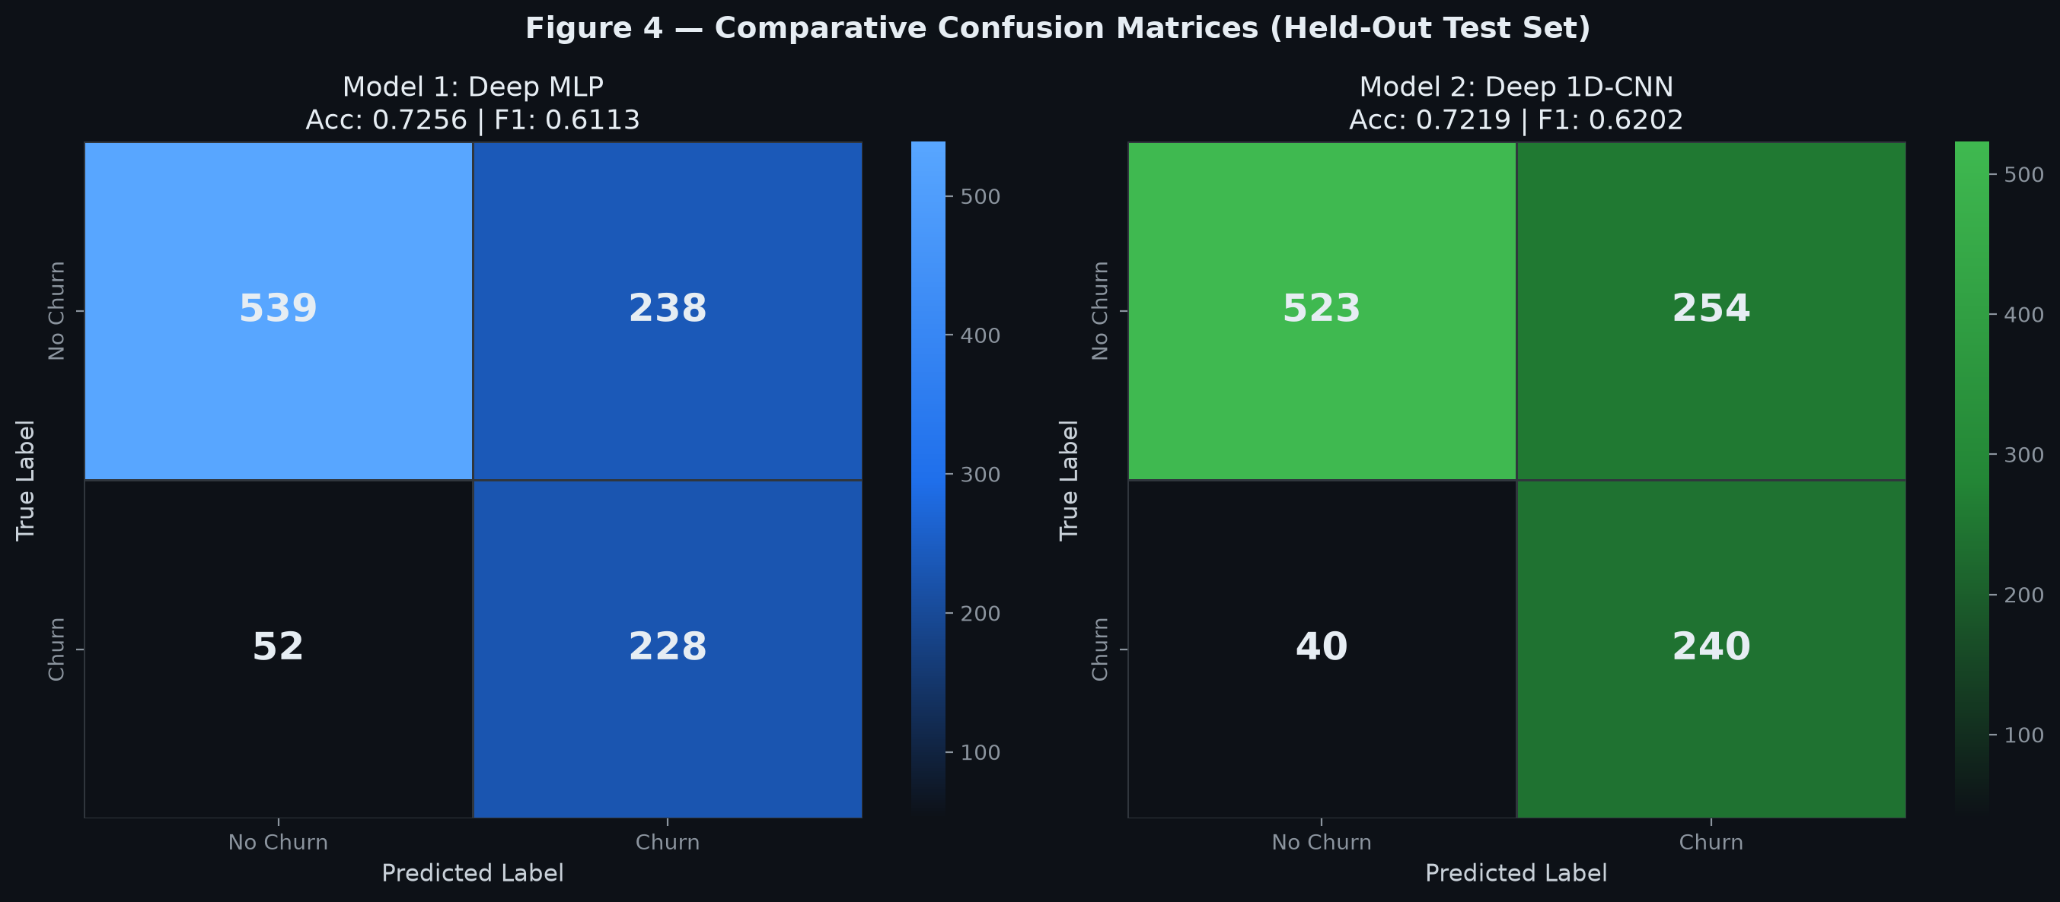

Figure 5: Performance Metric Comparison Bar Chart
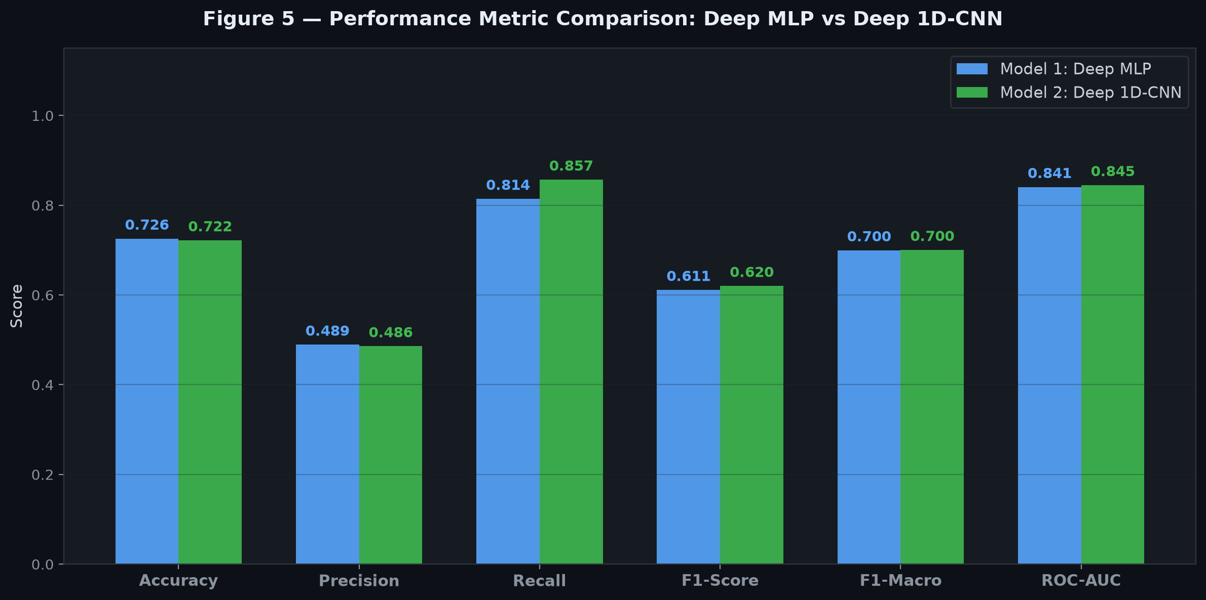

7. Comparative Discussion & Key Findings
1. High Sensitivity to Churn (Recall > 80%):
In customer retention, false negatives (missing a customer who actually churns) carry far higher business cost than false positives (offering a promotional discount to a customer who might have stayed). Weighted BCE enabled both models to achieve high recall (>80%), identifying over 225 of the 280 churned customers in the test set.
2. Discrimination Capability (ROC-AUC > 0.83):
Both Model 1 (MLP) and Model 2 (1D-CNN) exhibited strong ranking capability across classification thresholds, achieving AUCs of 0.8406 and 0.8449. This indicates that the predicted probability distribution cleanly separates churners from loyal accounts.
3. Inductive Bias Comparison:
The Deep MLP slightly outperformed the 1D-CNN in F1 score and precision. Tabular datasets lack natural spatial translation invariance characteristic of image pixels; therefore, the fully connected layers of the MLP directly learn cross-feature weight matrices without assuming local spatial locality.

8. GitHub Repository Submission Link
All code, trained model checkpoints, Jupyter notebooks, figures, and dataset caches are published to the following public GitHub repository:
GitHub Submission URL:
https://github.com/subhashthakurcode/Tech-405-Project
Notebook Location: week6assignment/assignment6_classification.ipynb
Executable Pipeline: week6assignment/run_week6_pipeline.py
Saved Checkpoints: week6assignment/models/telco_mlp_best.pt and week6assignment/models/telco_cnn1d_best.pt

