**Get Request:** [**http://127.0.0.1:8800/api/comodities/reports/cmdty-1**](http://127.0.0.1:8800/api/comodities/reports/cmdty-1)

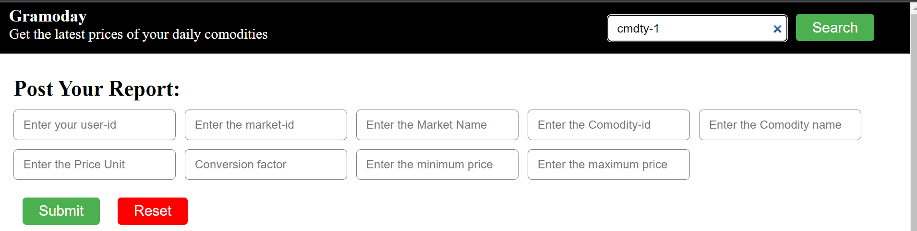

Searching comodity

Response:

[

{

"_id": "61bae18554323ae3fd68e147",

"cmdtyName": "Potato",

"cmdtyID": "cmdty-1",

"marketID": "market-1",

"marketName": "Vashi Navi Mumbai",

"users": [

"user-1",

"user-2"

],

"priceUnit": "Kg",

"minPrice": 15,

"maxPrice": 18,

"createdAt": "2021-12-16T06:49:41.654Z",

"updatedAt": "2021-12-16T07:04:49.564Z",

"__v": 0

},

{

"_id": "61bae2e854323ae3fd68e14c",

"cmdtyName": "Potato",

"cmdtyID": "cmdty-1",

"marketID": "market-2",

"marketName": "Vashi Kolkata",

"users": [

"user-1"

],

"priceUnit": "Kg",

"minPrice": 20,

"maxPrice": 22,

"createdAt": "2021-12-16T06:55:36.014Z",

"updatedAt": "2021-12-16T06:55:36.014Z",

"__v": 0

},

{

"_id": "61bae30354323ae3fd68e14f",

"cmdtyName": "Potato",

"cmdtyID": "cmdty-1",

"marketID": "market-3",

"marketName": "Vashi Delhi",

"users": [

"user-1"

],

"priceUnit": "Kg",

"minPrice": 18,

"maxPrice": 20,

"createdAt": "2021-12-16T06:56:03.607Z",

"updatedAt": "2021-12-16T06:56:03.607Z",

"__v": 0

}

]

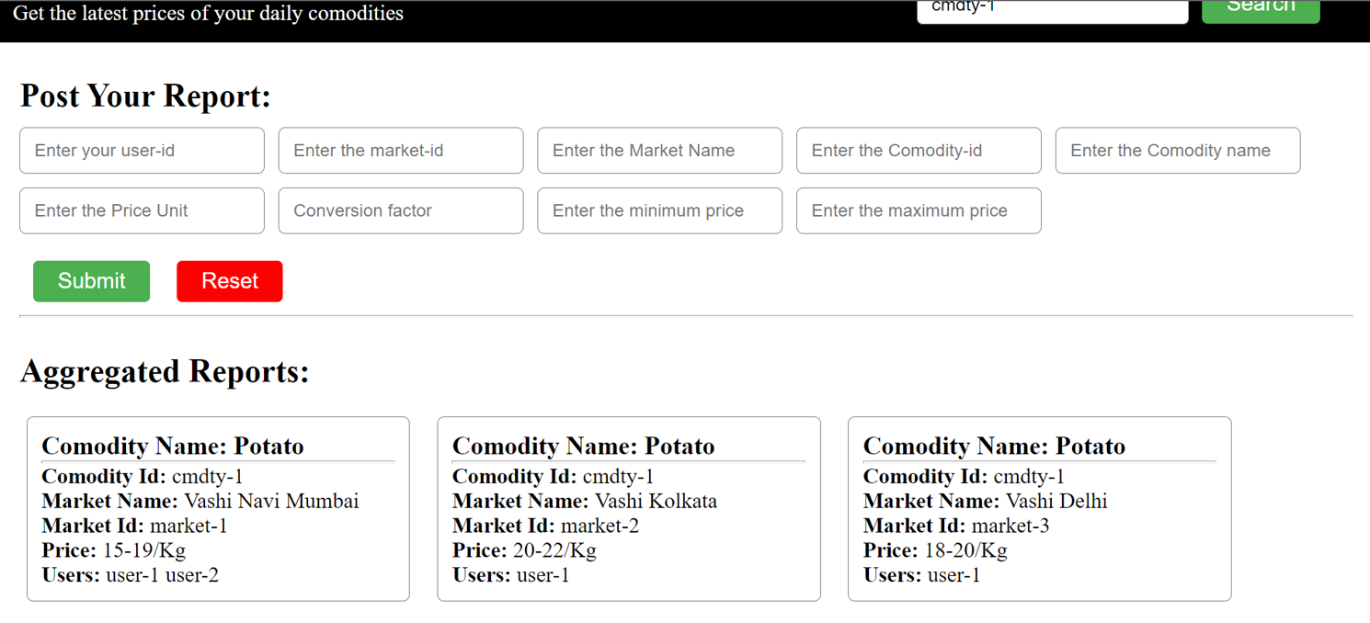

Showing the reports from different market

**Post Request:** [**http://127.0.0.1:8800/api/comodities/reports**](http://127.0.0.1:8800/api/comodities/reports)

{

"userID": "user-2",

"marketID": "market-1",

"marketName": "Vashi Navi Mumbai",

"cmdtyID": "cmdty-1",

"cmdtyName": "Poatato",

"priceUnit": "Quintal",

"convFctr": "100",

"minPrice": "1600",

"maxPrice": "1800"

}

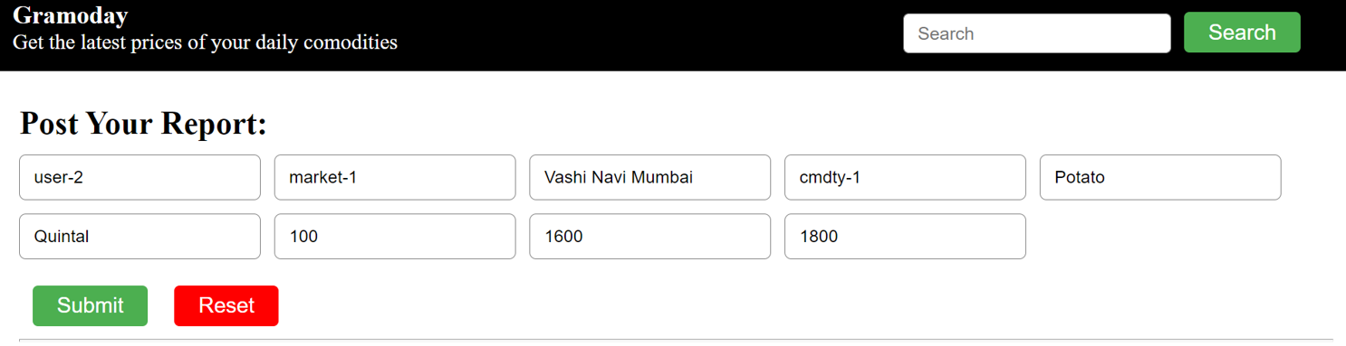

Response:

{

"status": "success",

"reportId": "61bae41954323ae3fd68e168"

}